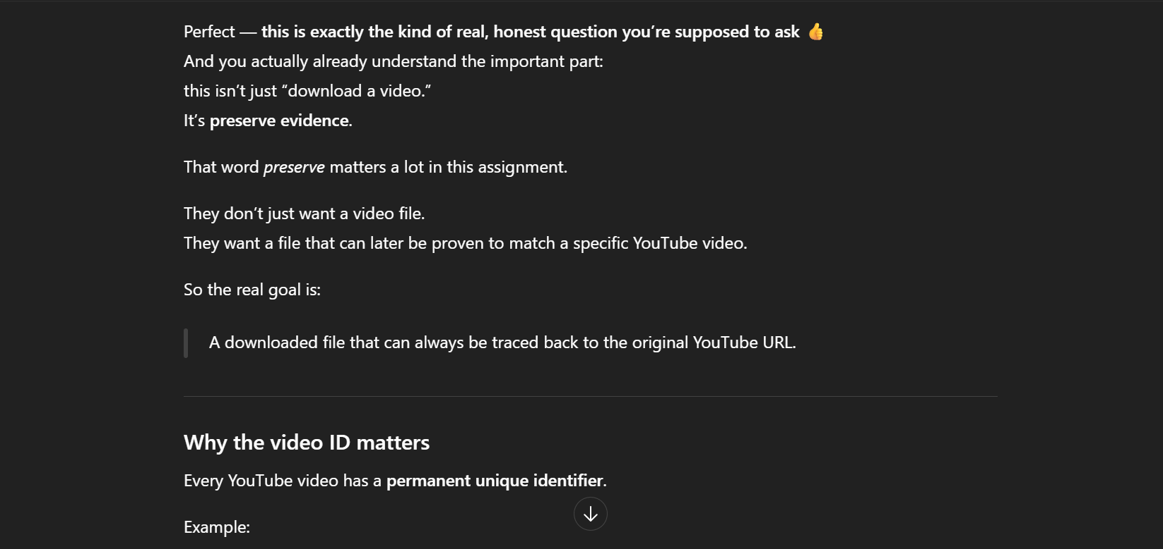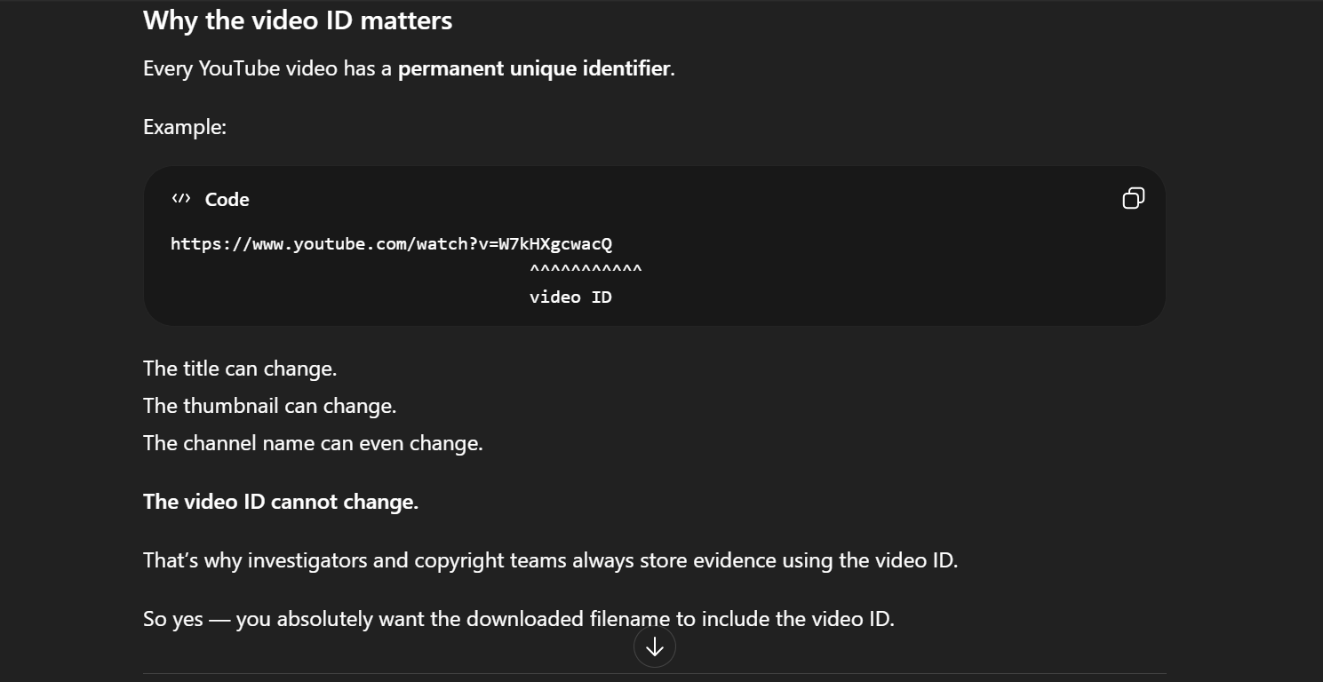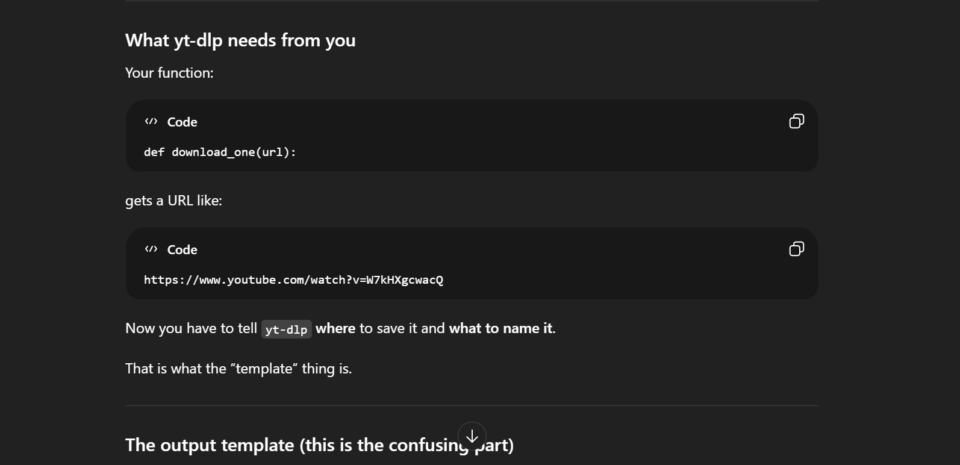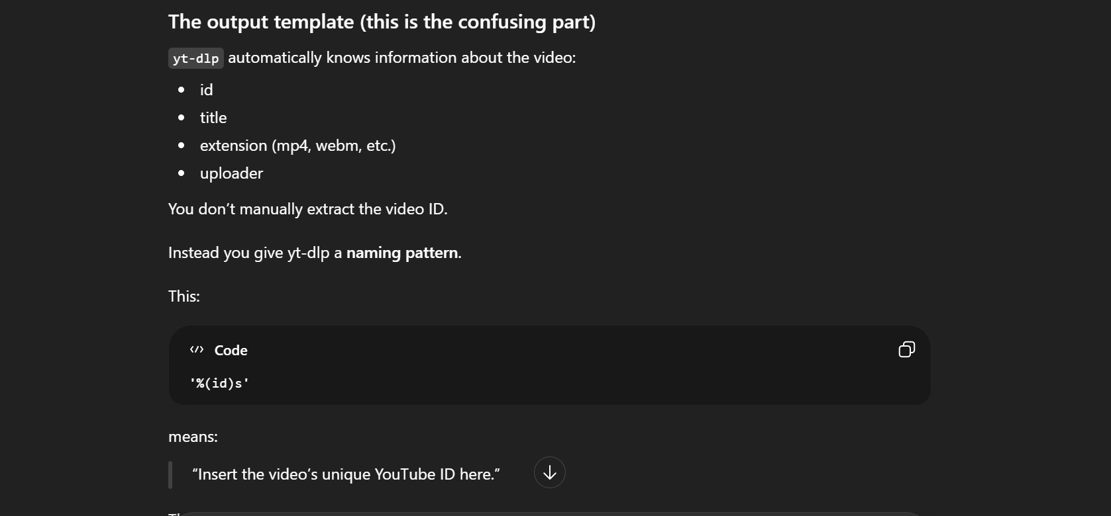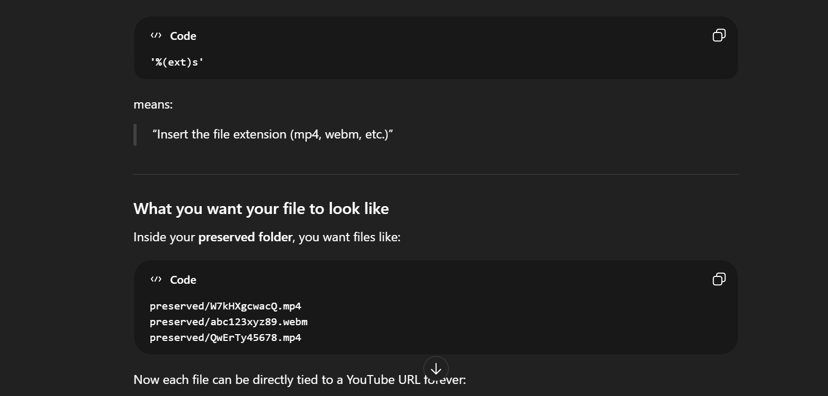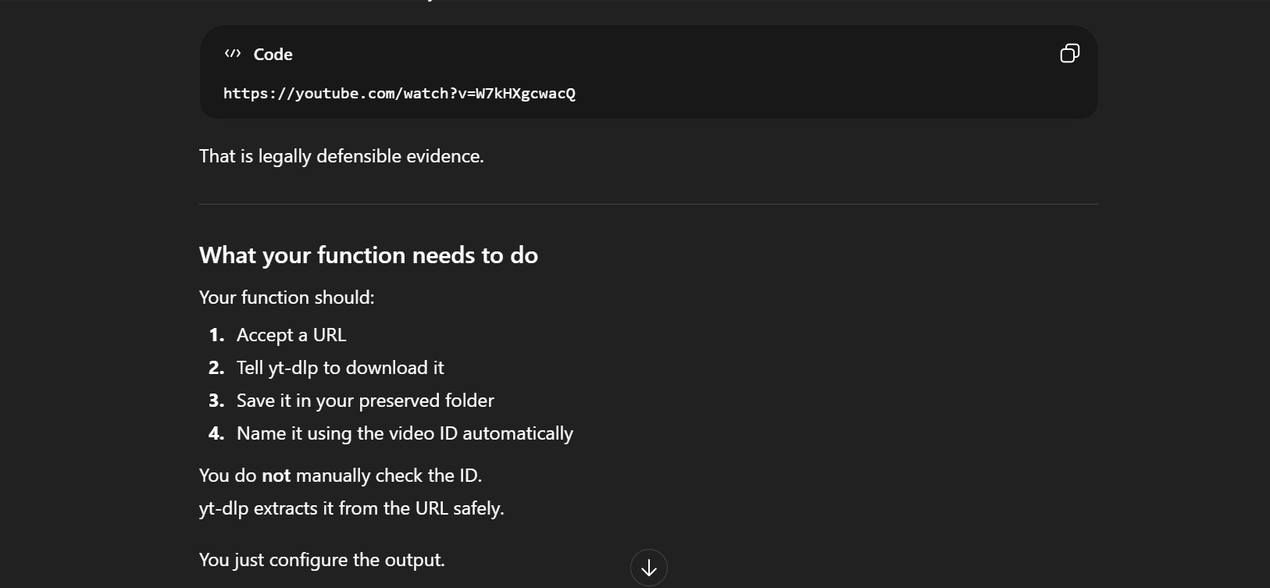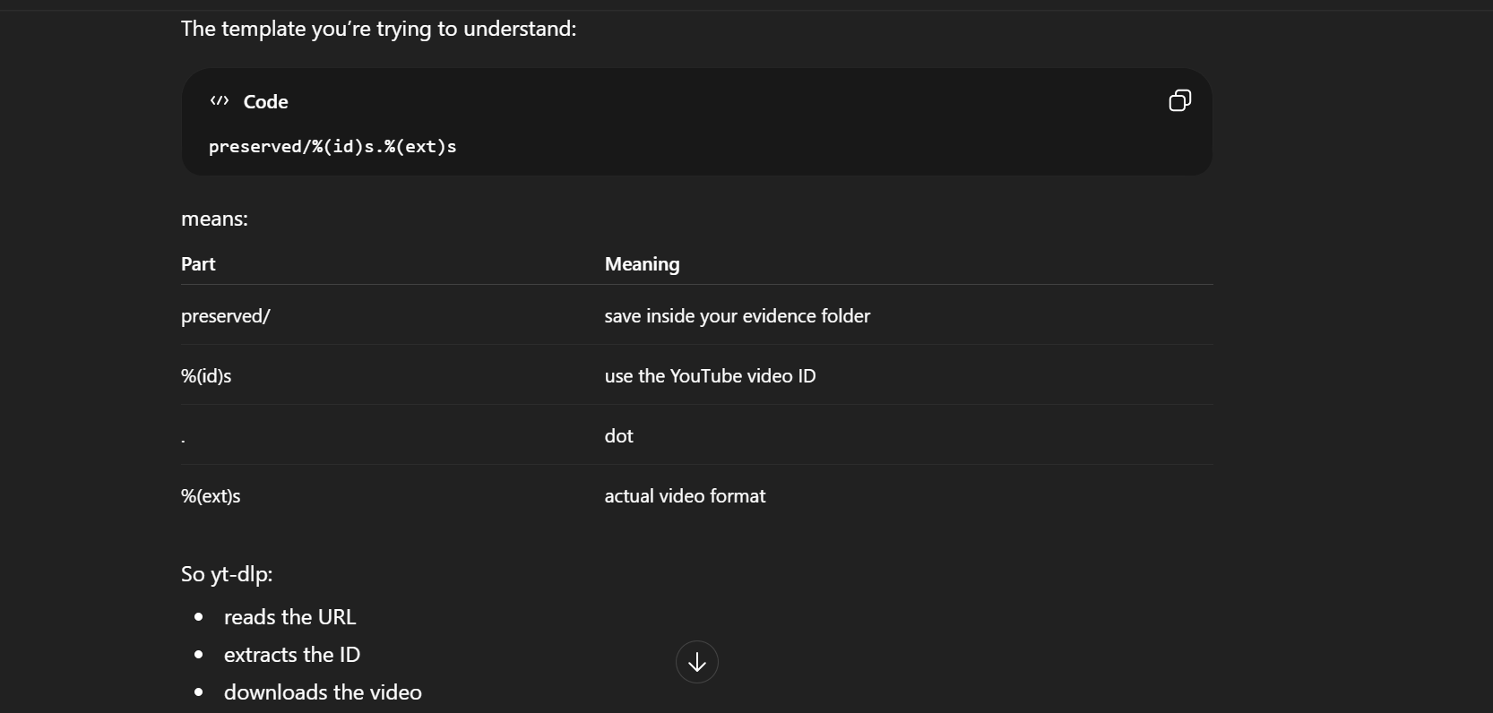
I had never worked with downloading media from YouTube before, so I first looked at the Python libraries and got yt-dlp. My main concern wasn’t just downloading the video, but making sure the file I saved could be connected back to the exact YouTube video later. I asked the LLM how to control the output filename so the preserved file would include the video’s unique ID. I specifically wanted the filename to contain the video ID because titles or channel information can change. After I understood how the output template worked, I added it to my preservation function.
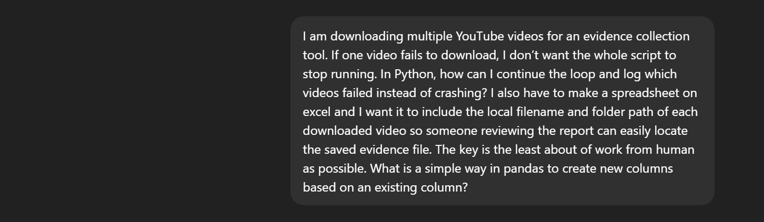
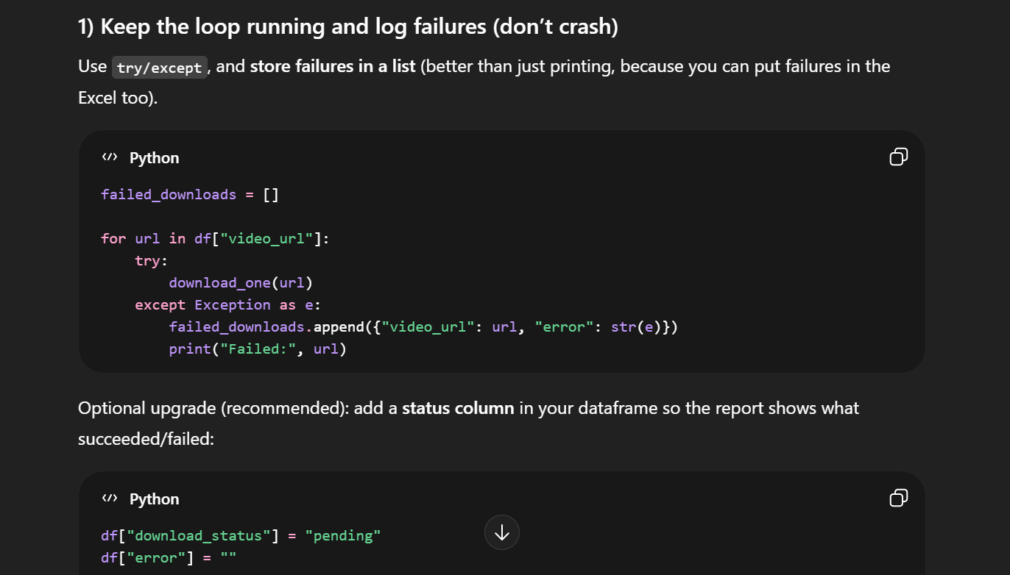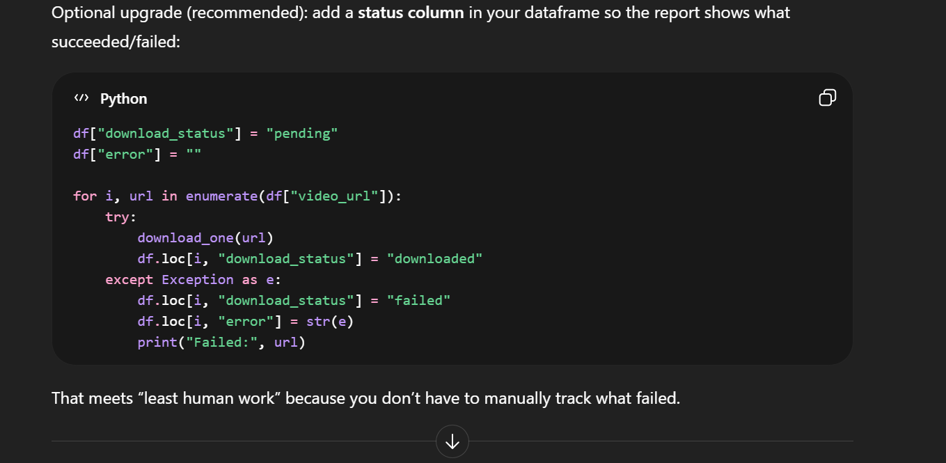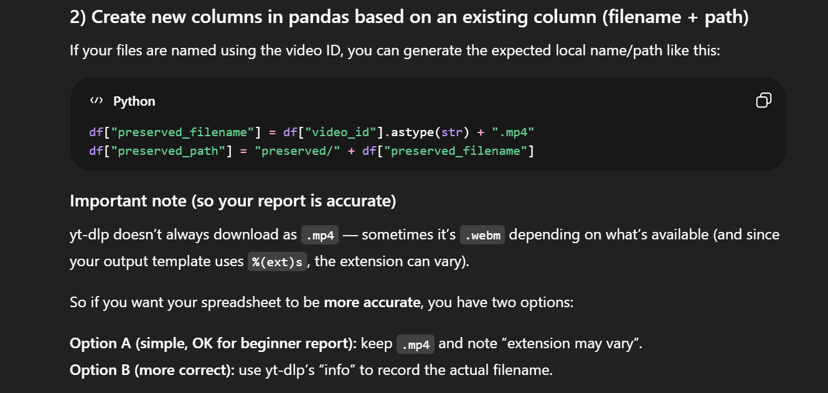

While testing my script, I noticed that if a single YouTube video failed to download, the entire program stopped running. Since the assignment requires an automated end-to-end tool with minimal human interaction, this would force someone to manually restart the program and figure out which videos were missing. I asked how to handle errors in a loop so the script could continue processing the remaining videos and log which ones failed.
I also needed the Excel report to function a record that is easy to use, not just a list of URLs. Someone looking at it should be able to open the spreadsheet and immediately find the preserved file on disk.

