Group 6 — Automated Public Health Procurement Auditor

Project Overview
The Automated Public Health Procurement Auditor is a web based tool that checks government medical purchases in Kenya and flags contracts priced far above the KEMSA market benchmark, so an auditor can review them before public funds are lost. It does not decide guilt or replace existing audit bodies. It is built for auditors, oversight officers and public health officials, and it replaces a manual review process that currently takes months with real time alerts.

System Architecture
The system follows a three tier client-server architecture, which keeps the interface, the business logic and the data independent of each other.
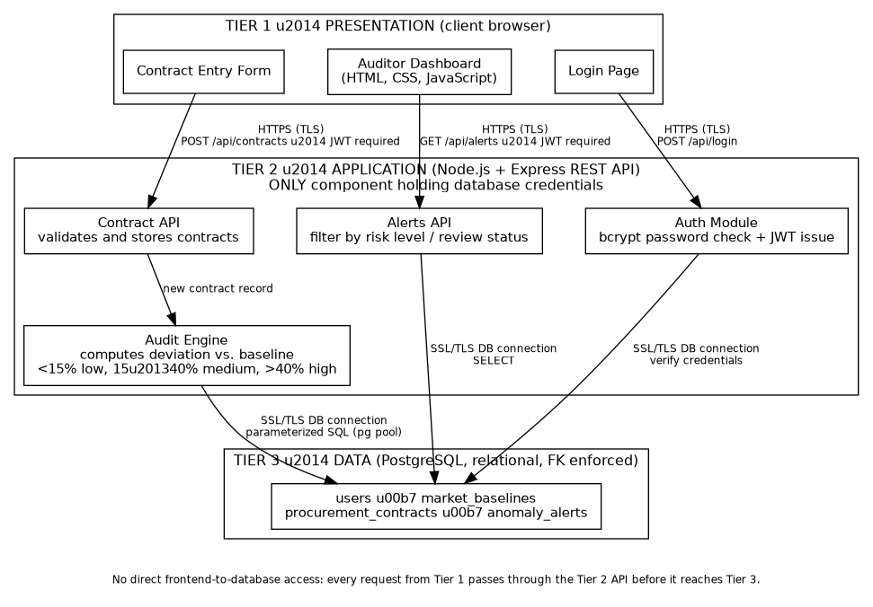
There is no direct connection between the frontend and the database. Every request from the dashboard, login page or contract form goes through the Node.js and Express API first; that API is the only component holding database credentials. The connection between the frontend and the API is secured with HTTPS (TLS), and the connection between the API and PostgreSQL is also encrypted (SSL enabled on the pg connection). This separation means the risk scoring rules can change without touching the frontend, and the database can be scaled or backed up on its own. We used Node.js and Express instead of a heavier framework such as Django because the team already had JavaScript experience across the stack, and Express keeps the API layer small for a project this size.
Other security measures: passwords are hashed with bcrypt before storage, every API request after login requires a valid JWT, and all database queries are parameterized through the pg driver to prevent SQL injection. Access is further restricted by the role field on each user account.

Data Flow: Submitting a Contract
1. The auditor fills in the contract entry form and submits it. 2. The frontend sends an authenticated POST request to the backend, including the JWT. 3. The backend validates the token and the submitted data. 4. The backend looks up the matching item in market_baselines. 5. The audit engine calculates the percentage deviation between the contracted price and the baseline price. 6. If the deviation passes the item's tolerance threshold, the backend inserts a row into anomaly_alerts with the computed risk level. 7. The dashboard fetches the alerts feed and shows the newly flagged contract to the auditor.

Database and Data Management
The database has four tables. market_baselines holds KEMSA reference prices and a tolerance percentage per item. procurement_contracts stores what was actually paid, linked to the user who submitted it and the baseline it should match. anomaly_alerts stores the result of comparing a contract to its baseline, including the risk level and how far off the price was. users stores login credentials, with passwords hashed using bcrypt, and a role field that controls access.
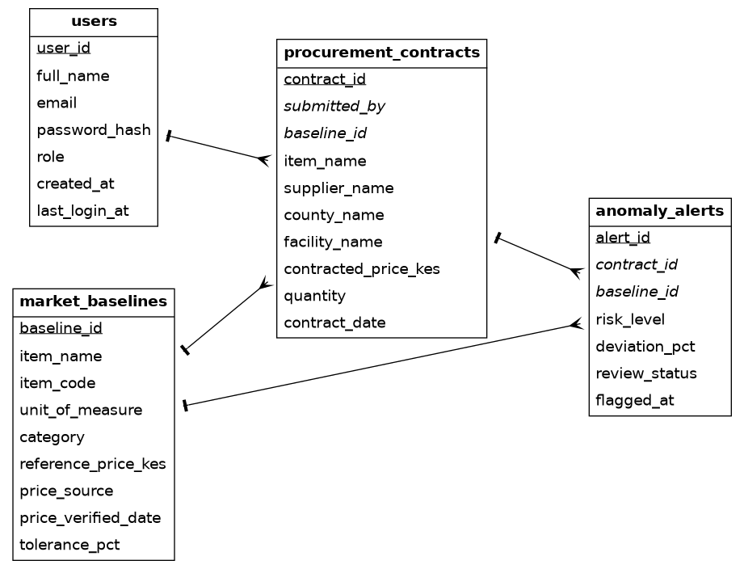
PostgreSQL was chosen over a NoSQL option such as MongoDB because procurement records are relational: contracts link to users and baselines, and PostgreSQL enforces that with foreign keys and constraints, which matters for audit data that has to stay consistent. Foreign keys and indexes on the contract, baseline and user lookups keep the checks fast and stop orphaned records from being created.

Tools Used
Backend: Node.js, Express, PostgreSQL (via the pg driver), bcryptjs and jsonwebtoken for authentication, Agile, dotenv for configuration. Development: Git and GitHub for version control, npm for package management, nodemon for local development, VS Code as the shared editor.

Team Contributions and Next Steps
Name | Role | Contribution so far
Gabriel Mugisha | Database / Team Lead | Project setup, database connection pool, backend support.
Philip | Database | Procurement ledger and alert tables, seed data, performance indexes.
Aimable | Frontend | Database design and data modeling.
James Kanneh | Architecture, Integration, Documentation | ERD, system architecture, tool selection, this documentation.
Clive | Backend | Backend development support alongside Philip.
Cedro Iranzi | Slides & Frontend | Frontend support and prepard the presentation slides.

