PyGameMaker — Tutorial 1: First Steps

How to Use This Handout
This handout follows the 4 pages of the in-app tutorial, found under Help > Tutorials > Getting Started. Read each part here, then do the matching part on your screen. Tick the check-boxes as you complete each task, and use the My Notes section at the end to write down anything you want to remember.

Part 1: Welcome to PyGameMaker
PyGameMaker is a visual game-making program. You build 2D games by creating assets — sprites (images), objects (things that are programmed to behave a certain way), and rooms (levels) — and connecting them together. By the end of this tutorial, you will be able to:
- Navigate the PyGameMaker interface confidently
- Create and manage game assets (sprites, objects, rooms)
- Add behaviors to game objects using events and actions
- Test and export your own games
You can close the tutorial panel at any time with the "Close" button at the top. To open it again later, use Help > Tutorials from the menu.
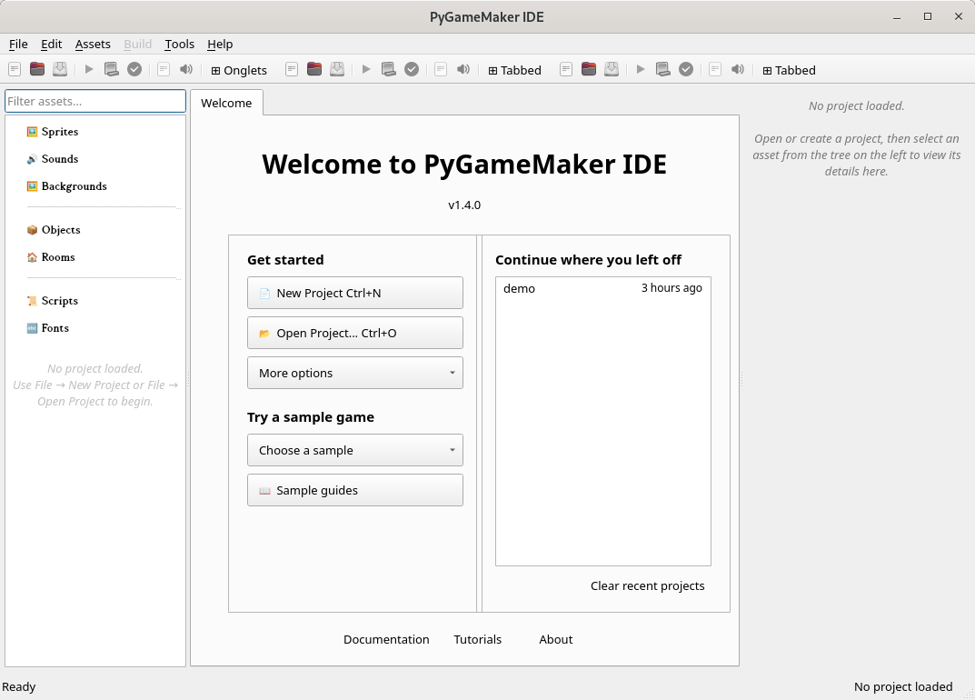
Title Bar
Close
Fullscreen
Minimize
Menu Bar
Toolbar
Assets
Editor Area
Properties

Part 2: The PyGameMaker Interface
Before building anything, take a moment to look around. The PyGameMaker window is divided into three main areas.

1. Asset List (left panel)
This is where every asset in your project lives, organized by type. Right-click any category here to create a new asset of that type.
- Sprites — the images and animations your game uses.
- Sounds — sound effects and music.
- Objects — the game entities that actually do things.
- Rooms — the levels or screens of your game.

2. Editor Area (center)
This is where you actually edit things. Double-click an asset in the asset list, and its editor opens here in a tab.
- The Sprite Editor lets you view and draw sprites.
- The Object Editor lets you define what an object does, using events.
- The Room Editor lets you design a level by placing objects in it.

3. Properties Panel (right panel)
Shows the settings of whatever you currently have selected. When you are editing a room or an object, this is where some of its properties are displayed and where you change them.

Key Menus
- File — create, open, and save projects
- Assets — create and import game assets
- Build — test and export your game
- Help — tutorials and documentation
Press F5, or click the green triangle ▶ in the toolbar, at any time to quickly test your game!
Assets
Editor Area
Properties

Part 3: Build Your First Project
Now it is time to build something! Follow these eight steps in order, and each one explains what you are doing and why, before telling you what to click.
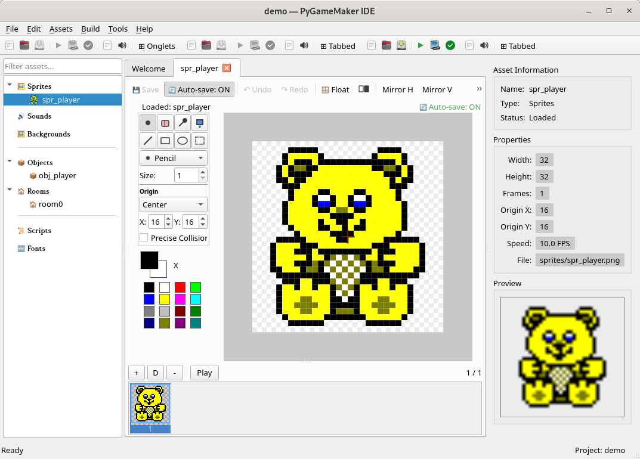
☐ 1. Create a new project. Every game starts as a project, which is a folder that holds all of its assets. Go to File > New Project (or press Ctrl+N), give your project a name, and choose where to save it.
☐ 2. Create a sprite. A sprite is the image your character (or any object) will use.
Right-click Sprites, choose + Create New Sprite..., and give it a name, for example spr_player.
☐ 3. Edit the sprite. Double-click the sprite's name, then draw a simple character in the Sprite Editor.
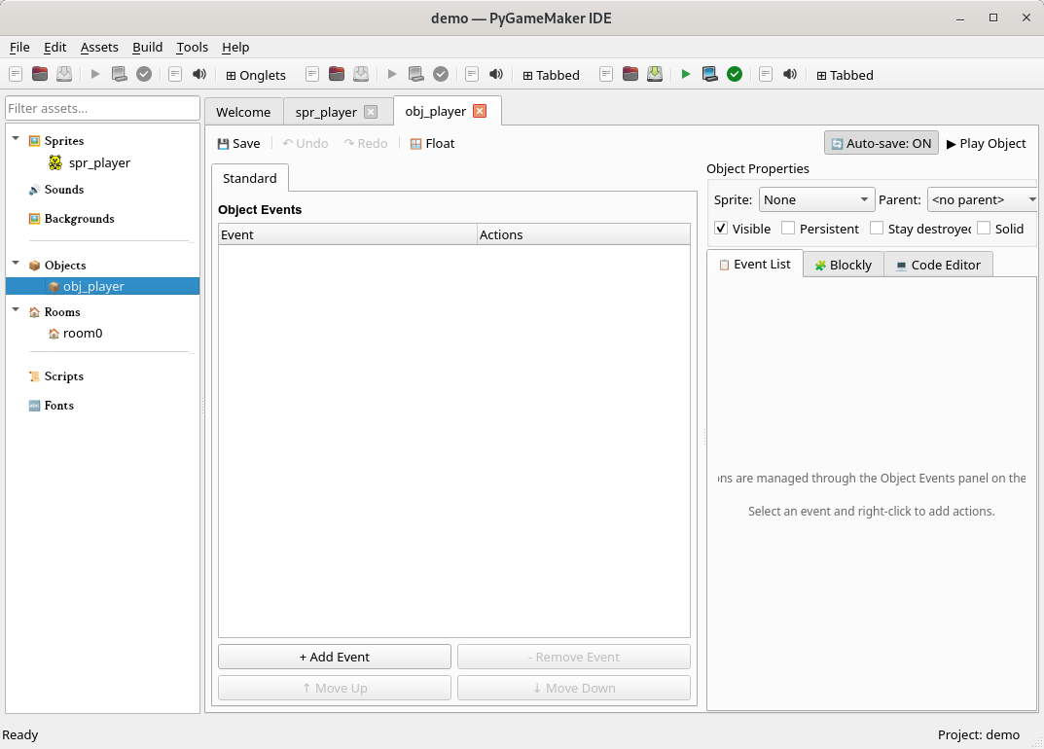
☐ 4. Create an object. A sprite is just a picture carried by an object — an object is what actually behaves in your game.
Right-click Objects, choose + Create New Object..., and give it a name, for example obj_player.
☐ 5. Assign a sprite. Assign a sprite to the object you just created by choosing spr_player from the list shown in the object's properties.
☐ 6. Rename the room. A room is a level or screen in your game. Right-click the room room0 and rename it room_game. This will be your very first level.
☐ 7. Place an object. An object only appears in the game once it has been placed in a room. Double-click your room to open the Room Editor, select obj_player from the list, and click inside the room to place it.
☐ 8. Test the game. Press F5 (or click the green triangle ▶ in the toolbar, or go to Build > Test Game). A window will open showing your room, with the object you placed inside it!
Congratulations! You have just created your first PyGameMaker project. It doesn't do much yet — your object won't move or react to anything — but you will learn how to add behaviors in the next tutorials.

Part 4: A Look Ahead
Now that you know the basics, here is a preview of what is coming next. You do not need to do anything now — you can just read this part to know what to look forward to:
- Adding movement — use a Keyboard event and actions like "Move in Direction" to make your object respond to key presses.
- Collision detection — make objects react when they touch each other, like stopping at a wall.
- Visual programming with Blockly — build behaviors by connecting blocks to each other instead of writing code.
- Multiple rooms — create several levels and move between them
- Exporting your game — turn your finished project into a game other people can play, for example as a web page or an executable file.
Need help? Ask your teacher, or press F1 in PyGameMaker for documentation.

Vocabulary
Term | What it means
Asset | Any resource in your project — a sprite, sound, object, or room.
Sprite | An image (or animation) used to draw something on screen.
Object | A game entity — what actually appears and behaves in a room.
Room | A level or screen in your game, where objects are placed.

My Notes

