PyGameMaker — Tutorial 15: Fruit Fusion

How to Use This Handout
This handout goes with the in-app tutorial Help > Tutorials > Fruit Fusion: Catch and Merge! (5 pages, about 20-25 minutes). Keep the tutorial open on one half of your screen. Tick each box when the step is done, and check the You should see line at the end of every phase. If something does not match, look at Stuck? before you call your teacher.

What You Will Make
A basket that always holds one fruit, starting with a cherry. Cherries, strawberries and oranges fall from the sky. Catch a fruit that matches what you are holding and it fuses into the next, bigger fruit. Fuse all the way up to a watermelon and you win!
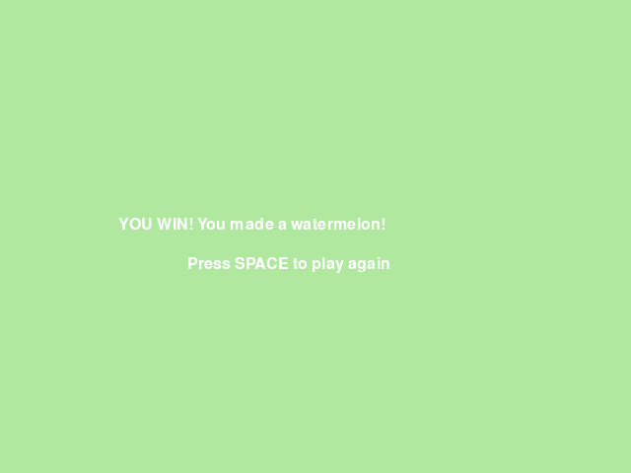

Phase 1: Moving Basket
☐ 1. Make a new project FruitFusion.
☐ 2. Create a sprite spr_basket_empty (56x40, a brown bowl shape) and an object obj_player with that sprite.
☐ 3. Create a room room_main and place obj_player near the bottom center.
☐ 4. In obj_player: Keyboard: Left Arrow (held) with *Set horizontal speed to -5*; Right Arrow (held) with *5*; Keyboard: No key with *Stop movement*.
You should see: press F5. Left and Right move the basket, and it stops when you let go.
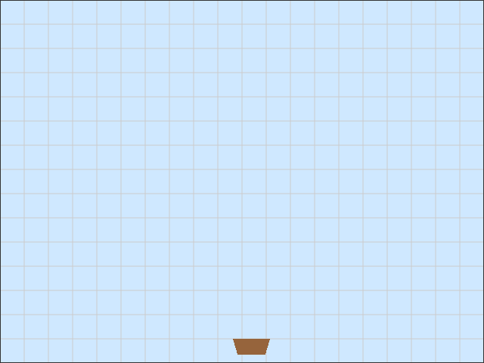

Phase 2: First Fusion
☐ 5. Create a sprite spr_fruit_cherry (20x20, a red circle) and an object obj_fruit_cherry with a Create event (*Set vertical speed 3*) and an Outside Room event (*Destroy this instance*).
☐ 6. Create obj_spawn_cherry (no sprite) with a Create event (*Set alarm 0 to 90*) and an Alarm 0 event (*Create instance of obj_fruit_cherry at a random x, y 0*, then *Set alarm 0 to 90* again). Place one in room_main.
☐ 7. Change obj_player's sprite to a new sprite spr_basket_cherry (a bowl with a cherry in it) — the basket now starts out already holding a cherry.
☐ 8. In obj_player: Create event sets *score to 0* and *variable held_level to 1*; Draw event does *Draw score at x 10, y 10*.
☐ 9. Add Collision with obj_fruit_cherry: *If held_level equals 1 then* [*set held_level to 2*, *add 10 to score*, *set sprite to spr_basket_strawberry*] *Otherwise* [*add 1 to score*]; then *Destroy other instance*.
You should see: press F5. Catch a falling cherry — the basket turns into a strawberry and the score jumps by 10.
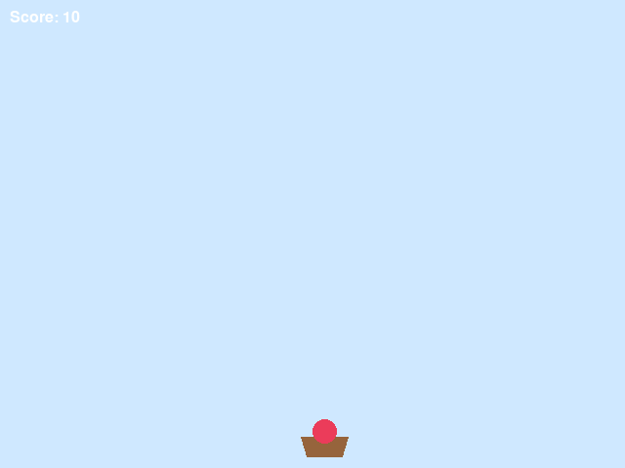

Phase 3: Second Fusion
This phase repeats the exact same recipe as Phase 2, with "cherry" changed to "strawberry" and the numbers changed from 1/2 to 2/3.
☐ 10. Create a sprite spr_fruit_strawberry (26x26, a pink-red circle) and an object obj_fruit_strawberry, built exactly like obj_fruit_cherry.
☐ 11. Create obj_spawn_strawberry (alarm 0 to 120 this time) and place one in room_main.
☐ 12. Add Collision with obj_fruit_strawberry on obj_player: *If held_level equals 2 then* [*set held_level to 3*, *add 20 to score*, *set sprite to spr_basket_orange*] *Otherwise* [*add 1 to score*]; then *Destroy other instance*.
You should see: press F5. Catch a cherry, then a strawberry — the basket ends up an orange, having scored 30 points.
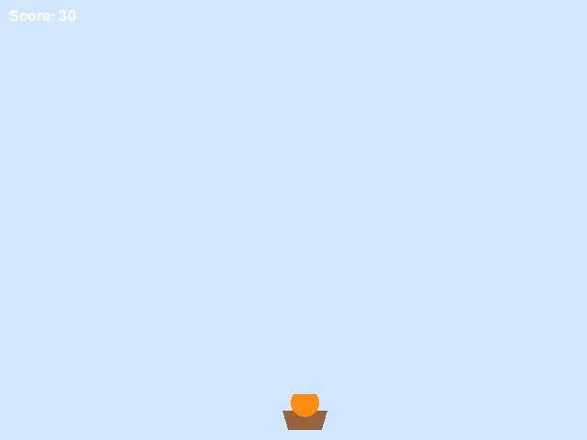

Phase 4: Winning
☐ 13. Create a sprite spr_fruit_orange (32x32, an orange circle) and an object obj_fruit_orange, built exactly like the others. There is no falling watermelon sprite or spawner — a watermelon is only ever something your basket becomes.
☐ 14. Create obj_spawn_orange (alarm 0 to 150) and place one in room_main.
☐ 15. Create obj_win_text. Draw event: *Draw text* "YOU WIN! You made a watermelon!" at x 120, y 220 and "Press SPACE to play again" at x 190, y 260. Key press: space: *Restart game*.
☐ 16. Create room_win with a bright background color, and place one obj_win_text instance in it.
☐ 17. Add Collision with obj_fruit_orange on obj_player: *If held_level equals 3 then* [*set held_level to 4*, *add 50 to score*, *set sprite to spr_basket_watermelon*, *Go to room room_win*] *Otherwise* [*add 1 to score*]; then *Destroy other instance*.
You should see: press F5. Chain all three fusions and the YOU WIN! room appears. SPACE starts a new game.
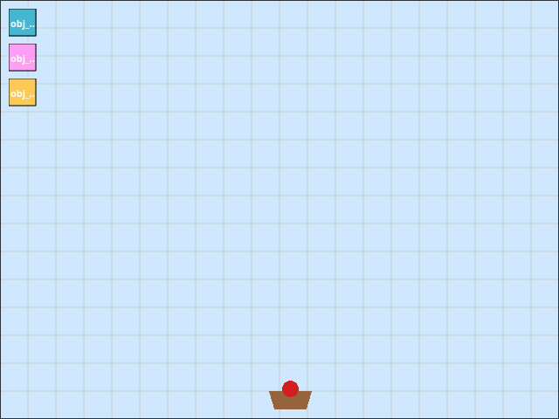

Stuck?
What is wrong | Most likely cause | What to do
The basket never changes picture | set_sprite is missing from the *If* branch, or it points at the wrong sprite name | Check the exact sprite name in *Set sprite to*
Catching a matching fruit only gives 1 point | held_level is not actually equal to the number the *If* checks, or the condition uses the wrong operator | Check *If held_level equals* uses the right number for that phase (1, then 2, then 3)
The basket is stuck as a cherry forever | The merge's *Otherwise* branch accidentally changed held_level too | Only the *If* branch should touch held_level and the sprite
Fruit piles up and never disappears | The fruit's Outside Room event is missing | Add *Destroy this instance* in Outside Room
No fruit ever falls | The spawner object has no instance placed in room_main, or its alarm was never set in Create | Place one spawner instance; check *Set alarm 0* is in Create, not somewhere else
Catching an orange does not win | The *Go to room room_win* action is in the wrong place, or the room name is misspelled | It must be inside the *If held_level equals 3* branch, spelled exactly room_win
The win screen is blank | obj_win_text was not placed in room_win, or its Draw event is missing | Place one instance; check the Draw event exists
SPACE does nothing on the win screen | The win room has no object with a Key press: space event | Add the event to obj_win_text

Challenges
- Try this (5 minutes): change the fruit fall speed, or how often a spawner fires.
- Push further: add a fourth spawner and fruit type between orange and watermelon.
- Invent: add lives that go down when you mismatch too many times in a row.

Vocabulary
Term | What it means
Held fruit | The one fruit the basket is currently carrying, remembered in held_level
Fusion | Catching a matching fruit so it grows into the next, bigger fruit
If / Else | A block that does one thing when something is true, and a different thing when it is not
Spawner | An invisible object whose only job is to create other objects on a timer
Outside Room | An event that fires when an instance leaves the room — used here to clean up missed fruit

Check Yourself
Write your answers in the notes below.
- Why does the basket need a variable like held_level at all?
- What happens if you catch a cherry while already holding an orange?
- Why is there no sprite or spawner for a falling watermelon?

My Notes
______________________________________________________________________________
______________________________________________________________________________
______________________________________________________________________________
______________________________________________________________________________
______________________________________________________________________________
______________________________________________________________________________
______________________________________________________________________________
______________________________________________________________________________
______________________________________________________________________________
______________________________________________________________________________

