PyGameMaker — Tutorial 16: Fruit Basket

How to Use This Handout
This handout goes with the in-app tutorial Help > Tutorials > Fruit Basket: Catch and Avoid! (6 pages, about 10-15 minutes). Keep the tutorial open on one half of your screen. Tick each box when the step is done, and check the You should see line at the end of every phase. If something does not match, look at Stuck? before you call your teacher.

What You Will Make
A basket that slides left and right along the bottom of the room. Fruit and bombs are already sitting in the room — nothing falls, nothing moves by itself. Walk the basket into a fruit and it disappears, adding to your score. Walk into a bomb and the room starts over. Collect every fruit and you win!

Phase 1: Moving Basket
☐ 1. Make a new project FruitBasket.
☐ 2. Create a sprite spr_basket (56x40, a brown bowl shape) and an object obj_player with that sprite.
☐ 3. Rename the project's starting room (room0) to room_main, set its width to 640 and height to 480 in its properties, and place obj_player near the bottom center.
☐ 4. In obj_player: Keyboard: Left Arrow (held) with *Set horizontal speed to -5*; Right Arrow (held) with *5*; Keyboard: No key with *Stop movement*.
You should see: press F5. Left and Right move the basket, and it stops when you let go.

Phase 2: Fruit and Bombs
☐ 5. Create a sprite spr_fruit (26x26, a green circle) and an object obj_fruit with that sprite. No events needed.
☐ 6. Create a sprite spr_bomb (26x26, a dark circle) and an object obj_bomb with that sprite. No events needed here either.
☐ 7. In room_main, place 5 fruit along the bottom with gaps between them (but not right where the basket starts), and 2 bombs, one near the left edge and one near the right edge, well away from any fruit.
You should see: press F5. The fruit and bombs sit still. The basket can move among them, but touching them does nothing yet.
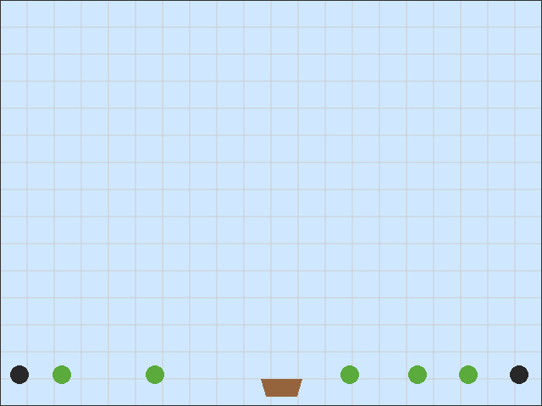

Phase 3: Catching and Avoiding
☐ 8. In obj_player, Create event: *Set score to 0*. Draw event: *Draw score at x 10, y 10*.
☐ 9. Add Collision with obj_fruit: *Add 10 to score*, then *Destroy other instance* (the fruit, not the basket!).
☐ 10. Add Collision with obj_bomb: *Restart Room*.
You should see: press F5. Catching a fruit adds 10 to the score and the fruit disappears. Touching a bomb puts everything back where it started, score included.

Phase 4: Winning
☐ 11. Create obj_win_text. Draw event: *Draw text* "YOU WIN!" at x 412, y 320 and "Press SPACE to play again" at x 340, y 400. Key press: space: *Restart game*.
☐ 12. Create room_win with a bright background color, and place one obj_win_text in it.
☐ 13. In obj_player, add a Step event: *If count of* obj_fruit *equals 0* then *Go to room* room_win.
You should see: press F5. Collect every fruit and the YOU WIN! room appears. SPACE starts a new game.
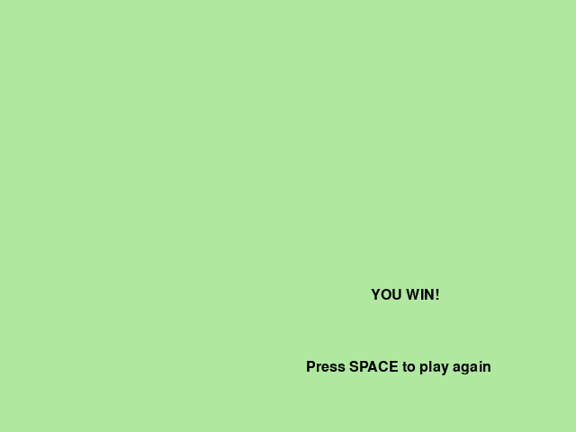

Bonus (optional): Import Ready-Made Art
Page 6 of the tutorial shows how to swap any of your drawings for ready-made pictures instead, if you'd rather not draw. Your game works exactly the same either way — this is only worth doing once everything above already works.

Stuck?
What is wrong | Most likely cause | What to do
The basket catches a fruit the instant the game starts | A fruit was placed too close to the basket's own starting spot | Move that fruit further away, or move the basket's start position
My basket disappears when it catches a fruit | I used *Destroy this instance* | Use Destroy other instance
Touching a bomb does nothing | No Collision with obj_bomb on obj_player, or it uses the wrong action | Add the collision and use Restart Room
The score does not show | No Draw event on the basket | Add *Draw score* to a Draw event
The game says YOU WIN! at once | There is no fruit in room_main (the count is already 0) | Place at least one fruit in the room
I catch every fruit but nothing happens | The Step event or the room name is wrong | Check *If count of obj_fruit equals 0* and the room name room_win
The win screen is blank | obj_win_text was not placed in room_win, or its Draw event is missing | Place one instance; check the Draw event exists
SPACE does nothing on the win screen | The win room has no object with a Key press: space event | Add the event to obj_win_text

Challenges
- Try this (5 minutes): add a few more fruit, or move the bombs closer together.
- Push further: add a second row of fruit higher up (you'll need to let the basket move up and down too, or add a ladder-like object).
- Invent: give fruit different point values by making a second fruit object worth more.

Vocabulary
Term | What it means
Collision | An event that fires the moment two objects touch
Instance count | How many copies of an object exist right now
Restart Room | An action that puts the current room back exactly how it started
Step event | An event that runs every single frame of the game, over and over

Check Yourself
Write your answers in the notes below.
- Why does the fruit never need its own events, unlike the basket?
- What happens to your score if you touch a bomb? Why?
- How does the game know when you've collected every fruit?

My Notes
______________________________________________________________________________
______________________________________________________________________________
______________________________________________________________________________
______________________________________________________________________________
______________________________________________________________________________
______________________________________________________________________________
______________________________________________________________________________
______________________________________________________________________________
______________________________________________________________________________
______________________________________________________________________________

