PyGameMaker Junior: Make Your Own Game
Keep this sheet next to your computer. Do each part, then tick the box. Stuck? Ask a neighbour first, then your teacher.

Part 1: Start a Project
When the program starts, you see this:
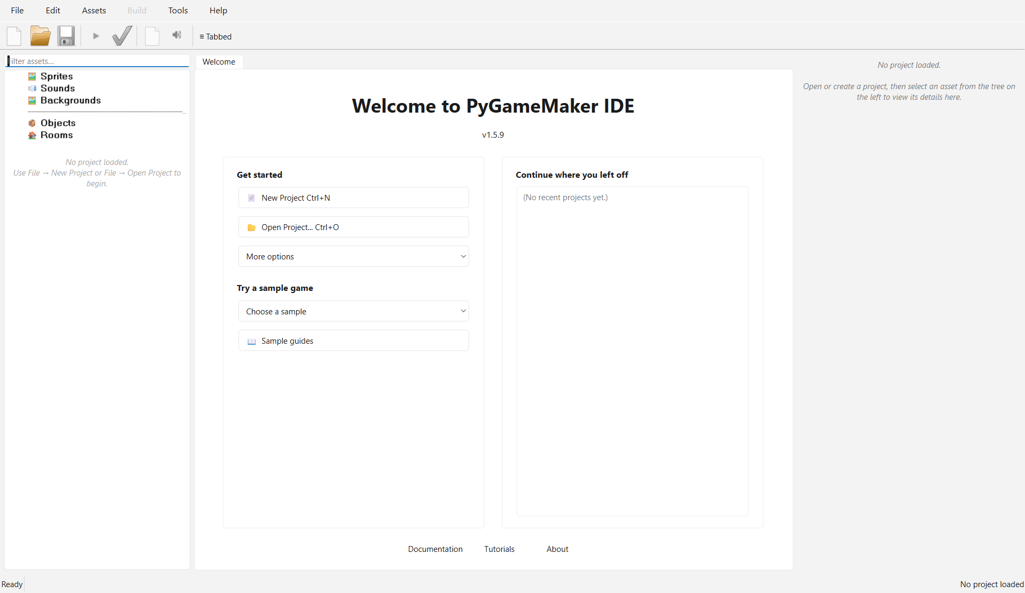
☐ Click New Project.
☐ Give your project a name, for example MyGame.
☐ Click OK.

Part 2: Your Tools
Look at the top of the window:

- New: start a game
- Open: open a game you saved
- Save: save your game. Do this often!
- Green triangle: play your game (or press F5)
- Green tick: share your game
On the left you have your resources: sprites, objects and rooms.
- A sprite is a picture.
- An object does things in your game.
- A room is a level (a screen of your game).

Part 3: Draw a Sprite
☐ Click Assets > Create Sprite.
☐ Give it a name, for example spr_hero.
☐ Choose a colour and draw with the pencil.
☐ Click Save.
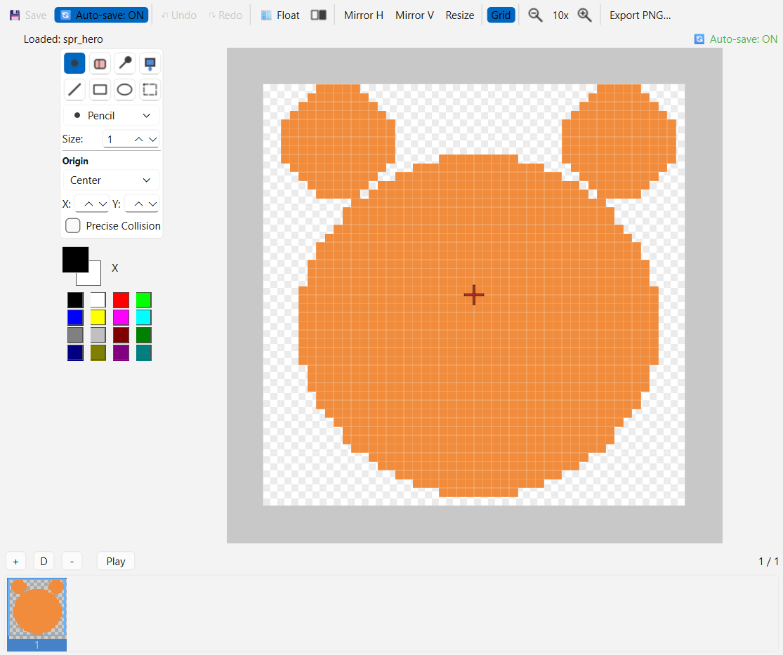
Start the names of your sprites with spr_.

Part 4: Make an Object Move in 4 Directions
☐ Click Assets > Create Object and name it obj_hero.
☐ In Sprite, choose your sprite.
☐ Add 4 Keyboard blocks (Left Arrow, Right Arrow, Up Arrow, Down Arrow). In each one, put Set horizontal speed or Set vertical speed to: left -4, right 4, up -4, down 4.
☐ Add Keyboard: No key, then Stop movement, so your hero stops when you touch nothing.
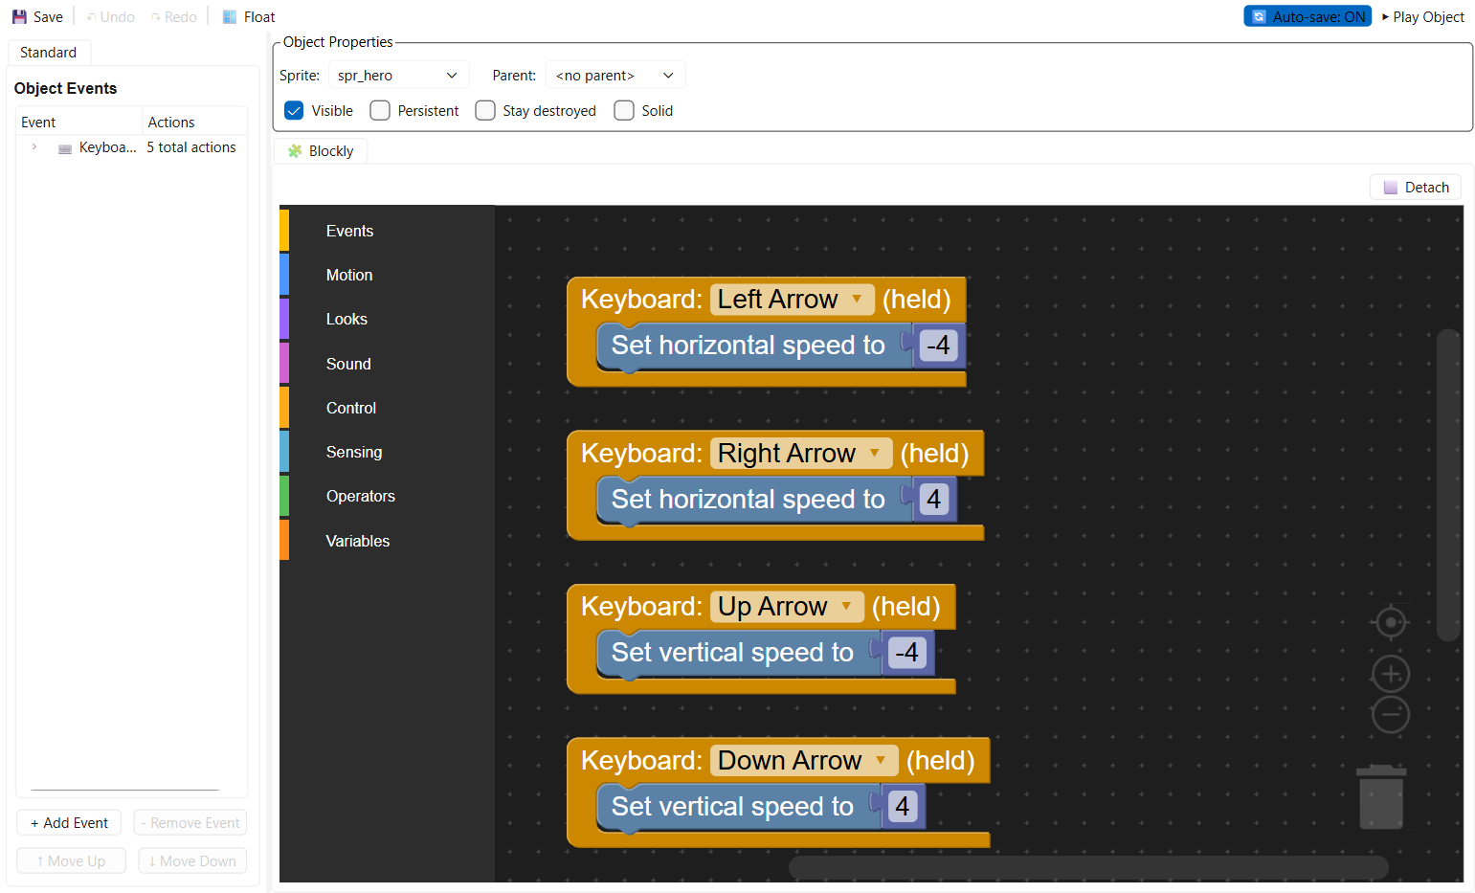
Right-click a block to duplicate or delete it. Duplicate the Left Arrow block three times, then just change the key and the number in each copy!

Part 5: Build a Room and Play
Your project already has a room, room0. You do not need to create one!
☐ Double-click room0 in the Rooms list on the left.
☐ Click your object in the list, then click in the room to place it.
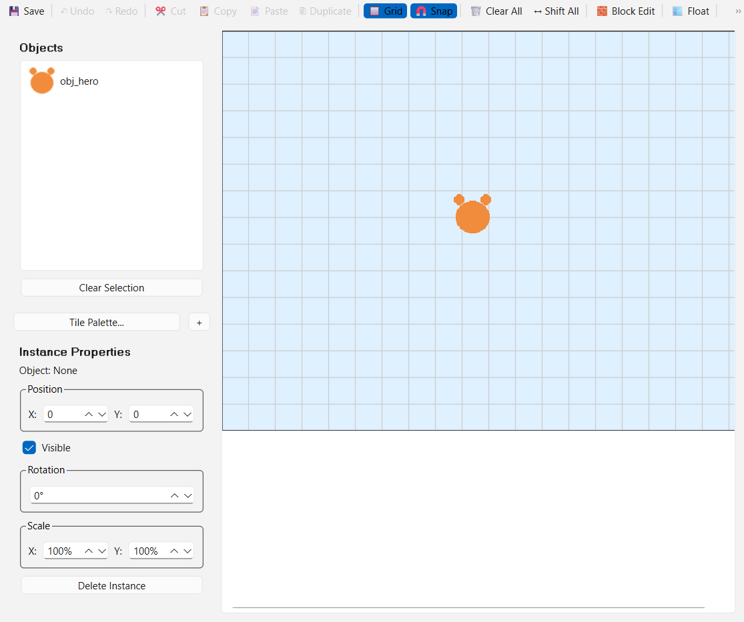
☐ Press the green triangle (or F5) to play.
You can rename room0 if you want (right-click > Rename).
You see your sprite in the game and you can make it move.

Part 6: Share Your Game
☐ Click File > Export as HTML5.
☐ Choose a folder.
☐ Click Yes to open it in your browser.
You get a file ending in .html. Send it to a friend: they can play it!

Part 7: BONUS: Pick Up Fruit!
Your game already works. If you still have time, add points!
☐ Create a sprite spr_fruit (a small red or yellow circle).
☐ Create an object obj_fruit with this sprite.
☐ Open obj_hero and add the event When colliding with obj_fruit.
☐ Put 2 blocks in it: Add to score 10 and Destroy other instance.
☐ Add the event When drawing, with the block Draw score at x: 10 y: 10.
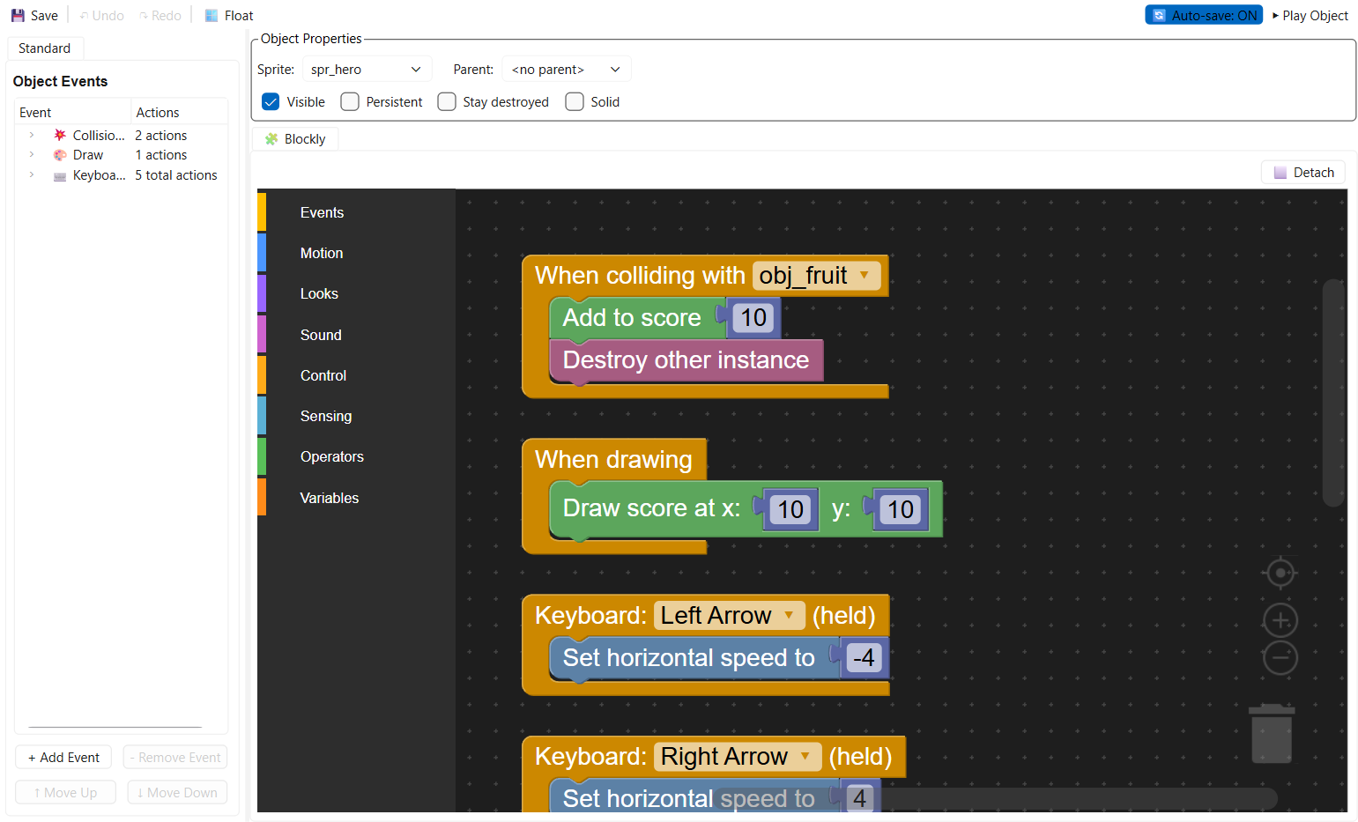
☐ Go back to room0 and place 2 or 3 obj_fruit in the room.
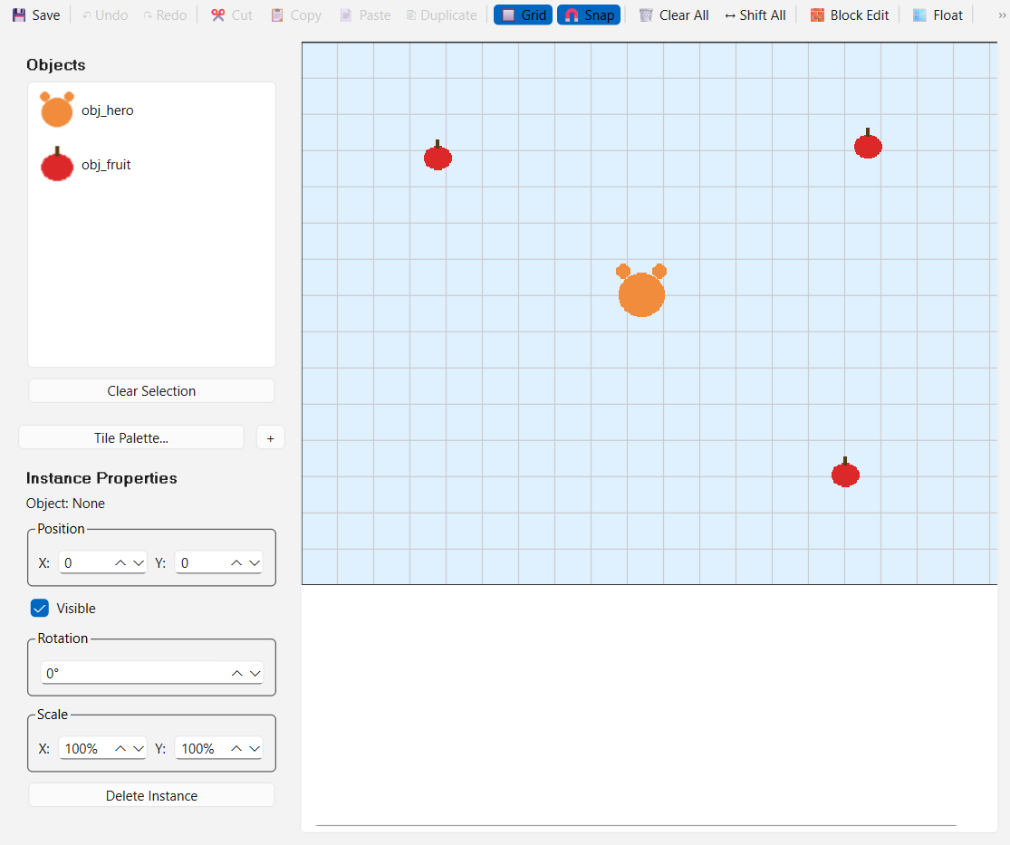
☐ Press F5: pick up the fruit to win points!
Your score goes up and the fruit disappears when you touch it.

Stuck?
What happens | Try this
My object does not move | Is there a block under Keyboard? Is the object in the room?
My hero never stops | Add Keyboard: No key + Stop movement
I cannot see my sprite | Did you choose the sprite in the Sprite box?
I deleted something by mistake | Tools > Restore Deleted Assets
The game shows a grey window | Wait a little, then try again
My score does not go up | Is the collision event on obj_hero, with the right object chosen?

Words to Know
- Sprite: a picture
- Object: a thing that does actions
- Room: a level (a screen of your game)
- Block: a piece of your program
- Collision: when two objects touch
- Score: your points

Challenges
- Try this: change the colour of your fruit, or how many points it is worth.
- Push further: add a second kind of fruit that is worth more points.

Think About It
- What is the Keyboard block for?
- What is the difference between a sprite and an object?

My Notes
______________________________________________________________________________
______________________________________________________________________________
______________________________________________________________________________
______________________________________________________________________________
______________________________________________________________________________
______________________________________________________________________________

