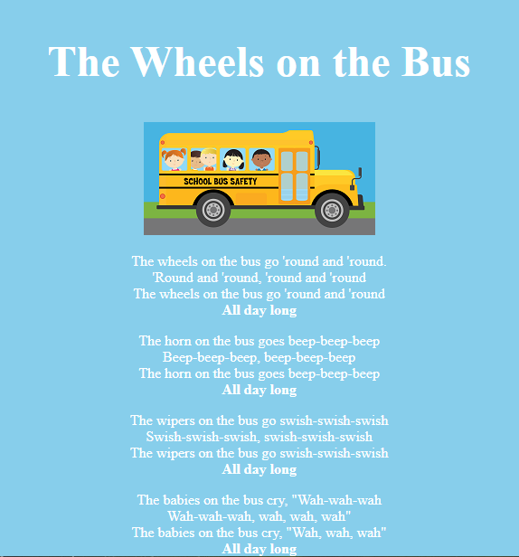

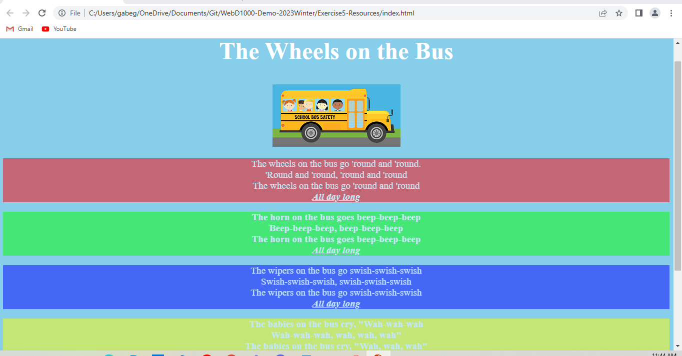

Tried for 20 minutes to get validator to work but host is down.