[D&D-inator]

**Team Members**

* Andrew Emlund
* Spencer Southam
* Gabe Hill
* Alice McClain

**Project Description**

DnDinator is a DM utility for Fifth Edition D&D. The application handles the creation and management of characters. Has a built in Dice roller, Loot stat generator, and Combat damage roller. Launch options lead to a version of the app for a DM and a version for the Players.

**Part 1: Functional Requirements**

**Glossary**

* DM – Dungeon Master, also referred to as Game Master/Manager
* Player – Individual participating in the game, has less application functionality than the DM

**Priority**

[1] Launch argument for DM vs Player

[1] Character sheet storage

[2] Character sheet creation

[1] Spell Repo

[1] Item Repo

[1] ?Effect Repo?

[1] Dice Roller with options for different type of dice, Including how many of that dice to roll

[2] Combat dice roller that takes in the effects of items held by the attacker

[1] Loot stat generator

[1] Loot type Repo

[1] Item Repo

**Part 2: Objective Coverage**

* Data persistence via writing files to disk and reading them back
* JavaFX for the application's GUI
* Proper encapsulation and sepparation of components into their respective MVC categories
* HashMaps will be used alongside enums to properly access and store class and race data
* Proper teamwork, communication, and load distribution will be used to ensure each group member pulls their own weight
* UML will be used to properly structure the application, and provide reference to that structure
* User input will be gathered and checked
* Output will be formatted in an intelligent way
* Overrides will be used for all applicable methods
* Proper optimizations, such as String Builder, shall be used where applicable

**Part 3: Basic Design**

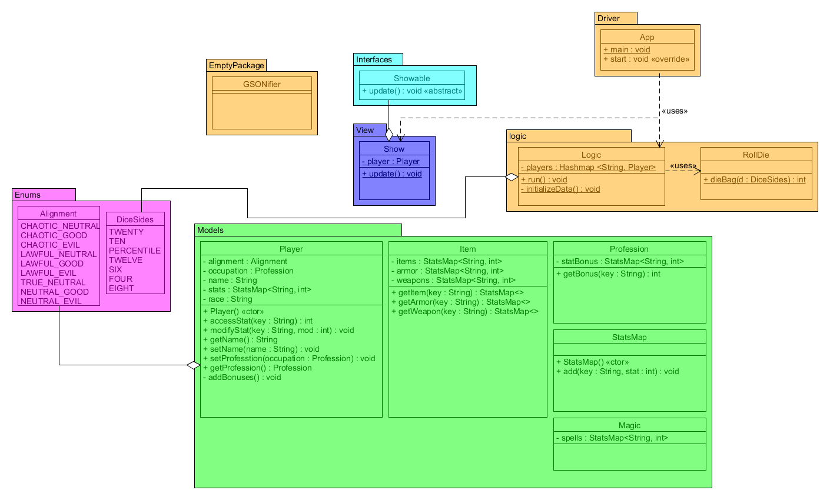**Part 4: Project Plan**

* Phases Base Level
* Phase one: Continued planning and distributing of jobs for the program
* Phase dos: pretesting and editing
* Phase san: polishing and finalizing
* Phase vier: demonstrating and final execution!