**CS312 Analysis of Algorithms**

**Lab 12 (10pts)**

**Graphs – Minimum number of colors for a map**

NAME__________________________________________

DATE___________________________________________

**Objective:**

Study the graph algorithms: breadth first search, adjacency matrix

**Procedure:**

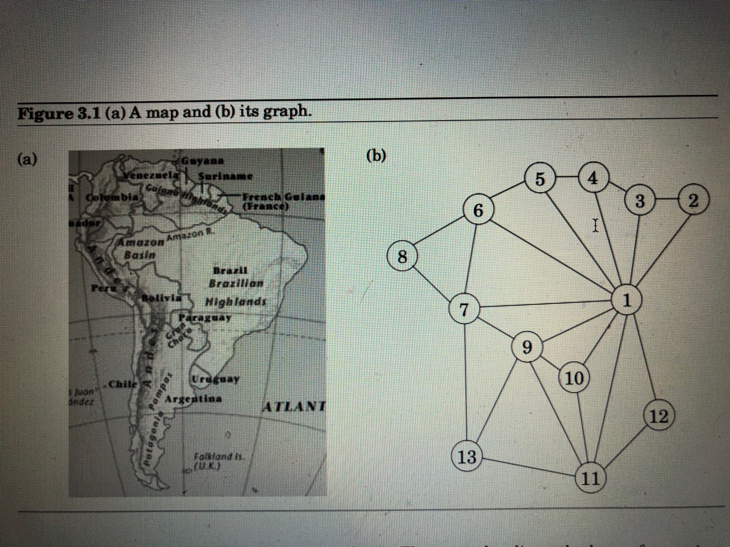

.

List of countries

1 – Brazil 1 - Red

2 – French Giana 2 – Green

3 – Suriname 3 - Blue

4 – Guyana 4 - Yellow

5 – Venezuela 5 - Magenta

6 – Colombia 6 - Cyan

7 – Peru 7 - Orange

8 – Ecuador

9 – Bolivia

10 – Bolivia

11 – Argentina

12- Uruguay

13 - Chile

Problem: Find the minimum number of colors to draw political map of South America

The product of this lab will be a list of countries with the colors that we will use for making the map. The object is to use minimum number of colors. All countries that share border have to have different colors.

We will use the example from the book as evidenced by the image.

Countries will be represented by vertices and the borders by edges.

Implement a class named Graph which will use adjacency matrix and will be able to perform breadth first search to create a list of countries. You can use previous lab implementation.

Derive from the Graph class a Map class which will read in a list of countries and a list of colors and will look through the list and adjacency matrix to produce a list of countries and colors such that we use minimum number of colors and no two countries sharing a border are of the same color.

Turn in zipped VS file