# Warps: Using Equations

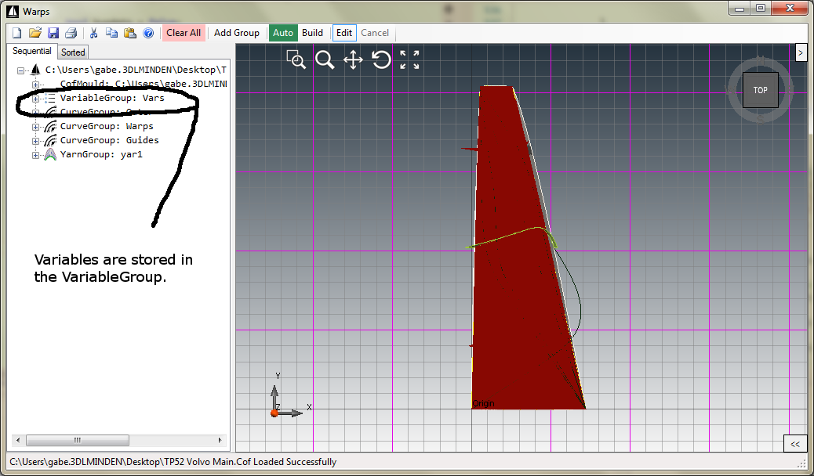

Figure 1 Variable Group Tree Node

## General Idea:

Equation objects allow the users to create relationships across groups at runtime. This is done by using a sequential tree structure. The group position in the sequential tree defines the accessibility level of each group. Equations (like all groups in Warps) are only allowed access to data that IS DEFINED ABOVE IT IN THE SEQUENTIAL TREE. Keeping this principle in mind, we will describe how to use the UI for effective equation use.

The equation parser used in Warps was taken from an open source project named NCalc (<ncalc.codeplex.com>). Along with the NCalc parsing capabilities, we have build in functions that are specific to the warps program. NCalc has documentation of the parser and supported functions on their website.

As of the time this document was written, the following warps functions are supported:

1. **Mold Curve Length**
   1. Accessed with the following command: [Length(*Curve Name*)]

## Editors:

**Figure 2** shows the variables as seen through the tree. The *Text* of the equation can be numeric or an expression and the *Value* of the equation variable is the *last evaluation of the equation text*. User can only modify the *Text* of an expression. Rebuilding the tree causes each equation to be re-evaluated. The sequential tree structure guarantees that by the time the equation is evaluated, all data above it will be current. The Vars VariableGroup location as shown in **Figure 2** shows that no curves or expression are located ABOVE it, so no curves or equations will be accessible to the Vars group.

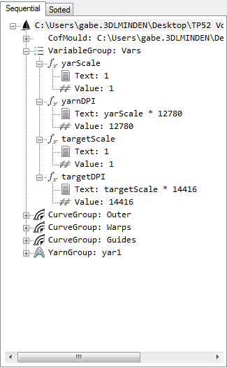

Figure 2 Variables in the tree

**Figure 3** shows the VariableGroup editor. This editor allows the user to add and delete variables from each group. VARIABLES MANIPULATED IN THE EDITOR ARE TREATED AS TEMPORARY UNTIL THE APPLY BUTTON IS PRESSED. Once the apply button is pressed, all changes in the editor are saved to the tree and propagated down.

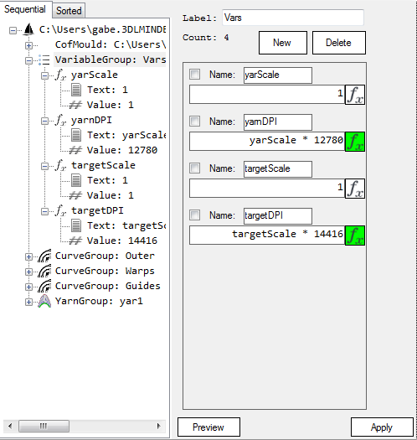

Figure 3 VariableGroup Editor

**Figure 4** shows an image of a single variable in the variable editor. The user can define the variable name and expression here. The checkbox allows the variable to be selected for deletion if one decides to delete it. The *fx* button opens the expression editor. The *fx*  button will go green if the text contains an expression instead of a number. Throughout the program and among the different editors, any textbox that has the *fx* icon will be able to be set with a variable.

Variable.PNG

Figure 4 Variable Editor

**Figure 5** shows the form for the expression editor. The Available Curves section shows what curves are available at the point in the tree the equation currently resides (for example, if the *Outers* group was above the current variable group, Available Curves would contain *Luff, Leech, Head, Foot*). The Available Equations section contains the equations that have already been defined above this point. The *Calculate* button allows the user to evaluate the expression in the textbox to see the result at that point in the tree.

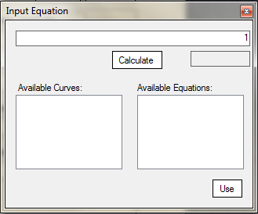

Figure 5 Expression Editor

# Examples:

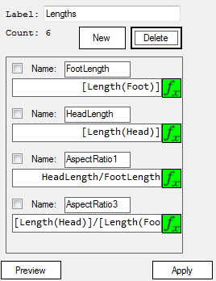

Figure 6 Example Equations

Two different ways to access the Length of a mold curve are shown in **Figure 6**. Defining a variable *HeadLength* will allow the user to use *HeadLength* beneath its definition in the tree without having to use the square brackets. If one wishes to use *[Length(Head)]* instead, the square brackets must be used every time.