Documentatie Lab 3

require 'csv'  
  
*# file_path - string, file with input data  
# @return - array*def read_config_file(*file_path*)  
 *lines* = []  
 File.open(*file_path*, 'r') do |*file*|  
 *lines* = *file*.readlines  
 end  
 *objects* = []  
 *n* = *lines*[0].strip.to_i  
 (1..*n*).each do |*i*|  
 *line* = *lines*[*i*].strip  
 *parts* = *line*.split(' ')  
 *objects*[*i*-1] = {}  
 *objects*[*i*-1]['value'] = *parts*[1].to_i  
 *objects*[*i*-1]['weight'] = *parts*[2].to_i  
 end  
 *max_sum* = *lines*[*n*+1].strip.to_i  
 [*n*, *max_sum*, *objects*]  
end  
  
*# n - integer, total number of objects  
# rand_arr - array, a possible solution  
# objects - array of hashes, contains value and weight for each object  
# max_sum - integer, maximum weight that fits in the backpack  
# @return - boolean*def is_solution(*n*, *rand_arr*, *objects*, *max_sum*)  
 *sum* = 0  
 (0..*n*-1).each do |*i*|  
 *sum* += *objects*[*i*]['weight']\**rand_arr*[*i*]  
 end  
 return true if *sum* <= *max_sum* false  
end  
  
*# n - integer, total number of objects  
# @return - array*def generate_random_array(*n*)  
 *rand_solution* = []  
 (0..*n*-1).each do |*i*|  
 *rand_solution*[*i*] = rand(0..1)  
 end  
 *rand_solution*.dup  
end  
  
*# n - integer, total number of objects  
# objects - array of hashes, contains value and weight for each object  
# max_sum - integer, maximum weight that fits in the backpack  
# @return - array*def generate_random_solution(*n*, *objects*, *max_sum*)  
 *rand_arr* = generate_random_array(*n*)  
 while is_solution(*n*, *rand_arr*, *objects*, *max_sum*) == false  
 *rand_arr* = generate_random_array(*n*)  
 end  
 *rand_arr*.dup  
end  
  
*# n - integer, total number of objects  
# objects - array of hashes, contains value and weight for each object  
# solution - array, a solution  
# @return - integer*def eval(*n*, *solution*, *objects*)  
 *sum* = 0  
 (0..*n*-1).each do |*i*|  
 *sum* += *objects*[*i*]['value']\**solution*[*i*]  
 end  
 *sum*end  
  
def greedy(*n*, *objects*, *max_sum*)  
 *solution* = []  
 (0..*n*-1).each do |*i*|  
 *solution*[*i*] = 1  
 end  
 *obj* = []  
 *objects*.each{|*e*| *obj* << *e*.dup}  
 *obj_cpy* = []  
 *obj*.each { |*e*| *obj_cpy* << *e*.dup}  
 *obj_cpy*.sort_by! { |*e*| *e*['value']}  
 *i* = 0  
 while is_solution(*n*, *solution*, *objects*, *max_sum*) == false  
 *a* = *obj*.index { |*e*| *e*['value'] == *obj_cpy*[*i*]['value'] }  
 *solution*[*a*] = 0  
 *i* += 1  
 end  
 [eval(*n*, *solution*, *objects*), *solution*.dup]  
end  
  
def generate_population(*num*, *n*, *objects*, *max_sum*)  
 *population* = []  
 *i* = 0  
 while *i* < *num  
 population* << generate_random_solution(*n*, *objects*, *max_sum*)  
 *i* += 1  
 end  
 *pop_cpy* = []  
 *population*.each { |*e*| *pop_cpy* << *e*.dup}  
 *pop_cpy*end  
  
def generate_parents(*num*, *k*, *population*, *objects*, *n*)  
 *parents* = []  
 *i* = 0  
 *number_of_pop* = *population*.length  
 while *i* < *num  
 rand_pos_i* = rand(*number_of_pop* - 1)  
 *chosen_parent* = *population*[*rand_pos_i*]  
 *i_fit* = eval(*n*, *population*[*rand_pos_i*], *objects*)  
 *j* = 0  
 while *j* < *k  
 rand_pos* = rand(*number_of_pop* - 1)  
 *new_fit* = eval(*n*, *population*[*rand_pos*], *objects*)  
 if *new_fit* > *i_fit  
 chosen_parent* = *population*[*rand_pos*].dup  
 *i_fit* = *new_fit* end  
 *j* += 1  
 end  
 *parents* << *chosen_parent  
 i* += 1  
 end  
 *par_cpy* = []  
 *parents*.each { |*e*| *par_cpy* << *e*.dup}  
 *par_cpy*end  
  
def cross_parents(*n*, *objects*, *max_sum*, *parents*)  
 *children* = []  
 *i* = 0  
 while *i* < *parents*.length  
 *p1* = *parents*[*i*]  
 *p2* = *parents*[*i* + 1]  
 *i* += 2  
 *c* = get_children(*p1*, *p2*, *n*, *objects*, *max_sum*)  
 *children* << *c*[0]  
 *children* << *c*[1]  
 end  
 *c_cpy* = []  
 *children*.each { |*e*| *c_cpy* << *e*.dup}  
 *c_cpy*end  
  
def fix_arr(*n*, *rand_arr*, *objects*, *max_sum*)  
 *i* = -1  
 until is_solution(*n*, *rand_arr*, *objects*, *max_sum*)  
 while *i* < *rand_arr*.length  
 *i* += 1  
 if *rand_arr*[*i*] == 1  
 *rand_arr*[*i*] = 0  
 break  
 end  
 end  
 end  
 *rand_arr*.dup  
end  
  
def get_children(*p1*, *p2*, *n*, *objects*, *max_sum*)  
 *sol_length* = *p1*.length  
 *cut_position* = rand(1..*sol_length* - 2)  
 *i* = 0  
 *c1* = []  
 *c2* = []  
 while *i* < *sol_length* if *i* <= *cut_position  
 c1*[*i*] = *p1*[*i*]  
 *c2*[*i*] = *p2*[*i*]  
 else  
 *c1*[*i*] = *p2*[*i*]  
 *c2*[*i*] = *p1*[*i*]  
 end  
 *i* += 1  
 end  
 *c1* = fix_arr(*n*, *c1*, *objects*, *max_sum*)  
 *c2* = fix_arr(*n*, *c2*, *objects*, *max_sum*)  
 [*c1*.dup, *c2*.dup]  
end  
  
def mutate_children(*n*, *objects*, *max_sum*, *children*)  
 *mutations* = []  
 *children*.each do |*c*|  
 *rand_flip* = rand(*n*-1)  
 *c*[*rand_flip*] = 1 - *c*[*rand_flip*]  
 *c* = fix_arr(*n*, *c*, *objects*, *max_sum*)  
 *mutations* << *c*.dup  
 end  
 *m_cpy* = []  
 *mutations*.each { |*e*| *m_cpy* << *e*.dup}  
 *m_cpy*end  
  
*# miu + lambda*def select_survivors(*num*, *parents*, *children*, *mutated_children*, *n*, *objects*)  
 *potential_survivors* = []  
 *survivors* = []  
 *parents*.each do |*p*|  
 *potential_survivors* << *p*.dup  
 end  
 *children*.each do |*c*|  
 *potential_survivors* << *c*.dup  
 end  
 *mutated_children*.each do |*m*|  
 *potential_survivors* << *m*.dup  
 end  
 *potential_survivors*.sort_by!{ |*e*| -eval(*n*, *e*, *objects*) }  
 (0..*num*-1).each do |*i*|  
 *survivors* << *potential_survivors*[*i*].dup  
 end  
 *survivors*end  
  
def best_and_average(*solutions*, *n*, *objects*)  
 *best_fit* = eval(*n*, *solutions*[0], *objects*)  
 *average_fit* = 0  
 *solutions*.each do |*s*|  
 *average_fit* += eval(*n*, *s*, *objects*)  
 end  
 *average_fit* = *average_fit*\*1.0/*solutions*.length  
 [*best_fit*, *average_fit*]  
end  
  
def best_and_average_unordered(*solutions*, *n*, *objects*)  
 *best_fit* = 0  
 *average_fit* = 0  
 *solutions*.each do |*s*|  
 *fit* = eval(*n*, *s*, *objects*)  
 *best_fit* = *fit* if *best_fit* < *fit  
 average_fit* += *fit* end  
 *average_fit* = *average_fit*\*1.0/*solutions*.length  
 [*best_fit*, *average_fit*]  
end  
  
def alg(*n_param*, *m_param*, *objects*, *n*, *max_sum*)  
 *best* = []  
 *values* = []  
 *t* = 0  
 *population* = generate_population(*n_param*, *n*, *objects*, *max_sum*)  
 *data* = best_and_average_unordered(*population*, *n*, *objects*)  
 *best* << *data*[0]  
 *values* << *data* while *t* < *m_param  
 parents* = generate_parents(*n_param*, 3, *population*, *objects*, *n*)  
 *children* = cross_parents(*n*, *objects*, *max_sum*, *parents*)  
 *mutated_children* = mutate_children(*n*, *objects*, *max_sum*, *children*)  
 *population* = select_survivors(*n_param*, *parents*, *children*, *mutated_children*, *n*, *objects*)  
 *t* += 1  
 *data* = best_and_average(*population*, *n*, *objects*)  
 *best* << *data*[0]  
 *values* << *data* end  
 [*best*.max, *values*]  
end  
  
def write_data(*n_param*, *m_param*, *n*, *objects*, *max_sum*, *repeat*: 10)  
 *i* = 1  
 *all_fit* = []  
 *all* = []  
 *t0* = Time.now  
 while *i* <= *repeat  
 values* = alg(*n_param*, *m_param*, *objects*, *n*, *max_sum*)  
 *best_fit* = *values*[0]  
 *all_fit*.push(*best_fit*)  
 *j* = 1  
 *plot_best* = []  
 *plot_avg* = []  
 *values*[1].each do |*v*|  
 *plot_best* << "(#{*j*}, #{*v*[0]})"  
 *plot_avg* << "(#{*j*}, #{*v*[1]})"  
 *j* += 1  
 end  
 *all*.push([*plot_best*.join(", ")])  
 *all*.push([*plot_avg*.join(", ")])  
 *i* += 1  
 end  
 *t1* = Time.now - *t0  
 worst* = *all_fit*.min  
 *best* = *all_fit*.max  
 *avg* = *all_fit*.sum(0.0)/*all_fit*.size  
 *all*.push(['Worst', *worst*])  
 *all*.push(['Best', *best*])  
 *all*.push(['Average', *avg*])  
 *all*.push(['Runtime', *t1*])  
 File.write("kp_#{*n*}_population_#{*n_param*}_generations_#{*m_param*}.csv", *all*.map(&:to_csv).join)  
end  
  
def main(*n_param*, *m_param*)  
 *values* = read_config_file('input_file_200.txt')  
 *n* = *values*[0]  
 *max_sum* = *values*[1]  
 *objects* = *values*[2]  
 write_data(*n_param*, *m_param*, *n*, *objects*, *max_sum*)  
end  
  
main(200, 400)

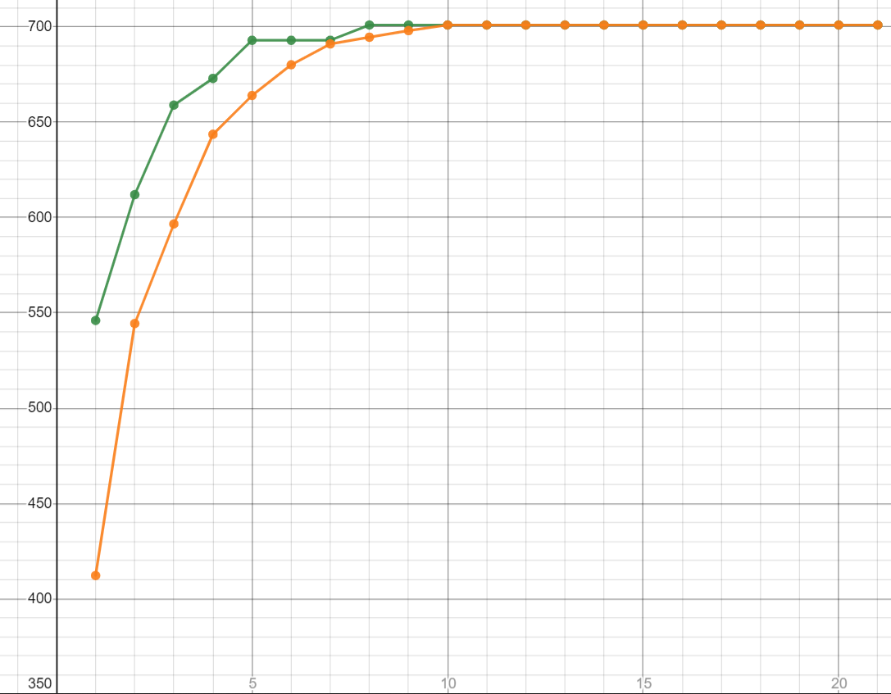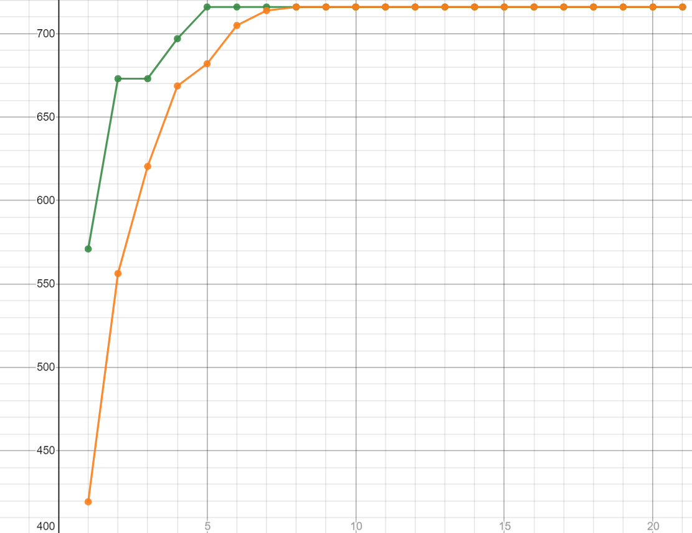

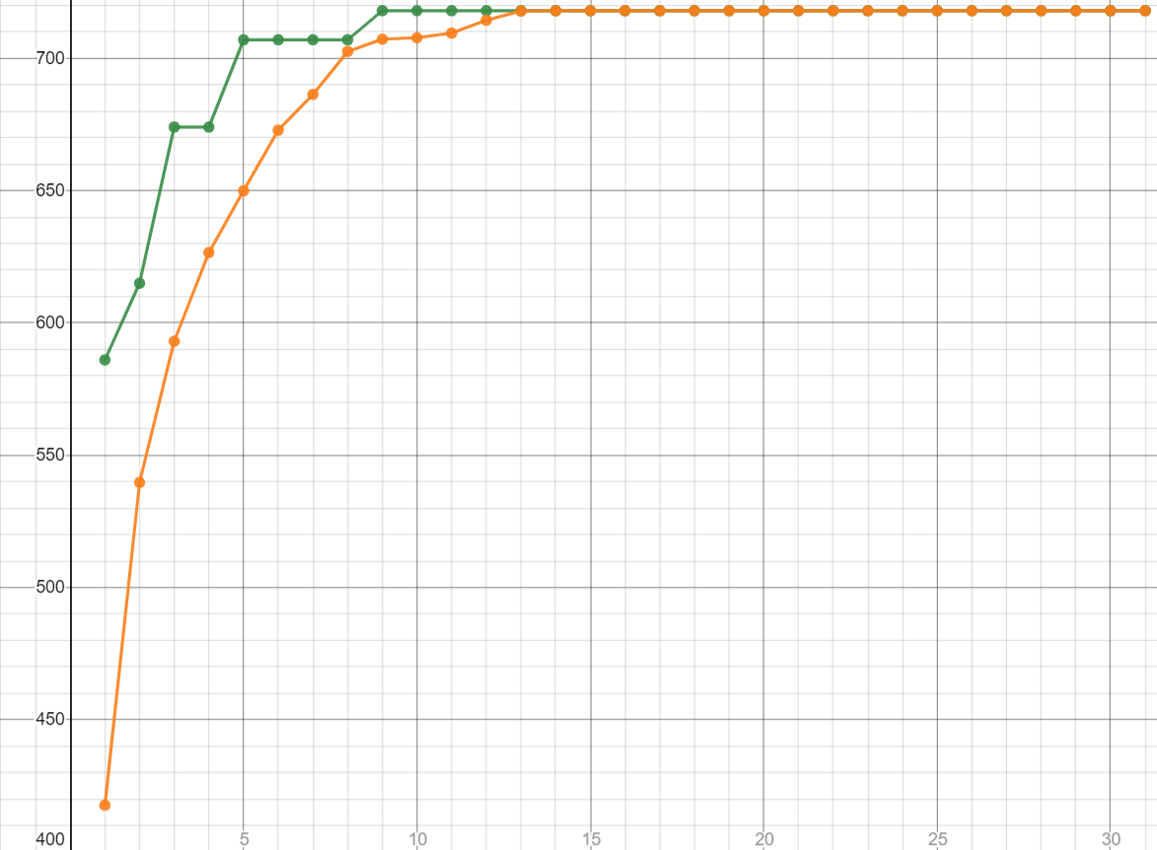

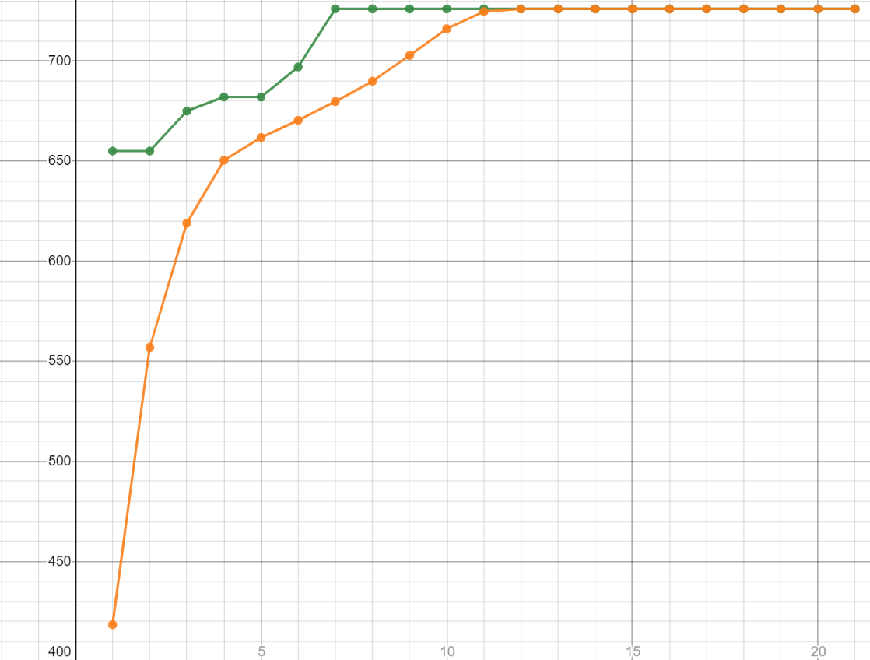

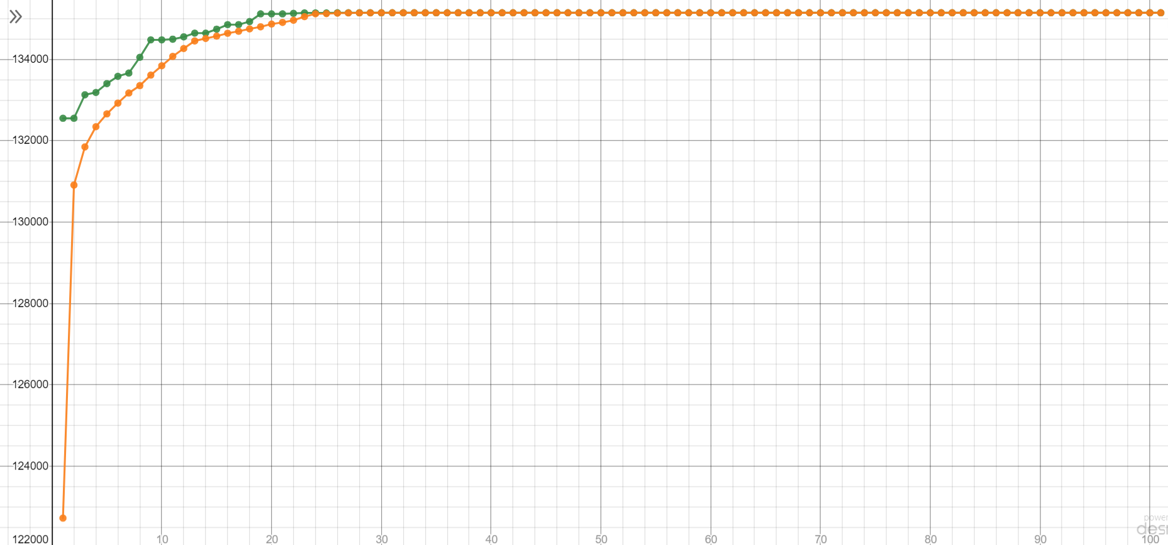

N = 500 si M = 200

|  |  |
| --- | --- |
| Worst | 134321 |
| Best | 135145 |
| Average | 134773.5 |
| Runtime | 81.35608 |