Case 1: Sales Performance Analysis
Company Background
TechSupply Co. is a regional distributor that sells electronics, office supplies, and office furniture to both retail and business customers. Management wants to better understand sales trends, customer purchasing behavior, and regional performance to improve future sales strategies.
You have been hired as a junior data analyst to explore the sales dataset and provide insights. Your task is to use Excel filtering and sorting tools to answer business questions and provide recommendations.
Dataset: use the techsupply_dataset.xlsx
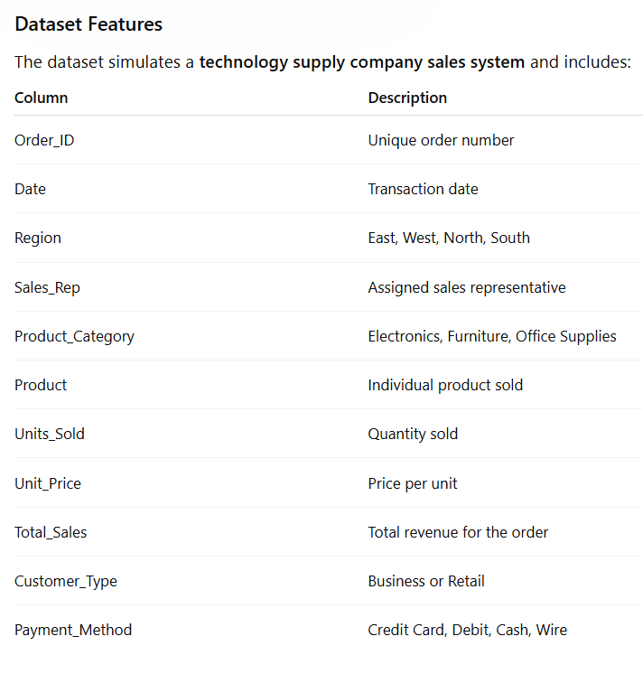

Complete the following 5 tasks.
REGIONAL PERFORMANCE ANALYSIS
Task 1: Use filters to explore sales by region.
- Filter by Region = East
- Sort Total_Sales from Largest to Smallest
Questions:
- What is the largest sale in the East region? 52,950 total sales in the East region
- Which product category appears most frequently? Electronics is the biggest and appears the most frequently at 33
- Which sales representative appears most often? Brown & Johnson appear the most often
CUSTOMER BEHAVIOR ANALYSIS
Task 2: Filter by
- Customer_Type = Business
Questions
- Which product category do business customers purchase most often? Electronics are purchased most often
- What is the largest business transaction? Order number 2027 is the largest transaction
- Which sales rep handles the most business orders? Brown handled 431 orders which makes him the one who handled the most
PRODUCT PERFORMANCE
Task 3: Use filters to analyze Product_Category.
Analyze each category separately:
- Electronics
- Furniture
- Office Supplies
Questions
- Which category appears to generate the highest total sales? Furniture generated the highest total sales at around 1.29 million
- Which specific product appears most frequently? Filing Cabinets, Printer Paper and Notebooks appear most frequently
- Which category tends to have the largest individual transactions? Furniture tends to have the largest Individual transactions
PAYMENT PATTERN ANALYSIS
Task 4: Filter by Payment_Method
Analyze:
- Credit Card
- Debit
- Cash
- Wire
Questions
- Which payment method is used most frequently? Credit cards is used most frequently
- Do business customers prefer a specific payment type? It seems like they prefer using Debit cards to pay for their items
- Which payment type is associated with larger purchases? Debit cards are associated with larger purchases
TOP SALES REPRESENTATIVES
Task 5: Sort by:
- Sales_Rep
- Total_Sales(Largset > Smallest)
Questions
- Which sales rep appears to handle high-value transactions? Lopez appears to handle the high-value transactions
- Which rep appears most frequently in the dataset? Brown appears the most frequently in the dataset
- Which region do they appear to sell in most often? They appear to sell in the East most often with them all totaling there at 80 and the west being the 2nd highest at 79
ANALYST RECOMMENDATION
Imagine you are presenting your findings to management.
Answer the following:
- Which region appears to be the strongest market? The East region appears to be the strongest market at around 582,000 total sales
- Which product category should the company promote more? They should promote the furniture category more because it’s total sales are dwarfing the other categories
- Are business customers or retail customers more valuable? Retail customers are the ones spending more so they are more valuable
- What two recommendations would you give the sales manager? I would recommend to focus heavily on the furniture product category to cater to the Retail customers to benefit and to claim the most profit. I would also recommend to shift most of the manpower to the East Region as well.

Bonus
Build
- Bar Chart – Sales by Product Category
- Pie Chart – Customer Type Distribution
- Column Chart – Sales by Region
What story does the data tell?
According to the sales data, our highest selling product category is our furniture category at a whopping 1.29 million total sales. Our highest contributing sector towards this is our East region which contributed around 582,000 sales towards the earned total. Although our Customer distribution shows that our Business customers outnumber our Retail customers, it was retail that brought in the most money at 1.1 million as opposed to our Business customers bringing in 1.06 million. With this information in hand, I believe that we should focus more of our efforts in the Furniture Category as well as on our Retail customers in the East region as they are our higher paying demographic so far.

