**Constantine**

**Map Info**

7 Territories- Turkmin, Helos, Huganar, Tutons, The New Roman Empire (TNRE), Francar, Britoni.

Turkmin: Capitol- Constantinople, Civilized: no tribes.

Helos: Capitol- Athens, Partially Civilized. One tribe: Macedonians.

Huganar- Uncivilized, One tribe: Galacians.

Tutons- Uncivilized, Three tribes: Angles, Huns, Saxons

Francar- Capitol- Paris, Partially Civilized. Two Tribes: Gauls, Franks

TNRE- Capitol- Rome, Civilized: No tribes.

Britoni- Capitol- London, Civilized, No tribes.

Turkmin- After the big event was almost overrun by mutants. Recovered within 15 years and became civilized. All of the remaining nomadic peoples were removed around 7 years before the awakening of Constantine. It is run by a very powerful demon making the entire territory un-enterable for Constantine immediately after his awakening.

Helos- A territory that has been partially overrun by the barbarians known as the Macedonians. Largely depopulated after the big even, the capitol, Athens, is now a large center of learning. This is where Constantine will be taken to by the angel after he was awakened.

Huganar- Completely overrun by the tribe known as the Galacians. After the big event it was completely depopulated and left to waste. The Galacians moved into the territory after about 150 years later.

Tutons- After the big event, the countries that once existed in this territory were thrown into chaos. Many of the people were killed in the big event and the ones that were left fought constantly. Within one hundred years there were two groups of people, the Saxons and the Huns. A faction of the Saxons would later split off to become the Angles.

Francar- After losing nearly 65% of the population to the big event and a war with the peoples that became the tribes in the Tutons, the country that had been France was close to depopulation. The city of Paris though was never fully depopulated and managed to remain civilized. Today the territory of Francar is partially civilized, being overrun by two tribes: the Gauls and Franks. They are also under threat from TNRE.

The New Roman Empire- Rome and Italy itself managed to stay civilized through the turmoil that plagued the world. The upper areas of Italy were initially overrun by barbarians but all were dispersed within 10 years by the mighty legions. The first emperor, someone inspired by the once mighty ancient empire, gave the current one its name. They are working hard to expand their borders and have their sights set on Francar, which they call Gaul. They are the strongest country in the region and as such have been able to keep their province relatively clean of mutants.

Britoni- Civilized and the second strongest country. They retained much of their population and civilization after the event. Unlike the other countries, they never were overrun by barbarians. The country did fall into disarray for several years after the event, but recovered relatively quickly.

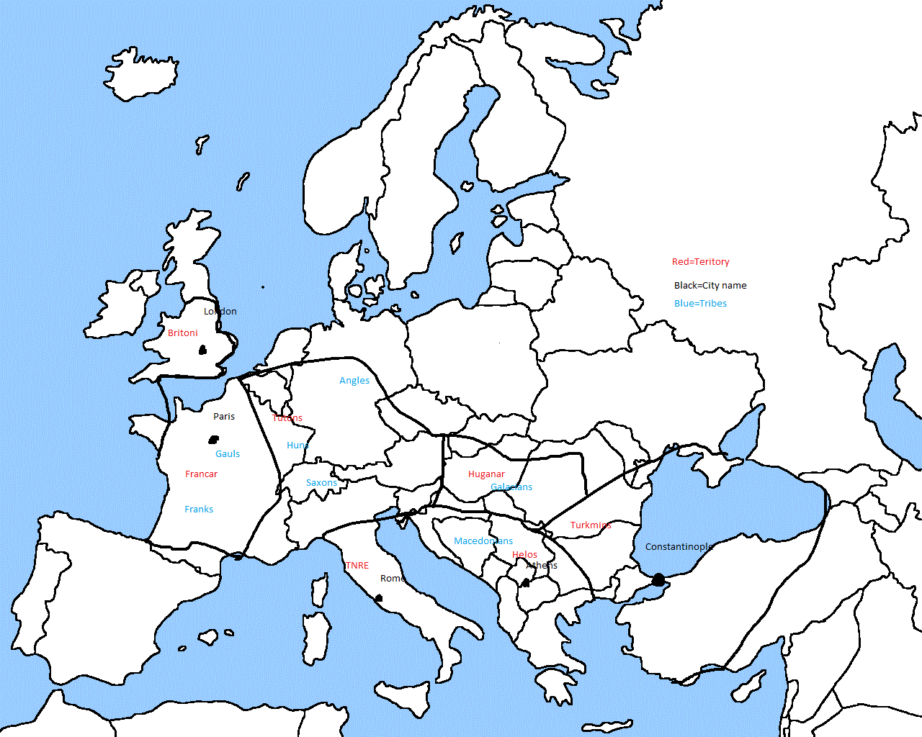

**The Tribes**

All tribes have their beginnings with the big event. Areas heavily devastated created many tribes but as the years have gone on the amount has decreased due to wars.

Macedonians- Strong and fearless warriors. They are constantly fighting with the people of Helos. They generally wear bronze armor and their primary weapons are spears and shields.

Galacians- Known for their ability with slings and bows. It is said that as children they are not allowed to eat until they hit a target from a good distance. They don’t typically wear armor, choosing to wear skins and read cloth.

Angles- The Angles live the farthest from the other tribes in Tutons, so they don’t have to fight many wars. A relatively peaceful people they do not like foreigners wandering to close to their encampment. Their favored weapons are an iron sword and chainmail armor covered in skins.

Huns- Very warlike, Iron armor and swords. They constantly fight with the Saxons to gain territory.

Saxons- Very warlike, Iron armor and spears/axes. They constantly fight with the Huns to gain territory.

Gauls- The Gauls and the Franks often work together to fend off attacks from Francar and TNRE. Currently the Gauls are the strongest of the two. They have iron armor and swards/axes. They often sacrifice captives to their Gods.

Franks- They are under threat from both Francar and TNRE. They work with the Gauls to fight both enemy’s. They also utilize iron armor and swords.

**The Rulers**

The New Roman Empire- Emperor Julius.

Britoni- King Alfred

Francar- King Louis

Helos- Heraclius

Turkmin- Sultan Mehmed XII

**The People**