
DIRECTION DE LA RECHERCHE TECHNOLOGIQUE



CEA/SACLAY
DEPARTEMENT DES TECHNOLOGIES DES SYSTEMES INTELLIGENTS
SERVICE OUTILS LOGICIELS

Service Outils Logiciels

Saclay, 2009 July 1st

REF. : DTSI/SOL/09-0120/YT

Applied Stereotype implementation in Papyrus

Par

Y. Tanguy, P. Tessier, R. Schnekenburger

DTSI/SOL/LISE (CEA)

IDENTIFICATION : | Rapport DTSI/SOL/09-0120/YT
Title: | Applied Stereotype implementation in Papyrus
Authors: | Yann Tanguy, Patrick Tessier, Rémi Schnekenburger
Keywords: | UML2, Profile, Papyrus, Plug-in, Developer documentation
Unit: | DRT/LIST/DTSI/SOL/LISE
Abstract/Context | This document is a developer guide giving a description about how the gmfgen file has to be modified in order to support stereotype application in Papyrus.

Ce document est la propriété du CEA. Il ne peut être reproduit ou communiqué sans son autorisation.
This document is the property of the CEA. It can not be copied or disseminated without its authorization.

 | REDACTEURS  WRITERS | VERIFICATEUR  CONTROLLER | CHEF DE SERVICE  SERVICE HEAD
NOM | Yann TANGUY | François TERRIER | Jan STRANSKY
DATE

SIGNATURE

Document changes history:

Date | Version | Writer(s) | Changes description
01/07/2009 | 1.0 | Y. Tanguy | Creation of this internal report.
03/07/2009 | 1.1 | P. Tessier | Minor corrections
06/07/2009 | 1.2 | Y. Tanguy | Minor corrections

Diffusion:
Papyrus website: http://www.eclipse.org/modeling/mdt/?project=papyrus

Document plan

1. Introduction 4
2. Installing the development environment 4
3. Overview of the Papyrus extension for GMFGEN model 5
4. Applied stereotype implementation on nodes 8
5. Applied stereotype implementation on edges 8

Introduction
This report contains developer documentation for the implementation of stereotype application management on UML2 elements in Papyrus.
In this document, Papyrus will always refer to the Eclipse MDT implementation (see http://www.eclipse.org/modeling/mdt/?project=papyrus).
The various step of the GMF process used to produce the gmfgen file of a diagram are not reminded in this document. This document focuses on modification directly made over the gmfgen file. For more information regarding GMF, the user should read dedicated document available on GMF website (http://www.eclipse.org/modeling/gmf/).

Installing the development environment
The basic steps first:
- Install the "Modelling" bundle of Eclipse (http://www.eclipse.org/downloads/)
- Install the SVN client over Eclipse (http://www.eclipse.org/subversive/)
- Get Papyrus sources from its repository (svn+ssh://dev.eclipse.org/svnroot/modeling/org.eclipse.mdt.papyrus)

Do not forget to download gmfgen extension plugin and other development tools located in trunk/plugins/developers:
- org.eclipse.papyrus.codegen (specific code generation)
- org.eclipse.papyrus.def (code generation templates)
- org.eclipse.papyrus.gmfgenextension (gmfgen model extension and tools)

For an easier access (directly usable in your development environment without starting a test workbench), it may be better to export a build of "codegen" and "gmfgenextension" in your development Eclipse installation:
- Open the plugin.xml file (from either "codegen" or "gmfgenextension")
- Select "export wizard" in the overview tab
- Select the plugins to export ("codegen" and "gmfgenextension" here)
- Choose "Install into host repository" as shown in the picture below.

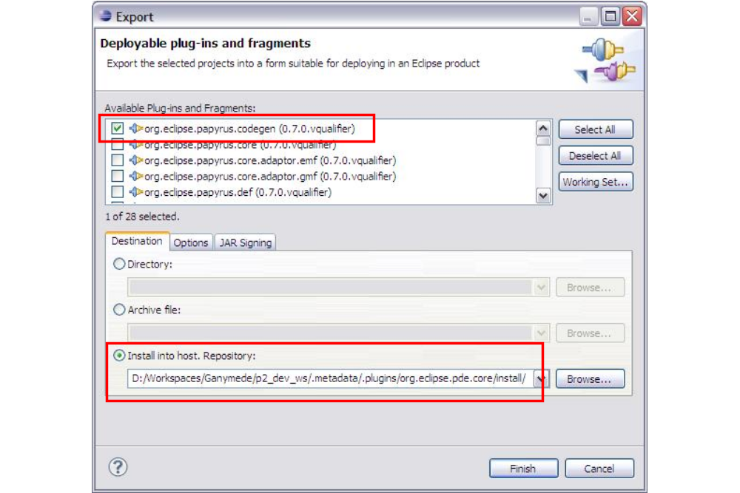
Figure 1 Export development plugins into host repository

Overview of the Papyrus extension for GMFGEN model
Due to UML2 specific needs in term of graphical edition, the GMF code generation has been enhanced. This new code generation relies on dynamic generation templates and an extended version of the GMFGEN model. The GMFGEN model was extended in order to take into account architectural needs that remained uncovered by GMFGEN.
The details of the creation of a new extension in an existing GMFGEN model, and the precise content of the provided extension are not given here (should be described in another document). This part only focuses on extensions that are directly used in stereotype application management.
As shown on the picture below, the default GMF generation for node produces an EditPart that inherits from ShapeNodeEditPart (from GMF runtime) and that contains its figure. In order to provide a common mechanism to manage stereotype application and display, or any other shared behaviour, a solution is to allow the generated EditPart(s) to have custom parent class. Doing this, it is necessary to modify the related figure in order to provide the display API expected by the EditPart.

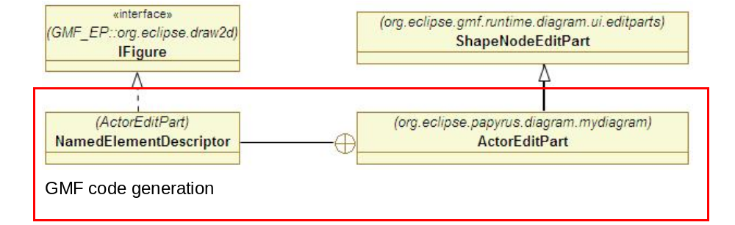
Figure 2 Standard GMF class generation for nodes
The customized GMF code generator is able to generate the EditPart(s) like in the picture below. In this case ActorEditPart is generated with an inheritance to NamedElementEditPart. This latter manage the name display assuming the managed figure is a NodeNamedElementFigure. For a consistent code a custom figure should be provided for the actor, consistent meaning in such a case that ActorFigure has to inherit from NodeNamedElementFigure.

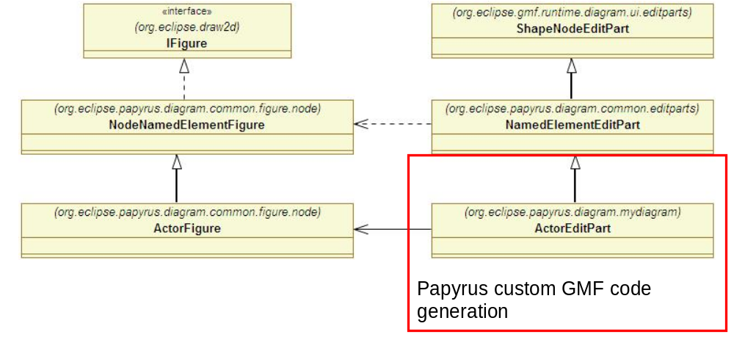
Figure 3 Papyrus custom GMF class generation for nodes
ActorFigure is no more generated on the basis of a GMFGraph file, it should be written manually. NodeNamedElementFigure and NamedElementEditPart are also written directly in Java. These hand made classes are likely to be used by several element in several diagrams. For a correct code generation the GMFGEN model has to be extended and modified.

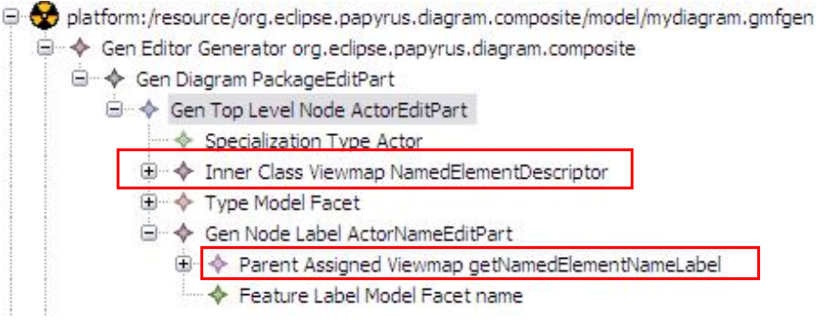
Figure 4 Standard GenNode for the ActorEditPart
The above picture (extracted from an exemplary GMFGEN model) shows the GenNode of the ActorEditPart, with the NamedElementDescriptor generated by GMF during the GMFMAP to GMFGEN transformation.
To customize the generation model (see Figure 1), the InnerClassViewmap should be replaced by a FigureViewmap which references the figure to use (ActorFigure here). As explained previously, ActorFigure inherits from NodeNamedElementFigure which owns the accessor for the name label. As a result, one should ensure that the accessor of "GenNodeLabel ActorNameEditPart" has the same name as expected by figure implementation (getNameLabel here).

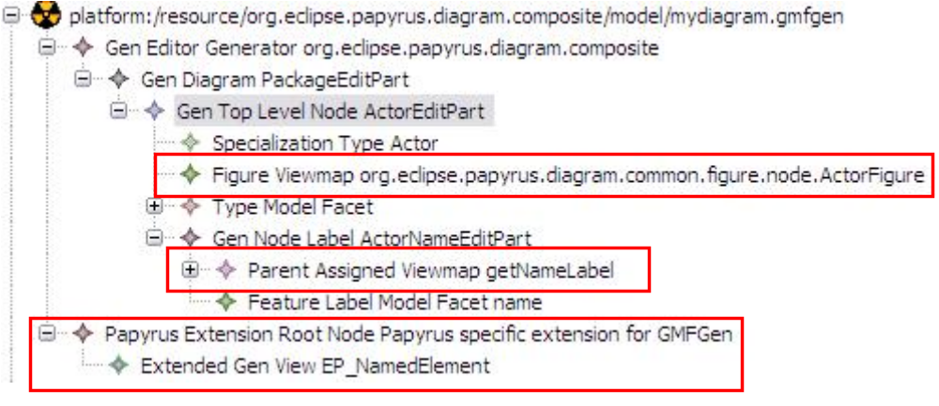
Figure 5 Customized GMFGEN model
The last step consists in creating the extension in the GMFGEN model:
- Right-click in GMFGEN editor / Add extension model
- Select (from workspace) papyrusGMFGenExtension.ecore

The selection dialog is shown in the picture below.

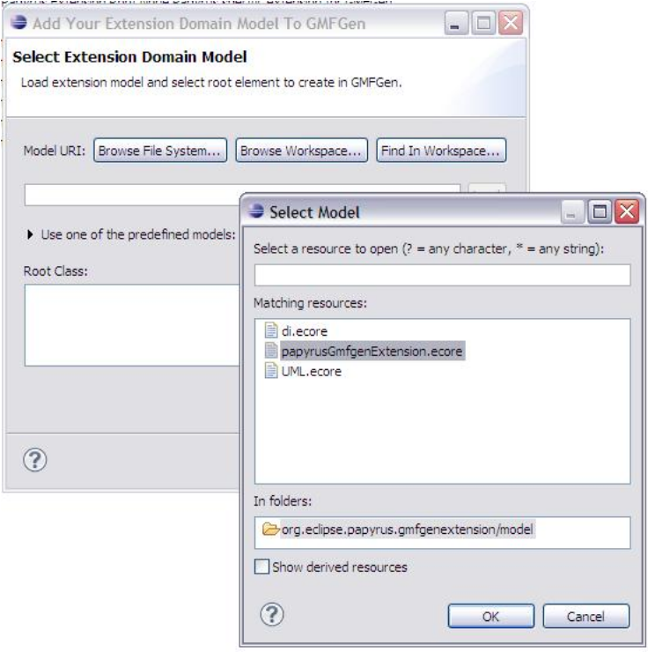
Figure 6 Select Papyrus extension for GMFGEN models
In the created extension, add an ExtendedGenView child. This kind of element is used to specify the inheritance to generate for a set of EditPart. This information should be set in the property view of the ExtendedGenView. An example (for the ActorEditPart example) is given in Figure 7.

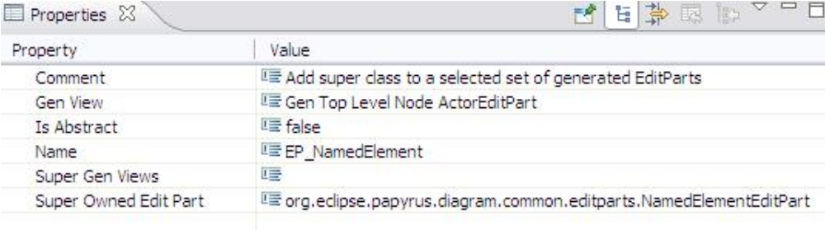
Figure 7 ExtendedGenView properties
The properties are the following:
- Name: informative name of the ExtendedGenView
- Comment: informative description
- IsAbstract: not managed yet
- SuperGenView: not managed yet
- GenView: the set of EditPart (GenNode in the GMFGEN model) which will inherit from SuperOwnedEditPart
- SuperOwnedEditPart: the EditPart parent of the generated EditPart(s)
In this example the extension states that the generated ActorEditPart will inherit from NamedElementEditPart.

Applied stereotype implementation on nodes
Well, not much to add here… In fact, current implementations of NamedElementEditPart / NodeNamedElementFigure implement the mechanism that manages the stereotype application and display. Use the previous part of the document to know how to use these classes in your GMFGEN model.
If the required figure has some specificity, create a new figure that inherits from NodeNamedElementFigure (like described in the previous part for ActorFigure).

Applied stereotype implementation on edges
The customization is a bit different for Edges, because the labels are not owned by the figure (they are showed on the link side).
First proceed like describe on chapter 3, by providing a custom figure, creating an ExtendedGenView (and making sure the getters from your figure match those in the GMFGEN model).
Then modify the GMFGEN like in Figure 8. This is not intended to be done manually (the procedure is described further in this document), but the expected modification are reminded here. A custom behaviour for the display of applied stereotypes is added, an additional EditPart is also added to manage the label where the applied stereotypes information is showed. A custom parser is also required (if not already added) used by the additional GenLinkLabel.

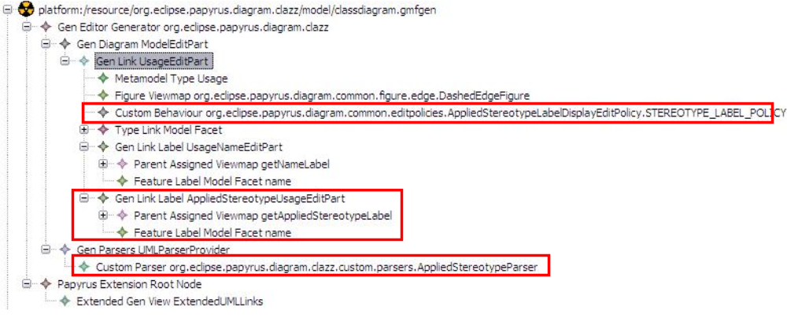
Figure 8 Customization in GMFGEN for GenLink(s)
To automate these changes in the GMFGEN model, a contextual popup action has been implemented. To use it, select a set of GenLink(s), right-click and choose "Papyrus GMFGen Tools"/"Add custom behaviour for StereotypeLabelDisplay". This will apply the previously described changes on the selected GenLinks.

These should definitely be implemented on ElementEditPart as stereotype can be applied on UML2 elements that are not NamedElement.

