


Papyrus Commit process

Editor | Yann Tanguy, CEA LIST
Status | Draft version
Version number | 0.3
Date of preparation | 16/02/09

Authors
Editor name (first/last name) | Company | E-mail | Initial
Yann Tanguy | CEA LIST | Yann.tanguy@cea.fr | YT

Authors name (first/last name) | Company | E-mail | Initial
Yann Tanguy | CEA LIST | Yann.tanguy@cea.fr | YT
Sébastien Gérard | CEA LIST | Sebastien.gerard@cea.fr | SG

Revision chart and history log
Version | Date | Reasons
0.1 | 2009-02-16 | Initial draft version
0.2 | 2009-02-16 (6 pm CET) | Minor modifications introduced by SG.
0.3 | 16/02/09 | Screenshots modified by YT.
Table of contents
Authors 3
Revision chart and history log 4
Table of contents 5
1 Introduction 6
2 Needed tools 7
3 Committing process 8
3.1 Process overview 8
3.2 Create / Retrieve bugzilla task 8
3.3 Prepare change set 8
3.4 Commit change set 9

Introduction
This document describes the committing process all Papyrus's committers will have to respect for committing changes on the source code of Papyrus.

Needed tools
This document assumes the following tools to be installed:
- Mylin (with Bugzilla integration) : Ganymede update site (Collaboration Tools)
- Subversive (SVN Team Provider) : Ganymede update site (Collaboration Tools)
  - SVN Connectors : http://www.polarion.org/projects/subversive/download/eclipse/2.0/update-site/

Committing process
The committing process is given hereafter.

Process overview
The following figure describe the process for committing a source modification for Papyrus (the formalism used for that is the SPEM2 language defined by the OMG).
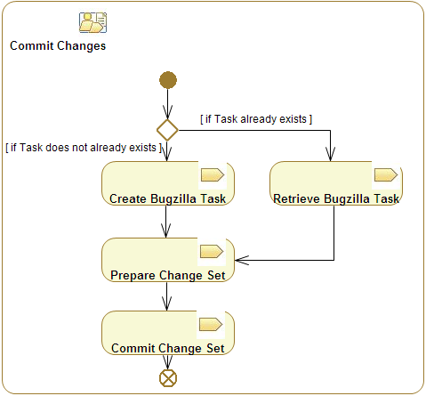Illustration 1: Process overview of commit activity

Create / Retrieve bugzilla task
Check Mylin website to know how to configure Mylin and to create new tasks and queries (http://www.eclipse.org/mylyn/index.php).

Each commit should be linked to a bugzilla task: so make sure the bugzilla task exists first and else create it .

Prepare change set
Switch to synchronize view (ctrl+alt+s to synchronize a project). You should then get a results similar to the one denoted in following Figure. Then let's proceed to the three following actions:
- Activate task
- Make change sets visible
- Add / Remove changes from the change set (“add to” in contextual menu)

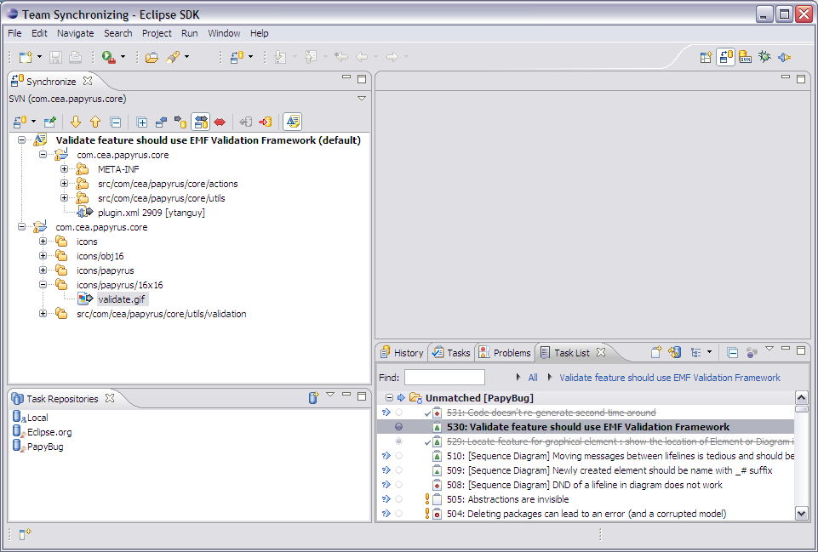Illustration 2: Prepare change set in synchronize view
(1)
(2)
(3)

Commit change set
Validate the change set (contextual menu) to proceed commit (see following figure).

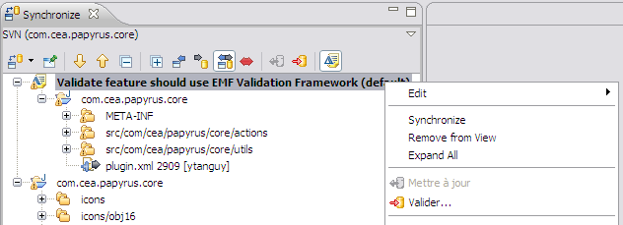Illustration 3: Change set validation in contextual menu
The commit window should appear (Illustration 4) with an automatically added comment linking the SVN commit to its related Bugzilla task.
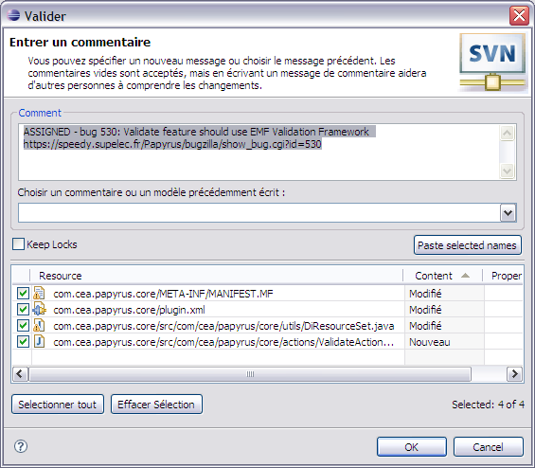Illustration 4: Commit window with pre-filled comment
If needed, additional comments may also be added directly in the task, independently from the commit.

