Papyrus Command Execution
Author : Cedric Dumoulin
Date : 2 Jun. 2010
Rev : 13 déc.. 2011

Introduction
A Command is a piece of code executing some actions interacting with the Editor. A Command can usually be undone and redone. This mechanism is usually implemented with a Command Stack: all commands are registered in the stack. When the user asks an undo, the previous command is taken in the stack, and its undo method is called. A redo take the next command in the stack, and call its redo method. The stack pointer is increase or decrease accordingly.
Sometime, ‘Commands’ are also called ‘Operations’, and the ‘Command Stack’ is called ‘Operation History’.

A Commands and undo/redo mechanism is made of three main parts:
- The Commands – used to execute user actions
- A Command Stack – used to store the executed commands in a stack manner
- Undo/Redo handlers – The UI button or menu used to ask to undo or redo the commands

In Eclipse, several frameworks and implementations exist to fulfill these three parts.
This study first describes the main frameworks and their interrelations. Then, it identifies what are the main Papyrus parts using which framework. Finally, it concludes and gives proposals for Papyrus.

Main Undo/Redo Frameworks
The following Undo/Redo frameworks are identified in Eclipse, GEF, EMF, and GMF (see These Frameworks are represented by the following Command Stacks: (see Figure 1, Figure 2 and Figure 3):):
- IOperationHistory – Eclipse
  - This is the main framework from Eclipse. Commands should be executed on this framework if possible.
- CommandStack – EMF
  - This is the framework provided by EMF.
- CommandStack – GEF
  - GEF provide a command stack and Commands to execute actions on a diagram.
- DiagramCommandStack – GMF
  - This extends the GEF framework to allow execution of GEF commands on the IOperationHistory.
- TransactionalCommandStack - EMF Transaction
  - This framework add transactional capabilities to the EMF Command Stack framework. It allows execution of transactional commands. It provides its own command stack.
- IWorkspaceCommandStack - EMF
  - This framework extends the TransactionalCommandStack and allows to execute Commands on the IOperationHistory.

These Frameworks are represented by the following Command Stacks: (see Figure 1, Figure 2 and Figure 3):
- org.eclipse.core.commands.operations.IOperationHistory.class (interface)
- org.eclipse.emf.common.command.CommandStack (interface)
- org.eclipse.gmf.runtime.diagram.ui.parts.DiagramCommandStack
- org.eclipse.emf.transaction.TransactionalCommandStack.class (interface)
- org.eclipse.emf.workspace.IWorkspaceCommandStack.class (interface)

The default implementations are:
- org.eclipse.core.commands.operations.DefaultOperationHistory
- org.eclipse.emf.common.command.BasicCommandStack
- org.eclipse.gmf.runtime.diagram.ui.parts.DiagramCommandStack
- org.eclipse.emf.transaction.impl.TransactionalCommandStackImpl
- org.eclipse.emf.workspace.impl.WorkspaceCommandStackImpl

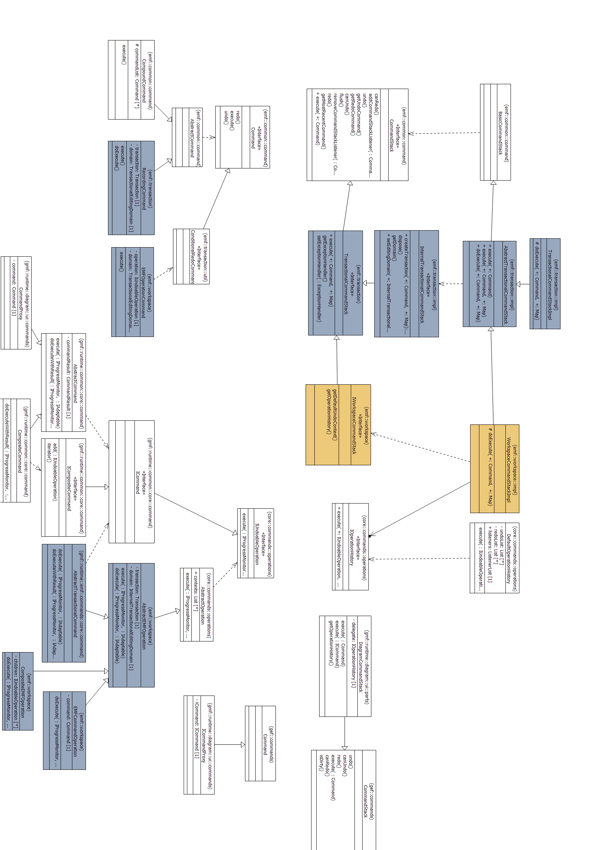
Figure 1 Identified Command Stacks and corresponding Commands

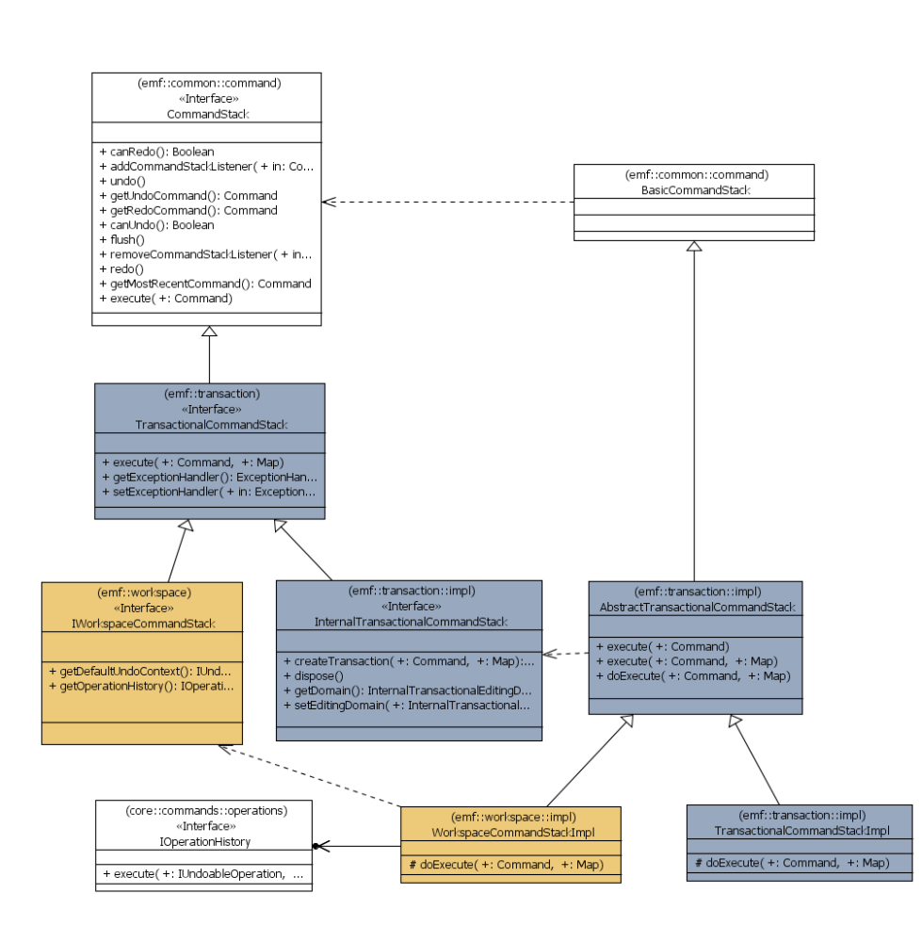
Figure 2 EMF, GMF and Eclipse CommandStacks and there relations

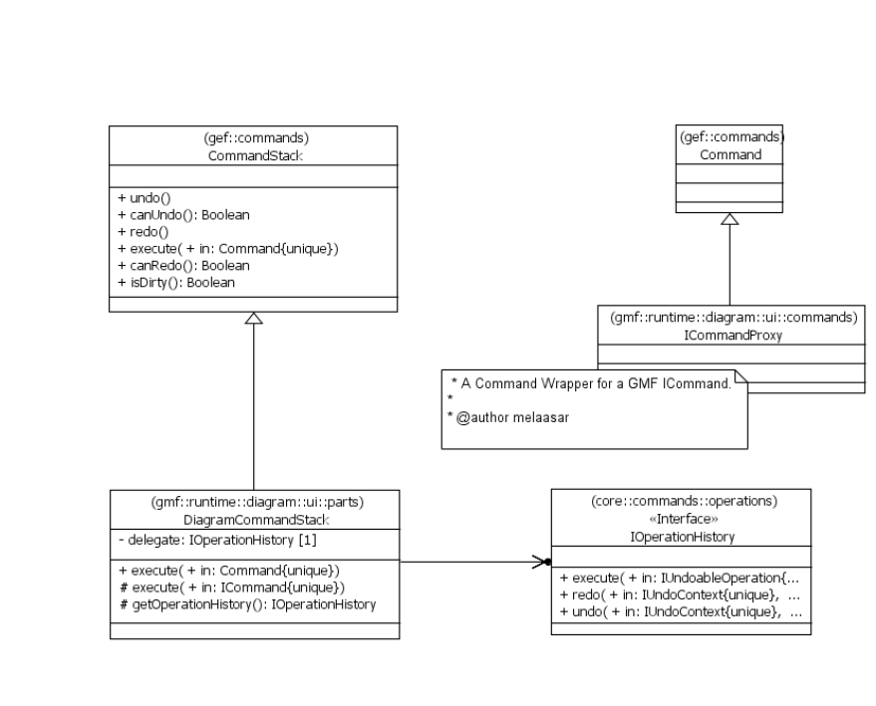
Figure 3 GEF and GMF related CommandStacks

DefaultOperationHistory
- This is the default implementation for IOperationHistory.
- One stack can be used for several applications.
  - In eclipse, all application share the same IOperationHistory
- There exist one global stack:
  - OperationHistoryFactory.getOperationHistory().execute(cmd)
- Use a notion of IUndoContext allowing to recognize commands coming from different applications.
- Each command can be associated with several IUndoContext.
- Undo and Redo are done for one particular context: the Stack lookup the command containing the specified context, and try to undo or redo it.

Command Execution :
- execute(IUndoableOperation)
  - Notify different listeners about the operation execution
  - Call operation.execute()
    - operation can encapsulate a Transaction (see above)
  - add the operation to the history if ok
  - call operation.dispose() if not ok.
- AbstractEMFOperation.execute()
  - org.eclipse.emf.workspace.AbstractEMFOperation
and org.eclipse.gmf.runtime.emf.commands.core.command.AbstractTransactionalCommand
  - Encapsulate a Transaction
    - create, commit, rollback

Commands Hierarchy

Undo-Redo Handlers

BasicCommandStack
Command Stack for emf Commands.
- execute(org.eclipse.emf.common.command.Command command)
  - call command.execute()
  - add the command to the stack if ok.

Do not interact with the IOperationHistory.

Commands Hierarchy

Undo-Redo Handlers

DiagramCommandStack
- Extends GEF CommandStack to allow execution of GEF commands.
- Commands are executed on the IOperationHistory.
- Used by GMF Diagram Tools
- Use its own IUndoContext
  - The IUndoContext can be set externally
  - The IUndoContext is automatically added to each executed command.
- In GMF generated diagrams, context is set to EditingDomainUndoContext(editingDomain).

Provides two kind of executes:
- execute(org.eclipse.gef.commands.Command)
  - Encapsulate the GEF command in a
org.eclipse.gmf.runtime.diagram.ui.commands.CommandProxy(Command)
  - call execute( ICommand)

- execute(ICommand command, IProgressMonitor)
  - execute command on IOperationHistory.execute(command)

TransactionalCommandStackImpl

- Allows to execute in a Transactional way Commands that are not Transactional.
- Maintain the Transaction instance in the stack.

Command Execution :
- execute(org.eclipse.emf.common.command.Command)
  - call doExecute(Command)
  - handle RollBackException, which do command.dispose() and call listeners.
- doExecute(Command)
  - create Transaction
  - basicExecute() – call some notifiers and command.execute()
  - tx.commit() or rollback(tx)

WorkspaceCommandStackImpl
- This is the default implementation of IWorkspaceCommandStack.
- It allows to execute transactional and non transactional commands on the IOperationHistory.
- Commands are always wrapped on a Transactional one.
- Each command maintains its Transaction instance.
- Commands are executed on the IOperationHistory.
  - Roughly, All CommandStack methods delegate to the IOperationHistory.
  - All undo/redo operations are queried in the IOperationHistory by using its own default IUndoContext.

- Use its own default IUndoContext
  - It is automatically added to each command.
- Also automatically add an instance of org.eclipse.emf.workspace.ResourceUndoContext(domain, Resource) to successfully executed Commands. This IUndoContext reference the domain and the modified Resources (as specified in the operation).
  - This is done by listening on IOperationHistory events, and adding the context to the successfully executed Commands.
  - Can be slightly controlled with IResourceUndoContextPolicy

Command Execution :
- execute(org.eclipse.emf.common.command.Command)
- Same as TransactionalCommandStackImpl (inherited from parent)
- doExecute(Command)
  - create a command wrapper of type org.eclipse.emf.workspace.EMFCommandOperation – this is a Transactional Operation
  - add the CommandStack default UndoContext
  - execute the operation on the History.

Available Command Types

Available Undo Action Handlers
- org.eclipse.ui.operations.UndoActionHandler
- org.eclipse.emf.edit.ui.action.UndoAction
- org.eclipse.emf.workspace.ui.actions.UndoActionWrapper
- org.eclipse.gmf.runtime.common.ui.action.actions.global.GlobalUndoAction

Undo on IOperationHistory:
Use following:
org.eclipse.ui.operations.UndoActionHandler
org.eclipse.gmf.runtime.common.ui.action.actions.global.GlobalUndoAction

UndoActionHandler show the undo actions list according to the undoContext it contains. The undoContext can be set dynamically.

- org.eclipse.gmf.runtime.common.ui.action.actions.global.GlobalActionManager
  - creates a GlobalUndoAction
  - created by GMF diagrams
- org.eclipse.gmf.runtime.common.ui.action.actions.global.GlobalUndoAction
  - create a UndoActionHandler
  - listen for part changed
  - set the undoContext when part changed
  - read the undo context by doing part.getAdapter(IUndoContext.class)

In Papyrus, gmf diagrams create GlobalActionManager from their ActionBarContributor.

Undo on WorkspaceTransactionalEditingDomain
Use following:
org.eclipse.emf.edit.ui.action.UndoAction

UndoAction call directly the editingDomain.getCommandStack().undo().

Note:
There exist org.eclipse.emf.workspace.ui.actions.UndoActionWrapper which delegate to the undoable operation framework's {@link UndoActionHandler}.

Handler created when a node of the navigator is selected.
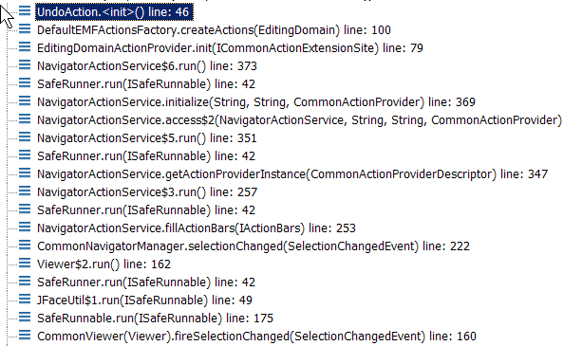

- Undo action declared from:
  - org.eclipse.papyrus.modelexplorer.factory.DefaultEMFActionsFactory

Encountered Problems
Warning
Mon Jun 21 22:42:11 CEST 2010
Conflict for 'org.eclipse.ui.edit.cut':
HandlerActivation(commandId=org.eclipse.ui.edit.cut,
handler=ActionHandler(org.eclipse.gmf.runtime.common.ui.action.internal.actions.global.GlobalCutAction@9b9515),
expression=AndExpression(LegacyEditorActionBarExpression(org.eclipse.papyrus.core.papyrusEditor),WorkbenchWindowExpression(org.eclipse.ui.internal.WorkbenchWindow@1da89a0)),sourcePriority=4210689)
HandlerActivation(commandId=org.eclipse.ui.edit.cut,
handler=ActionHandler(org.eclipse.gmf.runtime.common.ui.action.internal.actions.global.GlobalCutAction@9b9515),
expression=AndExpression(LegacyEditorActionBarExpression(org.eclipse.papyrus.core.papyrusEditor),WorkbenchWindowExpression(org.eclipse.ui.internal.WorkbenchWindow@1da89a0)),sourcePriority=4210689)

What is Used in Papyrus
Papyrus provides several diagrams and views, using different Commands, Command Stack and Undo Handlers. The Table 1 try to outline what is used in the identified views. Following Editors and Views are identified:
- Papyrus Model Explorer
- Creation Service (Command handlers used to create elements)
- Diagram tools
- Property views
- Diagram Creation

Papyrus Plugin | What is used
Papyrus Model Explorer | See creation service
Creation Service | - Stack  - org.eclipse.emf.transaction.impl.TransactionalCommandStackImpl  - Command  - org.eclipse.emf.common.command.Command  - undo handler  - d  - IOperationHistory impl  - d
Diagram tools | - Stack  - org.eclipse.gmf.runtime.diagram.ui.parts.DiagramCommandStack  - Command  - org.eclipse.gmf.runtime.common.core.command.ICommand  - Commands are wrapped  - undo handler  - org.eclipse.ui.operations.UndoActionHandler  - IOperationHistory impl  - d
Property views | - Stack  - Command  - undo handler  - d  - IOperationHistory impl  - d
Diagram Creation | - Stack  - Command  - undo handler  - IOperationHistory impl  - d
Table 1 Papyrus Views and there Command Stack

Main Editor
Actually, the main editor doesn’t handle directly the undo/redo mechanism. It is handled by nested editors, and so it is delegated to it.
The undo/redo behavior is mainly lead by the GMF Generated Editor.

Available Command Stack
All.

Commands
Commands mainly depend on the nested Editor.
Sash System commands are subclass of RecordingCommand, executed on the editingDomain.getCommandStack().

Undo-Redo Handlers
Undo-Redo handlers are defined by the nested editors, through the ContributorActionBar.
In case of GMF nested Editor, UndoHandler is used.

Undo-Redo IUndoContext
Undo-Redo IUndoContext is defined by the nested editors, through the getAdpator(IUndoContext.class) mechanism.
In case of GMF nested Editor, EditingDomainUndoContext(editingDomain) is returned

GMF Generated Editor
GMF Generated editors handle the undo/redo mechanism.
Inside such editor, several parts use the mechanism: the palette and its tools, the graphical objects when they are moved, and some action in the contextual menu. Each of this part can use its own approach describe above.
The GMF editor provides:
- undo/redo global action handlers
- a history listener listening to added command, and setting the IUndoContext if needed
- The DiagramCommandStack – to adapt GMF actions (tools, move) to the IOperationHistory.
- A editor dedicated IUndoContext : EditingDomainUndoContext(editingDomain)

Tools (Palette)

Diagram tools use the following:
- org.eclipse.gmf.runtime.diagram.ui.parts.DiagramCommandStack
- org.eclipse.gmf.runtime.common.core.command.ICommand
- org.eclipse.gmf.runtime.common.core.command.CompositeCommand

Command execution is done with the following method. All execute(…) methods fall down to this one:
- org.eclipse.gmf.runtime.diagram.ui.parts.DiagramCommandStack.execute(ICommand, IProgressMonitor)
- The method is registered in IOperationHistory

Command Associated Contexts:
- org.eclipse.gmf.runtime.emf.commands.core.command.EditingDomainUndoContext
- The context is automatically added by the DiagramCommandStack
  - GMF set this context as the default one for the DiagramCommandStack.

Relation with emf.Transaction ?
- See Figure 4
- Generally, The GMF tooling creates a CompositeCommand that contains subclasses of AbstractTransactionalCommand.

Experimentation Procedure
- Put a breakpoint in DiagramCommandStack.execute(ICommand, ?)
  - org.ecl ipse.gmf.runtime.diagram.ui.parts.DiagramCommandStack
- Create an element from the palette
  - ex: create a class

GMF DiagramCommandStack
- The DiagramCommandStack (Figure 4) is used to execute GEF commands coming from GEF tools and other GEF related stuff.
- The DiagramCommandStack intercept commands and execute them on the IOperationHistory. GEF Commands are wrapped to ICommand thanks to CommandProxy.
- Execution is done with the following method. All execute(…) methods fall down to this one:
  - org.eclipse.gmf.runtime.diagram.ui.parts.DiagramCommandStack.execute(ICommand, IProgressMonitor)
- ICommands can be wrapped to GEF commands thanks to ICommandProxy.
- The DiagramCommandStack try to reduce as most as possible the nested commands (removing unnecessary wrappers).
- The undo/redo operations are handled by the IOperationHistory. The menu and buttons are handled by the Eclipse UndoActionHandler (Figure 5).

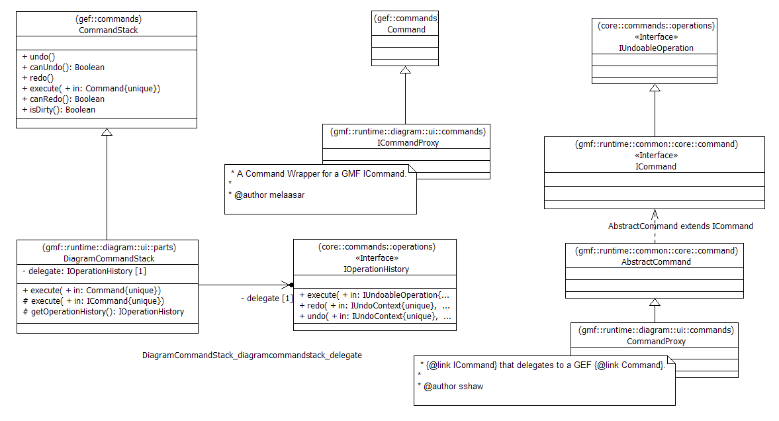
Figure 4 GMF DiagramCommandStack and associated Commands

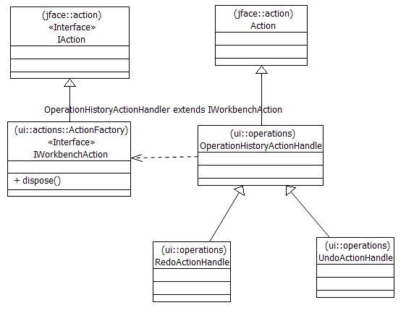
Figure 5 Eclipse Undo/Redo Handlers

Graphical Objects Moving
Such command are created by the GEF framework and executed on the DiagramCommandStack.
See 5.1 Tools (Palette)

Contextual Menu
No particular actions have been identified in ContextualMenu.

Undo-Redo Handlers
In case of a GMF generated nested editor, the undo handler is:
- org.eclipse.ui.operations.UndoActionHandler

The creation of handler is as follow:
- creation of
  - org.eclipse.gmf.runtime.common.ui.action.actions.global.GlobalActionManager
    - creates a GlobalUndoAction
    - created by GMF diagrams
- org.eclipse.gmf.runtime.common.ui.action.actions.global.GlobalUndoAction
  - create a UndoActionHandler
  - listen for part changed
  - set the undoContext when part changed
  - read the undo context by doing part.getAdapter(IUndoContext.class)
  - One common GlobalUndoAction for all GMF diagrams ?
- org.eclipse.ui.operations.UndoActionHandler

Undo-Redo IUndoContext
GMF Diagrams provide a EditingDomainUndoContext associated to the editingDomain of the editor.
- org.eclipse.gmf.runtime.emf.commands.core.command.EditingDomainUndoContext
- Associated with the current EditingDomain

Model Explorer
Model explorer should enable execution of creation commands and undo-redo actions.
The Model Explorer use the Creation Service to allow creation of children.

Creation Service (In ElementType)

The creation service uses the GMF creation service. It asks the GMF service for the creation command. GMF service returns an ICommand.
The ICommand is wrapped in a emf Command.

The emf Command is executed with:
EditorUtils.getTransactionalEditingDomain().getCommandStack().execute(getCommand());

Following IUndoContext are added to the command:
- WorkspaceCommandStackImpl.local – set by the WorkspaceCommandStack
- ResourceUndoContext – set by the when the transaction is commited
- EditingDomainUndoContext – set by one notifier (installed by the GMF editor)

About the EditingDomainUndoContext
- It is added by a listener set from org.eclipse.gmf.runtime.diagram.ui.parts.DiagramEditor.createHistoryListener().

Undo/Redo works (when created in Papyrus Model Explorer)
  - Use org.eclipse.emf.edit.ui.action.UndoAction
  - Which call TransactionalCommandStack.undo()

Undo-Redo Handlers

Undo-Redo IUndoContext

Property View
The Property View use different approaches:
- UML Properties are generated by an hande made generator, and use a particular framework.
- GMF Generated Appearance Properties – Are generated by GMF
- Appearance Properties (Non GMF) – Appearance properties hand coded from a previous version.

UML Properties
- Use IOperationHistory
- execute add IUndoContext of type ResourceUndoContext(affected uml file)
- Create ICommands
- A listener (from GMF editors) add EditingDomainUndoContext(editingDomain)

Commands
Commands are transactionals (see Figure 6).
Each command is associated with the file it modifies.
The GMF history listener add the EditingDomainUndoContext(editingDomain).

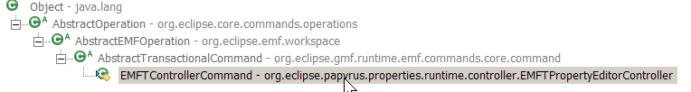
Figure 6 Uml Properties Commands base Class
Commands are executed on the IOperationHistory.

Experimentation Procedure
- Create a Class
- Put breakpoint on IOperationHistory.execute()
- Change the class name from property view

Property Views (GMF generated)

Experimentation Procedure
- org.eclipse.gmf.runtime.diagram.ui.properties.sections.appearance.
ShapeColorsAndFontsPropertySection
  - Section using a command to modify property

Property Views (non GMF)

Commands
Commands are subclass of RecordingCommand.
Command are executed on editingDomain.getCommandStack().

A Command is created in QualifiedNameAppearanceSection.updateSelectedElements().
Undo-Redo context added by

Experimentation Procedure
- org.eclipse.papyrus.tabbedproperties.appearance.QualifiedNameAppearanceSection
  - Section with a command to modify a property

Notes
- Command is created in QualifiedNameAppearanceSection. updateSelectedElements().
- Creates a org.eclipse.emf.common.command.CompoundCommand
  - Contains a subclass of RecordingCommand
- executed on editingDomain.getCommandStack().execute(cmd)
  - use its context

Stack:
- org.eclipse.emf.transaction.impl.AbstractTransactionalCommandStack
Commands:
- org.eclipse.emf.transaction.RecordingCommand
Undo Handler
- Same as Papyrus Model Explorer
- Work only when the Papyrus Model Explorer is selected (because it share the same CommandStack)
- Use the same CommandStack as Papyrus Model Explorer, so if an undo is done on the stack, it is executed.

getTransactionalEditingDomain().getCommandStack()
In Papyrus, most commands are executed like this:
EditorUtils.getTransactionalEditingDomain().getCommandStack().execute(getCommand());

- The command is executed with the returned TransactionalEditingDomain.
- The concrete implementation is:
  - org.eclipse.emf.transaction.impl.TransactionalCommandStackImpl
  - or org.eclipse.emf.workspace.impl.WorkspaceCommandStackImpl
- The returned implementation is specified when the ResourceSet is created. Actually (21 June 2010), it is the workspace version.
- The command is a subclass of
  - org.eclipse.emf.common.command.Command .
- It is wrapped (by WorkspaceCommandStackImpl) in a transactional command.

Undo-Redo Handlers

Undo-Redo IUndoContext

Experiment

Undo of a class creation in the ModelExplorer
- Create a class in Model Explorer
- add a breakpoint in DefaultOperationHistory
- add a breakpoint in org.eclipse.emf.workspace.impl.WorkspaceCommandStackImpl
  - this is the CommandStack set in Resource
- undo in Papyrus Model Explorer :
  - doesn’t work if no element is selected
  - work if an element is selected
- undo in Model Explorer :
  - doesn’t work
- undo in Property View :
  - doesn’t work
- undo in diagram : work
  - call DefaultOperationHistory.undo
  - undo context =
    - org.eclipse.gmf.runtime.emf.commands.core.command.EditingDomainUndoContext
  - operation context

  - undo handler :
    - org.eclipse.ui.operations.UndoActionHandler.
UndoActionHandler(IWorkbenchPartSite, IUndoContext)

Undo of Class renaming
- Create a class in diagram and set a name
- save
- change name in property view

- The operation is
  - org.eclipse.papyrus.properties.runtime.controller.EMFTPropertyEditorController.EMFTControllerCommand
- operation contexts
  - org.eclipse.gmf.runtime.emf.commands.core.command.EditingDomainUndoContext
  - org.eclipse.emf.workspace.ResourceUndoContext(resource name)

- undo in Papyrus Model Explorer :
  - doesn’t work
  - call WorkspaceCommandStackImpl
  - then call DefaultOperationHistory.undo(getDefaultUndoContext(), …)
  - undo context
    - The workspaceCommandStack context
  - operation context

- undo in Property View :
  - doesn’t work
- undo in diagram : work
  - call DefaultOperationHistory.undo
  - undo context
    - org.eclipse.gmf.runtime.emf.commands.core.command.EditingDomainUndoContext
  - undo handler :
    - org.eclipse.ui.operations.UndoActionHandler.
UndoActionHandler(IWorkbenchPartSite, IUndoContext)

What Already Exist

Notes

EditingDomains
EditingDomain
TransactionalEditingDomain

CommandStacks
org.eclipse.emf.workspace. IWorkspaceCommandStack

Commands
org.eclipse.core.commands.operations.AbstractOperation
org.eclipse.emf.workspace.AbstractEMFOperation

EMF
EMF Command framework is divided in two parts:
- Common Command Framework – provide basic commands, commandStack, … Designed to execute commands of any kind
- EMF.Edit – Designed to execute commands on EObject exclusively. It requires an EditingDomain

EditingDomain
Class provided by the EMF.Edit framework. It provides three functions:
- creating commands
- managaing a command stack
- access to the ResourceSet (the attached ResourceSet also know the EditingDomain)

The EditingDomain of an EObject is accessible from any EObject through the Resource and the ResourceSet.

- See: Working with EMF Operations (1)

EMFT
EMFT provides a bridge to the IOperationHistory : see
- EMF Model Transaction Workspace Integration Overview (1)
- Working with Workspace Editing Domains (2)

EMFT encourage to use IOperationHistory when possible (see (2)):
“In all respects, a workspace editing domain and command stack function much as a regular transactional editing domain and its command stack do. However, the execution of Commands on the workspace command stack is only really provided for compatibility with code (such as in the EMF property sheet) that expects to work with commands. Applications are encouraged to execute operations directly on the operation history, to take full advantage of the undo context and related capabilities.”

Conclusion
The operation history mechanism is made of three main parts:
- The Commands – used to execute user actions
- A Command Stack – used to store the executed commands in a stack manner
- Undo/Redo handlers – Used to ask to undo or redo the commands

In Eclipse, several frameworks and implementations exist to fulfill these three parts. For Papyrus, we want to use transactional commands. We recommend using:
- Commands – any command subclass of a Transactional one.
- Command Stack – The IOperationHistory
- Undo/Redo handlers – Any Handler interacting with the IOperationHistory and allowing to specify the IUndoContext. For example the org.eclipse.ui.operations.UndoActionHandler.
- A common IUndoContext. It should be associated to one Papyrus Editor. It can be associated with the EditingDomain or with the Editor Input.

Proposal

- We should use transactions (but this is already done)
- We should use the IOperationHistory
  - Use the WorkspaceTransactionnalEditingDomain (done)
    - All commands are wrapped in a transactional one
  - or Use the IOperationHistory directly
    - We should take care to use transactional commands
- Even load and save should be transactional
- All read and write should be transactional

- create an IUndoContext from core.editor
- changes in Model Explorer:
  - create and attach undo handlers
  - switch handlers when active part switched
  - call activate(part) when active part switched.

Sol 1
Use IWorkspaceCommandStack
- This Enable properties undo when ctrl-z is done on diagram or Model View Explorer
Check what GMF properties use.

How to get The CommandStack ?

- From the TransactionalEditingDomain:
  - transactionalEditingDomain.getCommandStack();
  - How to get the TransactionalEditingDomain ?
    - serviceRegistry.getService(TransactionalEditingDomain)
      - Never return null
    - EditorUtils.getTransactionalEditingDomain()
      - Can return null if the current Editor is not fully initialized
    - org.eclipse.emf.transaction.util.
TransactionUtil.getEditingDomain(eObjectInput);
      - Get the Resource, then the ResourceSet, then the attached TransactionalEditingDomain. Costly
- From the IOperationHistory:
  - OperationHistoryFactory.getOperationHistory().execute(cmd)

References
1. Working with EMF Operations. [En ligne] http://help.eclipse.org/galileo/index.jsp?topic=/org.eclipse.emf.workspace.doc/references/overview/operations.html.
2. EMF Model Transaction Workspace Integration Overview. Eclipse. [En ligne] http://help.eclipse.org/galileo/index.jsp?topic=/org.eclipse.emf.workspace.doc/references/overview/workspaceOverview.html.
3. Working with Workspace Editing Domains. Eclipse. [En ligne] http://help.eclipse.org/galileo/index.jsp?topic=/org.eclipse.emf.workspace.doc/references/overview/workspaceOverview.html.
4. Tutorial: EMF Model Transaction Workspace Integration. [En ligne] http://help.eclipse.org/galileo/index.jsp?topic=/org.eclipse.emf.workspace.doc/references/.
5. Implementing Undo/Redo Actions with the Operation History. [En ligne] http://help.eclipse.org/galileo/topic/org.eclipse.emf.workspace.doc/references/overview/undoredo.html?resultof=%22%75%6e%64%6f%2f%72%65%64%6f%22%20.
6. EMF Model Transaction Workspace Integration Overview. [En ligne] http://help.eclipse.org/galileo/topic/org.eclipse.emf.workspace.doc/references/overview/workspaceOverview.html?resultof=%22%75%6e%64%6f%2f%72%65%64%6f%22%20.
7. Example - Undo. [En ligne] http://help.eclipse.org/galileo/topic/org.eclipse.platform.doc.isv/samples/org.eclipse.ui.examples.undo/doc-html/ui_undo_ex.html.
8. EMF Model Transaction Examples Overview. [En ligne] http://help.eclipse.org/galileo/index.jsp?topic=/org.eclipse.emf.workspace.doc/references/examples/exampleOverview.html.
(4)

Annexes
http://help.eclipse.org/indigo/index.jsp?topic=%2Forg.eclipse.platform.doc.isv%2Fguide%2FwrkAdv_undo.htm
http://help.eclipse.org/galileo/index.jsp?topic=/org.eclipse.emf.workspace.doc/references/overview/undoredo.html
http://help.eclipse.org/galileo/topic/org.eclipse.emf.workspace.doc/references/examples/workspaceExample.html

