Sash and Core
Architectures
Author : Cedric Dumoulin
Date : 6 déc. 2009
Rev : 10 Jan. 2012

Introduction
Sash System and Core are used by the Papyrus UML editor.
The Sash System provides an editor of pages that can be arranged in multiple pages separated by sashes. A page can be either an editor or a SWT Component.
The Core provides the main Editor implemented with the Sash. The core also provides a notion of Services that can be added to the main editor. The services can then be retrieved and shared between nested pages.
The Core depends on the Sash System (Figure 1). The Sash System is independent.

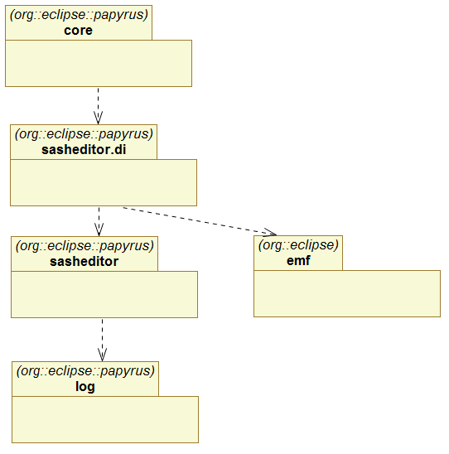
Figure 1 Sash and Core packages

Sash System
The sash system is used to render multiple nested pages in one main editor. A page can be an editor or a SWT component.
In the sash system, nested pages can be layed in tabfolders and side by side. The sash system allows to move the pages from tabfolder to tabfolder, or to create new tabfolders.

Architecture Overview
The sash system main component is the SashWindowsContainer class. It is used to render the pages as described above. The class requires two interfaces in order to work properly (Figure 2):
- ISashWindowsContentProvider – The content provider is used to store the structure representing the pages (editors or components) to be rendered. It is used by the SashContainer to discover and modify the structure.
- IMultiEditorManager – Is required if the SashContainer should render Eclipse IEditor. It is used to get Eclipse Site and EditorInput.

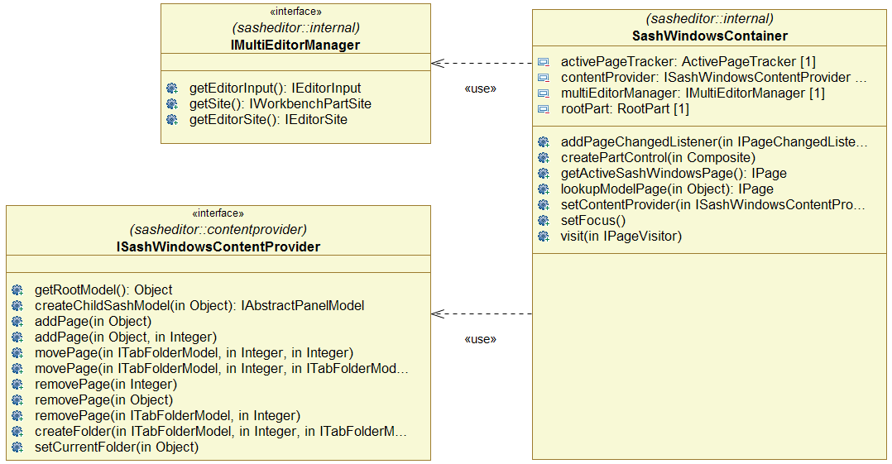
Figure 2 Sash Container and its required interfaces

The Sash Container can be used directly in an Eclipse editor. A base implementation is provided in AbstractMultiPageSashEditor. This implementation requires a concrete implementation for the ISashWindowsContentProvider interface.

Public API
The sah public API is composed of interfaces accessible from outside the sash plugins.
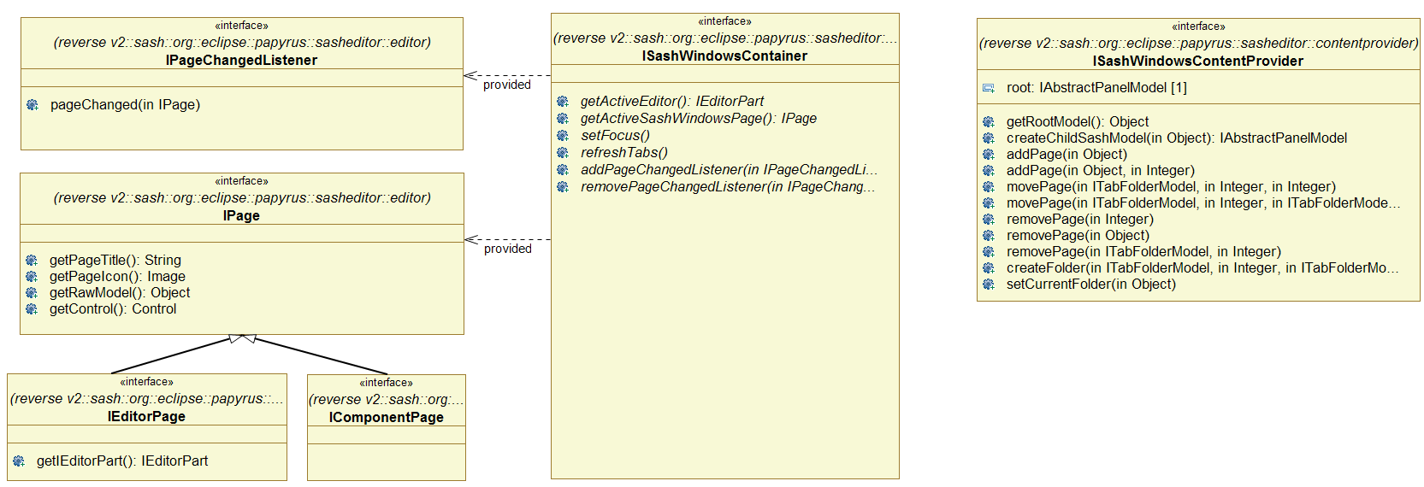
Figure 3 Sash Public API

ContentProvider
The ContentProvider is used by the SashContainer to discover the content of the sash, and to store this content externally.
The ContentProvider main API is ISashWindowContentProvider.

ContentProvider structure
The ContentProvider is used to read and store the structure to be rendered by the SashContainer. This structure can be implemented in different manners.
The ContentProvider API is design in order to be able to implement the structure by using any kind of Objects, called raw model. The Container call special methods (createChildSashModel(Object)) to obtain a well known API from a raw model used in the container.
The content provider returns a view on the real structure implementation. The SashContainer start to explore this view from the ISashWindowContentProvider. The virtual view is made of ‘Model’ represented by the different IXxxModel interfaces in Figure 4.
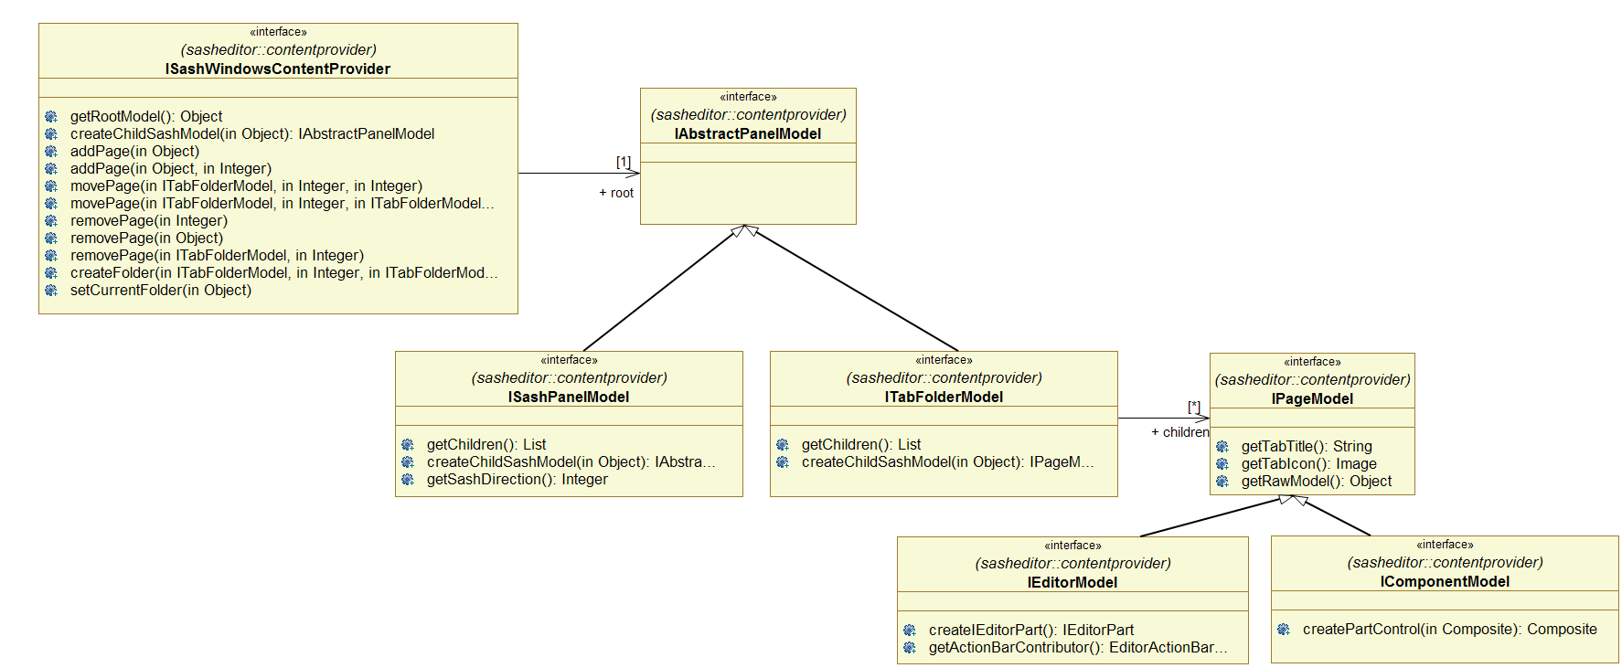
Figure 4 ContentProvider set of interfaces used by the SashContener

From the content provider, the virtual view is as follow:
- A root contains a PanelModel which can be either a ISashModel or a IFolderModel.
- A ISashModel is made of two children of type IPanelModel. This represent two panel separated by a sash.
- A IFolderModel is made of several children of type IPageModel. This represents a tabfolder made of pages.
- A IPageModel can be either a IComponentModel or a IEditorModel.
- A IComponentModel represents a SWT Component.
- A IEditorModel represent an Eclipse Editor.

ContentProvider main API
The main API of the content provider is ISashWindowsContentProvider.
There is two methods to explore the ContentProvider structure: getRootModel() and createChildSashModel(object).
Others methods are used by the Container to modify the content after a user interaction.

ContentProvider exploration
To discover the content, the Container first call the getRootModel() to get the root model of the content. This returns an Object representing the root of the structure of the Sash.
Then the container call createChildSashModel(object) whith the previous object to get the Model represented by the Object. This is either a ISashPanelModel or a ITabFolderModel.
For a ISashPanelModel the container call the getChildren() method to obtain the raw models of the node. Then for each childs it get the IAbstractPanelModel by calling createChildSashModel(object).
For a a ITabFolderModel, the container call the getChildren() method to obtain the raw models of the node. Then for each childs it get the IPageModel by calling createChildSashModel(object). This return either a IComponentModel or a IEditorModel, representing a SWT Component or a IEditor.
The container create the corresponding SWT component or IEditorPart by calling appropriate method.

ContentProvider Modification by the SashContainer
The SashContainer modify the ContentProvider by the way of the ISashWindowsContentProvider interface. It doesn’t create models by itself.
The SashContainer transforms user interactions in calls to ISashWindowsContentProvider. This should modify the ContentProvider internal structure. In turn, something must call the refresh() method on the SashContainer in order to refresh it (to force it to synchronize itself with the ContentProvider).
The SashContainer do not listen on the ContentProvider. This should be implemented externally.

DI ContentProvider
The DiContentProvider is an implementation of the ISashWindowContentProvider.
It is implemented with an EMF metamodel, to save its content as EMF model.
The DiContentProvider is accessible throw the DiSashModelMngr class or TransactionalDiSashModelMngr class.

The internal EMF implementation is not intended to be used directly by users. Some interfaces are provided in order to access it: IPageMngr and ISashWindowContentProvider.

IPageMngr, provides methods to add, open, remove Editors from the ContentProvider. This is the API used by user.
An implementation of the IPageMngr can be obtained from the DiSashModelMngr or the TransactionalDiSashModelMngr.

The DiContentProvider is provided by the org.eclipse.papyrus.sasheditor.di plugin.

DiSashModelMngr
To get an instance of the DiContentProvider, it is necessary to create an instance of DiSashModelMngr (or the Transactional one). This class requires two classes to work (Figure 5): an EMF Resource that is used to store/retrieve content, and a IPageModelFactory, used to create instance of IPageModel (model used by the SashContentProvider to create instance of nested Editor).

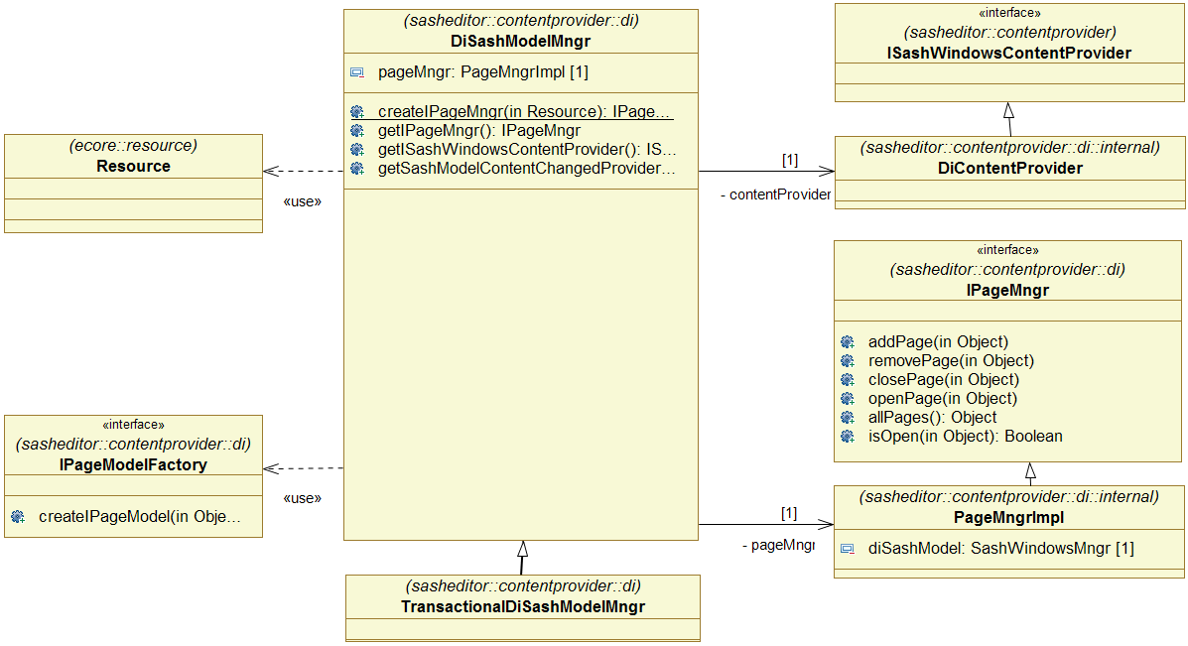
Figure 5 DiContentProvider Provided and Required Interfaces

Internal Structure
The implementation is made of 3 parts:
- The manager, used to retrieve the concrete implementations of provided interfaces (Figure 5)
- Implementations of ISashWindowContentProvider and IPageMngr (Figure 5)
- An EMF metamodel and model used to store/retrieve the sash structure (Figure 6).

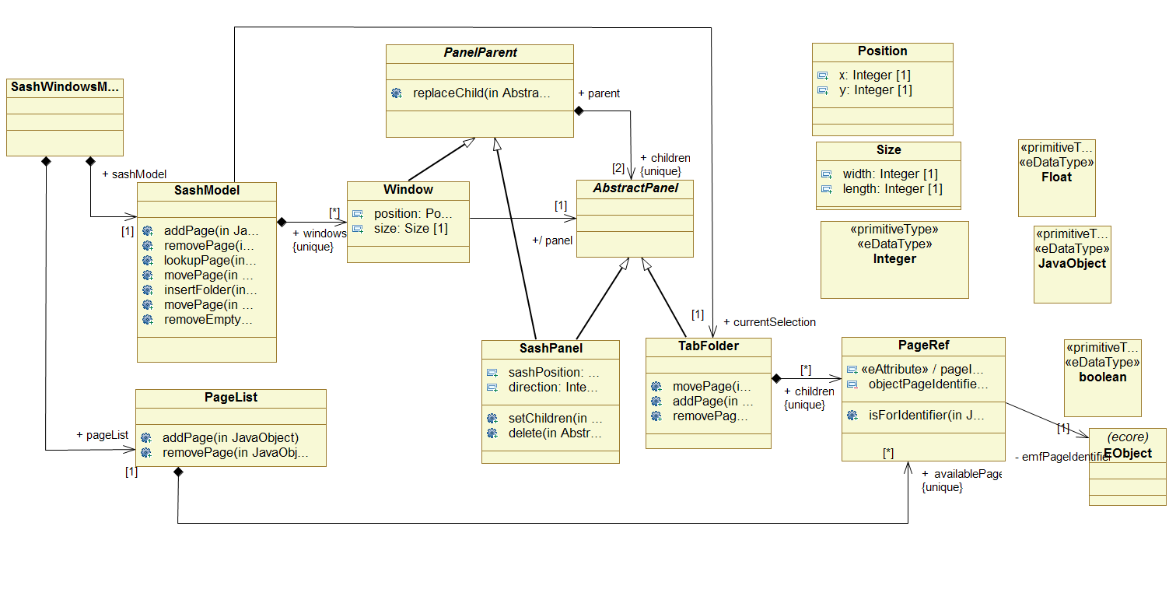
Figure 6 The di sashwindows metamodel (internal structure).

The EMF metamodel is itself made of two parts:
- A SashModel representing the structure of SashSystem. This is a tree structure whose leaf are objects representing pages (an Editor or a Component).
- A PageList – a list of pages currently available for the SashSystem. This list contains objects representing all the pages, the open ones as well as the closed ones.

AbstractMultiPageSashEditor
The Sash System provides an abstract base implementation of a multieditors. The class is AbstractMultiPageSashEditor. This implementation uses a SashContainer and requires a ISashWindowsContentProvider.
This later should be set by calling setContentProvider().

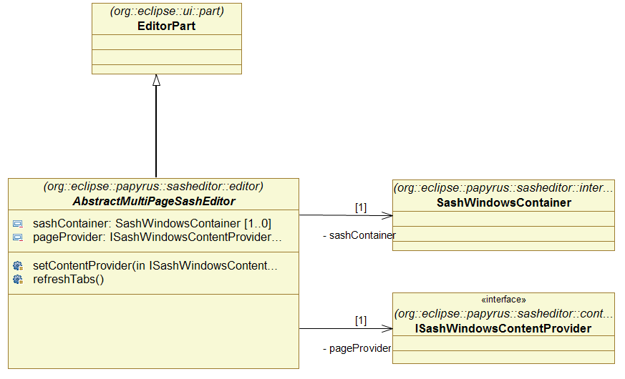
Figure 7 AbstractMultiPageSashEditor Overview

SashContainerFactory
The SashContainerFactory class can be used to get an instance of the SashContainer, as this later is not directly accessible.
Note: this class is not yet implemented. It will be if there is a need for it.

Contextual Menu in Tab Area
It is possible to set contextual menu in the tab area of a folder.
The org.eclipse.papyrus.sasheditor.editor.ISashWindowsContainer.setFolderTabMenuManager(MenuManager) method is used for that.
The MenuManager should be set to provide the menu.

Refreshing tab decorations (name and icon)
The rename command allows to rename a nested IEditorPart. The corresponding tab should be refreshed accordingly

Rename action
The rename action should change the name in diagram (for GMF diagrams) and in the IEditorPart.
The IEditorPart is not always available.
It is possible to set

Tabs Thumbnails as Tooltip
An overview of the diagram is shown as tooltip when the mouse is over the tab of the diagram.
Involved Classes:
- org.eclipse.papyrus.sasheditor.internal.ImageToolTipManager – Manage ToolTip and digram to image conversion.
- org.eclipse.papyrus.sasheditor.internal.TabFolderPart.MouseHoverTracker.mouseTrackListener – Track mouse over tab

Glossary
Concept | Definition
SashContainer | A sash container is the main component of the sash system. It contains pages that can be arranged in multiple windows, and inside each window the pages can be arranged side by side or in sash folder. Two adjacent pages are separated by a sash allowing to resize the pages.
Sash Window | A sash window is a window that can be moved independently from the Eclipse window. A sash window show one or more pages of a Sash container.  Note: the actual implementation allows only one window docked inside Eclipse.
Sash Folder  Sash tabfolder  Folder | A sash folder renders pages in a tab fashion. A folder contains several pages, but show only one of them at a time. Pages can be selected with a tab.
Sash Panel | A sash panel render two
Sash Page | A sash page is the final

Core / Backbone
The Core main intent is to provide a multieditors, that is, an editor of editors.
The provided multieditors is independent from the nested editors. These nested editors can be registered by using the Eclipse extension mechanism.
Nested editors can share objects thanks to the ServiceRegistry who register services. These services are registered programmatically or by using the Eclipse extension mechanism.
The multieditors use a Di ContentProvider to register the Sash content.

Architecture Overview
The main class of the core is the CoreMultiDiagramEditor. It extends the sasheditor.AbstractMultiPageEditor to provide a multieditors. It adds some services needed by the nested editors.
Figure 8 shows the main classes and the added services.

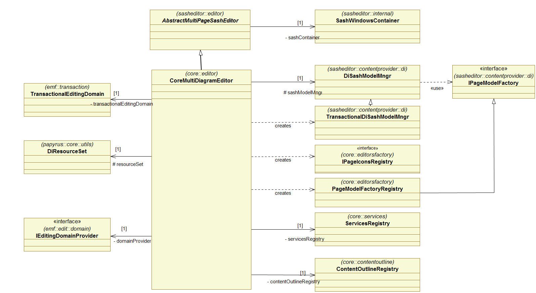
Figure 8 Core multieditors overview.
All the services are also accessible thanks to the ServicesRegistry. This ServicesRegistry is provided to all nested editors while they are created. The nested editors can then retrieve any service it need.

Public API
Main API of the core is represented in Figure 9.
From the main editor (aka instance of CoreMultiDiagramEditor) , it is possible to get the following members :
- ServicesRegistry – To get other registered services
- SashWindowsContainer – To get the active editor or refresh all editors
- DiSashModelManager – To add, remove move, open, close diagrams in the editors
- Main IEditorSite – To get the Eclipse SelectionService
- The currently active nested editor. – Required by some GMF stuff
- LifeCycleEventsProvider – To listen on life cycles events on the main editor (doSave, doSaveAs)

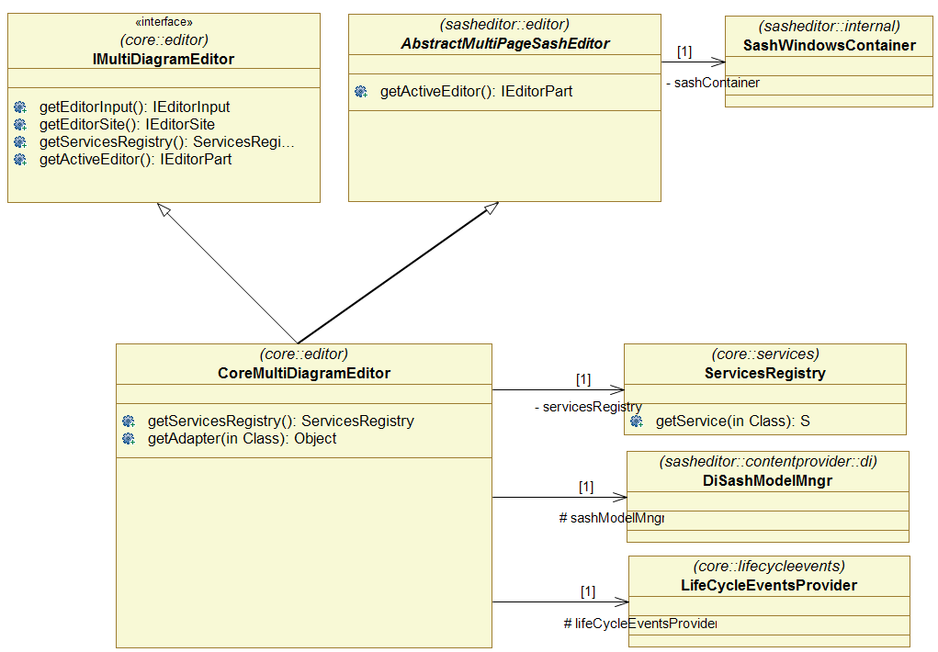
Figure 9 Core main APIs

- ServiceRegistry – Used to get registered services

Available Services
The core creates and registers a number of services:
- See org.eclipse.papyrus.core.editor.CoreMultiDiagramEditor.init(IEditorSite, IEditorInput)

- ILifeCycleEventsProvider
- ActionBarContributorRegistry
- DiResourceSet/ModelSet
- TransactionalEditingDomain
- IPageIconsRegistry
- ISashWindowsContentProvider
- IPageMngr
- ILabelProvider
- ElementCreation

ServiceRegistry
The ServiceRegistry is used to register services that can be found by a key, generally the classname of the service.
A service can be retrieve in a standard way, generally by using its ID or its implementation class.

Architecture Overview
Figure 10 shows the architecture of the ServiceRegistry.

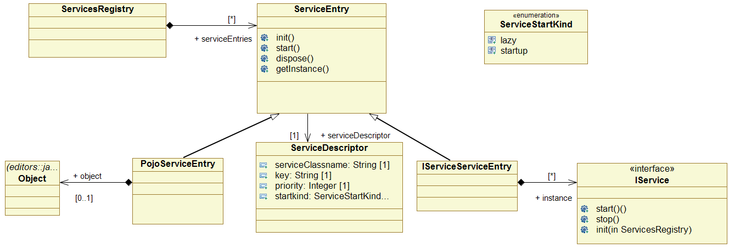
Figure 10 ServiceRegistry Architecture

Service Type
startup mode: lazy, startup
registered mode: named, anonymous
service type: pojo, IService, IFactory

 | lazy |  | startup
 | named | anonymous | named | anonymous
PoJo | ok | / | ok | ok
IService | ok | / | ok | ok
IFactory | ok | / | ok | ok
Figure 11 Service possible combinations

 | lazy |  |  | startup
calls on entry | pojo | IService | IFactory | pojo | IService | IFactory
createS() | / | / | / | s = new S();  register s | s = new S();  register s | f = new F()  s = f.createService();  register s
initS() | / | / | / | / | s.init() | s.init()
startS() | / | / | / | / | s.start() | s.start()
getS() | if( ! created) {  create()  register s  } | if( ! created) {  create()  init()  start()  register s  } | if( ! created) {  create()  init()  start()  register s  } | return s | return s | return s
dispose() | / | s.dispose | s.dispose | / | s.dispose | s.dispose

Behaviors
startRegistry
All Services of type StartStartup are started: first all services are created, then all init() are called then all start() are called.
Once started, named services are added to the registry.
Anonymous services are not added to the registry.
If an error occur during the startup process, the service is in error, and any attend to get it will throw an error.

LazyServices are not started, except those that are needed by started services.
if a StartStartup depends on a Lazy service, then the LazyService is treated like a StartStartup service. This is done recursively.
Normaly, there is no need to depend on a LazyService

DependsOn Use Cases

Get a LazyService that depends on a Service
The Service is already started.
The LazyService is started.

Get a LazyService A that depends on another LazyService B
The LazyService B is started
The LazyService A is started
LifeCycle methods are called in sequence: create(), init(), start()

Get a LazyService A that depends indirectly and transitively on another LazyService B
As the LazyService B is a dependence of a service, it was started with the service.

Start a service A that depends on a LazyService B
The LazyService B is started. ➔ The LazyService is considered as a Service
The Service A is started.

Start a service A that depends indirectly and transitively on a LazyService B
All lazyService that are dependence directly or indirectly of a Service are considered as Service, and are started with the service.

Designing a Service
A service is a class providing some methods.
The class can be a Pojo, or it can extend the IService interface.
If the service extends the IService interface, the ServiceRegistry will call the life cycle methods on the service.

Register a Service
A service can be registered in several ways:
- Using the Eclipse extension mechanism
- Programmatically

Using the Eclipse extension mechanism
A service can be registered using the Eclipse extension mechanism.
Figure 12 shows the extension names and fields.

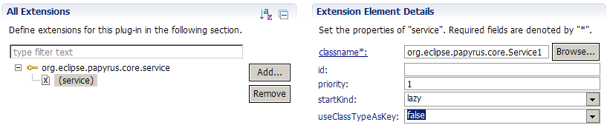
Figure 12 Register a Service with Eclipse extension
- classname – The name of the class implementing the service. The class should implements the IService interface.
- id – id used to register the service when useClassTypeAsKey=true.
- useClassTypeAsKey – Boolean. If true, use the class type as the key to register the service. Otherwise, use the id (which should not be null).
- priority – If more than one service are declared for the same key, only the service with the higher priority is registered.
- startkind – lazy or startup. Specify when the service should be started. startup: the service will start as soon as it is registered; lazy: the service will start when it is first retrieved from the registry.

Programmatically
Services can be registered programmatically using one of the add(…) methods (Figure 13). In this case, the service can be a Pojo.
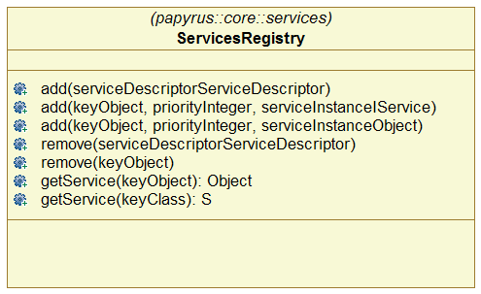
Figure 13 ServicesRegistry class public API.

Common Services

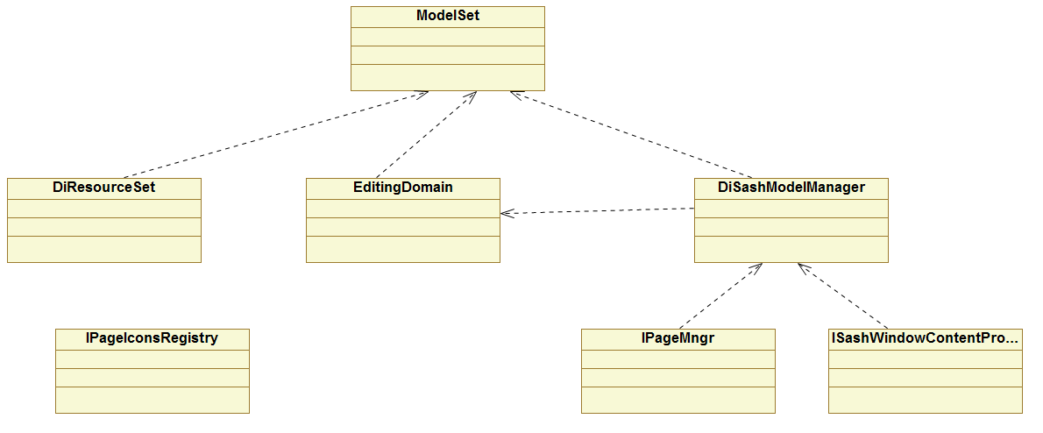
Figure 14 Base Services and their dependencies

How to get a Service or the ServiceRegistry ?
Papyrus main editor create one ServiceRegistry referencing all the services needed by Papyrus.
Once you get the ServiceRegistry, you can get all the services used in Papyrus. So, the first step is always to get the ServiceRegistry.
When a nested editor is created, the ServiceRegistry is provided as parameter. It can, and should, be used from the nested editor.

Some miscellaneous methods exist to get the ServiceRegistry, or a particular service. Method to get a particular service relies on the method to get the ServiceRegistry.

To get the ServiceRegistry:
- from code inside a nested editor – You need to pass to your code the ServiceRegistry provided at the Editor creation.
  - You should NOT get the ServiceRegistry from the Eclipse active Editor, because there is cases where there is no active editor.
  - In Papyrus GMF nested editors, you can use utility methods from:
org.eclipse.papyrus.diagram.common.util.DiagramCoreServiceUtils
- from code relying on the Eclipse Active Editor
  - Retrieve the Eclipse active editor and call:
ServiceRegistry serviceRegistry = editor.getAdapter(ServiceRegistry.class);
  - You can use utility methods from: org.eclipse.papyrus.core.utils.EditorUtils
  - Do not use these methods from code inside nested editors !
- from a UI handler – The ServiceRegistry can be retrieved from the Eclipse Active Editor, as the handler is designed to interact with it. If the ServiceRegistry cannot be found, the handler can’t be executed.
  - You can use utility methods from: org.eclipse.papyrus.core.utils.EditorUtils
- from a PropertyViewer – same as ui handler.

Migration Path
Migration Path to remove usage of EditorUtils.
Methods in EditorUtils can be replaced by methods from:
- org.eclipse.papyrus.core.utils.ServiceUtils
  - When you have the instance of the ServiceRegistry
- org.eclipse.papyrus.diagram.common.util.ServiceUtilsForGMF
  - from GMF EditPart
  - from GMF EditPolicies
- org.eclipse.papyrus.core.utils.ServiceUtilsForActionHandlers
  - from action handlers acting on the current active editor. This is the case for eclipse.ui.handler and similar code.
  - from property views ?

For each methods in EditorUtils, search for its references.

EditorRegistry
The EditorRegistry is used to register the descriptors of editors that can be created in the multieditor.
Editor descriptors can be registered using the Eclipse extension mechanism (Figure 15).

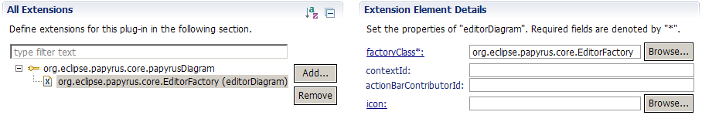
Figure 15 Nested Editor registered with Eclipse Extension
The EditorRegistry is mainly used by the SashContainer to create nested Editors when requested by the user, or when the multieditor is reopened.
The EditorRegistry requires the following to work:

Models and ModelSet
A Model is a collection of related concepts usually coming from an EMF model. A Model is identified by an identifier, used to retrieve it in the application.
A Model can provide methods dedicated to its concept.
Any project can declare its own model, and let other projects to use it. Model are declared with an Eclipse extension.
Models are grouped in a ModelSet, used to perform global operation on all models, like save, saveAs, loadModel …

Snippets can be associated to Models and ModelSet. A Snippet is a class that is informed when some defined event happen on its Model or ModelSet. The Snippet can also be used to perform some operations like adding Adapters.

A Model can be implemented with one or more emf.Resource, or it can share an emf.Resource with one or more Models.

It is a discouraged to let the user manipulate directly the emf.Resource associated to a Model, as this open a door on the internal implementation of the Model.

A ModelSet is usually implemented with an emf.ResourceSet.

Requirements
- Be able to add a kind of model that is loaded with other associated models
- Be able to define a group of kind of models. The group have some operations like load and save that are performed on all the members
- A group can be associated to an URL which is used to load, save, …
- Be able to load one kind of model, and later be able to create a group from this loaded model
  - used in import UML model.
  - Use case – import a UML model:
    - load a UML model
    - create a group with this UML model
    - set an URL to the group
- A group propose the following operations;
  - load
  - save
  - save as
  - create
  - …
- Be able to get one single domain model: get the UML model, get the Notation Model, get the History Model, get the Sash Model, …
- Be able to save one model:
  - Does all resources loaded for the model are saved, or only resources explicitly loaded ?
- A Model allows to perform operation dedicated to this model:
  - get the single root or get all the roots
  - initialize the particular model
- Be able to specify individually if an entity (resource or group or model) should be saved with other entity.

Public API

Internal Architecture

ModelLoader (ex DiResourceSet)
Old dependencies to DiResourceSet
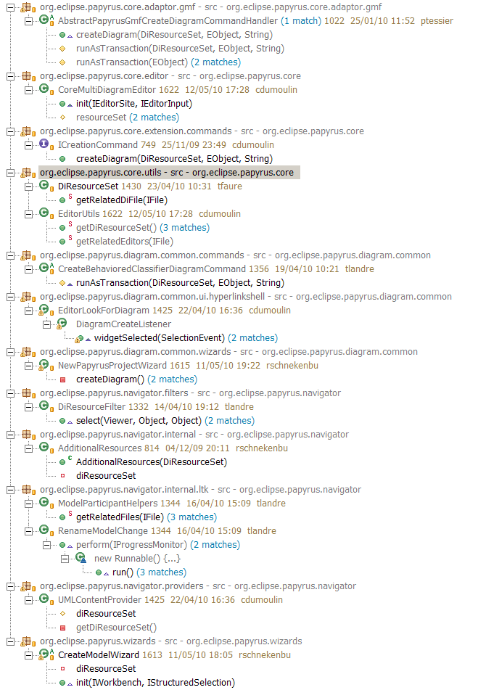
Figure 16 Old Dependencies on DiResourceSet

Proposed Replacement
- diResourceSet.createModelResources(IFile, type, extension)
  - mngr.registerModel(type);
  - mngr.createModels(IFile);
- DiResourceSet.getRelatedDiFile(IFile)
  - ??
  - Dans DiModel ?
- DiResourceSet.getAdditionalResources()
  - dans mngr ?
  - dans un IModel
  - return une liste qui contient toute les resources sauf celles qui sont utilize par les autres modèles
  - peut ajouter IModel.getAssociatedResources() qui retourne les resources associé (officielles) à un model
- DiResourceSet.createModelResources(IFile, String, String)
  - originally, the method check if the uml model already exists. If true, do not create it.
  - Add a method that createMissingModels(…)
    - creates the models that are not already created.
    - usage:
      - mngr = new ModelManager()
      - mngr.addModel( UmlModel )
      - mngr.createModels(File)
      - mngr.addModel(NotationModel)
      - mngr.createMissingModels(File)
    - or
      - mngr = new ModelManager()
      - mngr.addModel( UmlModel )
      - mngr.addModel(NotationModel)
      - mngr.createModel(modelKey);
      - …
      - mngr.createMissingModels(File)

IFile, IPath, URI …

IFile, IResource, …
package org.eclipse.core.resources

IResources are handles on real resources in filesystem.

IFile - Files are leaf resources which contain data. The contents of a file resource is stored as a file in the local file system.
IResource - The workspace analog of file system files and directories. There are exactly four types of resource: files, folders, projects and the workspace root
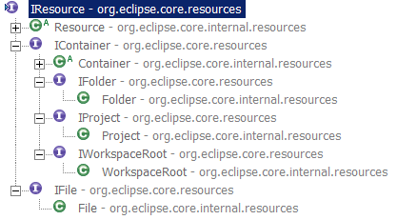
Figure 17 IResource hierarchy
Getting a IResource from system
IProject p = ResourcesPlugin.getWorkspace()
.getRoot().getProject("org.eclipse.papyrus.core");

IFile model1File = p.getFile("tmp/model1.uml");

IPath
package org.eclipse.core.runtime;

A path is an ordered collection of string segments, separated by a standard separator character, "/". A path may also have a leading and/or a trailing separator. Paths may also be prefixed by an optional device id, which includes the character(s) which separate the device id from the rest of the path. For example, "C:" and "Server/Volume:" are typical device ids. A device independent path has null for a device id.

Note that paths are value objects; all operations on paths return a new path; the path that is operated on is unscathed.

Getting a IResource from a IPath:

URI
package org.eclipse.emf.common.util.URI

A representation of a Uniform Resource Identifier (URI), as specified by RFC 2396, with certain enhancements. A URI instance can be created by specifying values for its components, or by providing a single URI string, which is parsed into its components. Static factory methods whose names begin with "create" are used for both forms of object creation. No public or protected constructors are provided; this class can not be subclassed.

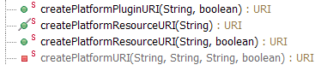
Figure 18 URI Useful Methods

TODO
Allows additions of classes that will perform additional operations once the model is loaded.
These additions are used to add notifiers, …

Site and IActionBar
See :
- SubActionBars
  - concrete implementation of ActionBars with activate/deactivate
- org.eclipse.ui.part.PageBookView.initPage(IPageBookViewPage)
  - an example managing multiple sites for one view
- org.eclipse.ui.part.PageSite
  - an example of nested site

Nested Editors
A nested editor, or embedded editor, is an editor that can be created and rendered in the multieditors.
A nested editor can be a regular Eclipse editor implementing the IEditorPart interface.
There is several ways to create nested editor, depending on which package you use (Sash only, Core, …).
Usually, all nested editors share common resources, like the EMF Resource. This can be achieved with the help of the ServiceRegistry.

Sash Requirements for nested Editors

On the Sash level, it is necessary to provide a ContentProvider managing the structure of rendered editors.
The sash package provides 3 implementations for the ContentProvider:
- org.eclipse.papyrus.sasheditor.contentprovider.singlefolder
  - Mainly used for test purpose. This implementation only allows one tabfolder, and all nested editor are in this tabfolder. Implementation using this ContentProvider will react as the original Eclipse MultiTabEditor.
- org.eclipse.papyrus.sasheditor.contentprovider.simple
  - A simple implementation where the structure is only maintained in memory. There is no way to save the structure. This is an example design.
- org.eclipse.papyrus.sasheditor.contentprovider.di
  - An implementation done with an EMF model called sashdi. This implementation allows save and restore of nested EMF based editors.

Sash Di Requirements for nested Editors

Core Requirements for nested Editors
The Core provides some services helping to manage nested editors.
To enable a nested editor in the multieditor, it is necessary to:
- Register the nested editor in the Core Editor Factory
- Enable an action creating an new instance of the editor

You need to provide the following;
- An Editor (not covered here)
- An Action or an Handler allowing to create the EObject representing the editor and add this EObject to the SashContentProvider
- A factory that will receive as input the previously created EObject, and will create an IEditorModel for your editor.
- A subclass of IEditorModel. This class is used as model by the SashEditor. It serves to create the instance of the Editor for the previously created EObject.

Environment Provided by Core
The Core provide following services that can be helpful when enabling a nested editor:
- PageModelFactoryRegistry – Used to register a nested editor. Editors are registered with the help of the Eclipse extension mechanism.
- ActionBarContributorRegistry – Used to share common ActionBarContributor between nested editor
- ServicesRegistry – Used to share services across nested editors.
- IPageMngr – Used to add or open an editor instance
- DiResourceSet – Use to get the available models.

Registering Nested Editor
You need an editor allowing to save its representation as an EMF model. GMF editors falls in this category, as well as EMF ones.
Once you have such an editor, you need to:
- Provide an implementation of IPluggableEditorFactory
- Provide an implementation of IEditorModel
- Register your editor with the Eclipse extension mechanism

The core impose some requirements on its nested editors: mainly, such editor should rely on an EMF model.

Editor Requirements
- Your Editor should answer to following requirements:
  - Implements org.eclipse.ui.IEditorPart
  - Can be represented by an EObject. That is, it is possible to 1) Get an EObject representing the type and the content of the editor. 2) Reopen the editor from the EObject. GMF editors fall in this category.

IPluggableEditorFactory
You need to provide an implementation of this class for your editor. This class will be used to register your editor in the Core.
The sash editor will ask the PageModelFactoryRegistry for an editor factory suitable for a specified EObject.
When found, the sash editor ask for the IEditorModel for this EObject.

IEditorModel
Implementations of this interface are used to create instances of editors.
The class provides methods to:
- Create the editor instance – Here you should instanciate your editor.
- Get the ActionBarContributor associated to the editor
- Get the editor icon and name
- …

Register as Eclipse Extension
The core load all EditorFactories registered as Eclipse extension (Figure 19).

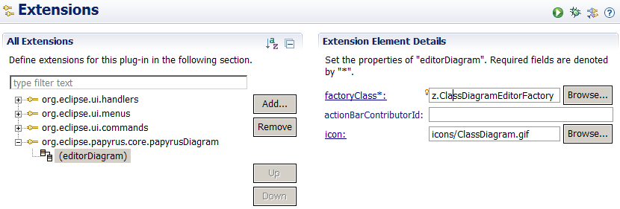
Figure 19 Registering an nested Editor

Create Editor Instance Action

To add a nested editor to the core, following actions should be done:
- Create the nested editor EMF representation
- Method org.eclipse.papyrus.core.adaptor.gmf.AbstractPapyrusGmfCreateDiagramCommandHandler.runAsTransaction(DiResourceSet, EObject, String) shows an (complex) example of how a GMF diagram can be created.
- Add the root EObject representing the nested editor to the DiContentProvider by using the IPageMngr.openPage(eObject) method.
- The IPageMngr can be obtained by calling org.eclipse.papyrus.core.utils.EditorUtils.getIPageMngr()
- The SashSystem should react automatically and show the newly added nested editor (if it know how to handle such editor ).

To let the Core handle a nested editor, following things are required:
- An implementation of IPageModel allowing to create the editor from its EObject (the object previously provided to IPageMngr.openPage(eObject) )
- The PageModel is registered to the PageModelFactory. This is done with the Eclipse extension
- 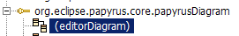

There can have several Action classes used to create a new editor. All the implementations should do what is described before (create a notation.Diagram and add it to the DiContentProvider). Example of implementation can be found for the class diagram:
- org.eclipse.papyrus.diagram.clazz.CreateClassDiagramCommand
  - used by the creation wizard (declared as extensions)
  - used by the toolbar and menu actions (declared as another extensions)
  - This class is quite complex because of old stuff (to be removed soon)

I would like to provide a more general mechanism for the creation wizard. This mechanism will complete the Eclipse mechanism for declaring menus and toolbar actions. It will allow:
- to declare creation wizard actions.
- to declare custom creation actions (for the creation wizard). Among this it will be possible to declare actions creating a prepopulated diagram, or actions asking input data before being executed.

From the core point of view, an nested editor can be added to the multieditor by adding the EObject representing the nested editor to the IPageMngr. Figure 20 shows what happen when an nested editor is added to the DiContentProvider.

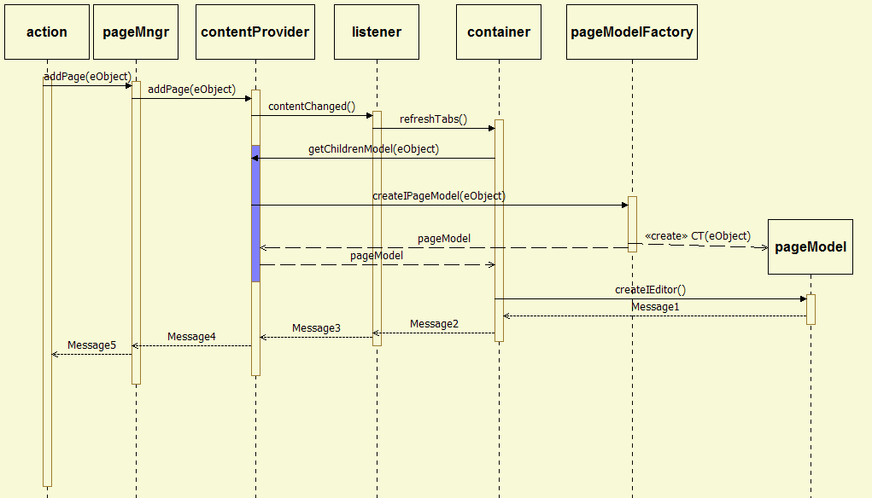
Figure 20 Adding nested Editor - Core Point of View

Example
A complete example can be found here:
org.eclipse.papyrus.diagram.umltools.clazz

Page Book View
Some View need to maintain a different page for each main editor.
For example, the Model Explorer View should present a different model explorer for each main editor. When the user switch the editor, the page should show the Model Explorer associated to this editor, in the state leave by user the last time he activate the editor.
Eclipse provide a mechanism to maintain different pages for a same View: org.eclipse.ui.part.PageBookView

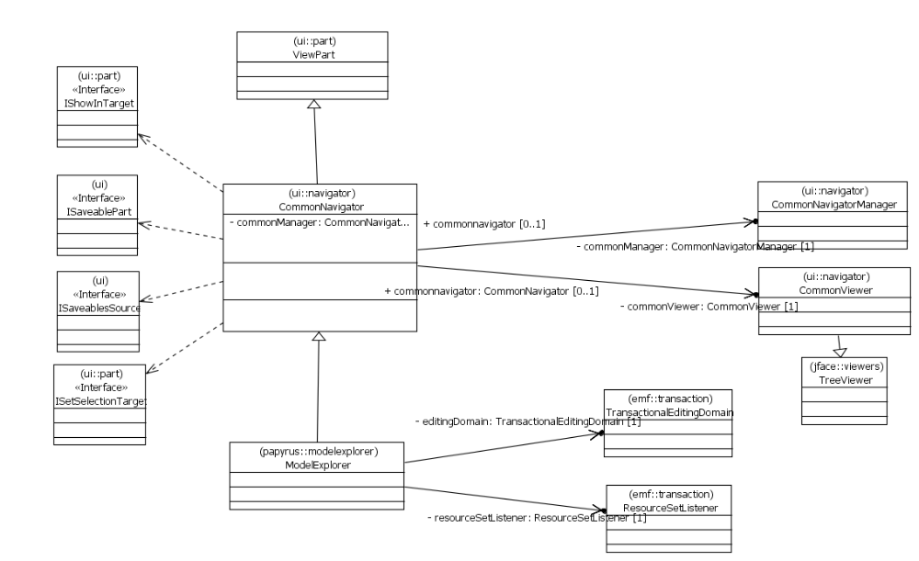
Figure 21 Papyrus Model Explorer before refactoring

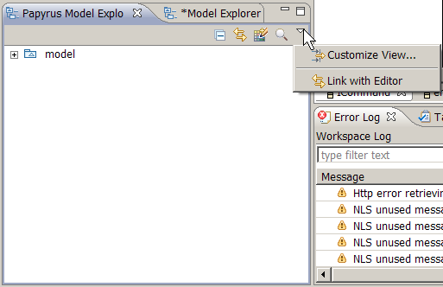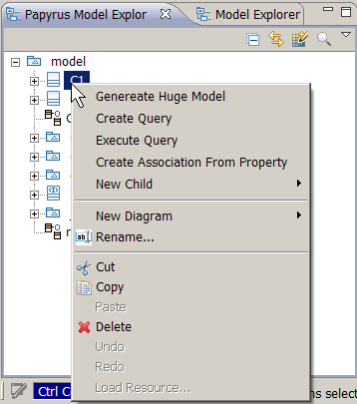
Menus in the original configuration
pb from org.eclipse.ui.internal.navigator.CommonNavigatorActionGroup.fillToolBar(IToolBarManager)

Reverse
transform class to interface
org.eclipse.papyrus.navigator.actions.GenericTransformAction.run()

