Specifications document

Collaborative work

Index
Document History 3
Version History 4
Introduction 5
Control Mode 6
Introduction 6
Use Cases 6
Example 6
Working with version control tool 6
Control action 7
Uncontrol action 8
Needs 9
Graphical editor enhancements 9
Manage UML profiles 10
Export Mode 11
Introduction 11
Use Cases 11
Needs 11
Management of external resources and references 11
Additional resources and editing 11
Additional resources and UML profiles 12
Additional resources and load 12
Model merging (TODO) 12
Questions & Known issues 12
Tests & Validation 13

Document History

Date | Comments
08/06/09 | Specifications only for control mode
30/10/09 | Update specifications. Define some tests
04/11/09 | Add section for DI resource management
24/11/09 | Describes use cases of control mode, add some explanations

Version History

Version | Date | Author | Company | Comments
1.0r1 | 08/06/09 | Emilien PERICO | Atos Origin | Initial content
1.0r2 | 08/06/09 | Thibault LANDRE | Atos Origin | Control Mode (Profil management) and Management of external resources and references

Introduction
This document aims to present the feature that will be developed to manage collaborative work right into the Papyrus editors.
The goal of the collaborative work is to share a model between team members and stakeholders, working together on a model as we use to do with programming language. We plan to provide several modes to work collaboratively. These modes are described in the document.
We defined different ways to work in collaborative mode:

- The first one is the control mode. This mode comes from EMF and it is available in all EMF editors. The purpose is to improve this existing mode for graphical editors, managing DI and notation resources

- The second one is the export mode dedicated to outsourcing work in order to share parts of a model without showing or accessing the whole model.

- The last one enables to merge models. A first model could be inserted in a second one as a part of it, such as a sub package.

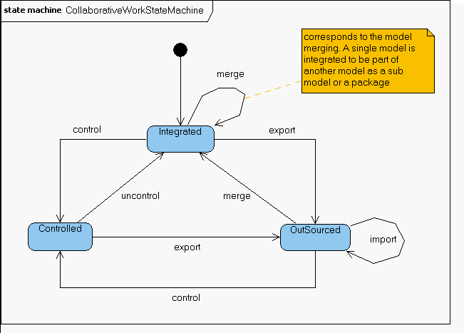Illustration 1: Overview of the different modes

Control Mode

Introduction
The control mode is used to split a resource (a model for our needs) into several resources. This mode helps team members to work on the same model at the same time without merging problems.

Use Cases
When a team wants to work on the same model, you can split this one in several resources according to the parts each member wants to work on. When a team member wants to share the part of the model he's in charge of, he can just commit changes of dedicated resource.

At this time, if you want to work on this model, you must check out all the required resources. Even if you're just working on one resource, you always need the whole model (and his resources) to manipulate it.

You are not supposed to work on the base resource (we'll call it the high level resource) which contains the entire model, because you will be allowed to change everything (only if additional resources are not in read-only) in the model and maybe bring conflicts with another team member's work.

Example
This sections presents some possibles use cases for the control mode.

UC 1
In this UC, a user work on a resource and want to put a package under control mode. This mean that the package and all its owned elements will be put in a new resource, and all the cross references between the two resources will be calculated and preserved.

Scenario 1 – only one package is put under control
- User creates a model m1.uml containing packages p1 and p2
- The system create a resource (resource1)
- User put P1 under control
- The system create a new resource (resource2) containing p2
- The user open another editor to edit resource2
- The user see and can edit the whole model from resource1 (p1 as well as p2): Cf. Needs section
- The user see and can edit only elements accessible from p2 when working with resource2: Cf. Needs section

Notes:
- Resources are dependant from each others. They can't be separated.
→ Not necessarily. If all the objects used in resource2 come from p2, then resource2 is independent from resource1. However, resource1 still references resource2.

- Resource1 and Resource2 have cross references.

Working with version control tool
It doesn't make sense to work with control mode without control version tool such CVS, SVN, Clearcase. Working with these tools, you can manage properties to enable read-only mode on the model. Then you can browse a model making difference between elements you can or can't edit.
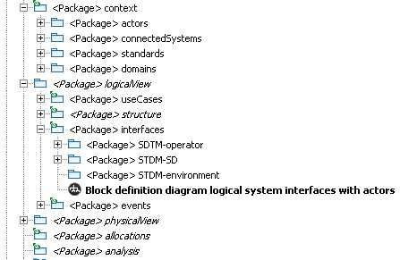
In the example below, italics elements are in read-only mode.

Control action
The control mode comes from EMF. All the EMF models (some properties are required) can be controlled through the editor with contextual menu.

A display dialog enables to select the resource created for the controlled element

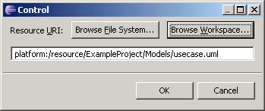

The resource is created and added as additional resource of the main model. This new resource is a kind of sub element of the main model. The controlled element is foregrounded with an icon decoration (a green arrow)

Uncontrol action
Uncontrol action is the reflective action of Control. Uncontrol an element merges it the initial resource. The action is only active on controlled elements.
With the default behavior, the additional resource is cleared out but the resource is not deleted. We want to improve this behaviour and delete the created additional resource when the uncontrol is effective. In Papyrus, a dialog box asks the user if he wants to delete the controlled resources.

The existing command of EMF is not sufficient for our needs. We have defined some enhancements to use the existing command in Papyrus.

Needs
Technically, a controlled resource becomes an additional resource.
Requirement-0011: you are able to edit all the controlled resources from the high level resource. Proposal
OR
Requirement-0012: A controlled resource is not editable in the high level resource. Edition is only done in controlled resource (a sub model). Proposal

Requirement-002: If a controlled resource hasn't got any reference to another one, it is managed such as a single resource.
Requirement-0031: If a controlled resource uses objects from another resource (R2), you can see all the R2 resource content. Proposal
OR
Requirement-0032: If a controlled resource uses objects from another resource (R2), R2 is added as additional resource and you only see the objects you are using. Proposal

Requirement-0041: If a controlled resource uses objects from another resource (R2), you can edit the content of R2. Proposal
OR
Requirement-0042: If a controlled resource uses objects from another resource (R2), you can't edit the content of R2. Proposal

Technical constraint: With these requirements, if we have several behaviours for an additional resource implies that we must know if a resource is controlled or it's not. Reference to the requirement req-resource-010.

Graphical editor enhancements
Control and uncontrol command should be available in the graphical editor. Proposal

req-control-001: Control and uncontrol commands will be added in contextual menu of a selected element into the Model View Explorer.

The EMF command doest not allow undo/redo action. Undo action will delete the created resources and merge the controlled element. Redo will split again the element and add the required resources.

req-control-002: Control and uncontrol command should be undone/ redone

req-control-003: The control command should only be available on container elements. It doesn't make sense to control element without child.

req-control-004: A default location (the current project) and default name (the selected element) will be the default value

req-control-005: Resolve conflict name if any. If the resource already exist, operation must be cancelled with a warning for the user.

The behaviour has been improved: when there is a conflict, a dialog box allows merging the existing resource with the new controlled one. If the user cancels, control action is not performed.

Once control is done, resources for model and graphic should be created. If we keep the current graphical notation, 3 files must be created:
- the model file (.uml, .sysml, other)
- the di file (diagrams references)
- the notation (graphical notation of objects)

req-control-006: Create the required files for the controlled element: files for model and diagrams

The controlled model should be opened as a single model. We must split graphical informations about elements and diagrams into di and notation files of this new sub model.

References must be added in:
- in main model: to the sub diagrams
- in sub model: to the parent model if needed

req-control-007: add references between graphical models that enable to split and merge a sub model. (cf Q1)

req-control-008: Use the existing icon decorators from EMF in Model View Explorer.

req-control-009: delete the created resources when uncontrol command is performed

For now a dialog box asks the user if controlled resource must be deleted. If not, uncontrol is done and the old controlled resource becomes a single resource. Tests must be done with strong references in the controlled resource.

Other proposal: any dialog box is displayed and resources are deleted.

Manage UML profiles
As control command is an EMF mechanism, it does not manage the profiles that come from UML. For now, it's not possible to keep stereotypes in sub model. We have to manage profiles and stereotypes to keep it in a sub model. The best way is to load required dependencies in the sub model.

req-control-010: Keep applied profiles and stereotypes in a sub model.

req-control-011: When controlling a model, the stereotypes applied to any element which is being controlled must be stored within the new sub model.

req-control-012 : When uncontrolling a sub model, the stereotypes applied to any element of the sub model must be stored within the main model.

req-control-013: When controlling a model, the new sub model should benefits from the profile applied on its parents.

Profile Application should be created if necessary in the submodel.

req-control-014: When uncontrolling a sub model, if there is a profile application defined in its root element, the profile application has to be kept only if it is not already defined in one of the parent in the main model.
Otherwise this profile application should be deleted.

req-control-015: If the sub model references the main model as additional resource (when stereotype is applied), the main model should be in read-only mode.

Additional resources management must be the same for all. We must decide if additional resources are editable or if they don't. Maybe a dialog box should inform the user the main model is loaded as additional resource.

Export Mode

Introduction
The export is used to share a part of a resource (a model for our needs) with stakeholders of a project. We could for example share this part with a client, with an offshore team to work in outsourcing.
The main difference with the control model is that you can open and edit your resource (part of a model) without sharing all the required resources.
If the exported part contains dependencies to another resource, you only see the dependent elements, not the whole dependent resource.

Use Cases
If the exported part contains dependencies to another resource, you only see the dependent elements, not the whole dependent resource. You can not change these dependent elements.
Technically, a cache mechanism enables to embed the dependencies and filter the content.
In the high level resource, you are not able to edit the exported part, this one is in read-only mode until the exported resource is merged.

Needs
req-outsourcing-001: the exported part must be restricted to read-only mode from the high level resource.

req-outsourcing-002: You don't need the high level resource to edit and manage an exported resource

req-outsourcing-003: an exported resource is managed as a single resource.

req-outsourcing-004: objects used in exported resource that are part of another resource are not editable.

Management of external resources and references

Additional resources and editing
req-resource-009 : Additional resource should be on read only mode and shouldn't be edited through the outline nor the editor.

Warning: an additional resource is only in read-only mode if the referenced resource is in read-only mode. You can not only set the mode on the additional resource

req-resource-010 : When saving a model, its additional resources must not be saved.

IMPORTANT: We must talk about these requirements. Some users would like to edit the additional resources. Maybe the user could choose the behaviour (editable or read-only) through a preference.
For control mode, if the user wants to edit a controlled model in the root model, additional resources must be saved. There is not way to distinguish an additional resource and a controlled resource. It will be required if we need different behaviours between both.
req-resource-011: Manage synchronisation between resources. Can the edition of a resource be reported in its dependency ?

Problem with resources synchronisation occur if you try to open a resource that depends to another already opened.

Additional resources and UML profiles

req-resource-001 : A mechanism should exist to create a library of UML profile in the users environment (extension point).

req-resource-002 : It should be possible for users to add a profile from a pre-defined library easily.

req-resource-003 : It should be possible for users to add profiles easily to a pre-defined library in their environment.

req-resource-004 : It should be possible for users to share easily their UML profile.

Additional resources and load
req-resource-005 : Additional resource should be loaded on demand

req-resource-006 : If an additional resource is not available, an error is raised. This behaviour should be enhanced to allow user to specify a new path to access the resource.

req-resource-007 : Users should be informed when a reference doesn't exist anymore.

Let's assume you have a property P typed by a ValueType VT coming from an additional resource. If VT is deleted from its resource, when you open again the model containing P, the information that P was typed by VT is lost and the user is not informed.

A mechanism should exist to inform the users on this.

Model merging (TODO)
reuse existing model => merge a given model to reuse below a container model element of an other UML model

Questions & Known issues

Q1: A reference must be stored in graphical notation to link a model and the controlled element. This reference can be stored in .di file or .notation file. Do we keep both formats for graphical notation ? We must decide it to know the location of parent references.

→ references are already managed by EMF resource management API.

Tests & Validation
req-control-001: Control and uncontrol commands will be added in contextual menu of a selected element into the Model View Explorer.

Control and uncontrol actions are available in model view explorer.
Uncontrol action should not be visible when control has not been performed yet.
Control action should not be visible if it already performed.

req-control-002: Control and uncontrol command should be undone/ redone

Control:
Undo: delete the controlled resources and update references in the root model.
Redo: control again

req-control-003: The control command should only be available on container elements. It doesn't make sense to control element without child.

Enable/Unable action according to the selected object.

req-control-004: A default location (the current project) and default name (the selected element) will be the default value

A dialog box should ask the user the name of the controlled resource with a default name.

req-control-005: Resolve conflict name if any. If the resource already exist, operation must be cancelled with a warning for the user.

A dialog box opens with a warning. The user can merge the controlled resource with the existing one

req-control-006: Create the required files for the controlled element: files for model and diagrams

3 resources are created for the controlled element. If the controlled element doesn't contain diagram, a di file is created without diagram.

The controlled model can be opened as a single model.

req-control-008: Use the existing icon decorators from EMF in Model View Explorer.

The icon enables to identify controlled resources in the model view explorer.

req-control-009: delete the created resources when uncontrol command is performed

Specification need to be defined first to test it.

