


Papyrus CookBook

Editor | Patrick Tessier CEA LIST
Status | Draft
Version number | 0.9
Date of preparation | YYYY-MM-DD
Authors
Editor name (first/last name) | Company | E-mail | Initial
Patrick Tessier | CEA LIST | Patrick.tessier@cea.fr | PT
Emilien Perico | Atos Origin | Emilien.perico@atosorigin.com | EP

Authors name (first/last name) | Company | E-mail | Initial
Cedric Dumoulin | LIFL | Cedric.dumoulin@lifl.fr | CD
Gabriel Merin | Prodevelop | gmerin@prodevelop.es | GM

Revision chart and history log
Version | Date | Author | Added content
0.1 | 04/07/2008 | Cedric Dumoulin
0.2 | 17/07/2008 | Gabriel Merin
0.3 | 23/07/2008 | Gabriel Merin
0.4 | 07/08/2008 | Patrick Tessier
0.5 | 14/08/2008 | Gabriel Merin
0.6 | 03/03/2009 | Patrick Tessier
0.7 | 29/05/09 | Emilien Perico | Solution for element's name initialization: 3.17.3
0.8 | 07/07/2009 | Patrick Tessier | Add solution for drag and drop
0.9 | 11/09/09 | Nicolas Velin | Add solution to handle custom figures and resize constraint
1.0 | 20/10/09 | Emilien Perico | How to add an action in model explorer
1.1 | 07/12/09 | Vincent Hémery | Create a new Papyrus editor for UML
1.2 | 09/12/09 | Vincent Hémery | Make a compartment in which children position is defined by the user.  Make a compartment with automatically managed children.
1.3 | 25/03/10 | Vincent Hémery | Correct view providing problems
1.4 | 26/05/10 | Tristan Faure | Add part for Notifications
List of abbreviations
Table of contents
Revision chart and history log 3
List of abbreviations 4
Table of contents 5
List of figures 7
List of tables 8
1 Introduction 9
2 GMF basics 10
3 Papyrus Diagrams 15
3.1 Diagram Template 15
4 Recipes 20
4.1 Recipe Template 20
4.2 List of Possible Recipes 20
4.3 Create a new Papyrus editor for UML 21
4.4 Node with predefined colors 30
4.5 Link A→B owned by A 31
4.6 Link A→B with Edge Object 37
4.7 Link with anchor anywhere on other link (Comment link) 40
4.8 Ports sticking to the side of a component 42
4.9 Node with a label 42
4.10 Figure swapping action 44
4.11 Links whose source/target graphical elements differ from the source/target semantic elements 44
4.12 Graphical elements that are contained within one element but semantically contained within another element 44
4.13 Links with polygonal anchoring area and/or oval anchors 53
4.14 Avoid link snapping to the centre of the figure 57
4.15 Element initialization 59
4.16 Diagram restrictions with OCL via gmfmap 62
4.17 Name initialization of the elements 67
4.18 Add Policy to remove orphaned View 74
4.19 Refreshing figure by taking in account features of element 76
4.20 Generate Association Link Special case 77
4.21 Add Drag and drop functionality 77
4.22 Add Custom Figure 79
4.23 Add a resize constraint : 80
4.24 Add action in model explorer menu 82
4.25 Make a compartment in which children position is defined by the user 83
4.26 Make a compartment with automatically managed children 83
4.27 Correct view providing problems 91
5 Summary and conclusion 94
6 References 95

List of figures

List of tables

Introduction
This cookbook contains a set of recipes useful to develop diagrams for Papyrus with the GMF framework. Each recipe focuses on a small recurrent problem. It provides a solution and an example for this problem and can be easily reused in another context. A recipe can be seen as a reusable pattern. Each recipe is described following the same guideline.

In the context of Papyrus and UML, several diagrams need to be developed. These diagrams can be decomposed in basic functionalities, each one solved by one of the recipe. A lot of diagrams share common functionalities, and so recipe can be shared.

Recipes can also be used to develop other GMF diagrams. This cookbook can be used as a reference and good practices using GMF. If well written, we can think to publish it later.

GMF basics
This section contains GMF basics principle.

Model roles
.ecore – define domain model
.genmodel – extends domain model by adding generation data

.gmfgraph – define figures and controllers
.gmftool – define palette, menu, …
.gmfmap – map domain element to controllers and figures
.gmfgen – gathers the information from the above models and adds generation properties for code generation

Compiling UML2Tools
- download sources from CVS
- Build the required plugin org.eclipse.uml2.diagram.codegen and put it in the current Eclipse plugin directory :
  - open the project org.eclipse.uml2.diagram.codegen
  - open its plugin.xml
  - choose Overview->Exporting->3. … Export Wizard
  - choose your Eclipse directory as destination (see Figure 1)
  - Restart Eclipse

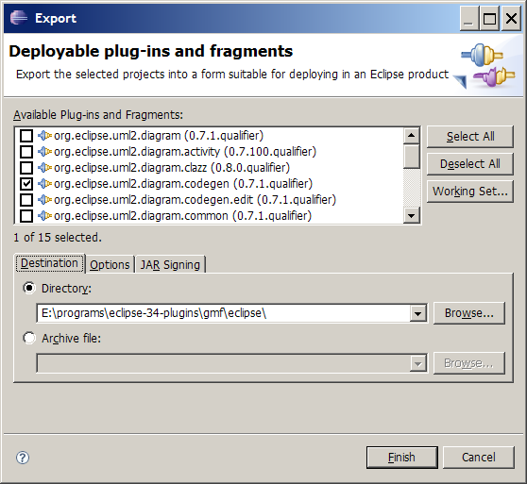
Figure 1 Building the required plugin

- open project org.eclipse.uml2.diagram.def
  - goto /org.eclipse.uml2.diagram.def/structures, check that *.gmfgen files open correctly
- Open the .gmfgen file corresponding to the diagram you want to generate
- Select the top level element
- right click->Generate UML2Tools Diagrams

Defining Figures
Figures are defined in the .gmfgraph, under a Figure Gallery. Several Figure Galleries can be defined within the same file.
Figure 2 shows what a Canvas can contain:

Figure 2 Canvas Containment

A FigureGallery contains figure Descriptors. Figure 3 shows the hierarchy of concepts used to describe a figure. The toplevel concept is FigureGallery.

Figure 3 FigureGallery Containment

Figure is the toplevel concept of figures. Figure 5 shows the Figure hierarchy.

Figure 4 Figures hierarchy

A figure can contain different decoration (colors, font, location, dimension, layout) as shown in Figure 5.

Figure 5 Figure Containment
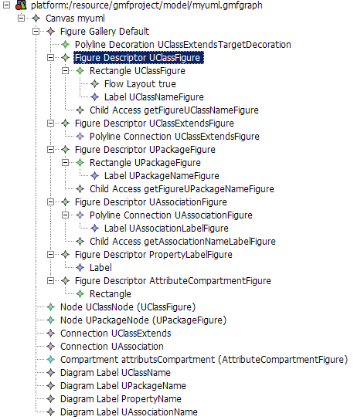
Figure 6 Figures and controllers definition

Papyrus Diagrams
This section describes the template for designing model graphical editors. The designs of the UML diagram editors included within Papyrus are in separate files.

Diagram Template
The aim of this template is to describe how to design a model graphical editor. It follows the logical procedure of creating a graphical editor that will create/edit metamodel instances. Therefore, the design must include information about the metamodel, the elements from the metamodel that should be edited graphically (or by other means of the editor), the graphical representation of each element, how to create the graphical elements and how to edit their properties (if any special mechanism is needed for some of them).

The template:

Introduction
A brief description should be given in order to explain the purpose of the current design.

Graphical Elements Design
Summary of the parts to describe:
- Editable Elements: Identification of the metamodel used and the set of elements that can be manipulated by the editor (graphically or by other means). If there is no existing metamodel that fit the needs and a new one must be implemented, then all the elements and their relationships should be described.
- Graphical representation: Identification and description of the graphical figures used by the user to manipulate the model elements.
- Creation mechanisms: Tools used for creating new graphical elements.
- Element properties edition: How to edit element properties (not necessarily for all of them but rather for the ones that need complex user interfaces).
- Additional specifications: Additional features that should be specified.
- Useful recipes: A set of recipes useful for fulfilling the task of creating the editor via GMF generative technology.

- Elements

When designing a Graphical Editor, we may start from two different cases. Each case has its own procedure:

Case 1. Use of an existing metamodel

Step 1.
Identify the metamodel
Step 2.
Select the set of elements that will be used without any modification.
Step 3.(If needed)
Select the set of elements that will be used with some modifications.
For each element from the previous set, indicate the modifications. A modification should contain the following information:
- List with new properties
  - Name and type
- Constrains list (plain text)
- Relationships with other elements (plain text)
Step 4.
Indicate the new elements that will be added to the metamodel. Each new element should contain the following information:
- Name
- Properties list
  - Name and type
- Constraints list (plain text)
- Relationships with other elements (plain text)

Case 2. Creation of a new metamodel

When there is no existing metamodel that fits our needs, a new one should be created. The description of each element should contain the following information:
- Name
- Properties list
  - Name and type
- Constraints list (plain text)
- Relationships with other elements (plain text)

- Graphical representation

The graphical figures represent the editable elements of a Graphical Editor. However, not all of the editable elements need to have a graphical representation because some of them may be manipulated by other means.
For each element with graphical representation, the following information should be provided:
- A list with the possible figures that can represent the current element. A figure description should contain the following information:
  - Element: Semantic element represented by the figure.
  - Drawing: Graphical appearance of the figure. It should include, if necessary, a division in different part that would be identified by numbers. Each part must include a description with the following information:
    - Type (the possible types are listed below)
    - Description of its contents

The possible part types in which a figure can be divided are the next ones:
- Label
  - It is necessary to describe how its text is obtained (defined statically, obtained from a property value, evaluating an expression, etc.)
- List
  - It is necessary to describe from where are the values obtained.
- Canvas
  - It is necessary to show the collection of elements that can be created over the canvas.
- Figure
  - It is necessary to describe the aspect of the figure (a rectangle, a rounded rectangle, etc.)

- Creation mechanisms

The creation mechanisms description includes how new figures are created within the diagrams manipulated by the graphical editor.
There are two basic mechanisms: (1) The palette and (2) the shortcuts.
(1) Palette
Basically a palette is divided into groups. A group contains buttons (one or more) and separators (to separate buttons within a same group). A button is used to create one (single) or more (multiple) graphical elements (if more than one, the user will be prompted to select one via a drop down list or some visual mechanism).

The following order is suggested for the groups:
- Group 1
  - Elements drawn into the canvas
- Group 2
  - Elements drawn into the object i
- Group 3
  - Elements drawn into the object j
- .....
- Group N
  - Links

Example (extracted from the Activity Design):
- Activity Palette
  - Activities
    - Single button: “Activity”
      - Creates an Activity element with its default values.
    - Single button: “ActivityPartition”
      - Creates an ActivityPartition element with its default values.
  - Actions
    - Single button: “Send object Action”
      - Creates a SendObjectAction element with its default values, an InputPin element referenced by the “target” property and another InputPin element referenced by the “request” property.
...

(2) Shortcuts
It is common in graphical editors to provide shortcuts for element creation in order to save time to the user. Shortcuts appear every time the user leaves the mouse over an element which can contain other elements. For describing the shortcuts the following information should be provided:
- Graphical element that provides the following shortcuts
  - Shortcut 1
    - Element created by the shortcut 1
...
  - Shortcut N
    - Element created by the shortcut N

- Element properties edition

The target of this section is to describe the mechanisms used by the graphical editor to modify the values of the editable elements properties.
The properties are grouped in tabs. If needed, synthetic properties can be used as long as a description of the property behaviour is given (a synthetic property is not stored within the semantic element because it does not exist. However, it must be edited in the same way as the others).
- Semantic Element
  - Tab 1
    - Property 1 [widget/s needed]
    - Property 2 [widget/s needed]
    - SubTab 1
      - Property 3 [widget/s needed]
  - Tab 2
    - Property 4
...

If the property should be edited in a specific way, the widgets/set of widgets should be indicated.

- Other specifications

The aim of this section is to describe additional properties of the graphical editor like file extensions, font styles, etc.

- Useful recipes

If there are any recipes within this document that can be useful for implementing the current editor, it would be very interesting to list them here.

Recipes
TODO:
- Organize recipes by categories
- Provide a template for the recipes
- Change early ‘recipes’ in accordance to the template
- Warning: some of the early recipes are built as a tutorial. This is not a way to go. This was done in another context and copied here.

Recipe Template

Context
Describe the purpose of the recipe.
If possible, provide both a figure showing what the recipe will supply and a class diagram of the business model used by the figure.
Add comments describing the difficulties if any.

Proposed Solution
- Overview of the solution (recommended if the solution implies a great number of steps).
- Steps of the solution:
  - GMF Models
    - For each GMF Model involved (gmfgraph, gmftool, gmfmap, gmfgen)
      - Description of what should be done in the model.
      - Describe the steps to follow. The use of screenshots is advisable as they can be used as a guide.
  - Java Code
    - For each generated Java File that should be modified:
      - Indicate the package where it is stored.
      - Describe the changes that should be done.
    - For each new Java File that should be implemented:
      - Indicate its name and the package where it should be stored.
      - Provide the Java code.
- If possible, supply a zip file with a project containing the solution. Ideally one small project per recipe. The project should focus only on the recipe.

List of Possible Recipes
Note: Even the simplest one should be explained.

- Node with rounded corner
- Node with predefined color
- Link with Edge Object
- Link with anchor anywhere
- Node with placed title
- Node with nested drawn area
- Node with ports
- Node with dedicated figure
- Complex Business Model Creation
- Link with floating role
- Node with compartment
  - compartment with list of properties
  - compartment with nested graphical area
- Different figure for the same business element
  - static: 2 different creation tool create the same business element, but shown in different flavor
  - dynamic: a business element can have different representation, changed by setting a property.

Create a new Papyrus editor for UML

Context
When creating a new diagram type with GMF, a few more steps are required to integrate it in Papyrus.

Proposed Solution
Integrating your XXX diagram editor to Papyrus UML editor requires the addition of classes XXXDiagramEditorFactory, CreateXXXDiagramCommand and UmlXXXDiagramForMultiEditor and the creation of 4 extensions in plugin.xml.

Steps to follow :
  - Add the 3 Java classes (add required dependencies to plugin.xml when needed and adapt classes names with XXX to your plugin)
    - If you do not have one yet, create the custom-src source package and a org.eclipse.papyrus.diagram.activity package inside
    - In this org.eclipse.papyrus.diagram.activity package, add the three classes :
      - ActivityDiagramEditorFactory.java :
package org.eclipse.papyrus.diagram.XXX;

import org.eclipse.papyrus.core.adaptor.gmf.GmfEditorFactory;
import org.eclipse.papyrus.diagram.XXX.edit.parts.XXXDiagramEditPart;

/**
* The editor factory to launch the XXX diagram.
*/
public class XXXDiagramEditorFactory extends GmfEditorFactory {

/**
* Instantiates a new activity diagram editor factory.
*/
public XXXDiagramEditorFactory() {
super(UmlXXXDiagramForMultiEditor.class,
XXXDiagramEditPart.MODEL_ID);
}
}
      - CreateActivityDiagramCommand.java :
package org.eclipse.papyrus.diagram.XXX;

import org.eclipse.core.commands.ExecutionException;
import org.eclipse.core.commands.operations.OperationHistoryFactory;
import org.eclipse.core.runtime.IAdaptable;
import org.eclipse.core.runtime.NullProgressMonitor;
import org.eclipse.emf.ecore.EObject;
import org.eclipse.emf.ecore.resource.Resource;
import org.eclipse.emf.transaction.TransactionalEditingDomain;
import org.eclipse.gmf.runtime.diagram.core.preferences.PreferencesHint;
import org.eclipse.gmf.runtime.diagram.core.util.ViewUtil;
import org.eclipse.gmf.runtime.diagram.ui.commands.CreateCommand;
import org.eclipse.gmf.runtime.diagram.ui.requests.CreateViewRequest.ViewDescriptor;
import org.eclipse.gmf.runtime.emf.core.util.EObjectAdapter;
import org.eclipse.gmf.runtime.emf.type.core.requests.CreateElementRequest;
import org.eclipse.gmf.runtime.notation.Diagram;
import org.eclipse.gmf.runtime.notation.Node;
import org.eclipse.papyrus.core.adaptor.gmf.AbstractPapyrusGmfCreateDiagramCommandHandler;
import org.eclipse.papyrus.core.adaptor.gmf.Activator;
import org.eclipse.papyrus.diagram.XXX.edit.commands.XXXCreateCommand;
import org.eclipse.papyrus.diagram.XXX.edit.parts.XXXDiagramEditPart;
import org.eclipse.papyrus.diagram.XXX.part.UMLDiagramEditorPlugin;
import org.eclipse.papyrus.diagram.XXX.providers.UMLElementTypes;
import org.eclipse.uml2.uml.XXX;
import org.eclipse.uml2.uml.Element;
import org.eclipse.uml2.uml.Package;

/**
* Define a command to create a new XXX Diagram. This command is used by all UI (toolbar,
* outline, creation wizards) to create a new XXX Diagram.
*/
public class CreateXXXDiagramCommand extends AbstractPapyrusGmfCreateDiagramCommandHandler {

/** the XXX class which must contain the diagram */
private XXX diagramOwner = null;

@Override
protected String getDiagramNotationID() {
return XXXDiagramEditPart.MODEL_ID;
}

@Override
protected PreferencesHint getPreferenceHint() {
return UMLDiagramEditorPlugin.DIAGRAM_PREFERENCES_HINT;
}

@Override
protected String getDefaultDiagramName() {
return super.openDiagramNameDialog("XXXDiagram");
}

@Override
protected EObject createRootElement() {
return UMLFactory.eINSTANCE.createModel();
}

The following methods are only used to set the context for a diagram. For example for activity (activity diagram) or interaction (sequence diagram).
@Override
protected void initializeDiagram(EObject diagram) {
if (diagram instanceof Diagram) {
Diagram diag = (Diagram) diagram;
if (diagramOwner != null) {
diag.setElement(diagramOwner);
createXXXGraph(diagramOwner, diag);
}
}
}

@Override
protected void initializeModel(EObject owner) {
// Get the editing domain
TransactionalEditingDomain editingdomain = getDefaultContext().getResourceSet().getTransactionalEditingDomain();

/*
* Assign to diagramOwner the object which will own the diagram.
* You can use getSelectedElement() and owner for this achievement.
* This may involve new element creation.
*/
}

@Override
protected Diagram createDiagram(Resource diagramResource, EObject owner, String name) {
Diagram diagram = null;
if (owner instanceof Package) {
diagram = super.createDiagram(diagramResource, owner, name);
} else {
if (owner instanceof Element) {
Element element = (Element) owner;
diagram = super.createDiagram(diagramResource, element.getModel(), name);
}
}
return diagram;
}

/**
* Complete an XXX diagram with required graphical elements.
*
* @param element
* the element to which the diagram is associated
* @param diagram
* the diagram to complete
*/
private void createXXXGraph(Element element, Diagram diagram) {
/*
* This method implementation allow you to create graphical nodes
* if required. You may delete it if not necessary.
*/
TransactionalEditingDomain editingdomain = getDefaultContext().getResourceSet().getTransactionalEditingDomain();
IAdaptable elementAdapter = new EObjectAdapter(element);
ViewDescriptor descriptor = new ViewDescriptor(elementAdapter, Node.class, null, ViewUtil.APPEND, false,
UMLDiagramEditorPlugin.DIAGRAM_PREFERENCES_HINT);

CreateCommand nodeCreationCommand = new CreateCommand(editingdomain, descriptor, diagram);

try {
OperationHistoryFactory.getOperationHistory().execute(nodeCreationCommand, new NullProgressMonitor(), null);
} catch (ExecutionException e) {
e.printStackTrace();
Activator.getInstance().logError("Unable to create model and diagram", e); //$NON-NLS-1$
}
}

}
      - UmlActivityDiagramForMultiEditor.java :
package org.eclipse.papyrus.diagram.XXX;

import org.eclipse.core.runtime.CoreException;
import org.eclipse.emf.common.ui.URIEditorInput;
import org.eclipse.emf.ecore.util.EcoreUtil;
import org.eclipse.gmf.runtime.notation.Diagram;
import org.eclipse.jface.dialogs.ErrorDialog;
import org.eclipse.jface.resource.ImageDescriptor;
import org.eclipse.papyrus.core.editor.BackboneException;
import org.eclipse.papyrus.core.services.ServiceException;
import org.eclipse.papyrus.core.services.ServicesRegistry;
import org.eclipse.papyrus.diagram.XXX.part.UMLDiagramEditor;
import org.eclipse.papyrus.diagram.XXX.part.UMLDiagramEditorPlugin;
import org.eclipse.swt.widgets.Composite;
import org.eclipse.swt.widgets.Shell;
import org.eclipse.ui.IEditorInput;
import org.eclipse.ui.IEditorSite;
import org.eclipse.ui.PartInitException;

/**
* Editor used in multitabs editor.
*
*/
public class UmlXXXDiagramForMultiEditor extends UMLDiagramEditor {

/**
* The location of diagram icon in the plug-in
*/
private static final String DIAG_IMG_PATH = "icons/XXXDiagram.gif";

/**
* The image descriptor of the diagram icon
*/
private static final ImageDescriptor DIAG_IMG_DESC = UMLDiagramEditorPlugin
.getBundledImageDescriptor(UmlXXXDiagramForMultiEditor.DIAG_IMG_PATH);

/** The editor splitter. */
private Composite splitter;

/**
* Constructor for SashSystem v2. Context and required objects are retrieved
* from the ServiceRegistry.
*
* @throws BackboneException
* @throws ServiceException
*
* @generated NOT
*/
public UmlXXXDiagramForMultiEditor(ServicesRegistry servicesRegistry,
Diagram diagram) throws BackboneException, ServiceException {
super(servicesRegistry, diagram);
}

/**
* {@inheritDoc}
*/
@Override
public void init(IEditorSite site, IEditorInput input)
throws PartInitException {
super.init(site, input);
setPartName(getDiagram().getName());
setTitleImage(DIAG_IMG_DESC.createImage());
}

/**
* {@inheritDoc}
*/
@Override
public void setInput(IEditorInput input) {
try {
// Provide an URI with fragment in order to reuse the same Resource
// and set the diagram to the fragment.
URIEditorInput uriInput = new URIEditorInput(EcoreUtil
.getURI(getDiagram()));
doSetInput(uriInput, true);
} catch (CoreException x) {
String title = "Problem opening";
String msg = "Cannot open input element:";
Shell shell = getSite().getShell();
ErrorDialog.openError(shell, title, msg, x.getStatus());
}
}

/**
* {@inheritDoc}
*/
@Override
protected void createGraphicalViewer(Composite parent) {
splitter = parent;
super.createGraphicalViewer(parent);
}

/**
* {@inheritDoc}
*/
@Override
public void setFocus() {
splitter.setFocus();
super.setFocus();
}

/**
* {@inheritDoc}
*/
@Override
public String getEditingDomainID() {
return "org.eclipse.papyrus.diagram.XXX.EditingDomain";
}
}
  - Add extensions to plugin.xml file :
    - These four extensions must be added (adapt names containing XXX):
<extension
point="org.eclipse.ui.commands">
<command
description="Create a new XXX Diagram (Papyrus II)"
id="org.eclipse.papyrus.diagram.XXX.CreateXXXDiagramCommand"
name="Create XXX Diagram">
</command>
</extension>
<extension
point="org.eclipse.ui.handlers">
<handler
class="org.eclipse.papyrus.diagram.XXX.CreateXXXDiagramCommand"
commandId="org.eclipse.papyrus.diagram.XXX.CreateXXXDiagramCommand">
<activeWhen>
<or>
<with
variable="activeEditorId">
<equals
value="org.eclipse.papyrus.core.papyrusEditor">
</equals>
</with>
</or>
</activeWhen>
</handler>
</extension>
<extension
point="org.eclipse.ui.menus">
<menuContribution
locationURI="toolbar:org.eclipse.ui.main.toolbar">
<toolbar
id="org.eclipse.papyrus.diagram.ui.toolbar">
<command
commandId="org.eclipse.papyrus.diagram.XXX.CreateXXXDiagramCommand"
icon="icons/XXXDiagram.gif"
label="Create a new XXX Diagram"
style="push"
tooltip="Create a new XXX Diagram">
<visibleWhen>
<with
variable="activeEditorId">
<equals
value="org.eclipse.papyrus.core.papyrusEditor">
</equals>
</with>
</visibleWhen>
</command>
</toolbar>
</menuContribution>
<menuContribution
locationURI="menu:org.eclipse.papyrus.ui.menu">
<menu
id="org.eclipse.papyrus.diagram.ui.menu"
label="Papyrus II">
<command
commandId="org.eclipse.papyrus.diagram.XXX.CreateXXXDiagramCommand"
icon="icons/XXXDiagram.gif"
label="Create XXX Diagram"
style="push"
tooltip="Create a new UML2 XXX Diagram (Papyrus II)">
</command>
</menu>
</menuContribution>
</extension>
<extension
point="org.eclipse.papyrus.core.papyrusDiagram">
<editorDiagram
contextId="com.cea.papyrus.gmf.editor.context"
factoryClass="org.eclipse.papyrus.diagram.XXX.XXXDiagramEditorFactory"
icon="icons/XXXDiagram.gif">
</editorDiagram>
<creationCommand
creationCommandClass="org.eclipse.papyrus.diagram.XXX.CreateXXXDiagramCommand"
icon="icons/XXXDiagram.gif"
id="org.eclipse.papyrus.diagram.XXX.CreationCommand"
label="UML XXX Diagram">
</creationCommand>
</extension>

Node with predefined colors
Node colors can be predefinied in the gmfgraph model.
For each figure, the background and the foreground can be predefined (Figure 7).
This doesn’t seem to work for link ☹.
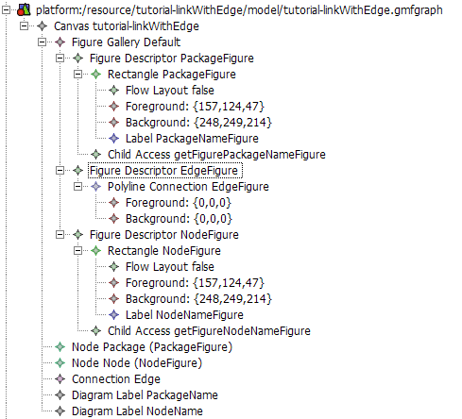
Figure 7 Setting color for nodes

Link A→B owned by A

Context
This tutorial explains how to generate a link between two shape A and B. The link is owned by A. The corresponding metamodel is shown Figure 8.

Figure 8 Metamodel representing a reference A → B owned by A
Warning : in the reference A → B, B should be contained by reference because it is contained by value by the package (from NamedElement).

Proposed solution
The GMF Dashboard eases the creation of the different files.
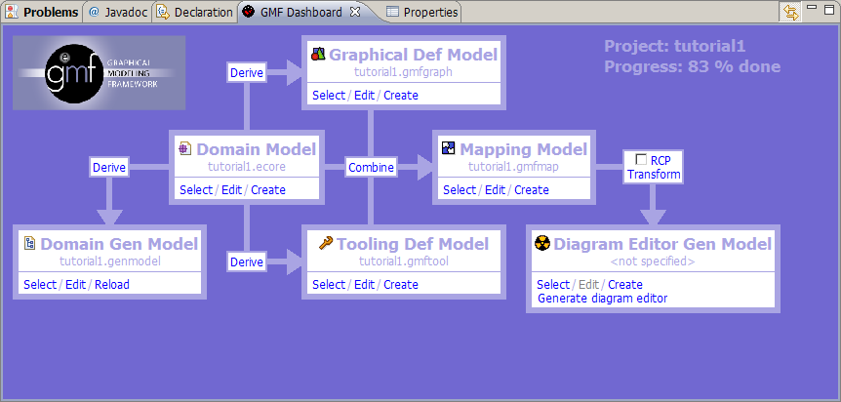
Figure 9 Control panel

Step 1 : Create .gmfGraph
Click on derive between Domain Model and Graphical Def Model. A new window open :
Set the name of the file to generate or accept the default one. Click next.
Select the top level element of your model. This top level element will be associated to the diagram area. In our case choose Package (Figure 10). Click next.
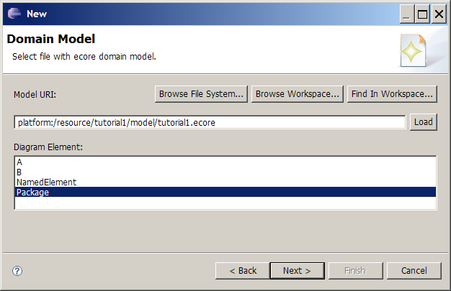
Figure 10 Select the top level element

In the next window, you can choose the figure for each element. There is tree basic kinds :
- shape
- link
- text label
For each element, select how you want it to be represented on the diagram.
Element A and B will be drawn as a shape.
Property A.name will be drawn as text.
Reference A.b will be drawn as a link.

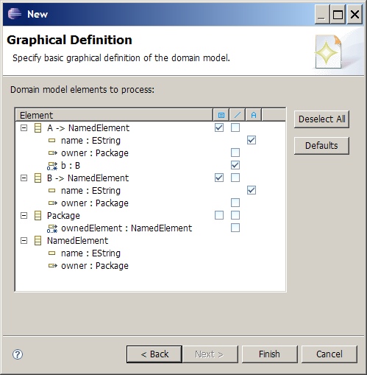
Figure 11 Choose figure for each of your domain elements
Click finish to generate the .gmfgraph file.
You should obtain something like in Figure 12.
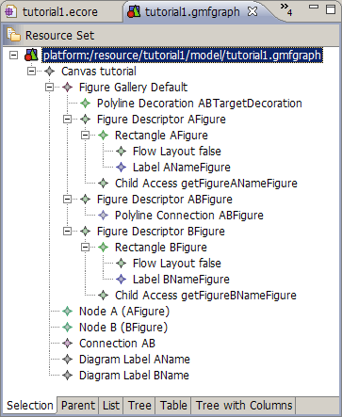
Figure 12 The .gmfgraph file
In Figure 12, Figure Gallery contains the figure definitions
Node , Connection and Diagram Label are the controllers for the figures. They reference their respective figures (look at the properties).
Node figures have “accessors”. This is used as an interface to modify the figure from the controller. Each accessor describe how to access a settable value in the figure (like a label).

Step 2 : Create .gmftool
Click on derive between Domain Model and Tooling Def Model. Set the name of the file to generate or accept the default one. Click next. A new window open.
Select the top level element of your model.

Select the tools you want to appear in the palette (Figure 13).
There is two kind of tool:
- shape creation tool
- link creation tool
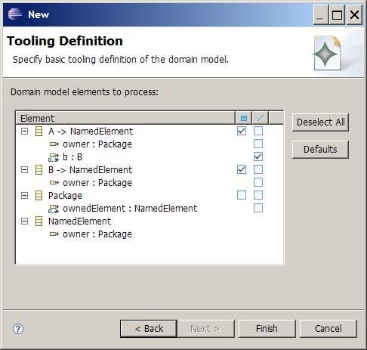
Figure 13 Creation Tools Selection.

Step 3 : Create .gmfmap
This is the more complicated model. It allows to associate figures and controllers to domain model elements.
Click on combine between Domain Model and Mapping Model. Set the name of the file to generate or accept the default one. Click next.
Select the top level element of your model.
Accept default palette and default diagram canvas until you got window of Figure 14.
Here GMF proposes some default mapping.

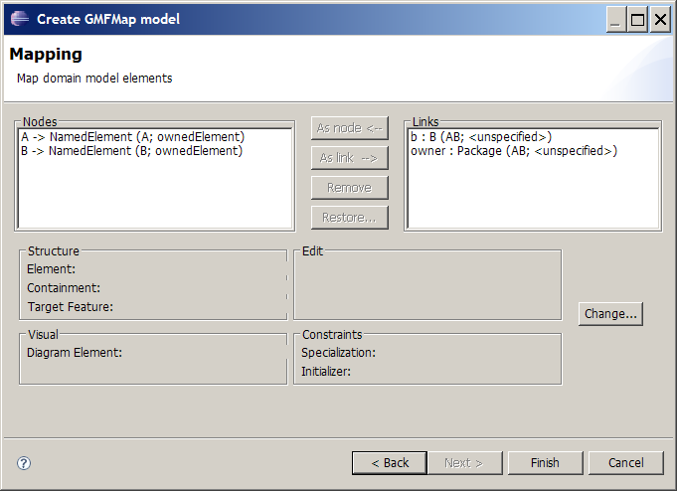
Figure 14 Mapping Wizard generated by GMF
Node elements are correct, but there is two links.
Remove the second link (owner : Package).
Figure 15 and Figure 16 try to explain generated names.

b : B (AB; <unspecified>)
domain element
feature b of type B
controller
element name
containing element
Figure 15 Element name interpretation

A → NamedElement (AB ; b)
domain elements
A extens NamedElement
controller
element name
containing feature
Figure 16 Element name interpretation
Click next until the new model is generated.
You need to perform changes in the model :
Open the “Feature Label Mapping”, and check its properties. You need to specify the Label controller for each Feature Label Mapping. Set it to the right label mapping (Node A -> Label AName)
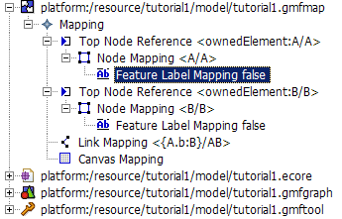

Node Mapping :
- Top Node Reference
  - Maps one domain element to the feature that will own it.
- Node Mapping
  - Map a domain element to its controller. Contains nested description of its feature mappings.
- Feature Label Mapping
  - Allows to map a feature of a domain element to its Label controller.

Link Mapping :
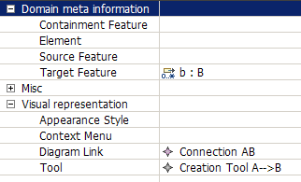

Link A→B with Edge Object

Figure 17 Node with Edge Metamodel
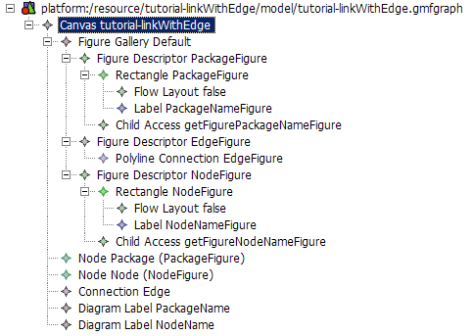
Figure 18 Figure definitions

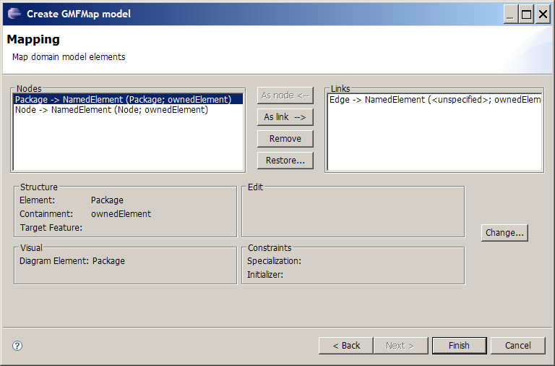
Figure 19 Mapping wizard

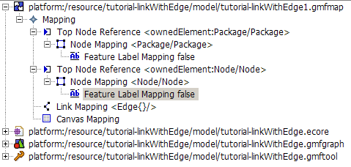
Figure 20 Mapping model
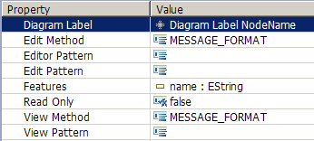
Figure 21 Feature Label Mapping Property View
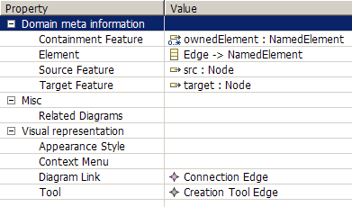
Figure 22 Link Mapping Properties View

Label Mapping
Select Feature Label Mapping in the tree (Figure 20) and set the Diagram Label property in the property view (Figure 21).

Link mapping
Select the Link Mapping in the tree and set the following properties:
- Containment Feature – name of the feature (in the element associated with the diagram) that will contain the created element
- Element – Element that will be created
- Source Feature – the element feature that will contain the source of the link
- Target Featute – the element feature that will contain the target of the link
- Diagram Link – the figure that will represent the element
- Tool – The tool that will be used to create the element.

Link with anchor anywhere on other link (Comment link)
tutorial-annotation.zip
A Comment with a list of annotatedElements.
Comment can be attached to any elements, including link.
The link anchor can be anywhere on the attached link.
This tutorial extends the Link A→B with Edge Object tutorial.

Figure 23 Comment Metamodel

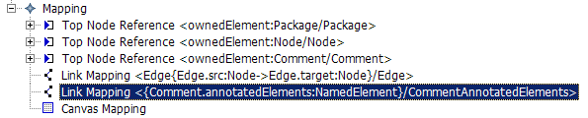
Figure 24 Comment Mapping
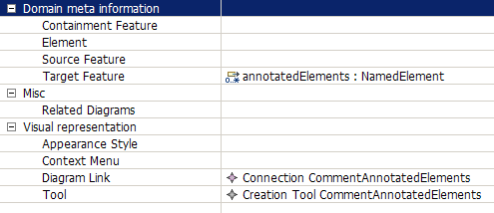
Figure 25 Comment Link Mapping Properties

The resulting link can be attached to any NamedElement, including Edge. The anchor is anywhere on the edge (Figure 26).

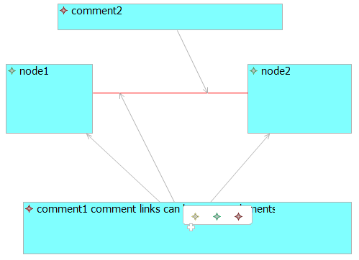
Figure 26 Comment link Example

Ports sticking to the side of a component
http://wiki.eclipse.org/GMF_Newsgroup_Q_and_A

How do I get ports to stick to the side of a component?
- Q: My first problem was that I couldn't find a good way to get the ports stick to the component since apparently GMF doesn't support nodes
- A: Did you try setting affixedParentSide attribute for port Node in .gmfgraph model? This attribute was recently added and is available in 2.0 builds.

Node with a label

Context
The purpose is to create a Node with a label, where the label is the name.
This example is based on the creation of the package element.

Proposed solution

Step 1: Gmgraph
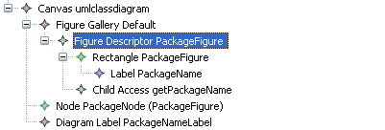
Figure 27: figure with a label
First, the figure descriptor with a rectangle figure has to be created. To add a label, create a label into the figure rectangle. Then an access to this label has to be created: create a child access and refers to the label figure.
Then create a diagram label that refers to the child access.

Step 2: Gmfmap

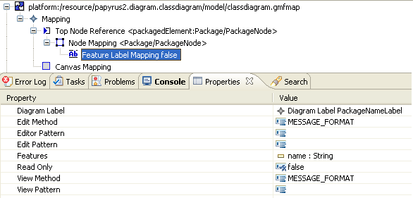
First the node has to be created. Then create a feature label mapping the map the feature (here the name of the package) and the diagram label figure.

Step 3: Result
The name is editable.
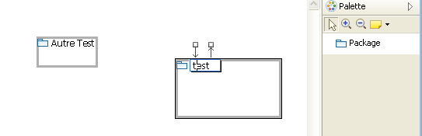

Optional step
To set a default name when you create the entity, the text property of the label can be filled in the gmfgraph.
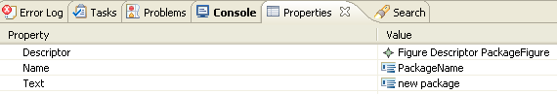

To modify view with a specific grammar, you can use fields “edit pattern” and “view pattern” in gmfmap.

For more information you can see http://wiki.eclipse.org/GMF_Labels

Figure swapping action
TODO

Links whose source/target graphical elements differ from the source/target semantic elements
TODO
main target: understand how to create uml2 associations

Graphical elements that are contained within one element but semantically contained within another element

Context
Occasionally, when working with already existing metamodels, we face the situation in which an element must contain graphically other elements but not semantically. This happens, for example, in the sequence diagram case where Lifelines contain graphically Behaviors but the Behaviors are contained within the Lifeline parent (an Interaction). The following figure shows a simplified view of what happens in the UML2 sequence diagram.

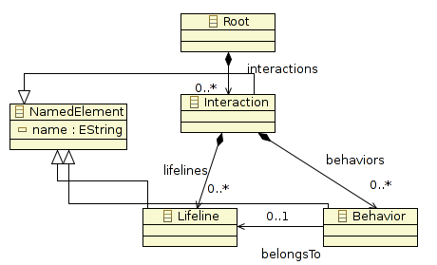
Figure 28: Sequence Diagram simplified view

This behavior is not supported by GMF as it is quite uncommon. Therefore, we will need to modify several things by hand.

Proposed solution
First we will need to create our gmfmap model without doing anything special, just trying to represent in the model the behavior described above. We will do the necessary changes after generating the diagram code.

Step 1: Create the gmfmap
Creating the gmfmap should be straightforward, the only element in which we need to pay special attention is the Behavior Child Reference:
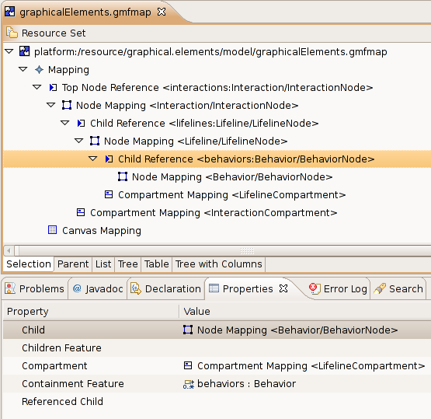
Figure 29: gmfmap view fo the sequence diagram
As we can see, the containment feature of the Behavior element is a feature from its grandparent and not from its parent. This is exactly what we want but, however, if we validate the model GMF will show an error message just because of this reason (We do not have to pay attention to this error).

Step 3: Generate the gmfgen model file
When generating the gmfgen model file, GMF will validate the gmfmap model file. As commented above, we do not need to worry about it. Continue with the gmfgen generation.

Once the gmfgen file is generated, generate the diagram code. Again, the same error as before will appear. Check “Ignore validation error” and continue with the generation.

Note: All the added lines to the generated code shown below will be in grey.

Step 2: Modify the XXXDiagramUpdater class
The DiagramUpdater class is the one in charge of returning the graphical elements contained within another element. Each graphical container element will have a getSemanticChildren operation returning the list of its graphical children. By default, this operation returns the same children that are contained “physically” within the semantic element. However, in this particular case, the Lilfeline's getSemanticChildren opeartion must be modified in order to return, as graphical child elements, all the Behaviors contained within its parent element (an Interaction) that are associated with this lifeline through the BelongsTo attribute.
Folder: src
Package: xxx.diagram.part
/**
* @generated
*/
public class GraphicalElementsDiagramUpdater {

/**
* @generated NOT
*/
public static List getLifelineLifelineCompartment_7003SemanticChildren(
View view) {
if (false == view.eContainer() instanceof View) {
return Collections.EMPTY_LIST;
}
View containerView = (View) view.eContainer();
if (!containerView.isSetElement()) {
return Collections.EMPTY_LIST;
}
Lifeline modelElement = (Lifeline) containerView.getElement();
Interaction parentElement = (Interaction) modelElement.eContainer();
List result = new LinkedList();
for (Iterator it = parentElement.getBehaviors().iterator(); it
.hasNext();) {
Behavior childElement = (Behavior) it.next();
int visualID = GraphicalElementsVisualIDRegistry.getNodeVisualID(
view, childElement);
if (visualID == BehaviorEditPart.VISUAL_ID) {
// The Behavior must belong to the Lifeline
Behavior behavior = (Behavior) childElement;
if (behavior.getBelongsTo() == modelElement)
result.add(new GraphicalElementsNodeDescriptor(
childElement, visualID));
continue;
}
}
return result;
}
...

}

Step 3: Modify the BehaviorCreateCommand class
When a Behavior element is created, the getElementToEdit and getEClassToEdit operations are called. The former is called to obtain its parent element and the later to know the class of its parent element. Only the first operation needs to be modified:
Folder: src
Package:xxx.diagram.edit.commands
/**
* @generated
*/
public class BehaviorCreateCommand extends CreateElementCommand {

/**
* @generated
*/
public BehaviorCreateCommand(CreateElementRequest req) {
super(req);
}

/**
* @generated NOT
*/
protected EObject getElementToEdit() {
EObject container = ((CreateElementRequest) getRequest())
.getContainer();
if (container instanceof View) {
container = ((View) container).getElement();
}

if (container instanceof Lifeline)
container = container.eContainer();

return container;
}

/**
* @generated
*/
protected EClass getEClassToEdit() {
return GraphicalelementsPackage.eINSTANCE.getInteraction();
}

}

Step 4: Modify the LifelineCompartmentItemSemanticEditPolicy class
The only way to make a relationship between a Behavior and a Lifeline is through the BelongsTo attribute of the Behavior. But, by default, if we create a Behavior within a Lifeline, this attribute is not set automatically. We need to do this by hand modifying the getCreateCommand for Behaviors. In this case, we will create and modify its BelongsTo feature at the same time thanks to an auxiliary command called CreateElementAndInitializeFeatureCommand:
Folder: src
Package: xxx.diagram.edit.policies
/**
* @generated
*/
public class LifelineLifelineCompartmentItemSemanticEditPolicy extends
GraphicalElementsBaseItemSemanticEditPolicy {

/**
* @generated NOT
*/
protected Command getCreateCommand(CreateElementRequest req) {
if (GraphicalElementsElementTypes.Behavior_3004 == req.getElementType()) {
if (req.getContainmentFeature() == null) {
req.setContainmentFeature(GraphicalelementsPackage.eINSTANCE
.getInteraction_Behaviors());
}
// Added to initialize the property "BelongsTo" of the new Behaviour
CreateElementCommand behaviorCmd = new BehaviorCreateCommand(req);
EReference feature = GraphicalelementsPackage.eINSTANCE
.getBehavior_BelongsTo();
Object value = req.getContainer();
return new CreateElementAndInitializeFeatureCommand(behaviorCmd,
feature, value);
return getGEFWrapper(new BehaviorCreateCommand(req));
}
return super.getCreateCommand(req);
}

}

Step 5: Create the CreateElementAndIntializeFeatureCommand class
Folder: custom-src
Package: xxx.diagram.edit.commands
public class CreateElementAndInitializeFeatureCommand extends Command {

/** Compound command to undo/redo. */
CompoundCommand compoundCommand = new CompoundCommand();

/** Command to create the element. */
private CreateElementCommand createElementCommand;

/** Feature to initialize. */
private EReference featureToInitialize;

/** Value to initialize the feature to. */
private Object initializationValue;

/**
* Instantiates a new creates the element and initialize feature command.
*
* @param createCommand the create command
* @param feature the feature
* @param value the value
*/
public CreateElementAndInitializeFeatureCommand(CreateElementCommand createCommand,
EReference feature, Object value)
{
createElementCommand = createCommand;
featureToInitialize = feature;
initializationValue = value;
}

/* (non-Javadoc)
* @see org.eclipse.gef.commands.Command#canExecute()
*/
@Override
public boolean canExecute() {
return createElementCommand != null && featureToInitialize != null && initializationValue != null;
}

/* (non-Javadoc)
* @see org.eclipse.gef.commands.Command#canUndo()
*/
@Override
public boolean canUndo() {
return compoundCommand.canUndo();
}

/* (non-Javadoc)
* @see org.eclipse.gef.commands.Command#chain(org.eclipse.gef.commands.Command)
*/
@Override
public Command chain(Command command) {
compoundCommand.chain(command);
return this;
}

/* (non-Javadoc)
* @see org.eclipse.gef.commands.Command#dispose()
*/
@Override
public void dispose() {
compoundCommand.dispose();
super.dispose();
}

/* (non-Javadoc)
* @see org.eclipse.gef.commands.Command#execute()
*/
@Override
public void execute() {

/**
* 1) Create element via createElementCommand
* 2) Retrieve created element via createElementCommand.getNewElement()
* 3) Create SetValueCommand on newElement with indicated feature and value on construction
* 4) Set feature value via setValueCommand
* 5) both the createElementCommand and the setValueCommand are stored in a CompoundCommand to undo() and redo() easily
*/

try {
createElementCommand.execute(null, null);
compoundCommand.add(new ICommandProxy(createElementCommand));
} catch (ExecutionException e) {
e.printStackTrace();
return;
}

EObject newElement = createElementCommand.getNewElement();

SetRequest setRequest = new SetRequest(newElement, featureToInitialize, initializationValue);
SetValueCommand setValueCommand = new SetValueCommand(setRequest);

try
{
setValueCommand.execute(null, null);
compoundCommand.add(new ICommandProxy(setValueCommand));
} catch (ExecutionException e) {
e.printStackTrace();
return;
}
}

/* (non-Javadoc)
* @see org.eclipse.gef.commands.Command#getDebugLabel()
*/
@Override
public String getDebugLabel() {
return super.getDebugLabel();
}

/* (non-Javadoc)
* @see org.eclipse.gef.commands.Command#getLabel()
*/
@Override
public String getLabel() {
return super.getLabel();
}

/* (non-Javadoc)
* @see org.eclipse.gef.commands.Command#redo()
*/
@Override
public void redo() {
compoundCommand.redo();
}

/* (non-Javadoc)
* @see org.eclipse.gef.commands.Command#setDebugLabel(java.lang.String)
*/
@Override
public void setDebugLabel(String label) {
super.setDebugLabel(label);
}

/* (non-Javadoc)
* @see org.eclipse.gef.commands.Command#setLabel(java.lang.String)
*/
@Override
public void setLabel(String label) {
super.setLabel(label);
}

/* (non-Javadoc)
* @see org.eclipse.gef.commands.Command#undo()
*/
@Override
public void undo() {
compoundCommand.redo();
}

}

Example zip file: tutorial-graphical_elements.zip

Links with polygonal anchoring area and/or oval anchors

Context
There are a couple of concepts that should be explained before to continue: anchoring points and anchors.

The figure anchor area defines the allowed regions where links can start/end in order to connect two figures. The default region generated by GMF is the rectangle that wraps the figure. In general this may seem correct but there are some specific cases where the anchoring area must be limited to a certain polygon (for example this happens with Lifelines in the Sequence Diagram).

However, Figure anchors are the elements used to store the points where the user pressed/released the mouse button when creating a link. Therefore, a link will have two anchors: one representing the source point and one representing the target point. This anchors are returned by the source/target figures. The link will ask the anchors which is the intersection point between the link and the source/target figure. The default anchor (called IdentityAnchor) returns always the intersection between the anchoring area of a figure and the reference point stored by the anchor.

GMF, by default, creates the user's figure and then stores it within a NodeFigure class (to be more specific, the DeafultSizeNodeFigure). Is this class the one in charge of managing the anchoring area and the anchor points.

This set of operations for anchoring purposes are really easy to overwrite. If combined with the IpolygonAnchorableFigure interface, the task of changing the anchoring area is really easy. Therefore it is only necessary to create a new class extending from DefaultSizeNodeFigure overwriting the proper operations.

Proposed solution
Both for changing the anchoring area and for changing the anchors returned by the figure, we will modify the generated EditPart class as it is the class that creates the graphical figure. Instead of returning the DefaultSizeNodeFigure figure created by default within the createNodePlate() operation, we will return our own Figure previously manipulated according to our needs.

Step 1 : Create our own Figure
CASE 1 – Polygonal anchoring area

/**
* @generated
*/
public class LifelineEditPart extends ShapeNodeEditPart implements
PrimaryShapeEditPart {

/**
* @generated
*/
public static final int VISUAL_ID = 2002;
...
/**
* @NOT-generated
*/
public class LifelineNodeFigure extends DefaultSizeNodeFigure implements
IPolygonAnchorableFigure {

public LifelineNodeFigure(Dimension defSize) {
super(defSize.width, defSize.height);
}

public LifelineNodeFigure(int width, int height) {
super(width, height);
}

// This returns as the anchoring area only the central line
@Override
public PointList getPolygonPoints() {
PointList polygonList = new PointList();

Rectangle r = getBounds();

Point pStart = new Point();
Point pEnd = new Point();

pStart.x = r.x + r.width / 2;
pStart.y = r.y + 1;

pEnd.x = pStart.x;
pEnd.y = pStart.y + r.height - 1;

polygonList.addPoint(pStart);
polygonList.addPoint(pEnd);

return polygonList;
}

}
}

CASE 2 – Oval anchoring area with oval anchors

/**
* @generated
*/
public class UseCaseEditPart extends ShapeNodeEditPart implements
PrimaryShapeEditPart {

/**
* @generated
*/
public static final int VISUAL_ID = 1001;

...

/**
* @NOT-generated
*/
public class UseCaseNodeFigure extends DefaultSizeNodeFigure implements
IOvalAnchorableFigure {

public UseCaseNodeFigure(Dimension defSize) {
super(defSize);
}

public UseCaseNodeFigure(int width, int height) {
super(width, height);
}

@Override
protected ConnectionAnchor createDefaultAnchor() {
return new SlidableOvalAnchor(this);
}

@Override
protected ConnectionAnchor createAnchor(PrecisionPoint p) {
if (p == null)
return createDefaultAnchor();
return new SlidableOvalAnchor(this, p);
}

public Rectangle getOvalBounds() {
return getBounds();
}

}

}

Step 2 : Return our own Figure within the createNodePlate() operation
CASE 1 – Polygonal anchoring area

/**
* @generated
*/
public class LifelineEditPart extends ShapeNodeEditPart implements
PrimaryShapeEditPart {

/**
* @generated
*/
public static final int VISUAL_ID = 2002;
...
/**
* @generated NOT
*/
protected NodeFigure createNodePlate() {
// To return EllipseAnchors
UseCaseNodeFigure ucFigure = new UseCaseNodeFigure(getMapMode().DPtoLP(
80), getMapMode().DPtoLP(40));
return ucFigure;
}
...
}

CASE 2 – Oval anchoring are with oval anchors

/**
* @generated
*/
public class UseCaseEditPart extends ShapeNodeEditPart implements
PrimaryShapeEditPart {

/**
* @generated
*/
public static final int VISUAL_ID = 1001;
...
/**
* @generated NOT
*/
protected NodeFigure createNodePlate() {
LifelineNodeFigure result = new LifelineNodeFigure(getMapMode().DPtoLP(
100), getMapMode().DPtoLP(250));
return result;
}
...
}

Avoid link snapping to the centre of the figure

Context
This recipe is related with the above one so it would be interesting to previously read, at least, its context to understand what comes next.

Another of the default behaviors of the DefaultSizeNodeFigure is the snapping mechanism to the centre of the figure. When the user moves the mouse around the anchoring area of the target figure, if the pointer is quite near from the middle part of the figure then the pointer snaps automatically to centre of it. Although this may seem something not very important, sometimes it results in really annoying behavior specially when you want to set the target anchor in a specific point.

Proposed solution
As it happens in the previous recipe, the solution is quite simple: create our own Figure extending the DefaultSizeNodeFigure class and overwriting the proper method. Then we must change the createNodePlate() operation in order to return our figure instead of the DefaultSizeNodeFigure.

Note: This recipe can be perfectly combined with the previous one.

Step 1 : Create our own figure

/**
* @generated
*/
public class LifelineEditPart extends ShapeNodeEditPart implements
PrimaryShapeEditPart {

/**
* @generated
*/
public static final int VISUAL_ID = 2002;
...
/**
* @NOT-generated
*/
public class LifelineNodeFigure extends DefaultSizeNodeFigure {

public LifelineNodeFigure(Dimension defSize) {
super(defSize.width, defSize.height);
}

public LifelineNodeFigure(int width, int height) {
super(width, height);
}

@Override
protected boolean isDefaultAnchorArea(PrecisionPoint p) {
// We don't want a default snapping area for the Lifeline Node Figure.
return false;
}

}
}

Step 2 : Return our own figure within the createNodePlate() operation

/**
* @generated
*/
public class LifelineEditPart extends ShapeNodeEditPart implements
PrimaryShapeEditPart {

/**
* @generated
*/
public static final int VISUAL_ID = 2002;
...
/**
* @generated NOT
*/
protected NodeFigure createNodePlate() {
// To return EllipseAnchors
UseCaseNodeFigure ucFigure = new UseCaseNodeFigure(getMapMode().DPtoLP(
80), getMapMode().DPtoLP(40));
return ucFigure;
}
...
}

Element initialization

Context
Model elements usually have a set properties for describing the state the element. This properties are attributes and references to other model elements. Normally is the user the one in charge of giving the correct values to this properties but, as there are usually restrictions associated with the possible values, it results to be convenient to assign an initial value that does not violate the restriction in order to help the user.

Furthermore, some created elements do not have much sense by themselves. For example, in UML2 when creating an Association element, two more elements have to be created for describing the ends of the Association. Therefore, when the user creates an Association through our diagram editor he does not only expect an Association to be created but all the necessary elements (and their properties) for describing correctly an UML2 Association.

Although this can be achieved manipulating the GMF generated classes, GMF already provides us a mechanism for describing element initialization via its gmfmap model.
You can also do the job directly in the gmfgen, if you work on the this in this case fo directly ..

Proposed solution
The gmfmap model allows us to initialize the new element properties and also to create some children elements and initialize its properties as well.

Both for initializing the properties and for creating new child elements, select the Node Mapping to initialize, right click over it → new Child → Feature Seq Initializer.

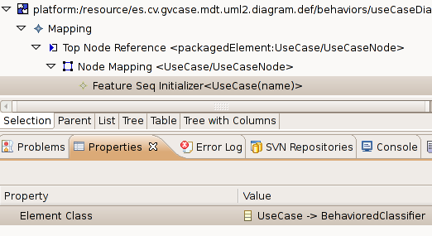
Figure 30: Feature Seq Initializer

Initializing element properties
To initialize the value of a property, select the new “Feature Seq Initializer” element, right click over it → new Child → “Feature Value Spec”:

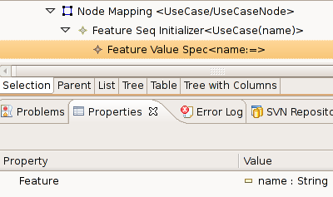
Figure 31: Feature Value Spec properties

Select the feature of the element to initialize and give the value to the feature by means of creating a Value Expression doing right click over the “Feature Value Spec” → new Child → “Value Expression”:

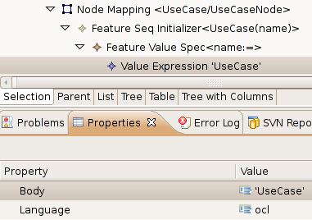
Figure 32: Value Expression properties

Creating new child elements within an element
It is important to mention that using this mechanism, only child elements can be created. We are not allowed to create siblings or parent elements. If this is our case, will need to modify the doDefaultElementCreation() operation within the CreateCommand class of the generated element code.

To create a new child element, right click over the “Feature Seq Initializer” → new Child → “Reference New Element Spec”.

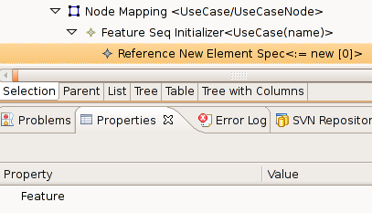
Figure 33: Reference New Element feature property

The next step is to select the feature where the element will be stored and the element to be created. The format is the following <feature> : <elementType>.

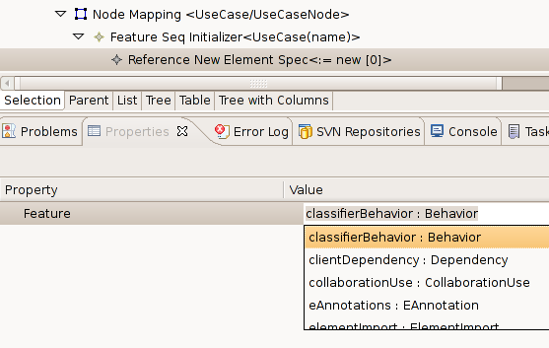
Figure 34: Reference New Element Spec <feature> : <childElement> selection

The new created element can be initialized as well using the same procedure explained here.

Diagram restrictions with OCL via gmfmap

Context
When dealing with models it is quite normal to specify some constraints so that the created models fulfill a set of requirements. Not to mention that all this constraints should be specified within the metamodel although sometimes this is not possible or it requires to much handwork as EMF does not give support for OCL constraints by default (Check this address if this is your case: http://www.eclipse.org/articles/article.php?file=Article-EMF-Codegen-with-OCL/index.html).

In other cases it is just that you want to force the editor to have a more restricted behavior than the originally specified within the metamodel. Independently of the case, GMF allows the specification of OCL constraints both for the diagram and for each element different Node/Link element in a very easy way.

Proposed solution
All the constraints of a diagram editor can be added within the gmfmap model. In order to add a new constraint we need to open our gmfmap model and, depending on the case, add the constraint to the model, Node or Link.

Add a Model constraint
To add a model constraint, right click over the general “Mapping” element and select new Child → “Audit Container”.

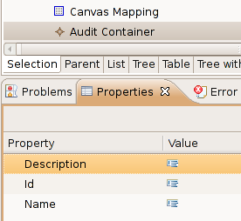
Figure 35: Audit Container properties
The meaning of the properties is quite straightforward:
- Description: Description of the container.
- Id: Identifier of the container. It should be unique within this diagram.
- Name: Name of the container.

Both the Description and the Name are visible by the user. Therefore it is convenient give appropriate values to these properties. Remember that all the editor constraints can be accessed by the user by clicking Window menu → Preferences → Model Validation → Constraints.

Within the “Audit Container” we can add as many rules (constraints) as we may need. To add a rule, right click over the “Audit Container” element → new Child → “Audit Rule”.

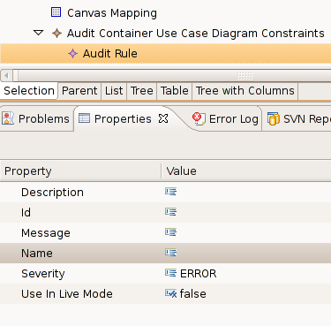
Figure 36: Audit Rule properties
The meaning of the properties is the following:
- Description: Description of the Rule.
- Id: Identifier of the Rule.
- Message: Message for the user when there is a violation of the rule.
- Severity: Severity grade of the rule. Possible values are
  - ERROR
  - WARNING
  - INFO
- Use In Live Mode: When will the constraint be checked. If true, then the constraint will be checked in every action of the user, canceling the action in case the rule is violated. If false, then the rule will only be checked when the user validates the Diagram (right click over the diagram file → Validate).

Each rule is composed by two more elements: a Constraint (with the body of the constraint) and a Target Element/Attribute (the context of the constraint). To create both elements, right click over a Rule → new Child.

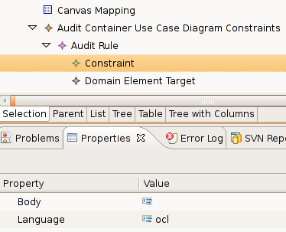
Figure 37: Audit Rule Constraint properties

The different target elements/attributes are the following:

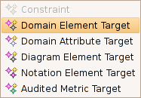
Figure 38: Different target elements/attributes
A description of the most important ones:
- Domain Element Target: The rule is applied to all the instances of a metamodel Class.
- Domain Attribute Target: The rule is applied to one attribute of all the instances of a metamodel Class.
- Diagram Element Target: The rule is applied to one of the gmfmap elements of the current Diagram (Only Node Mapping and Link Mapping elements).

For further information about GMF constraints check this addres:
http://wiki.eclipse.org/index.php/GMF_Constraints

Add a Node constraint
To add a Node constraint, right click over the “Node Mapping” element and select new Child → “Constraint”:

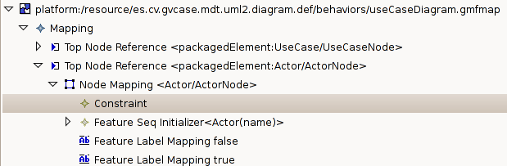
Figure 39: New Node constraint
The properties of the constraint are the following:

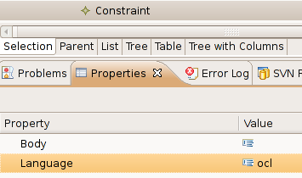
Figure 40: Node constraint properties
Language property specifies in which language is the constraint going to be declared. The most common languages are OCL(Object Constraint Language) and Java. The constraint itself is described within the Body property. Obviously if the language is OCL the body must be written in OCL language. The same happens with the rest of languages. You may check it the constraint is syntactically correct by doing: right click over the Node Mapping → validate.

Add a Link constraint
To add a Link constraint, right click over the “Link Mapping” element and select “Link Constraints”:

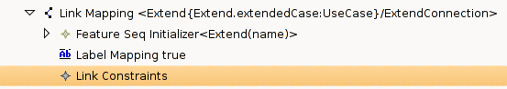
Figure 41: New Link constraint
GMF allows us to attach a constraint to the source element and/or to the target element. The source constraint will be checked when selecting the source of the link whereas the target constraint will be checked when selecting the target of the link. To attach a constraint to one of the ends right click over Link constraint -> New child -> Source End Constraint or Target End Constraint:

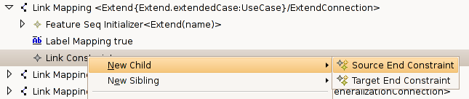
Figure 42: Election between source/target end constraint

Independently of the chosen constraint, the properties of the constraint are the following:

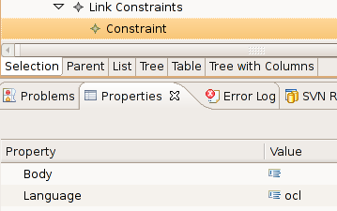
Figure 43: Source/Target end constraint properties

The properties have the same meaning as in the Node Constraint explanation. However, GMF supports a special OCL variable called oppositeEnd that can be used within the Body of the OCL expressions when dealing with Source/Target end constraints. This variable represents the opposite element of the current end. That means that if we are writing the body of the target end constraint, then the oppositeEnd represents the source element of the link and vice-verse.

An example is provided below:
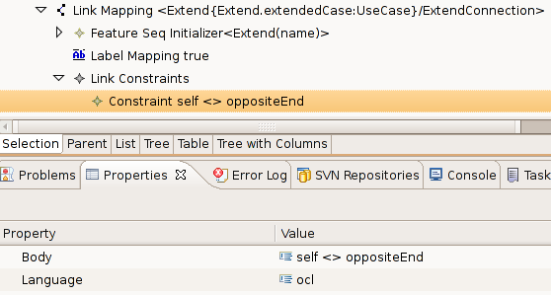

This example illustrates how to avoid a connection between one element and itself. The constraint created is a Target End Constraint, therefore oppositeEnd represent the source element of the connection.

Name initialization of the elements

Context

Element creation within a diagram editor usually has to deal with the naming problem, above all when a creation of a graphical element has as a result the creation of more than one semantic element.

As it happens quite often, the great majority of elements usually have a name attribute in order to identify (at least at user level) the different instances of a same element (for example, different classes from a UML2 Class diagram).

If it is the case, it is desirable to give unique names to the new elements. Even though this task should be done by the user, it is quite interesting to grant that all elements created by the editor will start with a unique name (user is free to change it afterwards).

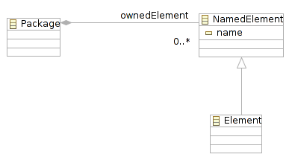
Figure 44 Element with name

First Proposed Solution
First, we are going to create a Java Class called LabelHelper.java whose purpose is to provide a suitable name for an Element that inherits from the NamedElement class.
The next step is to use the gmfmap element initialization via Java specifying that the initialization of the name feature would be done through Java code instead of OCL rules (which is quite more common).
After generating the diagram editor code (via the gmfgen model), the last step is to use the above class within the initialization operation generated automatically.

Step 1 : Create LabelHelper.java
Name: LabelHelper.java
Package: Anywhere provided that it is visible by all our editors.
Note: This class is based on the org.topcased.modeler.utils.LabelHelper.java and considering the UML2 NamedElement.

public class LabelHelper {
/** The singleton */
public static final LabelHelper INSTANCE = new LabelHelper();

/**
* Initialize the name of a child EObject contained in a parent EObject
*
* @param parentEObject
* the parent EObject to start searching
* @param childEObject
* the child EObject whose name should be initialized
*/
public void initName(EObject parentEObject, EObject childEObject) {
if ((childEObject != null) && (childEObject instanceof NamedElement)) {
String name = findName(parentEObject, (NamedElement) childEObject);

// Either delegate the call or return nothing.
EAttribute att = null;
att = UMLPackage.eINSTANCE.getNamedElement_Name();

if (att != null
&& ((EDataType) att.getEType()).getInstanceClass().equals(
String.class)) {
childEObject.eSet(att, name);
}
}
}

/**
* This returns a name to give to given EObject
*
* @param parentEObject
* the parent EObject
* @param childEObject
* the new EObject to add
* @return the name
*/
public String findName(EObject parentEObject, NamedElement childEObject) {
return findName(parentEObject, childEObject.eClass());
}

/**
* This returns a name to give to a new EObject
*
* @param parentEObject
* the parent EObject
* @param childEClass
* the new EObject to add
* @return the name
*/
public String findName(EObject parentEObject, EClass childEClass) {
int cpt = 1;
while (!isNameAvailable(parentEObject, childEClass, cpt)) {
cpt++;
}
return childEClass.getName() + cpt;
}

/**
* Check if a name is available
*
* @param parentEObject
* the parent EObject
* @param childEClass
* EClass of the new EObject to add
* @param currentCpt
* the current cpt
* @return true if the name is available
*/
private boolean isNameAvailable(EObject parentEObject, EClass childEClass,
int currentCpt) {
EList list = parentEObject.eContents();
for (Iterator i = list.iterator(); i.hasNext();) {
EObject child = (EObject) i.next();

// check if the current child is the same type of the childEObject
if (childEClass.getName().equals(child.eClass().getName())) {
String nameToMatch = child.eClass().getName() + currentCpt;
if (nameToMatch.equals(((NamedElement) child).getName())){
return false;
}
}
}
return true;
}

}
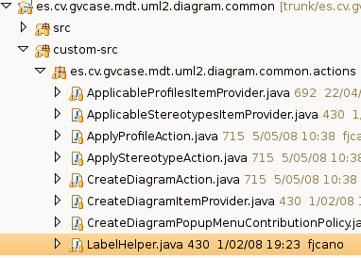
Figure 45 Example of where to store LabelHelper

Step 2 : Modify gmfmap model
Select the Nodes that need to be initialized by clicking on “Node Mapping” elements. Next, right click “New Child → Feature Seq Initializer”. Over the new element, right click “New child → Feature Value Spec”. Next step is to add a “Value Expression” within the new created “Feature Value Spec” doing right click “New child → Value Expression”:
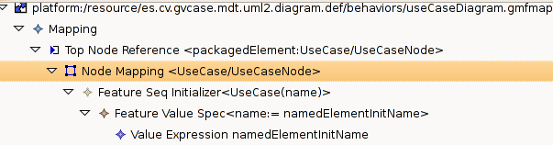
Figure 46 Value expression hierarchy
The last step is to modify the “Value Expression” as it is shown in the figure below:
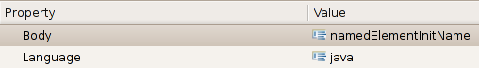
Figure 47 Value expression example

In the GmfGen
In the Gen model you obtain the following tree see Figure 49. It contains a node Gen Expression. This node contains all expression that you have defined in the gmf map. But You can also create new expression at this level.
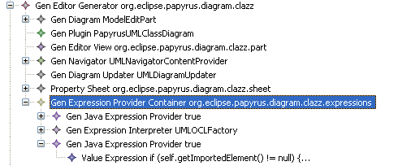
Figure 48 GmfGen tree with Java expression.
Add an new Value expression if it is not created and edit body of the value.
In the body your can write the java code.
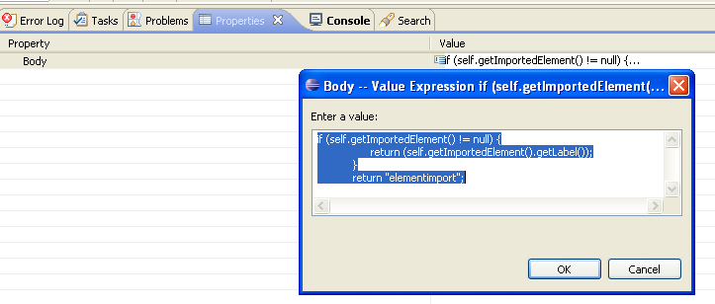
Figure 49 Value expression java code

Then, don't forget to set True “Inject expression body”.
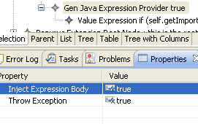
Figure 50 properties to inject code
Ensure that the gen Feature Value Spec of the gen node as in Figure 51 is associated to the good value Expression
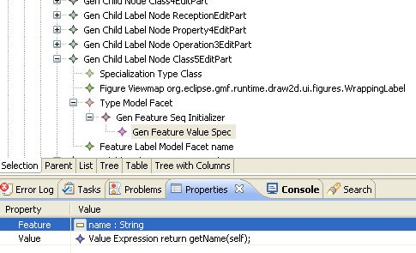
Figure 51 A Genfeature for initializer associated to a ValueExression.

The class ElementInitializer will be generated with appropriate body.
NB: When you generate from the mapping a lot of value Expression are created. So it is interesting to clean the number of value at this step. But you to pay attention if the reference of GenfeatureValueSpec are well set.

Second Proposed Solution
There is another way to initialize name of elements without additional custom code. All we need to do is to add a sequence initializer for the specified node in the gmfmap or gmfgen model. In this case, we are using a more specific ocl value expression that enables to automatically initialize element's name.

Modify gmfmap model
For example we want to internalize name of Actors in use case diagram. Select the Node Mapping, add a sequence initializer: right click > New child > feature Seq Initializer. Then add a Feature Value Spec and specify the name as feature property.

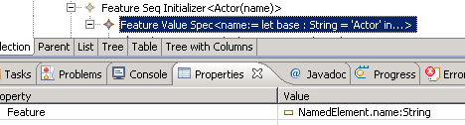Illustration 1: Name initialization in gmfmap
Next add a Value Expression with the following properties:
- language: ocl
- body:

let base : String = 'Actor' in
let suffixes : Sequence(String) = Sequence {'', '1', '2', '3', '4', '5', '6', '7', '8', '9', '10'} in
let space : Namespace = self.namespace in
let allMissed : Sequence(String) = suffixes->
select(s : String | not space.member->exists(e : NamedElement | e.name = base.concat(s))
) in
let firstMissed : String = allMissed->first() in
let noMisses : Boolean = firstMissed.oclIsUndefined() in
let allNames : Set(String) =
if noMisses
then
space.member->collect(e : NamedElement |
if e = self or e.name.oclIsUndefined() or e.name.substring(1, e.name.size().min(base.size())) <> base
then ''
else e.name
endif)->asSet()->excluding('') else Set{'not in use'}
endif in
let longestName : String =
if noMisses
then allNames->select(n : String | not allNames->exists(nn : String | nn.size() > n.size()))->asSequence()->first()
else 'not in use'
endif in
if noMisses then
if longestName.oclIsUndefined()
then base
else longestName.concat('1')
endif
else
base.concat(firstMissed)
endif

As you see in the screenshot, you obtain the same initializer in gmfgen model.

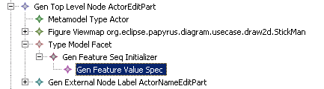Illustration 2: Name initialization in gmfgen
As we did in gmfmap, you are also able to add the sequence initializer right into the gmfgen model. You need to add the value expression in the Gen Expression Provider Container first. Then you can add it in the Gen Top Level Node.

After code generation, your element will be create graphically with an unique default name value.

Add Policy to remove orphaned View
The purpose is to add an editpolicy that removes all orphan view (views that are linked to UML element).
Another constraint is to avoid modifying generated code.

Create a new Edit Policy
First , create a new editpolicy that inherits org.eclipse.papyrus.diagram.common.editpolicies.OrphanViewPolicy.
In This edit policy you will create an array that will contains all VISUAL ID of element that must not be removed. Indeed, in a graphical appearance, elements are not always linked to an uml element, for example compartment, special link…
Then create the constructor, in the snapshot. Don’t forget to call the method init.

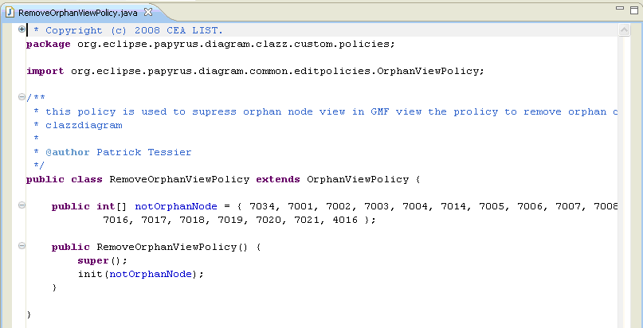

GmfGen
The editpolicy must be referenced into the gmfgen. To do that, create an new custom behaviour in the Gen Diagram and in all Gen Compartment.

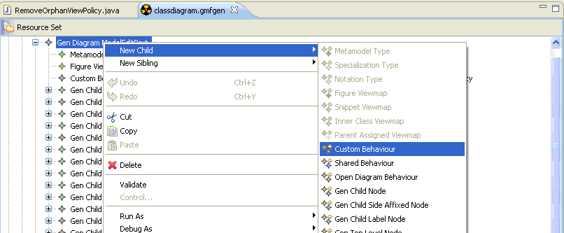

In the property view, fill the following information:
- Key: "RemoveOrphanView"
- class name: org.eclipse.papyrus.diagram.clazz.custom.policies.RemoveOrphanViewPolicy
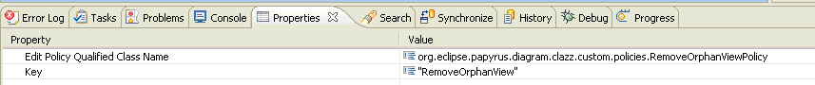

Result
At the generation, the method createDefaultEditPolicies() is filled in each edit part diagram and compartment

Refreshing figure by taking in account features of element
Sometimes, we would like to refresh the figure by taking in account the value of a feature. For instance, when a class in uml is active, we would like to see a double line on the figure.

Write code in figure
First, the figure has to contains a method that can be called that set allow drawing the changes in the figure. To that, a public method is sufficient.

Modification in genModel
In the gen model, an extension will be used. Click on Create extension model and choose http://www.eclipse.org/papyrus/2009/papyrusgmfgenextension model.
Then create annew ExtendedGenNode.
An extended Gen node, is used to add more information about a node. So first select the gen node that will would like to extend. Then add a name and a comment.
This editpart is not abstract so set false the property “isAbstract”.

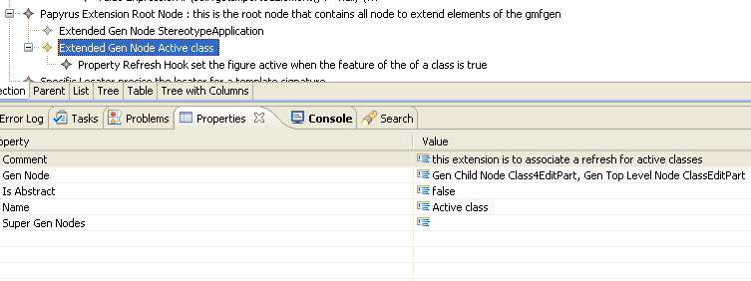
Add a new child node “Property refresh hook”

This node describe how to refresh the figure. You will write java code, and it will injected in the editpart.
First add a comment. Describe the condition (here we test if the notification is semantic and the source of the notification is an attribute).
Add in the action field, the code to add in order to refresh the figure.
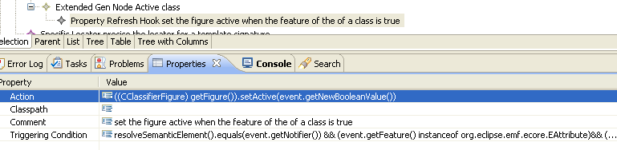

Result
Generate with dynamic template in org.eclipse.papyrus.def.
The generated code is the following.

Generate Association Link Special case
Todo
→ gmf map endType attribute
→ change the command, add code to construct the attribute

Add Drag and drop functionality
The default behavior in GMF is drop only nodes.
The goal in Papyrus is to obtain the drag and drop of nodes and links. In the case of links, if nodes have not been dropped, the tool add automatically a view for these nodes.
The design of the solution takes in account specific drop, for example, imagine that for an element that this is a set of view that we have to create: association class.
This solution does not modify generated code. We need, to add custom classes, and info in the gmfgen.
First you need to enable the drag and drop mechanism for the specified plugin in charge of a diagram:
In the class *DiagramForMultiEditor that inherits the class UMLDiagramEditor, you must override the method initializeGraphicalViewer to enable drop action:
@Override
protected void initializeGraphicalViewer() {
super.initializeGraphicalViewer();
// Enable Drop
getDiagramGraphicalViewer().addDropTargetListener(
new DropTargetListener(getDiagramGraphicalViewer(), LocalSelectionTransfer.getTransfer()) {
@Override
protected Object getJavaObject(TransferData data) {
return LocalSelectionTransfer.getTransfer().nativeToJava(data);
}
@Override
protected TransactionalEditingDomain getTransactionalEditingDomain() {
return getEditingDomain();
}
});
}
To allow dropping in the plugin in charge of the diagram, create
- CustomDiagramDragDropEditPolicy
This class has in charge to be called when a drop is detected. Its inherits from CommonDiagramDragDropEditPolicy
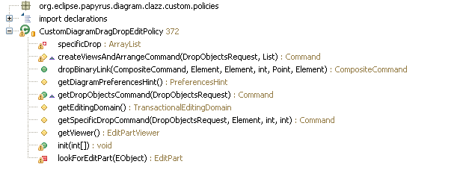

This class contains generic algorithm to draw nodes and binary links.
This class does not call generated classes from gmf to find source and target for a link. Why?
First to find the source and the target of a semantic element, we need to create an edge. Then their method call only found existed nodes that plays the role of source or target of a link. So, in order to use their method, we need to create an temporary edge and to create all possible graphical nodes that can play the role of source or target. Secondly, it execute several loops in the semantic model and graphical model, that are not an economic solution.
So in order to run it , we need to create a ClassLinkMappingHelper that implements ILinkMappingHelper.
- ILinkMappingHelper
This is an interface to provide the semantic target and semantic source for a link.
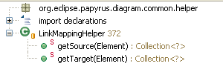
- ClassLinkMappingHelper this is specific class for the class diagram. I think that is class can be generated, because the information is the mapping already exist in the gen model. For each semantic link, it returns the semantic source or the semantic target.

- ClassDiagramDragDropEditPolicy, this is a more specific class to allows adding your own algorithm to drop element, I my case i write code to drop multi association dependencies, associationClass.
It implements only the method getSpecificDropCommand. This method call more specific methods, drop association, drop associationClass, or dropDependency
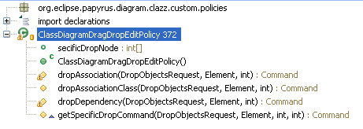
Then in order to connect this behavior, add the ClassDiagramEditPolicy into your gmf gen file. See 3,1 Create a new Edit Policy. For each container and diagramEditpart add this policy with the key “EditPolicyRoles.DRAG_DROP_ROLE”. Finally regenerate the code in order to install this new editpolicy in all interesting editpart.

Add Custom Figure
To add custom figure, you can add a Custom Figure child to your Figure Descriptor in your GMFGraph. Fill Name and Qualified Class Name of your Custom Figure.
You can also customize your Figure (change layout, set attributes, add figures, …)
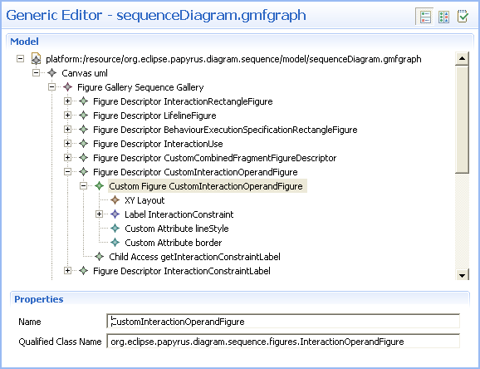Figure 52: Custom figure in GMFGraph

Add a resize constraint :
To add a resize constraint on a node, you have to set its Resize Constraint attribute in GMFGraph.
By default, it's NSEW, so you can resize in all direction.
If you want resize only on top and botton, set to NORTH_SOUTH.
If you want to block the resize capability, set to NONE.
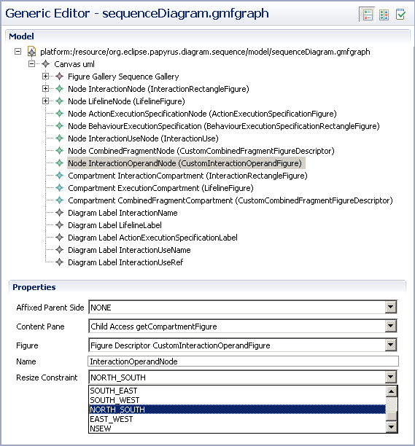Figure 53: Add resize constraint in GMFGraph

Add action in model explorer menu
If you need to add a custom action in model explorer menu, an extension point provides a way to register your action from your dedicated plugin. This extension point is declared in org.eclipse.papyrus.navigator plugin with this schema:
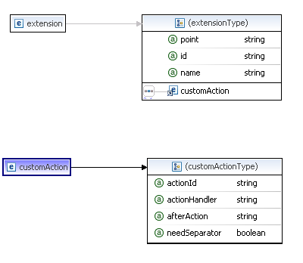
ActionHandler

Identifier:
org.eclipse.papyrus.navigator.org.eclipse.papyrus.navigator.actionHandler

Since:
[Enter the first release in which this extension point appears.]

Description:
This extension point allows adding action in the contextual menu of the model explorer

Configuration Markup:
<!ELEMENT extension (customAction)*>
<!ATTLIST extension
point CDATA #REQUIRED
id CDATA #IMPLIED
name CDATA #IMPLIED>

<!ELEMENT customAction EMPTY>
<!ATTLIST customAction
actionId CDATA #REQUIRED
actionHandler CDATA #REQUIRED
afterAction CDATA #IMPLIED
needSeparator (true | false) "false">
- actionId - registered action identifier
- actionHandler - implement the action handler factory to add your custom actions
- afterAction - fill the action id after you want to insert yours
- needSeparator - Add a separator before your action(s) if needed

Examples:
org.eclipse.papyrus.navigator.factory.DefaultEMFActionsFactory adds default EMF actions in model explorer. See registered extension org.eclipse.papyrus.navigator.actionHandler

API Information:
The class must implement interface org.eclipse.papyrus.navigator.factory.IActionHandlerFactory.

You need to create your factory that implements IactionHandlerFactory. Create your action(s) in the factory and specify the needed behavior.
Extension properties enable adding a separator and specify the position of your action(s).
Warning: The extension is only usable for action, not for actions group or sub-menu.

Make a compartment in which children position is defined by the user

Context
In the diagram, top level nodes can be freely positioned by the user. On the other hand, when a compartment contains children, these are by default displayed as a list the user can not easily alter.
This recipe shows how to adopt the same behavior as for top level nodes.

Proposed Solution
This behavior is controlled by a simple property in the gmfgen file.
Steps of the solution:
  - Open the gmfgen file. Find the concerned Gen Compartment node.
    - In Compartment, the List Layout property controls this behavior :
      - if true, children nodes will be organized as a list, on after the other.
      - If false, the user will be able to move children nodes within the compartment.

Make a compartment with automatically managed children

Context
A compartment may contain children node which are not drawn from the palette. In such a case, we may want to synchronize the displayed children with the model, without the user creating any node.
As an example, the activity displays preconditions and postconditions it contains, whereas these can not be created from the palette :
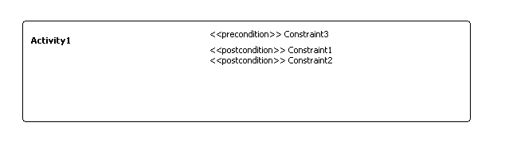
Using a complex parser is often not a satisfying replacement solution, since it leads to a complex edition and does not handle model changes in the child element. This solution is extensible to any node type (not only labels).

Proposed Solution
This feature implies to edit the compartment part and the view provider. We provide here a generic notifier which will do most of the job to draw each child node once. You may modify it if your needs differ a little.
Steps of the solution:
  - GMF Models
    - Create your compartment and contained elements, as if they were to be created by a user (except there is no creation tool in the palette).
  - Java Code
    - The class NotificationHelper allows to listen a model EObject. Copy it in the helper package of your custom-src source folder if it is not available in your plugin's context :
/*****************************************************************************
* Copyright (c) 2009 Atos Origin.
*
*
* All rights reserved. This program and the accompanying materials
* are made available under the terms of the Eclipse Public License v1.0
* which accompanies this distribution, and is available at
* http://www.eclipse.org/legal/epl-v10.html
*
* Contributors:
* Atos Origin - Initial API and implementation
*
*****************************************************************************/
package org.eclipse.papyrus.diagram.XXX.helper;

import java.util.ArrayList;
import java.util.List;

import org.eclipse.emf.common.notify.Notifier;
import org.eclipse.papyrus.diagram.common.providers.UIAdapterImpl;

public class NotificationHelper {

private UIAdapterImpl modelListener;

private List<Notifier> listeners = new ArrayList<Notifier>();

public NotificationHelper(UIAdapterImpl modelListener) {
this.modelListener = modelListener;
}

/**
* Add listener on a element
*
* @param element
* The object to listen
*/
public void listenObject(Notifier element) {
// Only listen the object if it isn't yet listened
if(element != null && !element.eAdapters().contains(modelListener)) {
element.eAdapters().add(modelListener);
listeners.add(element);
}
}

/**
* Remove listener on a element
*
* @param element
* The object to unlisten
*/
public void unlistenObject(Notifier element) {
// Only listen the object if it isn't yet listened
if(element != null && element.eAdapters().contains(modelListener)) {
element.eAdapters().remove(modelListener);
}
listeners.remove(element);
}

/**
* Remove all listeners
*/
public void unlistenAll() {
if(listeners.size() > 0) {
for(Notifier listener : listeners) {
if(listener != null && listener.eAdapters().contains(modelListener)) {
listener.eAdapters().remove(modelListener);
}
}
listeners.clear();
}
}

}
    - The class SelfCompartmentNotificationHelper provide a generic implementation for notifying and managing nodes so that each element is displayed once. Copy it in the helper package of your custom-src source folder if it is not available in your plugin's context :
/*****************************************************************************
* Copyright (c) 2009 Atos Origin.
*
*
* All rights reserved. This program and the accompanying materials
* are made available under the terms of the Eclipse Public License v1.0
* which accompanies this distribution, and is available at
* http://www.eclipse.org/legal/epl-v10.html
*
* Contributors:
* Atos Origin - Initial API and implementation
*
*****************************************************************************/
package org.eclipse.papyrus.diagram.XXX.helper;

import java.util.ArrayList;
import java.util.List;

import org.eclipse.core.commands.ExecutionException;
import org.eclipse.core.commands.operations.OperationHistoryFactory;
import org.eclipse.core.runtime.IAdaptable;
import org.eclipse.core.runtime.NullProgressMonitor;
import org.eclipse.emf.common.notify.Notification;
import org.eclipse.emf.ecore.EObject;
import org.eclipse.emf.ecore.EStructuralFeature;
import org.eclipse.gmf.runtime.common.core.command.CompositeCommand;
import org.eclipse.gmf.runtime.diagram.core.util.ViewUtil;
import org.eclipse.gmf.runtime.diagram.ui.commands.CreateCommand;
import org.eclipse.gmf.runtime.diagram.ui.editparts.CompartmentEditPart;
import org.eclipse.gmf.runtime.diagram.ui.requests.CreateViewRequest.ViewDescriptor;
import org.eclipse.gmf.runtime.emf.core.util.EObjectAdapter;
import org.eclipse.gmf.runtime.emf.type.core.IHintedType;
import org.eclipse.gmf.runtime.notation.Node;
import org.eclipse.gmf.runtime.notation.View;
import org.eclipse.papyrus.core.adaptor.gmf.Activator;
import org.eclipse.papyrus.diagram.common.providers.UIAdapterImpl;

/**
* SelfCompartmentNotificationHelper is a particular NotificationHelper which manages the editparts drawn in a particular compartment for a particular
* feature. It automatically add or remove appropriate parts when model is modified, so that all contained elements are represented once.
*/
public class SelfCompartmentNotificationHelper extends NotificationHelper {

/**
* Construct a new NotificationHelper which automatically manages contained element for a particular feature.
*
* @param compartmentPart
* the compartment part containing parts to manage
* @param childFeature
* the feature for children parts (list feature)
* @param childType
* the {@link IHintedType} for chidren node parts
*/
public SelfCompartmentNotificationHelper(final CompartmentEditPart compartmentPart, final EStructuralFeature childFeature, final IHintedType childType) {
super(new UIAdapterImpl() {

@Override
protected void safeNotifyChanged(Notification msg) {
if(childFeature != null && childFeature.isMany() && childFeature.equals(msg.getFeature())) {
updateChildrenParts(compartmentPart, childFeature, childType);
}
}
});
}

/**
* Update children edit parts so that each child is represented once
*
* @param compartmentPart
* the compartment part containing children
* @param childFeature
* the feature containing children
* @param childType
* the children's IHintedType represented as Node
*/
public static void updateChildrenParts(GraphicalEditPart compartmentPart, EStructuralFeature childFeature, IHintedType childType) {
// Check parameter values
if(compartmentPart == null || childFeature == null || childType == null) {
return;
}
Object modelElt = compartmentPart.getModel();
if(modelElt instanceof View) {
View modelCompartmentView = (View)modelElt;
Class<?> containerClass = childFeature.getContainerClass();
if(containerClass.isInstance(modelCompartmentView.getElement())) {
EObject containerObject = modelCompartmentView.getElement();
Object untypedOwnedObjects = containerObject.eGet(childFeature);
if(untypedOwnedObjects instanceof List<?>) {
List<?> ownedEObjectChildren = (List<?>)untypedOwnedObjects;
List<EObject> drawnEObjectChildren = new ArrayList<EObject>(ownedEObjectChildren.size());
// list children already drawn and remove double parts
for(Object childView : modelCompartmentView.getChildren()) {
if(childView instanceof View) {
EObject child = ((View)childView).getElement();
if(ownedEObjectChildren.contains(child) && !drawnEObjectChildren.contains(child)) {
drawnEObjectChildren.add(child);
} else if(childFeature.getEType().isInstance(child) && !child.equals(containerObject) && child.eContainer() == null) {
modelCompartmentView.removeChild((View)childView);
}
}
}
// draw remaining children
List<Object> childrenToDraw = new ArrayList<Object>(ownedEObjectChildren);
childrenToDraw.removeAll(drawnEObjectChildren);
CompositeCommand drawChildrenCommand = new CompositeCommand("draw children nodes");
for(Object child : childrenToDraw) {
if(child instanceof EObject) {
IAdaptable adapter = new EObjectAdapter((EObject)child);
ViewDescriptor descriptor = new ViewDescriptor(adapter, Node.class, childType.getSemanticHint(), ViewUtil.APPEND, false, compartmentPart.getDiagramPreferencesHint());
CreateCommand nodeCreationCommand = new CreateCommand(compartmentPart.getEditingDomain(), descriptor, modelCompartmentView);
drawChildrenCommand.add(nodeCreationCommand);
}
}
if(!drawChildrenCommand.isEmpty()) {
try {
OperationHistoryFactory.getOperationHistory().execute(drawChildrenCommand, new NullProgressMonitor(), null);
} catch (ExecutionException e) {
e.printStackTrace();
Activator.getInstance().logError("Unable to create diagram elements", e); //$NON-NLS-1$
}
}
}
}
}
}
}
    - Modify your CompartmentEditPart class to add the notifier and use it :
      - Add “notifier” attribute (replace XXX by the feature containing children and YYY by the type of the contained Node parts):
/**
* Notifier for listening and stop listening model element.
*
* @generated NOT
*/
private SelfCompartmentNotificationHelper notifier = new SelfCompartmentNotificationHelper(this, UMLPackage.eINSTANCE.getXXX(), (IHintedType)UMLElementTypes.YYY);
      - Add methods (or complete them) in which listening must start or stop (replace XXX by the feature containing children and YYY by the type of the contained Node parts):
/**
* Activate a listener for to Handle notification for new owned YYY
*
* @generated NOT
*/
public void activate() {
super.activate();
EObject parent = resolveSemanticElement();
notifier.listenObject(parent);
// ensure children parts are correctly initialized.
SelfCompartmentNotificationHelper.updateChildrenParts(this, UMLPackage.eINSTANCE.getXXX(), (IHintedType)UMLElementTypes.YYY);
}

/**
* Deactivate listeners to handle notification in the message occurence
* specification
*
* @generated NOT
*/
@Override
public void deactivate() {
notifier.unlistenAll();
super.deactivate();
}

/**
* Remove listeners to handle notification in the message occurence specification
*
* @generated NOT
*/
@Override
public void removeNotify() {
notifier.unlistenAll();
super.removeNotify();
}
    - Modify the UMLViewProvider class to add children nodes at parent node's initialization :
      - Where XXX stands for your diagram kind and YYY for the parent figure, find the method org.eclipse.papyrus.diagram.XXX.providers.UMLViewProvider.createYYY(EObject, View, int, boolean, PreferencesHint).
      - Assign the result of the appropriate createCompartment method call to a variable to collect the compartment node.
      - Call the appropriate createZZZ methods to create required children in the compartment node.
      - Do not forget to place the tag @generated NOT in the method.

Correct view providing problems

Symptoms
Problems may occur if you are performing view creation during a drag and drop with the null value as semantic hint (equivalent to the Visual Id, but as a string). This happen typically with canonical edit policies, or if you are performing view creation during a drag and drop without knowing the exact type of view created on advance.
Check the following symptoms :
- some views are not created or a view creation is forbidden
- once you have created a node with the palette, the problem no longer appear. You may close and reopen your diagram if problem is at diagram initialization (in case of canonical edit policies).
If you meet these symptoms, this paragraph probably applies to your situation.

You can check this situation really happens by placing a breakpoint in the method
org.eclipse.gmf.runtime.diagram.core.services.ViewService.ProviderDescriptor.provides(IOperation)
after the line
if (provider == null) {
Add a breakpoint condition to check that “toString()” contains the name of your plugin's base package. If you stop at this breakpoint while the semantic hint contained in the operation is null, false will be returned and the view will not be provided.

Context
When calling the method
org.eclipse.gmf.runtime.diagram.core.services.ViewService.ProviderDescriptor.provides(
Ioperation),
the operation may have no semantic hint specified. In such a case, the provider should look among different possibilities to deduce the appropriate semantic hint.

But when the provider has not been set yet, a strange situation occurs :
Instead of recovering the provider then ask it as we could expect, the operation is checked against different possibilities in the XML extension. Then, as “null” is not one of the possible semantic hints, the method returns false, which means the operation is not provided.
On the other hand, once the provider has been set once, the provider returns true and everything works fine.

If you are able to know in advance the semantic hint to use, specify it in calling code. Otherwise, you can use the hack proposed here.

Proposed Solution
In this hack, we simply ensure the provider is correctly set before requesting a view creation.
You may edit one of the following class :
- the custom class (if you have such a one)
org.eclipse.papyrus.diagram.*.Uml*DiagramForMultiEditor
- or the generated class org.eclipse.papyrus.diagram.*.part.UMLDiagramEditor
Edit the method initializeGraphicalViewer :
Replace
super.initializeGraphicalViewer();
By (where XXX_NNN describes a top level node of the diagram)
/*
* During content initialization, view with unknown semantic hint can be loaded (hint must be deduced).
* In such cases, if the provider has not been set yet, view providing fails instead of loading the provider.
* Ensure the activity diagram provider is correctly loaded before trying to initialize content.
* To do so, we ask to provide the main activity node with all required details.
*/
IAdaptable adapter = new SemanticAdapter(getDiagram().getElement(), null);
String semanticHint = ((IHintedType)UMLElementTypes.XXX_NNNN).getSemanticHint();
// We already know that result is true. Provider is correctly initialized during the process.
ViewService.getInstance().provides(Node.class, adapter, getDiagram(), semanticHint, ViewUtil.APPEND, false, getPreferencesHint());
// initialize content
super.initializeGraphicalViewer();
Check at least once that the provides method returns true.

Notification Framework

Papyrus Notification View
The papyrus Notification View provides an area to display notifications to users. The notifications can be created to display information but can also be used to obtain information from the user.

The first icon runs all the default action of the notifications (the first one)
The second icon destroys all the notifications (no action is performed)

Notification builders
The notifications builders are registered through extension points.
The developer uses the NotificationBuilder class to set parameters to its notification. The notification builder is chosen according to these parameters.
The 3 basics builders are:
- ViewBuilder
- PopupBuilder
- AsyncNotifierBuilder
If no builders can accept the parameters the popup builder is chose by default.
There is two usages of NotificationBuilder.
NotificationBuilder builder = new NotificationBuilder();
builder.setMessage("Hello World !");
INotification notification = builder.run();
or
INotification notification = new NotificationBuilder().setMessage("Hello World !").run();
The result is the same. You can use the syntax you prefer. The result object of the run method is an instance of INotification interface. This interface provides services for the notification created.
The current service provided is : delete. This service allows the developer to delete a created notification (works only for View notifications).
API:
–public NotificationBuilder setMessage (String message) ;
• The notification will display the message “message”
–public NotificationBuilder setAsynchronous (boolean asynchronous)
• Define if the notification is Asynchronous (ie if the notification blocks the user or not)
–public NotificationBuilder addAction (NotificationRunnable runnable)
• Add an action to the notification, the runnable is associated to a button. The first is the default one
–public NotificationBuilder setComposite (ICompositeCreator creator)
• If the developer wants to customize the composite inside the notification he can provide an ICompositeCreator instance . This parameter can be combined with type parameter, but it overrides the message parameter.
–public NotificationBuilder setDelay (long delayMs)
• How long the notification is displayed
–public NotificationBuilder setTemporary (boolean temporary)
• Set if the notification is temporary or not
–public NotificationBuilder setTitle (String title)
• Define a title for the notification
–public NotificationBuilder setHTML(boolean useHTML)
• Define if the content of the message is HTML
–public NotificationBuilder setType(Type type)
• Define a type for the notification (INFO, WARNING, ERROR, QUESTION)
–public NotificationBuilder setImage(Image image)
• Define an image to display in the notification
–public NotificationBuilder setBuilderClass(Class<? extends IBuilder> builderClass)
• Force a builder class
-public NotificationBuilder setParameter(String name, Object value)
• Add a value not planned in the original design. A builder plugged through extension point can be enabled using a custom parameter.

View Builder
Use the papyrus notification view to display the notification.
Specific Parameters value to enable it:
- ASYNCHRONOUS = TRUE
- TEMPORARY undefined or FALSE
- DELAY undefined

PopupBuilder
Display a modal popup. This notification blocks the work of user.
Specific Parameters value to enable it:
- ASYNCHRONOUS = FALSE
- TEMPORARY undefined or = FALSE
- DELAY undefined
Snippet:

new NotificationBuilder()
.setType(Type.QUESTION)
.setAsynchronous(false)
.setMessage("Do you want to continue ?")
.addAction(new NotificationRunnable() {
public void run(IContext context) {
// code for yes
}
public String getLabel() {
return "Yes";
}
})
.addAction(new NotificationRunnable() {
public void run(IContext context) {
// code for no
}
public String getLabel() {
return "No";
}
})
.run();
You can also do :
NotificationBuilder
.createYesNo("Do you want to continue ?", new Runnable() {
public void run() {
// code for yes
}
}, new Runnable() {
public void run() {
// code for no
}
})
.setAsynchronous(false)
.run();

AsyncNotifierBuilder
Display a message in the bottom right corner of the screen and disappears after a given time.
Specific Parameters value to enable it:
- ASYNCHRONOUS = TRUE
- TEMPORARY = TRUE
Snippet:

new NotificationBuilder()
.setMessage("Information\nI want to show you a possible way to display a message")
.setType(Type.INFO)
.setAsynchronous(true)
.setTemporary(true)
.run()

new NotificationBuilder()
.setMessage("More information at this address")
.setType(Type.INFO)
.setAsynchronous(true)
.setTemporary(true)
.addAction(new NotificationRunnable() {

public void run(IContext context) {
// code to open a browser
}

public String getLabel() {
return "link";
}
})
.run();

ICompositeCreator and NotificationRunnable
If displaying a message is not enough for the developer. He can use ICompositeCreator instance to customize the notification.
public interface ICompositeCreator {
Composite createComposite(Composite parent, FormToolkit toolkit);
}
This ICompositeCreator will be call by the notification builder and allows the developer to add a composite in the original widget. The developer can add textfields, buttons checkboxes...
If the user adds a NotificationRunnable to the NotificationBuilder, the composite created will be contained in the context of the Runnable. This allows the developer to retrieve the values given by the user.
void run(IContext context){
MyCustomComposite compo =
(MyCustomComposite)context.get(IContext.COMPOSITE_CREATED);
}

Utils methods
It exists some static methods to get preconfigured NotificationBuilders:
* Creates a notification builder already configured to display an information builder
public static NotificationBuilder createInformationBuilder()
* Creates a notification builder already configured to display an asynchronous popup
public static NotificationBuilder createAsyncPopup(String text)
* Creates a notification builder already configured to display an asynchronous popup with a specified title
public static NotificationBuilder createAsyncPopup(String title, String text)
* Creates a notification builder already configured to display an information popup
public static NotificationBuilder createInfoPopup(String text)
* Creates a notification builder already configured to display an warning popup
public static NotificationBuilder createWarningPopup(String text)
* Creates a notification builder already configured to display a popup with question icon
public static NotificationBuilder createQuestionPopup(String text)
* Creates a notification builder already configured to display a popup with error icon
public static NotificationBuilder createErrorPopup(String text)
* Creates a notification builder already configured to display a yes no question
public static NotificationBuilder createYesNo(String message, final Runnable yes, final Runnable no)
It's necessary to launch the run method after the NotificationBuilder creation.

How to get a Papyrus Service or the ServiceRegistry ?

Context
Each Papyrus Editor (main editor) provides a set of Services used nearly everywhere.
This Services are registered and accessible from the ServiceRegistry. Having the instance of this class allow to access all services.
But special care should be take to get this class. Especially, it is a bad practice to get the ServiceRegistry from the Eclipse Active Editor, as there is no guarantee that there is an Active Editor !
This recipe describe how to safely get the ServiceRegistry from any Papyrus code.

Proposed Solution
Papyrus main editor create one ServiceRegistry referencing all the services needed by Papyrus.
Once you get the ServiceRegistry, you can get all the services used in Papyrus. So, the first step is always to get the ServiceRegistry.
When a nested editor is created, the ServiceRegistry is provided as parameter. It can, and should, be used from the nested editor.

Some miscellaneous methods exist to get the ServiceRegistry, or a particular service. Method to get a particular service relies on the method to get the ServiceRegistry.

To get the ServiceRegistry, you should use the right ServiceUtils, according to what kind of object you have at disposal. Use one of the following:
- org.eclipse.papyrus.core.utils.ServiceUtils
  - When you have the instance of the ServiceRegistry
- org.eclipse.papyrus.diagram.common.util.ServiceUtilsForGMF
  - When you have a GMF EditPart
  - When you have a GMF EditPolicies
- org.eclipse.papyrus.core.utils.ServiceUtilsForActionHandlers
  - from action handlers acting on the current active editor. This is the case for eclipse.ui.handler and similar code.
  - from property views ?

More generally, :
- if your code is part of a nested editor,
  - you need to pass the ServiceRegistry or use ServiceUtilsForGMF.
  - You should NOT get the ServiceRegistry from the Eclipse active Editor, because there is cases where there is no active editor.
- If your code rely on the Eclipse active editor:
- Retrieve the Eclipse active editor and call:
ServiceRegistry serviceRegistry = editor.getAdapter(ServiceRegistry.class);
- You can use utility methods from: org.eclipse.papyrus.core.utils.ServiceUtilsForActionHandlers
- from a UI handler – The ServiceRegistry can be retrieved from the Eclipse Active Editor, as the handler is designed to interact with it. If the ServiceRegistry cannot be found, the handler can’t be executed.
  - You can use utility methods from: org.eclipse.papyrus.core.utils.ServiceUtilsForActionHandlers

Migration Path
Migration Path to remove usage of EditorUtils.
Methods in EditorUtils can be replaced by methods from:
- org.eclipse.papyrus.core.utils.ServiceUtils
  - When you have the instance of the ServiceRegistry
- org.eclipse.papyrus.diagram.common.util.ServiceUtilsForGMF
  - from GMF EditPart
  - from GMF EditPolicies
- org.eclipse.papyrus.core.utils.ServiceUtilsForActionHandlers
  - from action handlers acting on the current active editor. This is the case for eclipse.ui.handler and similar code.
  - from property views ?

For each methods in EditorUtils, search for its references. Then replace method usage by one methods from the new ServiceUtils classes.

Summary and conclusion

References

