Papyrus GMF Cookbook

Contents
Papyrus GMF Cookbook 1
Contents 2
1. Introduction 3
2. GMF basics 3
2.1. Model roles 3
2.2. Compiling UML2Tools 3
2.3. Defining Figures 4
3. Papyrus Diagrams 8
3.1. Diagram Template 8
3.2. Class Diagram 9
3.3. Activity 9
3.3.1. Papyrus Features 9
3.3.2. Required Constructs 13
3.3.3. GMF Papyrus 14
3.4. Sequence 14
4. Recipes 14
4.1. Recipe Template (draft) 14
4.1.1. Context 14
4.1.2. Proposed Solution 14
4.2. List of Possible Recipes 14
4.3. Node with predefined colors 15
4.4. Link A→B owned by A 15
4.4.1. Create .gmfGraph 16
4.4.2. Create .gmftool 18
4.4.3. Create .gmfmap 19
4.5. Link A→B with Edge Object 21
4.5.1. Label Mapping 23
4.5.2. Link mapping 23
4.6. Link with anchor anywhere on other link (Comment link) 24
4.7. Making figures sensitive to attributes of semantic elements 25
4.8. Ports sticking to the side of a component 25
4.9. Node with a label 26
4.9.1. Gmgraph 26
4.9.2. Gmfmap 26
4.9.3. Result 26
4.9.4. Options 27
4.10. Add Policy to remove orphaned View 27
4.10.1. Create a new Edit Policy 27
4.10.2. GmfGen 28
4.10.3. Result 29

Introduction
This cookbook contains a set of recipes useful to develop diagrams for Papyrus with the GMF framework. Each recipe focuses on a small recurrent problem. It provides a solution and an example for this problem and can be easily reused in another context. A recipe can be seen as a reusable pattern. Each recipe is described following the same guideline.

In the context of Papyrus and UML, several diagrams need to be developed. These diagrams can be decomposed in basic functionalities, each one solved by one of the recipe. A lot of diagrams share common functionalities, and so recipe can be shared.

Recipes can also be used to develop other GMF diagram. This cookbook can be used as a reference and good practices using GMF. If well written, we can think to publish it later.

GMF basics
This section contains GMF basics principale.

Model roles
.ecore – define domain model
.genmodel – extends domain model by adding generation data

.gmfgraph – define figures and controllers
.gmftool – define palette, menu, …
.gmfmap – map domain element to controllers and figures

Compiling UML2Tools
- download sources from CVS
- Build the required plugin org.eclipse.uml2.diagram.codegen and put it in the current Eclipse plugin directory :
  - open the project org.eclipse.uml2.diagram.codegen
  - open its plugin.xml
  - choose Overview->Exporting->3. … Export Wizard
  - choose your Eclipse directory as destination (see Figure 1)
  - Restart Eclipse

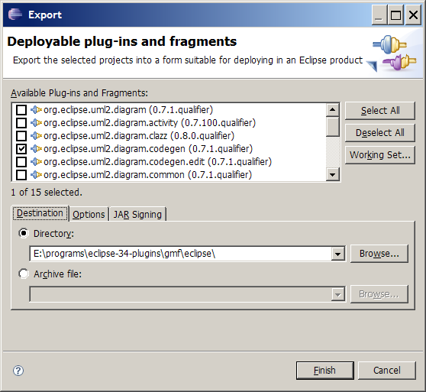
Figure 1 Building required plugin
- open project org.eclipse.uml2.diagram.def
  - goto /org.eclipse.uml2.diagram.def/structures, check that *.gmfgen files open correctly
- Open the .gmfgen file corresponding to the diagram you want to generate
- Select the top level element
- right click->Generate Diagram Code
- right click->Generate UML2Tools Diagrams

Defining Figures
Figure are defined in the .gmfgraph, under a Figure Gallery
Several FigureGallery can be defined in the same file.
Figure 2 shows what a Canvas can contain.

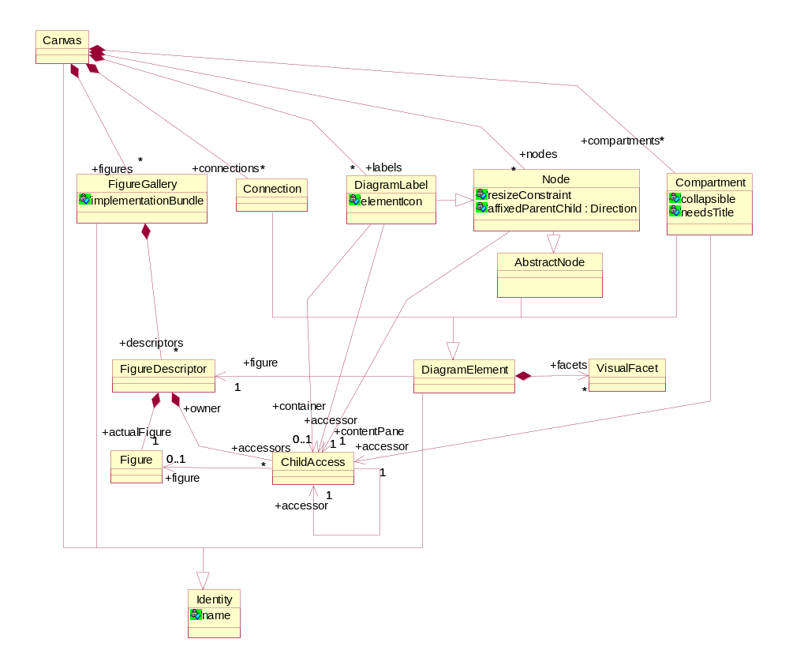Figure 2 Canvas Containment
A FigureGallery contains figure Descriptors. Figure 3 shows the hierarchy of concepts used to describe a figure. The toplevel concept is FigureGallery.
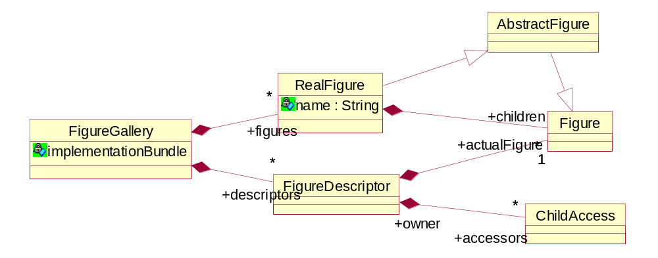
Figure 3 FigureGallery Containment

Figure is the toplevel concept of figures. Figure 5 shows the Figure hierarchy.
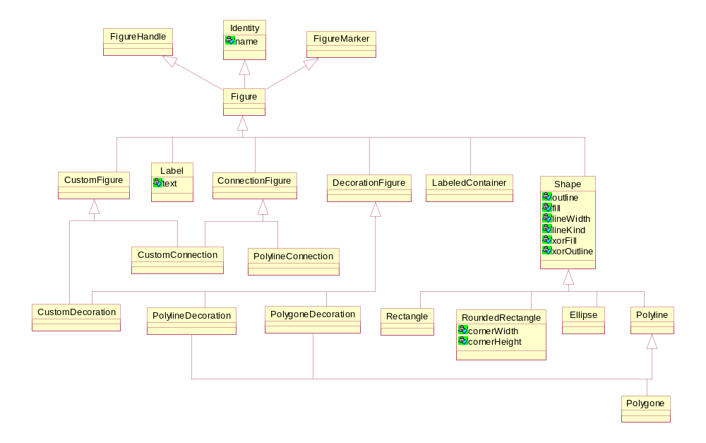
Figure 4 Figures hierarchy

A figure can contain different decoration (colors, font, location, dimension, layout) as shown in Figure 5.

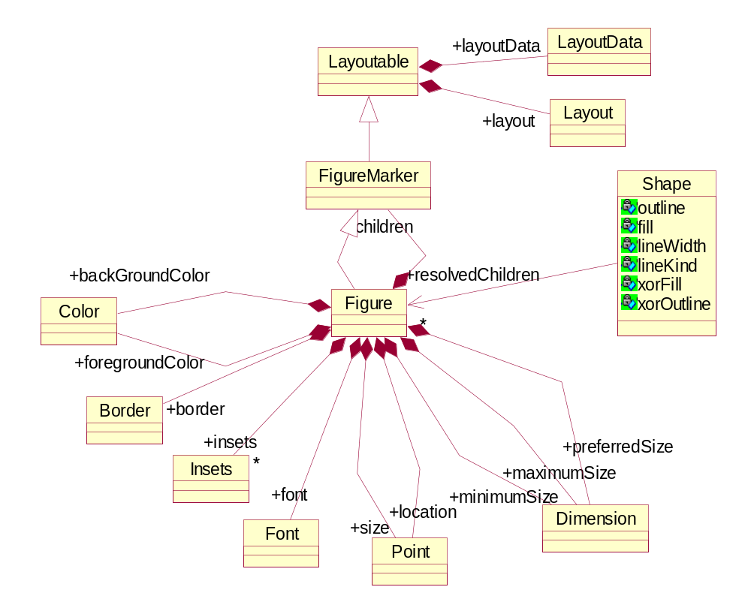
Figure 5 Figure Containment
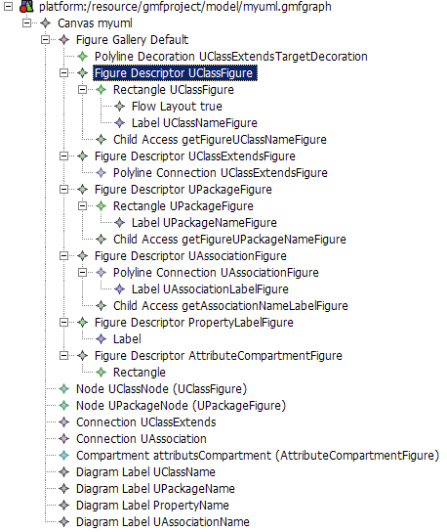
Figure 6 Figures and controllers definition

Papyrus Diagrams
This section describe the UML diagrams and for each list the required recipes. It also contains additional material helping in the realization of these diagrams.
TODO:
Provide a template for the diagrams descriptions

Diagram Template
- List of required features. Can be organized hierarchically by features.
- for each feature:
  - description of the feature, snapshot, possible difficulties
  - A snapshot of the associated business metamodel, or a reference to it
  - [optional] an example of the associated business model (xmi? object diagram?)
  - list of recipes needed to implement the feature

Class Diagram

Activity

Papyrus Features
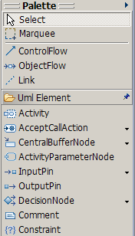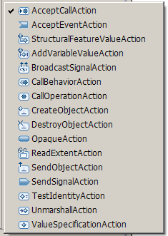
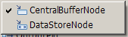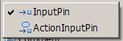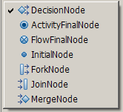
Figure 7 Activity Diagram Menus

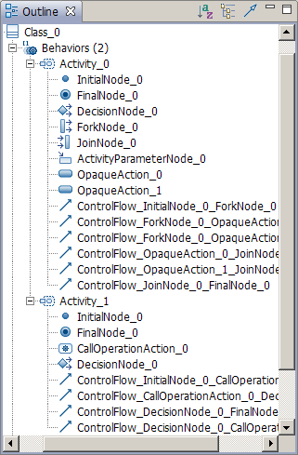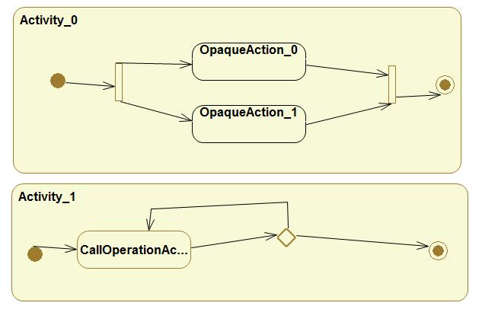
Figure 8 Activity Example and Outline

<ownedBehavior xmi:type="uml:Activity" xmi:id="_5D9oYA_eEd2hANj3aOj-pw" name="Activity_0">
<node xmi:type="uml:InitialNode" xmi:id="_8Soj0A_eEd2hANj3aOj-pw" name="InitialNode_0" outgoing="_hOtOAA_fEd2hANj3aOj-pw"/>
<node xmi:type="uml:ActivityFinalNode" xmi:id="_9rJ18A_eEd2hANj3aOj-pw" name="FinalNode_0" incoming="_kGSfIA_fEd2hANj3aOj-pw"/>
<node xmi:type="uml:DecisionNode" xmi:id="_-rX80A_eEd2hANj3aOj-pw" name="DecisionNode_0"/>
<node xmi:type="uml:ForkNode" xmi:id="_ATiNcA_fEd2hANj3aOj-pw" name="ForkNode_0" outgoing="_h4RvcA_fEd2hANj3aOj-pw _icpAwA_fEd2hANj3aOj-pw" incoming="_hOtOAA_fEd2hANj3aOj-pw"/>
<node xmi:type="uml:JoinNode" xmi:id="_BO_JEA_fEd2hANj3aOj-pw" name="JoinNode_0" outgoing="_kGSfIA_fEd2hANj3aOj-pw" incoming="_jGqOIA_fEd2hANj3aOj-pw _jsqeMA_fEd2hANj3aOj-pw"/>
<node xmi:type="uml:CentralBufferNode" xmi:id="_UhG6AA_fEd2hANj3aOj-pw" name="ActivityParameterNode_0"/>
<node xmi:type="uml:OpaqueAction" xmi:id="_cbTJYA_fEd2hANj3aOj-pw" name="OpaqueAction_0" outgoing="_jGqOIA_fEd2hANj3aOj-pw" incoming="_h4RvcA_fEd2hANj3aOj-pw"/>
<node xmi:type="uml:OpaqueAction" xmi:id="_erY8sA_fEd2hANj3aOj-pw" name="OpaqueAction_1" outgoing="_jsqeMA_fEd2hANj3aOj-pw" incoming="_icpAwA_fEd2hANj3aOj-pw"/>
<edge xmi:type="uml:ControlFlow" xmi:id="_hOtOAA_fEd2hANj3aOj-pw" name="ControlFlow_InitialNode_0_ForkNode_0" source="_8Soj0A_eEd2hANj3aOj-pw" target="_ATiNcA_fEd2hANj3aOj-pw">
<guard xmi:type="uml:LiteralString" xmi:id="_hPAI8A_fEd2hANj3aOj-pw" name="Guard"/>
<weight xmi:type="uml:LiteralString" xmi:id="_hPAI8Q_fEd2hANj3aOj-pw" name="Weight"/>
</edge>
<edge xmi:type="uml:ControlFlow" xmi:id="_h4RvcA_fEd2hANj3aOj-pw" name="ControlFlow_ForkNode_0_OpaqueAction_0" source="_ATiNcA_fEd2hANj3aOj-pw" target="_cbTJYA_fEd2hANj3aOj-pw">
<guard xmi:type="uml:LiteralString" xmi:id="_h4RvcQ_fEd2hANj3aOj-pw" name="Guard"/>
<weight xmi:type="uml:LiteralString" xmi:id="_h4Rvcg_fEd2hANj3aOj-pw" name="Weight"/>
</edge>
<edge xmi:type="uml:ControlFlow" xmi:id="_icpAwA_fEd2hANj3aOj-pw" name="ControlFlow_ForkNode_0_OpaqueAction_1" source="_ATiNcA_fEd2hANj3aOj-pw" target="_erY8sA_fEd2hANj3aOj-pw">
<guard xmi:type="uml:LiteralString" xmi:id="_icyxwA_fEd2hANj3aOj-pw" name="Guard"/>
<weight xmi:type="uml:LiteralString" xmi:id="_icyxwQ_fEd2hANj3aOj-pw" name="Weight"/>
</edge>
<edge xmi:type="uml:ControlFlow" xmi:id="_jGqOIA_fEd2hANj3aOj-pw" name="ControlFlow_OpaqueAction_0_JoinNode_0" source="_cbTJYA_fEd2hANj3aOj-pw" target="_BO_JEA_fEd2hANj3aOj-pw">
<guard xmi:type="uml:LiteralString" xmi:id="_jGqOIQ_fEd2hANj3aOj-pw" name="Guard"/>
<weight xmi:type="uml:LiteralString" xmi:id="_jGqOIg_fEd2hANj3aOj-pw" name="Weight"/>
</edge>
<edge xmi:type="uml:ControlFlow" xmi:id="_jsqeMA_fEd2hANj3aOj-pw" name="ControlFlow_OpaqueAction_1_JoinNode_0" source="_erY8sA_fEd2hANj3aOj-pw" target="_BO_JEA_fEd2hANj3aOj-pw">
<guard xmi:type="uml:LiteralString" xmi:id="_jszoIA_fEd2hANj3aOj-pw" name="Guard"/>
<weight xmi:type="uml:LiteralString" xmi:id="_jszoIQ_fEd2hANj3aOj-pw" name="Weight"/>
</edge>
<edge xmi:type="uml:ControlFlow" xmi:id="_kGSfIA_fEd2hANj3aOj-pw" name="ControlFlow_JoinNode_0_FinalNode_0" source="_BO_JEA_fEd2hANj3aOj-pw" target="_9rJ18A_eEd2hANj3aOj-pw">
<guard xmi:type="uml:LiteralString" xmi:id="_kGcQIA_fEd2hANj3aOj-pw" name="Guard"/>
<weight xmi:type="uml:LiteralString" xmi:id="_kGcQIQ_fEd2hANj3aOj-pw" name="Weight"/>
</edge>
</ownedBehavior>
Figure 9 UML Corresponding to Activity

Edges are plain object with source and target.

Activity with flow object
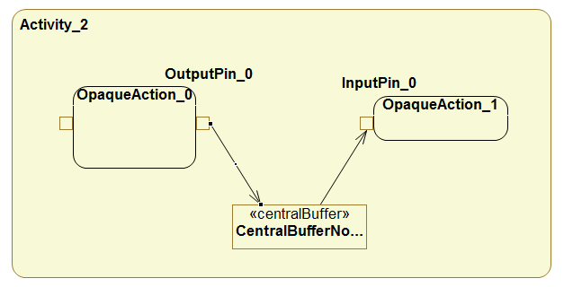
Figure 10 Activity Diagram with flow object
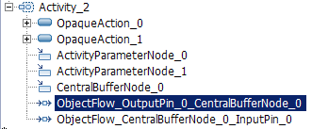
Figure 11 Activity Diagram with flow object
<ownedBehavior xmi:type="uml:Activity" xmi:id="_B8aS8A_jEd2hANj3aOj-pw" name="Activity_2">
<node xmi:type="uml:OpaqueAction" xmi:id="_EVmX4A_jEd2hANj3aOj-pw" name="OpaqueAction_0">
<inputValue xmi:id="_FIaU4A_jEd2hANj3aOj-pw" name="InputPin_0">
<upperBound xmi:type="uml:LiteralUnlimitedNatural" xmi:id="_FIkF4A_jEd2hANj3aOj-pw" value="*"/>
</inputValue>
<outputValue xmi:id="_GRk8YA_jEd2hANj3aOj-pw" name="OutputPin_0" outgoing="_k4e0QA_jEd2hANj3aOj-pw">
<upperBound xmi:type="uml:LiteralUnlimitedNatural" xmi:id="_GRk8YQ_jEd2hANj3aOj-pw" value="*"/>
</outputValue>
</node>
<node xmi:type="uml:OpaqueAction" xmi:id="_HnaG4A_jEd2hANj3aOj-pw" name="OpaqueAction_1">
<inputValue xmi:id="_JDfqYA_jEd2hANj3aOj-pw" name="InputPin_0" incoming="_mGth8A_jEd2hANj3aOj-pw">
<upperBound xmi:type="uml:LiteralUnlimitedNatural" xmi:id="_JDpbYA_jEd2hANj3aOj-pw" value="*"/>
</inputValue>
</node>
<node xmi:type="uml:CentralBufferNode" xmi:id="_XJnQgA_jEd2hANj3aOj-pw" name="ActivityParameterNode_0"/>
<node xmi:type="uml:CentralBufferNode" xmi:id="_aZfF0A_jEd2hANj3aOj-pw" name="ActivityParameterNode_1"/>
<node xmi:type="uml:CentralBufferNode" xmi:id="_jEQdkA_jEd2hANj3aOj-pw" name="CentralBufferNode_0" outgoing="_mGth8A_jEd2hANj3aOj-pw" incoming="_k4e0QA_jEd2hANj3aOj-pw">
<upperBound xmi:type="uml:LiteralUnlimitedNatural" xmi:id="_jEZngA_jEd2hANj3aOj-pw" value="*"/>
</node>
<edge xmi:type="uml:ObjectFlow" xmi:id="_k4e0QA_jEd2hANj3aOj-pw" name="ObjectFlow_OutputPin_0_CentralBufferNode_0" source="_GRk8YA_jEd2hANj3aOj-pw" target="_jEQdkA_jEd2hANj3aOj-pw">
<guard xmi:type="uml:LiteralString" xmi:id="_k4olQA_jEd2hANj3aOj-pw" name="Guard"/>
<weight xmi:type="uml:LiteralString" xmi:id="_k4olQQ_jEd2hANj3aOj-pw" name="Weight"/>
</edge>
<edge xmi:type="uml:ObjectFlow" xmi:id="_mGth8A_jEd2hANj3aOj-pw" name="ObjectFlow_CentralBufferNode_0_InputPin_0" source="_jEQdkA_jEd2hANj3aOj-pw" target="_JDfqYA_jEd2hANj3aOj-pw">
<guard xmi:type="uml:LiteralString" xmi:id="_mG3S8A_jEd2hANj3aOj-pw" name="Guard"/>
<weight xmi:type="uml:LiteralString" xmi:id="_mG3S8Q_jEd2hANj3aOj-pw" name="Weight"/>
</edge>
</ownedBehavior>
Figure 12 Corresponding UML

Required Constructs
UML | Construct | Example
Activity Diagram | diagram | 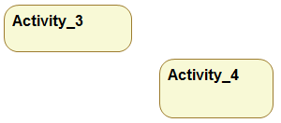
Activity | Node with  - rounded corner,  - title  - nested draw area | 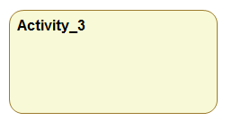
Action | Node inside activity  - rounded corner,  - title  - pins (port like) | 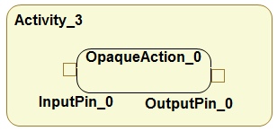
Control Flow | Arrow between Actions  Link with its own edge  Complex Business Model creation (link with 2 sub objects) | 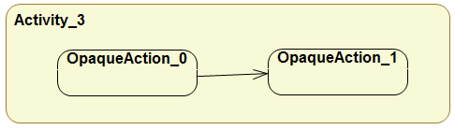
Initial Node  Final Node  Flow Final Node  Fork Node  Join Node  Decision Node  Merged Node | Node with dedicated figure | 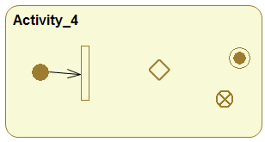

Required Receipts
- Node with rounded corner
- Node with predefined color
- Node with placed title
- Node with nested drawn area
- Node with ports
- Link with Edge Object
- Node with dedicated figure
- Complex Business Model Creation

GMF Papyrus

Sequence

Recipes
TODO:
- Organize recipes by categories
- Provide a template for the recipes
- Change early ‘recipes’ in accordance to the template
- Warning: some of the early recipes are built as a tutorial. This is not a way to go. This was done in another context and copied here.

Recipe Template (draft)

Context
- An overview of the required figure/element
- A description and a figure of what the recipe will provide
- A description and a class diagram of the business model used by the figure. An example of the expected model (xmi? object diagram?)
- Some comments describing the difficulties if any

Proposed Solution
- overview of the solution
- More details about the solution
- Example and snapshots of the differents GMF models
- A zip file with a project containing the solution. Ideally one small project per recipe. The project focusing on the recipe.

List of Possible Recipes
Note: Even the simplest one can be explained.

- Node with rounded corner
- Node with predefined color
- Link with Edge Object
- Link with anchor anywhere

- Node with placed title
- Node with nested drawn area
- Node with ports
- Node with dedicated figure
- Complex Business Model Creation

- Link with floating role
- Node with compartment
  - compartment with list of properties
  - compartment with nested graphical area
- Different figure for the same business element
  - static: 2 different creation tool create the same business element, but shown in different flavor
  - dynamic: a business element can have different representation, changed by setting a property.

Node with predefined colors
Node colors can be predefinied in the gmfgraph model.
For each figure, the background and the foreground can be predefined (Figure 13).
This doesn’t seem to work for link ☹.
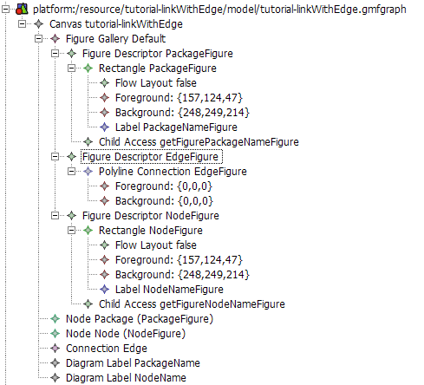
Figure 13 Setting color for nodes

Link A→B owned by A
This tutorial explain how to generate a link between two shape A and B. The link is owned by A. The corresponding metamodel is shown Figure 14.
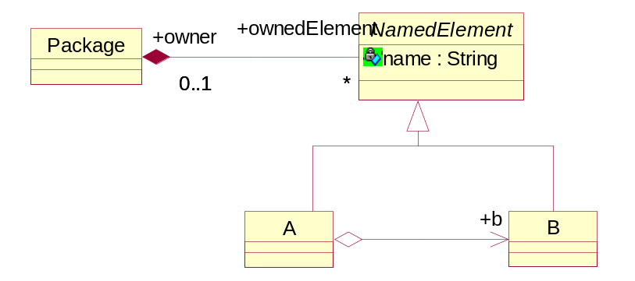
Figure 14 Metamodel representing a reference A → B owned by A
Warning : in the reference A → B, B should be contained by reference because it is contained by value by the package (from NamedElement).

The GMF Dashboard eases the creation of the different files.
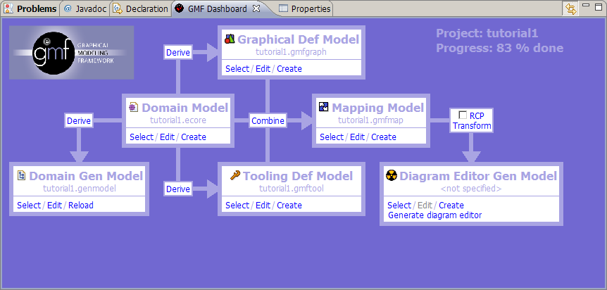
Figure 15 Control panel

Create .gmfGraph
Click on derive between Domain Model and Graphical Def Model. A new window open :
Set the name of the file to generate or accept the default one. Click next.
Select the top level element of your model. This top level element will be associated to the diagram area. In our case choose Package (Figure 16). Click next.
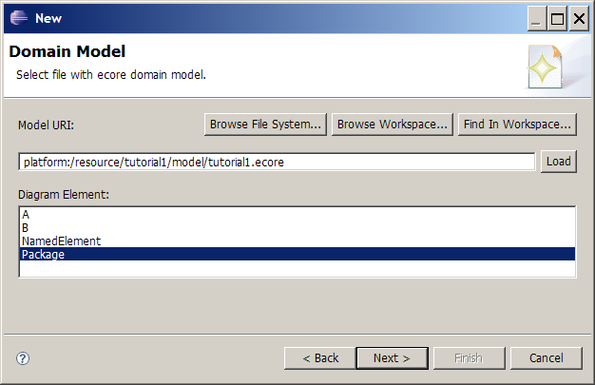
Figure 16 Select the top level element

In the next window, you can choose the figure for each element. There is tree basic kinds :
- shape
- link
- text label
For each element, select how you want it to be represented on the diagram.
Element A and B will be drawn as a shape.
Property A.name will be drawn as text.
Reference A.b will be drawn as a link.

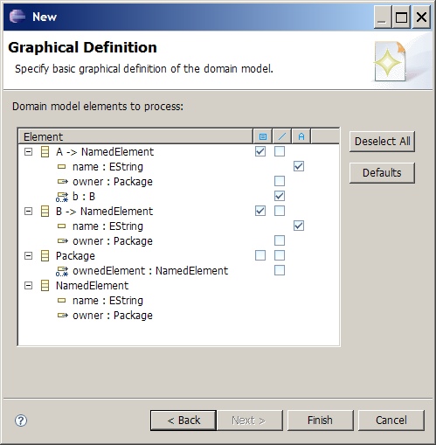
Figure 17 Choose figure for each of your domain elements
Click finish to generate the .gmfgraph file.
You should obtain something like in Figure 18.
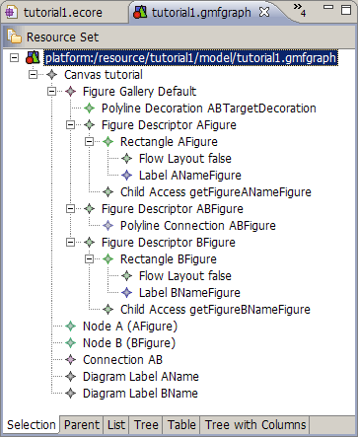
Figure 18 The .gmfgraph file
In Figure 18, Figure Gallery contains the figure definitions
Node , Connection and Diagram Label are the controllers for the figures. They reference their respective figures (look at the properties).
Node figures have “accessors”. This is used as an interface to modify the figure from the controller. Each accessor describe how to access a settable value in the figure (like a label).

Create .gmftool
Click on derive between Domain Model and Tooling Def Model. Set the name of the file to generate or accept the default one. Click next. A new window open.
Select the top level element of your model.

Select the tools you want to appear in the palette (Figure 19).
There is two kind of tool:
- shape creation tool
- link creation tool
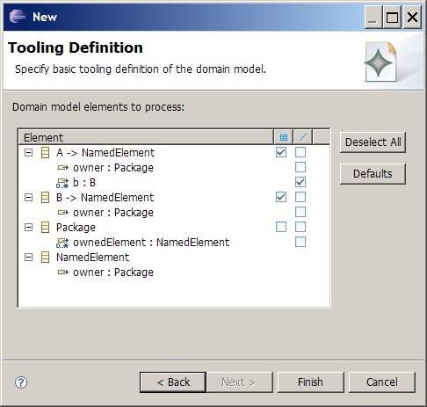
Figure 19 Creation Tools Selection.

Create .gmfmap
This is the more complicated model. It allows to associate figures and controllers to domain model elements.
Click on combine between Domain Model and Mapping Model. Set the name of the file to generate or accept the default one. Click next.
Select the top level element of your model.
Accept default palette and default diagram canvas until you got window of Figure 20.
Here GMF proposes some default mapping.

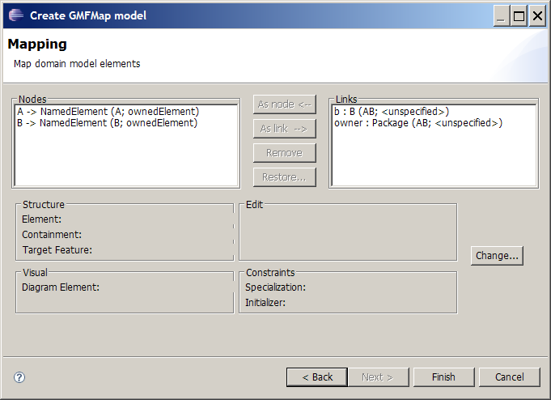
Figure 20 Mapping Wizard generated by GMF
Node elements are correct, but there is two links.
Remove the second link (owner : Package).
Figure 21 and Figure 22 try to explain generated names.

b : B (AB; <unspecified> )
domain element
feature b of type B ght label mapping ()ller for each Feature Label Mapping. feauture
controller
element name
containing element
Figure 21 Element name interpretation

A -> NamedElement (AB; b )
domain elements
ght label mapping ()ller for each Feature Label Mapping. A extends NamedElement
controller
element name
containing feature
Figure 22 Element name interpretation
Click next until the new model is generated.
You need to perform changes in the model :
Open the “Feature Label Mapping”, and check its properties. You need to specify the Label controller for each Feature Label Mapping. Set it to the right label mapping (Node A -> Label AName)
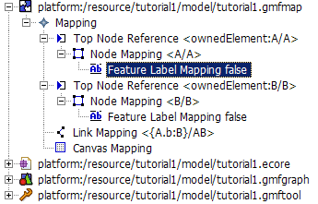

Node Mapping :
- Top Node Reference
  - Maps one domain element to the feature that will own it.
- Node Mapping
  - Map a domain element to its controller. Contains nested description of its feature mappings.
- Feature Label Mapping
  - Allows to map a feature of a domain element to its Label controller.

Link Mapping :
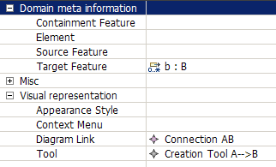

Link A→B with Edge Object
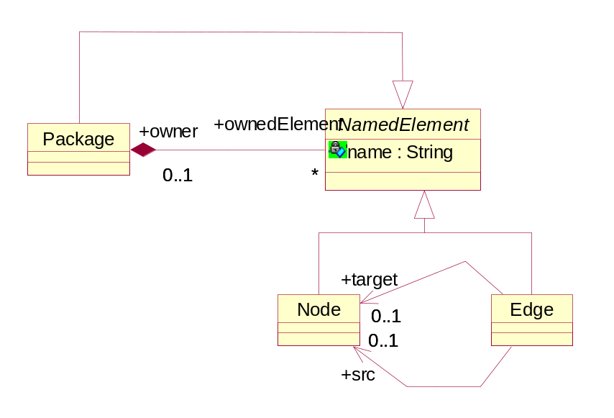
Figure 23 Node with Edge Metamodel
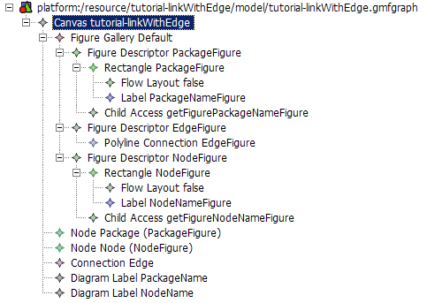
Figure 24 Figure definitions

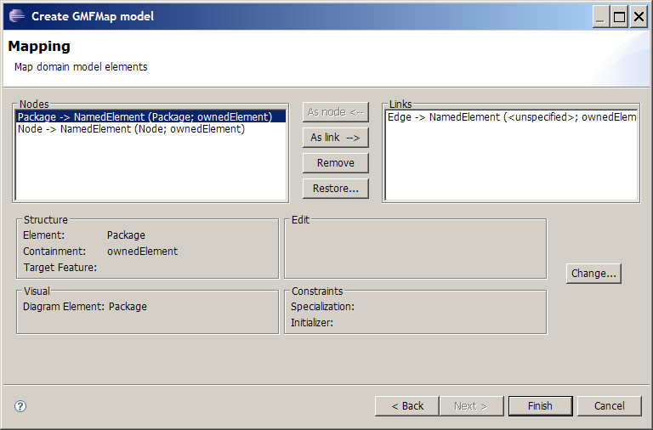
Figure 25 Mapping wizard

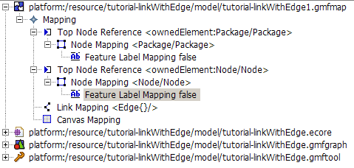
Figure 26 Mapping model
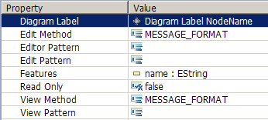
Figure 27 Feature Label Mapping Property View
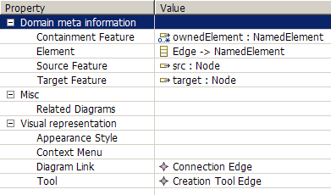
Figure 28 Link Mapping Properties View

Label Mapping
Select Feature Label Mapping in the tree (Figure 26) and set the Diagram Label property in the property view (Figure 27).

Link mapping
Select the Link Mapping in the tree and set the following properties:
- Containment Feature – name of the feature (in the element associated with the diagram) that will contain the created element
- Element – Element that will be created
- Source Feature – the element feature that will contain the source of the link
- Target Featute – the element feature that will contain the target of the link
- Diagram Link – the figure that will represent the element
- Tool – The tool that will be used to create the element.

Link with anchor anywhere on other link (Comment link)
tutorial-annotation.zip
A Comment with a list of annotatedElements.
Comment can be attached to any elements, including link.
The link anchor can be anywhere on the attached link.
This tutorial extends the Link A→B with Edge Object tutorial.

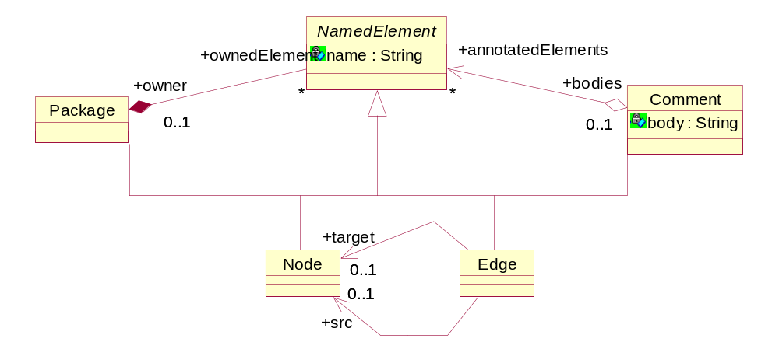
Figure 29 Comment Metamodel

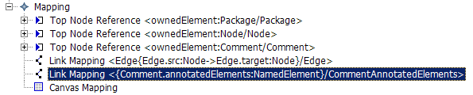
Figure 30 Comment Mapping
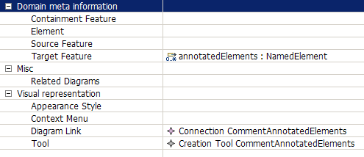
Figure 31 Comment Link Mapping Properties

The resulting link can be attached to any NamedElement, including Edge. The anchor is anywhere on the edge (Figure 32).

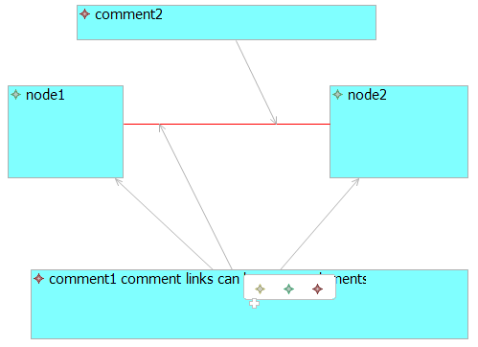
Figure 32 Comment link Example

Making figures sensitive to attributes of semantic elements
http://serdom.szn.pl/serwiki/Eclipse/GMF/Making_figures_sensitive_to_attributes_of_semantic_elements
http://wiki.eclipse.org/GMF_Tips#Making_figures_sensitive_to_attributes_of_semantic_elements

Ports sticking to the side of a component
http://wiki.eclipse.org/GMF_Newsgroup_Q_and_A

How do I get ports to stick to the side of a component?
- Q: My first problem was that I couldn't find a good way to get the ports stick to the component since apparently GMF doesn't support nodes
- A: Did you try setting affixedParentSide attribute for port Node in .gmfgraph model? This attribute was recently added and is available in 2.0 builds.

Node with a label
The purpose is to create a Node with a label, where the label is the name.
This example is based on the creation of the package element.

Gmgraph
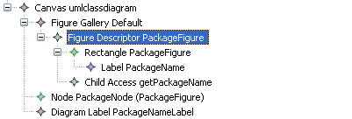
Figure 33: figure with a label
First, the figure descriptor with a rectangle figure has to be created. To add a label, create a label into the figure rectangle. Then an access to this label has to be created: create a child access and refers to the label figure.
Then create a diagram label that refers to the child access.

Gmfmap

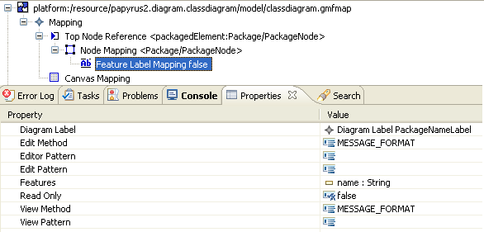
First the node has to be created. Then create a feature label mapping the map the feature (here the name of the package) and the diagram label figure.

Result
The name is editable.
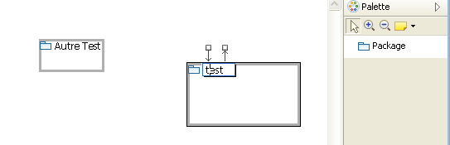

Options
To set a default name when you create the entity, the text property of the label can be filled in the gmfgraph.
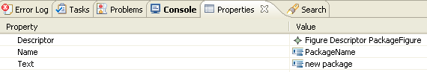

To modify view with a specific grammar, you can use fields “edit pattern” and “view pattern” in gmfmap.

For more information you can see http://wiki.eclipse.org/GMF_Labels

Add Policy to remove orphaned View
The purpose is to add an editpolicy that removes all orphan view (views that are linked to UML element).

Create a new Edit Policy

First , create a new editpolicy that inherits org.eclipse.papyrus.diagram.common.editpolicies.OrphanViewPolicy.
In This edit policy you will create an array that will contains all VISUAL ID of element that must not be removed. Indeed, in a graphical appearance, elements are not always linked to an uml element, for example compartment, special link…
Then create the constructor, in the snapshot. Don’t forget to call the method init.

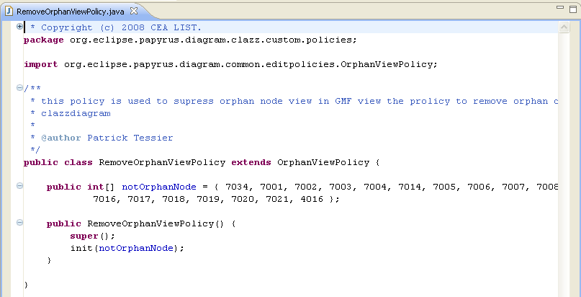

GmfGen
The editpolicy must be referenced into the gmfgen. To do that, create an new custom behaviour in the Gen Diagram and in all Gen Compartment.

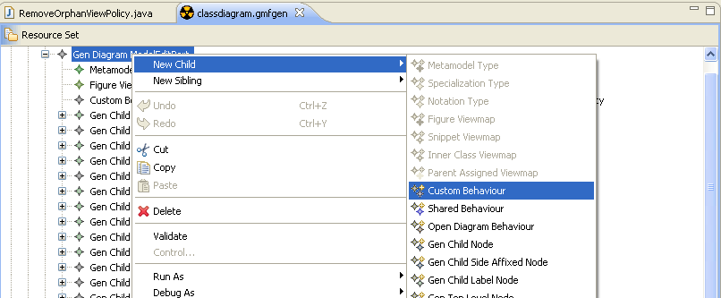

In the property view, fill the following information:
- Key: "RemoveOrphanView"
- class name: org.eclipse.papyrus.diagram.clazz.custom.policies.RemoveOrphanViewPolicy
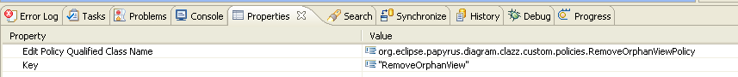

Result
At the generation, the method createDefaultEditPolicies() is filled in each edit part diagram and compartment

