Introduction
This cookbook contains a set of recipes useful to develop diagrams for Papyrus with the GMF framework. Each recipe focuses on a small recurrent problem. It provides a solution and an example for this problem and can be easily reused in another context. A recipe can be seen as a reusable pattern. Each recipe is described following the same guideline.

In the context of Papyrus and UML, several diagrams need to be developed. These diagrams can be decomposed in basic functionalities, each one solved by one of the recipe. A lot of diagrams share common functionalities, and so recipe can be shared.

Recipes can also be used to develop other GMF diagrams. This cookbook can be used as a reference and good practices using GMF. If well written, we can think to publish it later.

GMF basics
This section contains GMF basics principle.

Model roles
.ecore – define domain model
.genmodel – extends domain model by adding generation data

.gmfgraph – define figures and controllers
.gmftool – define palette, menu, …
.gmfmap – map domain element to controllers and figures
.gmfgen – gathers the information from the above models and adds generation properties for code generation

Compiling UML2Tools
- download sources from CVS
- Build the required plugin org.eclipse.uml2.diagram.codegen and put it in the current Eclipse plugin directory :
  - open the project org.eclipse.uml2.diagram.codegen
  - open its plugin.xml
  - choose Overview->Exporting->3. … Export Wizard
  - choose your Eclipse directory as destination (see Figure 1)
  - Restart Eclipse

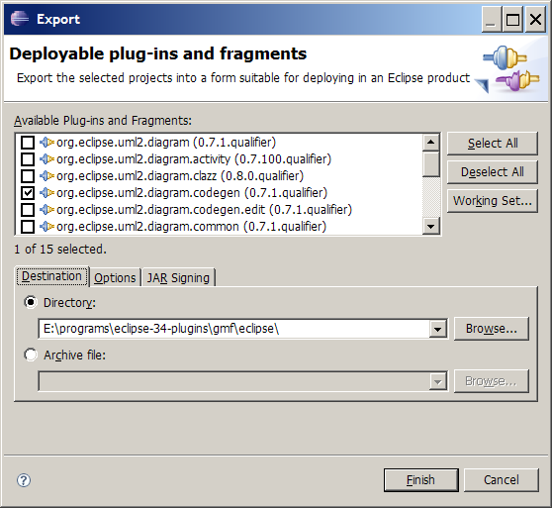
Figure 1 Building the required plugin

- open project org.eclipse.uml2.diagram.def
  - goto /org.eclipse.uml2.diagram.def/structures, check that *.gmfgen files open correctly
- Open the .gmfgen file corresponding to the diagram you want to generate
- Select the top level element
- right click->Generate UML2Tools Diagrams

Defining Figures
Figures are defined in the .gmfgraph, under a Figure Gallery. Several Figure Galleries can be defined within the same file.
Figure 2 shows what a Canvas can contain:

Figure 2 Canvas Containment

A FigureGallery contains figure Descriptors. Figure 3 shows the hierarchy of concepts used to describe a figure. The toplevel concept is FigureGallery.

Figure 3 FigureGallery Containment

Figure is the toplevel concept of figures. Figure 5 shows the Figure hierarchy.

Figure 4 Figures hierarchy

A figure can contain different decoration (colors, font, location, dimension, layout) as shown in Figure 5.

Figure 5 Figure Containment
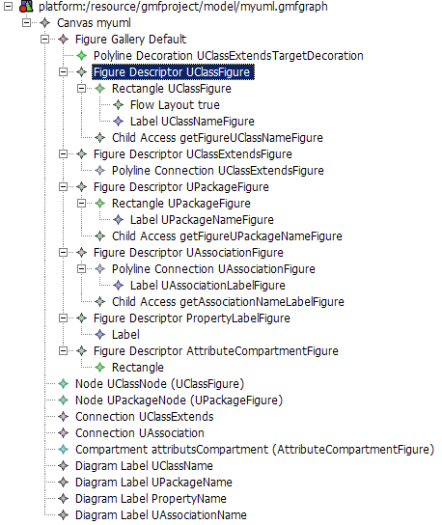
Figure 6 Figures and controllers definition

Papyrus Diagrams
This section describes the template for designing model graphical editors. The designs of the UML diagram editors included within Papyrus are in separate files.

Diagram Template
The aim of this template is to describe how to design a model graphical editor. It follows the logical procedure of creating a graphical editor that will create/edit metamodel instances. Therefore, the design must include information about the metamodel, the elements from the metamodel that should be edited graphically (or by other means of the editor), the graphical representation of each element, how to create the graphical elements and how to edit their properties (if any special mechanism is needed for some of them).

The template:

Introduction
A brief description should be given in order to explain the purpose of the current design.

Graphical Elements Design
Summary of the parts to describe:
- Editable Elements: Identification of the metamodel used and the set of elements that can be manipulated by the editor (graphically or by other means). If there is no existing metamodel that fit the needs and a new one must be implemented, then all the elements and their relationships should be described.
- Graphical representation: Identification and description of the graphical figures used by the user to manipulate the model elements.
- Creation mechanisms: Tools used for creating new graphical elements.
- Element properties edition: How to edit element properties (not necessarily for all of them but rather for the ones that need complex user interfaces).
- Additional specifications: Additional features that should be specified.
- Useful recipes: A set of recipes useful for fulfilling the task of creating the editor via GMF generative technology.

- Elements

When designing a Graphical Editor, we may start from two different cases. Each case has its own procedure:

Case 1. Use of an existing metamodel

Step 1.
Identify the metamodel
Step 2.
Select the set of elements that will be used without any modification.
Step 3.(If needed)
Select the set of elements that will be used with some modifications.
For each element from the previous set, indicate the modifications. A modification should contain the following information:
- List with new properties
  - Name and type
- Constrains list (plain text)
- Relationships with other elements (plain text)
Step 4.
Indicate the new elements that will be added to the metamodel. Each new element should contain the following information:
- Name
- Properties list
  - Name and type
- Constraints list (plain text)
- Relationships with other elements (plain text)

Case 2. Creation of a new metamodel

When there is no existing metamodel that fits our needs, a new one should be created. The description of each element should contain the following information:
- Name
- Properties list
  - Name and type
- Constraints list (plain text)
- Relationships with other elements (plain text)

- Graphical representation

The graphical figures represent the editable elements of a Graphical Editor. However, not all of the editable elements need to have a graphical representation because some of them may be manipulated by other means.
For each element with graphical representation, the following information should be provided:
- A list with the possible figures that can represent the current element. A figure description should contain the following information:
  - Element: Semantic element represented by the figure.
  - Drawing: Graphical appearance of the figure. It should include, if necessary, a division in different part that would be identified by numbers. Each part must include a description with the following information:
    - Type (the possible types are listed below)
    - Description of its contents

The possible part types in which a figure can be divided are the next ones:
- Label
  - It is necessary to describe how its text is obtained (defined statically, obtained from a property value, evaluating an expression, etc.)
- List
  - It is necessary to describe from where are the values obtained.
- Canvas
  - It is necessary to show the collection of elements that can be created over the canvas.
- Figure
  - It is necessary to describe the aspect of the figure (a rectangle, a rounded rectangle, etc.)

- Creation mechanisms

The creation mechanisms description includes how new figures are created within the diagrams manipulated by the graphical editor.
There are two basic mechanisms: (1) The palette and (2) the shortcuts.
(1) Palette
Basically a palette is divided into groups. A group contains buttons (one or more) and separators (to separate buttons within a same group). A button is used to create one (single) or more (multiple) graphical elements (if more than one, the user will be prompted to select one via a drop down list or some visual mechanism).

The following order is suggested for the groups:
- Group 1
  - Elements drawn into the canvas
- Group 2
  - Elements drawn into the object i
- Group 3
  - Elements drawn into the object j
- .....
- Group N
  - Links

Example (extracted from the Activity Design):
- Activity Palette
  - Activities
    - Single button: “Activity”
      - Creates an Activity element with its default values.
    - Single button: “ActivityPartition”
      - Creates an ActivityPartition element with its default values.
  - Actions
    - Single button: “Send object Action”
      - Creates a SendObjectAction element with its default values, an InputPin element referenced by the “target” property and another InputPin element referenced by the “request” property.
...

(2) Shortcuts
It is common in graphical editors to provide shortcuts for element creation in order to save time to the user. Shortcuts appear every time the user leaves the mouse over an element which can contain other elements. For describing the shortcuts the following information should be provided:
- Graphical element that provides the following shortcuts
  - Shortcut 1
    - Element created by the shortcut 1
...
  - Shortcut N
    - Element created by the shortcut N

- Element properties edition

The target of this section is to describe the mechanisms used by the graphical editor to modify the values of the editable elements properties.
The properties are grouped in tabs. If needed, synthetic properties can be used as long as a description of the property behaviour is given (a synthetic property is not stored within the semantic element because it does not exist. However, it must be edited in the same way as the others).
- Semantic Element
  - Tab 1
    - Property 1 [widget/s needed]
    - Property 2 [widget/s needed]
    - SubTab 1
      - Property 3 [widget/s needed]
  - Tab 2
    - Property 4
...

If the property should be edited in a specific way, the widgets/set of widgets should be indicated.

- Other specifications

The aim of this section is to describe additional properties of the graphical editor like file extensions, font styles, etc.

- Useful recipes

If there are any recipes within this document that can be useful for implementing the current editor, it would be very interesting to list them here.

Recipes
TODO:
- Organize recipes by categories
- Provide a template for the recipes
- Change early ‘recipes’ in accordance to the template
- Warning: some of the early recipes are built as a tutorial. This is not a way to go. This was done in another context and copied here.

Recipe Template

Context
- Describe the purpose of the recipe.
- If possible, provide both a figure showing what the recipe will supply and a class diagram of the business model used by the figure.
- Add comments describing the difficulties if any.

Proposed Solution
- Overview of the solution (recommended if the solution implies a great number of steps).
- Steps of the solution:
  - GMF Models
    - For each GMF Model involved (gmfgraph, gmftool, gmfmap, gmfgen)
      - Description of what should be done in the model.
      - Describe the steps to follow. The use of screenshots is advisable as they can be used as a guide.
  - Java Code
    - For each generated Java File that should be modified:
      - Indicate the package where it is stored.
      - Describe the changes that should be done.
    - For each new Java File that should be implemented:
      - Indicate its name and the package where it should be stored.
      - Provide the Java code.
- If possible, supply a zip file with a project containing the solution. Ideally one small project per recipe. The project should focus only on the recipe.

List of Possible Recipes
Note: Even the simplest one should be explained.

- Node with rounded corner
- Node with predefined color
- Link with Edge Object
- Link with anchor anywhere
- Node with placed title
- Node with nested drawn area
- Node with ports
- Node with dedicated figure
- Complex Business Model Creation
- Link with floating role
- Node with compartment
  - compartment with list of properties
  - compartment with nested graphical area
- Different figure for the same business element
  - static: 2 different creation tool create the same business element, but shown in different flavor
  - dynamic: a business element can have different representation, changed by setting a property.

Node with predefined colors
Node colors can be predefinied in the gmfgraph model.
For each figure, the background and the foreground can be predefined (Figure 7).
This doesn’t seem to work for link ☹.
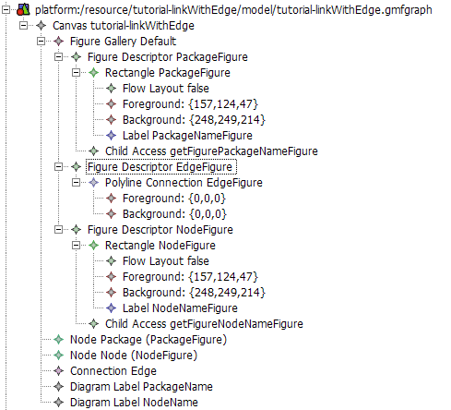
Figure 7 Setting color for nodes

Link A→B owned by A

Context
This tutorial explains how to generate a link between two shape A and B. The link is owned by A. The corresponding metamodel is shown Figure 8.

Figure 8 Metamodel representing a reference A → B owned by A
Warning : in the reference A → B, B should be contained by reference because it is contained by value by the package (from NamedElement).

Proposed solution
The GMF Dashboard eases the creation of the different files.
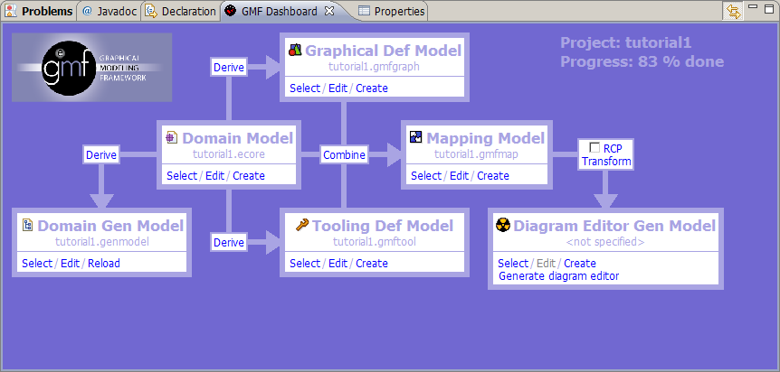
Figure 9 Control panel

Step 1 : Create .gmfGraph
Click on derive between Domain Model and Graphical Def Model. A new window open :
Set the name of the file to generate or accept the default one. Click next.
Select the top level element of your model. This top level element will be associated to the diagram area. In our case choose Package (Figure 10). Click next.
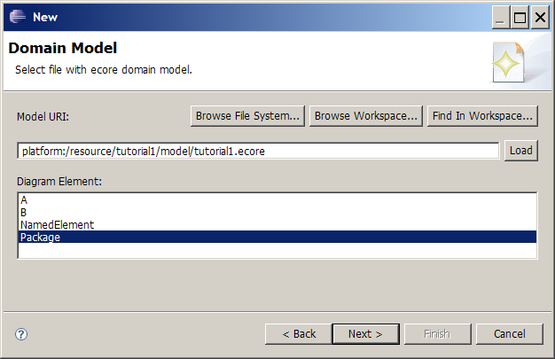
Figure 10 Select the top level element

In the next window, you can choose the figure for each element. There is tree basic kinds :
- shape
- link
- text label
For each element, select how you want it to be represented on the diagram.
Element A and B will be drawn as a shape.
Property A.name will be drawn as text.
Reference A.b will be drawn as a link.

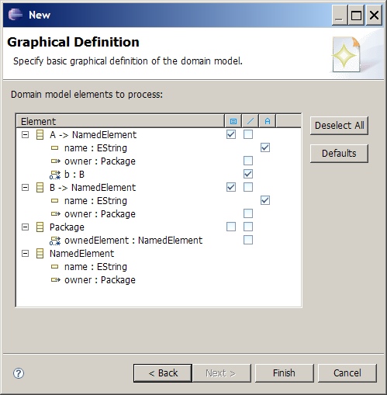
Figure 11 Choose figure for each of your domain elements
Click finish to generate the .gmfgraph file.
You should obtain something like in Figure 12.
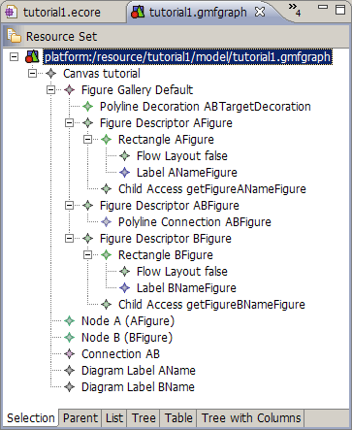
Figure 12 The .gmfgraph file
In Figure 12, Figure Gallery contains the figure definitions
Node , Connection and Diagram Label are the controllers for the figures. They reference their respective figures (look at the properties).
Node figures have “accessors”. This is used as an interface to modify the figure from the controller. Each accessor describe how to access a settable value in the figure (like a label).

Step 2 : Create .gmftool
Click on derive between Domain Model and Tooling Def Model. Set the name of the file to generate or accept the default one. Click next. A new window open.
Select the top level element of your model.

Select the tools you want to appear in the palette (Figure 13).
There is two kind of tool:
- shape creation tool
- link creation tool
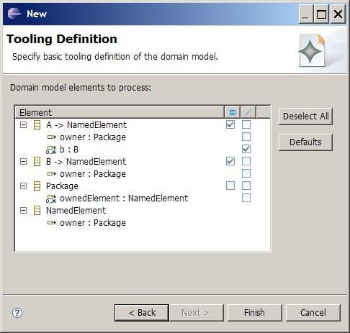
Figure 13 Creation Tools Selection.

Step 3 : Create .gmfmap
This is the more complicated model. It allows to associate figures and controllers to domain model elements.
Click on combine between Domain Model and Mapping Model. Set the name of the file to generate or accept the default one. Click next.
Select the top level element of your model.
Accept default palette and default diagram canvas until you got window of Figure 14.
Here GMF proposes some default mapping.

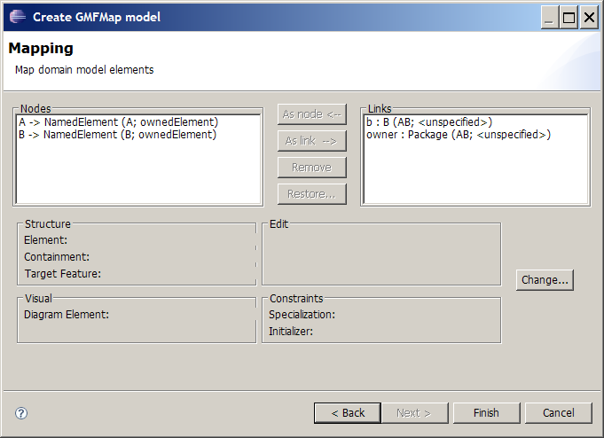
Figure 14 Mapping Wizard generated by GMF
Node elements are correct, but there is two links.
Remove the second link (owner : Package).
Figure 15 and Figure 16 try to explain generated names.

b : B (AB; <unspecified>)
domain element
feature b of type B
controller
element name
containing element
Figure 15 Element name interpretation

A → NamedElement (AB ; b)
domain elements
A extens NamedElement
controller
element name
containing feature
Figure 16 Element name interpretation
Click next until the new model is generated.
You need to perform changes in the model :
Open the “Feature Label Mapping”, and check its properties. You need to specify the Label controller for each Feature Label Mapping. Set it to the right label mapping (Node A -> Label AName)
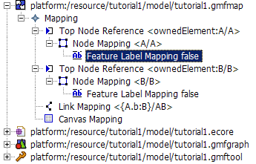

Node Mapping :
- Top Node Reference
  - Maps one domain element to the feature that will own it.
- Node Mapping
  - Map a domain element to its controller. Contains nested description of its feature mappings.
- Feature Label Mapping
  - Allows to map a feature of a domain element to its Label controller.

Link Mapping :
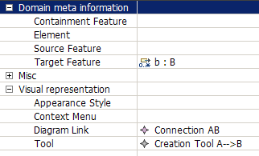

Link A→B with Edge Object

Figure 17 Node with Edge Metamodel
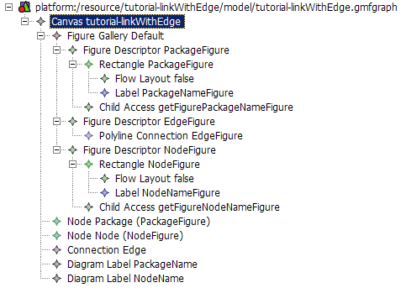
Figure 18 Figure definitions

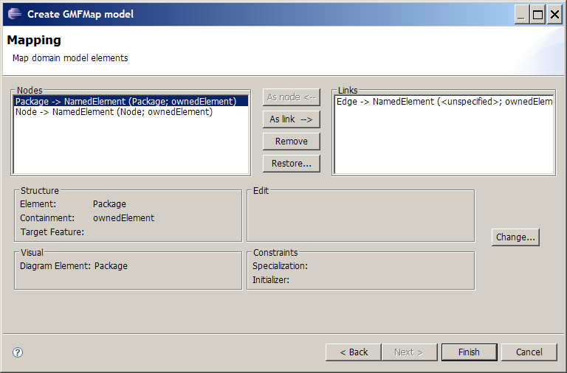
Figure 19 Mapping wizard

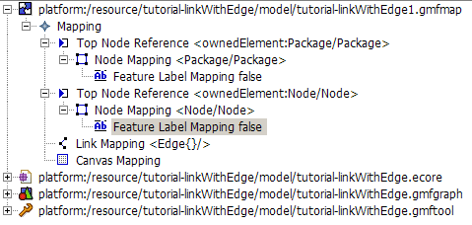
Figure 20 Mapping model
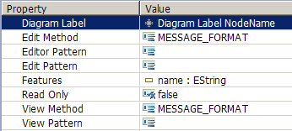
Figure 21 Feature Label Mapping Property View
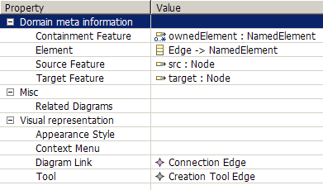
Figure 22 Link Mapping Properties View

Label Mapping
Select Feature Label Mapping in the tree (Figure 20) and set the Diagram Label property in the property view (Figure 21).

Link mapping
Select the Link Mapping in the tree and set the following properties:
- Containment Feature – name of the feature (in the element associated with the diagram) that will contain the created element
- Element – Element that will be created
- Source Feature – the element feature that will contain the source of the link
- Target Featute – the element feature that will contain the target of the link
- Diagram Link – the figure that will represent the element
- Tool – The tool that will be used to create the element.

Link with anchor anywhere on other link (Comment link)
tutorial-annotation.zip
A Comment with a list of annotatedElements.
Comment can be attached to any elements, including link.
The link anchor can be anywhere on the attached link.
This tutorial extends the Link A→B with Edge Object tutorial.

Figure 23 Comment Metamodel

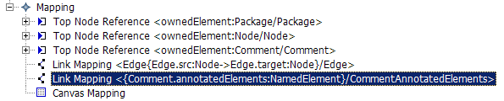
Figure 24 Comment Mapping
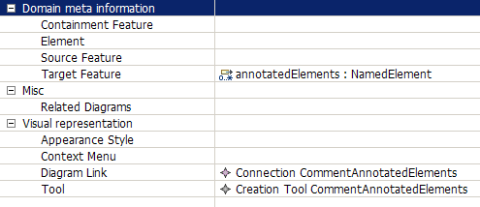
Figure 25 Comment Link Mapping Properties

The resulting link can be attached to any NamedElement, including Edge. The anchor is anywhere on the edge (Figure 26).

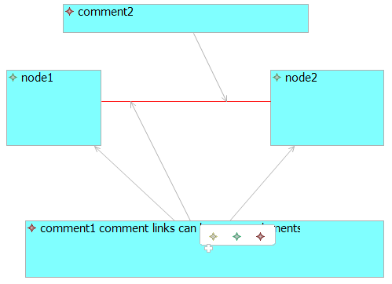
Figure 26 Comment link Example

Making figures sensitive to attributes of semantic elements
http://serdom.szn.pl/serwiki/Eclipse/GMF/Making_figures_sensitive_to_attributes_of_semantic_elements
http://wiki.eclipse.org/GMF_Tips#Making_figures_sensitive_to_attributes_of_semantic_elements

Ports sticking to the side of a component
http://wiki.eclipse.org/GMF_Newsgroup_Q_and_A

How do I get ports to stick to the side of a component?
- Q: My first problem was that I couldn't find a good way to get the ports stick to the component since apparently GMF doesn't support nodes
- A: Did you try setting affixedParentSide attribute for port Node in .gmfgraph model? This attribute was recently added and is available in 2.0 builds.

Node with a label

Context
The purpose is to create a Node with a label, where the label is the name.
This example is based on the creation of the package element.

Proposed solution

Step 1: Gmgraph
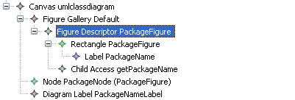
Figure 27: figure with a label
First, the figure descriptor with a rectangle figure has to be created. To add a label, create a label into the figure rectangle. Then an access to this label has to be created: create a child access and refers to the label figure.
Then create a diagram label that refers to the child access.

Step 2: Gmfmap

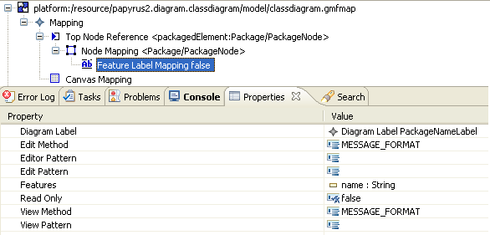
First the node has to be created. Then create a feature label mapping the map the feature (here the name of the package) and the diagram label figure.

Step 3: Result
The name is editable.
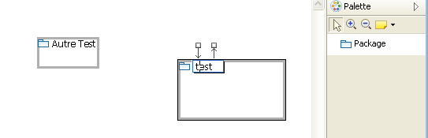

Optional step
To set a default name when you create the entity, the text property of the label can be filled in the gmfgraph.
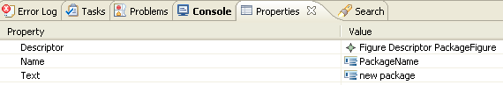

To modify view with a specific grammar, you can use fields “edit pattern” and “view pattern” in gmfmap.

For more information you can see http://wiki.eclipse.org/GMF_Labels

Figure changes in response of semantic changes
TODO

Figure swapping action
TODO

Links whose source/target graphical elements differ from the source/target semantic elements
TODO
main target: understand how to create uml2 associations

Graphical elements that are contained within one element but semantically contained within another element

Context
Occasionally, when working with already existing metamodels, we face the situation in which an element must contain graphically other elements but not semantically. This happens, for example, in the sequence diagram case where Lifelines contain graphically Behaviors but the Behaviors are contained within the Lifeline parent (an Interaction). The following figure shows a simplified view of what happens in the UML2 sequence diagram.

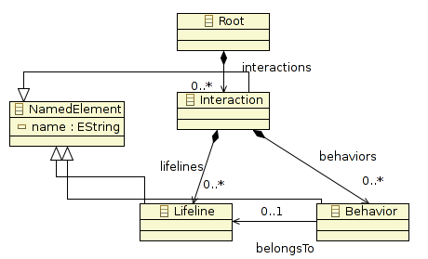
Figure 28: Sequence Diagram simplified view

This behavior is not supported by GMF as it is quite uncommon. Therefore, we will need to modify several things by hand.

Proposed solution
First we will need to create our gmfmap model without doing anything special, just trying to represent in the model the behavior described above. We will do the necessary changes after generating the diagram code.

Step 1: Create the gmfmap
Creating the gmfmap should be straightforward, the only element in which we need to pay special attention is the Behavior Child Reference:
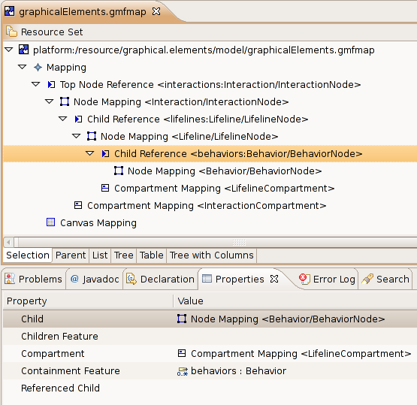
Figure 29: gmfmap view fo the sequence diagram
As we can see, the containment feature of the Behavior element is a feature from its grandparent and not from its parent. This is exactly what we want but, however, if we validate the model GMF will show an error message just because of this reason (We do not have to pay attention to this error).

Step 3: Generate the gmfgen model file
When generating the gmfgen model file, GMF will validate the gmfmap model file. As commented above, we do not need to worry about it. Continue with the gmfgen generation.

Once the gmfgen file is generated, generate the diagram code. Again, the same error as before will appear. Check “Ignore validation error” and continue with the generation.

Note: All the added lines to the generated code shown below will be in grey.

Step 2: Modify the XXXDiagramUpdater class
The DiagramUpdater class is the one in charge of returning the graphical elements contained within another element. Each graphical container element will have a getSemanticChildren operation returning the list of its graphical children. By default, this operation returns the same children that are contained “physically” within the semantic element. However, in this particular case, the Lilfeline's getSemanticChildren opeartion must be modified in order to return, as graphical child elements, all the Behaviors contained within its parent element (an Interaction) that are associated with this lifeline through the BelongsTo attribute.
Folder: src
Package: xxx.diagram.part
/**
* @generated
*/
public class GraphicalElementsDiagramUpdater {

/**
* @generated NOT
*/
public static List getLifelineLifelineCompartment_7003SemanticChildren(
View view) {
if (false == view.eContainer() instanceof View) {
return Collections.EMPTY_LIST;
}
View containerView = (View) view.eContainer();
if (!containerView.isSetElement()) {
return Collections.EMPTY_LIST;
}
Lifeline modelElement = (Lifeline) containerView.getElement();
Interaction parentElement = (Interaction) modelElement.eContainer();
List result = new LinkedList();
for (Iterator it = parentElement.getBehaviors().iterator(); it
.hasNext();) {
Behavior childElement = (Behavior) it.next();
int visualID = GraphicalElementsVisualIDRegistry.getNodeVisualID(
view, childElement);
if (visualID == BehaviorEditPart.VISUAL_ID) {
// The Behavior must belong to the Lifeline
Behavior behavior = (Behavior) childElement;
if (behavior.getBelongsTo() == modelElement)
result.add(new GraphicalElementsNodeDescriptor(
childElement, visualID));
continue;
}
}
return result;
}
...

}

Step 3: Modify the BehaviorCreateCommand class
When a Behavior element is created, the getElementToEdit and getEClassToEdit operations are called. The former is called to obtain its parent element and the later to know the class of its parent element. Only the first operation needs to be modified:
Folder: src
Package:xxx.diagram.edit.commands
/**
* @generated
*/
public class BehaviorCreateCommand extends CreateElementCommand {

/**
* @generated
*/
public BehaviorCreateCommand(CreateElementRequest req) {
super(req);
}

/**
* @generated NOT
*/
protected EObject getElementToEdit() {
EObject container = ((CreateElementRequest) getRequest())
.getContainer();
if (container instanceof View) {
container = ((View) container).getElement();
}

if (container instanceof Lifeline)
container = container.eContainer();

return container;
}

/**
* @generated
*/
protected EClass getEClassToEdit() {
return GraphicalelementsPackage.eINSTANCE.getInteraction();
}

}

Step 4: Modify the LifelineCompartmentItemSemanticEditPolicy class
The only way to make a relationship between a Behavior and a Lifeline is through the BelongsTo attribute of the Behavior. But, by default, if we create a Behavior within a Lifeline, this attribute is not set automatically. We need to do this by hand modifying the getCreateCommand for Behaviors. In this case, we will create and modify its BelongsTo feature at the same time thanks to an auxiliary command called CreateElementAndInitializeFeatureCommand:
Folder: src
Package: xxx.diagram.edit.policies
/**
* @generated
*/
public class LifelineLifelineCompartmentItemSemanticEditPolicy extends
GraphicalElementsBaseItemSemanticEditPolicy {

/**
* @generated NOT
*/
protected Command getCreateCommand(CreateElementRequest req) {
if (GraphicalElementsElementTypes.Behavior_3004 == req.getElementType()) {
if (req.getContainmentFeature() == null) {
req.setContainmentFeature(GraphicalelementsPackage.eINSTANCE
.getInteraction_Behaviors());
}
// Added to initialize the property "BelongsTo" of the new Behaviour
CreateElementCommand behaviorCmd = new BehaviorCreateCommand(req);
EReference feature = GraphicalelementsPackage.eINSTANCE
.getBehavior_BelongsTo();
Object value = req.getContainer();
return new CreateElementAndInitializeFeatureCommand(behaviorCmd,
feature, value);
return getGEFWrapper(new BehaviorCreateCommand(req));
}
return super.getCreateCommand(req);
}

}

Step 5: Create the CreateElementAndIntializeFeatureCommand class
Folder: custom-src
Package: xxx.diagram.edit.commands
public class CreateElementAndInitializeFeatureCommand extends Command {

/** Compound command to undo/redo. */
CompoundCommand compoundCommand = new CompoundCommand();

/** Command to create the element. */
private CreateElementCommand createElementCommand;

/** Feature to initialize. */
private EReference featureToInitialize;

/** Value to initialize the feature to. */
private Object initializationValue;

/**
* Instantiates a new creates the element and initialize feature command.
*
* @param createCommand the create command
* @param feature the feature
* @param value the value
*/
public CreateElementAndInitializeFeatureCommand(CreateElementCommand createCommand,
EReference feature, Object value)
{
createElementCommand = createCommand;
featureToInitialize = feature;
initializationValue = value;
}

/* (non-Javadoc)
* @see org.eclipse.gef.commands.Command#canExecute()
*/
@Override
public boolean canExecute() {
return createElementCommand != null && featureToInitialize != null && initializationValue != null;
}

/* (non-Javadoc)
* @see org.eclipse.gef.commands.Command#canUndo()
*/
@Override
public boolean canUndo() {
return compoundCommand.canUndo();
}

/* (non-Javadoc)
* @see org.eclipse.gef.commands.Command#chain(org.eclipse.gef.commands.Command)
*/
@Override
public Command chain(Command command) {
compoundCommand.chain(command);
return this;
}

/* (non-Javadoc)
* @see org.eclipse.gef.commands.Command#dispose()
*/
@Override
public void dispose() {
compoundCommand.dispose();
super.dispose();
}

/* (non-Javadoc)
* @see org.eclipse.gef.commands.Command#execute()
*/
@Override
public void execute() {

/**
* 1) Create element via createElementCommand
* 2) Retrieve created element via createElementCommand.getNewElement()
* 3) Create SetValueCommand on newElement with indicated feature and value on construction
* 4) Set feature value via setValueCommand
* 5) both the createElementCommand and the setValueCommand are stored in a CompoundCommand to undo() and redo() easily
*/

try {
createElementCommand.execute(null, null);
compoundCommand.add(new ICommandProxy(createElementCommand));
} catch (ExecutionException e) {
e.printStackTrace();
return;
}

EObject newElement = createElementCommand.getNewElement();

SetRequest setRequest = new SetRequest(newElement, featureToInitialize, initializationValue);
SetValueCommand setValueCommand = new SetValueCommand(setRequest);

try
{
setValueCommand.execute(null, null);
compoundCommand.add(new ICommandProxy(setValueCommand));
} catch (ExecutionException e) {
e.printStackTrace();
return;
}
}

/* (non-Javadoc)
* @see org.eclipse.gef.commands.Command#getDebugLabel()
*/
@Override
public String getDebugLabel() {
return super.getDebugLabel();
}

/* (non-Javadoc)
* @see org.eclipse.gef.commands.Command#getLabel()
*/
@Override
public String getLabel() {
return super.getLabel();
}

/* (non-Javadoc)
* @see org.eclipse.gef.commands.Command#redo()
*/
@Override
public void redo() {
compoundCommand.redo();
}

/* (non-Javadoc)
* @see org.eclipse.gef.commands.Command#setDebugLabel(java.lang.String)
*/
@Override
public void setDebugLabel(String label) {
super.setDebugLabel(label);
}

/* (non-Javadoc)
* @see org.eclipse.gef.commands.Command#setLabel(java.lang.String)
*/
@Override
public void setLabel(String label) {
super.setLabel(label);
}

/* (non-Javadoc)
* @see org.eclipse.gef.commands.Command#undo()
*/
@Override
public void undo() {
compoundCommand.redo();
}

}

Example zip file: tutorial-graphical_elements.zip

Links with polygonal anchoring area and/or oval anchors

Context
There are a couple of concepts that should be explained before to continue: anchoring points and anchors.

The figure anchor area defines the allowed regions where links can start/end in order to connect two figures. The default region generated by GMF is the rectangle that wraps the figure. In general this may seem correct but there are some specific cases where the anchoring area must be limited to a certain polygon (for example this happens with Lifelines in the Sequence Diagram).

However, Figure anchors are the elements used to store the points where the user pressed/released the mouse button when creating a link. Therefore, a link will have two anchors: one representing the source point and one representing the target point. This anchors are returned by the source/target figures. The link will ask the anchors which is the intersection point between the link and the source/target figure. The default anchor (called IdentityAnchor) returns always the intersection between the anchoring area of a figure and the reference point stored by the anchor.

GMF, by default, creates the user's figure and then stores it within a NodeFigure class (to be more specific, the DeafultSizeNodeFigure). Is this class the one in charge of managing the anchoring area and the anchor points.

This set of operations for anchoring purposes are really easy to overwrite. If combined with the IpolygonAnchorableFigure interface, the task of changing the anchoring area is really easy. Therefore it is only necessary to create a new class extending from DefaultSizeNodeFigure overwriting the proper operations.

Proposed solution
Both for changing the anchoring area and for changing the anchors returned by the figure, we will modify the generated EditPart class as it is the class that creates the graphical figure. Instead of returning the DefaultSizeNodeFigure figure created by default within the createNodePlate() operation, we will return our own Figure previously manipulated according to our needs.

Step 1 : Create our own Figure
CASE 1 – Polygonal anchoring area

/**
* @generated
*/
public class LifelineEditPart extends ShapeNodeEditPart implements
PrimaryShapeEditPart {

/**
* @generated
*/
public static final int VISUAL_ID = 2002;
...
/**
* @NOT-generated
*/
public class LifelineNodeFigure extends DefaultSizeNodeFigure implements
IPolygonAnchorableFigure {

public LifelineNodeFigure(Dimension defSize) {
super(defSize.width, defSize.height);
}

public LifelineNodeFigure(int width, int height) {
super(width, height);
}

// This returns as the anchoring area only the central line
@Override
public PointList getPolygonPoints() {
PointList polygonList = new PointList();

Rectangle r = getBounds();

Point pStart = new Point();
Point pEnd = new Point();

pStart.x = r.x + r.width / 2;
pStart.y = r.y + 1;

pEnd.x = pStart.x;
pEnd.y = pStart.y + r.height - 1;

polygonList.addPoint(pStart);
polygonList.addPoint(pEnd);

return polygonList;
}

}
}

CASE 2 – Oval anchoring area with oval anchors

/**
* @generated
*/
public class UseCaseEditPart extends ShapeNodeEditPart implements
PrimaryShapeEditPart {

/**
* @generated
*/
public static final int VISUAL_ID = 1001;

...

/**
* @NOT-generated
*/
public class UseCaseNodeFigure extends DefaultSizeNodeFigure implements
IOvalAnchorableFigure {

public UseCaseNodeFigure(Dimension defSize) {
super(defSize);
}

public UseCaseNodeFigure(int width, int height) {
super(width, height);
}

@Override
protected ConnectionAnchor createDefaultAnchor() {
return new SlidableOvalAnchor(this);
}

@Override
protected ConnectionAnchor createAnchor(PrecisionPoint p) {
if (p == null)
return createDefaultAnchor();
return new SlidableOvalAnchor(this, p);
}

public Rectangle getOvalBounds() {
return getBounds();
}

}

}

Step 2 : Return our own Figure within the createNodePlate() operation
CASE 1 – Polygonal anchoring area

/**
* @generated
*/
public class LifelineEditPart extends ShapeNodeEditPart implements
PrimaryShapeEditPart {

/**
* @generated
*/
public static final int VISUAL_ID = 2002;
...
/**
* @generated NOT
*/
protected NodeFigure createNodePlate() {
// To return EllipseAnchors
UseCaseNodeFigure ucFigure = new UseCaseNodeFigure(getMapMode().DPtoLP(
80), getMapMode().DPtoLP(40));
return ucFigure;
}
...
}

CASE 2 – Oval anchoring are with oval anchors

/**
* @generated
*/
public class UseCaseEditPart extends ShapeNodeEditPart implements
PrimaryShapeEditPart {

/**
* @generated
*/
public static final int VISUAL_ID = 1001;
...
/**
* @generated NOT
*/
protected NodeFigure createNodePlate() {
LifelineNodeFigure result = new LifelineNodeFigure(getMapMode().DPtoLP(
100), getMapMode().DPtoLP(250));
return result;
}
...
}

Avoid link snapping to the centre of the figure

Context
This recipe is related with the above one so it would be interesting to previously read, at least, its context to understand what comes next.

Another of the default behaviors of the DefaultSizeNodeFigure is the snapping mechanism to the centre of the figure. When the user moves the mouse around the anchoring area of the target figure, if the pointer is quite near from the middle part of the figure then the pointer snaps automatically to centre of it. Although this may seem something not very important, sometimes it results in really annoying behavior specially when you want to set the target anchor in a specific point.

Proposed solution
As it happens in the previous recipe, the solution is quite simple: create our own Figure extending the DefaultSizeNodeFigure class and overwriting the proper method. Then we must change the createNodePlate() operation in order to return our figure instead of the DefaultSizeNodeFigure.

Note: This recipe can be perfectly combined with the previous one.

Step 1 : Create our own figure

/**
* @generated
*/
public class LifelineEditPart extends ShapeNodeEditPart implements
PrimaryShapeEditPart {

/**
* @generated
*/
public static final int VISUAL_ID = 2002;
...
/**
* @NOT-generated
*/
public class LifelineNodeFigure extends DefaultSizeNodeFigure {

public LifelineNodeFigure(Dimension defSize) {
super(defSize.width, defSize.height);
}

public LifelineNodeFigure(int width, int height) {
super(width, height);
}

@Override
protected boolean isDefaultAnchorArea(PrecisionPoint p) {
// We don't want a default snapping area for the Lifeline Node Figure.
return false;
}

}
}

Step 2 : Return our own figure within the createNodePlate() operation

/**
* @generated
*/
public class LifelineEditPart extends ShapeNodeEditPart implements
PrimaryShapeEditPart {

/**
* @generated
*/
public static final int VISUAL_ID = 2002;
...
/**
* @generated NOT
*/
protected NodeFigure createNodePlate() {
// To return EllipseAnchors
UseCaseNodeFigure ucFigure = new UseCaseNodeFigure(getMapMode().DPtoLP(
80), getMapMode().DPtoLP(40));
return ucFigure;
}
...
}

Element initialization

Context
Model elements usually have a set properties for describing the state the element. This properties are attributes and references to other model elements. Normally is the user the one in charge of giving the correct values to this properties but, as there are usually restrictions associated with the possible values, it results to be convenient to assign an initial value that does not violate the restriction in order to help the user.

Furthermore, some created elements do not have much sense by themselves. For example, in UML2 when creating an Association element, two more elements have to be created for describing the ends of the Association. Therefore, when the user creates an Association through our diagram editor he does not only expect an Association to be created but all the necessary elements (and their properties) for describing correctly an UML2 Association.

Although this can be achieved manipulating the GMF generated classes, GMF already provides us a mechanism for describing element initialization via its gmfmap model.

Proposed solution
The gmfmap model allows us to initialize the new element properties and also to create some children elements and initialize its properties as well.

Both for initializing the properties and for creating new child elements, select the Node Mapping to initialize, right click over it → new Child → Feature Seq Initializer.

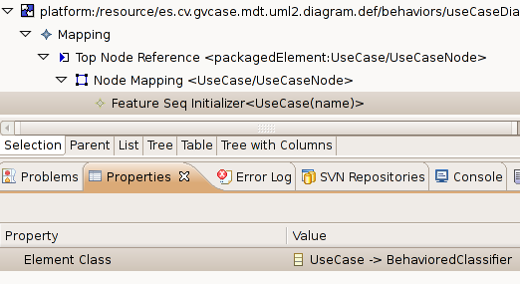
Figure 30: Feature Seq Initializer

Initializing element properties
To initialize the value of a property, select the new “Feature Seq Initializer” element, right click over it → new Child → “Feature Value Spec”:

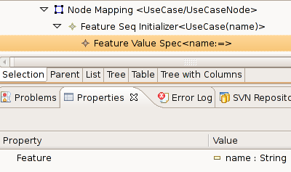
Figure 31: Feature Value Spec properties

Select the feature of the element to initialize and give the value to the feature by means of creating a Value Expression doing right click over the “Feature Value Spec” → new Child → “Value Expression”:

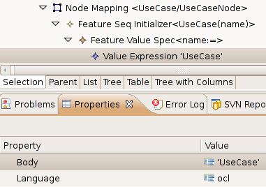
Figure 32: Value Expression properties

Creating new child elements within an element
It is important to mention that using this mechanism, only child elements can be created. We are not allowed to create siblings or parent elements. If this is our case, will need to modify the doDefaultElementCreation() operation within the CreateCommand class of the generated element code.

To create a new child element, right click over the “Feature Seq Initializer” → new Child → “Reference New Element Spec”.

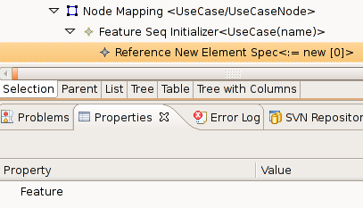
Figure 33: Reference New Element feature property

The next step is to select the feature where the element will be stored and the element to be created. The format is the following <feature> : <elementType>.

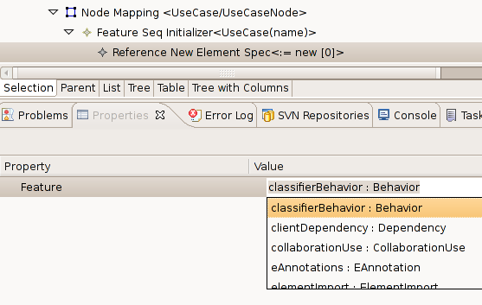
Figure 34: Reference New Element Spec <feature> : <childElement> selection

The new created element can be initialized as well using the same procedure explained here.

Diagram restrictions with OCL via gmfmap

Context
When dealing with models it is quite normal to specify some constraints so that the created models fulfill a set of requirements. Not to mention that all this constraints should be specified within the metamodel although sometimes this is not possible or it requires to much handwork as EMF does not give support for OCL constraints by default (Check this address if this is your case: http://www.eclipse.org/articles/article.php?file=Article-EMF-Codegen-with-OCL/index.html).

In other cases it is just that you want to force the editor to have a more restricted behavior than the originally specified within the metamodel. Independently of the case, GMF allows the specification of OCL constraints both for the diagram and for each element different Node/Link element in a very easy way.

Proposed solution
All the constraints of a diagram editor can be added within the gmfmap model. In order to add a new constraint we need to open our gmfmap model and, depending on the case, add the constraint to the model, Node or Link.

Add a Model constraint
To add a model constraint, right click over the general “Mapping” element and select new Child → “Audit Container”.

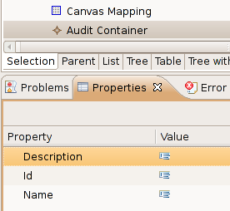
Figure 35: Audit Container properties
The meaning of the properties is quite straightforward:
- Description: Description of the container.
- Id: Identifier of the container. It should be unique within this diagram.
- Name: Name of the container.

Both the Description and the Name are visible by the user. Therefore it is convenient give appropriate values to these properties. Remember that all the editor constraints can be accessed by the user by clicking Window menu → Preferences → Model Validation → Constraints.

Within the “Audit Container” we can add as many rules (constraints) as we may need. To add a rule, right click over the “Audit Container” element → new Child → “Audit Rule”.

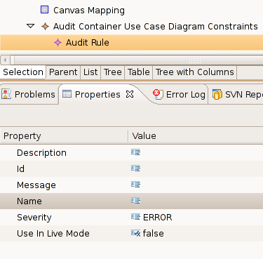
Figure 36: Audit Rule properties
The meaning of the properties is the following:
- Description: Description of the Rule.
- Id: Identifier of the Rule.
- Message: Message for the user when there is a violation of the rule.
- Severity: Severity grade of the rule. Possible values are
  - ERROR
  - WARNING
  - INFO
- Use In Live Mode: When will the constraint be checked. If true, then the constraint will be checked in every action of the user, canceling the action in case the rule is violated. If false, then the rule will only be checked when the user validates the Diagram (right click over the diagram file → Validate).

Each rule is composed by two more elements: a Constraint (with the body of the constraint) and a Target Element/Attribute (the context of the constraint). To create both elements, right click over a Rule → new Child.

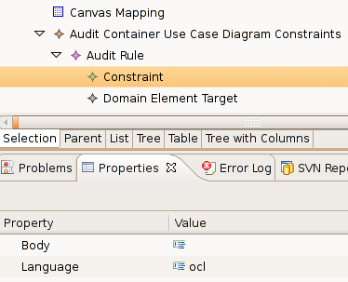
Figure 37: Audit Rule Constraint properties

The different target elements/attributes are the following:

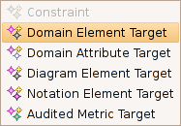
Figure 38: Different target elements/attributes
A description of the most important ones:
- Domain Element Target: The rule is applied to all the instances of a metamodel Class.
- Domain Attribute Target: The rule is applied to one attribute of all the instances of a metamodel Class.
- Diagram Element Target: The rule is applied to one of the gmfmap elements of the current Diagram (Only Node Mapping and Link Mapping elements).

For further information about GMF constraints check this addres:
http://wiki.eclipse.org/index.php/GMF_Constraints

Add a Node constraint
To add a Node constraint, right click over the “Node Mapping” element and select new Child → “Constraint”:

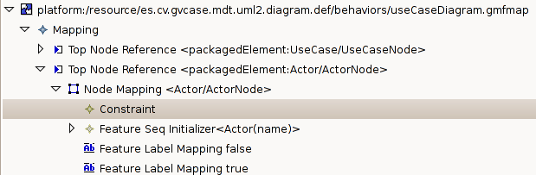
Figure 39: New Node constraint
The properties of the constraint are the following:

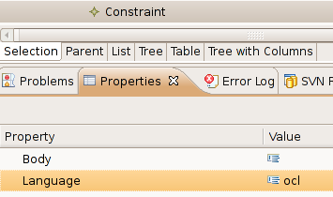
Figure 40: Node constraint properties
Language property specifies in which language is the constraint going to be declared. The most common languages are OCL(Object Constraint Language) and Java. The constraint itself is described within the Body property. Obviously if the language is OCL the body must be written in OCL language. The same happens with the rest of languages. You may check it the constraint is syntactically correct by doing: right click over the Node Mapping → validate.

Add a Link constraint
To add a Link constraint, right click over the “Link Mapping” element and select “Link Constraints”:

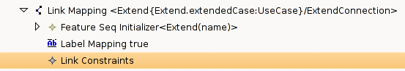
Figure 41: New Link constraint
GMF allows us to attach a constraint to the source element and/or to the target element. The source constraint will be checked when selecting the source of the link whereas the target constraint will be checked when selecting the target of the link. To attach a constraint to one of the ends right click over Link constraint -> New child -> Source End Constraint or Target End Constraint:

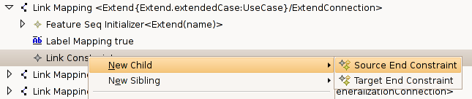
Figure 42: Election between source/target end constraint

Independently of the chosen constraint, the properties of the constraint are the following:

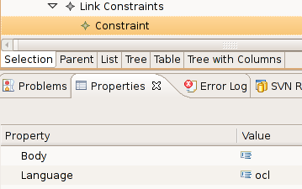
Figure 43: Source/Target end constraint properties

The properties have the same meaning as in the Node Constraint explanation. However, GMF supports a special OCL variable called oppositeEnd that can be used within the Body of the OCL expressions when dealing with Source/Target end constraints. This variable represents the opposite element of the current end. That means that if we are writing the body of the target end constraint, then the oppositeEnd represents the source element of the link and vice-verse.

An example is provided below:
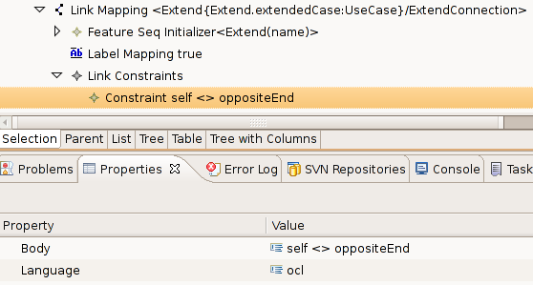

This example illustrates how to avoid a connection between one element and itself. The constraint created is a Target End Constraint, therefore oppositeEnd represent the source element of the connection.

Name initialization of the elements

Context

Element creation within a diagram editor usually has to deal with the naming problem, above all when a creation of a graphical element has as a result the creation of more than one semantic element.

As it happens quite often, the great majority of elements usually have a name attribute in order to identify (at least at user level) the different instances of a same element (for example, different classes from a UML2 Class diagram).

If it is the case, it is desirable to give unique names to the new elements. Even though this task should be done by the user, it is quite interesting to grant that all elements created by the editor will start with a unique name (user is free to change it afterwards).

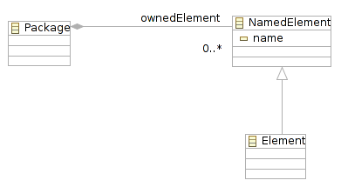
Figure 44 Element with name

Proposed Solution
First, we are going to create a Java Class called LabelHelper.java whose purpose is to provide a suitable name for an Element that inherits from the NamedElement class.
The next step is to use the gmfmap element initialization via Java specifying that the initialization of the name feature would be done through Java code instead of OCL rules (which is quite more common).
After generating the diagram editor code (via the gmfgen model), the last step is to use the above class within the initialization operation generated automatically.

Step 1 : Create LabelHelper.java
Name: LabelHelper.java
Package: Anywhere provided that it is visible by all our editors.
Note: This class is based on the org.topcased.modeler.utils.LabelHelper.java and considering the UML2 NamedElement.

public class LabelHelper {
/** The singleton */
public static final LabelHelper INSTANCE = new LabelHelper();

/**
* Initialize the name of a child EObject contained in a parent EObject
*
* @param parentEObject
* the parent EObject to start searching
* @param childEObject
* the child EObject whose name should be initialized
*/
public void initName(EObject parentEObject, EObject childEObject) {
if ((childEObject != null) && (childEObject instanceof NamedElement)) {
String name = findName(parentEObject, (NamedElement) childEObject);

// Either delegate the call or return nothing.
EAttribute att = null;
att = UMLPackage.eINSTANCE.getNamedElement_Name();

if (att != null
&& ((EDataType) att.getEType()).getInstanceClass().equals(
String.class)) {
childEObject.eSet(att, name);
}
}
}

/**
* This returns a name to give to given EObject
*
* @param parentEObject
* the parent EObject
* @param childEObject
* the new EObject to add
* @return the name
*/
public String findName(EObject parentEObject, NamedElement childEObject) {
return findName(parentEObject, childEObject.eClass());
}

/**
* This returns a name to give to a new EObject
*
* @param parentEObject
* the parent EObject
* @param childEClass
* the new EObject to add
* @return the name
*/
public String findName(EObject parentEObject, EClass childEClass) {
int cpt = 1;
while (!isNameAvailable(parentEObject, childEClass, cpt)) {
cpt++;
}
return childEClass.getName() + cpt;
}

/**
* Check if a name is available
*
* @param parentEObject
* the parent EObject
* @param childEClass
* EClass of the new EObject to add
* @param currentCpt
* the current cpt
* @return true if the name is available
*/
private boolean isNameAvailable(EObject parentEObject, EClass childEClass,
int currentCpt) {
EList list = parentEObject.eContents();
for (Iterator i = list.iterator(); i.hasNext();) {
EObject child = (EObject) i.next();

// check if the current child is the same type of the childEObject
if (childEClass.getName().equals(child.eClass().getName())) {
String nameToMatch = child.eClass().getName() + currentCpt;
if (nameToMatch.equals(((NamedElement) child).getName())){
return false;
}
}
}
return true;
}

}
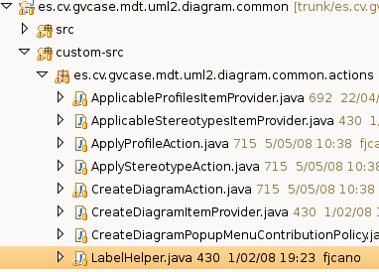
Figure 45 Example of where to store LabelHelper

Step 2 : Modify gmfmap model
Select the Nodes that need to be initialized by clicking on “Node Mapping” elements. Next, right click “New Child → Feature Seq Initializer”. Over the new element, right click “New child → Feature Value Spec”. Next step is to add a “Value Expression” within the new created “Feature Value Spec” doing right click “New child → Value Expression”:
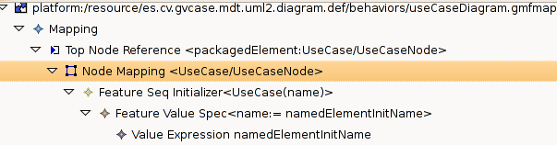
Figure 46 Value expression hierarchy
The last step is to modify the “Value Expression” as it is shown in the figure below:
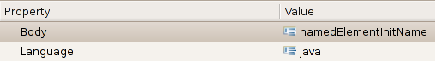
Figure 47 Value expression example
Note: The value of the Body attribute is irrelevant, it is just a name for the value expression (In the previous version of Eclipse, Europa, this attribute was important because it represented the name of the generated operation).

Step 3 : Modify generated Java Code
Generate the code of the diagram again by doing right click over the gmfgen → Generate diagram code. Modify the “ElementInitializers” class as shown below:
Name: ElementInitializers.java
Package: xxx.providers
Search the following generated code:
/**
* Implementation provided
*
* @generated
*/
private static String name_UseCase_1001(UseCase self) {
// TODO: implement this method to return value
// for org.eclipse.uml2.uml.UMLPackage.eINSTANCE.getNamedElement_Name()
// Ensure that you remove @generated or mark it @generated NOT
throw new UnsupportedOperationException(
"No user java implementation provided in 'name_UseCase_1001' operation");//$NON-NLS-1$
}

For each initialized node, an operation similar to the one above will appear. This operation will be called every time a new Node is created in order to initialize its name attribute. The default generated code throws an exception unless the user replaces its code (obvious, since the machine does not know what code should be here). The final step is to replace all the code with the following:
/**
* Implementation provided
*
* @generated NOT
*/
private static String name_UseCase_1001(UseCase self) {
if (self != null && self.eContainer() != null) {
return LabelHelper.INSTANCE.findName(self.eContainer(), self);
}
return "";
}

Index
1 Introduction 1
2 GMF basics 1
2.1 Model roles 1
2.2 Compiling UML2Tools 1
2.3 Defining Figures 2
3 Papyrus Diagrams 6
3.1 Diagram Template 6
4 Recipes 10
4.1 Recipe Template 11
4.2 List of Possible Recipes 11
4.3 Node with predefined colors 12
4.4 Link A→B owned by A 13
4.5 Link A→B with Edge Object 20
4.6 Link with anchor anywhere on other link (Comment link) 22
4.7 Making figures sensitive to attributes of semantic elements 24
4.8 Ports sticking to the side of a component 24
4.1 Node with a label 24
4.2 Figure changes in response of semantic changes 26
4.3 Figure swapping action 26
4.4 Links whose source/target graphical elements differ from the source/target semantic elements 26
4.5 Graphical elements that are contained within one element but semantically contained within another element 26
4.6 Links with polygonal anchoring area and/or oval anchors 33
4.7 Avoid link snapping to the centre of the figure 36
4.8 Element initialization 37
4.9 Diagram restrictions with OCL via gmfmap 40
4.10 Name initialization of the elements 46

Version History
Version | Date | Author | Comments
0.1 | 04/07/2008 | Cedric Dumoulin | Initial draft.
0.2 | 17/07/2008 | Gabriel Merin | Improvements on appearence and structure of the document. Definition of a diagram template.
0.3 | 23/07/2008 | Gabriel Merin | Minor changes in some explanations.
0.4 | 07/08/2008 | Patrick Tessier | Recipe node with a label
0.5 | 14/08/2008 | Gabriel Merin | Added recipies: Graphical elements, Links anchors, avoid link snapping, element initialization, diagram restrictions and name initialization of elements.

