


UTILITY CLASSES

Date: | 29/10/09
Editor | Javier Cano
Status | Draft Version
Version number | 1

Authors
Editor | E-mail
Francisco Javier Cano (Prodevelop) | fjcano@prodevelop.es

Authors | E-mail
Francisco Javier Cano (Prodevelop) | fjcano@prodevelop.es

Revision chart and history log

Version | Date | Reason
1 | 29/10/09 | Initial version

Purpose
The purpose of these classes is to ease some common tasks developed such as showing debug information, reading extension points, working with and working with paths.
The initial list of classes is:
- DebugUtil
- ExtensionPointParser
- ImageUtils
- PathsUtil

DebugUtil
This class offers some methods to show debugging information in the console. Currently it has methods to show information about Commands, Icommands and CompoundCommands.

ImageUtils
Offers methods to load images from URL strings, load images from bundles and to modify the aspect ratio of an image.

PathsUtil
Offers methods to manipulate paths and convert them from relative to absolute and vice versa.

ExtensionPointParser
This utility class can parse an extension point and load all of the contributed entries and data to a set of classes that are given to it.
To read an extension point with this parser two paremeters are needed:
- The extension point identifier, as a String.
- An array of classes representing the elements that can be found in the extension point. These classes have to met certain specifications so that the parser can use them lo load the data of the extension point into them:
  - The name of a class must match the name (case sentitive) of an element in the extension point.
  - The array of classes given must have at least one class for each element defined in the extension point.
  - Every class must be public, as java reflective constructors are used to create new instances of the classes.
  - Each class must have a public field for each attribute of the element the class represents. Those fields names must match (case sensitive) the name of the defined attributes.
  - Each class must have a public field of type List for each child element that it can have in the extension point. That field's name must match (case sensitive) the name of the child element.
  - The types that are supported by this parser are:
    - Boolean : use Boolean instead of boolean as this allows the value to be null.
    - List : use List for those fields that represent the children that an element can have.
    - String : for any other attribute.
  - If the given classes are declared inside another class, an instance of the containing class must be given to the ExtensionPointParser.
The parser gives, as output:
- List<Object>: this is a list of object instances representing the structure of the read extension point. For each element in the extension point there will be an instance of a proper class representing that element with each field in that instance having the value of the proper attribute in the element, whereas the parent/child structure is preserved via the List fields that hold the children of each element in each instance.

Example of use
Here is an example of use of the ExtensionPointParser, with a schema definition and the classes that represent that schema.
All attributes are String, except the ones named 'remove' that are booleans.
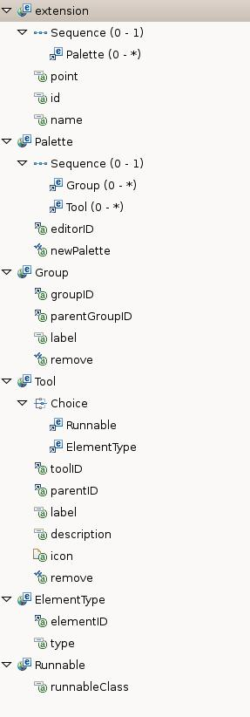
To represent this extension point the folowing classes have been defined, with this data structure:
public class Palette {
public String editorID;
public String newPalette;
public List<Group> Group;
public List<Tool> Tool;

public Palette() {
}
}

public class Group {
public String groupID;
public String parentGroupID;
public String label;
public Boolean remove;

public Group() {
}
}

public class Tool {
public String toolID;
public String parentID;
public String label;
public String description;
public String icon;
public Boolean remove;
public List<ElementType> ElementType;
public List<Runnable> Runnable;

public Tool() {
}
}

public class ElementType {
public String elementID;
public String type;

public ElementType() {
}
}

public class Runnable {
public String runnableClass;

public Runnable() {
}
}

The element extension is the root where the parsing starts and needs not to be declared as a class as it is not hold in the data structure.
These classes are decclared inside an enclosing class.
These classes have the same name that the elements defined in the extension point and public fields that match the attributes of those elements in the extension point. The classes that represent elements that can hold child elements declare too additional fields of type List to hold those children elements.
To read the extension point so that a structure of those classes is given as result the ExtensionPointParser must be used this way:
Class<Object>[] classes = new Class[] { Palette.class, Group.class,
Tool.class, ElementType.class, Runnable.class };
ExtensionPointParser parser = new ExtensionPointParser(
getExtensionPointID(), classes, this);
for (Object object : parser.parseExtensionPoint()) {
// work with each element
}

The constructor of the ExtensionPointParser class needs an array of classes that represent the elements in the extension point and an identifier of the extension point to parse. In this case, as the classes given are declared inside another class, an instance of the enclosing class must also be given.
Calling the method parseExtensionPoint() returns a list of instances of all contributions that are done to that extension point, representing the structure in the extension point.
The given structure can be assumed to:
- A filed in an instance of a class can be uninitialized. If a field that represents an attribute is null that means that the attribute was not specified in the extension point.
- A Boolean type field will be true or false or null if it has not been initialized.
- A List type field that represents children elements will be null if no children are specified in the extension point.

