Architecture and design document

Collaborative work

Index
Document History 3
Version History 4
Introduction 5
Technical constraints 5
Control Mode 5
Control an UML model 5
Control a notation model 5
Control a di model 6
Uncontrol action 6
Export Mode 6
Architecture 6

Document History

Date | Comments
24/08/09 | Describe technical solution for control mode

Version History

Version | Date | Author | Company | Comments
1.0r1 | 24/08/09 | Emilien PERICO | Atos Origin | Initial content

Introduction
This document aims to describe the architecture of components and plugins used to implement the collaborative work.
Technical solution for each mode is described to ensure feasibility. A prototype could be made to check the proposed solution.

Technical constraints

Control Mode
Control action comes from EMF component (org.eclipse.emf.edit). This action enables to split a part of a resource to export it in a single one.

To set up the control mode on MDT Papyrus models and diagrams, we need to allow this mechanism on uml, notation and di model.

Control an UML model
Control is already available on UML model. We will be able to use it on UML Papyrus model.

Control a notation model
Notation meta model is part of GMF, use to represent graphical part of models based on GMF editors. Unfortunately the control action is not available on elements of this meta model.

An object is only controllable if it is fulfil these conditions:
(part of the sources of org.eclipse.emf.edit.domain.AdapterFactoryEditingDomain)

public boolean isControllable(Object object)
{
if (!(object instanceof EObject)) return false;
EObject eObject = (EObject)object;
EObject container = eObject.eContainer();
return container != null
&& eObject.eContainmentFeature().isResolveProxies()
&& !isReadOnly(eObject.eResource())
&& !isReadOnly(container.eResource());
}

Additional informations here:
http://dev.eclipse.org/newslists/news.eclipse.modeling.gmf/msg19364.html

Actually, control action on notation meta model is need-not to perform the split of the graphical resource. We can create a new resource into the existing resource set. This new resource contains the diagrams node of the controlled UML element. We have made a prototype to ensure the feasibility. Change the diagram reference of a notation model enables to split the notation in a controlled resource.

Control a di model
Di meta model comes from org.eclipse.papyrus.sasheditor.di. Control action could be set up on needed elements of the sash editor. We have to think about it according our needs.

Sasheditor.di depends on org.eclipse.papyrus.di (comes from papyrus I). This one must be deleted and dependencies cleaned.

Once this refactor made, we could control a di resource with a clean sasheditor.di.

Uncontrol action

The uncontrol action is the reflective behavior of control action. From a model having controlled resources, you can uncontrol it. This one is merged to the parent model and the resources are deleted.

Export Mode
TODO

Architecture

For now, control action from EMF is overridden in a PapyrusControlAction to manage control for notation resource and di resource.
This class was created in org.eclipse.papyrus.navigator plugin in order to access EditingDomainActionProvider and NavigatorUtils.

It's not possible to export this action in a single plugin because of cycling dependencies. Extension points must be used to avoid dependencies problems. Refactoring is needed on DiResourseSet and BackboneContext before.

Here is a components model we plan to set up:

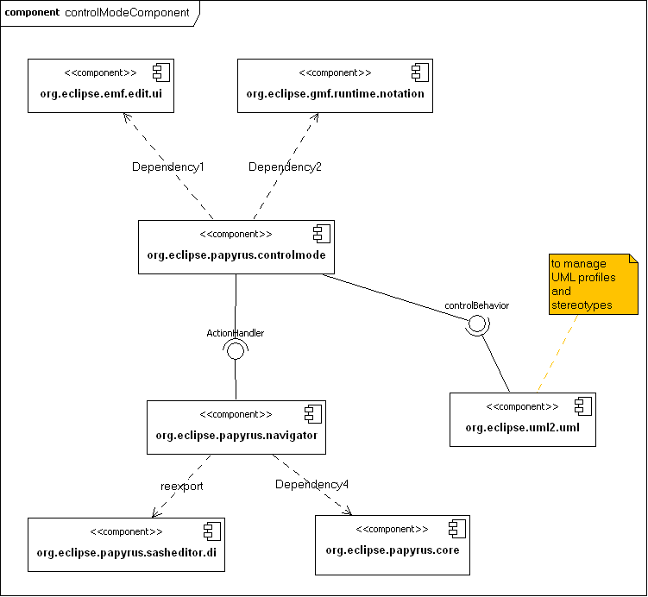

A single plugin (org.eclipse.papyrus.controlmode) will be in charge of split the specified model to have a controlled resource.
This one depends on sasheditor.di, gmf.runtime.notation and emf.edit.ui for di, notation and emf (such as uml) resources management.

An extension point (actionHandler) will allow adding additional actions on navigator menu.
Another extension point will allow managing UML profiles in the control mode plugin. This one need to be define precisely.

