Sash and Core
Architectures
Author : Cedric Dumoulin
Date : 6 déc. 2009
Rev : 11 Jan. 2010

Introduction
Sash System and core are used by the Papyrus UML editor.
The Sash System provides an editor of pages that can be arranged in multiple pages separated by sashes. A page can be either an editor or a SWT Component.
The Core provides the main Editor implemented with the Sash. The core also provides a notion of Services that can be added to the main editor. The services can then be retrieved and shared between nested pages.
The Core depends on the Sash System (Figure 1). The Sash System is independent.

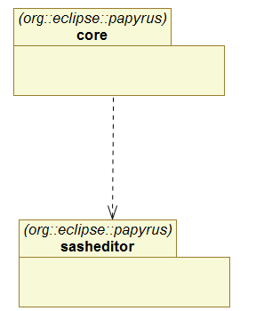
Figure 1 Sash and Core packages

Sash System
The sash system is used to render multiple nested pages in one main editor. A page can be an editor or a SWT component.
In the sash system, nested pages can be layed in tabfolders and side by side. The sash system allows to move the pages from tabfolder to tabfolder, or to create new tabfolders.
The sash system main component is the SashWindowsContainer class. It is used to render the pages as described above. The class requires two interfaces in order to work properly (Figure 2):
- ISashWindowsContentProvider – The content provider is used to store the structure representing the pages (editors or components) to be rendered. It is used by the SashContainer to discover and modify the structure.
- IMultiEditorManager – Is required if the SashContainer should render Eclipse IEditor. It is used to get Eclipse Site and EditorInput.

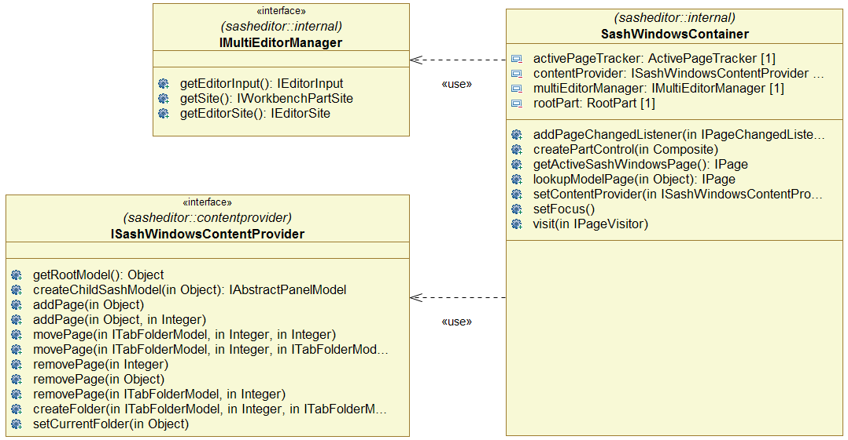
Figure 2 Sash Container and its required interfaces

The Sash Container can be used directly in an Eclipse editor. A base implementation is provided in AbstractMultiPageSashEditor. This implementation requires a concrete implementation for the ISashWindowsContentProvider interface.

ContentProvider
The ContentProvider is used by the SashContainer to discover the content of the sash, and to store this content externally.
The ContentProvider main API is ISashWindowContentProvider.

ContentProvider structure
The ContentProvider is used to read and store the structure to be rendered by the SashContainer. This structure can be implemented in different manners.
The ContentProvider API is design in order to be able to implement the structure by using any kind of Objects, called raw model. The Container call special methods (createChildSashModel(Object)) to obtain a well known API from a raw model used in the container.
The content provider returns a view on the real structure implementation. The SashContainer start to explore this view from the ISashWindowContentProvider. The virtual view is made of ‘Model’ represented by the different IXxxModel interfaces in Figure 3.
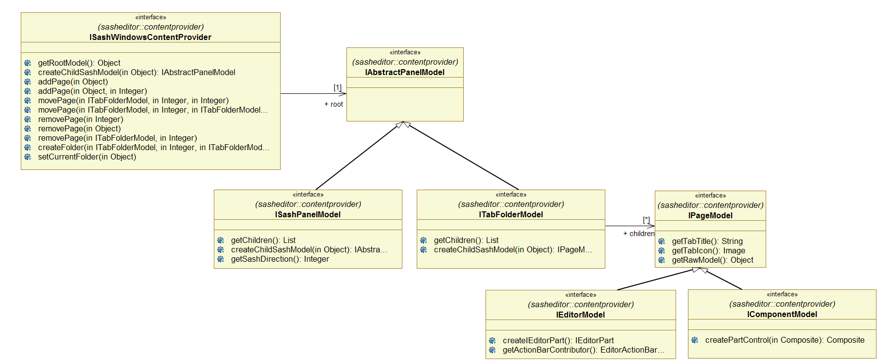
Figure 3 ContentProvider set of interfaces used by the SashContener

From the content provider, the virtual view is as follow:
- A root contains a PanelModel which can be either a ISashModel or a IFolderModel.
- A ISashModel is made of two children of type IPanelModel. This represent two panel separated by a sash.
- A IFolderModel is made of several children of type IPageModel. This represents a tabfolder made of pages.
- A IPageModel can be either a IComponentModel or a IEditorModel.
- A IComponentModel represents a SWT Component.
- A IEditorModel represent an Eclipse Editor.

ContentProvider main API
The main API of the content provider is ISashWindowsContentProvider.
There is two methods to explore the ContentProvider structure: getRootModel() and createChildSashModel(object).
Others methods are used by the Container to modify the content after a user interaction.

ContentProvider exploration
To discover the content, the Container first call the getRootModel() to get the root model of the content. This returns an Object representing the root of the structure of the Sash.
Then the container call createChildSashModel(object) whith the previous object to get the Model represented by the Object. This is either a ISashPanelModel or a ITabFolderModel.
For a ISashPanelModel the container call the getChildren() method to obtain the raw models of the node. Then for each childs it get the IAbstractPanelModel by calling createChildSashModel(object).
For a a ITabFolderModel, the container call the getChildren() method to obtain the raw models of the node. Then for each childs it get the IPageModel by calling createChildSashModel(object). This return either a IComponentModel or a IEditorModel, representing a SWT Component or a IEditor.
The container create the corresponding SWT component or IEditorPart by calling appropriate method.

ContentProvider Modification by the SashContainer
The SashContainer modify the ContentProvider by the way of the ISashWindowsContentProvider interface. It doesn’t create models by itself.
The SashContainer transforms user interactions in calls to ISashWindowsContentProvider. This should modify the ContentProvider internal structure. In turn, something must call the refresh() method on the SashContainer in order to refresh it (to force it to synchronize itself with the ContentProvider).
The SashContainer do not listen on the ContentProvider. This should be implemented externally.

DI ContentProvider
The DiContentProvider is an implementation of the ISashWindowContentProvider.
It is implemented with an EMF metamodel, to save its content as EMF model.
The DiContentProvider is accessible throw the DiSashModelMngr class or TransactionalDiSashModelMngr class.

The internal EMF implementation is not intended to be used directly by users. Some interfaces are provided in order to access it: IPageMngr and ISashWindowContentProvider.

IPageMngr, provides methods to add, open, remove Editors from the ContentProvider. This is the API used by user.
An implementation of the IPageMngr can be obtained from the DiSashModelMngr or the TransactionalDiSashModelMngr.

DiSashModelMngr
To get an instance of the DiContentProvider, it is necessary to create an instance of DiSashModelMngr (or the Transactional one). This class requires two classes to work (Figure 4): an EMF Resource that is used to store/retrieve content, and a IPageModelFactory, used to create instance of IPageModel (model used by the SashContentProvider to create instance of nested Editor).

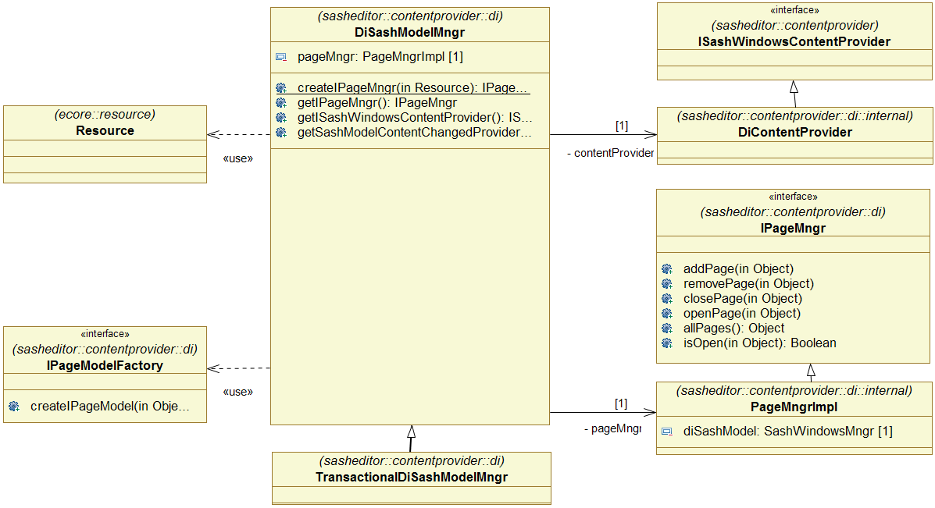
Figure 4 DiContentProvider Provided and Required Interfaces

Internal Structure
The implementation is made of 3 parts:
- The manager, used to retrieve the concrete implementations of provided interfaces (Figure 4)
- Implementations of ISashWindowContentProvider and IPageMngr (Figure 4)
- An EMF metamodel and model used to store/retrieve the sash structure (Figure 5).

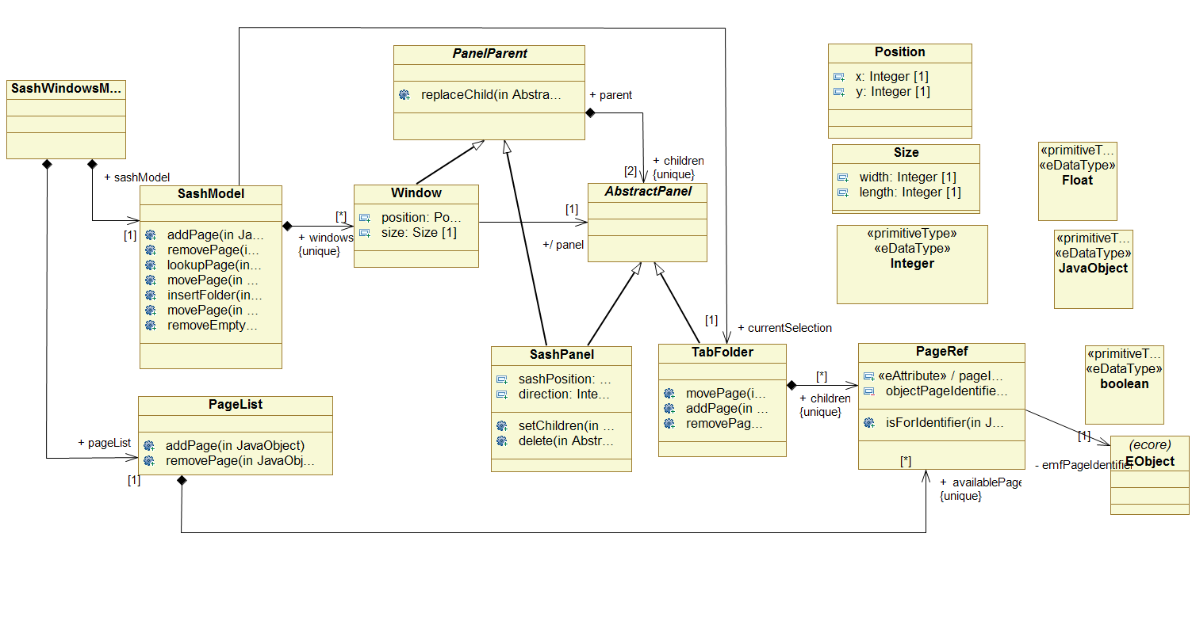
Figure 5 The di sashwindows metamodel (internal structure).

The EMF metamodel is itself made of two parts:
- A SashModel representing the structure of SashSystem. This is a tree structure whose leaf are objects representing pages (an Editor or a Component).
- A PageList – a list of pages currently available for the SashSystem. This list contains objects representing all the pages, the open ones as well as the closed ones.

AbstractMultiPageSashEditor
The Sash System provides an abstract base implementation of a multieditors. The class is AbstractMultiPageSashEditor. This implementation uses a SashContainer and requires a ISashWindowsContentProvider.
This later should be set by calling setContentProvider().

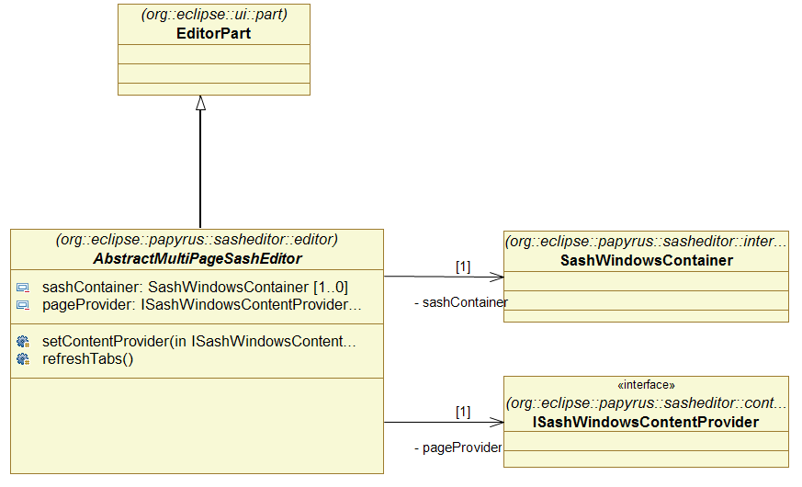
Figure 6 AbstractMultiPageSashEditor Overview

SashContainerFactory
The SashContainerFactory class can be used to get an instance of the SashContainer, as this later is not directly accessible.
Note: this class is not yet implemented. It will be if there is a need for it.

Glossary
Concept | Definition
SashContainer | A sash container is the main component of the sash system. It contains pages that can be arranged in multiple windows, and inside each window the pages can be arranged side by side or in sash folder. Two adjacent pages are separated by a sash allowing to resize the pages.
Sash Window | A sash window is a window that can be moved independently from the Eclipse window. A sash window show one or more pages of a Sash container.  Note: the actual implementation allows only one window docked inside Eclipse.
Sash Folder  Sash tabfolder  Folder | A sash folder renders pages in a tab fashion. A folder contains several pages, but show only one of them at a time. Pages can be selected with a tab.
Sash Panel | A sash panel render two
Sash Page | A sash page is the final

Core / Backbone
The Core main intent is to provide a multieditors, that is, an editor of editors.
The provided multieditors is independent from the nested editors. These nested editors can be registered by using the Eclipse extension mechanism.
Nested editors can share objects thanks to the ServiceRegistry who register services. These services are registered programmatically or by using the Eclipse extension mechanism.
The multieditors use a Di ContentProvider to register the Sash content.

Architecture Overview
The main class of the core is the CoreMultiDiagramEditor. It extends the sasheditor.AbstractMultiPageEditor to provide a multieditors. It adds some services needed by the nested editors.
Figure 7 shows the main classes and the added services.

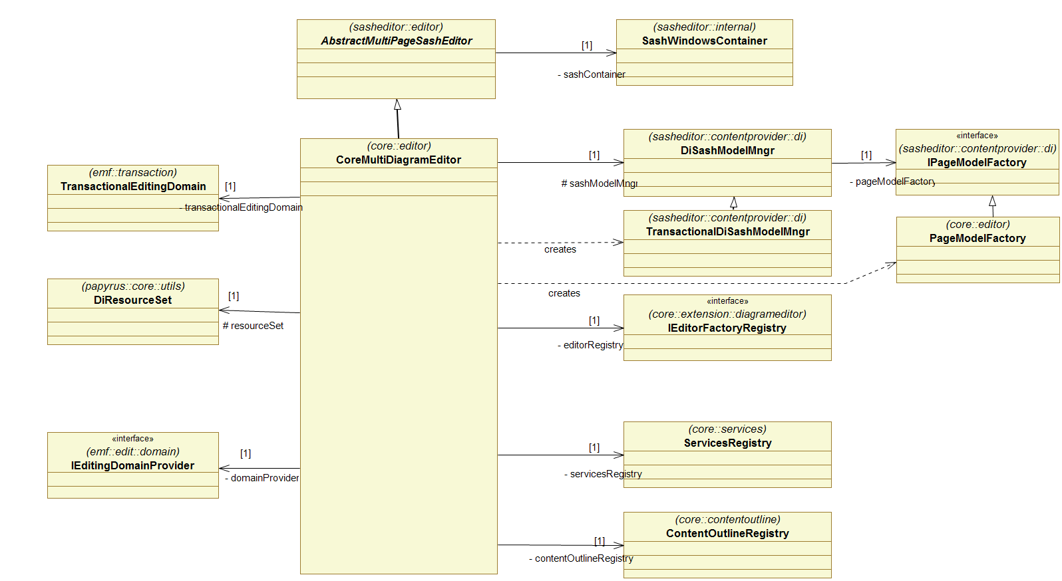
Figure 7 Core multieditors overview.
All the services are also accessible thanks to the ServicesRegistry. This ServicesRegistry is provided to all nested editors while they are created. The nested editors can then retrieve any service it need.

ServiceRegistry
The ServiceRegistry is used to register services that can be found by a key, generally the classname of the service.
A service can be retrieve in a standard way, generally by using its ID or its implementation class.

Architecture Overview
Figure 8 shows the architecture of the ServiceRegistry.

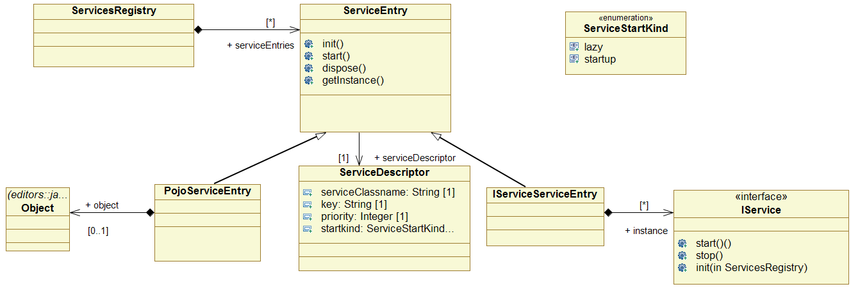
Figure 8 ServiceRegistry Architecture

Designing a Service
A service is a class providing some methods.
The class can be a Pojo, or it can extend the IService interface.
If the service extends the IService interface, the ServiceRegistry will call the life cycle methods on the service.

Register a Service
A service can be registered in several ways:
- Using the Eclipse extension mechanism
- Programmatically

Using the Eclipse extension mechanism
A service can be registered using the Eclipse extension mechanism.
Figure 9 shows the extension names and fields.

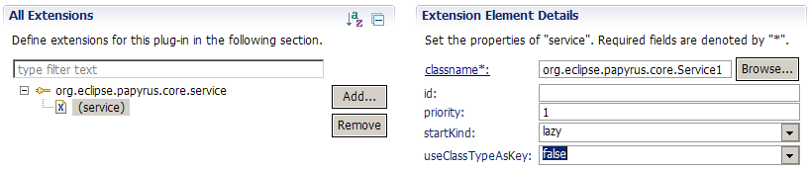
Figure 9 Register a Service with Eclipse extension
- classname – The name of the class implementing the service. The class should implements the IService interface.
- id – id used to register the service when useClassTypeAsKey=true.
- useClassTypeAsKey – Boolean. If true, use the class type as the key to register the service. Otherwise, use the id (which should not be null).
- priority – If more than one service are declared for the same key, only the service with the higher priority is registered.
- startkind – lazy or startup. Specify when the service should be started. startup: the service will start as soon as it is registered; lazy: the service will start when it is first retrieved from the registry.

Programmatically
Services can be registered programmatically using one of the add(…) methods (Figure 10). In this case, the service can be a Pojo.
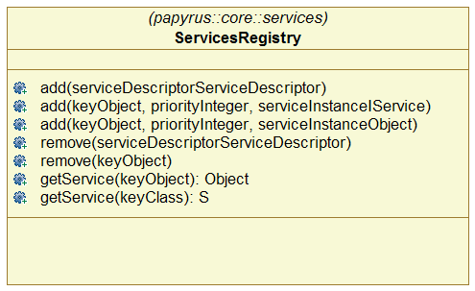
Figure 10 ServicesRegistry class public API.

EditorRegistry
The EditorRegistry is used to register the descriptors of editors that can be created in the multieditor.
Editor descriptors can be registered using the Eclipse extension mechanism (Figure 11).

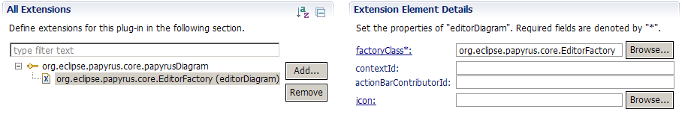
Figure 11 Nested Editor registered with Eclipse Extension
The EditorRegistry is mainly used by the SashContainer to create nested Editors when requested by the user, or when the multieditor is reopened.
The EditorRegistry requires the following to work:

Nested Editors
A nested editor, or embedded editor, is an editor that can be created and rendered in the multieditors.
A nested editor can be a regular Eclipse editor implementing the IEditorPart interface.
Usually, all nested editors share common resources, like the EMF Resource. This can be achieved with the help of the ServiceRegistry.

Sash Requirements for nested Editors
On the sash level, a nested editor is created when the sash.ContentProvider provide a

Sash Di Requirements for nested Editors

Core Requirements for nested Editors

A nested editor can be managed by the Core if:
- The nested editor can be represented by an EObject, and saved in an EMF resource;
  - for example, a GMF diagram is represented by its notation.Diagram class, which is an EObject.
- The nested editor can be created from its EObject.
  - For example, a GMF diagram can be created from its Diagram object.

To add a nested editor to the core, following actions should be done:
- Create the nested editor EMF representation
- Method org.eclipse.papyrus.core.adaptor.gmf.AbstractPapyrusGmfCreateDiagramCommandHandler.runAsTransaction(DiResourceSet, EObject, String) shows an (complex) example of how a GMF diagram can be created.
- Add the root EObject representing the nested editor to the DiContentProvider by using the IPageMngr.openPage(eObject) method.
- The IPageMngr can be obtained by calling org.eclipse.papyrus.core.utils.EditorUtils.getIPageMngr()
- The SashSystem should react automatically and show the newly added nested editor (if it know how to handle such editor ).

To let the Core handle a nested editor, following things are required:
- An implementation of IPageModel allowing to create the editor from its EObject (the object previously provided to IPageMngr.openPage(eObject) )
  - Actually this implementation is hidden in classes handling the old way to manage nested editor. Old stuff will be removed if possible.
- The PageModel is registered to the PageModelFactory. This is done with the Eclipse extension
- 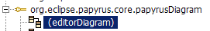

There can have several Action classes used to create a new editor. All the implementations should do what is described before (create a notation.Diagram and add it to the DiContentProvider). Example of implementation can be found for the class diagram:
- org.eclipse.papyrus.diagram.clazz.CreateClassDiagramCommand
  - used by the creation wizard (declared as extensions)
  - used by the toolbar and menu actions (declared as another extensions)
  - This class is quite complex because of old stuff (to be removed soon)

I would like to provide a more general mechanism for the creation wizard. This mechanism will complete the Eclipse mechanism for declaring menus and toolbar actions. It will allow:
- to declare creation wizard actions.
- to declare custom creation actions (for the creation wizard). Among this it will be possible to declare actions creating a prepopulated diagram, or actions asking input data before being executed.

From the core point of view, an nested editor can be added to the multieditor by adding the EObject representing the nested editor to the IPageMngr. Figure 12 shows what happen when an nested editor is added to the DiContentProvider.

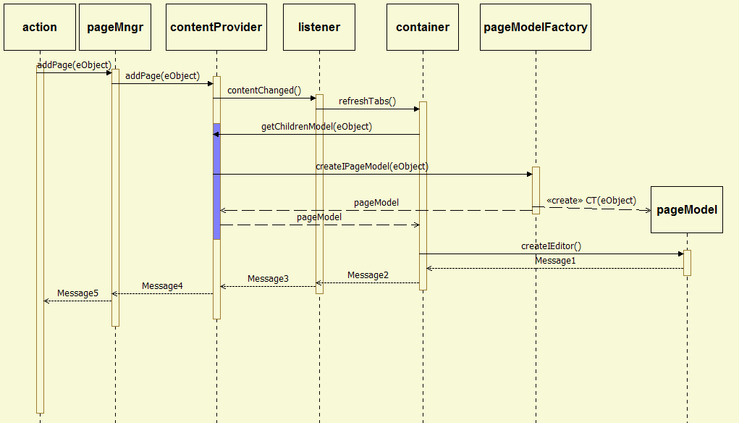
Figure 12 Adding nested Editor - Core Point of View

Tutorial
This short tutorial shows how to add a new kind of nested editor to the core.

Requirements:
- An Editor with following requirements:
  - Implements org.eclipse.ui.IEditorPart
  - Can be represented by an EObject. That is, it is possible to 1) Get an EObject representing the type and the content of the editor. 2) Reopen the editor from the EObject. GMF editors fall in this category.

You need to provide the following;
- An Action or an Handler allowing to create the EObject representing the editor and add this EObject to the SashContentProvider
- A factory that will receive as input the previously created EObject, and will create an IEditorModel for your editor.
- A subclass of IEditorModel. This class is used as model by the SashEditor. It serves to create the instance of the Editor for the previously created EObject.

Creation Handler

Create Editor Action

Developing Editor
- The editor should implements the eclipse.IEditorPart interface
  - Only few methods of the interface are used by the Container
- An editor factory should be provided
  - This factory is used by the SashContainer to create an instance of the editor when the SashProvider return IPageModel representing the editor.
- The factory could be registered as Eclipse extension

Papyrus GMF Requirements for nested Editors

Developing a Nested Editor

Nested Editors Creation Action

