Specifications document

Collaborative work

Index
Document History 3
Version History 4
Introduction 5
Control Mode 6
Control action 6
Uncontrol action 7
Graphical editor enhancements 7
Manage UML profiles 8
Export Mode (TODO) 9
Management of external resources and references 9
Additional resources and UML Profile 9
Additional resources and load 10
Additional resources and editing 10
Model merging (TODO) 10
Questions & Known issues 10
Tests & Validation (TODO) 10

Document History

Date | Comments
08/06/09 | Specifications only for control mode

Version History

Version | Date | Author | Company | Comments
1.0r1 | 08/06/09 | Emilien PERICO | Atos Origin | Initial content
1.0r2 | 08/06/09 | Thibault LANDRE | Atos Origin | Control Mode (Profil management) and Management of external resources and references

Introduction
This document aims to present the feature that will be developed to manage collaborative work right into the Papyrus editors.
The goal of the collaborative work is to share a model between team members and stakeholders, working together on a model as we use to do with programming language. We plan to provide several modes to work collaboratively. These modes are described in the document.
We defined different ways to work in collaborative mode:

- The first one is the control mode. This mode comes from EMF and it is available in all EMF editors. The purpose is to improve this existing mode for graphical editors.

- The second one is the export mode dedicated to outsourcing work in order to share parts of a model without showing or accessing the whole model.

- The last one enables to merge models. A first model could be inserted in a second one as a part of it, such as a sub package.

Most of the requirements defined in this document should be proposed as patch to the UML2 Editor component of Eclipse or EMF component.

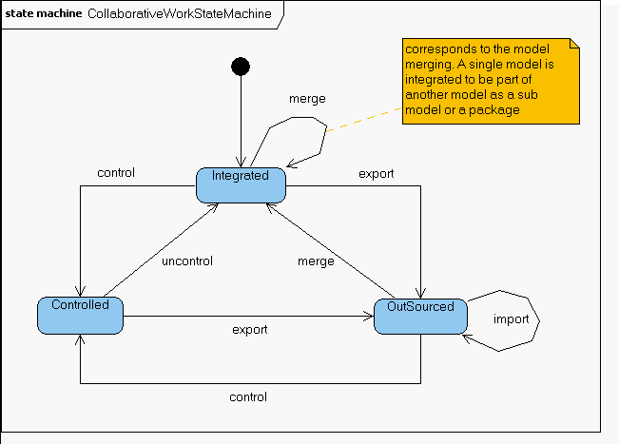Illustration 1: Overview of the different modes

Control Mode

The control mode comes from EMF. All the EMF models can be controlled through the editor with contextual menu.

Control action

A display dialog enables to select the resource created for the controlled element

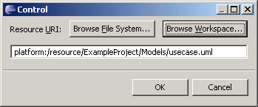

The resource is created and added as a dependency of the main model. This new resource is a kind of sub element of the main model. The controlled element is foregrounded with an icon decoration (a green arrow)

Uncontrol action

Uncontrol action is active on the controlled element in the main model. Uncontrol the selected element will merge it in the main model as initially.

For now, the additional resource is cleared out but the resource is not deleted. We want to improve this behaviour and delete the created additional resource when the uncontrol is effective.

The existing command of EMF is not sufficient for our needs. We have defined some enhancements to use the existing command in Papyrus.

Graphical editor enhancements
Control and uncontrol command should be available in the graphical editor.

req-control-001: Control and uncontrol commands will be added in contextual menu of a selected element into the Model View Explorer.

The EMF command doest not allow undo/redo action. Undo action will delete the created resources and merge the controlled element. Redo will split again the element and add the required resources.

req-control-002: Control and uncontrol command should be undone/ redone

req-control-003: The control command should only be available on container elements. It doesn't make sense to control element without child.

req-control-004: A default location (the current project) and default name (the selected element) will be the default value

req-control-005: Resolve conflict name if any. If the resource already exist, operation must be cancelled with a warning for the user.

Once control is done, resources for model and graphic should be created. If we keep the current graphical notation, 3 files must be created:
- the model file (.uml, .sysml, other)
- the di file (diagrams references)
- the notation (graphical notation of objects)

req-control-006: Create the required files for the controlled element: files for model and diagrams

The controlled model should be opened as a single model. We must split graphical informations about elements and diagrams into di and notation files of this new sub model.

References must be added in:
- in main model: to the sub diagrams
- in sub model: to the parent model

Content for the specified files (notation and di) should be defined.

req-control-007: add references between graphical models that enable to split and merge a sub model. (cf Q1)

req-control-008: Use the existing icon decorators from EMF in Model View Explorer.

req-control-009: delete the created resources when uncontrol command is performed

Manage UML profiles
As control command is an EMF mechanism, it does not manage the profiles that come from UML. For now, it's not possible to keep stereotypes in sub model. We have to manage profiles and stereotypes to keep it in a sub model. The best way is to load required dependencies in the sub model.

req-control-010: Keep applied profiles and stereotypes in a sub model.

req-control-011: When controlling a model, the stereotypes applied to any element which is being controlled must be stored within the new sub model.

req-control-012 : When uncontrolling a sub model, the stereotypes applied to any element of the sub model must be stored within the main model.

req-control-013: When controlling a model, the new sub model should benefits from the profile applied on its parents.
Profile Application should be created if necessary in the submodel.

req-control-014: When uncontrolling a sub model, if there is a profile application defined in its root element, the profile application has to be kept only if it is not already defined in one of the parent in the main model.
Otherwise this profile application should be deleted.

req-control-015: If the sub model references the main model as additional resource (when stereotype is applied), the main model should be in read-only mode.

req-control-016: A controlled element shouldn't be editable in the main model. Edition is only done in sub model.

Export Mode (TODO)
export a sub model as an autonomous model (creation of the sub model with embedded copy of the parent model dependencies) ?
integrate an exported sub model

req-outsourcing-001: the sub model created should be restricted to read-only mode from the main model view. (ref to req-control-015)

Management of external resources and references
Additional resources

Additional resources allows a model to access resources from a different model.
Currently, it exists for UML a dialog box available through a right click on an element, which allow users to select a 'new resource'.

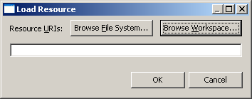

Additional resources and UML Profile

req-resource-001 : A mechanism should exist to create a library of UML profile in the users environment (extension point).

req-resource-002 : It should be possible for users to add a profile from a pre-defined library easily.

req-resource-003 : It should be possible for users to add profiles easily to a pre-defined library in their environment.

req-resource-004 : It should be possible for users to share easily their UML profile.

Additional resources and load
req-resource-005 : Additional resource should be loaded on demand

req-resource-006 : If an additional resource is not available, an error is raised. This behaviour should be enhanced to allow user to specify a new path to access the resource.

req-resource-007 : Users should be informed when a reference doesn't exist anymore.

Let's assume you have a property P typed by a ValueType VT coming from an additional resource. If VT is deleted from its resource, when you open again the model containing P, the information that P was typed by VT is lost and the user is not informed.

A mechanism should exist to inform the users on this.

Additional resources and editing
req-resource-009 : Additional resource should be on read only mode and shouldn't be edited through the outline nor the editor.

req-resource-010 : When saving a model, its additional resources must not be saved.

Model merging (TODO)
reuse existing model => merge a given model to reuse below a container model element of an other UML model

Questions & Known issues

Q1: A reference must be stored in graphical notation to link a model and the controlled element. This reference can be stored in .di file or .notation file. Do we keep both formats for graphical notation ? We must decide it to know the location of parent references.

Tests & Validation (TODO)

Define tests for each requirement. Waiting for potential refinements.

