


Papyrus Tutorial:
How to contribute to the code generation menu

Editor | Saadia DHOUIB - CEA LIST
Status | Production
Version number | 0.1
Date of preparation | 07/11/11
Authors

Authors name (first/last name) | Company | E-mail | Initial
Saadia Dhouib | CEA LIST | Saadia.dhouib@cea.fr | SD

Revision chart and history log
Version | Date | Reasons
0.1 | 19/10/11 | Initial contribution.
Table of contents

Authors 2
Revision chart and history log 3
Table of contents 4
1 Introduction 5
2 Set the Java execution environment 6
3 Add the menu contribution extension point 10
4 Add the command extension point 14
5 Add the handler extension point 15

Introduction
This tutorial explains how to contribute to the RobotML code generation menu in the papyrus model explorer view, as shown in the following figure:

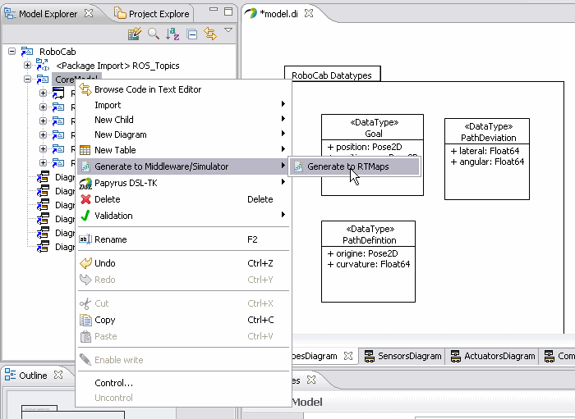

Set the Java execution environment
It is very important that your Eclipse projects use the J2SE-1.5, this is the java version used by papyrus. To do this, follow the steps in the table:
Step 1  click on project properties | 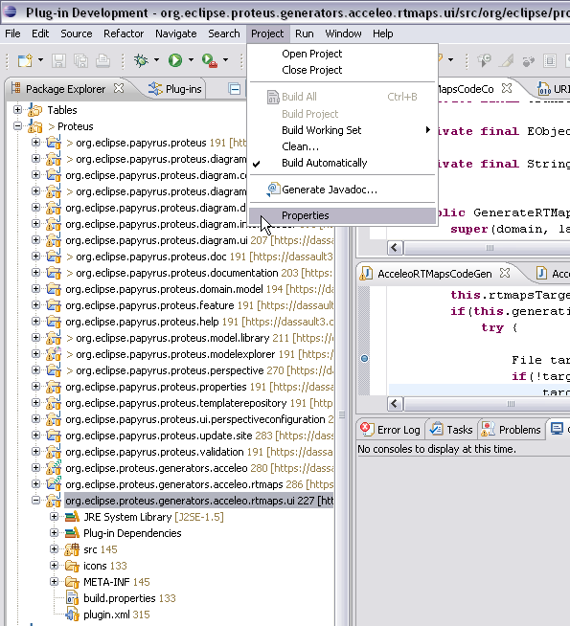  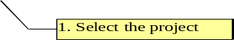  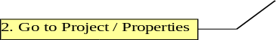
Step 2  Edit the JRE system library and set it to J2SE-1.5 | 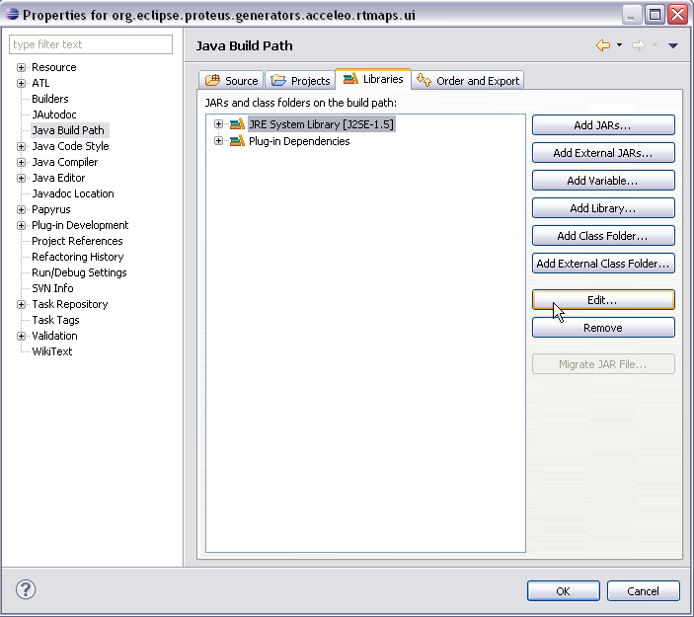
Step 3  Set the minimum execution environment in the plug-in manifest editor | 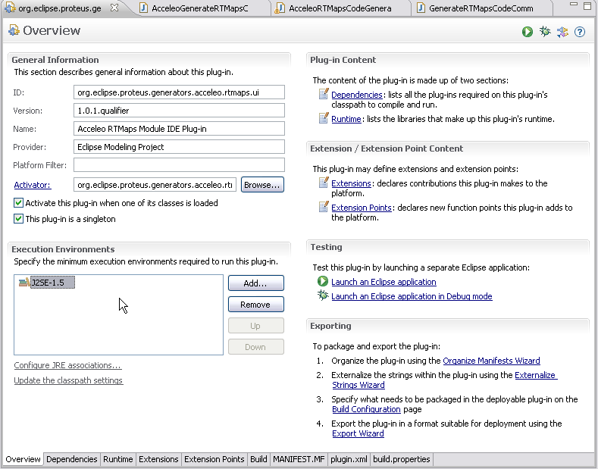

Add the menu contribution extension point
Go to the user interface project, org.eclipse.proteus.generators.acceleo.yourplatform.ui:
Then open the plug-in manifest editor.
In the Extensions corner, you are going to add a new extension that will contribute to the RobotML code generation menu.
To do this, follow the steps described in the table:
Step1  Go to the extension corner | 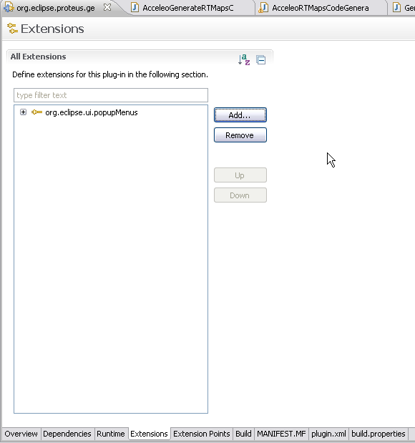  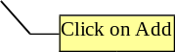
Step 2  Add org.eclipse.ui.menus extension | 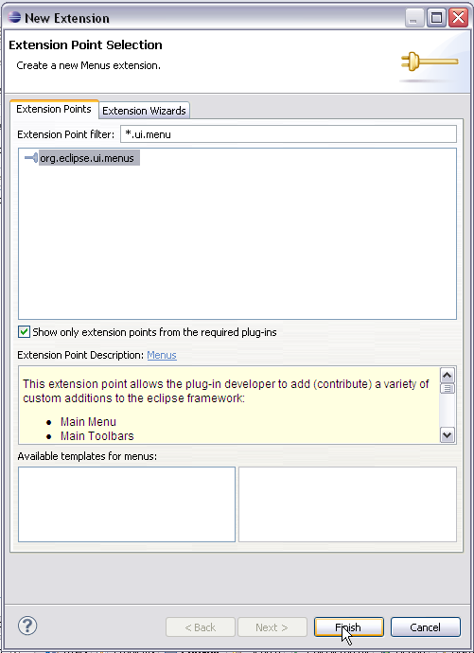
Step 3  Add a new menu contribution | 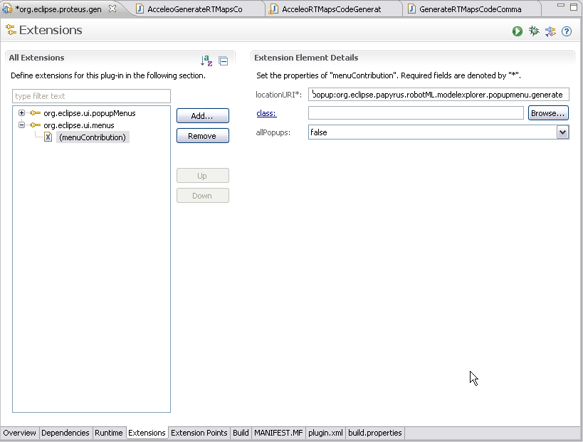  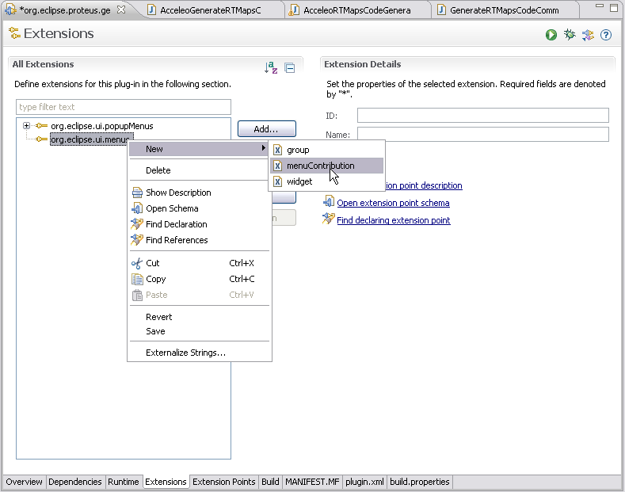  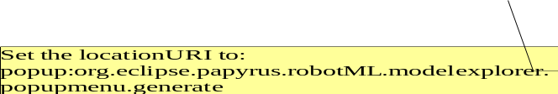
Step 4  Add a command to the menucontribution | 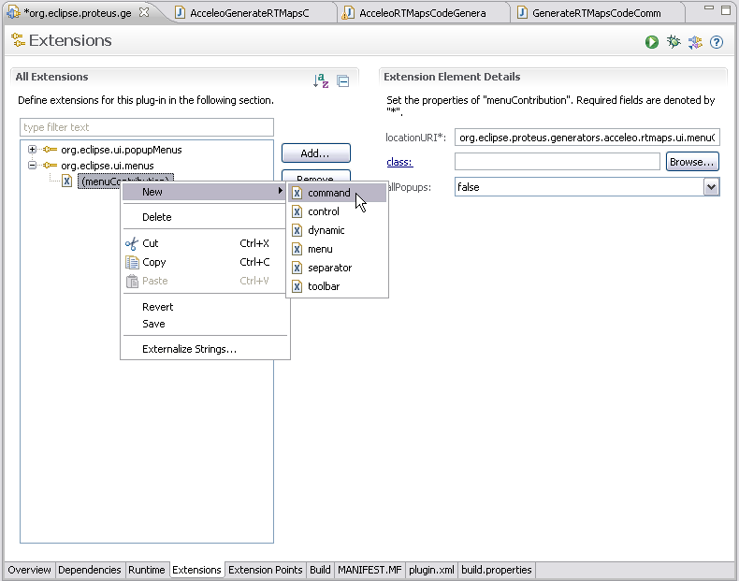  <extension  point="org.eclipse.ui.menus">  <menuContribution  allPopups="true"  LocationURI=  "popup:org.eclipse.papyrus.robotML.modelexplorer.popupmenu.generate">  <command  commandId="org.eclipse.robotML.generateRTMapsCommand"  icon="icons/default.gif"  id="org.eclipse.robotML.generateRTMaps"  label="Generate to RTMaps"  style="push"  tooltip="Generate code to RTMaps middleware">  <visibleWhen>  <reference  DefinitionId=  "org.eclipse.papyrus.proteus.diagram.common.IsPapyrusActiveWithProteus">  </reference>  </visibleWhen>  </command>  </menuContribution>  </extension>  The extension details (plugin.xml corner)

Add the command extension point
Then add an extension point to define the code generation command called by the previously defined menu. A command is is a declarative description of a component and is independent from the implementation details. Commands are defined via the extension point "org.eclipse.ui.commands". A command can be categorized, assigned to the user interface and a key binding can be defined for the command. The behavior of a command can be defined via a handler.
Step  Add a command extension point | 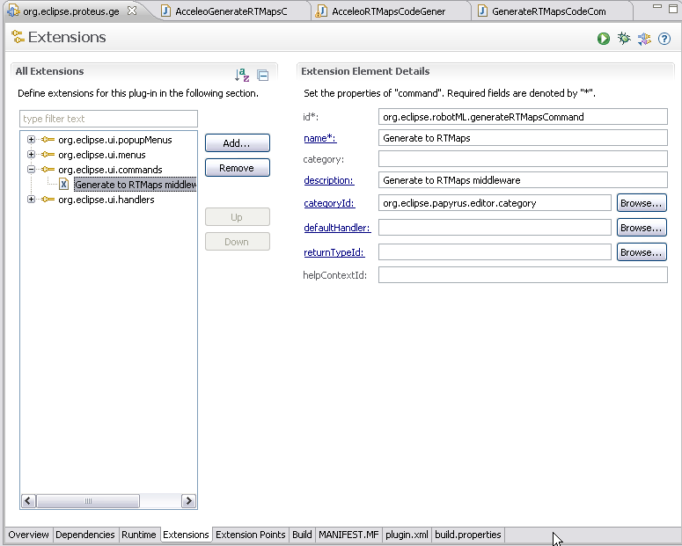  <extension  point="org.eclipse.ui.commands">  <command  categoryId="org.eclipse.papyrus.editor.category"  description="Generate to RTMaps middleware"  id="org.eclipse.robotML.generateRTMapsCommand"  name="Generate to RTMaps">  </command>  </extension>

Add the handler extension point
Add an extension point to define the handler of the command. The handler is used to define the command behavior.
Step  Add the handler extension point | 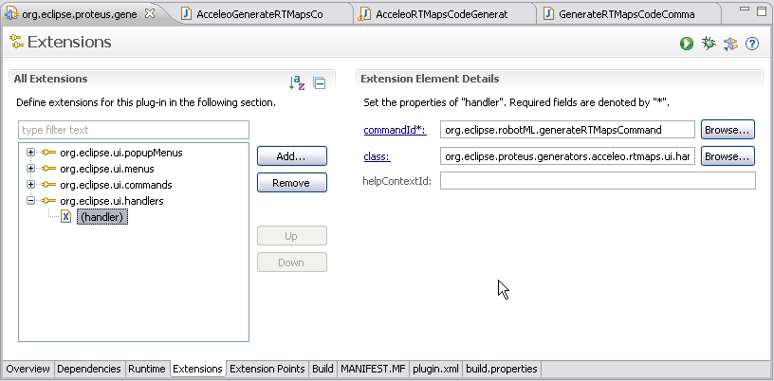  <extension  point="org.eclipse.ui.handlers">  <handler  Class="org.eclipse.proteus.generators.acceleo.rtmaps.ui.  handler.AcceleoGenerateRTMapsCommandHandler"  commandId="org.eclipse.robotML.generateRTMapsCommand">  </handler>  </extension>

You can find an example of a generation command handler class in “org.eclipse.proteus.generators.acceleo.rtmaps.ui.handler.AcceleoGenerateRTMapsCommandHandler” package. [Proteus wp2 svn repository: https://dassault3.ddo.net/svn/proteus-wp2/trunk/S2.2.8-RTMaps-connectors/rtmaps-generator/org.eclipse.proteus.generators.acceleo.rtmaps.ui]

