|  |
| --- |
| CEA LIST |
| Display properties of applied Stereotypes as a «Comment » Developper Guide |
| [Tapez le sous-titre du document] |

|  |
| --- |
| TESSIER Patrick 202707  23/10/2012 |



Sommaire

Display properties of applied Stereotypes as a « Comment » 1

Use Cases 3

1. Papyrus shall enable to show stereotypes values in a comment symbol. 3

1.1 Creation of the comment symbol used to show stereotype values 4

2.1 Deletion of the comment symbol used to show stereotype values 4

3.1 Creation of the Link 4

4.1 Deletion of the link 4

5.1 Move the comment symbol showing the stereotypes values 4

Solution proposition 5

Test Use case 8

2. *To create the symbol comment from the stereotyped element*: 8

3. For the deletion: 8

4. For the move : 9

# Use Cases

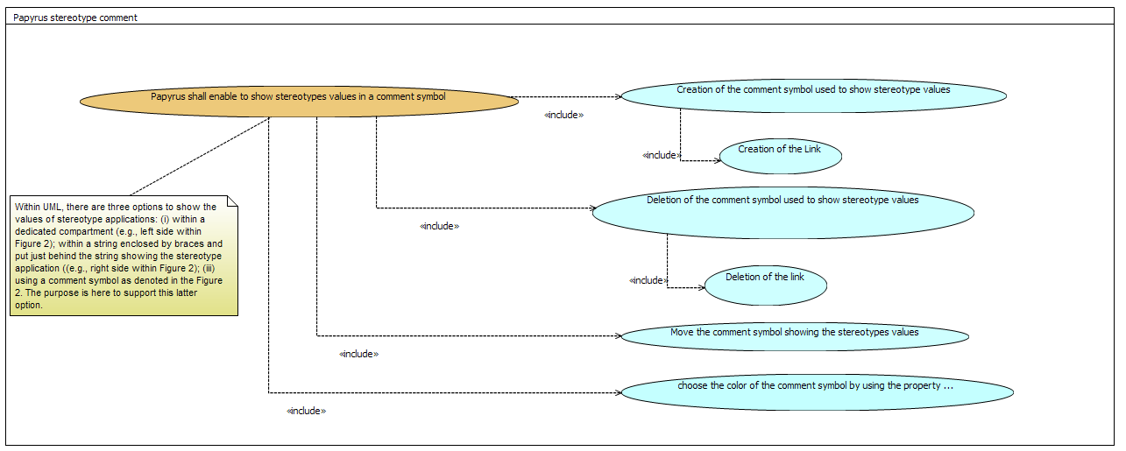

Figure 1: use cases overview

## Papyrus shall enable to show stereotypes values in a comment symbol.

Within UML, there are three options to show the values of stereotype applications: (i) within a dedicated compartment (e.g., left side within Figure 2); within a string enclosed by braces and put just behind the string showing the stereotype application ((e.g., right side within Figure 2); (iii) using a comment symbol as denoted in the Figure 2. The purpose is here to support this latter option.



Figure 2. Examples of stereotypes values shown either ina specific compartmen (left-side) or in a dedicated string enclosed with braces (right-side)



Figure 3: Example of stereotype values shown within a comment symbol attached to stereotyped model element (extracted from the specification UML2.5, p. 289)

### Creation of the comment symbol used to show stereotype values

* The comment symbol is created when a user decide to show at least one property value of a stereotype applied on a model element.

### Deletion of the comment symbol used to show stereotype values

* The comment symbol, and its link, used to display the stereotype values shall be deleted when the annotated model element is deleted.
* The comment symbol, and its link, used to display the stereotype values shall be deleted when the graphical representation of the annotated model element is deleted, that is to say when the annotated model element is hidden from the diagram.
* The comment symbol, and its link, used to display the stereotype values shall be deleted when the user hides all values of a stereotype.
* The comment symbol, and its link, used to display the stereotype values shall be deleted when the applied stereotype whose values are currently shown are unapplied.
* When the user delete or cut graphically the comment symbol, this latter is deleted, as well its link with the annotated model element and the stereotypes values that were shown in the deleted comment symbol are set to be no more shown in the notation file.
* For the moment, this element cannot be deleted semantically or graphically.
  + Semantically = unapplication of stereotypes?
  + graphically = update information of the display of the property of stereotype in the property view (maybe later)

### Creation of the Link

* Create it when the element is stereotyped and when a property of the stereotype is displayed as "comment shape"

### Deletion of the link

* When the semantic element is deleted
* when all properties of applied stereotypes are not displayed as "comment shape"
* when all properties of applied stereotypes that are displayed as " comment shape" are unapplied
* For the moment, this element cannot be deleted semantically or graphically, because it is only to be link the "comment"

### Move the comment symbol showing the stereotypes values

* The comment symbol showing the stereotype values can be graphically moved everywhere in the diagram.
* The comment symbol showing the stereotype values cannot be copy/past.

# Solution proposition

The applied stereotypes properties “comment” is represented as in Figure 4 by:

The editpart *AppliedStereotypesCommentEditpart,*  the comment shape that will contains the editpart in charge of the edition of sterotype (*AppliedStereotypeConpartmentEditPart*, *AppliedStereotypePropertyEditPart*).

The editpart *AppliedSterotypesCommentLinkEditPart,* the link between the stereotyped element and the comment.

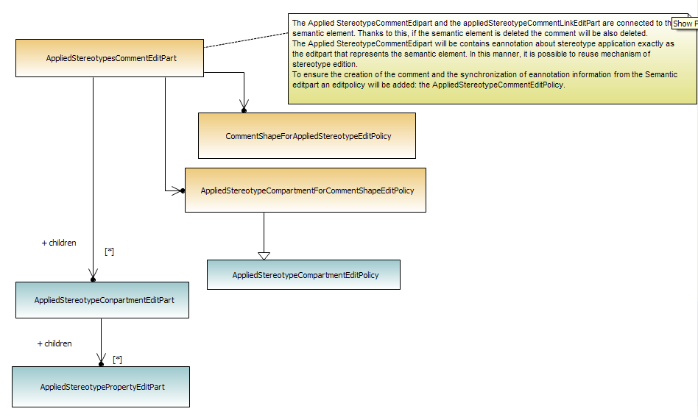

Figure 4: AppliedStereotypeComment Editpart

The Applied *StereotypeCommentEdipart* and the *AppliedStereotypeCommentLinkEditPart* are connected to the semantic element. Thanks to this, if the semantic element is deleted the comment will be also deleted.

The Applied *StereotypeCommentEdipart* will be contains eannotation about stereotype application exactly as the editpart that represents the semantic element. In this manner, it is possible to reuse mechanism of stereotype edition. It has two editpolicy:

* *CommentShapeForAppliedStereotypeEditPolicy* : this editpolicy attached to *StereotypeCommentEdipart* has in charge to prevent the remove form model and launch command of deletion if it detect that any properties of applied stereotype are displayed.
* AppliedStereotypeCompartmentForCommentShapeEditPolicy is another editpolicy attached to *StereotypeCommentEdipart.* It does the same work as AppliedStereotypeCompartmentEditPolicy. Because the *StereotypeCommentEdipart*  is not attached to a semantic element by the attribute element of the notation view. It specializes the method getUMLElement to find the semantic element

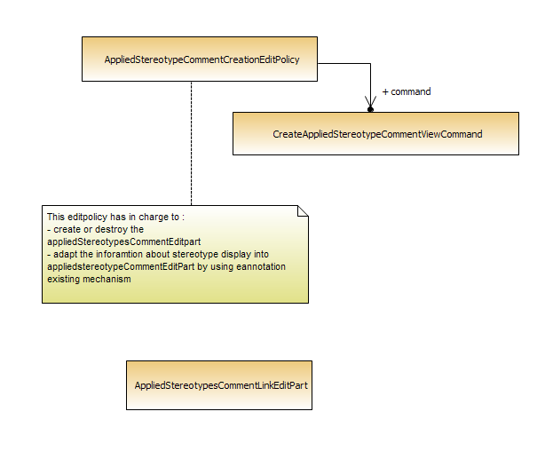

Figure 5:AppliedStereotypeCommentCreationEditPolicy

To ensure the creation of the comment and the synchronization of eannotation information from the Semantic editpart an editpolicy will be added: the *AppliedStereotypeCommentCreationEditPolicy*.

This editpolicy has in charge to:

* + Create by using the command *CreateAppliedStereotypeCommentViewCommand*
  + Destroy the A*ppliedStereotypesCommentEditpart*
  + Adapt the information about stereotype display into A*ppliedstereotypeCommentEditPart* by using eannotation existing mechanism

In Figure 3, two stereotypes are applied on the **Class1**. By default two ApplicationStereotypeCompartment are created (one references **stapp1**, and the second references **stapp2**). By default there are not visible. This is the normal behavior.

The user has decided to display a property if the applied stereotype **stapp1.**

An AppliedStereotypesCommentEditpart and *AppliedStereotypeCommentLinkEditPart* are created. (They do not references directly **Class1,** the notation references it by using a EObjectValueStyle with the name BASE_ELEMENT). If not the gmf framework launch the command of reparent of container when you move the object

The AppliedStereotypesCommentEditpart reuse the standard mechanism of stereotype displaying:

Two ApplicationStereotypeCompartment are created (one references **stapp1** with visibility=true, and the second references **stapp2** with the visibility=false).

An appliedStereotypePropertyEditpart is created because we want to see a property of **stapp1**

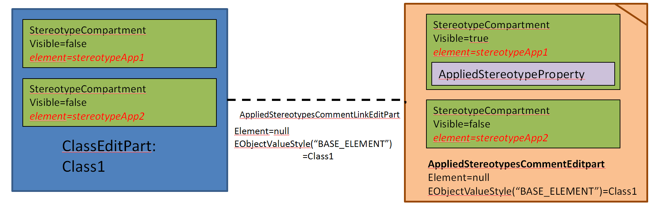

Figure 6: Editpart representation into a diagram

# Test Use case

For each use case a model test has been created in the plugin: org.eclipse.papyrus.uml.appliedstereotypecommend.recipetest.

## To create the symbol comment from the stereotyped element:

CreateDirectlyAcomment

A node and a link are stereotyped. The purpose is to display applied stereotype properties as comment

ReOpenFile

A node and a link are stereotyped. Applied stereotype properties are displayed as comment. The purpose is to open the file with papyrus and ensure that there are displayed as comment.

CreateFromComment

A node and a link are stereotyped. Applied stereotype properties are displayed as compartment. The purpose is to display them as comment. The comment has to be created and compartments disappear.

Creation of a comment by selecting several properties of stereotype

Display stereotype directly as comment shape by selecting two properties. A bug was raised because several comment were created

🡪393530: [Stereotypes] doublon of applied stereotype comment can be created

## For the deletion:

ChangeDisplay

A node and a link are stereotyped. Applied stereotype properties are displayed as comment. The purpose is to open the file with papyrus and and to display as compartment. Comment has to disappear.

UnapplyStereotype

A node and a link are stereotyped. Applied stereotype properties are displayed as comment. The purpose is to open the file with papyrus and to unapply stereotype. Comment has to disappear.

UnapplyProfile

A node and a link are stereotyped. Applied stereotype properties are displayed as comment. The purpose is to open the file with papyrus and to unapply profile. Comment has to disappear.

BadUnapplyProfile

A node and a link are stereotyped. Applied stereotype properties are displayed as comment. But the profile has been unapplied with the UML editor.So the notation is not up to date.The purpose is to open the file with papyrus. Comment has to disappear.

UnapplyProfileDiagramClosed

A node and a link are stereotyped. Applied stereotype properties are displayed as comment. But the profile has been unapplied with diagram closed.The purpose is to open the diagram. Comment has to disappear.

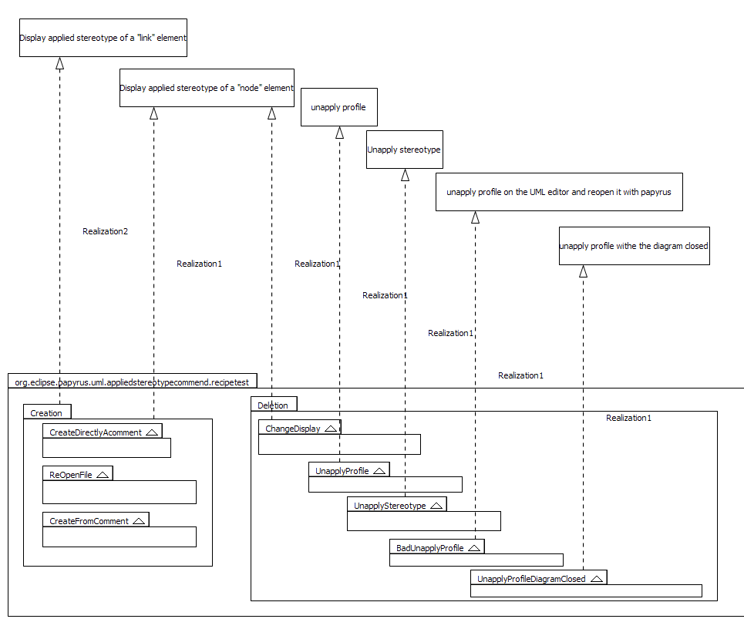

Figure 7: Test about creation and deletion

## For the move :

MoveComment

A node and a link are stereotyped. Applied stereotype properties are displayed as comment. The purpose is to open the file with papyrus and ensure that you can move comment everywhere.

MoveCommentWithPackage

A node and a link are stereotyped. Applied stereotype properties are displayed as comment. The purpose is to open the file with papyrus and ensure that you can move comment into package without move stereotyped element.

MoveSemanticWithPackage

A node and a link are stereotyped. Applied stereotype properties are displayed as comment. The purpose is to open the file with papyrus and ensure that you can move semantic into package without move comment.