

Patrick Tessier

Display properties of applied Stereotypes as a « Comment » User Guide

Version 0.0.3

Table of Content

Display properties of applied Stereotypes as a « Comment » 1

User Guide 1

1. Use Cases 3

1.1 Papyrus shall enable to show stereotypes values in a comment symbol. 3

2.1 Creation of the comment symbol used to show stereotype values 4

3.1 Deletion of the comment symbol used to show stereotype values 5

4.1 Move the comment symbol showing the stereotypes values 6

5.1 Choose the color of the comment symbol by using the property view 6

# Use Cases

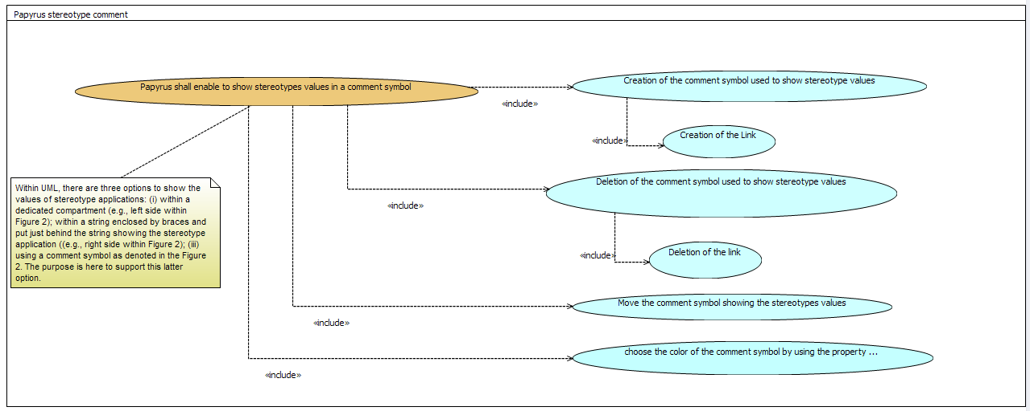

Figure 1: use cases overview

## Papyrus shall enable to show stereotypes values in a comment symbol.

Within UML, there are three options to show the values of stereotype applications: (i) within a dedicated compartment (e.g., left side within Figure 2); within a string enclosed by braces and put just behind the string showing the stereotype application ((e.g., right side within Figure 2); (iii) using a comment symbol as denoted in the Figure 2. The purpose is here to support this latter option.



Figure 2. Examples of stereotypes values shown either ina specific compartmen (left-side) or in a dedicated string enclosed with braces (right-side)



Figure 3: Example of stereotype values shown within a comment symbol attached to stereotyped model element (extracted from the specification UML2.5, p. 289)

## Creation of the comment symbol used to show stereotype values

* The comment symbol is created when a user decide to show at least one property value of a stereotype applied on a model element.

The creation of the comment symbol includes the creation of the link

#### How to

* Apply chosen profile and chosen stereotype on the element by using profile tab.
* Go to the property view (appearance tab).
* Select properties to stereotype to select and then choose the “display place” as Comment

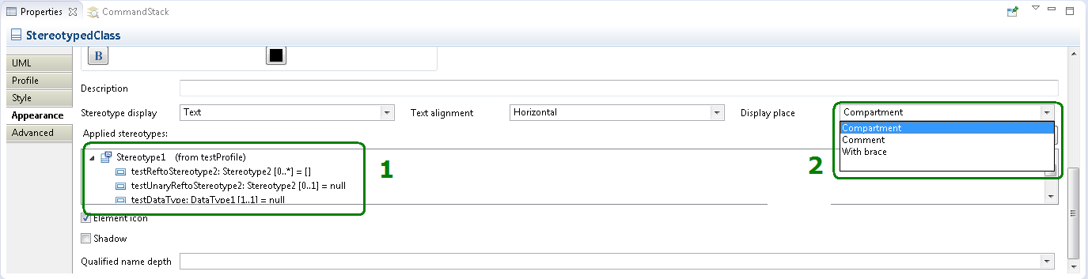

Figure 4: the property view to display applied stereotype property with comment shape

Thank to this, a comment symbol appear. It contains the applied stereotype property that you want to see. The property of stereotype can be edited. This functionality can be use on links or nodes see Figure 5.

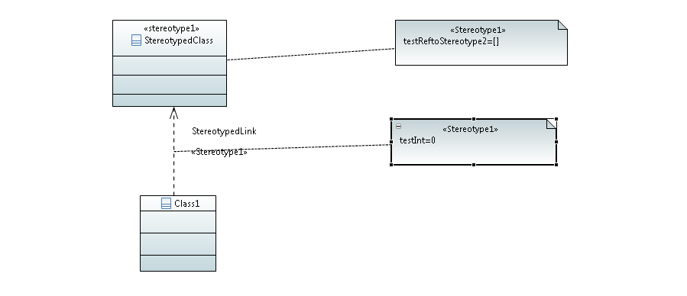

Figure 5: display applied stereotype with the comment symbol

## Deletion of the comment symbol used to show stereotype values

* The comment symbol, and its link, used to display the stereotype values shall be deleted when the annotated model element is deleted.

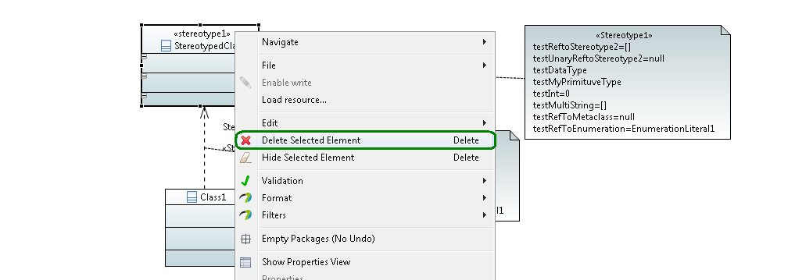

Figure 6: Deletion of the selected element

* The comment symbol, and its link, used to display the stereotype values shall be deleted when the graphical representation of the annotated model element is deleted, that is to say when the annotated model element is hidden from the diagram.

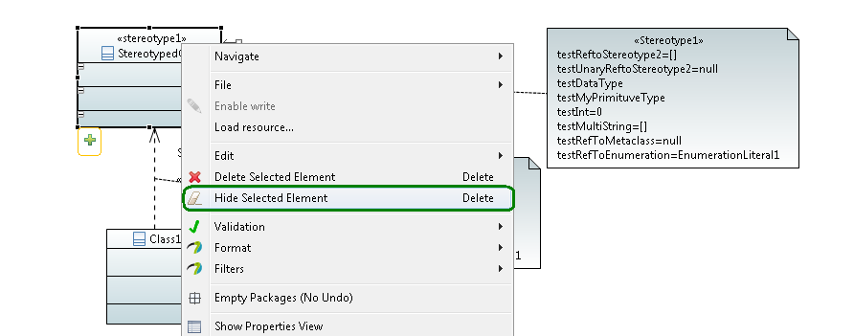

Figure : Hide element

* The comment symbol, and its link, used to display the stereotype values shall be deleted when the user hides all values of a stereotype.

To that, go the property view select each property of stereotype (1) and click on the small TV (2) Figure 8 . When the property is displayed the symbol is , when it is not displayed the symbol is .

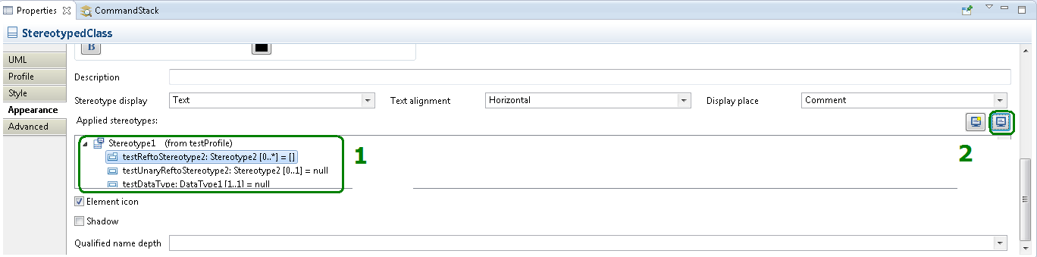

Figure 8: Remove the display of applied stereotype property

* The comment symbol, and its link, used to display the stereotype values shall be deleted when the applied stereotype whose values are currently shown are unapplied.
  + To do that , go the property view (Figure 9), select profile tab, and first select the stereotype to remove (1) and then the click on the red cross (2)

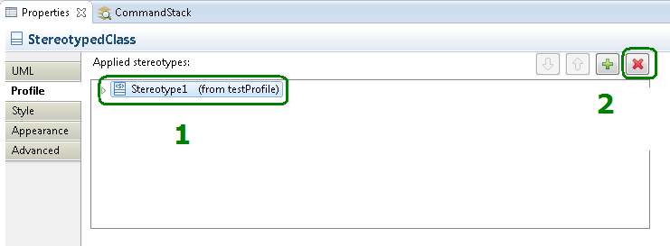

Figure : remove applied stereotype

## Move the comment symbol showing the stereotypes values

• The comment symbol showing the stereotype values can be graphically moved everywhere in the diagram.

• The comment symbol showing the stereotype values cannot be copy/past.

## Choose the color of the comment symbol by using the property view

The presentation of the comment symbol can be customized by the user. You can change the background and the foreground color.

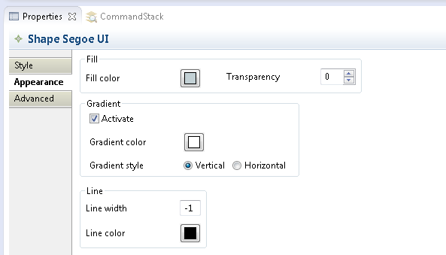

Figure 10: change the appearance of the comment symbol