EngineAuth: Multi-Provider Authentication for App Engine
EngineAuth is a standardized approach to third party authentication / authorization, designed to be as simple as possible, both for the developer and the end user.

Disclaimer
Warning
EngineAuth is in the very early stages of development and the api is likely to change frequently and in non-backwards compatible ways. Please provide any issues, suggestions, or general feedback through the Issue Tracker, or in the comments section of this documentation.

Demo
EngineAuth Example - Example site

How it Works
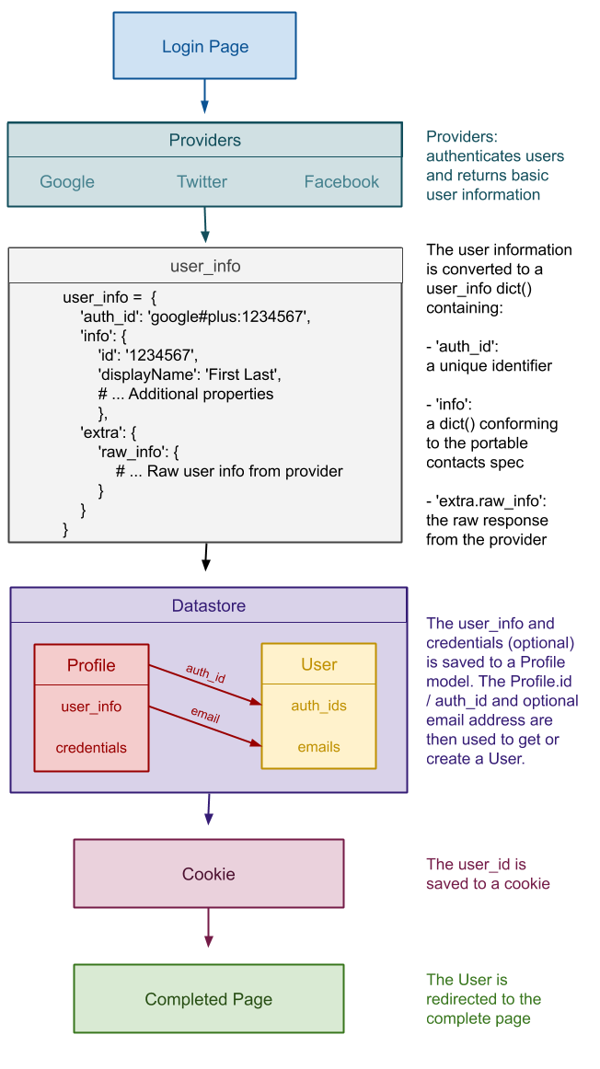
Note
If you are unable to view the above image. Please log into your Google Docs account, or log out of Google altogether. There’s currently a Google Docs bug that requires a user to be sign in to Google Docs to view public content.

Supported Strategies & Providers
New strategies will be written as needed. If there’s a particular strategy that your interested in please create a new issues using the strategy request label.

OAuth
- Twitter

OAuth2
- Facebook
- Google

OpenID Provider
- All - via App Engine OpenID

Email & Password
If the provider that you need isn’t provided not to worry, adding additional providers is simple, and in many cases only requires a few lines of code.

Requirements
- Google App Engine running Python 2.7

Installation
Copy the engineauth directory and the contents of lib directory to your project’s rootdirectory.

Dependencies
- oauth2client - Required for OAuth2 Strategies
- httplib2 - Required for OAuth and OAuth2 Strategies
- uri-templates - Required for OAuth and OAuth2 Strategies
- python-gflags - Required for OAuth and OAuth2 Strategies
- python-oauth2 - Required for OAuth Strategies

Configuring EngineAuth
In your appengine_config.py add:
def webapp_add_wsgi_middleware(app):
from engineauth import middleware
return middleware.AuthMiddleware(app)

engineauth = {
'secret_key': 'CHANGE_TO_A_SECRET_KEY',
'user_model': 'engineauth.models.User',
}

engineauth['provider.auth'] = {
'user_model': 'engineauth.models.User',
'session_backend': 'datastore',
}

# Facebook Authentication
engineauth['provider.facebook'] = {
'client_id': 'CHANGE_TO_FACEBOOK_APP_ID',
'client_secret': 'CHANGE_TO_FACEBOOK_CLIENT_SECRET',
'scope': 'email',
}

# Google Plus Authentication
engineauth['provider.google'] = {
'client_id': 'CHANGE_TO_GOOGLE_CLIENT_ID',
'client_secret': 'CHANGE_TO_GOOGLE_CLIENT_SECRET',
'api_key': 'CHANGE_TO_GOOGLE_API_KEY',
'scope': 'https://www.googleapis.com/auth/plus.me',
}

# Twitter Authentication
engineauth['provider.twitter'] = {
'client_id': 'CHAGNE_TO_TWITTER_CONSUMER_KEY',
'client_secret': 'CHAGNE_TO_TWITTER_CONSUMER_SECRET',
}

Acquiring Client Keys

Facebook
- Go to: https://developers.facebook.com/apps
- Select your application
- Under Select how your app integrates with Facebook click Website. In the Site URL: field enter your domain E.g. http://example.com/ or http://localhost:8080/ be sure to include the closing /.
- Copy App ID/API Key as client_id
- Copy App Secret as client_secret
Note
Zuckerberg won’t allow you to specify multiple callback domains for a single application. So for development you must create a separate application. Then, in your appengine_config.py you can specify which config will be loaded at runtime.
import os
ON_DEV = os.environ.get('SERVER_SOFTWARE', '').startswith('Dev')
if ON_DEV:
# Facebook settings for Development
FACEBOOK_APP_KEY = 'DEVELOPMENT_APP_KEY'
FACEBOOK_APP_SECRET = 'DEVELOPMENT_APP_SECRET'
else:
# Facebook settings for Production
FACEBOOK_APP_KEY = 'PRODUCTION_APP_KEY'
FACEBOOK_APP_SECRET = 'PRODUCTION_APP_SECRET'
engineauth['provider.facebook'] = {
'client_id': FACEBOOK_APP_KEY,
'client_secret': FACEBOOK_APP_SECRET,
'scope': 'email',
}

Google Plus
- Go to: https://code.google.com/apis/console
- Select your application or create a new one.
- Choose API Access
- Click Create an OAuth 2.0 client ID..
- Enter Product name -> Next
- Select Web application
- Under Your site or host select (more options)
- Under Authorized Redirect URIs add your domain name followed by /auth/google/callbackE.g. http://localhost:8080/auth/google/callback, http://YOUR_DOMAIN.COM/auth/google/callback
- Click Create client ID
- Copy Client ID as client_id
- Copy Client secret as client_secret
- Enable Google+ API in the console.

Twitter
- Go to: https://dev.twitter.com/apps
- Select your application or create a new one.
- Make sure the you set the callback to http://YOUR_DOMAIN.COM/auth/twitter/callback. It’s fine to set this to your production url, EngineAuth passes a redirect url while authenticating so there’s no need to specify localhost:8080 here.
- Go to Details OAuth settings
- Copy Consumer key as client_id
- Copy Consumer secret as client_secret

LinkedIn
- Go to: https://www.linkedin.com/secure/developer?newapp
- Fill in required fileds. You may leave OAuth Redirect URL: blank.
- Click Add Application
- Copy API Key as client_id
- Copy Secret Key as client_secret
- Click Done

Github
- Go to: https://github.com/account/applications/new
- Fill in required fileds. For Callback URL enter ``http://YOUR_DOMAIN.COM/auth/github/callback`
- Click Create Application
- Copy Client ID as client_id
- Copy Secret as client_secret
- Click Done

App Engine OpenID
- Go to: https://appengine.google.com
- Select your application
- Choose Application Settings
- Choose (Experimental Federated Login) from the Authentication Options drop down
- Click Save

Screen short

