Gabriel Molina

TopBike’s Case

This Feasibility Study Report was prepared for the TopBike Case, to evaluate potential remedial alternatives for through expansion of the current brick and the mortar store. Implementing this new system, the employees will be able to keep track of the inventory and decrease the time and effort spent on the organization TopBike. The specific functionalities that the new system should have are:

* Organize in-store sales
* Purchase items from the suppliers
* Establish a customer database
* Organize employee payroll into an employee database
* Search for items in the inventory database
* Establish a work order database

These specific functionalities were based on the issues found, for example, The Paper-based system was leading to multiple issues particularly with tracking inventory and accounts receivable. Adding possible solutions to solve and make improvements to the TopBike company one of them is the Addition of the payroll function to accommodate larger shop employment. Also, the owner Helbert wants an estimated Net Present Value of $347,696 mostly in the form of reduced shrink and more efficient of the customer accounts.

In this system that we have been planned and proposed, we believe that that system will increase sales by allowing the employees to retrieve information on items in a timely manner that will allow for better customer service. We expect the larger store increase revenue by having a large selection of items and bikes. We also expect some cross-selling once a customer purchases a bike or a part they will be more inclined to purchase more bikes or parts.

With this new system, the owner Helbert will accomplish his goals for the store estimates of tangible value to the company with the 40% increase in sales, $700,000 ins store sales from bikes and parts, and $200,000 sales in sales bike repairs. And, this system needs to be implemented as soon as possible because of the nearby competition Malfords.

The Feasibility of this new system we are expecting an increasing turnover of 100% in the space of 3 years. The average Annual Benefits will be increased by $300,000. The total calculated cost of this project to implement the new system would be around $200,000. Annual Operational Costs will be increased by $219,700. The intangible benefits that the store would experiment are: increase market share, improve customer service, better supplier relation, increase brand recognition.

When we develop the cost benefits of this case for the improvement of this particular store, those costs would be Purchase & Refurbishment of new premises, Development of Computerized Sales, Internet- Software Interface, Advertising, Purchase New Stocks, and Website Construction. These elements are essential to building our system in the TopBike store. Also, we have Operational Costs: Computer maintenance, Repayment for the new Premises, Advertising, Operational Labor, Internet Services Fees.

In this current case, we have technical feasibility analysis, we can tell that these applications are moderated risk, the technology is a high risk too. The project size is a moderate risk, and the compatibility is a low risk.

The Organizational Feasibility Analysis of this case, the project has the Project Champion that is Helbert, the owner of TopBike that is the main sponsor for the project. Top management is all those members of management that work efficient methods for running the business operations. Again Helbert is the Stakeholders with his group of employees that are part of the TopBike because they are investing a considerable amount of time and money into making sure that the system is a complete success. The Users, it is confirmed by all the employees that work in TopBike since they expect to use the new system.

Data Flow Diagrams

Context Diagram

Item Request (Part/Bike)

Deposit

Deposit

Approved

Items

Order

Technician /

Owner

Staff Member

Hours worked

Paycheck

Repair Bill

Repair Information

0

Customer

Information

Paycheck

Employees

Unpaid

Notification

(Customer)

Customer

Information

Customer

Information

Top Bike System

Manager of TopBike

Request (Part/Bike/Repair)

Receipt

Payment Approved

Payment

pAYMENT

Customer

Bank

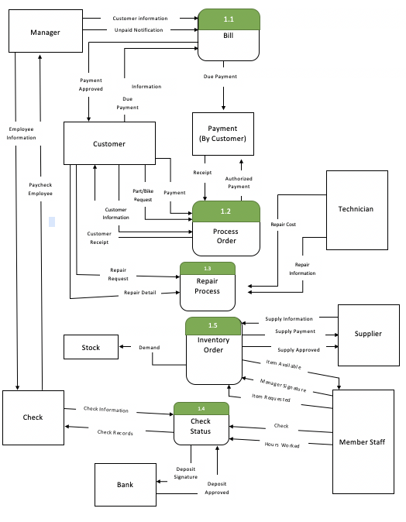

Level 1

Logical Data Structure diagram

PART_BIKE

Part_ID

Part_Color

Part_Qty

Part_Price

Part_Brand

Supplier_ID

CUSTOMER

Customer_ID

Customer_First

Customer_Last

Customer_Phone

Customer_Address

Customer_Email

Payment

contains

makes

PURCHASED

Purchase_Date

Customer_Last

Customer_First

Bike_ID

Part_ID

by

by

lists

Bike_ID

Bike_Size

Bike_Color

Bike_Qty

Bike_Price

Bike_Brand

Supplier_ID

BIKE

by

by

produce

by

make

by

payment

SUPPLIER

Repair_Date

Repair_Cost

Customer_ID

Employee_ID

Quote

SHOP_REPAIR

EMPLOYEE

PAYROLL

Supplier_ID

Supplier_Name

Supplier_Address

Supplier_Email

Supplier_Phone

Employee_Title

Employee_Last

Employee_First

Employee_Address

Employee_Phone

Employee_Email

Paycheck

Pay_Rate

Hours

Employee_ID

Level 2

Indirect Receipt

Indirect Plan

Telephone Payment

Employee

Payment

Customer Plan

Customer Payment

Customer Invoice

Approved Customer Plan

Approved Customer Payment

Approved Customer Invoice

Customer Payment

Payment

Item ID

Order Information

Customer Receipt

Customer Information

Product Information

Customer

2.1

cv

Information

(Order)

Customer Information

Contacts

Item Available

Sale Price

Price List

Item ID

Inventory

Inventory

Stock

2.2

Item Quantity

Details

2.3