

Pr2AP

Author: John Doe
File name: Pr2AP.vp
Date: 10/18/26, 2:25 AM
Version: 1.0

Screens
01

01. Screens / Pr2AP
Main Menu
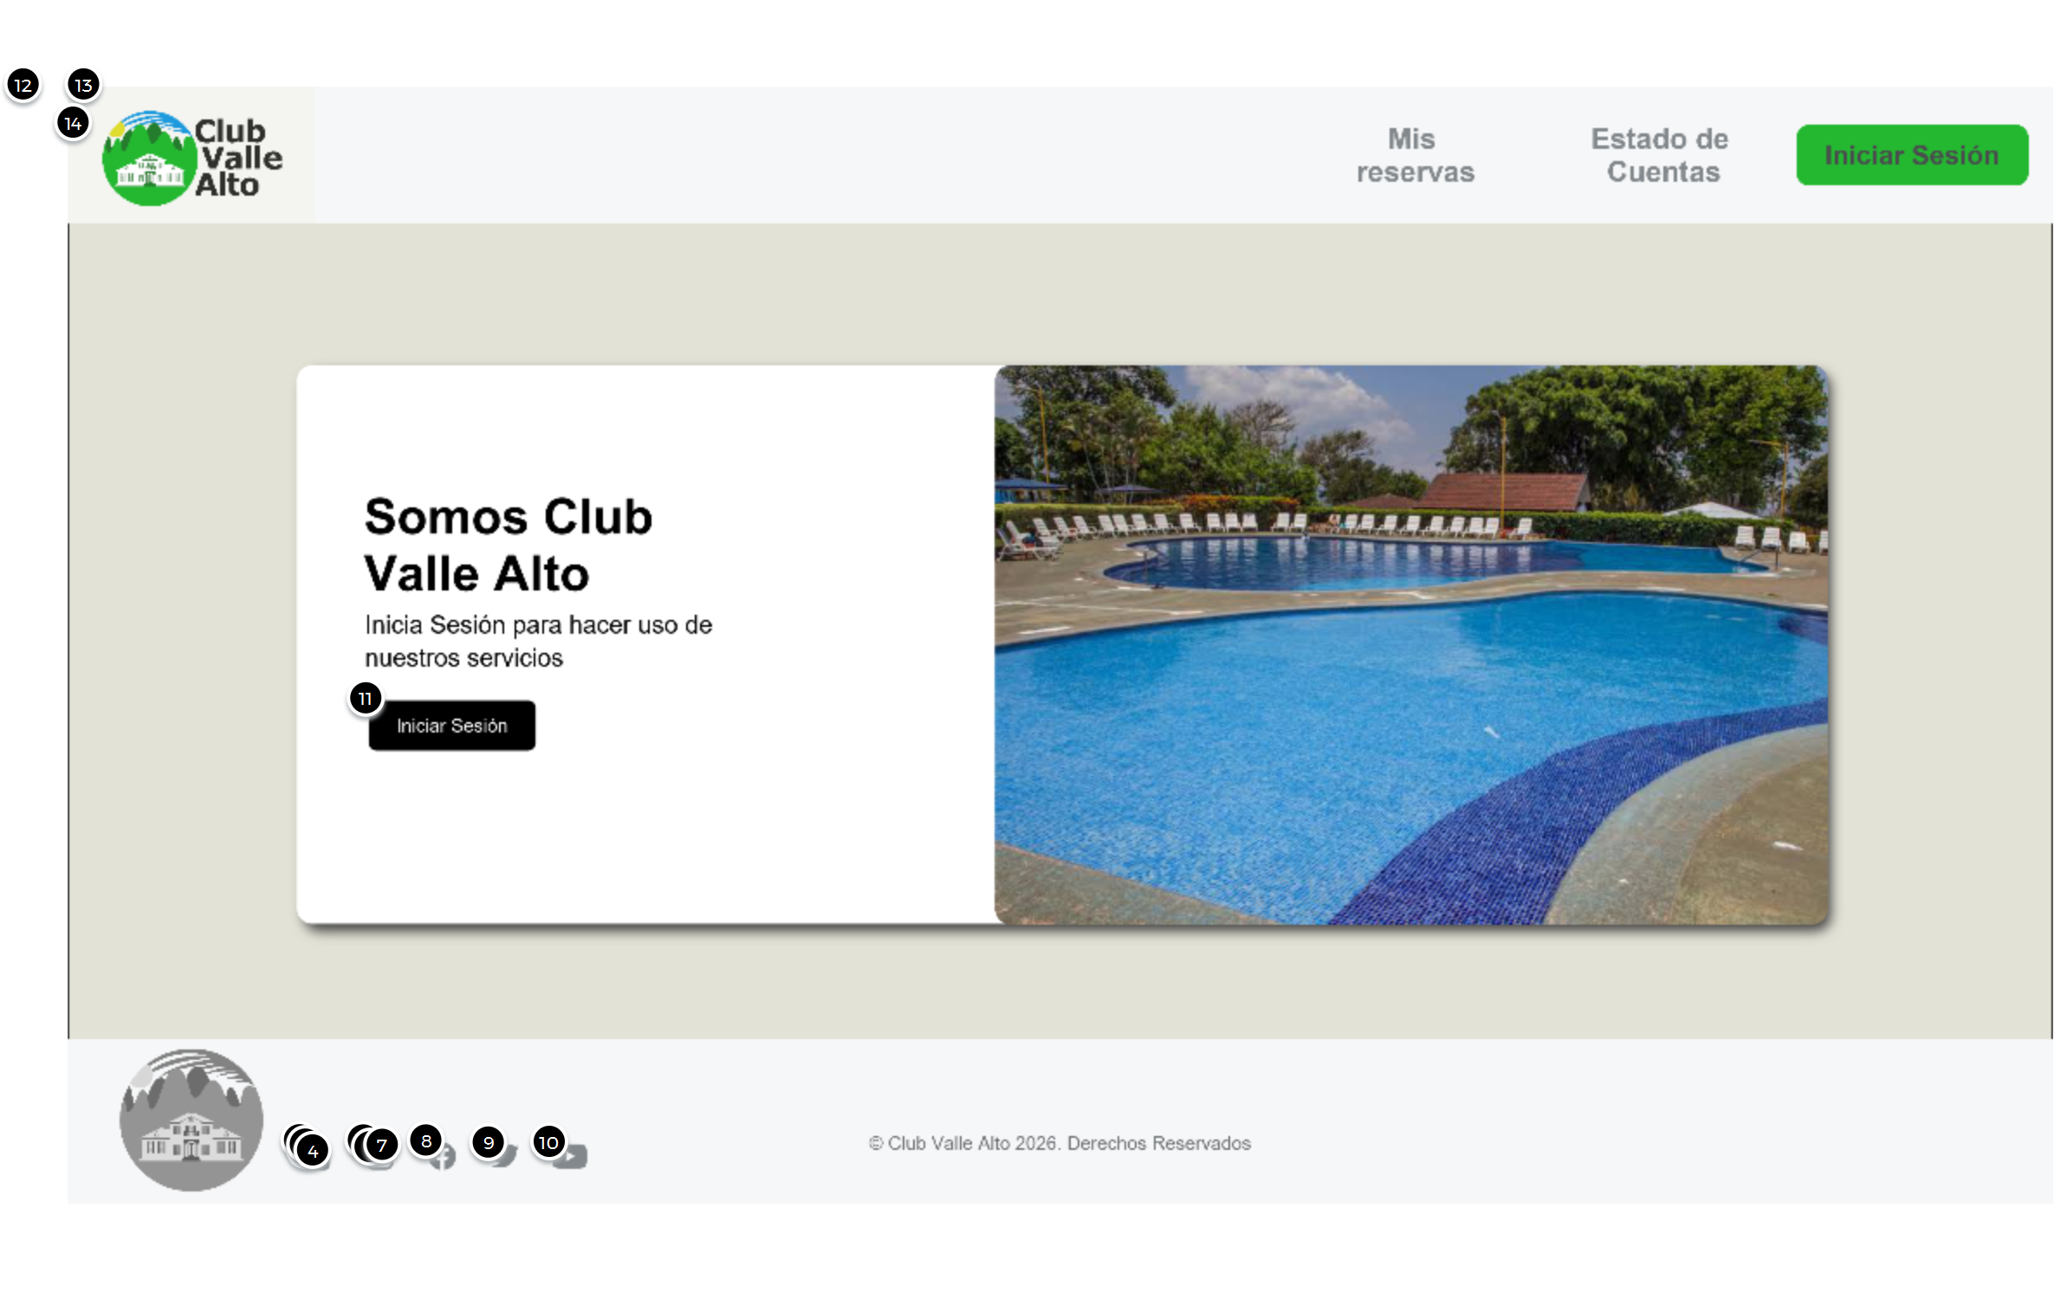

Interactions

11 | on Click: goes to 'Login Screen'
12 | on Click: goes to 'Login Screen'
13 | on Click: goes to 'Login Screen'
14 | on Click: goes to 'Login Screen'

01. Screens / Pr2AP
Login Screen
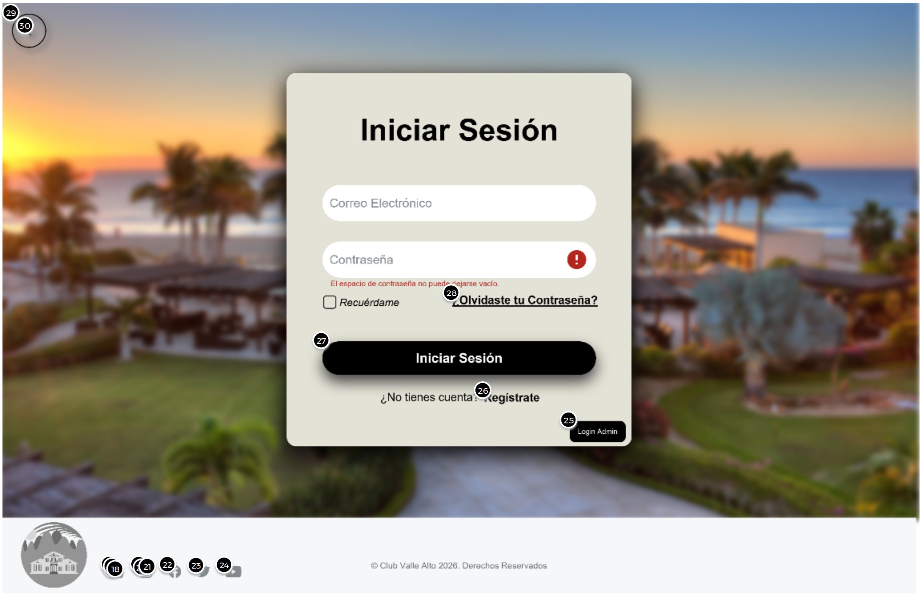

Interactions

25 | on Click: goes to 'Admin Screen'
26 | on Click: goes to 'Register Screen'
27 | on Click: goes to 'Member Profile Screen'
28 | on Click: goes to 'Recovery Screen'
29 | on Click: goes to 'Main Menu'
30 | on Click: goes to 'Main Menu'

01. Screens / Pr2AP
Register Screen
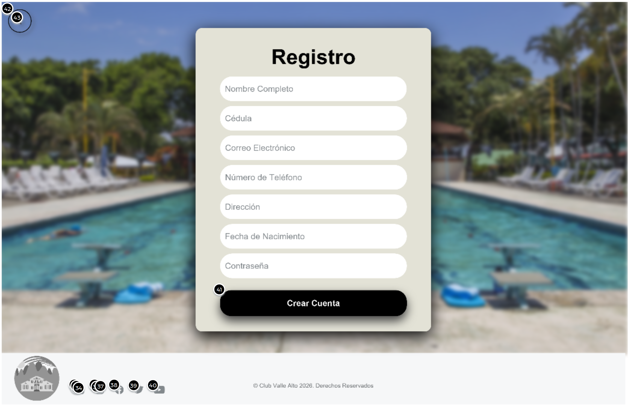

Interactions

41 | on Click: goes to 'Login Screen'
42 | on Click: goes to 'Login Screen'
43 | on Click: goes to 'Login Screen'

01. Screens / Pr2AP
Recovery Screen
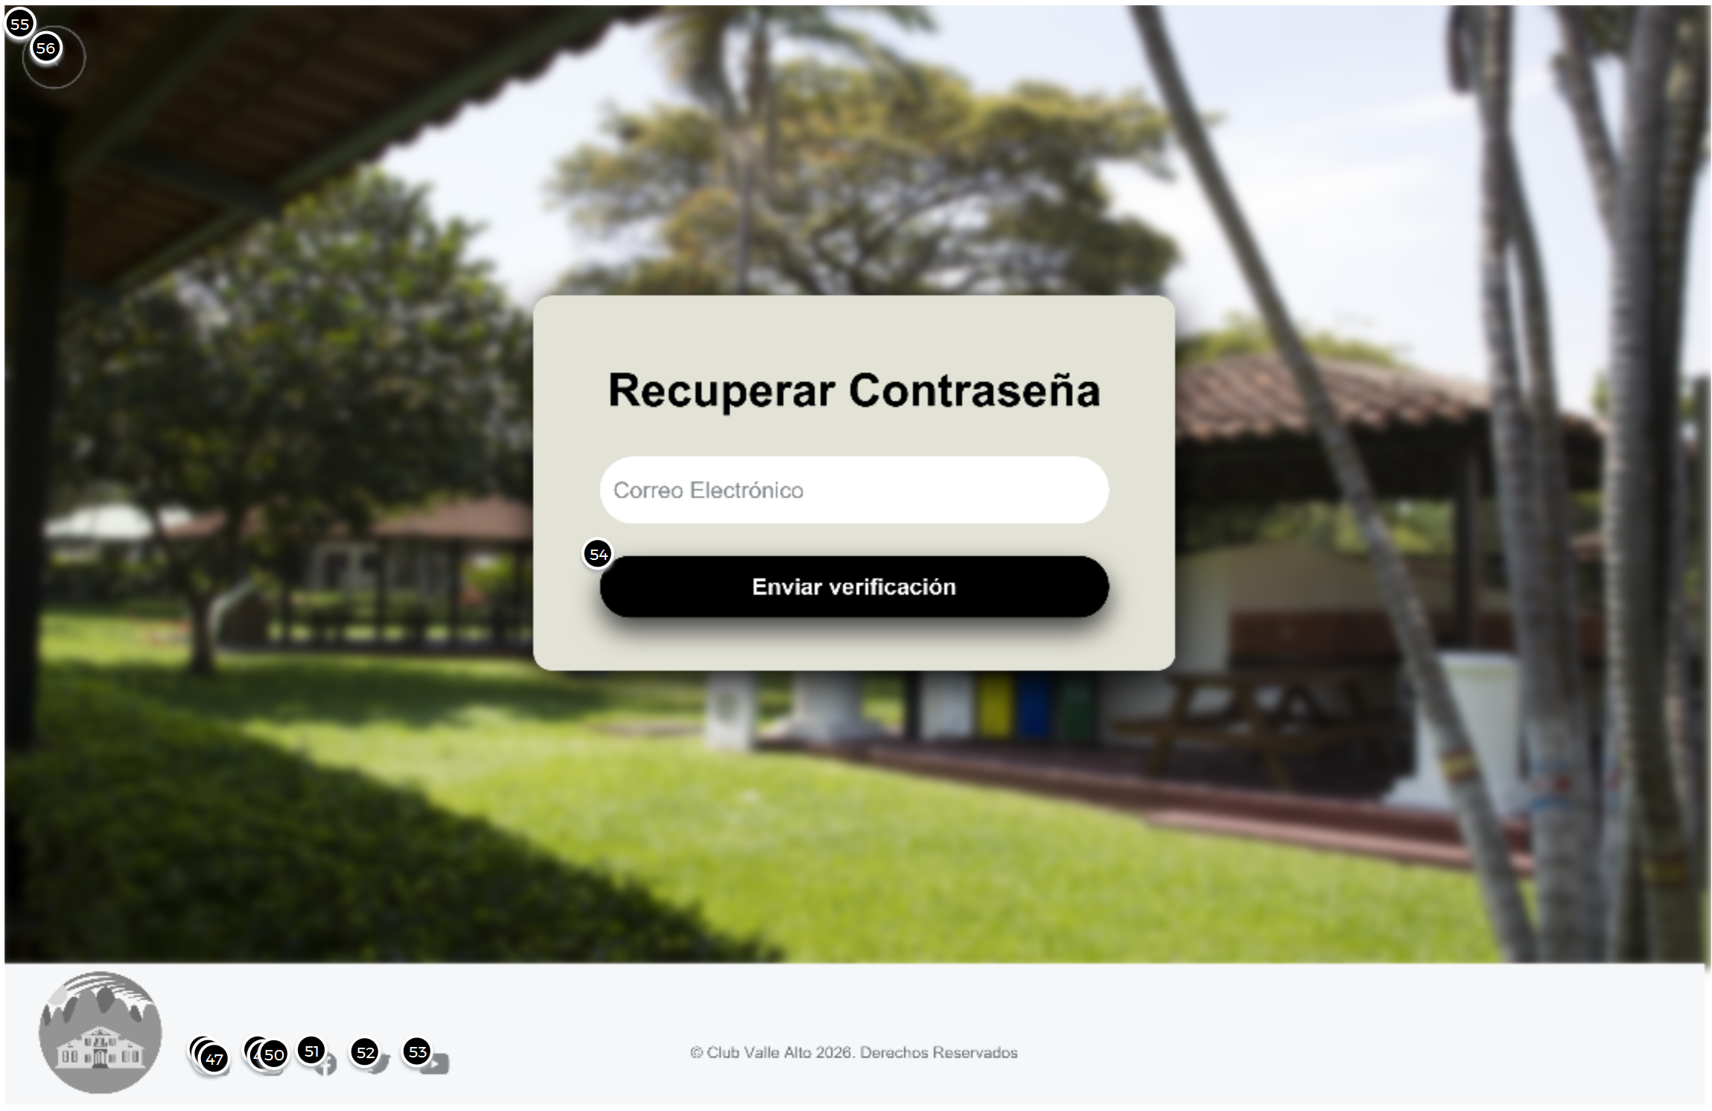

Interactions

55 | on Click: goes to 'Login Screen'
56 | on Click: goes to 'Login Screen'

01. Screens / Pr2AP
Member Screen
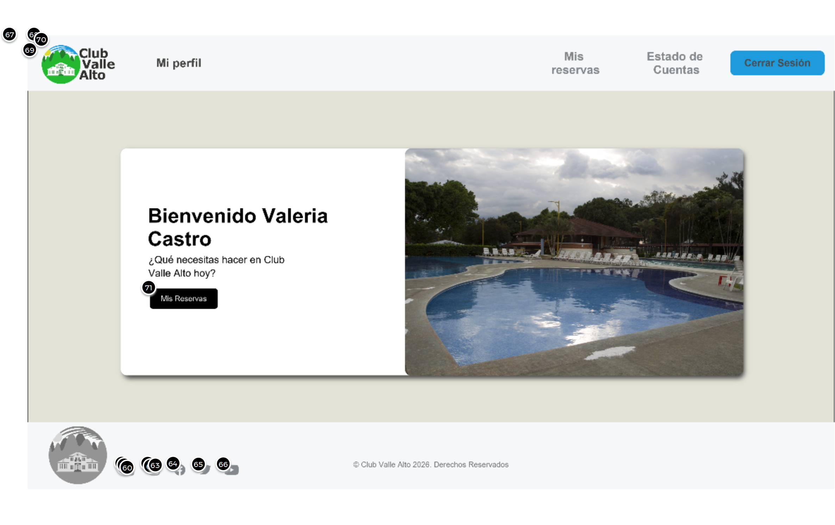

Interactions

67 | on Click: goes to 'Member Reservation Screen'
68 | on Click: goes to 'Membership Screen'
69 | on Click: goes to 'Main Menu'
70 | on Click: goes to 'Member Profile Screen'
71 | on Click: goes to 'Member Profile Screen'

01. Screens / Pr2AP
Member Profile Screen
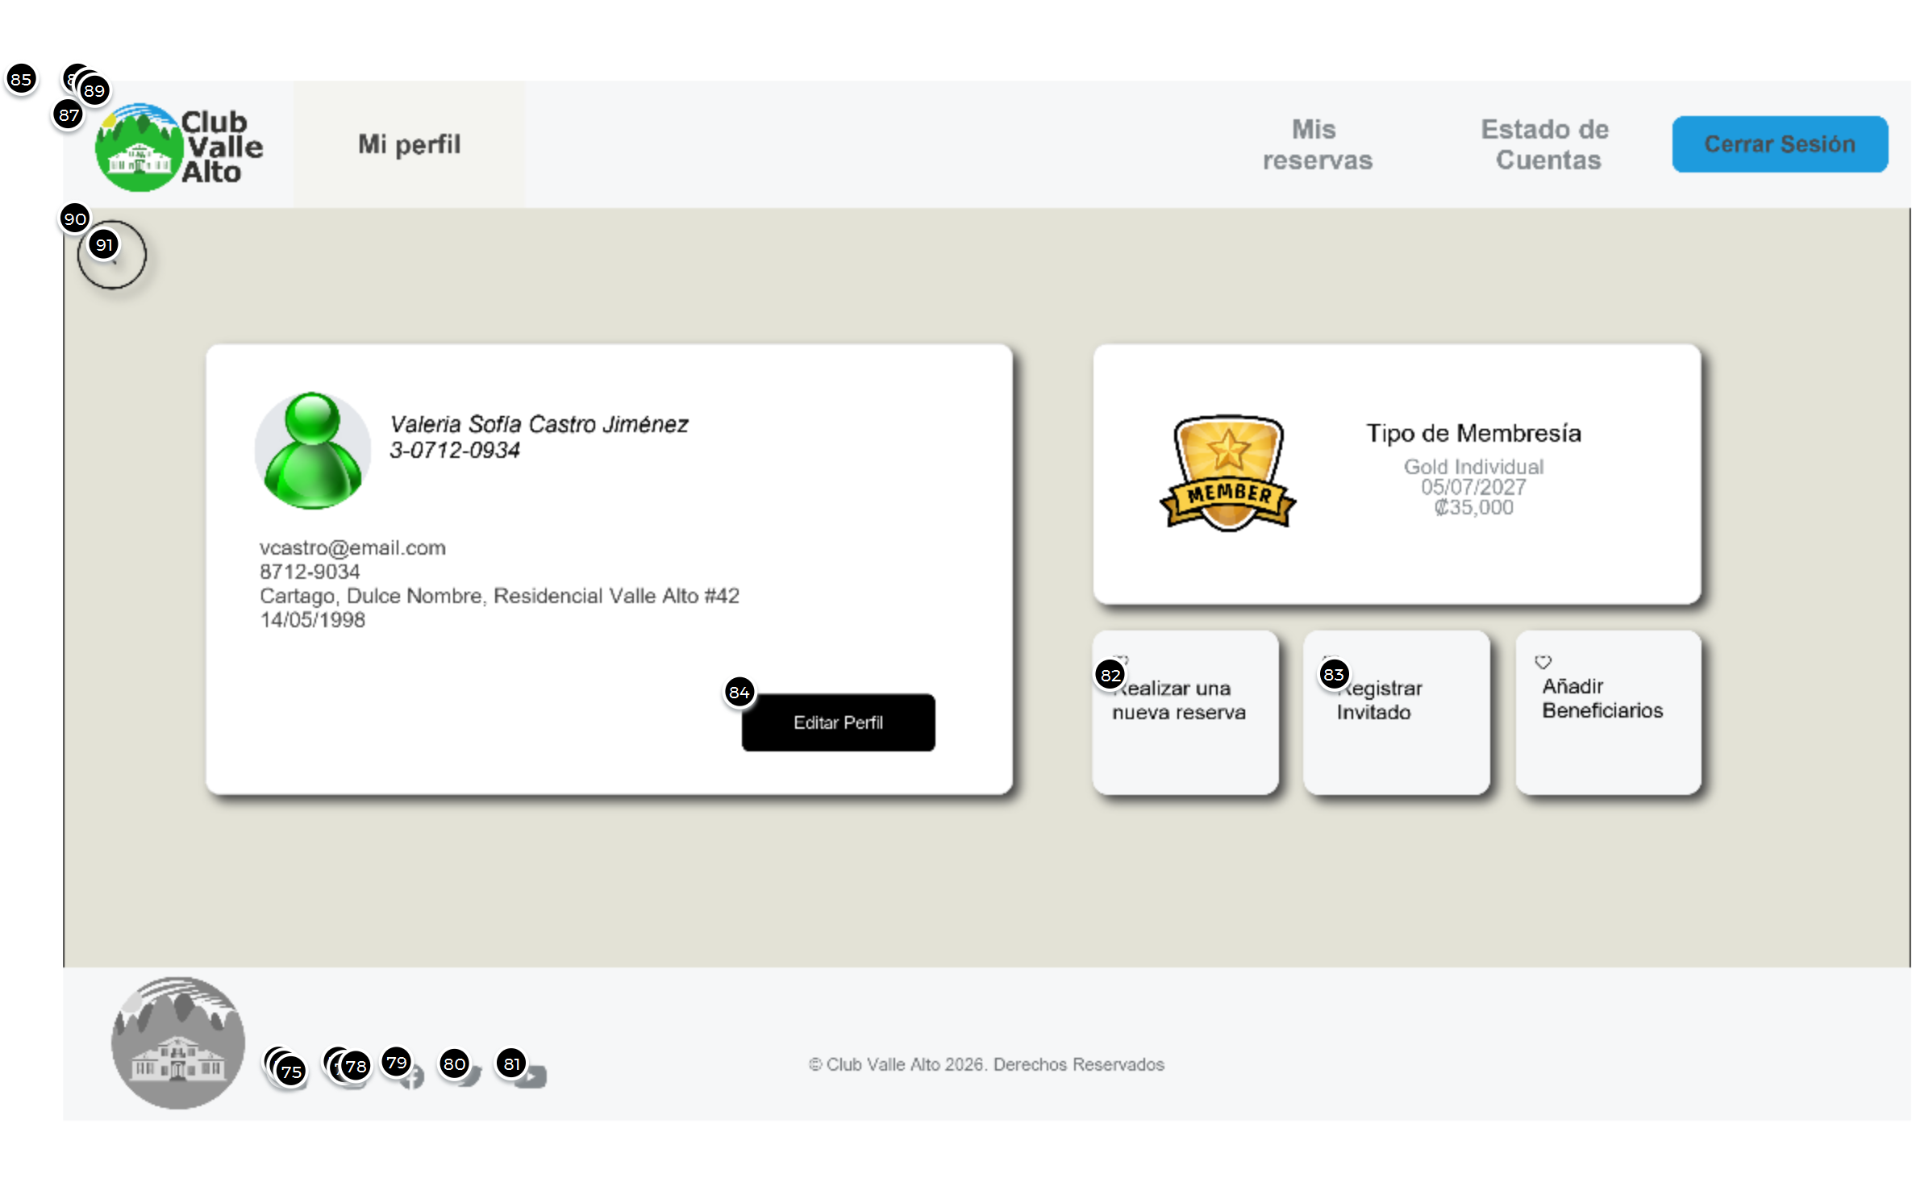

Interactions

82 | on Click: goes to 'Member Reservation Screen'
83 | on Click: goes to 'Member Reservation Screen'
85 | on Click: goes to 'Member Reservation Screen'
86 | on Mouse Over: goes to 'Membership Screen'
87 | on Click: goes to 'Main Menu'  on Mouse Over: goes to 'Main Menu'
88 | on Click: goes to 'Member Screen'
90 | on Click: goes to 'Member Screen'
91 | on Click: goes to 'Member Screen'

01. Screens / Pr2AP
Member Reservation Screen
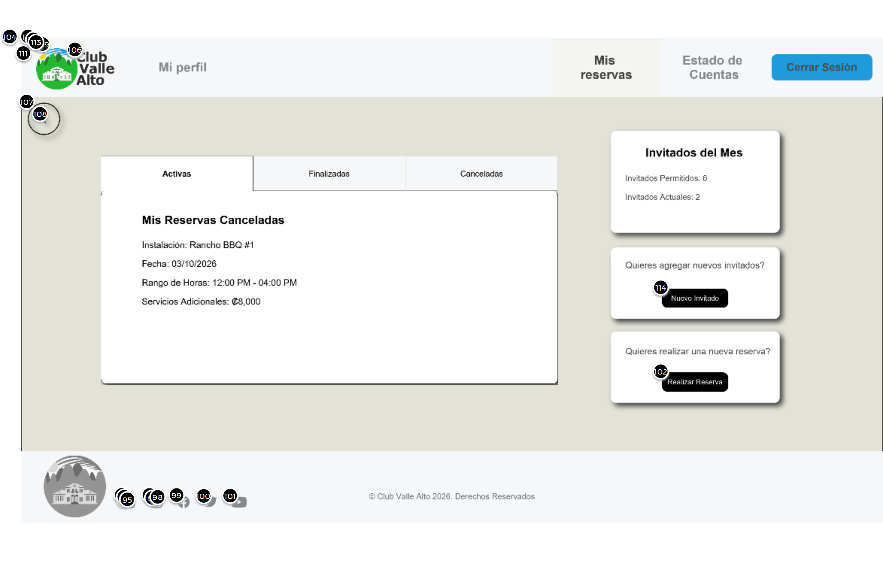

Interactions

102 | on Click: goes to 'Member Reservation Form Screen'
107 | on Click: goes to 'Member Screen'
108 | on Click: goes to 'Member Screen'
110 | on Click: goes to 'Membership Screen'
111 | on Click: goes to 'Main Menu'
112 | on Click: goes to 'Member Screen'
113 | on Click: goes to 'Member Profile Screen'
114 | on Click: goes to 'Member Reservation Form Screen'

02. Screens / Member Reservation Screen
Other states
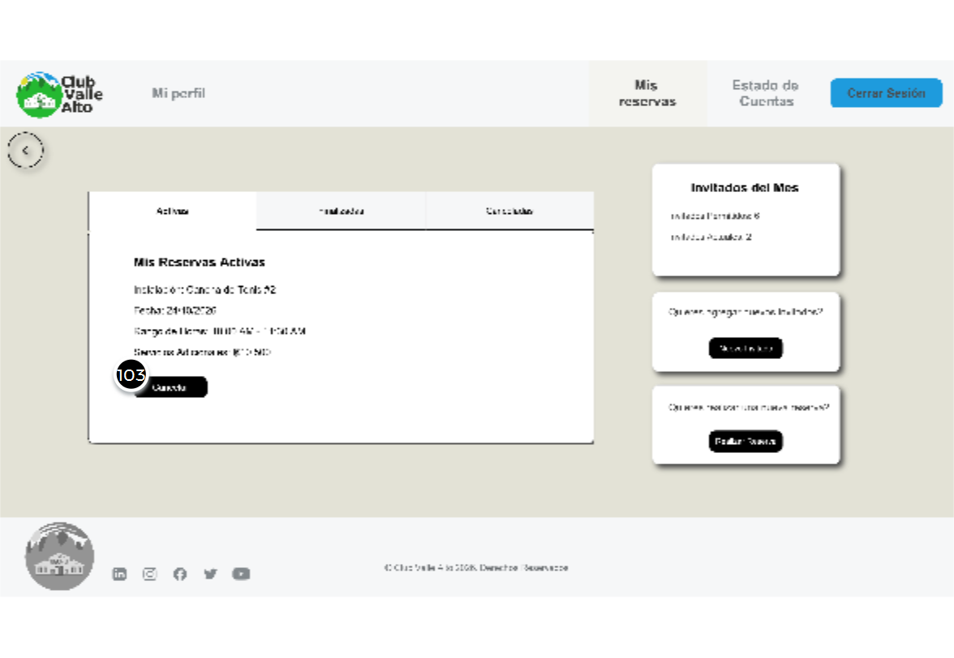
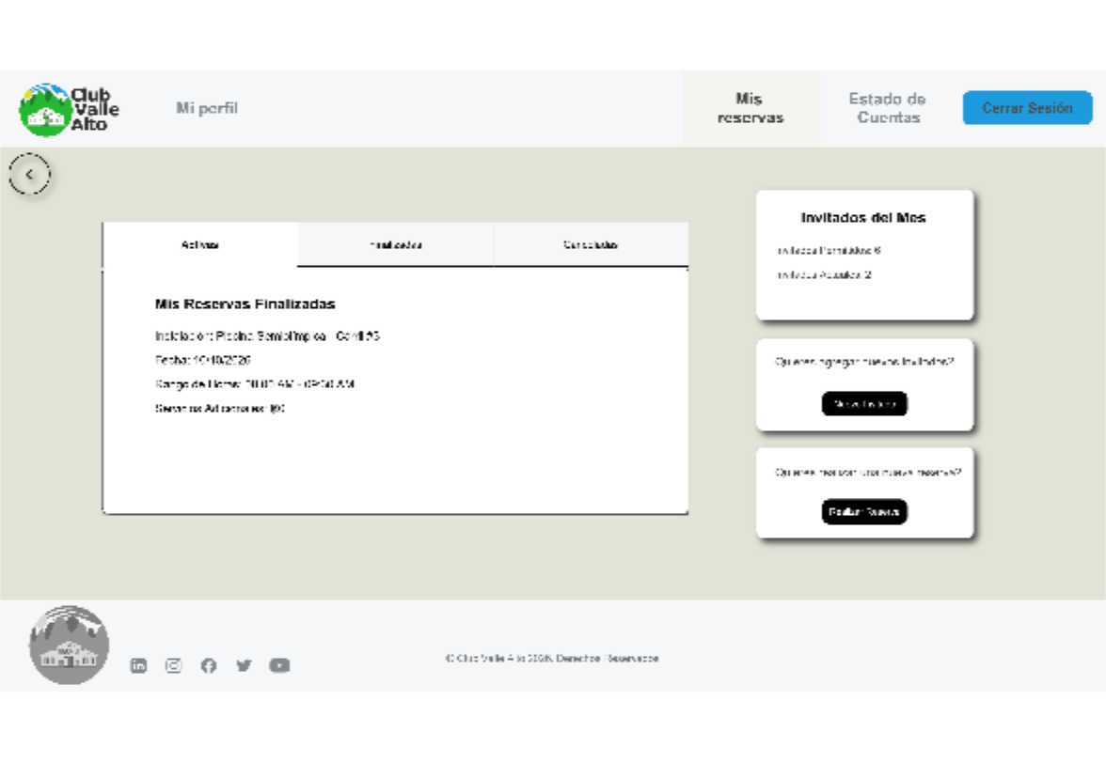

01. Screens / Pr2AP
Member Reservation Form Screen
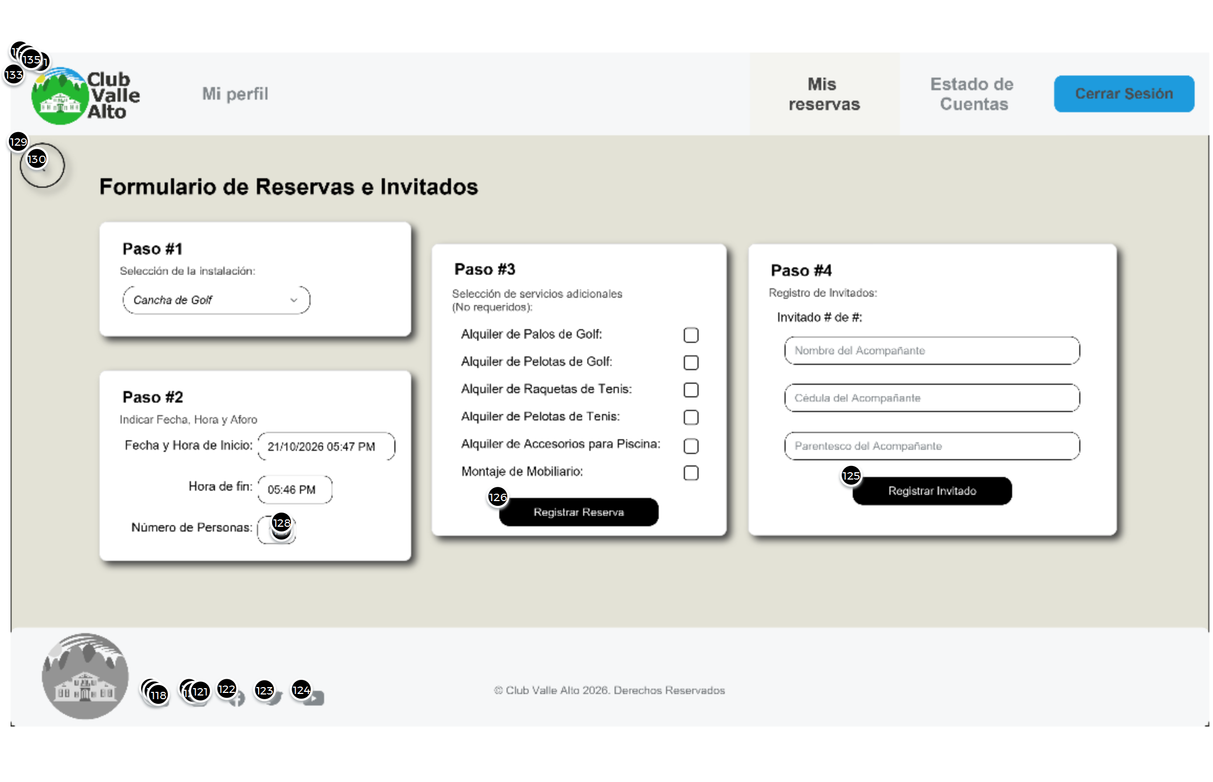

Interactions

129 | on Click: goes to 'Member Screen'
130 | on Click: goes to 'Member Screen'
132 | on Click: goes to 'Membership Screen'
133 | on Click: goes to 'Main Menu'
134 | on Click: goes to 'Member Screen'
135 | on Click: goes to 'Member Profile Screen'

01. Screens / Pr2AP
Membership Screen
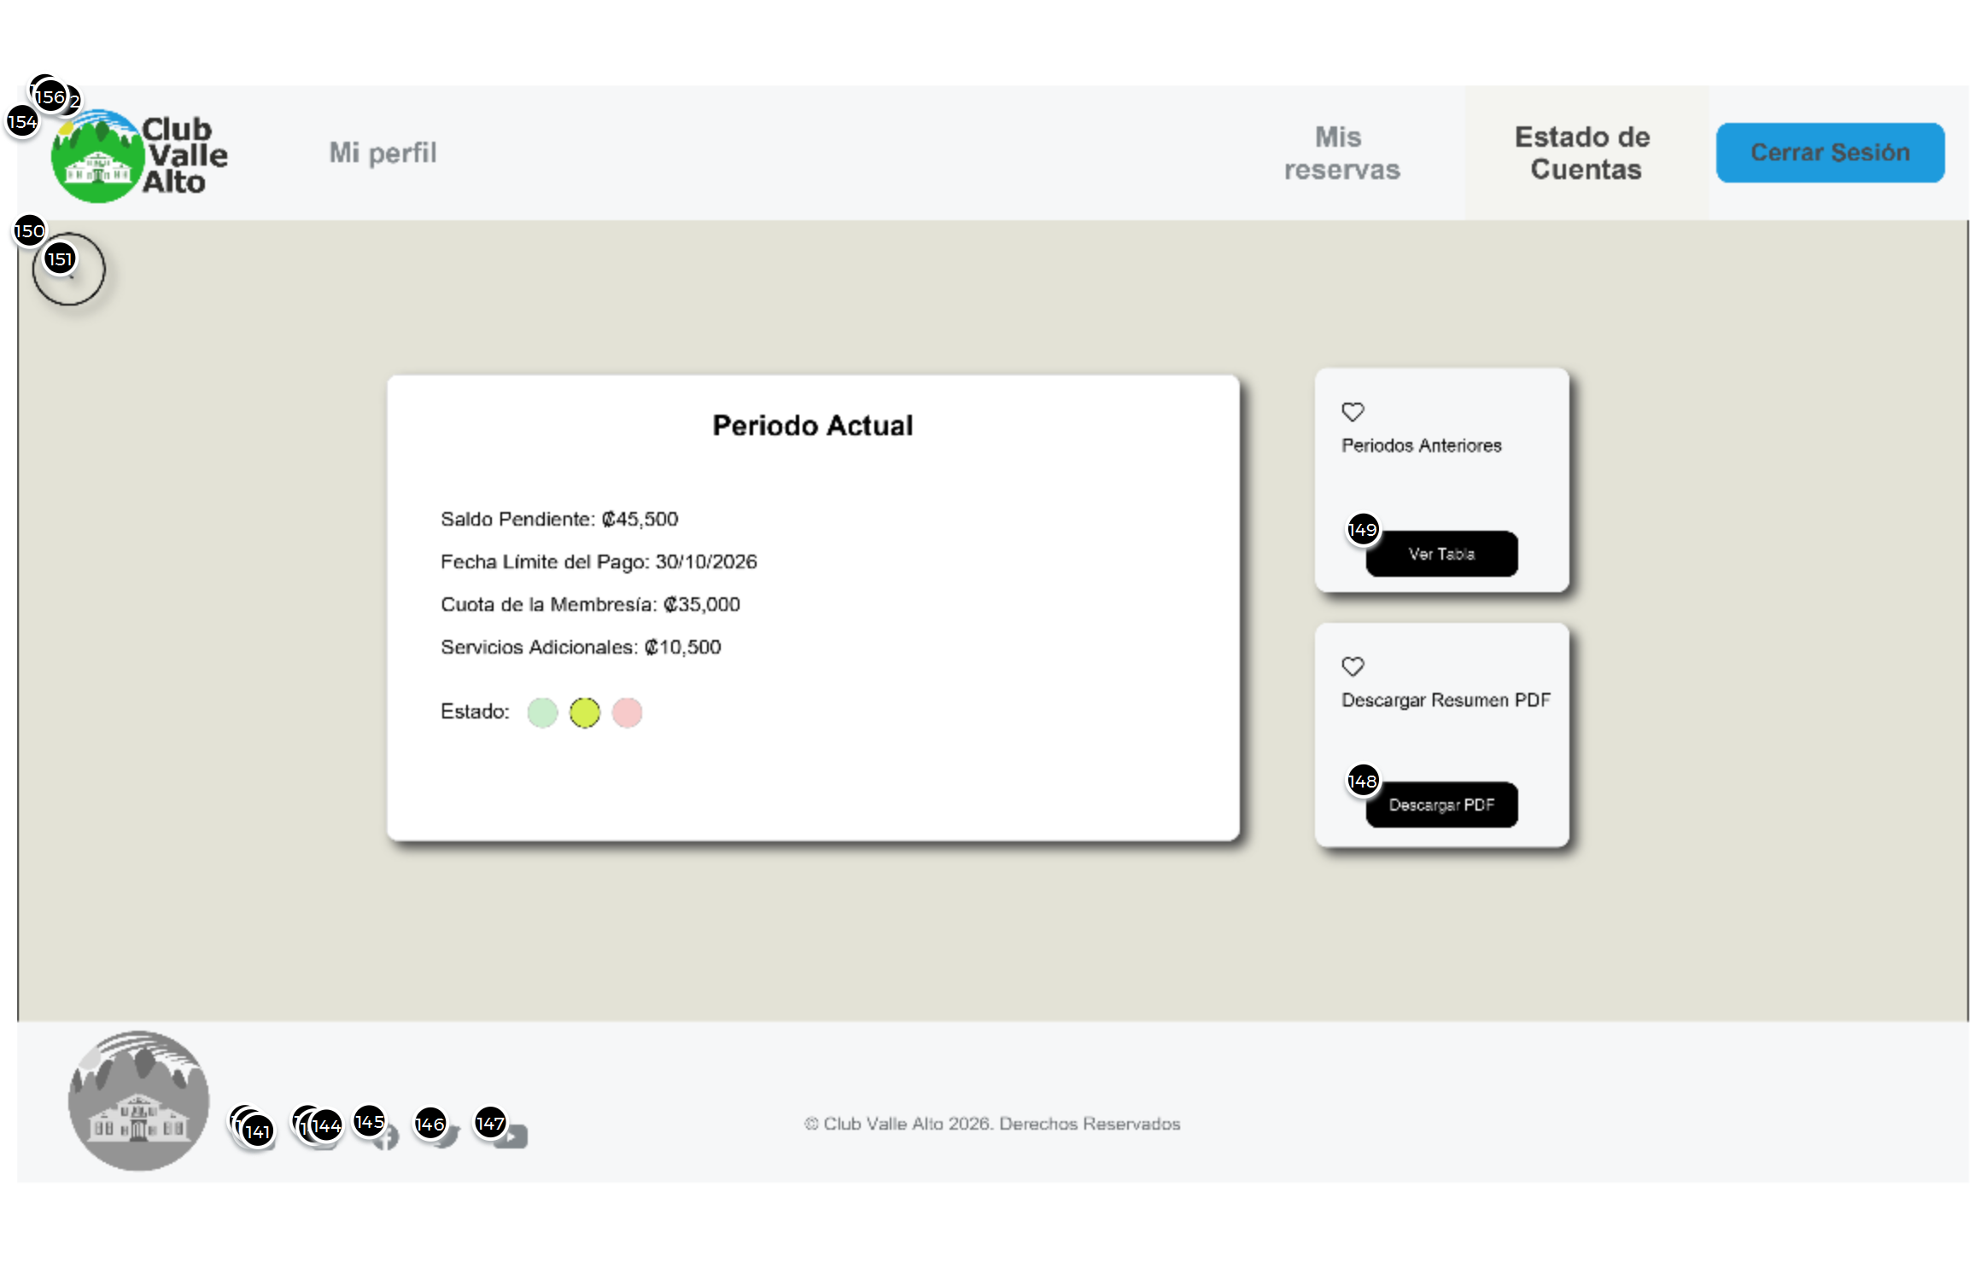

Interactions

149 | on Click: goes to 'Periodos Anteriores Screen'
150 | on Click: goes to 'Main Menu'
151 | on Click: goes to 'Main Menu'
152 | on Click: goes to 'Member Reservation Screen'
154 | on Click: goes to 'Main Menu'
155 | on Click: goes to 'Member Screen'
156 | on Click: goes to 'Member Profile Screen'

01. Screens / Pr2AP
Periodos Anteriores Screen
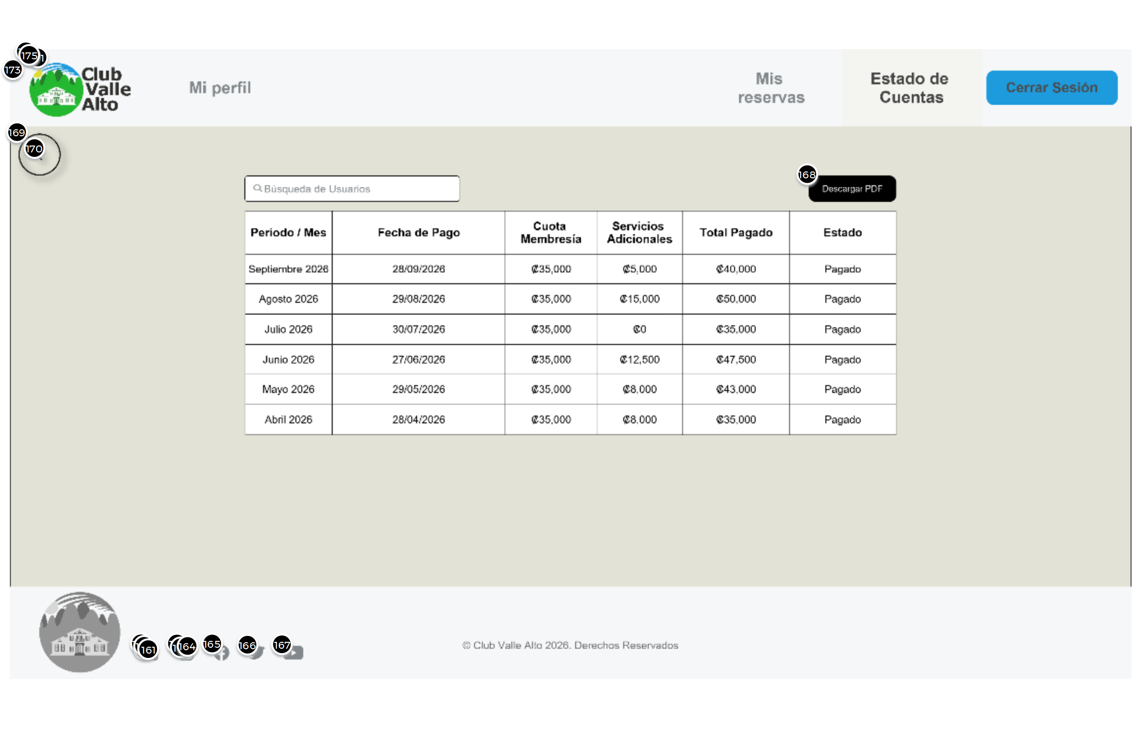

Interactions

169 | on Click: goes to 'Membership Screen'
170 | on Click: goes to 'Membership Screen'
171 | on Click: goes to 'Member Reservation Screen'
173 | on Click: goes to 'Main Menu'
174 | on Click: goes to 'Member Screen'
175 | on Click: goes to 'Member Profile Screen'

01. Screens / Pr2AP
Admin Screen
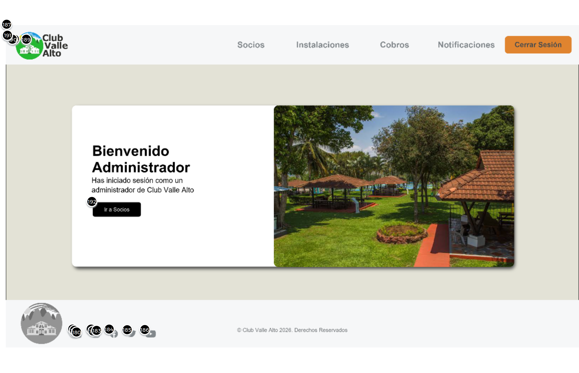

Interactions

187 | on Click: goes to 'Admin Members' Screen'
188 | on Click: goes to 'Admin Facilities Screen'
189 | on Click: goes to 'Admin Charges Screen'
190 | on Click: goes to 'Admin Notification Screen'
191 | on Click: goes to 'Main Menu'
192 | on Click: goes to 'Admin Members' Screen'

01. Screens / Pr2AP
Admin Members' Screen
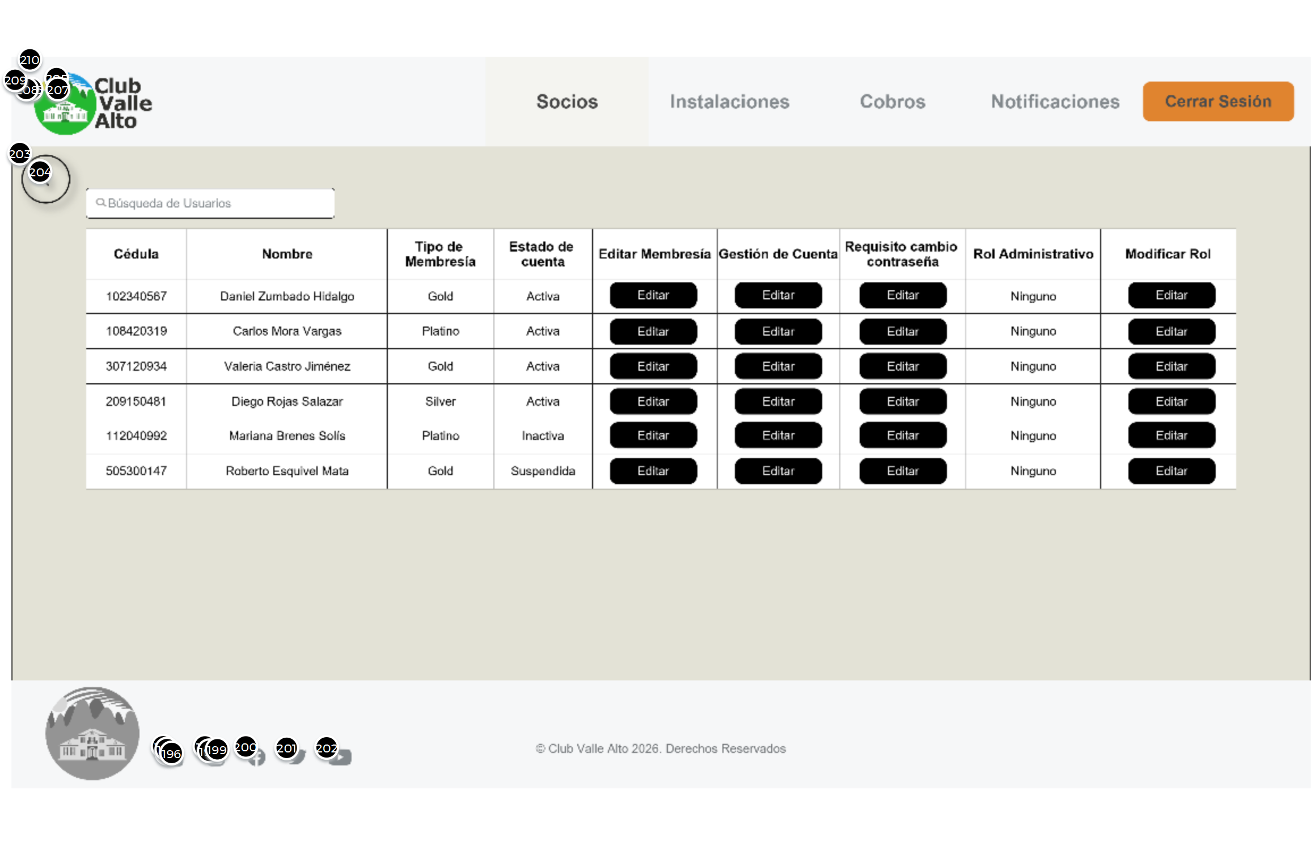

Interactions

203 | on Click: goes to 'Admin Screen'
204 | on Click: goes to 'Admin Screen'
206 | on Click: goes to 'Admin Facilities Screen'
207 | on Click: goes to 'Admin Charges Screen'
208 | on Click: goes to 'Admin Notification Screen'
209 | on Click: goes to 'Main Menu'
210 | on Click: goes to 'Admin Screen'

01. Screens / Pr2AP
Admin Facilities Screen
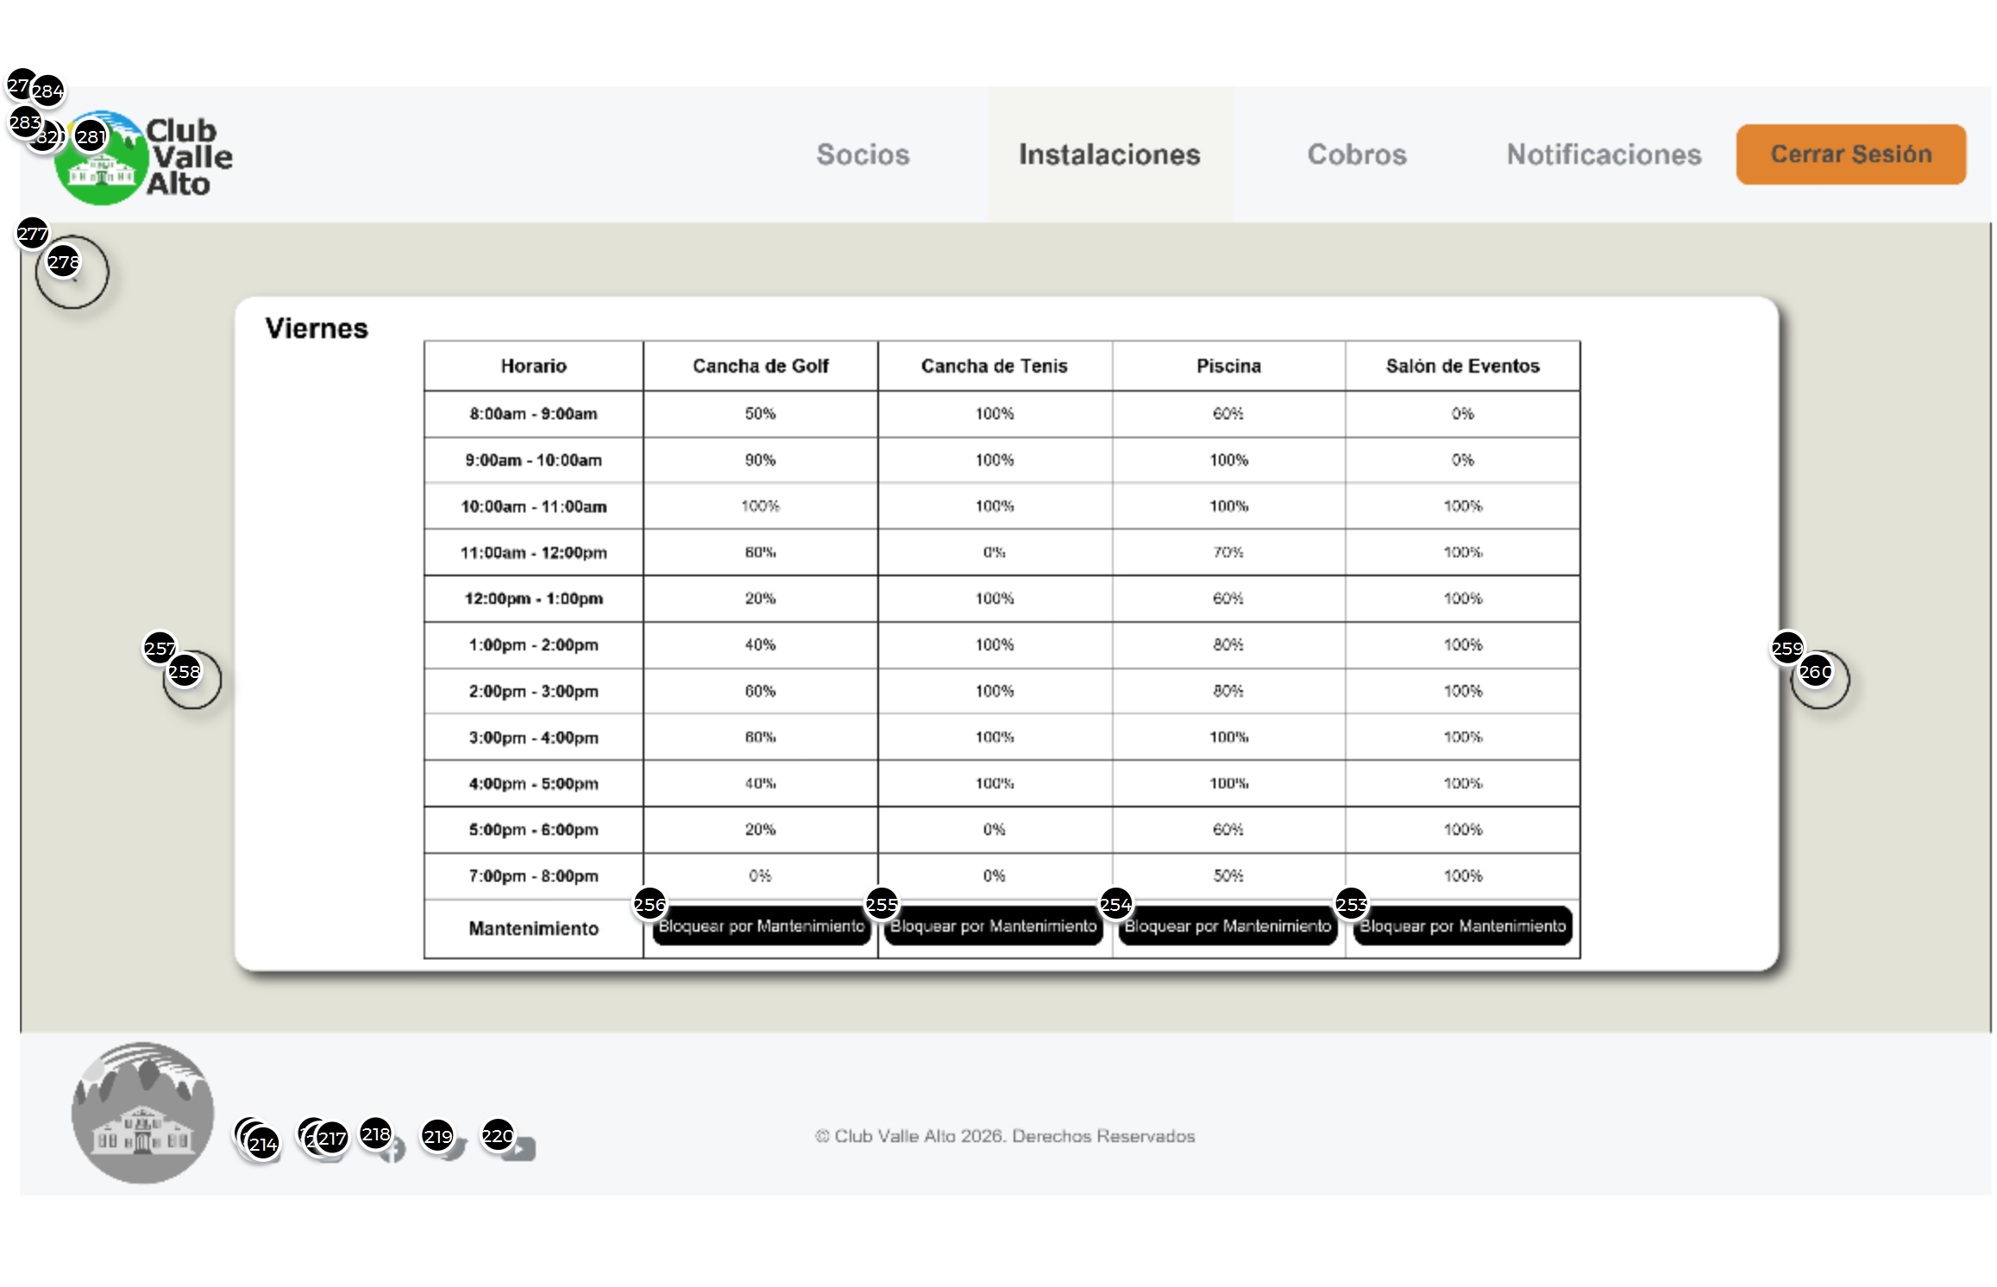

Interactions

277 | on Click: goes to 'Admin Screen'
278 | on Click: goes to 'Admin Screen'
279 | on Click: goes to 'Admin Members' Screen'
281 | on Click: goes to 'Admin Charges Screen'
282 | on Click: goes to 'Admin Notification Screen'
283 | on Click: goes to 'Main Menu'
284 | on Click: goes to 'Admin Screen'

02. Screens / Admin Facilities Screen
Other states
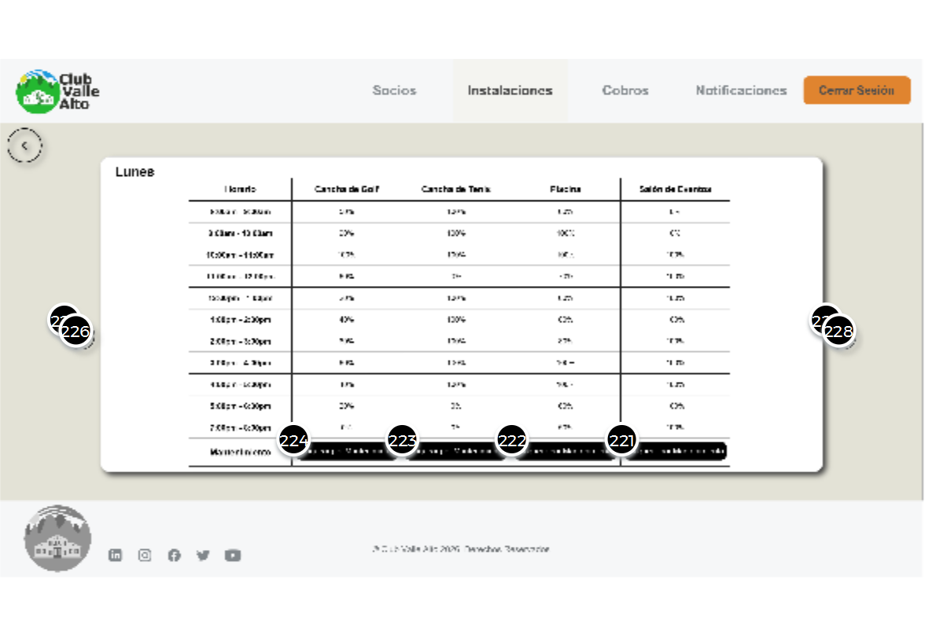
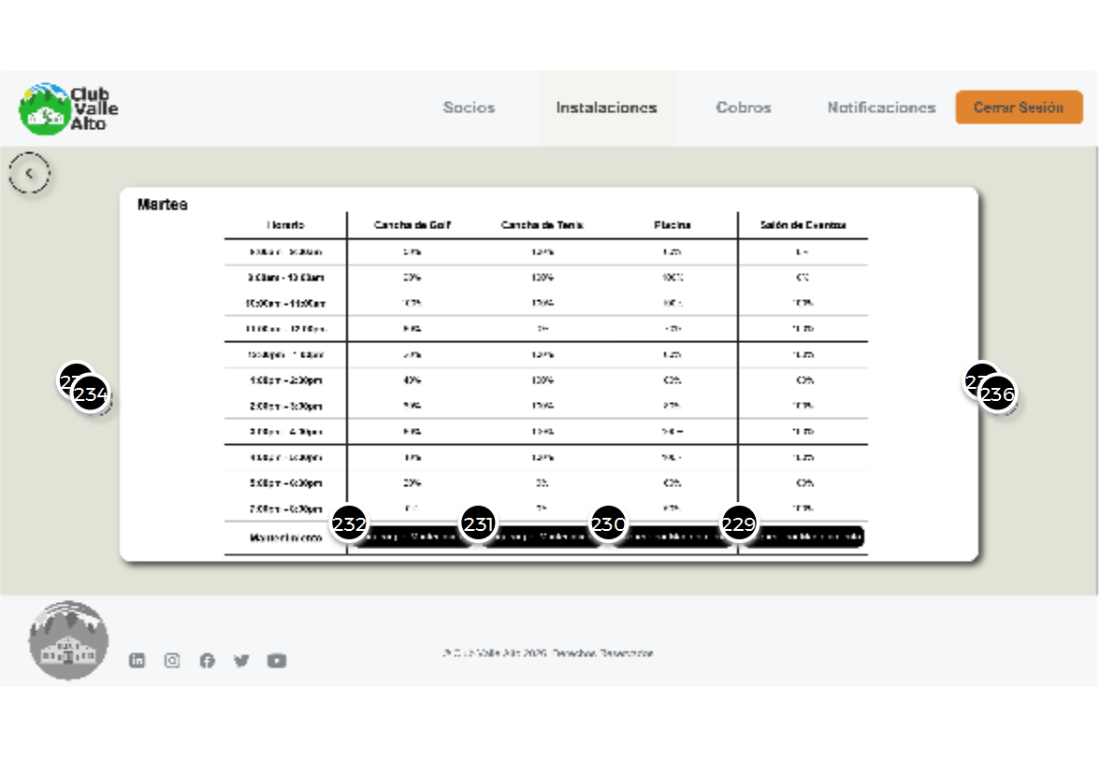
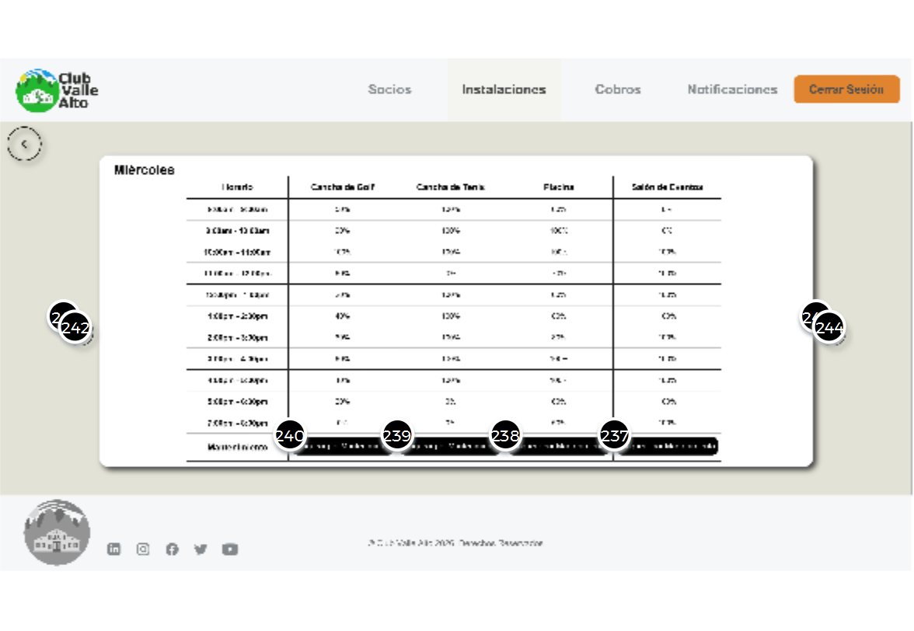
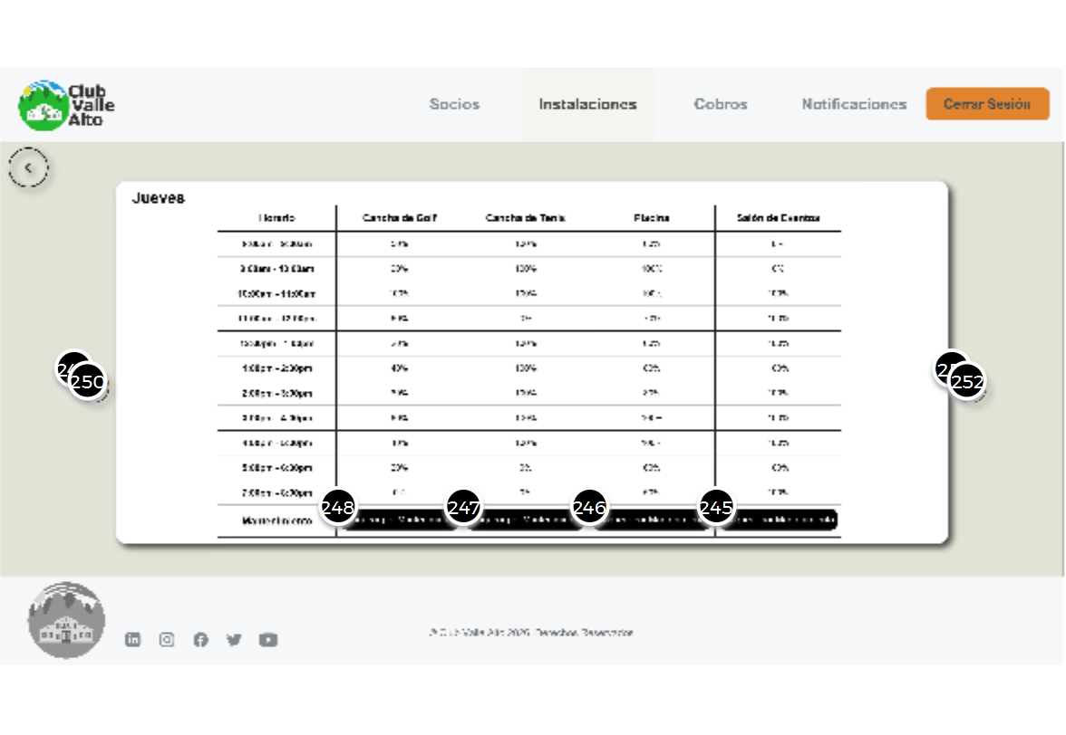
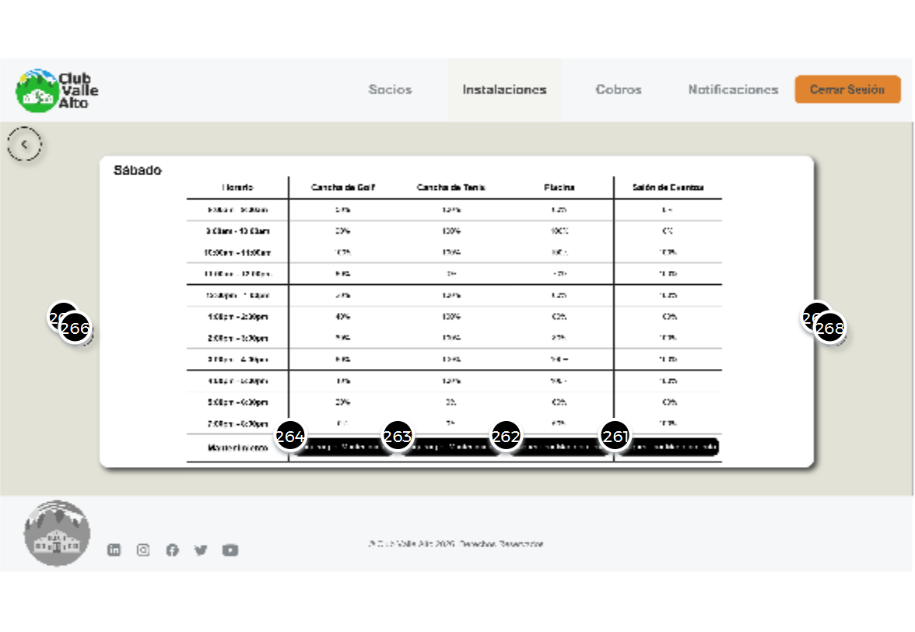
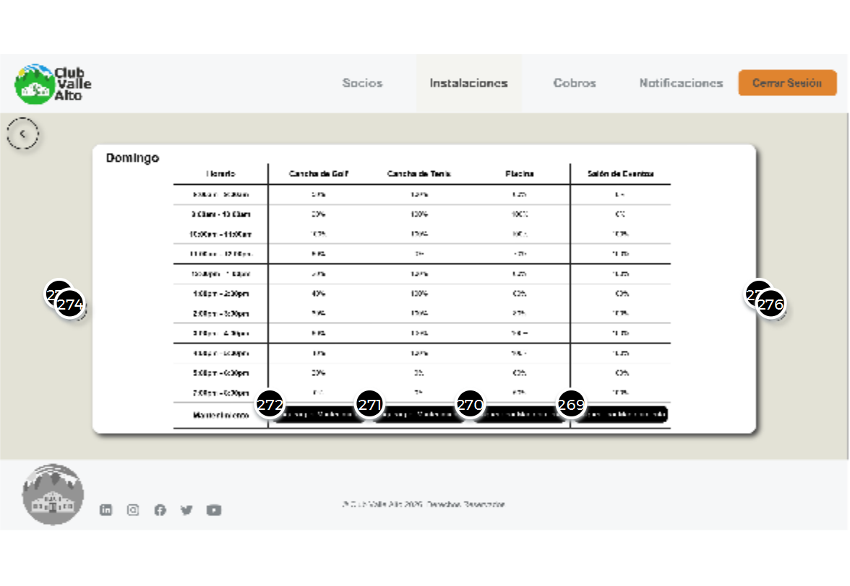

01. Screens / Pr2AP
Admin Charges Screen
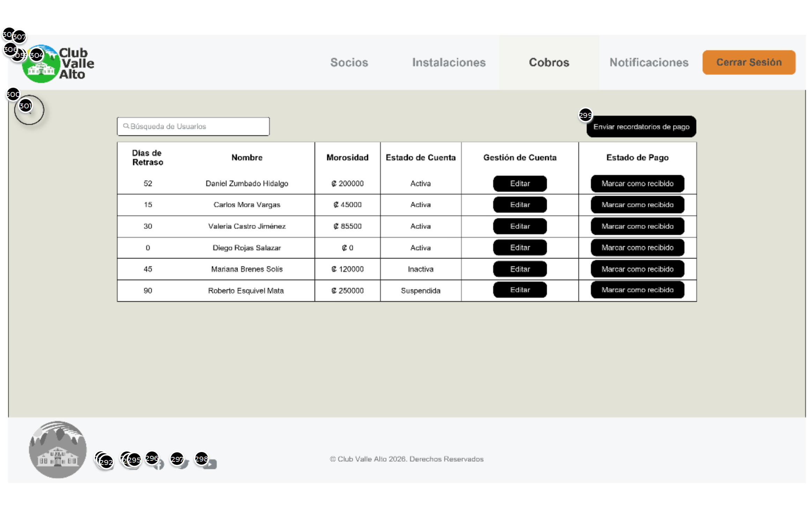

Interactions

300 | on Click: goes to 'Admin Screen'
301 | on Click: goes to 'Admin Screen'
302 | on Click: goes to 'Admin Members' Screen'
303 | on Click: goes to 'Admin Facilities Screen'
305 | on Click: goes to 'Admin Notification Screen'
306 | on Click: goes to 'Main Menu'
307 | on Click: goes to 'Admin Screen'

01. Screens / Pr2AP
Admin Notification Screen
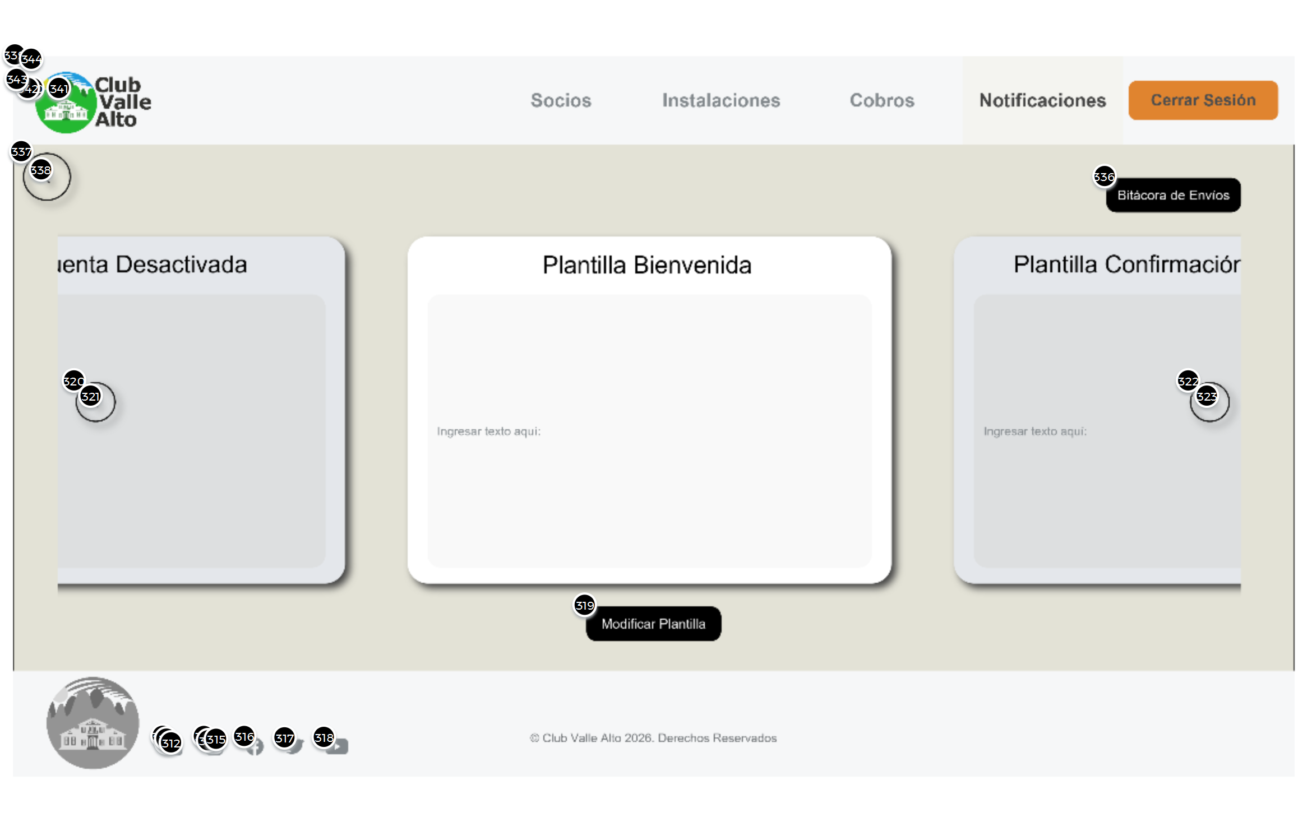

Interactions

336 | on Click: goes to 'Admin Notifs Log'
337 | on Click: goes to 'Admin Screen'
338 | on Click: goes to 'Admin Screen'
339 | on Click: goes to 'Admin Members' Screen'
340 | on Click: goes to 'Admin Facilities Screen'
341 | on Click: goes to 'Admin Charges Screen'
343 | on Click: goes to 'Main Menu'
344 | on Click: goes to 'Admin Screen'

02. Screens / Admin Notification Screen
Other states
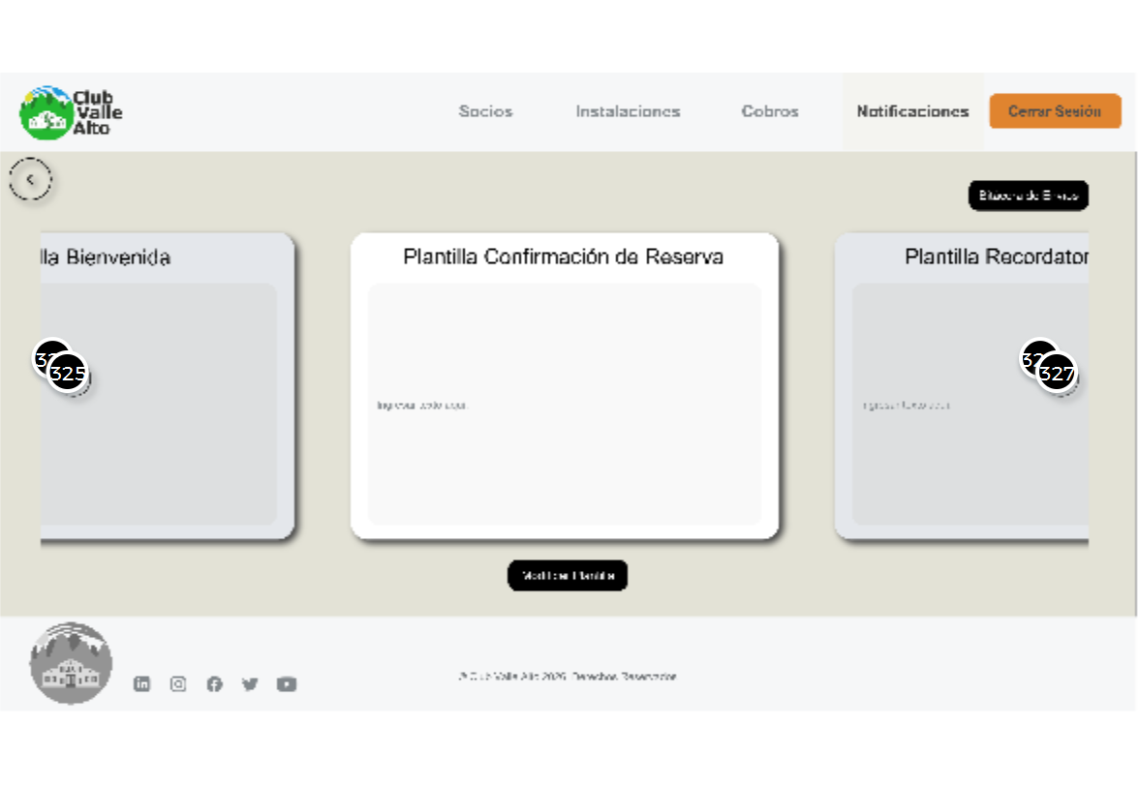
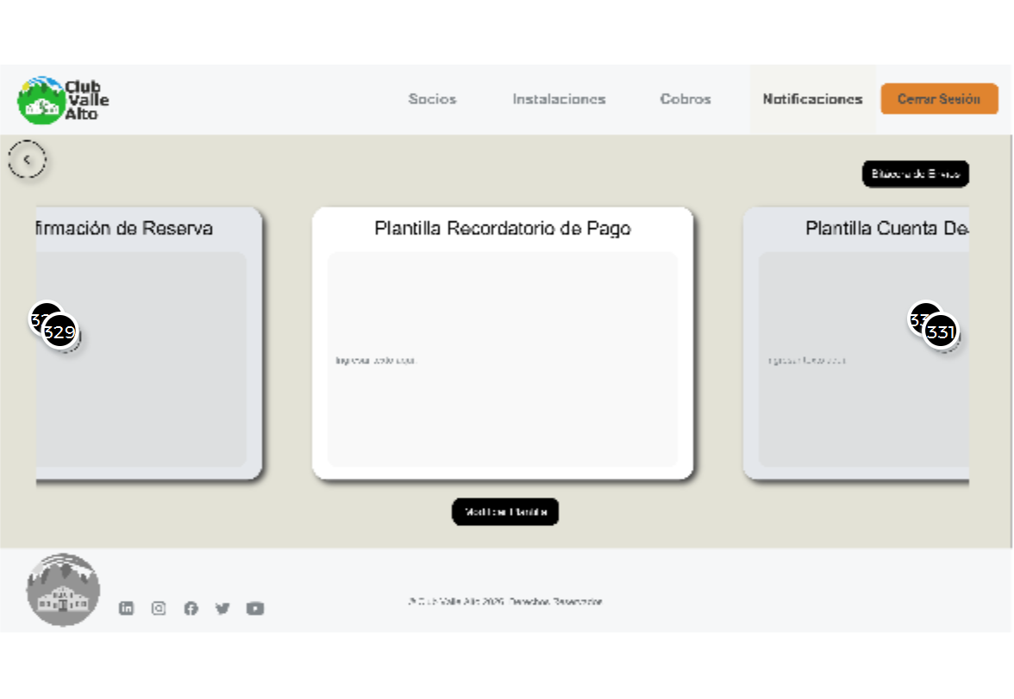
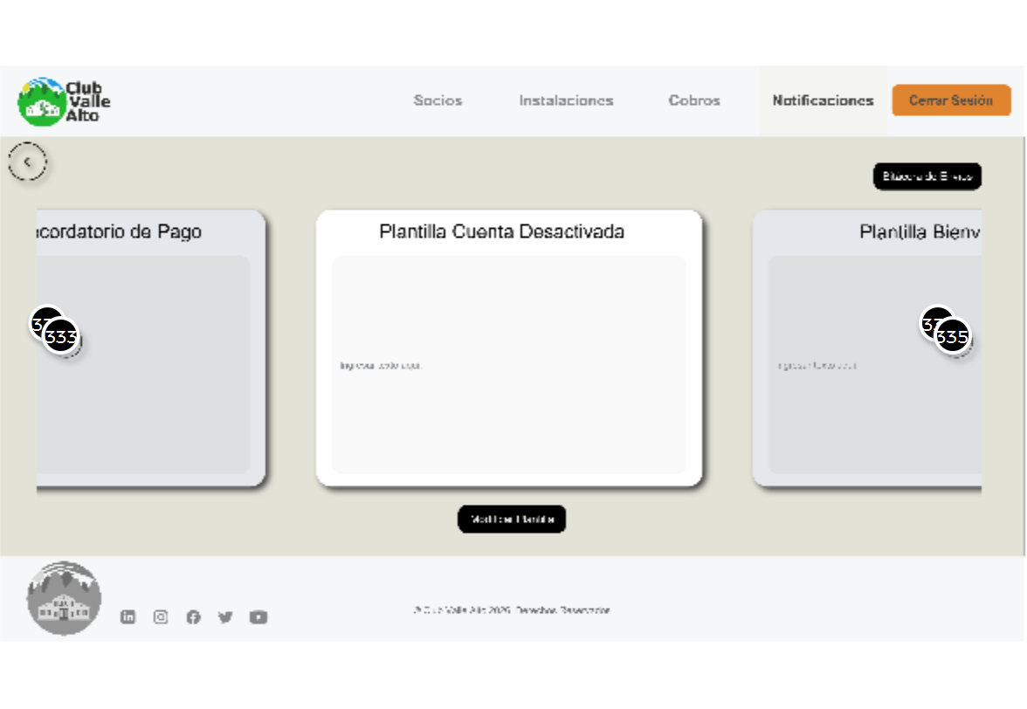

01. Screens / Pr2AP
Admin Notifs Log
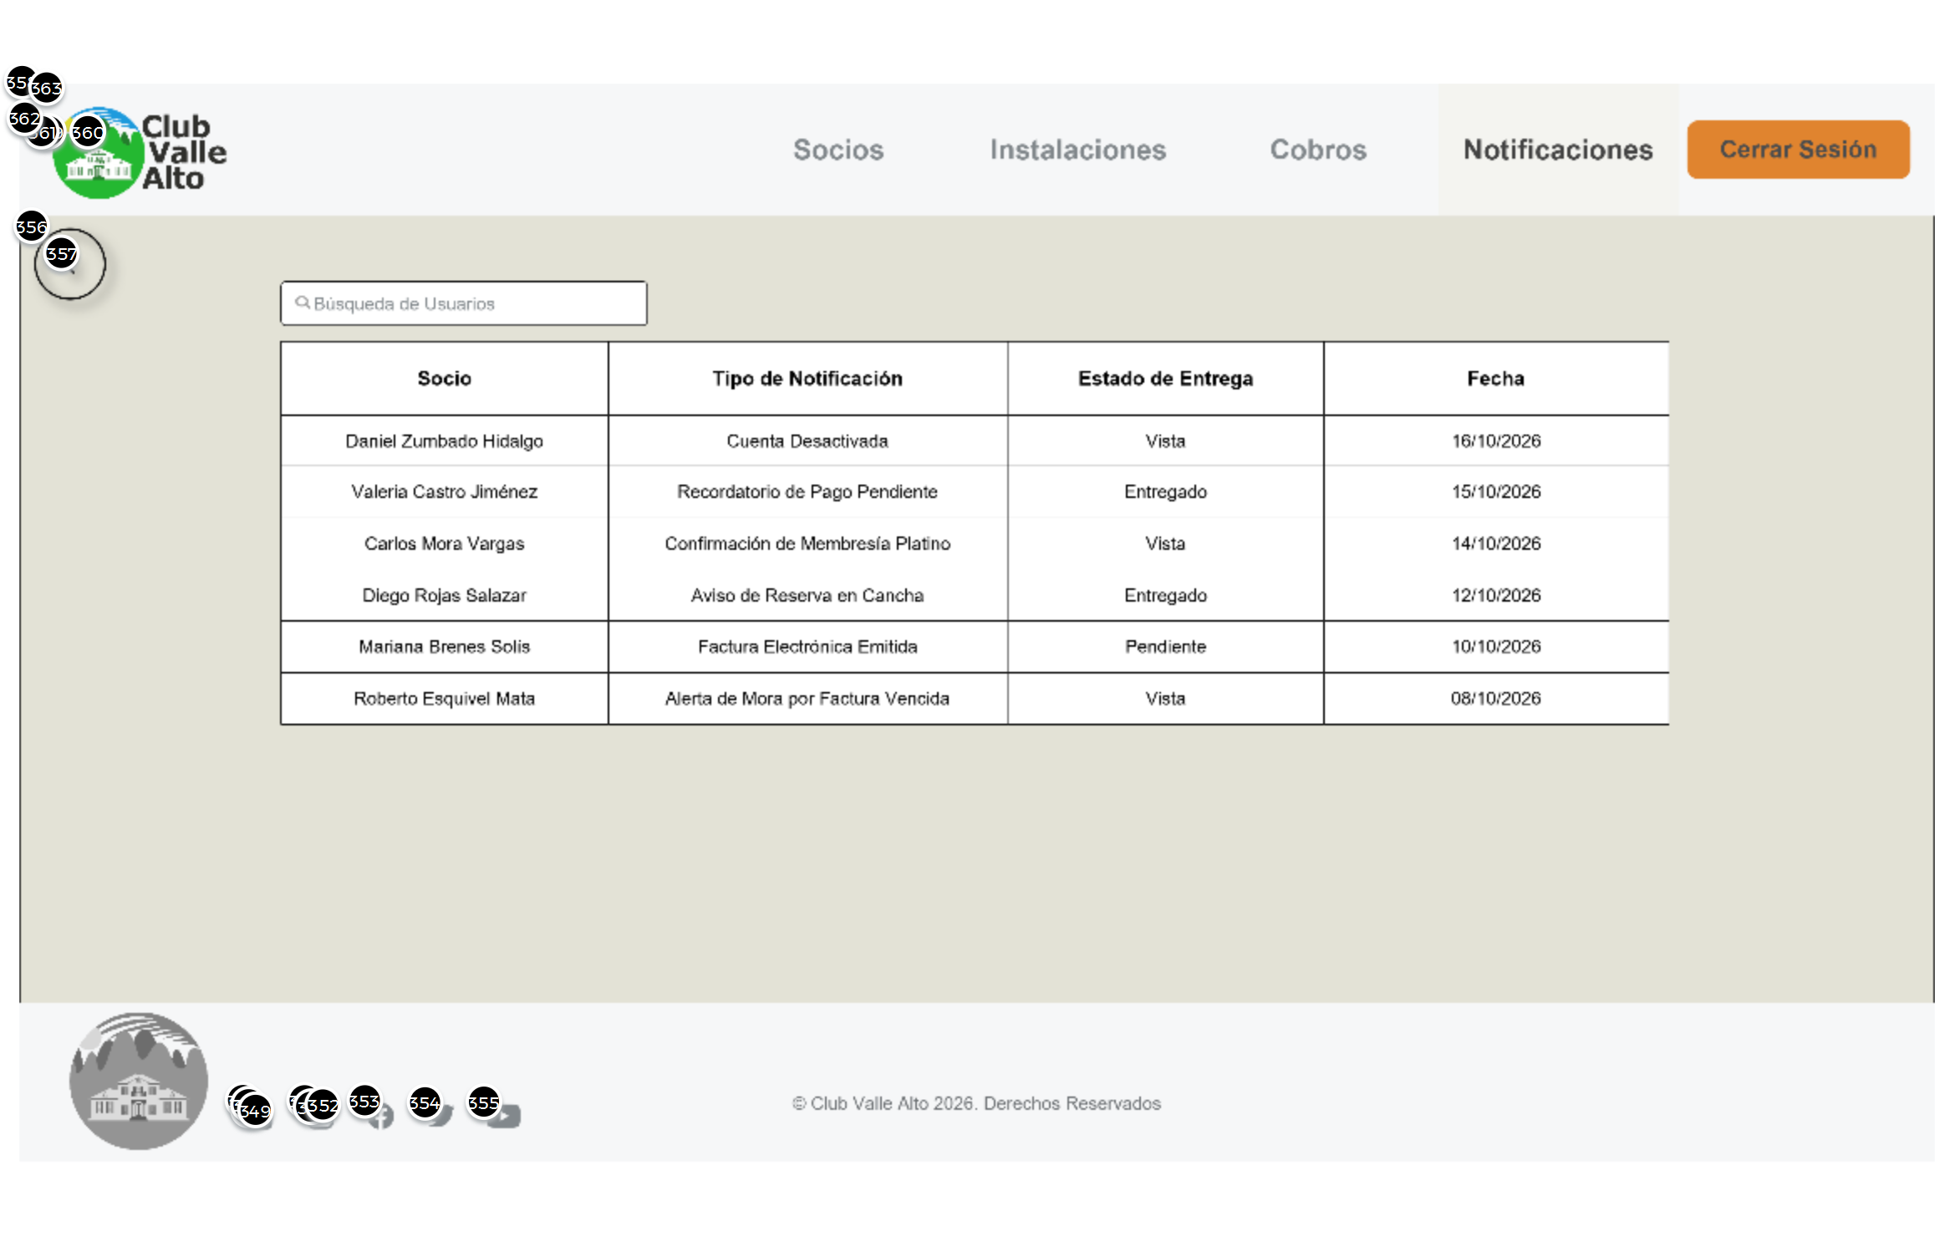

Interactions

356 | on Click: goes to 'Admin Notification Screen'
357 | on Click: goes to 'Admin Notification Screen'
358 | on Click: goes to 'Admin Members' Screen'
359 | on Click: goes to 'Admin Facilities Screen'
360 | on Click: goes to 'Admin Charges Screen'
362 | on Click: goes to 'Main Menu'
363 | on Click: goes to 'Admin Screen'

Templates
02

02. Templates / Pr2AP
Template 1
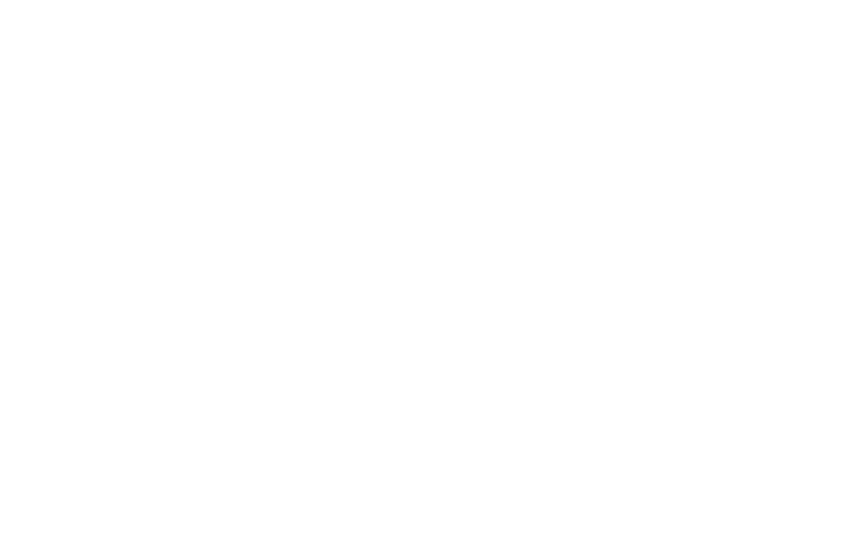

Scenarios
03

03. Scenarios / Pr2AP
Board 1

