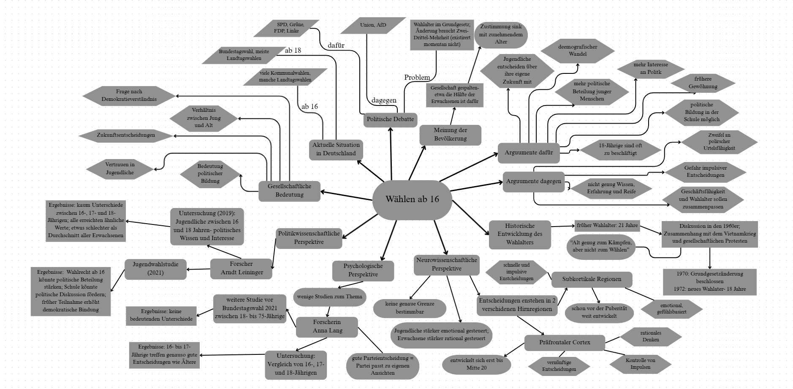
https://www.canva.com/design/DAHKaq4W5QM/2yM20ze6_lLRUl8qMg9o7Q/edit

