|  |  |  |  |  |  |
| --- | --- | --- | --- | --- | --- |
| **Project/Problem/Situation Analysis Report and Recommendations** | | | | |  |
| Author:  To: | | Roger Ashpole  Eutop Innovation USA  *15485 Sand Canyon Ave, Irvine. CA 92618*  *+001 949 720 2550 / 832 7696568* | | | Date: 18/01/2023 |
| Company:  Country: | | Sanhuan  China (CN) | | |  |
| Material:  Application: | | Grilon BRZ 334 H  Oil filter disk | | |  |
| Trouble Shooting  Project Support | |  | | |  |
| **Problem description / Targets**  Various materials were tried out for the filter discs, which form the end of the filter mesh. Zytel ST811 was chosen because of its softness and swelling in the oil on the dome.  The swelling on the dome, however, is undefined and tends to stick very strongly, which makes it difficult to dismantle when changing the filter. The customer would like to have a countertype to Zytel ST811, with similar properties and possibly less "sticking" to the dome.  Considered counter type to ST811 are Grilon BZ 3/2 and Grilon BRZ 334 H. Please compare the  material properties and oil storage swelling. If possible, use a plate with a hole to measure the dimensional change of the hole diameter.  Oil: Shell Helix Plus  Temp: 150°C, 200h after that swelling should be finished. (Test at customer runs 2000h) | | | | | |
| **Work** [h]**: 40** | **Test/Analysis** [h]**: 45** | | **Material** [CHF]**: 2’000** | **Ʃ Cost** [CHF]**: 16’550** | |

### Result / Solution / Proposal:

***Task:***

A type with comparable mechanical properties and less oil swelling.

Determination of swelling in Shell Helix Plus after storage over 200h at 150°C

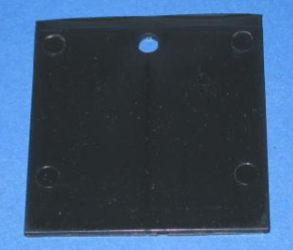

***Test conditions:***

200h in Shell Helix Plus at 150°C.

Measurements carried out:

1. weight change

2. dimensional change outer dimensions

3. dimensional change inner hole

***Test specimen:***

"Shrinkage plate with hole"

Dimension: 60mm x 60mm x 2mm, hole close to sprue, Ø 6mm

Connection: Film gate

**Weight change**

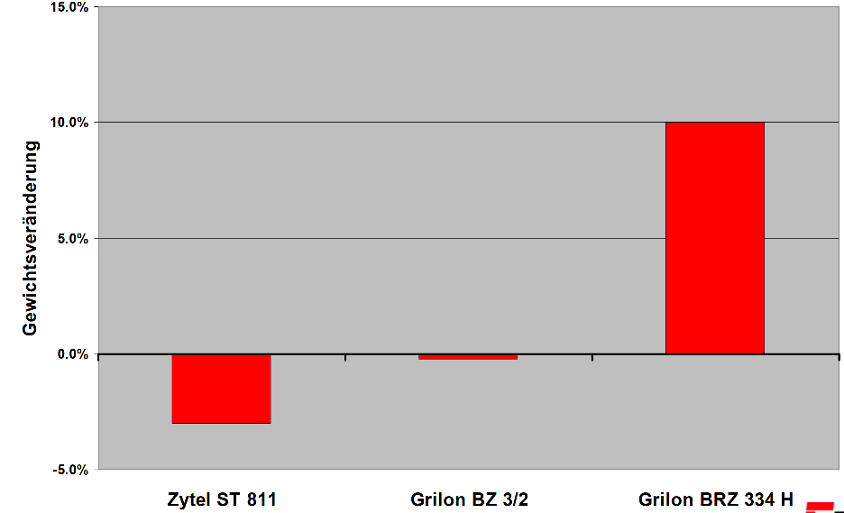

**Change of hole dimension**

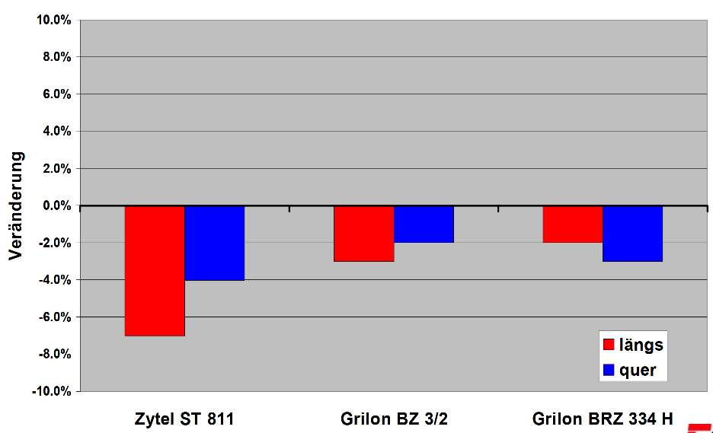

Long

Trans

**Change of outer dimensions**

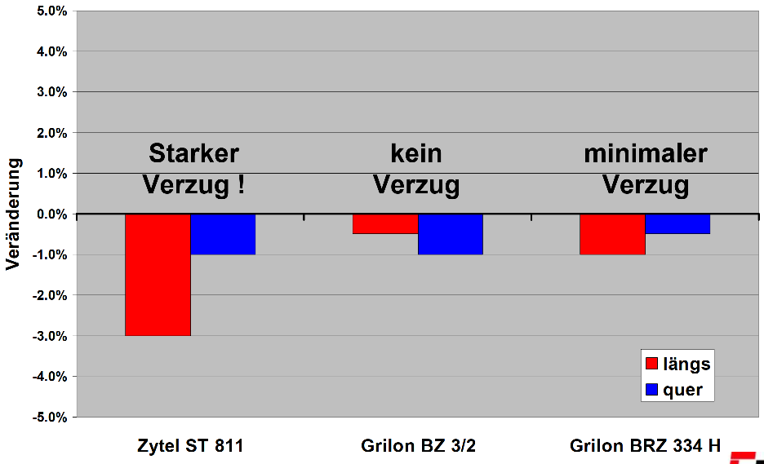

**High**

**warpage**

**no**

**warpage**

**Small**

**warpage**

Long

Trans

***Warpage***

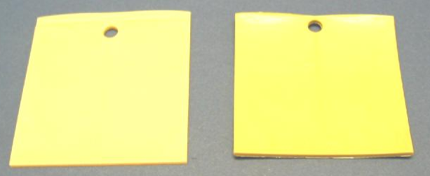

Zytel ST 811

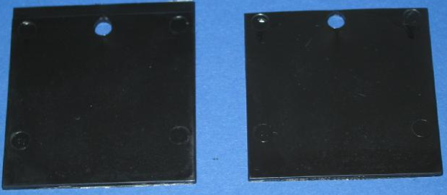

Grilon BZ 3/2

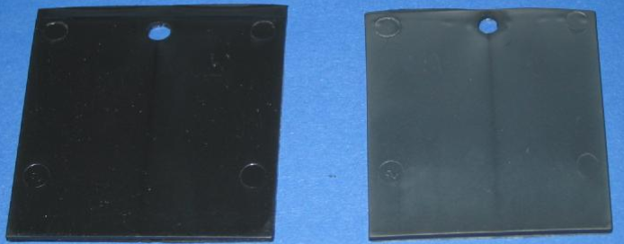

Grilon BRZ 334

***Conclusion***

* The mechanical properties of Zytel ST811 and Grilon BRZ-334H are largely comparable.
* Grilon BZ 3/2 is significantly stiffer than the other two products.
* Grilon BRZ 334 H shows a clear increase in weight after oil storage, while Grilon BZ 3/2 shows no change in weight and Zytel ST811 shows a weight reduction.
* The Zytel ST811 plates warp significantly during oil storage, whereas the Grilon plates remain dimensionally stable.
* Zytel shows the greatest changes in inner hole diameter.
* In particular, the products Zytel ST811 and Grilon BRZ 334 H seem to be comparable in the tested properties.
* However, we recommend testing the materials in a component test, since dimensional test, as dimensional changes always depend on the component are dependent.