Hot Runners:

RANDY KERKSTRA

Tooling Columnist

With advances in technology, hot runners have many more uses today than they did years ago. They are used to eliminate the cold sprue and runner, which can save you money on scrap when regrind is not an option.

Hot runners allow direct gating onto the part with a low-vestige tip or valve gate and eliminate the need for three-plate runner systems. They also allow you to gate on the outside edge of the part when it is centred on the mold.

On larger parts where knit lines or flow lines are a concern, you can use sequential valve gates to control the flow and move the knit lines. You can use multiple hot drops to reduce fill pressures. And they can be used to eliminate long cold runners to reduce the pressure loss and improve the process window.

So hot runners have many applications and can be very beneficial to the process, providing savings in cycle time and elimination of cold runner and sprue. Of course, hot runners can add a significant cost to the tool up front and therefore need to be justified economically. But the payback can be very significant On tools that run higher volumes and/or higher-cost resins.

Hot runners do add some complexity to the mold and require added maintenance; but improved designs have drastically reduced issues with hot runners over the years. The terrifying sight of a hot-runner pocket and wire channels packed full of plastic can bring instant heartburn. This sight was more common years ago, but in my arena, managing thousands of preventive-maintenance operations (PMs) and repairs a year, it is not so common anymore.

A ‘SIMPLE’ VIEW OF HOT RUNNERS

I want to simplify the understanding of the hot runner and its function. First, think of it as an extension of the molding machine itself. Its purpose is to keep the plastic molten at a proper temperature on its path to the cavity. So basically it’s just a piece of heated steel with a round channel in it for the melt to flow through. Ideally, this channel would be running at the exact temperature on the controller, free of obstacles such as dead spots or components that could create hangups and cause scrap issues with color changes or contamination.

The flow channel needs properly placed heaters and thermocouples to ensure that the correct temperature is maintained. The thermocouple itself is the most critical component. It is what reads the hot-runner temperature and tells the controller how much current to send to the heater to maintain the set temperature. In most cases when there is an issue with temperature, the thermocouple is the root cause, not the heater.

A heater is basically like a light bulb, it’s either working or burnt out, but there are times when it appears to be functioning but is not able to come up to temperature. I will get into how to verify the function of the heater in the press by measuring resistance/ohms.

If a thermocouple is loose or not held tight against the steel whose temperature it is supposed to read, the thermocouple will be reading the ambient air temperature instead, causing the controller to send excessive current to the heater and result in extreme overheating. I’ve seen this situation cause material in hot runners to spew smoke while the controller was showing that zone to be under the set temperature. I have also seen this happen when the thermocouple and heaters were not wired to the correct zones on the connection plugs.

Years ago, heaters with integrated thermocouples were more common, but they are not reliable for providing accurate temperature of hot-runner components. So you need to understand how critical the thermocouple and its placement are. Fortunately, most hot-runner manufacturers today are very good at thermocouple and heater placement to maintain accurate temperature without cold or hot spots.

I have also tried to stay away from the old analog-style hot-runner controllers. The newer electronic controllers are much more accurate and provide a smoother flow of amps. I have seen a few cases where just changing controllers to the newer technology eliminated issues with parts.

One case involved brown streaks on a polycarbonate part. We spent a lot of time working on the hot runner and process with no improvements, but the controller was the issue and when we changed the controller our issue disappeared. Another case concerned a part that had a specification on reflectivity. We were getting erratic results, but with a controller change our issue was eliminated.

TIPS ON TIPS

Many times over the years, hot runners have been a source of concern over dead spots where the material can hang up and degrade. With today’s hot-runner designs, this is not an issue in most cases.

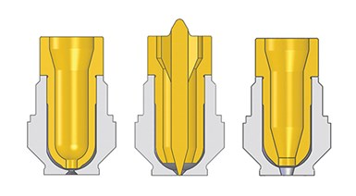

Hot-runner tips can have a great influence on part cosmetics. Left to right: sprue style, low-vestige tip, and valve gate.  
Photo Credit: Incoe

The one area of the hot runner that causes the most issues with part cosmetics is the hot-drop tip. The other area to consider is the orifices on the hot runner and on the nozzle tip. Hot-runner designs have seen many technical advances in tip designs and styles, which have helped with cycle times and gate vestige, but these components are obstacles in the flow path and can cause hangups.

There are three general styles of hot-drop tip designs, with many variations of each: The low-vestige tip, straight-through sprue style, and the valve gate.

• The low-vestige tip is used to direct gate onto the part with minimal vestige, and also is used on cold runners to reduce stringers. But I have found, in most cases, that this tip style is not a necessity. It can increase fill pressures (pressure loss) and contribute to color issues when running multiple colors. This tip style will also plug easier, as the orifice has less volume/area. This can be a big headache when running regrind with this style of tip.

• The straight-through tip style is usually the least problematic for color changes and contamination, without as many areas for the material to hang up. But even with some of the new designs today, and with an insulating gap, even a sprue-style tip can create problems. Most systems provide components to fill these gaps, commonly known as color seals.

• Valve gates are used to directgate onto the part with minimal vestige and are also used to control the flow when using multiple valve gates. Because they can be shut off independently you can control flow fronts and knit-line locations.

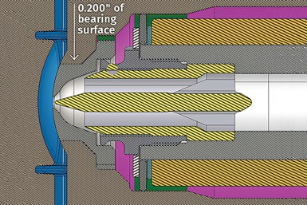

A common assumption about hot runners is that reducing the bearing contact surface between the nozzle tip and the cavity steel is desired to minimize heat transfer. In my experience, the opposite is most often true.   
Photo Credit: Deppe Mold & Tooling (all images)

In the last column, I left off with discussion of the three basic hot-runner tip styles, and there are numerous variations of each. Tip designs over the years have evolved drastically, with a focus on improved color changes and temperature control at the tip orifice to combat opposing tendencies toward either freeze-off or drooling. Color changes alone can be very costly in terms of scrap and machine time. But for each plastic material, different tip variations are needed to optimize color changes and temperature control at the hot-drop tip and orifice. I am writing from experience with a broad range of materials. So some of this info may not line up with your particular issues if you are confined to running specific materials.

DISPELLING A MYTH

One area I would like to clear up is bearing/contact surface and cooling at the hot-drop tip. I have run across the assumption many times that reduced bearing surface between the hot-drop tip and the cavity steel is desirable to minimize heat transfer. In my experience, the opposite is true in most—though not all—cases when dealing with drooling, stringing, and [sprue sticking](https://www.ptonline.com/articles/injection-molding-are-your-sprue-or-parts-sticking-here-are-some-solutions" \t "_blank). Although there is no universal prescription, I wanted to stress this point because getting to the root cause of an issue can become a challenge when opinions and assumptions get in the way of understanding what is really going on.

The multiple effects of gate orifice size are often overlooked when addressing hot-runner problems.

I can count on both hands the times over the past 28 years when I had to reduce bearing/contact surface to solve a hot-runner problem. In fact, lack of sufficient cooling and bearing/contact surface has been more often the case.

The few times I have had to reduce bearing surface was when dealing with freeze-off at the tip orifice, requiring excessive pressure to push plastic through—if it was possible at all. These cases involved using cheaper grades of PC and nylon. Reducing the contact between the tip and cavity steel keeps the nozzle tip hotter because you are not allowing the cooler cavity steel to pull as much heat from the tip area. As I mentioned last month, most new tip styles have insulator gaps to reduce the heat transfer. But these also can cause issues, and in some specific cases I do not recommend using them.

In most cases, I have observed over the years a lack of focus on cooling in the tool itself around the hot-drop tips and gate area. It would make logical sense to me that you would want to concentrate cooling in these areas when you have a component that can be hotter than 260ºC. When you have a sprue-style hot tip and are seeing problems of sprue sticking, the root cause is typically lack of cooling—either from inadequate water in the tool or lack of contact between the tip and cavity steel. The same is true with drooling issues.

In my experience, these problems can be material specific. The two materials that come to mind for sprue sticking are glass-filled nylons and PC/ABS. I have had to modify many tools over the years by adding water lines to the tip area and increasing the contact surface to resolve these issues.

OFTEN OVERLOOKED: GATE ORIFICES

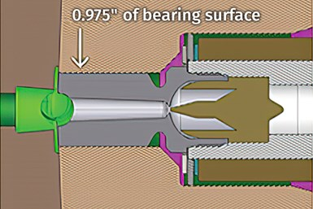

Nozzle orifice size has a big impact on processing window and part aesthetics. But with low-vestige tips like this one, be sure to take into account the orifice area lost to the spreader.

One area often overlooked when addressing hot-runner problems is the orifice size. This alone can impact all of the issues mentioned above, as well as the process window and scrap rates. Many are hesitant to play with the tip orifice, although it alone can resolve many issues. But I do not recommend just diving in without some experience and understanding of the impact of orifice size changes—and the possible need to go back to where you started.

The orifice is often overlooked with regard to fill pressure when gating into a cold runner. I have seen numerous cases where people focus on the runner and gates when the tip alone was the root cause as the main point of restriction in the flow path. Pressure-drop studies are very beneficial to understand this but are not always used. A pressure-drop study helps you understand where your pressure loss is occurring. Shoot just through the [injection nozzle](https://www.ptonline.com/articles/know-your-options-in-injection-machine-nozzles), then through just the hot-runner orifice, and then the part. (With a cold runner, you shoot through the nozzle, then the runner, then just through the gate and then the part.)

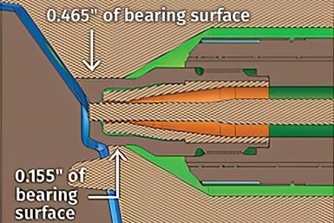

Nozzle orifice size can also cause or relieve processing problems with valve gates. Changing the orifice size is relatively easy by replacing the seat insert and valve pin.

Orifices can have more of an impact on the process than just pressures. A case in point is one where I was dealing with a high gate vestige from a valve gate. The part had 2.794 mm. nominal wall stock and was center gated with a valve-gate orifice of 6.35 mm. I’m not the process guy, but I was asked to get involved to see if there was anything we could do to the tool. The process window was small: Any slight change in fill speed or time could create a high gate. But a change in backpressure would not create one.

So my first decision was to reduce the valve-gate orifice. With today’s options it was as easy an ordering a new seat insert and new valve pin. I went down to a 4.064 mm diam. orifice. The results were very interesting. With the gate area reduced by half, a slight change in backpressure would create a high gate and any change in fill speed would not create one. With this puzzling result and a process window that was still not robust, we hadn’t improved the situation.

We then changed the valve-gate orifice to a 5.334 mm diam., which left a gate area midway between the original size and smaller one. The results again were very interesting, we ended up with a robust process window where we could not create a high gate with either a change in speed or backpressure. I have a couple of theories as to why the orifice size had such a big impact. I would welcome readers’ input on this if you’d like to send me an email.

I also ran across a scrap issue caused by splay, where changing the orifice size ended up being the solution. This was a part with four low-vestige tips, which have a spreader tip in the center of the gate orifice. In this case, the overlooked factor was the amount of gate area taken up by the spreader tip, which restricts flow. In this case the orifice was 1.27 mm. and the spreader tip in the center of the gate was 0.635 mm. The area of the spreader tip reduce the gate area by 25%. The fill speeds with this gate needed to be on the high end to make a good part, but we struggled with a lot of splay. We opened the orifice size to 1.524 mm, which gave a 55% increase in effective gate area not occupied by the spreader tip. This allow us to adjust the fill speed and eliminate our shear and splay issue.