[European Polymer Journal](https://www.sciencedirect.com/journal/european-polymer-journal" \o "Go to European Polymer Journal on ScienceDirect)

[Volume 109](https://www.sciencedirect.com/journal/european-polymer-journal/vol/109/suppl/C), December 2018, Pages 16-25

Redefining polyamide property profiles via renewable long-chain aliphatic segments: Towards impact resistance and low water absorption

Author links open overlay panelPhan Huy Nguyen, Steven Spoljaric, Jukka Seppälä

Abstract

A series of renewable, long-chain, fatty acid-derived [polyamides](https://www.sciencedirect.com/topics/chemistry/polyamide) (PA) ranging from PA 6,14 to PA 6,18 were synthesized via [polycondensation](https://www.sciencedirect.com/topics/materials-science/polycondensation), yielding very high [molecular weights](https://www.sciencedirect.com/topics/chemistry/molecular-mass) and a remarkable property profile distinct from short-chain commercial grades. Most notably, synthesized polyamides exhibited good impact resistance, excellent stiffness-to-toughness balance and very low water absorption yet high oxygen and water vapour permeability; with this property profile being exemplified by PA 6,18. The increased repeating unit length and reduced number of amide linkages able to participate in interchain hydrogen bonding imparted a strong influence on [material properties](https://www.sciencedirect.com/topics/materials-science/materials-property). The data highlights the benefits and technical advantages of utilising long-chain polyamides, while also significantly expanding the repertoire, knowledge and property profile of the long-chain aliphatic polyamide family, and providing a basis for further development of polyamides from renewable sources.

Graphical abstract

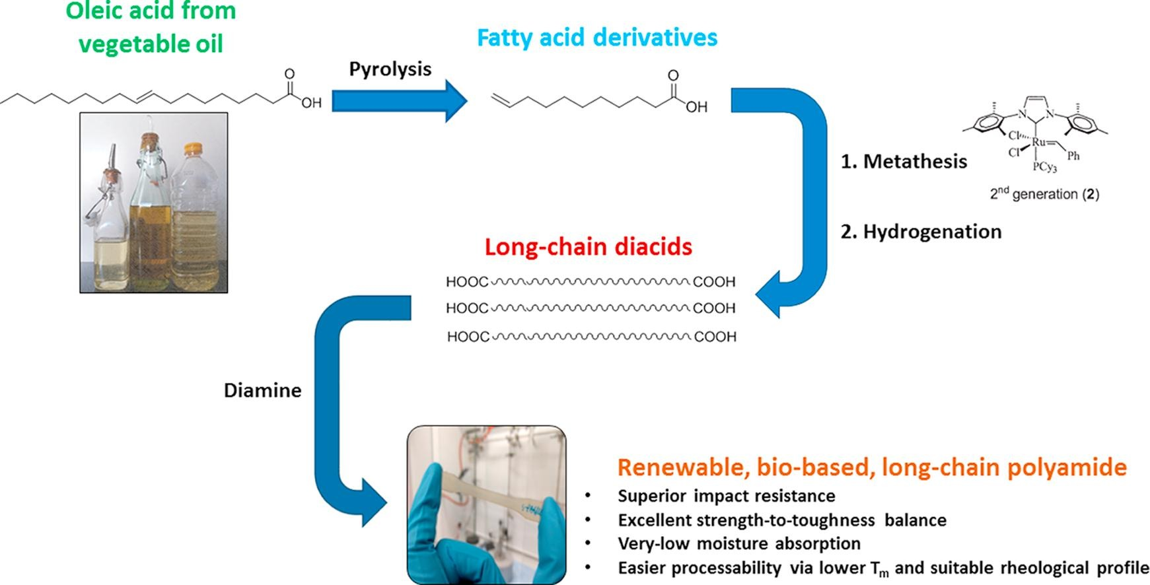

Introduction

Within all polyamides, inter- and intramolecular hydrogen bonding between amide groups are amongst the most important and interesting phenomena, appearing in both crystalline and amorphous domains. Their presence and the extent to which they occur is responsible for a range of different material characteristics and properties, including melting temperature, the degree of water absorption, tensile strength, impact strength, density, solvent resistivity, etc [1]. Short aliphatic-segment polyamides such as polyamide 6 (PA 6) or polyamide 6,6 (PA 6,6) have a relatively high ratio of amide:methylene groups per repeating units; this correlates to a high degree of hydrogen bonding between polymer chains. The strong nature of these bonds results in polyamides that typically exhibit high melting temperatures, superior tensile strength and resilience values, and good abrasion resistance. However, one negative consequence of the presence of amide groups is their high sensitivity to moisture. The adsorbed water molecules behave as plasticizing agents, while also reducing the number of potential sites that can participate in inter-polyamide chain hydrogen bonding. As a result, strength and stiffness are reduced and dimensional instability increases. Furthermore, polyamidation is a reversible reaction in which amide linkages can be broken and lead to chain scissoring. Thus, water molecules which are adsorbed during polymerisation are able to cause hydrolysis degradation for polyamides [2].

Long-chain, aliphatic PAs are a well-established class of polyamides, which for the purpose of this manuscript will be defined as possessing a repeating unit with a carbon number of 10 or higher. Within AABB-type polyamides, this increased repeating unit length is usually derived from the dicarboxylic acid segment (eg. PA 6,10, PA 6,12), however it can also stem from the diamine component (eg. PA 10,10). These PAs possess a range of attractive properties, including high mechanical strength, good solvent stability/resistance, lower melting temperatures and low moisture absorption [3], [4]. In particular, reduced moisture absorption gives long-chain PAs a competitive edge over their shorter-chain counterparts, such as PA 6 and PA 6,6. This stems from the longer segments of aliphatic chain, and higher ratio of methylene:amide linkages per repeating units. As such, they have found use in a broad field of applications, including packaging, automotive components, sporting equipment, cables and tubing [4].

As with many classes of polymer, the push towards bio-based or renewable source materials and monomers has caused a search for new polyamide synthesis techniques [5]. This generally involves the use of di-acids which are derived (eg. hydrolysis or alcoholysis) from fatty acid triglycerides, which constitute up to 95%·wt of vegetable oils and fats. One common example involves the extraction of ricinoleic acid from castor oil, which can be further subjected to pyrolysis to yield fatty acid derivatives for subsequent use as monomers in polyamide synthesis. A wide range of polyamides have already been synthesized utilising these fatty acid derivatives [6], [7], [8], [9]. Furthermore, fully- or partly- bio-based long-chain PAs have already been commercialized by a range of industrial polymer manufacturers [10], including Rilsan® (PA 11) from Arkema S.A., Zytel® (PA 6,10, PA 10,10) from DuPont and Vestamid® Terra (PA 6,10, PA 10,10, PA 10,12) from Evonik Industries AG. This growing interest from both academia and industry, the increased availability and production of bio-sourced fatty acid reserves and the recent developments into the preparation bio-base diamines [11] encourages further study and development of this class of polymers.

Despite the volume of research interest and literature regarding long chain PAs, there exists a need to expand the repertoire and knowledge of these materials. For example, although a variety of long-chain polyamides have been synthesized utilising repeating units containing up to 34 carbons [12], [13], [14], [15], [16], [17], [18], [19], [20], [21], a rather limited overview of basic intrinsic properties is presented, without exploring practical properties (eg. impact strength, tear strength, etc.). Similarly, the possibility to modify and manipulate polyamide behaviour and characteristics by increasing segment length and reducing amide linkage density provides great potential for expanding the applicability and limitations of this class of polymers. Furthermore, several of the aforementioned long-chain PAs possess various other functional groups along the backbone chain [22], [23]; this provides the opportunity to characterise and identify the effect of non-modified long-segments of aliphatic chains, establishing crucial structure-property correlations in the process. Finally, the ongoing commercialisation of vegetable oil-derived, long-chain fatty acids possesses, in addition to bio-fuel production, a viable and renewable resource for the production of next-generation polymers with increased aliphatic segment length. This serves to heighten the need to synthesize, characterise and profile these long chain polyamides, providing a basis and understanding for synthesizing and developing similar polyamides from bio-based, renewable resources.

Herein, a series of AABB-type, aliphatic long-chain polyamides were synthesized via polycondensation, utilising a number of renewable long-chain dicarboxylic acids with varying repeating unit lengths. The molecular weight, crystallinity, thermal, mechanical, barrier and water absorption properties of the synthesized polyamides are presented and compared with several commercially-available polyamides. Key structure-property relationships are identified and presented, in particular focusing on the influence of repeating unit length and molecular weight.

Bio-based polyamides are polymers derived from renewable sources such as vegetable oils, starch, or lignin. They have some advantages over conventional polyamides, such as:

* Reducing the carbon footprint and greenhouse gas emissions due to their high bio-content and biodegradability.
* Offering mechanical strength, ductility, flexibility, and abrasion resistance.
* Having outstanding thermal, barrier, and electrical properties.
* Having special structures and functionalities that are difficult to achieve with fossil-based polyamides.