|  |  |  |  |  |  |
| --- | --- | --- | --- | --- | --- |
| **Project/Problem/Situation Analysis Report and Recommendations** | | | | |  |
| Author:  To: | | Roger Ashpole  Eutop Innovation USA  *15485 Sand Canyon Ave, Irvine. CA 92618*  *+001 949 720 2550 / 832 7696568* | | | Date: 27/02/2023 |
| Company:  Country: | | AY Automotive  China (CN) | | |  |
| Material:  Application: | | Grilamid XE12230  2K fuel tank valve | | |  |
| Trouble Shooting  Project Support | |  | | |  |
| **Problem description / Targets**  AY is using Grilamid LV-3A HX for fuel tank connectors/valves. To meet future and stricter permeation demands (China 7, Euro 7), AY is evaluating the new and improved Grilamid XE 12230. Outsourced mini SHED trails have however not confirmed any improvement with the new grade. In contrast the EMS test showed an improvement of at least 50%. Hard tooling at AY is finished.  Additional test has to be carried out to identify the real permeation situation | | | | | |
| **Work** [h]**: 3,000** | **Test/Analysis** [h]**: 11,400** | | **Material** [CHF]**: 2,000** | **Ʃ Cost** [CHF]**: 16,400** | |

# Result / Solution / Proposal:

**Actual Situation:**

The trials at AY have been carried out with Fuel E0 and E10 at 40C, while EMS used FAM B at 60C. The EMS permeation test showed significantly lower permeation with the more serious FAM B and at a higher temperature.

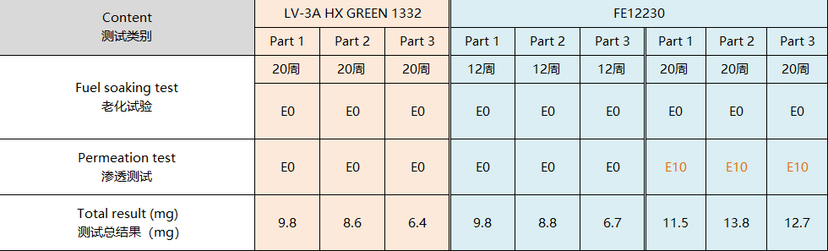Results from AY

The test procedure has been discussed, it shows that EMS test and mini SHED test are very different. While EMS measures the permeation of the polymer, the mini SHED test measured the permeation of the component including the tank material and sealing.

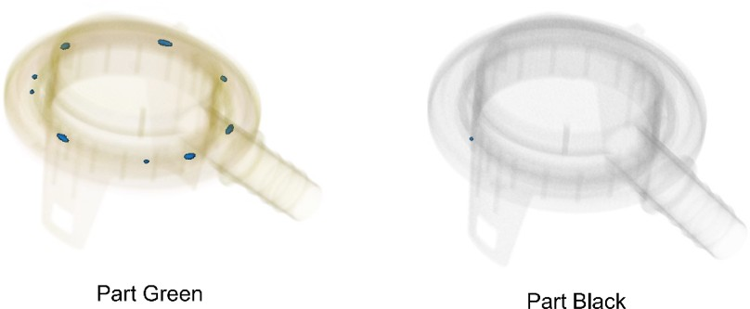

If check the CT-Scan, Grilamid XE 12230 should be better as well. There is just one small void in the XE 11230 part *(Black)*, while there are several the reference *(LV-3A HX green)*. In numbers, the porosity of Grilamid XE 12230 is ***0.01%*** compared to ***0.93%*** for the reference.

The potential causes for unexpected and unexplainable permeation of Grilamid XE 12230 are:

* Testing method (permeation data are predominantly caused by something else)
* Design (Permeation of the tank material, the welding surface, the sealing material, influence of the welding area after fuel saturation)
* Materials

**Solution:**

Additional tests to identify the real causes for permeation are needed.

**Test results:**

Additional tests have been carried out and result as below:

**Conclusion:** The initial low permeation properties of Grilamid L FE 12230 could not be confirmed. It is just marginally better than Grilamid LV-3A HX. EMS R&D does not see any possibility for significantly improving the permeation performance, thus EMS decided to stop this product development project.