Vision II: Penalty Analysis in Broadcast Football Video
Review draft for group verification, 12 October 2026. This document has not been submitted. It describes the saved development results consolidated in outputs/final_analysis/; it does not report a new raw-video experiment. The group must verify its final cover information, contribution statements, video evidence, and references before using this text in the submitted report.

1. Literature Review
Penalty analysis requires observable definitions and evidence that the measurements represent the intended actions. The OSPAF study, Design and Validation of an Observational System for Penalty Kick Analysis in Football, developed a structured observation system with expert feedback and observer agreement checks. It also examined viewing angles and recommended combining multiple views. Its findings motivate defining the observation window and documenting uncertainty before interpreting a player's behavior. They do not validate this project's automatic rules. In particular, some proposed variables, including run-up type and length, were excluded from OSPAF's final system, so citing the paper cannot establish that any chosen run-up feature is already a validated measurement.
Football broadcasts combine detection, identity association, camera geometry, and editing. SoccerNet Game State Reconstruction treats field localization, player roles, teams, and identities as connected tasks, with evaluation against annotated data. This is a useful reference for decomposing the penalty task: a correct-looking person detection is insufficient if the selected track belongs to the referee or goalkeeper instead of the kicker. SoccerNet serves as a conceptual comparison here; this project does not claim to have imported its development kit, reproduced its benchmark, or obtained its evaluation scores.
The SoccerNet Camera Shot Segmentation task distinguishes camera classification from finding shot boundaries. This distinction matters because locating a cut does not establish that the following shot is one of the four camera views requested by the assignment. Similarly, the OpenCV homography tutorial describes transformations between planes. A calibrated pitch-plane mapping can support a ground trajectory, but an image trace, a stabilized image trace, and an airborne ball's three-dimensional trajectory are different measurements. This project therefore keeps source-image coordinates and calibration status explicit.
The literature suggests a sequence of responsibilities: identify the relevant actor and event, check the available views, define the feature, produce a candidate, and evaluate it using an independent reference. The present work has made progress on candidate extraction and inspectable evidence. Its current evaluation remains a descriptive audit of development records, which limits the football conclusions that can be drawn.

2. Data Collection and Preparation
The unit of analysis is one penalty attempt. The canonical dataset contains 39 attempts from four 2018 FIFA World Cup shootouts: Colombia versus England has 10, Croatia versus Denmark has 10, Spain versus Russia has 9, and Russia versus Croatia has 10. Frames, camera shots, and replays belonging to an attempt are associated observations rather than additional independent penalties. The course permits manual video slicing; the subsequent extraction must be scripted and reproducible. The slicing manifest records the selected intervals and canonical clip IDs.
The final analysis table is outputs/final_analysis/features_39.csv. The consolidation script joins saved step, foot, goalkeeper, camera, and ball records by clip ID. Each row keeps candidate values separate from recorded references and verification flags. The old 49-row demonstration table is excluded from the final analysis. The saved camera supplement has been recovered, with its CSV and JSON hashes matching the recorded supplement manifest. It contains 197 candidate intervals across all 39 attempts. Recovering this artifact is not a new video-inference experiment and does not establish the correctness of its interval boundaries or camera labels.
The adjacent manifest records the canonical IDs and artifact hashes, while the provenance file records the source inputs and their hashes. The EDA reader rejects an incorrect event count, duplicate or unexpected IDs, incompatible schemas, and stale table or evaluation hashes. These checks demonstrate that the analysis is using a consistent saved bundle. They do not establish that a detected ball is the real ball or that the recorded source-video hashes have been verified against the raw files. Raw-video source verification was not performed during this consolidation.
Missing numeric values remain missing rather than becoming zero. An unknown categorical result contributes to the event denominator but not to candidate availability. A stored nominal kicking-foot candidate, a result stable across method variants, a reference, and a verified prediction are stored separately. References for the ball outcome are recorded as external FIFA-source labels for all 39 events, but the individual source records have not been independently checked during this work. The ten kicking-foot labels are prior user-review references recorded in upstream annotations; the original review messages were not independently inspected during this consolidation. They were used during method development and are not an untouched test set.

3. Exploratory Data Analysis
The EDA first asks what is available before comparing action categories. Figure 1 shows candidate availability and its distribution across matches. Nominal kicking-foot and step-count candidates exist for all 39 events, and all 39 have a saved count of trajectory points and available camera-interval candidates. These counts indicate available outputs rather than correct identities, complete motion, or accurate measurements. Only one nominal foot result is marked stable across the saved method checks. Goalkeeper direction has 36 candidates, while the pre-movement field has 33 legacy candidates whose measurements require recomputation with the repaired stabilizer. They should not be used for a current movement comparison.
Of the 197 recovered camera intervals, three have a behind-the-kicker course-class candidate and seven have a 45-degree-right candidate. The remaining 187 have an unknown course-class candidate. Playback-speed status is unknown for all 197 intervals, and zero intervals are recorded as human verified. Thus, event-level interval availability is 39 out of 39, while reliable extraction of the four requested course views and slow-motion properties remains unestablished. The coverage chart must not be interpreted as 39 successfully classified camera sequences.
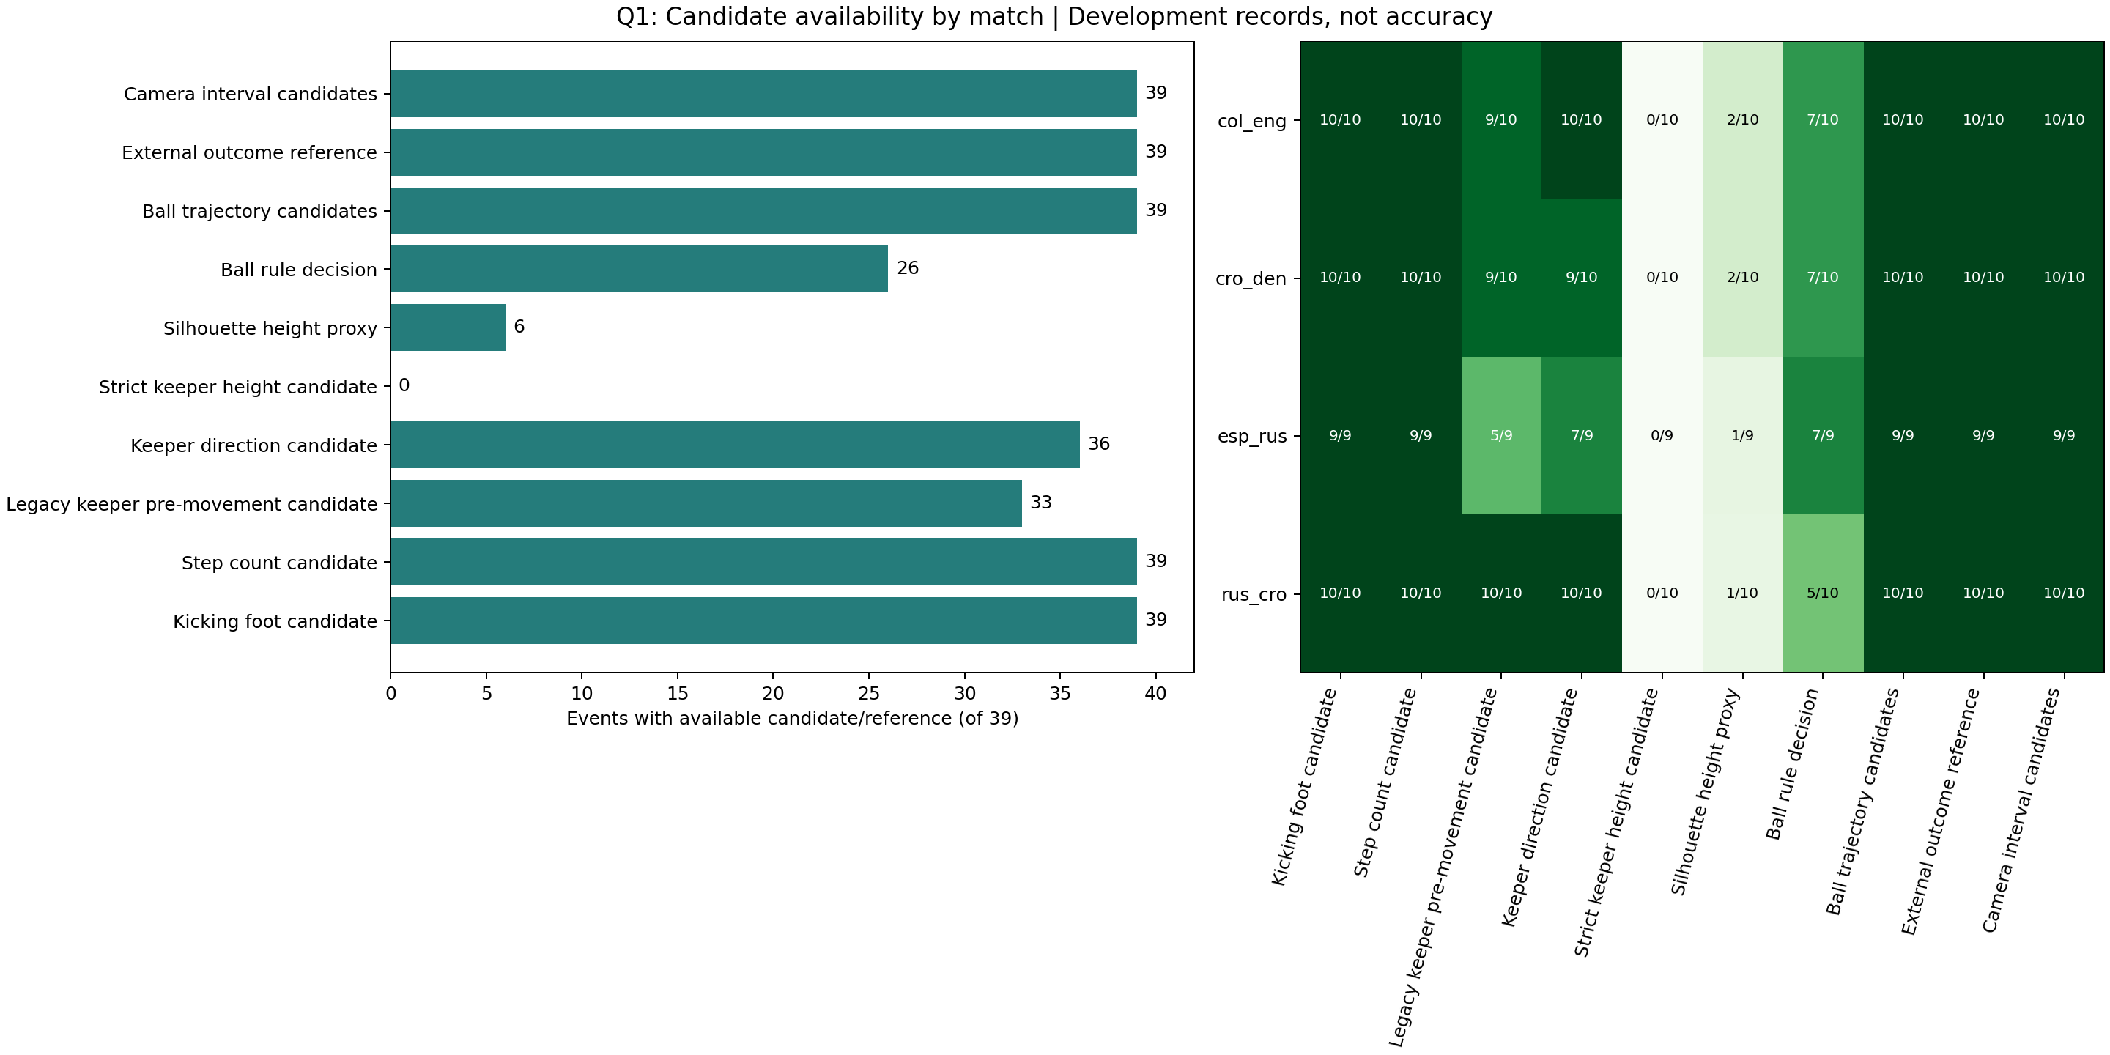
Figure 1. Candidate and reference availability in the 39-event development cohort, with match-level availability.
Strict phase-based goalkeeper height has zero available candidates out of 39. The separate silhouette-height proxy has six candidates; it does not supply the missing strict measurement. Validated ground-plane run-up trajectories and verified event-final ball positions also have zero coverage out of 39. These are failures to establish the required measurements, not observed zero heights, stationary approaches, or balls ending at the origin. The three ball-outcome conflicts and all unresolved identities require evidence review before tactical interpretation.
Figure 2 shows step-count candidates and saved parameter sensitivity. The modal candidate is six steps, occurring in 12 events. Counts range from two to fifteen, with isolated candidates of fourteen and fifteen. All 39 have a recorded sensitivity range; only four ranges have identical endpoints, and the median range width is two steps. This spread shows that the saved threshold and contact-window choices can materially change the answer. The ranges are engineering sensitivity intervals rather than statistical confidence intervals.
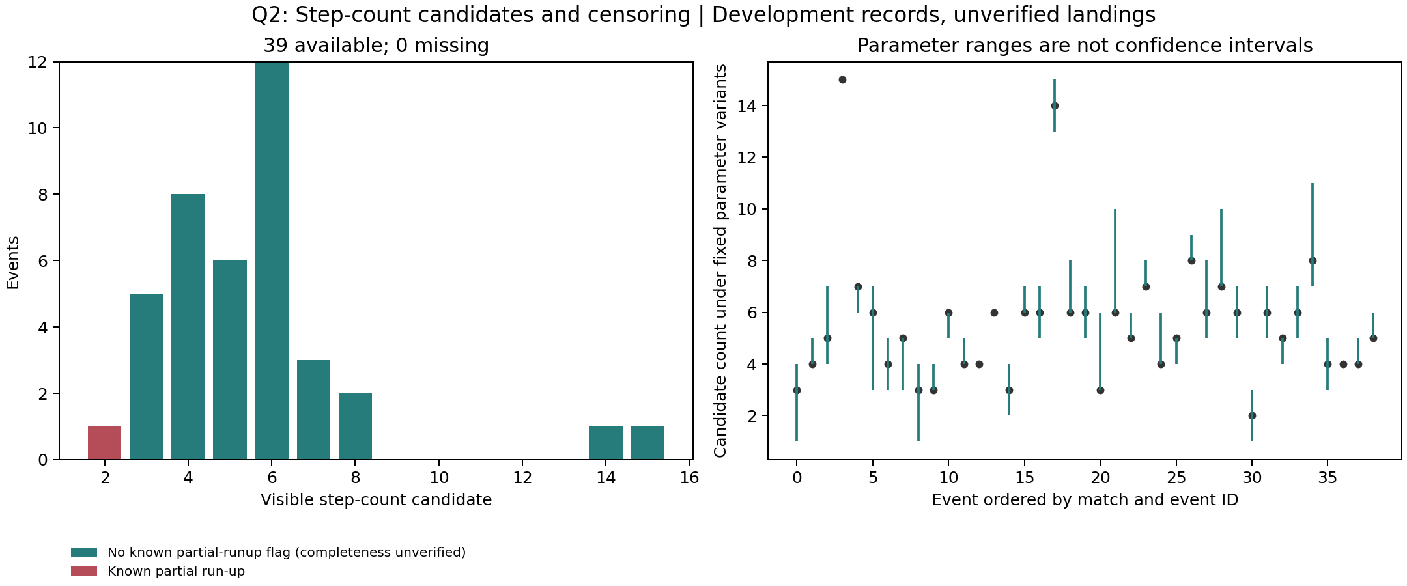
Figure 2. Visible step-count candidates and parameter sensitivity in development records; candidates are not verified landing counts.
One event, rus_cro_p02_brozovic_cro11, is explicitly marked as a partial run-up. Its visible count cannot represent a complete approach total. The other events' negative partial flags do not establish that their full approaches were captured. No step count has been independently verified in the final bundle, so the distribution is useful for prioritizing inspection and does not establish the true distribution of run-up steps.
Figure 3 compares decided automatic ball rules with the stored references. The rule outputs 20 likely goals, six likely non-goals, and 13 unknowns. It therefore makes a decision for 26 of 39 events, giving 66.7% coverage. Of those 26 decisions, 23 match the stored references, giving 88.5% covered reference agreement. Both values describe development records with unverified external-source provenance. They are not held-out accuracy. The three disagreements are esp_rus_p02_smolov_rus10, esp_rus_p05_koke_esp8, and rus_cro_p01_smolov_rus10.
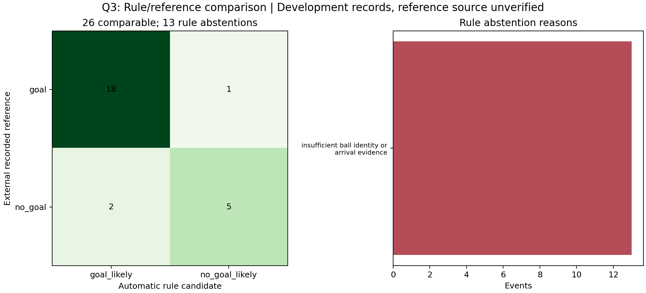
Figure 3. Ball-rule decisions, abstentions, and comparison with recorded external references in the development cohort.
The covered confusion table contains 18 recorded goals classified as goals, one recorded goal classified as a non-goal, two recorded non-goals classified as goals, and five recorded non-goals classified as non-goals. The remaining 13 events are abstentions with the recorded reason insufficient_ball_identity_or_arrival_evidence. Treating these unknowns as correctly detected misses would distort the comparison. The separate reference totals of 26 goals and 13 non-goals describe stored labels rather than the automatic rule's successful extraction.

4. Research Questions and Findings
The first research question is: how does candidate feature observability vary across the four matches? Availability is computed as the number of events with an available candidate divided by the match's event count. Ball rules decide seven of ten Colombia-England events, seven of ten Croatia-Denmark events, seven of nine Spain-Russia events, and five of ten Russia-Croatia events. Goalkeeper direction availability is ten of ten, nine of ten, seven of nine, and ten of ten, respectively. The differences identify recordings that merit closer review. They do not identify a causal camera effect, because match, image quality, actor identity, and available observation windows have not been independently controlled. Strict height availability is zero in every match, indicating a common measurement limitation rather than a match-specific football behavior.
The second research question is: how sensitive are candidate step counts to parameter choices and incomplete run-ups? The saved candidate range has a median width of two steps, and only four of 39 events show no change across the recorded parameter variants. The known incomplete approach must be interpreted as censored evidence. With no independent landing labels and only one explicitly partial event, the data are insufficient to estimate an effect of partial recording on true step count, report a step-count MAE, or associate true step counts with scoring. The answer is therefore an observed sensitivity and coverage limitation, accompanied by specific cases for review.
The third research question is: when do ball rules abstain or disagree with stored outcome references? The rule abstains on 13 events and disagrees with three of the 26 decided cases. The two recorded non-goals classified as goals deserve inspection of ball identity, arrival evidence, and post-save or rebound branches. The recorded goal classified as a non-goal deserves the same evidence review. A last observed detection cannot establish where the ball finishes the event, and a projected overlap with a goal region cannot independently establish whole-ball crossing. The answer is an auditable set of disagreements and abstentions, not a validated scoring detector or an inferred optimal penalty strategy.
All 39 attempts have already been involved in development or diagnostic inspection. Relabeling a subset as a test set after these inspections would not create independent evidence. Future evaluation should reserve new, uninspected attempts, grouping all shots and replays of the same event together, before further method selection. The ten-foot development comparison illustrates this problem: a camera-scoped shortcut matched all ten reviewed examples, but that result cannot be extrapolated to the remaining 29 attempts or called generalization accuracy.

5. New Techniques, Iteration, and Limitations
The project combines pretrained pose and object detectors with local temporal rules. Pose keypoints provide candidate hip and ankle traces; the penalty-specific logic selects an actor, estimates a contact window, and separates preparation, approach, strike, and recovery evidence. Saved step experiments use normalized ankle motion and signal extrema with explicit parameter variants. The engineering lesson is that a signal peak can arise from a landing, a leg swing, a stationary adjustment, or keypoint jitter. A method that always returns a number can conceal these ambiguities, so candidate status and review requirements accompany the output.
Background-motion compensation extends the use of image alignment to the broadcast setting. The current stabilization module excludes person regions from background feature sampling, uses forward and backward optical-flow checks, and estimates a partial affine transform with RANSAC. A rejected frame pair breaks the chain of transforms to the reference frame and makes later unsupported transforms missing. This prevents silently treating an unobserved camera displacement as zero. The repair has implementation and test evidence; the legacy goalkeeper pre-movement values in this bundle were not regenerated with it, so this report does not claim an improvement in those measurements.
Stricter event definitions exposed the project's principal remaining failures. The pipeline has not established calibrated ground-plane trajectories for the 39 run-ups. It has not produced strict phase-based goalkeeper height candidates, and it has not verified the final event position of any ball. Image-left and image-right goalkeeper directions must remain explicitly tied to source-image coordinates rather than being silently interpreted as the goalkeeper's anatomical left and right. Actor selection and temporal coverage also remain unverified for the full cohort.
Further computation can assist high-resolution detection, temporal association, and systematic reruns, but hardware alone does not provide labels, calibration landmarks, or complete footage. A 4090-based experiment should be justified by a measurable bottleneck and followed by the same provenance and independent evaluation steps. The current report does not claim that such an experiment has been performed. The most useful next work is to verify actor identities and contact windows, establish review definitions, evaluate the recovered camera evidence, and rerun affected extraction before assessing accuracy.
Human review is an evaluation and diagnostic aid. It cannot be substituted for the assignment's scripted extraction by entering all requested outputs manually and then describing the result as automatic. The final submission should present the script's original predictions, independent references, reviewed corrections, abstentions, and unresolved requirements separately. Previous AI-generated labels and visual judgments do not constitute independent human ground truth.

6. Code Structure and Reproducibility
The src/ directory contains reusable extraction and analysis modules. Video handling, detector invocation, contact estimation, phase analysis, ball association, goalkeeper processing, camera processing, and geometry remain separate components. The scripts/ directory supplies command-line experiment and evidence-building entry points, while configs/ contains runtime configuration and the canonical slicing and consolidation manifests. Historical experiment artifacts remain associated with their original outputs rather than being silently overwritten by the final analysis.
The final bundle is assembled by scripts/build_final_results.py using configs/final_analysis.yaml and src/final_results.py. It writes the flat 39-row table, a structured feature JSON, evaluation metadata, provenance, and an artifact manifest. The optional raw-clip argument supports source-video hash verification when the actual clips are available. Consolidation reuses saved results; running it alone does not perform detector inference. This distinction is essential when reproducing a saved analysis on another machine.
The formal EDA entry point is src/eda_analysis.py. It reads outputs/final_analysis/features_39.csv and the matching sidecars, validates their identity and hashes, and exports the three figures and an independently recomputed descriptive summary to outputs/final_analysis/eda. The read-only notebooks/final_analysis.ipynb loads the same bundle and renders the analysis in memory. The analysis does not default to the old demonstration CSV, and missing values are preserved. Guard tests cover incompatible cohorts, stale artifacts, duplicate identities, malformed values, and the distinction between missing measurements and actual zero values. These tests establish analysis integrity; they do not establish video-extraction accuracy.
The full raw-video extraction still requires the documented model weights, video inputs, dependencies, and selected experiment configuration. Reproducing saved figures is a narrower achievement than rerunning every extraction stage. The submitted code and data package should make both routes explicit and include usable local paths or documented retrieval steps without depending on a student's personal account. The final demonstration should connect an actual input clip, intermediate identity and timing evidence, the candidate row, and the corresponding analysis, including an unresolved case.
AI assistance was used to audit the inherited project, implement consolidation and EDA safeguards, and draft this review text. The students remain responsible for understanding the methods and checking the evidence, code, figures, references, and final statements. No authorship allocation, independent accuracy result, or completed submission is asserted in this draft.

