Vision II: Evidence-Aware Penalty Analysis in Broadcast Football Video
Review draft for group verification, 13 October 2026. This document has not been submitted. It reports the frozen 39-event bundle in outputs/fresh_course_experiment/final_bundle_v3_shoe_fusion/, the original-recording continuous-shoe experiment in shoe_approach_analysis_v2/, and separate earlier pilots. Independent human annotation remains pending. The group must verify the wording, references, contribution statements, figures, and video narration before submission.

1. Literature Review
Penalty analysis is an observational measurement problem before it is a classification problem. Pinheiro et al. (2021), Design and Validation of an Observational System for Penalty Kick Analysis in Football (OSPAF), motivates explicit event definitions, viewing-angle checks and observer agreement, but it does not validate this project's automatic rules. The study is therefore used to justify a measurement protocol, not to claim that a detected foot, step or dive is correct.
Broadcast soccer combines person detection, role association, camera geometry, identity tracking and editing. The SoccerNet Game State Reconstruction task similarly treats field localization, player roles and identities as connected quantities. This project adopts that decomposition: a pose track is retained only as a candidate until the actor, source pixels and action interval pass independent guards. The SoccerNet material is conceptual context rather than an imported benchmark or an achieved benchmark score.
The project also uses planar homography for a restricted ground-plane diagnostic. OpenCV's homography documentation explains the transformation between planes; it does not turn an airborne ball, hip point or image polyline into a metric trajectory. The analysis therefore reports source-image coordinates, sparse sole candidates, held-out line checks and calibration status separately. A same-frame ground candidate is not a continuous top-down run-up measurement.
The MediaPipe Pose Landmarker provides 33 image landmarks, including heel and foot index, beyond the ankle locations available in the original 17-point pose. This motivates a paired shoe-landmark experiment. The predicted points remain model evidence: neither a high visibility score nor a foot segment near a ball proves physical contact. Model world-coordinate outputs are not used to infer metric height.
The new methodological component is a source-only, staged evidence design. YOLO11 pose and object detectors supply candidate observations, a frozen contact rule binds a stationary ball identity to causal departure, SAM2 supplies a guarded goalkeeper-mask pilot, and image processing reads broadcast penalty icons without OCR or external outcome labels. The independent reference audit is joined after prediction. This ordering supports skepticism about impressive-looking agreement and makes abstention a reportable result.

2. Data Collection and Preparation
The unit is one penalty event. The canonical cohort contains 39 attempts: ten from Colombia-England, ten from Croatia-Denmark, nine from Spain-Russia and ten from Russia-Croatia. The four original recordings were hashed before clipping. Each context clip stores its original source frame interval, source-video hash, 1280 by 720 dimensions and 30 FPS clock. Context boundaries are not treated as verified semantic walk-to-spot or play-end boundaries.
The rerun uses an isolated Linux environment with Python 3.11, PyTorch 2.7.0 plus CUDA 12.8 and Ultralytics 8.4.175. Official YOLO11n, YOLO11m, YOLO11m-pose and SAM2-t bytes are recorded with sizes and SHA256 values. YOLO11n and YOLO11m object inference use the identical 39-event source cohort, pose input, image size, thresholds and temporal rules. Model selection is based on source evidence coverage and disagreement diagnostics, never on a reference outcome.
The contact selector is pre-registered. If both detectors support a contact, their actor IDs and timing brackets must agree and at least three shared stationary source frames must occupy the same spot. Compatible alternatives are ranked by contact score, bracket width and actual departure confidence. A single supported producer is retained; a conflict abstains. The selector copies existing neural artifacts and performs no new neural inference. Original nano and medium directories remain frozen.
The final evidence bundle binds pose, selected ball/goal-guard result, revised foot, contact-bound phase, joint pitch diagnostic, camera-v2 result, endpoint, goalkeeper height and scoreboard components to one source manifest. Each component records code, model, source and producer hashes. Missing numeric values remain null. human_verified, accuracy_validated, physical height and event-final position are explicit flags rather than inferred defaults.
Additional data collection follows the course brief's invitation to seek relevant evidence. A public FIFA edition of Colombia-England was downloaded at 1920 by 1080 with a 50 FPS container clock. Sequential decoding yielded 25,607 frames without adjacent exact repetitions; this does not establish native camera capture rate or playback speed. Three coarse main-view intervals were cut for Falcao, Kane and Cuadrado without resizing, using lossy CRF10 encoding. Their source hashes, frame mappings and endpoint comparisons are recorded separately. This alternate edit is neither three new independent attempts nor a replacement for the four specified course recordings.

3. Exploratory Data Analysis
Figure 1 reports availability in the fresh 39-event bundle. Independent contact candidates exist for 33 events. Contact-bound phase candidates exist for 32 events, with 29 source-bound keeper movement candidates and 23 image-direction candidates. The camera stage has 11 target spatial-view candidates and zero automatic slow-motion decisions. These counts describe observable candidates and complete source chains, not feature accuracy.
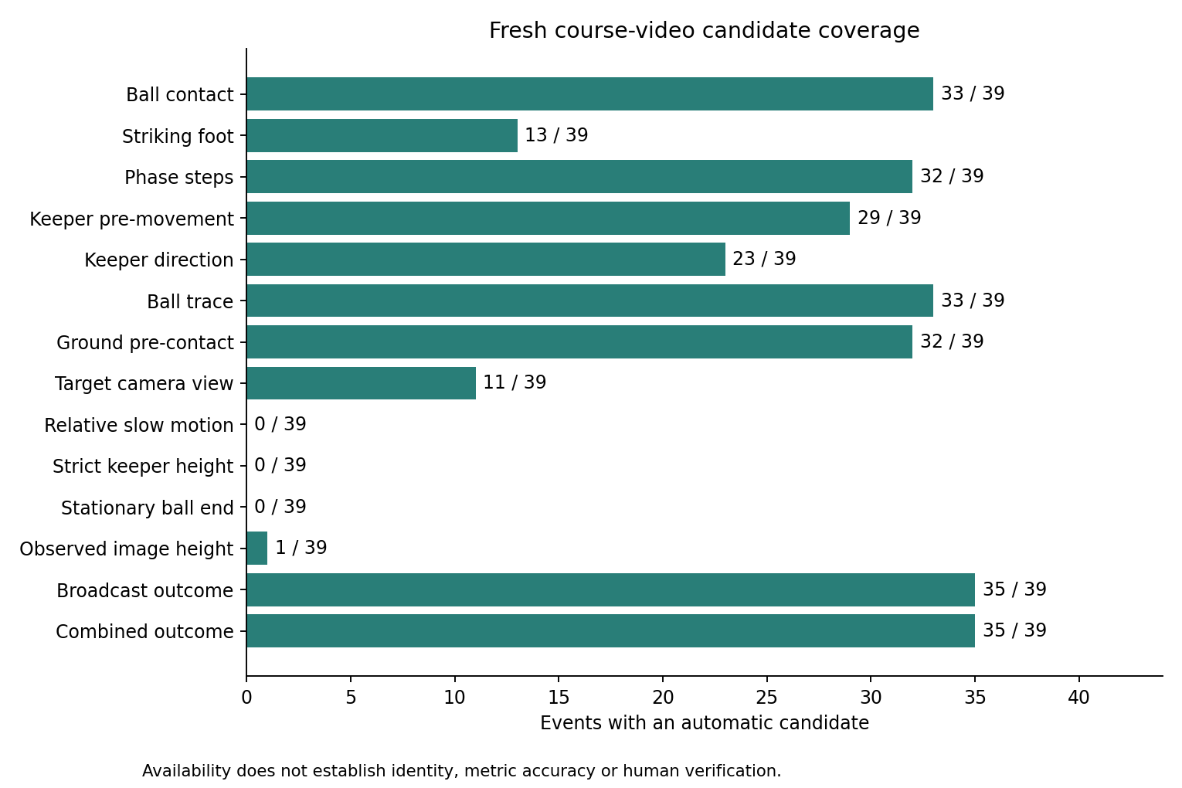
Figure 1. Fresh source-bound candidate availability across the 39 events.
The selected final joint-calibration output supports 521 of 609 sampled source frames, with 339 sparse sole candidates and 226 pre-contact ground candidates across 32 events. Seven events have no pre-contact ground candidate under the source checks. These are geometric support counts, not a continuous top-down trajectory or metric distance. A diagnostic overlay is retained for review; the original pixels and held-out line checks are hash-bound.
Figure 2 shows the relationship between baseline pose candidates and contact-bound phase candidates, together with the difference between the pose peak and the independent contact bracket. The method deliberately preserves unknowns when stationary departure, actor identity or camera support is absent.
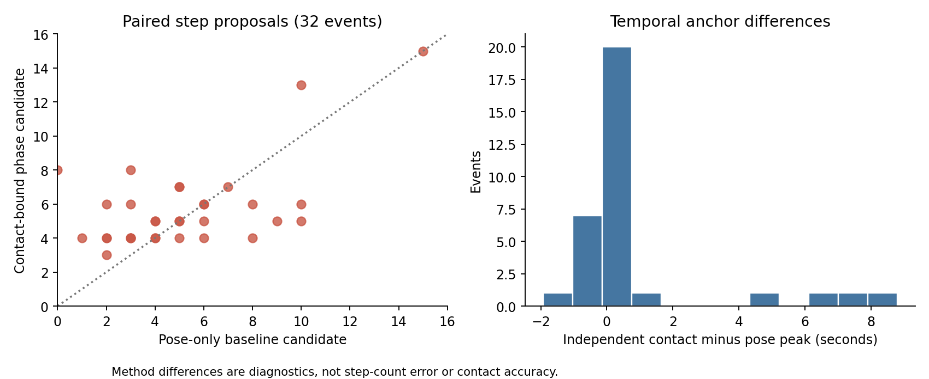
Figure 2. Contact-bound phase candidates and independent timing anchors.
The selected foot module reports thirteen candidates, nine right and four left, while 26 events remain unknown. Eight come from the earlier ankle-based V2 rule. Five previously unknown events gain a fallback from the new paired shoe-swing and shoe-region checks: Rashford, Dier, Spain-Russia Smolov and Vida are right candidates, while Pivaric is left. Both producers and the selection reason are retained. The stationary nearest-foot value remains diagnostic and cannot by itself choose the anatomical striking foot. This is increased development availability, not measured anatomical accuracy.
A reference-validity repair withdraws five former low-height categories whose fixed-depth reference had failed. One conditional low image-plane signal remains for Brozovic, with 38 unknowns. The underlying measured values are retained, while all strict complete-dive ordinal candidates and physical-metre estimates remain unknown.
The continuous-shoe experiment revisits the same original recordings. Thirty-two attempts have supported approach intervals; fresh normal/mirror inference processes 2,121 source frames through 4,242 model calls. Seven events contain twelve stance-transition proposals, twenty processed windows contain no accepted proposal, five abstain on temporal anatomical-channel ambiguity, and seven lack eligible inputs. Figure 5 compares these proposals with the previous ankle extrema. Rashford changes from fifteen extrema to three proposals, and Pivaric from thirteen to three. Both outputs remain unverified: every new stance support lasts only three shared frames, or 0.0667 seconds. A detected zero is not evidence that the player took zero steps.
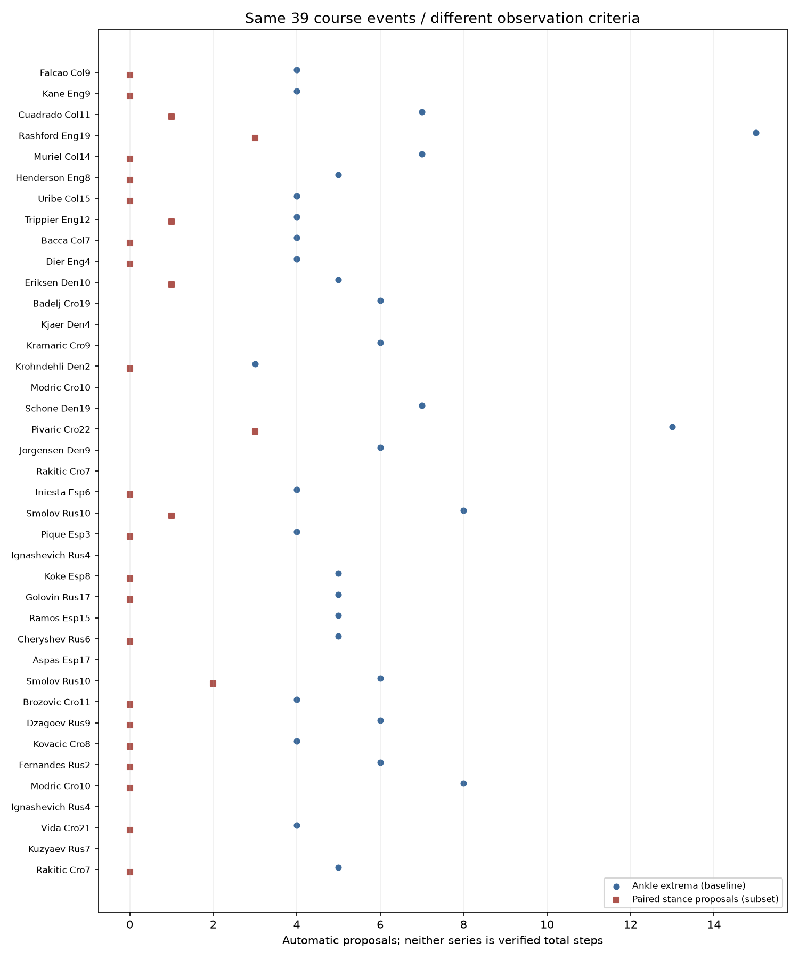
Figure 5. Ankle extrema and paired stance-transition proposals on the same original course events; neither series measures verified total steps.
Figure 3 compares the frozen ball rule, a source-only broadcast-scoreboard rule and their conflict-abstaining combination with the audited named-event reference. The ball geometry rule decides ten events after its keeper-occlusion guard. The scoreboard parser supplies 35 icon candidates and abstains on four final attempts. The combined source rule decides 35 events because the scoreboard and ball evidence agree where both are available or the scoreboard is the only bounded source witness.
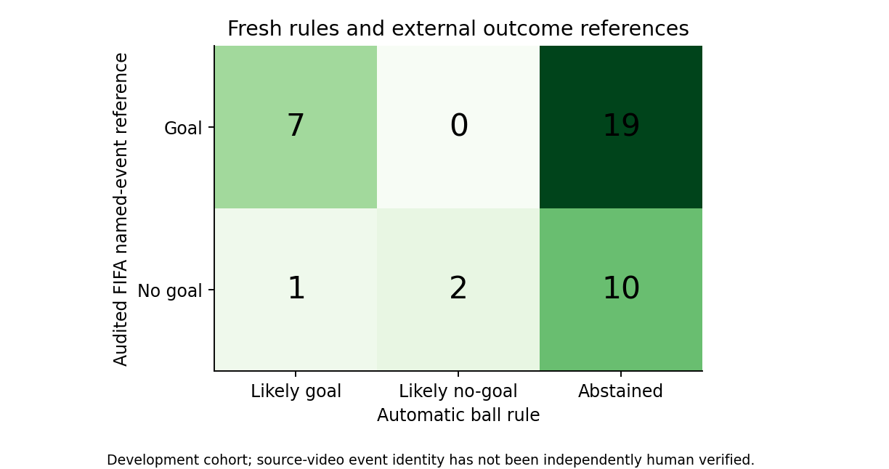
Figure 3. Frozen ball, broadcast icon and conflict-abstaining outcome evidence.
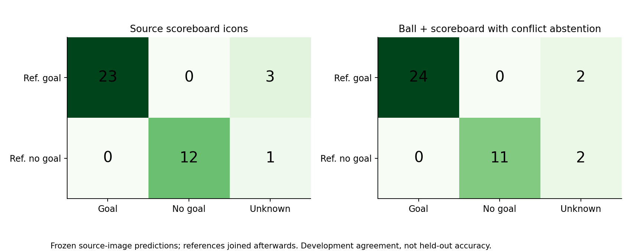
Figure 4. Broadcast and combined source outcome matrices.
The scoreboard result is an ordinal broadcast-icon candidate, not proof that the tracked ball crossed the goal plane or that the event ended at the last visible observation. Against the audited external named-event references, the 35 decided scoreboard candidates agree 35 out of 35. This is development agreement on a cohort inspected during method development, not held-out accuracy or independent human video ground truth.

4. Research Questions and Findings
The first question asks how much of each requested feature is observable from the four broadcast shootouts. The answer is heterogeneous. Source-bound contact exists for 33 of 39 events, yet strict endpoint verification is zero and camera playback classification is zero. The missingness is informative: replays lose lower-body or role continuity, goal-line occlusion hides the ball, and a context clip can end before play ends. Treating every missing output as a negative football behavior would be a measurement error.
The second question asks whether independent contact timing changes run-up and step candidates. The phase module produces 32 contact-bound step candidates; its sensitive, central and strict windows are retained for each event. The median range and event-level differences are descriptive sensitivity evidence. They do not establish true landing precision or a step-count error because no untouched landing annotations exist and one broadcast approach is explicitly incomplete. The appropriate conclusion is that contact and phase definitions materially affect candidate counts and should be shown in the report.
Continuous heel/toe evidence further shows that threshold stability within one ankle rule does not imply agreement with a different event definition. The new proposals require a swing followed by low image motion, paired model agreement, body progression and supported camera transforms. Brief low motion can also occur during airborne reversal, as remains ambiguous in Rashford frame 275 and Pivaric frames 245 and 310. Independent video annotation is needed before comparing count error or interpreting steps as football behavior.
The third question asks whether source-only outcome evidence can reduce outcome abstention. A ball trajectory rule remains conservative after the keeper-body occlusion guard: it decides ten events. The independent scoreboard parser identifies stable, repeated red or green penalty icons for 35 events in original full-video frames and uses neither numbers nor FIFA labels. Combining these evidence sources decides 35 events, with four unresolved final attempts. This is a useful engineering result about observability, while the remaining endpoint and human-identity limits prevent a claim of scoring accuracy.
The outcome references come from a separately audited FIFA technical-report extraction, joined after all predictions. They are not used to select the model, actor, contact frame, scoreboard icon or trajectory. The cohort is not held out: source identity, references and diagnostic frames have been inspected during development. A future evaluation should reserve new uninspected attempts and review their actor, contact, endpoint and outcome definitions before any threshold choice.

5. New Techniques, Iteration, and Limitations
The first iteration used pose peaks, nearest-ankle proximity and legacy event boundaries. The fresh iteration exposed their failure modes. A pose peak is not necessarily a foot-ball contact, the nearest ankle can be the planted support foot, and a stationary last observation is not a final event position. The repaired analysis therefore requires a source-bound stationary-to-departure bracket, preserves the detector identity, and abstains when the actor or departure evidence fails.
The medium detector was tested as a controlled ablation against the nano detector. Nano supports 26 contacts and medium supports 29, with 22 events supported by both, seven medium-only events, four nano-only events and six shared abstentions. Their outcome branches differ substantially, including a Muriel source-frame disagreement; the selection protocol does not resolve that disagreement with the external score. This comparison is evidence about model sensitivity, not proof that the larger model is universally better.
The joint pitch calibration fits small-area and goal-line geometry and checks held-out penalty-area sides and goal-width corners. It improves geometric support counts while retaining cases with ambiguous line families. The goalkeeper height work adds a SAM2 temporal mask pilot. It rejects a mask when the body is truncated, a ball is absorbed, or identity continuity fails. The resulting observed image-plane signal is labelled conditional and censored; no physical height is invented.
The scoreboard method searches the original full recording from each event's slice end to the next canonical slice start, or to source end for the final attempt. It detects repeated five-circle icon geometry and state transitions, requires a stable ordinal-compatible panel and stores source-frame pixel hashes. It does not read the displayed numeric score. This is a new source-image witness and remains separate from tracked-ball crossing and event-final position.
The camera-v2 repair reuses high-resolution source-bound live tracks from the fresh pose result when the actor, shot and contact identity match, while cross-shot queries still require their own fresh analysis. This raises the live reference continuity from 13 to 33 kicker clips and from 2 to 28 keeper clips under the fixed ten-sample guard. It changes view candidates modestly, from two to three back-of-kicker and two to eight 45-degree-right candidates, while playback remains unknown for all 320 intervals. Of these intervals, 301 do not enter action alignment and 19 enter without sufficient role-specific alignment support. Identity and spatial-view failures therefore also limit playback classification.
A 13 October strike-window experiment ends the foot-motion vote at the first observed departure instead of including support-leg recoil for a further 0.20 seconds. Replaying all 39 paired source-pose caches gives three right-channel hypotheses for Trippier, Dier and Spain-Russia Smolov, previously unknown in V2. However, it abstains on all eight previous V2 candidates. The change identifies a failure mechanism but does not improve total coverage or establish accuracy. Normal, inverse-mirror and paired views must agree; Kane and Rashford still fail that check. The new hypotheses and their source-frame sheets remain outside the main feature table.
The subsequent 33-landmark experiment runs new neural inference in 33 contact-supported events, with 1,404 normal/mirror calls; six events lack an independent contact and abstain. Two independent VIDEO trackers use a fixed union ROI within the event's shot. Original same-frame actor anchors and rival boxes guard the predicted body, out-of-crop shoe points are missing, and source decoder clocks are checked. Leg-motion confidence remains 0.4; torso identity and paired near-shoe support require 0.5. The unchanged swing rule gives six candidates; requiring a same-frame paired heel-to-foot-index segment near the last observed stationary-ball position retains five. The sixth, Ramos, lacks that paired regional support. The five become fallbacks only where V2 is unknown; a decided-method disagreement would abstain. Kane remains unknown. Dier's supporting regional frame is already post-departure, so it must not be presented as observed physical foot-ball contact. Source-frame boards and code, model, contact, pose and producer hashes are retained. The cohort and pilots informed development; none is held out.
A new neural pilot applies fixed goalkeeper/goal crops with 0, 90 and 270 degree pose views to Kane, Rashford and Cuadrado. The baseline and ROI treatment share contact and newly estimated camera evidence. Same-frame person geometry must match an original track; refined detections retain that track's identity and exclusions. Crop-edge detections are rejected. Kane gains a usable preparation body reference, but its landing remains unobserved; none of the three gains a complete-dive or observed-height category. This distinguishes an intermediate measurement repair from a completed requested feature.
The subsequent continuous-shoe run extends the same two VIDEO trackers to the visible approach, stopping landing analysis at the final actual stationary-ball frame. It adds no video and reads no reference label. Camera chains, pose gaps, identity guards and exact repeated-pixel hashes control support. The dense strike rule supplies five foot candidates, four agreeing with the previous table and one new right candidate for Dzagoev. Rashford's previous right candidate is not reproduced. The region check uses median actor height across the approach, rather than the earlier short preparation scale, so it is not a fully identical treatment. Dzagoev has paired shoe-region support only at frame 262, between stationary frame 261 and departure frame 263. Rechecking restored points and exact source pixels supports retaining a hypothesis, not claiming observed physical contact or higher accuracy.
Prediction hashes are frozen before producing a blank 39-event human reference template. A separate blind viewer shows original video without predicted counts, foot labels, selected candidate frames or overlays. At release all rows remain pending. The evaluator requires matching observable intervals and one-to-one event matches; independent reviewer disagreement is retained. Precision, recall, agreement and step-count error remain null until genuine reviews are supplied. These videos have already informed development, so later agreement is still not held-out performance.
A foot-only supplement independently redecodes every eligible source interval, reconstructs mirrored coordinates and duplicate flags, checks exact original actor/rival anchors and contact/camera bindings, then recomputes the dense rule. Applying the earlier agreement/conflict/unknown selector retains the thirteen existing candidates and adds Dzagoev: fourteen of thirty-nine, comprising ten right and four left, with no decided-method conflicts. Each event binds both producer artifacts and the selection protocol. The frozen main bundle and all step counts remain unchanged; this modest availability gain needs independent anatomical review.
The alternate FIFA-source pilot processes three 1080p clips using fresh pose, object and paired-foot inference. Under the same input pose, image size and contact settings, medium detects contact candidates in Falcao and Kane, while nano detects Falcao only; both abstain on Cuadrado. Falcao's source-clock candidate is 54.58 seconds with a 54.54-54.62 bracket, and Kane's is 98.30 seconds with a 98.26-98.34 bracket. The 17-point foot rule abstains on all three. The guarded shoe model gives a right swing hypothesis in the HD Kane pilot but fails paired regional support. Higher resolution therefore does not remove all temporal and occlusion failures. A stale contact-time field was found in the original pilot outputs after frame rebracketing; the comparison derives time directly from final frames and FPS, and the producer has been repaired for future runs. Frozen outputs preserve the discrepancy rather than silently changing the experiment record.
The main feature table likewise derives clip and original-source seconds from final candidate frames and source FPS. A separate timing audit retains each producer's stored value and whether it matches the final frame, while bound input artifacts remain unchanged. This prevents an early ankle-proximity timestamp from being presented as the revised contact candidate.
The main limitations are observable in the bundle. No human reviewer has independently verified all 39 actor identities, foot labels, landing events, camera classes or outcome endpoints. The source clip is a context interval, not a guaranteed semantic play-end boundary. Image-left and image-right are source-image conventions. Sparse ground points are not a continuous bird's-eye path. A scoreboard icon is not a goal-plane crossing. The automatic agreement numbers are development diagnostics. These limits define the next review work rather than being hidden by a complete-looking table.

6. Code Structure and Reproducibility
Reusable components live in src/. Experiment entry points live in scripts/, and tests cover source binding, stale producer rejection, coordinate contracts, camera chains, model ablation, endpoint censoring, mask identity, scoreboard parsing and outcome conflict abstention. Additional regression tests reject invalid height categories and prevent ROI aliases from bypassing original-person exclusions. Passing tests establish implementation contracts, not video accuracy.
The 39-event bundle is built with scripts/build_fresh_results.py, verified and graphed with src/fresh_eda.py, and reviewed with the offline scripts/build_fresh_review.py viewer. The viewer lets a reviewer select an event, inspect source-image detector evidence, inspect sparse ground projections and read the component record. Video playback additionally requires including the corresponding context clips; the committed viewer contains images and records only. The bundle manifest and review manifest record every copied artifact hash. Raw videos remain outside the Git working tree; the current source copies are stored in a draft release.
Neural extraction and saved-result analysis have separate dependency files. The original extraction environment is listed in requirements-cuda.txt, continuous MediaPipe inference in requirements-pose33.txt, and CPU EDA in requirements-analysis.txt. The continuous model ran on CPU without training. A teaching-team reproduction package should include ordinary source files, documented model retrieval and permitted course data. The public repository supports saved-result EDA and image review, while raw-video extraction and blind video review require the original footage.
The report and demonstration must be reviewed by the students. The final video should use a real source clip, show the source-to-frame clock, actor/contact evidence, one candidate row and one abstention, and use a student's natural human narration without speed-up or AI voice. The group must check every line of code and every statement, describe AI assistance and genuine contributions, and complete the official submission and peer-evaluation process separately from this development repository.

