https://www.bugsnag.com/

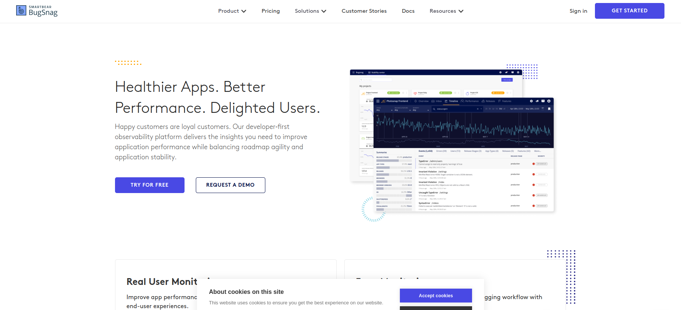

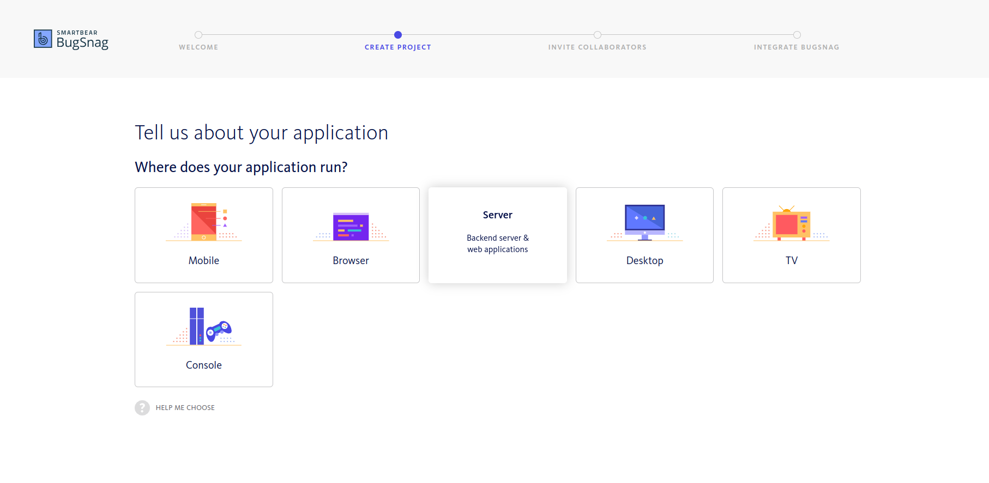

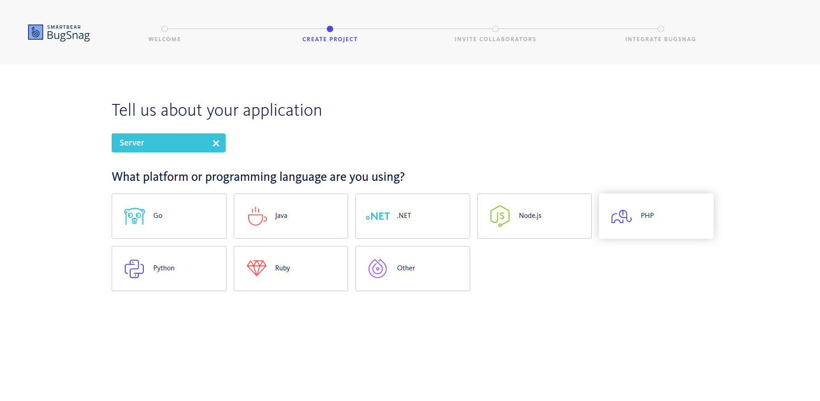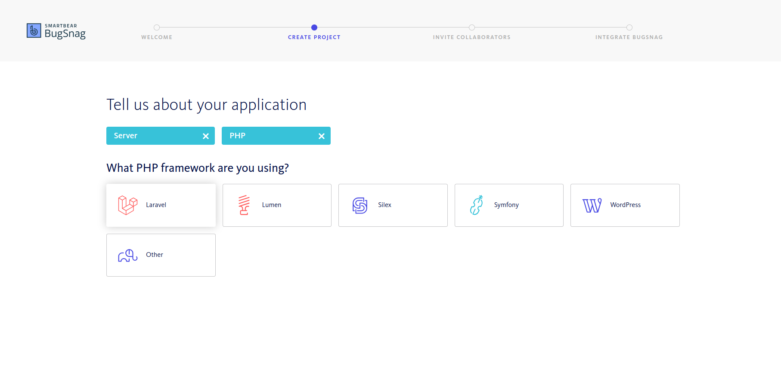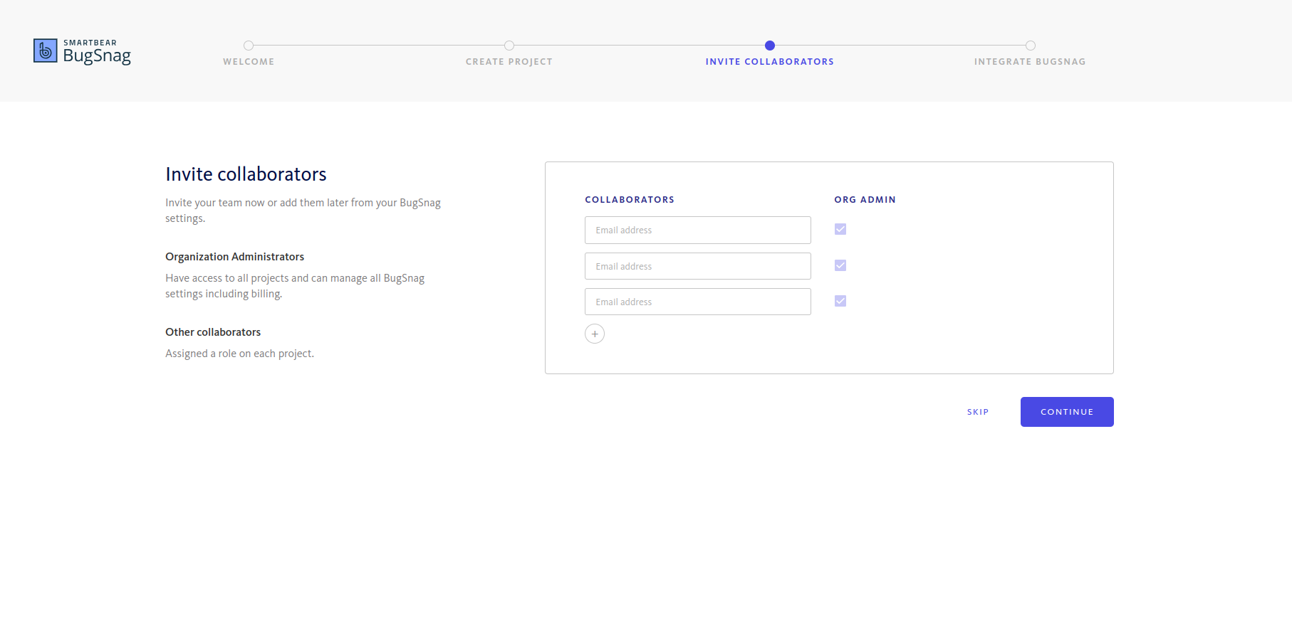

Steps to add BugSnag to Laravel:

https://docs.bugsnag.com/platforms/php/laravel/

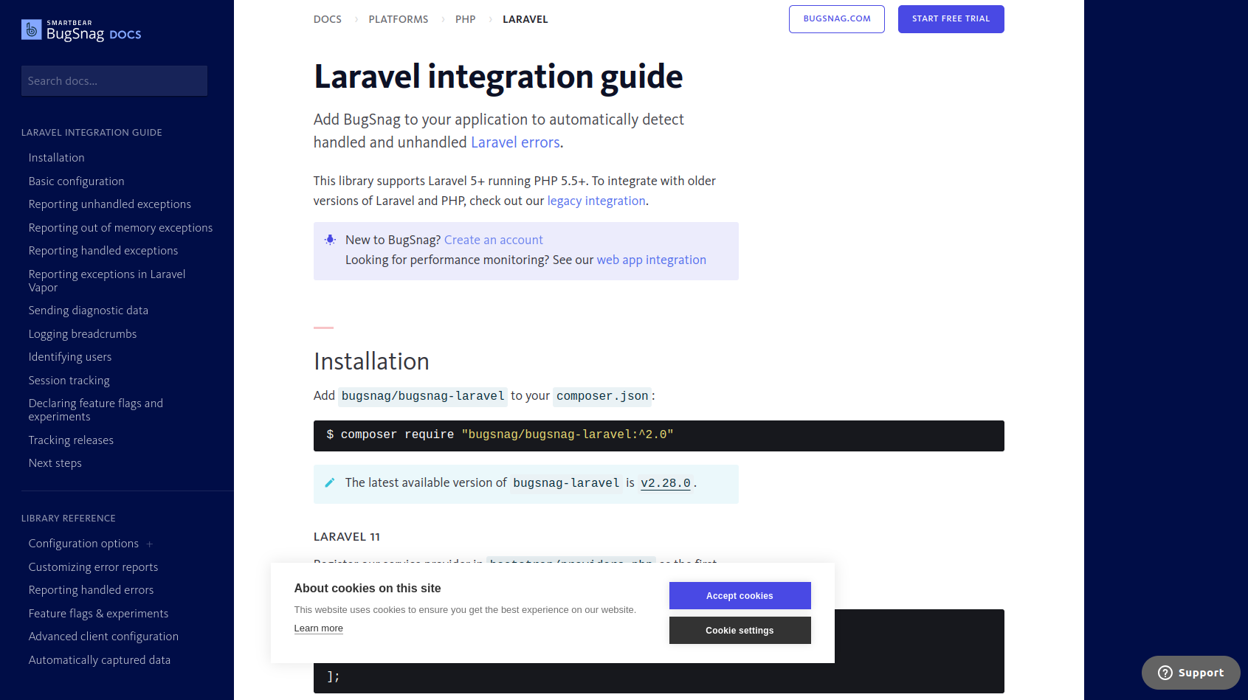

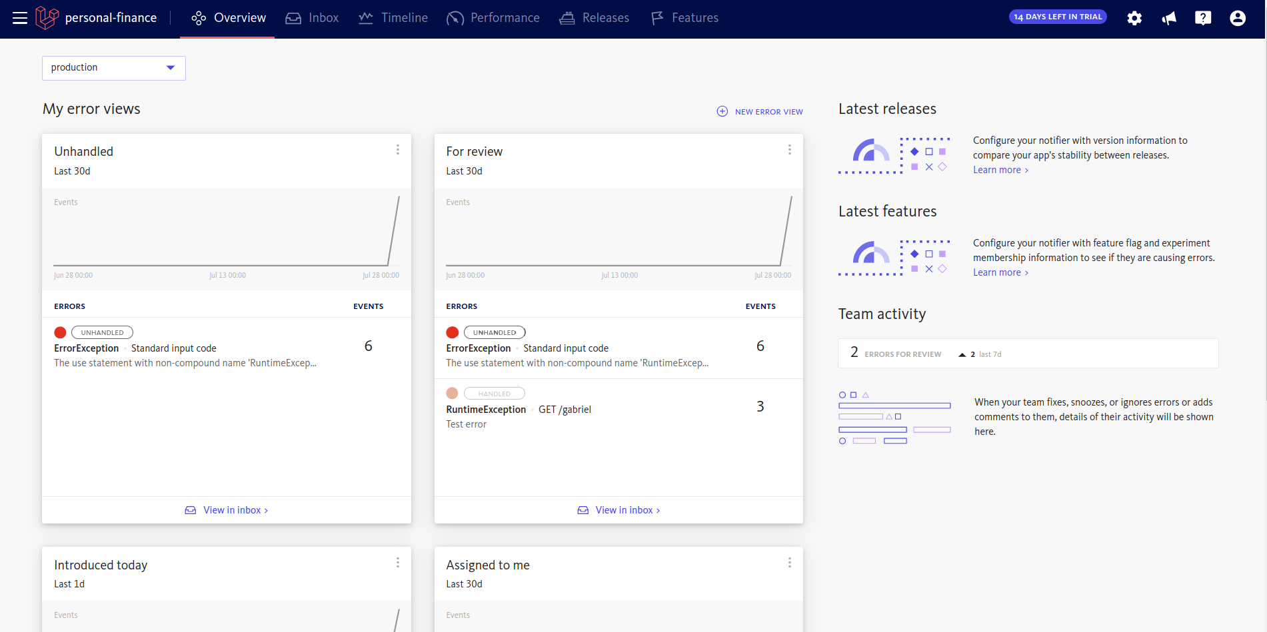

use Bugsnag\BugsnagLaravel\Facades\Bugsnag;

Bugsnag::notifyError('ErrorType', 'Mensaje de error');

try {

throw new Exception("TEST-FINAL");

} catch (Exception $exception) {

Bugsnag::notifyException($exception, function ($report) use ($user) {

$report->setUser([

'id' => $user->id,

'name' => $user->name,

'email' => $user->email

]);

$report->addMetaData([

'order' => [

'id' => "AA-CC-11",

'amount' => 1250,

'status' => 'Pending'

]

]);

});

}

