https://gtmetrix.com/

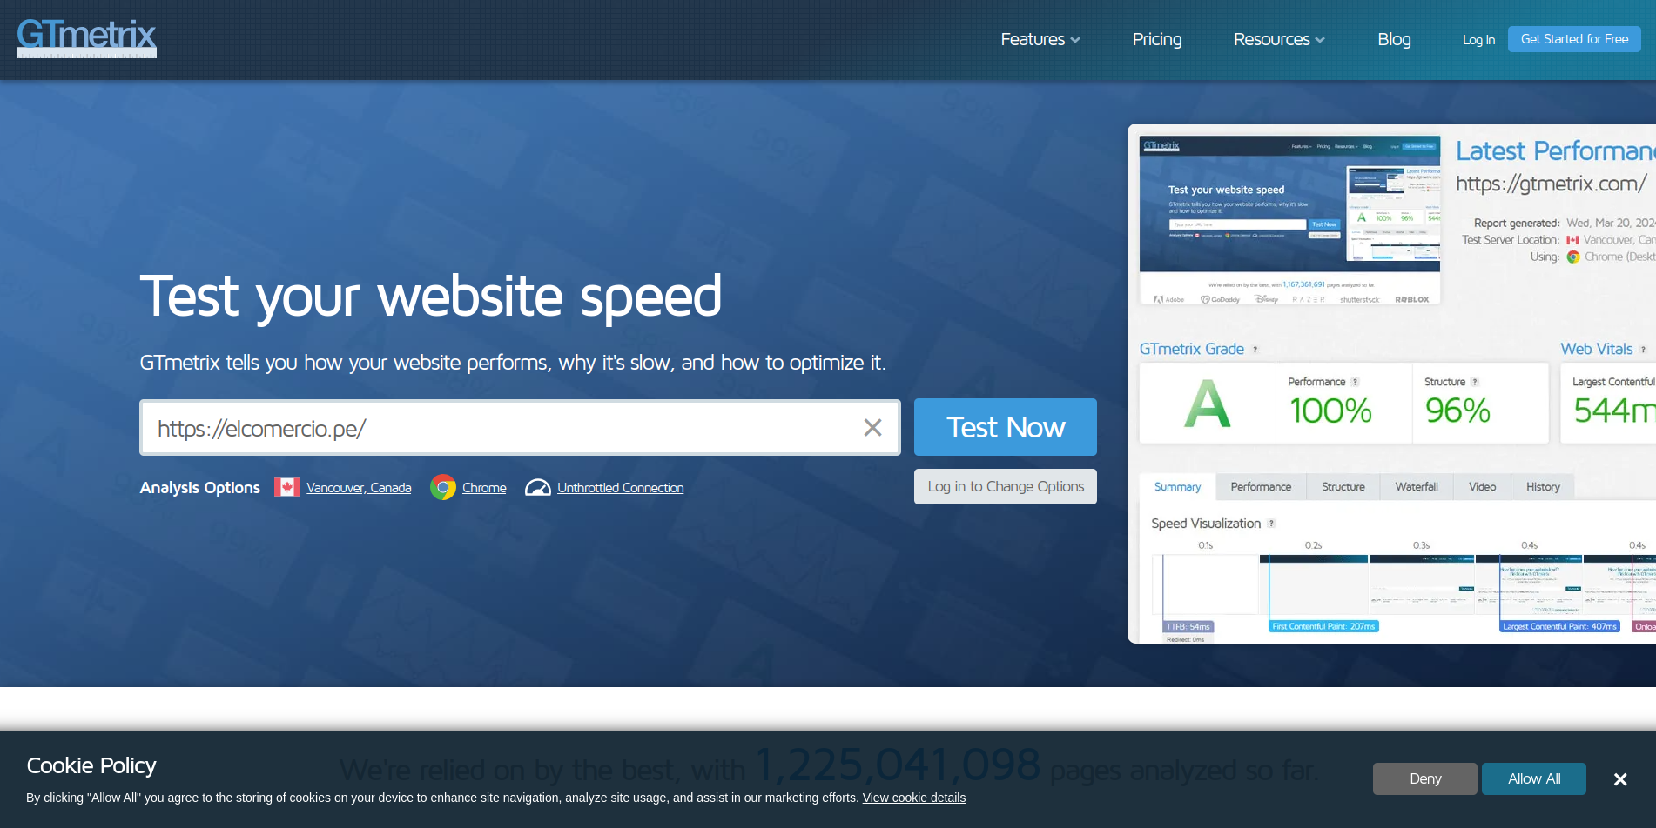

Example with: <https://elcomercio.pe/?ref=ecr>have a very poor result “D”, where the best is “A”

