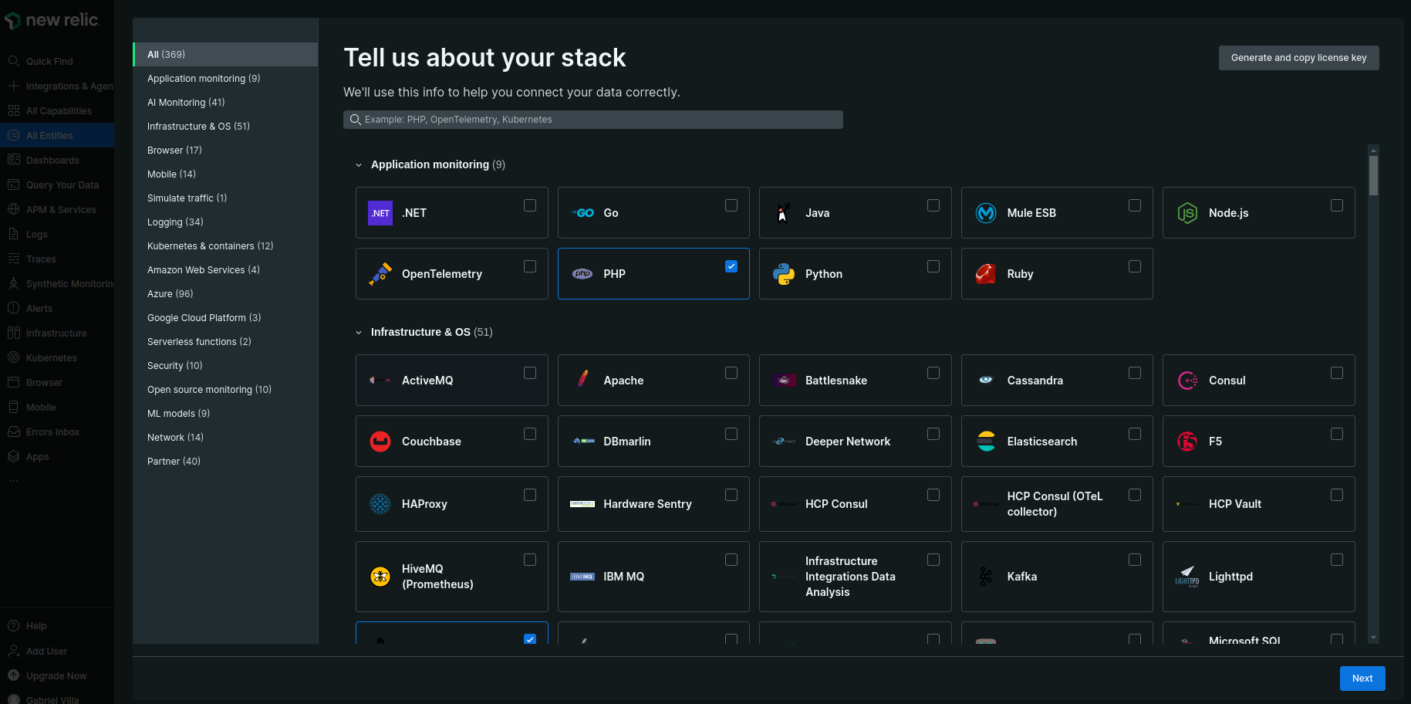Select the stack

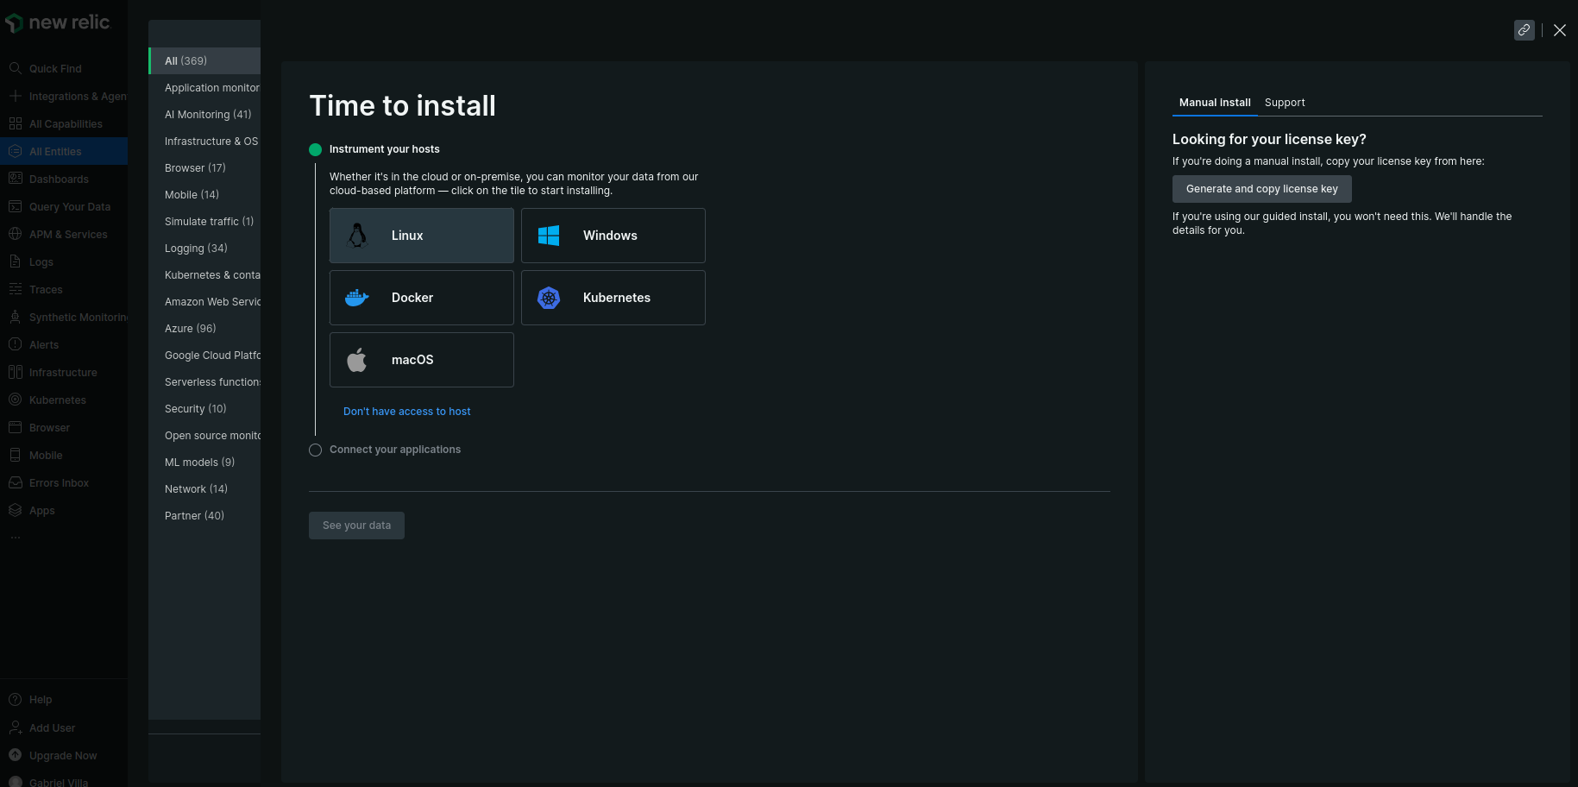

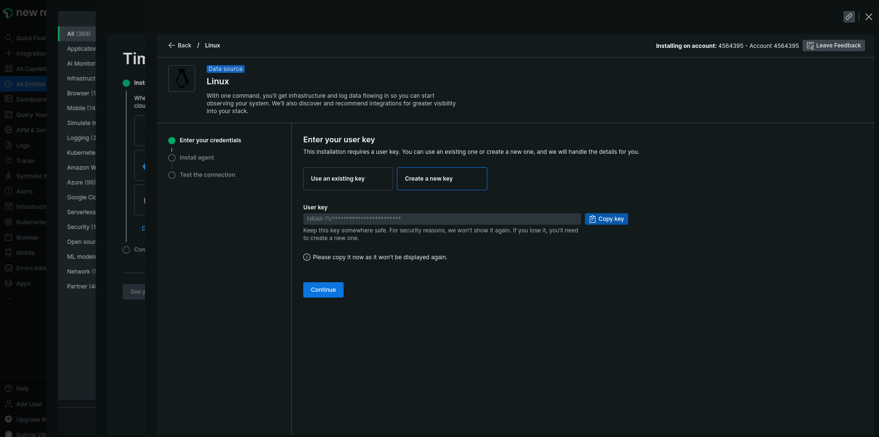

Create of use a existing key

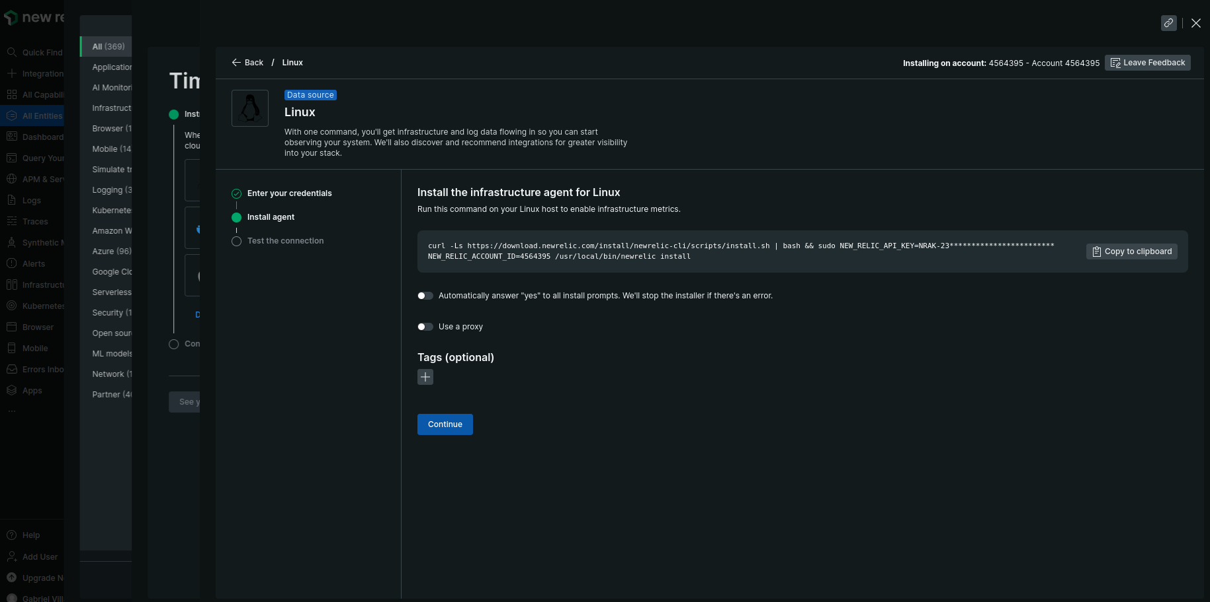Install newrelic in the machine:

curl -Ls https://download.newrelic.com/install/newrelic-cli/scripts/install.sh | bash && sudo NEW_RELIC_API_KEY=XXX NEW_RELIC_ACCOUNT_ID=XXXX /usr/local/bin/newrelic install

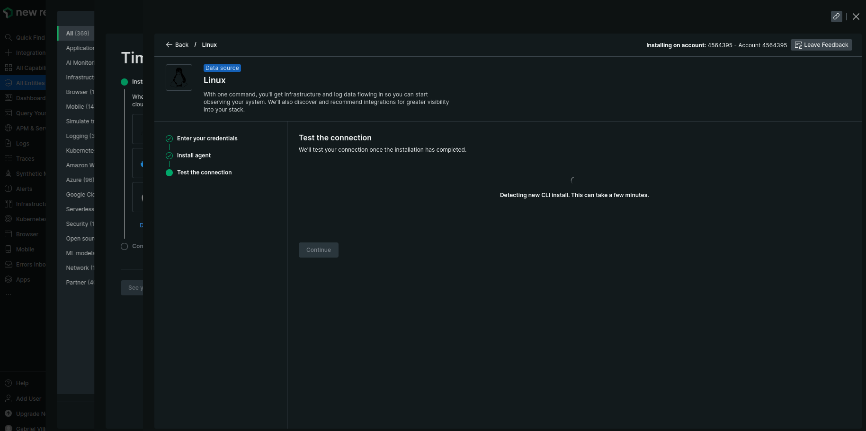

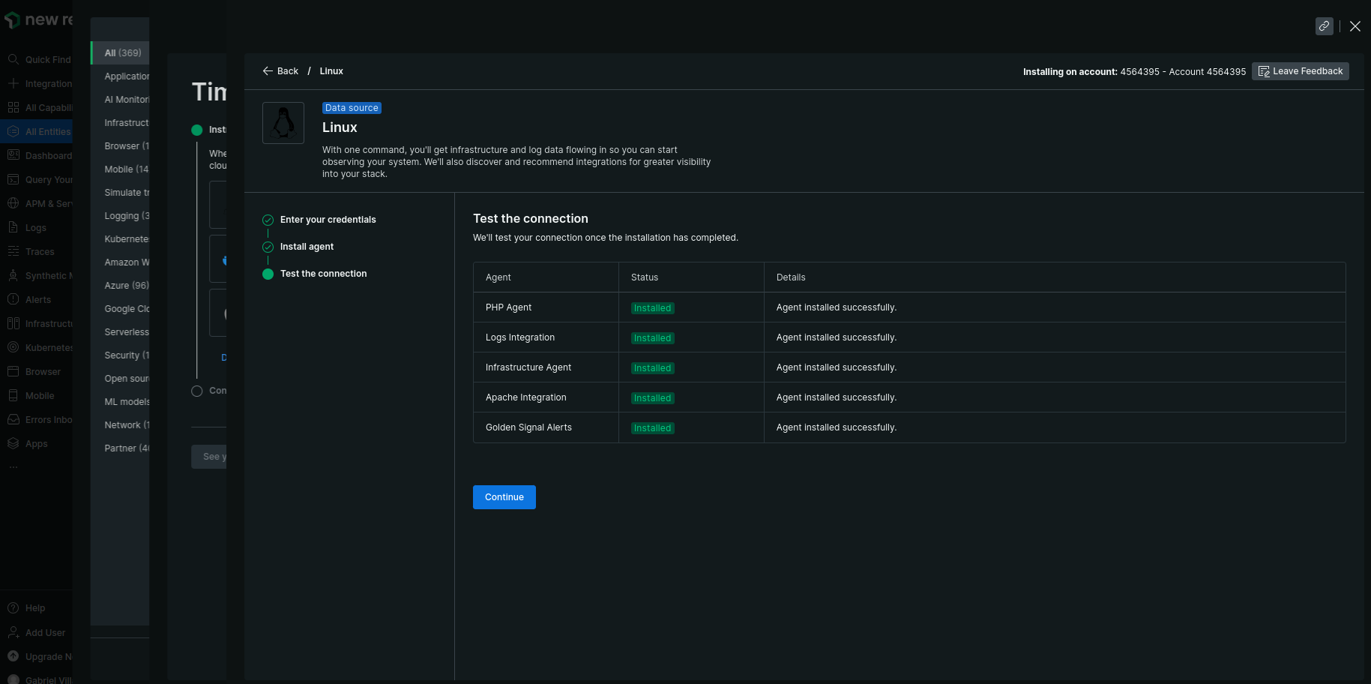

Installation end

