# SkillLink – Growth, Scalability, and Competitive Advantage

## 1. Growth Strategy

Phase 1: Local MVP Launch  
- Target market: Port Harcourt, Nigeria  
- 1,000+ service providers in plumbing, electrical, beauty, transport, cleaning  
- In-app wallet, job completion system, and trust features  
  
Phase 2: City Expansion + Partnerships  
- Expand to 5 major Nigerian cities: Lagos, Abuja, Enugu, Ibadan, Kano  
- Partner with training centers, churches, youth groups  
- Launch SkillLink mobile app  
  
Phase 3: Regional Expansion  
- Expand to Ghana, Kenya, South Africa (Year 2)  
- Add localization and introduce SkillLink Pro (verified providers)  
  
Revenue Streams:  
- 5–10% commission per job  
- Featured provider ads  
- Wallet transaction fees  
- Business accounts

## 2. Market Opportunity

- The informal service economy in Sub-Saharan Africa is valued at over $330 billion.  
- Nigeria alone has over 70M informal workers (source: NBS, ILO)  
- Smartphone penetration >50% and growing  
- Over $1B raised globally by gig startups — Africa is underinvested

## 3. Competitive Advantage

SkillLink offers multiple features that competitors lack, giving it a unique position in the market.

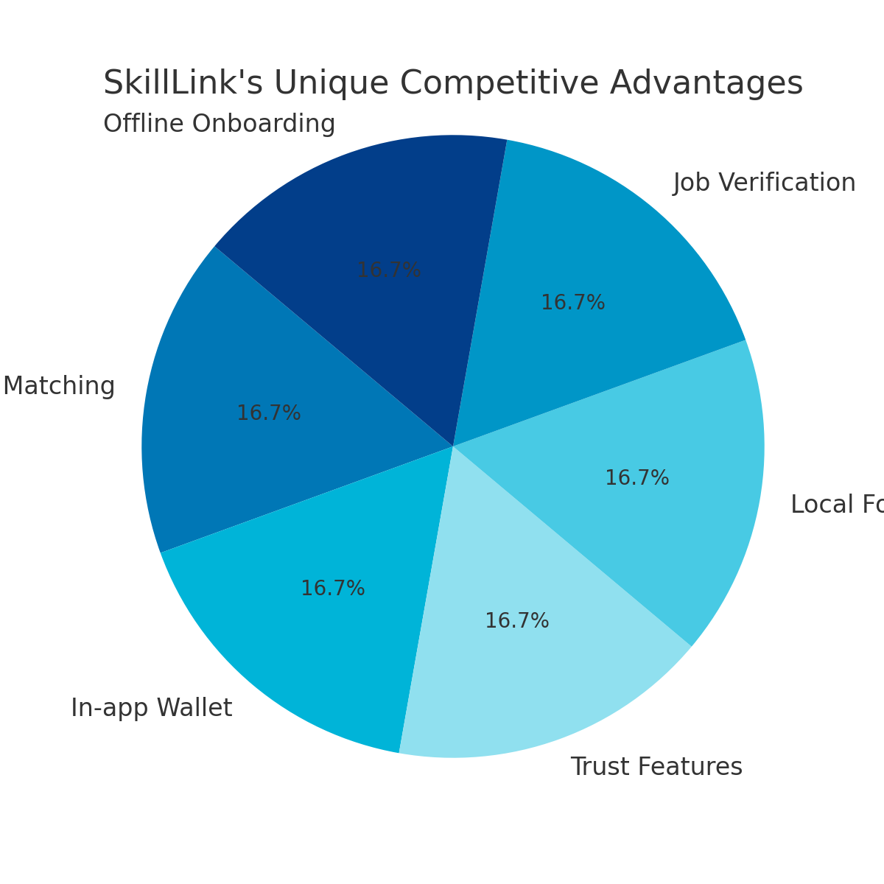

## 4. Traction & Roadmap

Current Stage:  
- UI/UX complete  
- Investor and grant applications ongoing  
- Early signups and market surveys  
  
Next 6 Months (Q3–Q4 2025):  
- MVP launch in Port Harcourt  
- Onboard 100+ providers  
- Reach first 1,000 users  
  
Next 12 Months (2026):  
- Expand to 3+ cities  
- Reach 10,000 users  
- Secure pre-seed investment