
RAGTree
BYOS Semantic RAG Architecture and Installable Library Design
A layered, protocol-oriented design for a pip-installable framework with optional integrations

Document objective
This document expands the RAGTree design into a complete bring-your-own-stack architecture. It focuses on a pip-installable package, optional extras, protocol boundaries between layers, separated integration adapters, a dedicated test architecture, application surfaces such as FastAPI and Streamlit, graph integration through Neo4j, and a migration path that preserves the existing experiments.

Field | Decision
Project identity | RAGTree as a bring-your-own-stack Semantic RAG framework.
Main technical promise | Users can install a lightweight core and add only the integrations they need.
Architecture style | Layered package with stable protocols and replaceable adapters.
Packaging goal | pip-installable with optional extras such as dev, docs, litellm, chroma, qdrant, neo4j, api, streamlit, langgraph and all.
Compatibility goal | Current benchmark scripts and datasets remain supported through wrappers, examples and regression tests.

Table of contents
1. Executive summary
2. Product identity and scope
3. Bring-your-own-stack principle
4. Layered architecture
5. Repository structure with src layout
6. Core schemas and protocols
7. Adapter architecture and optional integrations
8. Application surfaces: CLI, FastAPI and Streamlit
9. Installation model and optional extras
10. Testing architecture
11. Current experiment preservation
12. Docker and deployment profile
13. CI, quality gates and release discipline
14. Migration roadmap
15. Implementation backlog
16. README positioning block and interview narrative
17. Appendix: code skeletons

1. Executive summary
RAGTree should be designed and presented as a bring-your-own-stack Semantic RAG framework. The core package must remain small, typed, testable and installable. Optional integrations should add concrete capabilities such as LLM providers, vector stores, graph stores, ontology tooling, web APIs, UI demos, notebooks and deployment profiles.
The important architectural correction is that integrations are not the same thing as tests. The source package contains adapter implementations under src/ragtree/integrations. The test suite contains unit, contract, integration, end-to-end and regression tests under tests/. This separation makes the library easier to install, easier to validate and easier to extend.
- The core defines protocols and stable schemas.
- Adapters implement protocols for external systems such as Neo4j, Chroma, Qdrant, LiteLLM, Ollama, FastAPI and Streamlit.
- Applications consume the core through CLI, Python API, FastAPI services, Streamlit apps and notebooks.
- Experiments remain available and are gradually wrapped by clean APIs and CLI commands.
- Tests validate the core independently from optional stacks, then validate selected integrations when extras are installed.
Main design rule
RAGTree core must not import Chroma, Qdrant, Neo4j, FastAPI, Streamlit, LangGraph, LiteLLM or Ollama directly. The core defines interfaces. Integrations implement them. Tests verify both the interfaces and the implementations.

2. Product identity and scope
RAGTree should not be reduced to relation extraction, even though relation extraction is currently the strongest implemented benchmark task. The project should be positioned as a Semantic RAG framework whose first mature benchmark layer is document-level relation extraction and whose architecture can support multiple RAG tasks.
Dimension | Design decision
One-line definition | RAGTree is a bring-your-own-stack framework for building, evaluating and integrating Semantic RAG pipelines over complex documents.
What the core owns | Schemas, protocols, configuration, task model, pipeline lifecycle, run metadata and evaluation structures.
What adapters own | Concrete bindings to LLM providers, vector stores, graph stores, ontology engines, agent frameworks, APIs and UI tools.
What experiments own | Research scripts, benchmark logic, dataset-specific workflows and reproducibility artifacts.
What apps own | User-facing surfaces such as CLI commands, FastAPI endpoints, Streamlit demos and notebooks.

2.1 RAGTree should support more than relation extraction
Task family | Purpose | Output
Question answering | Answer questions over documents with retrieved evidence. | Answer, citations, evidence spans, optional confidence.
Relation extraction | Extract typed relations or causal links from documents. | Relations, entities, labels, evidence, document provenance.
Claim verification | Assess whether documents support, refute or do not contain enough information for a claim. | Decision label, evidence, rationale, confidence.
Summarization | Generate faithful summaries over one document or a retrieved document set. | Summary, coverage metadata, cited evidence.
Ontology linking | Map mentions or entities to ontology concepts. | Concept candidates, scores, aliases, ontology provenance.
Graph construction | Build graph-ready nodes and edges from text. | Nodes, edges, labels, evidence, graph export artifacts.
Evidence selection | Rank passages or chunks for a specific task request. | Ranked evidence list with score and provenance.

3. Bring-your-own-stack principle
The central product principle is BYOS: bring your own stack. A user should be able to choose the LLM provider, embedding backend, vector database, graph database, ontology resources, retriever, evaluator, exporter, API surface and UI surface without changing the core pipeline.

3.1 What BYOS means in practice
Replaceable component | Examples | Core dependency?
LLM provider | LiteLLM, Ollama, OpenAI-compatible APIs, vLLM gateways | No. Implement LLMProvider.
Embedder | LiteLLM embeddings, sentence-transformers, OpenAI-compatible embeddings | No. Implement Embedder.
Vector store | In-memory, Chroma, Qdrant, FAISS, pgvector | No. Implement VectorStore.
Graph store | Neo4j, local graph store, exported CSV graph | No. Implement GraphStore or Exporter.
Ontology store | RDFLib, OWLReady2, local TTL/OWL loaders | No. Implement OntologyStore.
Retriever | Dense, sparse, hybrid, ontology-guided, KG-guided, community-level | No. Implement Retriever.
Application surface | CLI, FastAPI, Streamlit, notebooks | No. Use core as a dependency.

Why this matters
Companies rarely adopt a research project by replacing their whole infrastructure. They integrate libraries that respect their existing stack. RAGTree should therefore be a framework that accepts external components instead of forcing one stack.

4. Layered architecture
The architecture should be explicit and layered. The src package should separate core contracts, task definitions, pipeline mechanics, adapter implementations, application surfaces and experiment compatibility. This keeps the code understandable and makes testing straightforward.
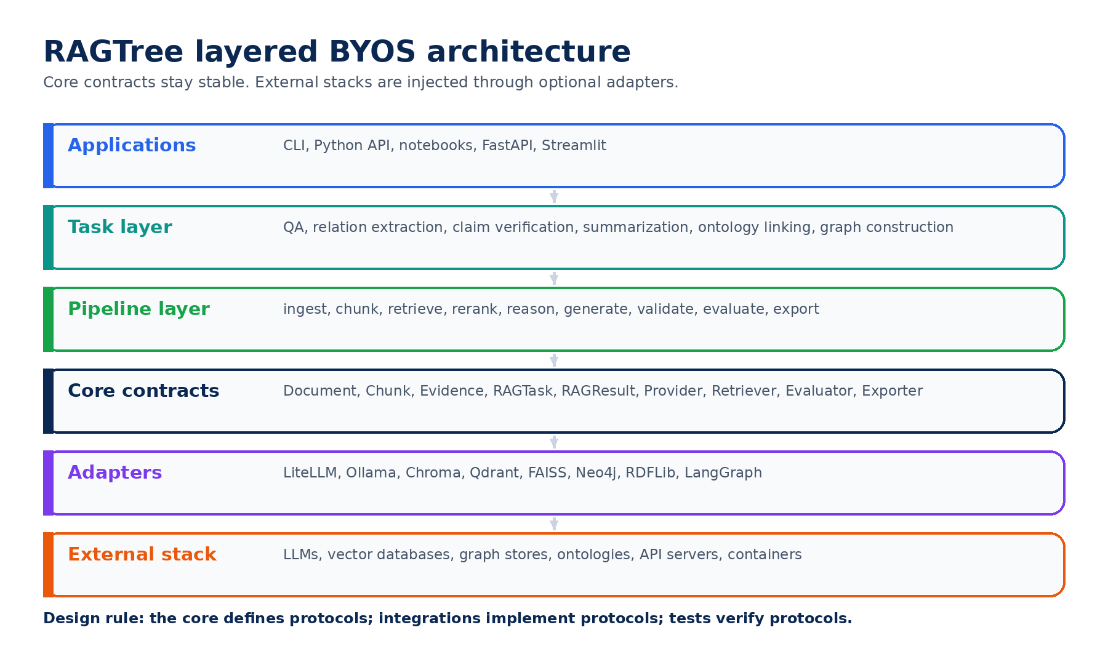
Figure 1. Layered BYOS architecture. The core is stable, integrations are replaceable and applications consume the framework through different surfaces.

4.1 Layer responsibilities
Layer | Responsibility | Should contain | Should not contain
Applications | Expose workflows to users. | CLI commands, API endpoints, Streamlit demo, notebooks. | Core business logic duplicated in app files.
Task layer | Represent user-level RAG tasks. | QuestionAnsweringTask, RelationExtractionTask, ClaimVerificationTask. | Provider-specific code.
Pipeline layer | Run the lifecycle from inputs to outputs. | index, retrieve, generate, validate, evaluate, export. | Hardcoded dataset or provider assumptions.
Core contracts | Define stable schemas and interfaces. | Document, Chunk, Evidence, RAGResult, Protocol classes. | Imports from Neo4j, Chroma, FastAPI or Streamlit.
Adapters | Connect external tools to contracts. | LiteLLMProvider, ChromaVectorStore, Neo4jGraphStore. | Global side effects on import.
External stack | Real services and libraries. | Docker services, databases, LLM gateways. | Code that must be imported by the core.

5. Repository structure with src layout
RAGTree should migrate to a src layout. This is important for a pip-installable library because tests will import the installed package rather than accidentally importing files from the repository root.
RAGTree/
├── src/
│ └── ragtree/
│ ├── core/
│ │ ├── schemas.py
│ │ ├── protocols.py
│ │ ├── config.py
│ │ ├── pipeline.py
│ │ ├── registry.py
│ │ └── errors.py
│ ├── tasks/
│ │ ├── base.py
│ │ ├── question_answering.py
│ │ ├── relation_extraction.py
│ │ ├── claim_verification.py
│ │ ├── summarization.py
│ │ ├── ontology_linking.py
│ │ └── graph_construction.py
│ ├── retrieval/
│ │ ├── base.py
│ │ ├── dense.py
│ │ ├── hybrid.py
│ │ ├── ontology_guided.py
│ │ └── kg_guided.py
│ ├── generation/
│ │ ├── prompts.py
│ │ ├── structured_output.py
│ │ └── json_repair.py
│ ├── evaluation/
│ │ ├── metrics.py
│ │ ├── relation_metrics.py
│ │ ├── faithfulness.py
│ │ └── reports.py
│ ├── integrations/
│ │ ├── llms/
│ │ ├── vectorstores/
│ │ ├── graphstores/
│ │ ├── ontologies/
│ │ ├── agents/
│ │ └── exporters/
│ ├── apps/
│ │ ├── api/
│ │ └── streamlit/
│ └── cli/
├── tests/
│ ├── unit/
│ ├── contract/
│ ├── integration/
│ ├── e2e/
│ ├── regression/
│ └── fixtures/
├── examples/
├── experiments/
├── scripts/
├── docs/
├── pyproject.toml
├── Dockerfile
└── docker-compose.yml

5.1 Role of top-level folders
Folder | Purpose
src/ragtree | Installable package code. This is what users import.
tests | Automated test suite split by unit, contract, integration, e2e and regression levels.
examples | Small runnable examples with tiny data and minimal dependencies.
experiments | Research workflows, benchmark configs and wrappers around current scripts.
scripts | Transitional and operational entry points. Long term, most scripts should call package functions.
docs | Architecture, installation, API, examples, development and release documentation.
apps | If kept top-level instead of src/ragtree/apps, this contains optional app surfaces only.

6. Core schemas and protocols
The core should define small, stable contracts. These contracts should be simple enough that users can implement their own integrations in a few lines of code. A strong protocol layer is what makes BYOS credible.
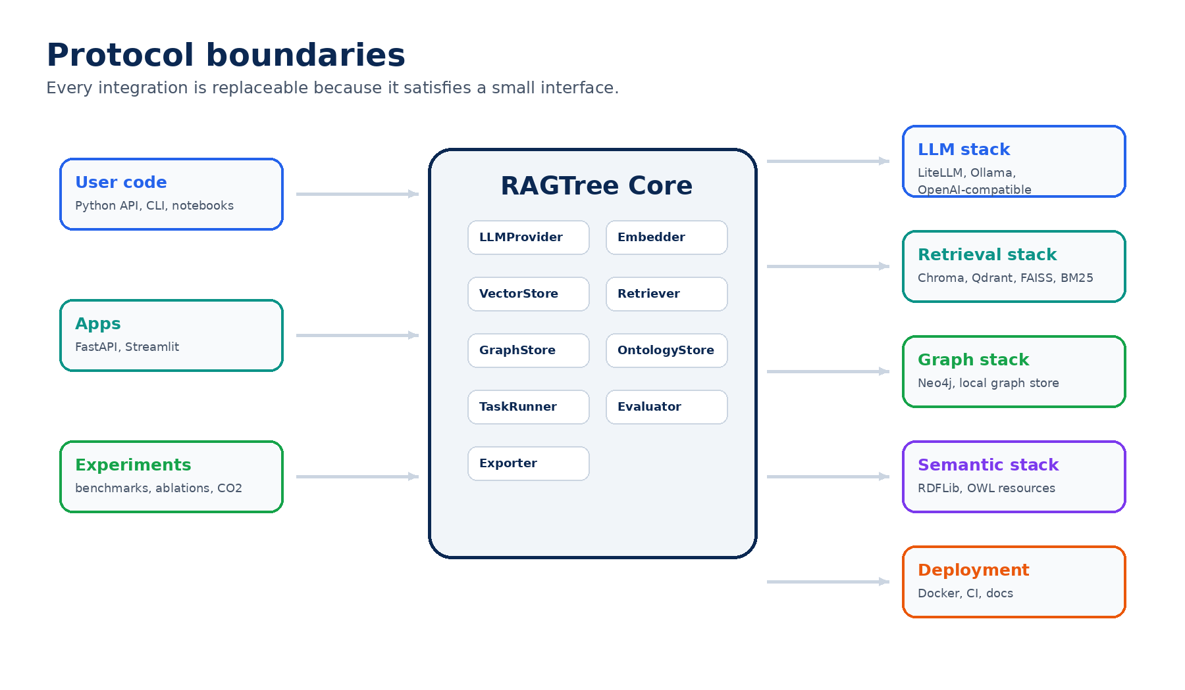
Figure 2. Protocol boundaries between core and external stacks.

6.1 Core schemas
Schema | Purpose | Minimum fields
Document | Original input unit. | id, text, title, source, metadata
Chunk | Indexed content unit. | id, document_id, text, index, metadata
EvidenceSpan | Grounding information for an output. | document_id, chunk_id, text, score, span, metadata
RAGTask | Abstract task request. | task_type, query, schema, constraints, metadata
RAGResult | Generic output object. | task_type, output, evidence, artifacts, metrics, metadata
RelationPrediction | Relation extraction output. | document_id, relations, evidence, method, model
RunManifest | Reproducibility record. | run_id, config, versions, timestamps, artifacts
EvaluationResult | Metric report. | metrics, counts, method, dataset, metadata

6.2 Protocols
from typing import Any, Protocol
class LLMProvider(Protocol):
def complete(self, messages: list[dict[str, str]], **kwargs: Any) -> str: ...
class Embedder(Protocol):
def embed(self, texts: list[str], **kwargs: Any) -> list[list[float]]: ...
class VectorStore(Protocol):
def add_chunks(self, chunks: list[Chunk], embeddings: list[list[float]] | None = None) -> None: ...
def search(self, query: str, top_k: int = 5, **filters: Any) -> list[EvidenceSpan]: ...
class Retriever(Protocol):
def retrieve(self, task: RAGTask, documents: list[Document] | None = None) -> list[EvidenceSpan]: ...
class GraphStore(Protocol):
def upsert_nodes(self, nodes: list[dict[str, Any]]) -> None: ...
def upsert_edges(self, edges: list[dict[str, Any]]) -> None: ...
def query(self, query: str, params: dict[str, Any] | None = None) -> list[dict[str, Any]]: ...
class Evaluator(Protocol):
def evaluate(self, result: RAGResult, reference: Any | None = None) -> EvaluationResult: ...
class Exporter(Protocol):
def export(self, result: RAGResult, output_path: str) -> None: ...

7. Adapter architecture and optional integrations
Adapters are the implementation side of BYOS. Each adapter lives under src/ragtree/integrations and imports the external dependency only inside that integration package. Missing optional dependencies should produce helpful errors, not import-time crashes.

7.1 Adapter folders
src/ragtree/integrations/
├── llms/
│ ├── litellm.py
│ ├── ollama.py
│ └── openai_compatible.py
├── vectorstores/
│ ├── memory.py
│ ├── chroma.py
│ ├── qdrant.py
│ ├── faiss.py
│ └── pgvector.py
├── graphstores/
│ ├── neo4j.py
│ └── local.py
├── ontologies/
│ ├── rdflib_store.py
│ └── owlready_store.py
├── agents/
│ └── langgraph.py
├── exporters/
│ ├── jsonl.py
│ ├── csv.py
│ └── graph_csv.py
└── apps/
├── fastapi.py
└── streamlit.py

7.2 Required adapter behavior
Rule | Explanation
Lazy imports | External packages should be imported inside adapter modules or constructors, not by the core.
Helpful errors | If a dependency is missing, the error should say which extra to install, for example pip install ragtree[neo4j].
Contract tests | Every adapter should pass shared contract tests for its protocol.
No hidden services | Adapters should not assume that Docker services are running unless the test or example explicitly starts them.
Configuration first | Adapters should be buildable from typed config objects and YAML files.

7.3 Example missing-extra error
def require_extra(package_name: str, extra_name: str) -> None:
try:
__import__(package_name)
except ImportError as exc:
raise ImportError(
f"This integration requires the '{extra_name}' extra. "
f"Install it with: pip install 'ragtree[{extra_name}]'"
) from exc

8. Application surfaces: CLI, FastAPI and Streamlit
Application surfaces should be optional consumers of the core. They are not the core itself. CLI should be available in the lightweight installation. FastAPI and Streamlit should be optional extras.
Surface | Install extra | Purpose | Should depend on
CLI | default or cli | Run doctor, demos, evaluation, experiment wrappers and exports. | Core, config, lightweight examples.
FastAPI | api | Expose RAGTree as a service with health, run, retrieve, evaluate and artifact endpoints. | Core plus optional adapters selected by config.
Streamlit | streamlit | Interactive workbench for demos, evidence inspection and benchmark exploration. | Core plus selected adapters.
Notebooks | notebooks | Exploration and reproducible experiment walkthroughs. | Examples, datasets and optional integrations.
Docker | docker or deployment profile | Provide local stack orchestration for Neo4j, Qdrant and API services. | Docker engine and compose outside Python.

8.1 CLI command set
ragtree --help
ragtree doctor
ragtree demo semantic-rag
ragtree demo relation-extraction
ragtree run --config examples/semantic_rag/config.yaml
ragtree evaluate --gold data/gold.jsonl --pred outputs/predictions.jsonl
ragtree export --input outputs/result.json --format jsonl
ragtree serve --config examples/api/config.yaml

8.2 FastAPI endpoint sketch
GET /health
GET /version
POST /runs
POST /retrieve
POST /generate
POST /evaluate
GET /runs/{run_id}
GET /runs/{run_id}/artifacts

9. Installation model and optional extras
The installation model is central to the BYOS design. The default package should be lightweight and safe to install. Optional extras should add integrations by category. Users should be able to install only the stack they need or install everything for a full local showcase.
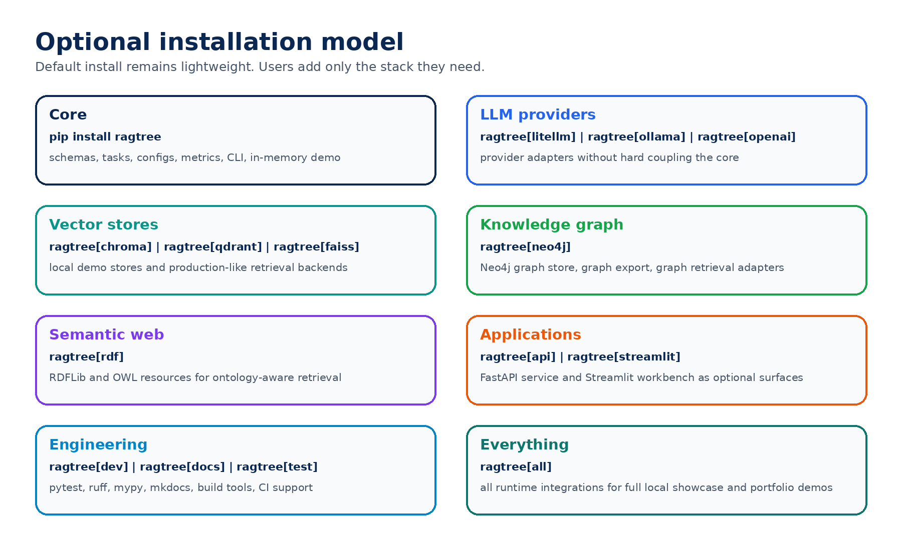
Figure 3. Optional installation model with lightweight core and stack-specific extras.

9.1 User-facing install commands
Command | Meaning
pip install ragtree | Install lightweight core: schemas, protocols, config, metrics, CLI and in-memory demo.
pip install "ragtree[dev]" | Install development tools: tests, coverage, linting, typing, build helpers and pre-commit.
pip install "ragtree[test]" | Install test-only dependencies for CI and local validation.
pip install "ragtree[docs]" | Install documentation tools such as MkDocs and diagram helpers.
pip install "ragtree[litellm]" | Install LiteLLM provider adapter.
pip install "ragtree[ollama]" | Install Ollama provider adapter.
pip install "ragtree[openai]" | Install OpenAI-compatible client adapter.
pip install "ragtree[chroma]" | Install Chroma vector store adapter.
pip install "ragtree[qdrant]" | Install Qdrant vector store adapter.
pip install "ragtree[faiss]" | Install FAISS local vector index adapter.
pip install "ragtree[pgvector]" | Install PostgreSQL / pgvector adapter.
pip install "ragtree[neo4j]" | Install Neo4j graph store and graph export adapter.
pip install "ragtree[rdf]" | Install RDF / OWL ontology support.
pip install "ragtree[langgraph]" | Install LangGraph agent integration.
pip install "ragtree[api]" | Install FastAPI and Uvicorn app surface.
pip install "ragtree[streamlit]" | Install Streamlit workbench surface.
pip install "ragtree[notebooks]" | Install Jupyter notebook support.
pip install "ragtree[docker]" | Install Python-side helpers for Docker-based demos. Docker Engine itself remains external.
pip install "ragtree[all]" | Install all runtime integrations for local showcase and broad experimentation.

9.2 Canonical pyproject.toml optional dependencies
[project]
name = "ragtree"
version = "0.1.0-alpha.0"
description = "A bring-your-own-stack framework for Semantic RAG pipelines."
requires-python = ">=3.10"
dependencies = [
"pydantic>=2.0",
"typer>=0.12",
"pyyaml>=6.0",
"numpy>=1.24",
"pandas>=2.0",
"rich>=13.0",
]
[project.optional-dependencies]
test = [
"pytest>=8.0",
"pytest-cov>=5.0",
]
dev = [
"pytest>=8.0",
"pytest-cov>=5.0",
"ruff>=0.5",
"mypy>=1.10",
"pre-commit>=3.0",
"build>=1.2",
"twine>=5.0",
]
docs = [
"mkdocs>=1.6",
"mkdocs-material>=9.5",
]
litellm = ["litellm>=1.0"]
ollama = ["ollama>=0.4"]
openai = ["openai>=1.0"]
chroma = ["chromadb>=0.5"]
qdrant = ["qdrant-client>=1.9"]
faiss = ["faiss-cpu>=1.8"]
pgvector = ["pgvector>=0.3", "psycopg[binary]>=3.1"]
neo4j = ["neo4j>=5.0"]
rdf = ["rdflib>=7.0", "owlready2>=0.46"]
langgraph = ["langgraph>=0.2"]
api = ["fastapi>=0.115", "uvicorn[standard]>=0.30"]
streamlit = ["streamlit>=1.35"]
notebooks = ["jupyterlab>=4.0", "ipykernel>=6.0", "ipywidgets>=8.0"]
docker = ["python-dotenv>=1.0"]
all = [
"litellm>=1.0",
"ollama>=0.4",
"openai>=1.0",
"chromadb>=0.5",
"qdrant-client>=1.9",
"faiss-cpu>=1.8",
"pgvector>=0.3",
"psycopg[binary]>=3.1",
"neo4j>=5.0",
"rdflib>=7.0",
"owlready2>=0.46",
"langgraph>=0.2",
"fastapi>=0.115",
"uvicorn[standard]>=0.30",
"streamlit>=1.35",
"jupyterlab>=4.0",
"ipykernel>=6.0",
"ipywidgets>=8.0",
"python-dotenv>=1.0",
]
[project.scripts]
ragtree = "ragtree.cli.main:app"
Important note about the docker extra
pip cannot install Docker Engine or Docker Compose. The docker extra should only install Python-side helpers used by Docker examples. The actual containers are started through docker compose files.

10. Testing architecture
A BYOS framework needs tests that prove the core is stable and integrations are interchangeable. The test suite must be organized by responsibility. Integration code belongs in src/ragtree/integrations. Integration tests belong in tests/integration.
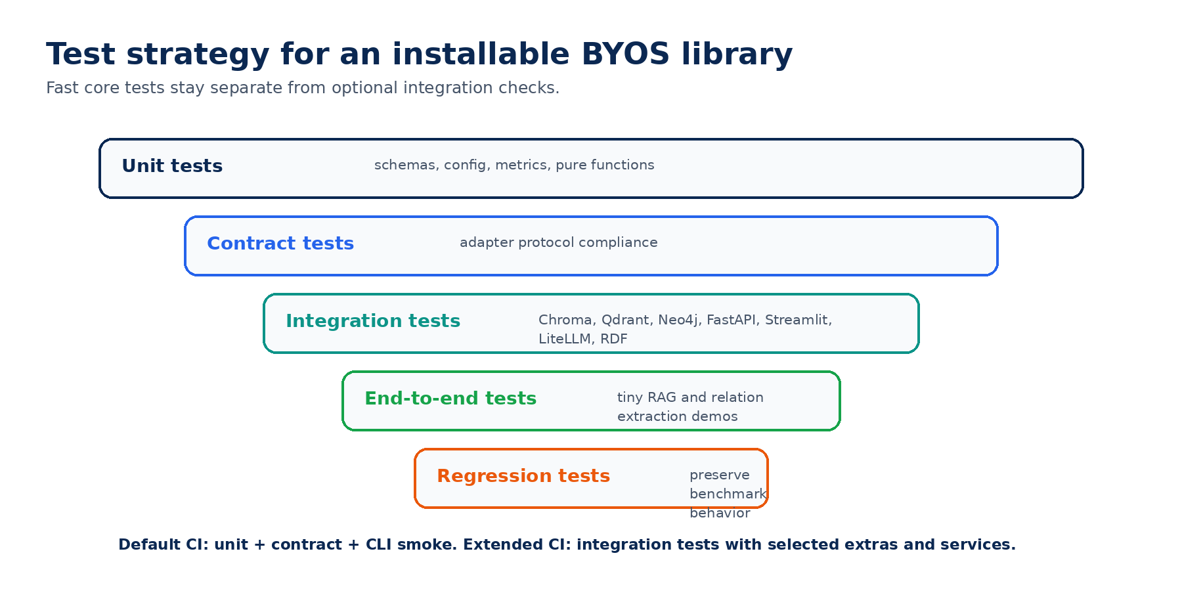
Figure 4. Test architecture for a pip-installable BYOS library.

10.1 Test folders
tests/
├── unit/
│ ├── test_schemas.py
│ ├── test_config.py
│ ├── test_metrics.py
│ └── test_json_normalization.py
├── contract/
│ ├── test_llm_provider_contract.py
│ ├── test_embedder_contract.py
│ ├── test_vectorstore_contract.py
│ ├── test_retriever_contract.py
│ ├── test_graphstore_contract.py
│ └── test_exporter_contract.py
├── integration/
│ ├── test_litellm_provider.py
│ ├── test_chroma_vectorstore.py
│ ├── test_qdrant_vectorstore.py
│ ├── test_neo4j_graphstore.py
│ ├── test_fastapi_app.py
│ └── test_streamlit_import.py
├── e2e/
│ ├── test_semantic_rag_demo.py
│ └── test_relation_extraction_demo.py
├── regression/
│ ├── test_eval_relations_fixture.py
│ └── test_current_script_outputs.py
└── fixtures/
├── tiny_documents.jsonl
├── tiny_gold_relations.jsonl
├── tiny_predictions.jsonl
└── tiny_ontology.ttl

10.2 Test markers
[tool.pytest.ini_options]
markers = [
"integration: tests requiring optional integrations",
"docker: tests requiring docker compose services",
"neo4j: tests requiring Neo4j",
"qdrant: tests requiring Qdrant",
"api: tests requiring FastAPI extras",
"streamlit: tests requiring Streamlit extras",
"slow: tests that should not run in default CI",
]

10.3 Test commands
# Fast local validation
pip install -e ".[dev]"
pytest tests/unit tests/contract tests/regression
# Integration validation for selected stacks
pip install -e ".[dev,chroma,qdrant,neo4j,api,streamlit]"
pytest tests/integration
# Docker-backed integration validation
docker compose up -d neo4j qdrant
pytest -m "integration or docker"
# Release validation
pip install -e ".[all,dev,docs]"
pytest
ruff check src tests
mypy src/ragtree

11. Current experiment preservation
The existing experiments are a major asset. The migration should not destroy them. Instead, experiments should be wrapped behind stable package APIs and protected by regression tests.
Current entry point | Future wrapper role
scripts/run_single_llm_baseline.py | Baseline method for RelationExtractionTask.
scripts/run_icl_baseline.py | ICL method for RelationExtractionTask.
scripts/run_cot_baseline.py | CoT method for RelationExtractionTask.
scripts/run_growlrag_relations.py | Ontology-guided RAG method.
scripts/run_kg_rag_relations.py | KG-guided RAG method.
scripts/run_ograg_relations.py | Ontology-grounded RAG method.
scripts/run_chunk_orag_relations.py | Chunk-level ontology retrieval method.
scripts/run_community_kgrag_relations.py | Community graph retrieval method.
scripts/run_triple_kg_rag_relations.py | Triple-level graph retrieval method.
scripts/run_agentic_hybrid_relations.py | Agentic hybrid retrieval method.
scripts/run_marag_relations.py | Multi-agent RAG method.
scripts/eval_relations.py | Relation evaluation command and RegressionTest fixture.
runtime / CO2 scripts | Supplementary benchmark artifact generator.

11.1 Compatibility contracts
- Dataset keys should remain stable during the migration.
- Existing output fields such as document_id, relations and pred_relations should remain readable.
- Evaluation scripts should accept old outputs and new RAGResult exports.
- Scripts can become thin wrappers, but their command-line behavior should not disappear suddenly.
- Regression fixtures should protect at least one tiny relation extraction evaluation case.

12. Docker and deployment profile
Docker should be treated as a deployment and integration profile, not as a core dependency. The repository should include Dockerfile and docker-compose.yml files for optional local stacks.
services:
qdrant:
image: qdrant/qdrant:latest
ports:
- "6333:6333"
neo4j:
image: neo4j:5
ports:
- "7474:7474"
- "7687:7687"
environment:
NEO4J_AUTH: neo4j/password
api:
build: .
command: ragtree serve --host 0.0.0.0 --port 8000
ports:
- "8000:8000"
depends_on:
- qdrant
- neo4j
Docker profile | Purpose
Minimal API | Run the FastAPI surface with in-memory retrieval.
Vector demo | Run API plus Qdrant for vector retrieval.
Graph demo | Run API plus Neo4j for graph storage and graph export.
Full showcase | Run API, Qdrant, Neo4j and Streamlit demo.

13. CI, quality gates and release discipline
The repository should have a CI matrix that separates fast tests from optional integration tests. This avoids making every pull request depend on heavy services while still proving that real integrations work when requested.
name: tests
on:
push:
pull_request:
jobs:
core:
runs-on: ubuntu-latest
steps:
- uses: actions/checkout@v4
- uses: actions/setup-python@v5
with:
python-version: "3.11"
- run: pip install -e ".[dev]"
- run: pytest tests/unit tests/contract tests/regression
- run: ruff check src tests
optional-api:
runs-on: ubuntu-latest
steps:
- uses: actions/checkout@v4
- uses: actions/setup-python@v5
with:
python-version: "3.11"
- run: pip install -e ".[dev,api,streamlit]"
- run: pytest tests/integration -m "api or streamlit"

13.1 Release checklist
- pip install -e . works from a clean environment.
- pip install -e .[dev] works from a clean environment.
- pip install -e .[all] resolves dependencies or documented conflicts are known.
- README describes BYOS install commands clearly.
- CLI doctor command reports installed and missing optional extras.
- Unit, contract and regression tests pass in CI.
- At least one integration test path exists for Chroma or Qdrant.
- At least one graph export path exists for Neo4j or graph-ready CSV.
- Examples use tiny data and can run quickly.
- Existing experiment scripts are preserved or wrapped.

14. Migration roadmap
The shortest credible roadmap is four sprints. Three sprints can make the project look cleaner, but four sprints are needed to cover installability, protocols, adapters, apps, tests and experiment preservation without cutting serious parts of the BYOS vision.
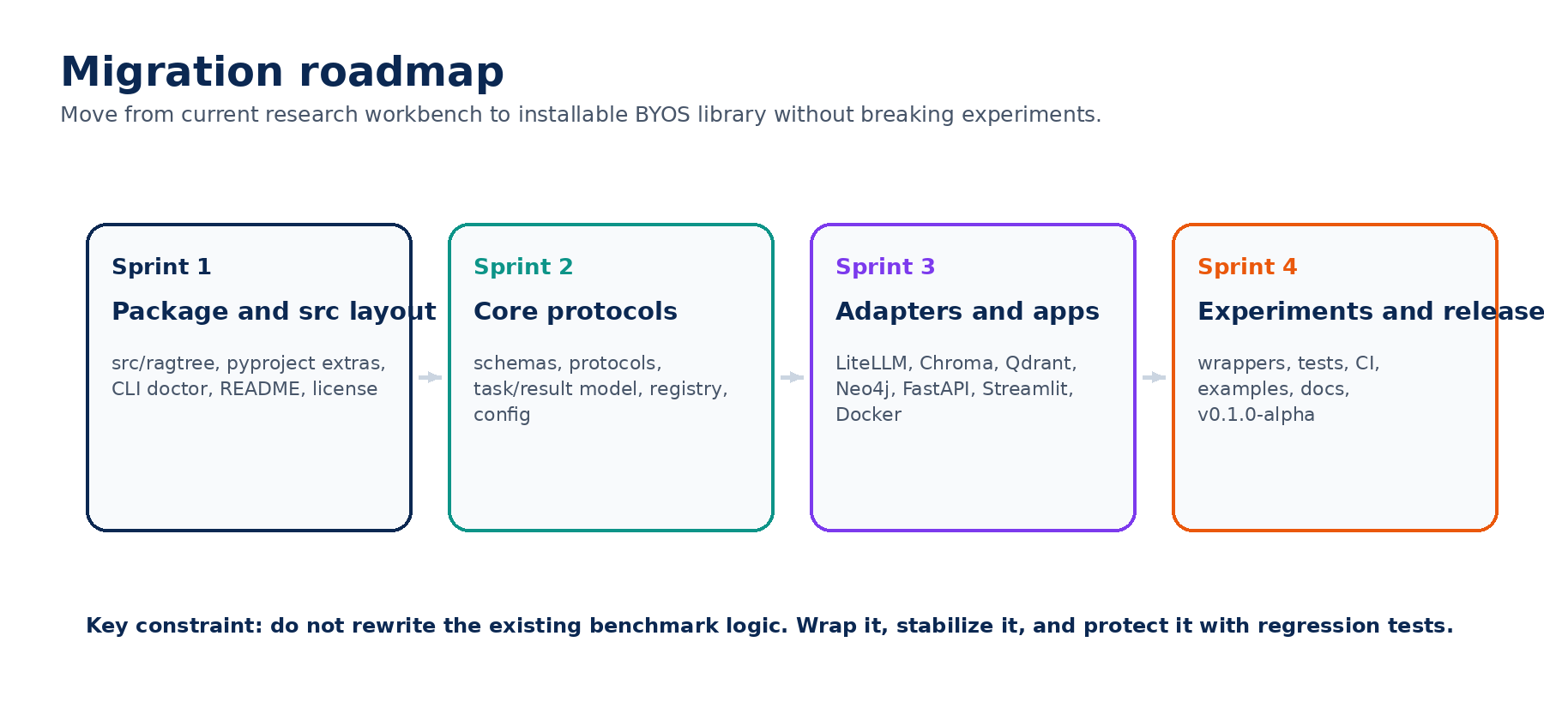
Figure 5. Four-sprint migration from research workbench to installable BYOS library.
Sprint | Goal | Main deliverables | Definition of done
1. Package and src layout | Make the project installable and reorganized. | src/ragtree, pyproject extras, README, license, CLI doctor, basic tests. | pip install -e . and pytest tests/unit pass.
2. Core protocols | Define stable BYOS contracts. | schemas, protocols, task/result model, config registry, simple pipeline. | Adapters can be tested against protocols.
3. Adapters and apps | Add optional surfaces and integrations. | LiteLLM, in-memory, Chroma or Qdrant, Neo4j export, FastAPI, Streamlit, Docker profile. | pip install extras works and selected integration tests pass.
4. Experiments and alpha release | Preserve current benchmark value and ship alpha. | wrappers, regression fixtures, docs, examples, CI, release notes. | v0.1.0-alpha tag can be created.

15. Implementation backlog
Priority | Task | Notes
P0 | Create src/ragtree package layout | Move package code or add transitional package mapping.
P0 | Create pyproject.toml optional extras | Include dev, test, docs, litellm, ollama, openai, chroma, qdrant, faiss, pgvector, neo4j, rdf, langgraph, api, streamlit, notebooks, docker, all.
P0 | Add core schemas | Document, Chunk, EvidenceSpan, RAGTask, RAGResult, EvaluationResult, RunManifest.
P0 | Add protocol interfaces | LLMProvider, Embedder, VectorStore, Retriever, GraphStore, OntologyStore, Evaluator, Exporter.
P0 | Add CLI doctor | Report package version, installed extras and missing optional dependencies.
P1 | Add InMemoryVectorStore | Needed for demos and tests without external services.
P1 | Add LiteLLMProvider | Primary provider abstraction for model access.
P1 | Add Chroma adapter | Local demo vector store.
P1 | Add Neo4j exporter or graph store | Graph integration and portfolio signal.
P1 | Add FastAPI app surface | Optional service layer.
P1 | Add Streamlit demo surface | Optional visual demo layer.
P1 | Add tests/unit and tests/contract | Foundation for reliability.
P2 | Add Qdrant adapter | More production-like vector database.
P2 | Add LangGraph adapter | Agentic orchestration as optional integration.
P2 | Wrap current experiments | Current scripts should call package code progressively.
P2 | Add Docker profiles | Qdrant, Neo4j, API and Streamlit local stack.

16. README positioning block and interview narrative
The README should avoid inflated wording. It should sound serious, concrete and engineering-focused. The word "professional" does not need to appear in the title to make the project look strong. The strength comes from architecture, installability, protocols, tests and integrations.

16.1 Suggested README opening
# RAGTree
RAGTree is a bring-your-own-stack framework for building, evaluating and integrating Semantic RAG pipelines over complex documents.
It provides a lightweight core with stable schemas, protocols, configuration, task abstractions and evaluation utilities. External systems such as LLM providers, vector stores, graph databases, ontology engines, API servers and UI surfaces are added through optional integrations.
The project currently includes a research workbench for relation extraction, ontology-guided retrieval, KG-RAG, agentic RAG, evaluation and runtime analysis. The library design generalizes this foundation toward reusable Semantic RAG tasks such as question answering, relation extraction, claim verification, summarization, ontology linking and graph construction.

16.2 Interview explanation
RAGTree started as a research workbench for evaluating RAG and LLM methods on relation extraction tasks. I am redesigning it as a bring-your-own-stack Semantic RAG framework. The core defines schemas, protocols, task abstractions, configuration, evaluation and run metadata. Integrations such as LiteLLM, Chroma, Qdrant, Neo4j, FastAPI, Streamlit, Docker and LangGraph are optional adapters. This lets the same core support research experiments, local demos and integration into existing company stacks.

17. Appendix: code skeletons

17.1 RAGTreePipeline skeleton
class RAGTreePipeline:
def __init__(
self,
retriever: Retriever,
generator: LLMProvider,
evaluator: Evaluator | None = None,
exporter: Exporter | None = None,
):
self.retriever = retriever
self.generator = generator
self.evaluator = evaluator
self.exporter = exporter
def run(self, task: RAGTask) -> RAGResult:
evidence = self.retriever.retrieve(task)
output = self.generator.complete(task.to_messages(evidence))
result = RAGResult(
task_type=task.task_type,
output=output,
evidence=evidence,
)
if self.evaluator:
result.metrics = self.evaluator.evaluate(result)
return result

17.2 CLI doctor sketch
OPTIONAL_PACKAGES = {
"litellm": "litellm",
"ollama": "ollama",
"openai": "openai",
"chroma": "chromadb",
"qdrant": "qdrant_client",
"neo4j": "neo4j",
"rdf": "rdflib",
"langgraph": "langgraph",
"api": "fastapi",
"streamlit": "streamlit",
}
@app.command()
def doctor() -> None:
"""Report installed optional integrations."""
for extra, import_name in OPTIONAL_PACKAGES.items():
try:
__import__(import_name)
status = "installed"
except ImportError:
status = f"missing. Install with: pip install 'ragtree[{extra}]'"
typer.echo(f"{extra}: {status}")

17.3 Example BYOS usage
from ragtree import RAGTreePipeline
from ragtree.tasks import QuestionAnsweringTask
from ragtree.integrations.llms import LiteLLMProvider
from ragtree.integrations.vectorstores import ChromaVectorStore
from ragtree.retrieval import HybridRetriever
llm = LiteLLMProvider(model="openai/gpt-4o-mini")
vector_store = ChromaVectorStore(collection_name="demo", persist_directory=".chroma")
retriever = HybridRetriever(vector_store=vector_store)
pipeline = RAGTreePipeline(retriever=retriever, generator=llm)
result = pipeline.run(
QuestionAnsweringTask(question="What caused the machine alarm?")
)
print(result.output)
print(result.evidence)
Final recommendation
The next implementation branch should not add more experimental methods first. It should establish src layout, pyproject extras, core protocols, adapter boundaries, tests and two minimal demos. Once this foundation exists, every future method or integration becomes easier to add, easier to explain and easier to test.

