PASO 1
Agregar un router mod 1941, 1 switch mod 2960, y 2 computadoras
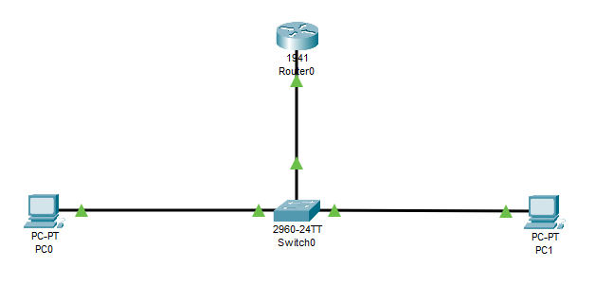

PASO 2
Conectar el cable de red de la pc1 al puerto fa0/1 del switch
Conectar el cable de red de la pc2 al puerto fa0/2 del switch
Conectar el cable de red al puerto GigabitEthernet0/1 del switch al puerto GigabitEthernet0/0 del Router

PASO 3
Configurar las tarjetas de red de la pc0 IP: 172.17.10.10 255.255.255.0 Gateway: 172.17.10.1
Configurar las tarjetas de red de la pc1 IP: 172.17.20.10 255.255.255.0 Gateway: 172.17.20.1

PASO 4
Crear VLANS en el switch
S1>enable
S1#configure terminal
S1(config)# vlan 10
S1(config-vlan)# name estudiante
S1(config-vlan)# end

S1(config)# vlan 20
S1(config-vlan)# name docente
S1(config-vlan)# end

PASO 5
Asignar puertos a cada VLANS
S1#configure terminal
S1(config)# interface fa0/1
S1(config-if)# switchport mode access
S1(config-if)# switchport access vlan 10
S1(config-if)# end
S1(config)# interface fa0/2
S1(config-if)# switchport mode access
S1(config-if)# switchport access vlan 20
S1(config-if)# end

PASO 6
Revisar las vlan
S1#show vlan brief
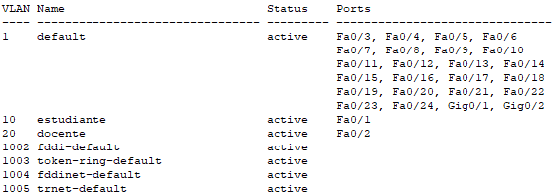

PASO 7
Si ejecutan un ping entre las pc´s, va a mostrar error, ya que están en diferentes redes y diferentes vlans.

PASO 8
Configurar las subinterfaces en le Router con la encapsulación 802.1Q o dot1Q
Router>enable
Router#configure terminal
Enter configuration commands, one per line. End with CNTL/Z.
Router(config)#interface Gigabitethernet0/0.1
Router(config-subif)#encapsulation dot1Q 10
Router(config-subif)#ip address 172.17.10.1 255.255.255.0
Router(config-subif)#interface Gigabitethernet0/0.2
Router(config-subif)#encapsulation dot1Q 20
Router(config-subif)#ip address 172.17.20.1 255.255.255.0
Router(config-subif)#end
Router#

PASO 9
Levantar o activar el puerto GigabitEhternet0/0 del router
Router#configure terminal
Enter configuration commands, one per line. End with CNTL/Z.
Router(config)#interface Gigabitethernet0/0
Router(config-if)#no shutdown

Router(config-if)#
%LINK-5-CHANGED: Interface GigabitEthernet0/0, changed state to up

%LINEPROTO-5-UPDOWN: Line protocol on Interface GigabitEthernet0/0, changed state to up

%LINK-5-CHANGED: Interface GigabitEthernet0/0.1, changed state to up

%LINEPROTO-5-UPDOWN: Line protocol on Interface GigabitEthernet0/0.1, changed state to up

%LINK-5-CHANGED: Interface GigabitEthernet0/0.2, changed state to up

%LINEPROTO-5-UPDOWN: Line protocol on Interface GigabitEthernet0/0.2, changed state to up

Router(config-if)#end

Router#show ip interface brief
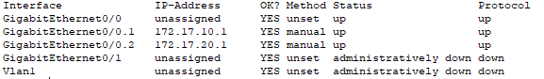
Router#

PASO 10
Habilitar el enlace troncal en el switch
Switch>enable
Switch#configure terminal
Enter configuration commands, one per line. End with CNTL/Z.
Switch(config)#interface gigabitethernet0/1
Switch(config-if)#switchport mode trunk

Switch(config-if)#
%LINEPROTO-5-UPDOWN: Line protocol on Interface GigabitEthernet0/1, changed state to down

%LINEPROTO-5-UPDOWN: Line protocol on Interface GigabitEthernet0/1, changed state to up

Switch(config-if)#end
Switch#
%SYS-5-CONFIG_I: Configured from console by console

Switch#show interface trunk
Port Mode Encapsulation Status Native vlan
Gig0/1 on 802.1q trunking 1

Port Vlans allowed on trunk
Gig0/1 1-1005

Port Vlans allowed and active in management domain
Gig0/1 1,10,20

PASO 11
Probar conectividad entre las pc’s

PARA QUITAR PUERTOS DE UNA VLAN:
SW1# configure terminal
Enter configuration commands, one per line. No command
SW1(config)# interface GigabitEthernet 0/1
SW1(config-if)# no switchport access vlan
SW1(config-if)# exit
SW1(config)# end

PARA QUITAR VLANS

switch# configure terminal
Enter configuration commands, ending with CTRL-Z or EXEC
switch(config)# no vlan 100
switch(config)# exit

