Lab 5 Report
學號：B11030001
姓名：葉衍巖

Introduction

Implementation

TASK1:

CartPole’s small action space and its dense reward mechanism naturally leads to a simple model structure. Therefore, I implemented it by only three linear layers interleaved with ReLU activation function.
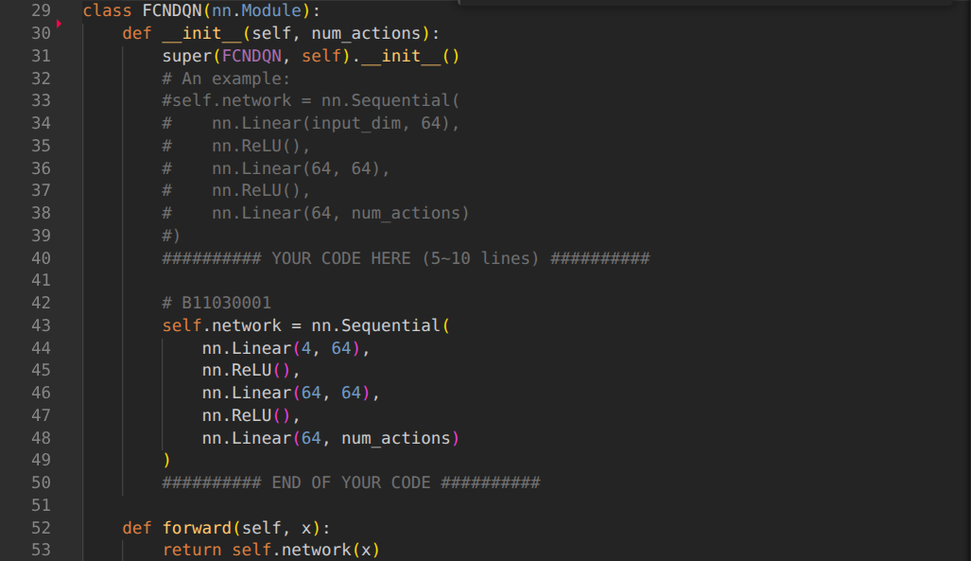

The loss function is simply the MSE of the Bellman error. I implemented it in a more modularized way for future adjustment such as double DQN.

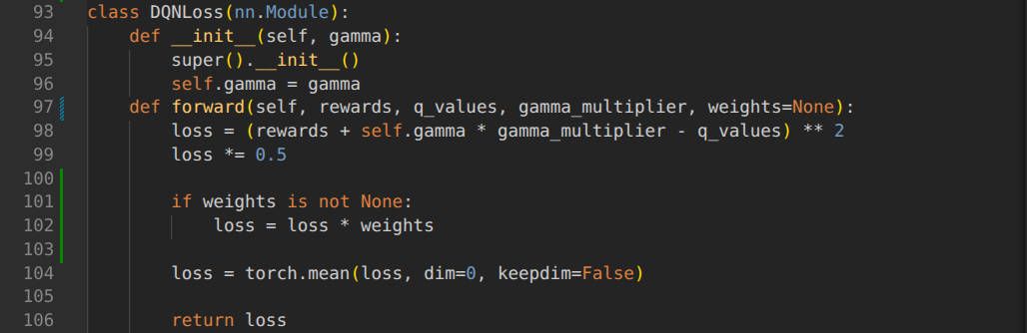
For DQN, run the target network to obtain max Q value, and multiply (1 – done) to indicate the episode ends.
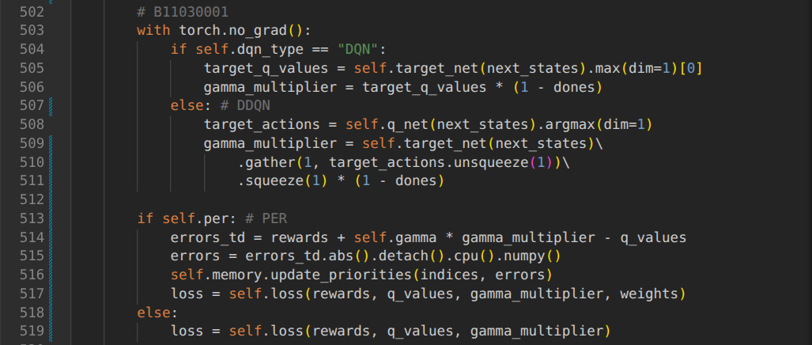

TASK2:

In the Pong game, the state uses images as its representation, which naturally leads to using convolution neural network to implement the DQN model structure. I followed the design in “Human-level control through deep reinforcement learning” for implementing the structure.
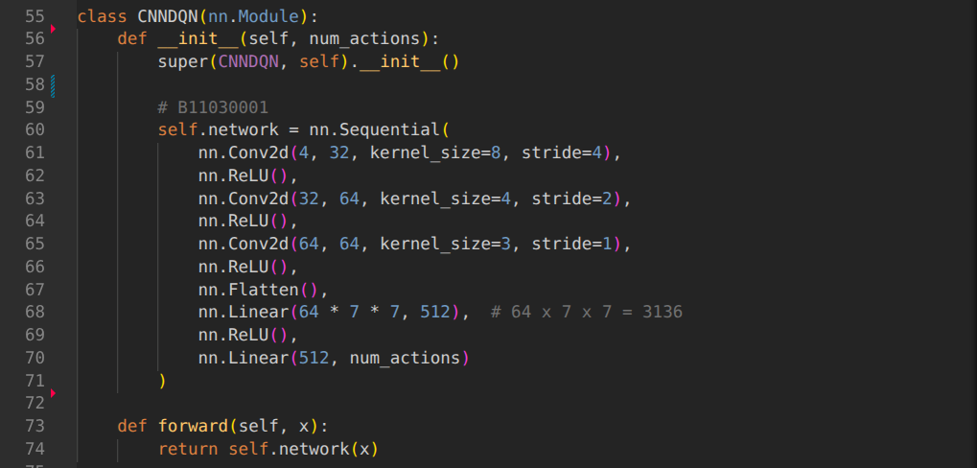
For every state going to be fed into the DQN, I do normalization to avoid unstable training. I considered to do it in the preprocessor, however it take too much memory to store float32 tensors. Therefore, it was done in a more tedious way for avoiding OOM. (convert before getting into model)
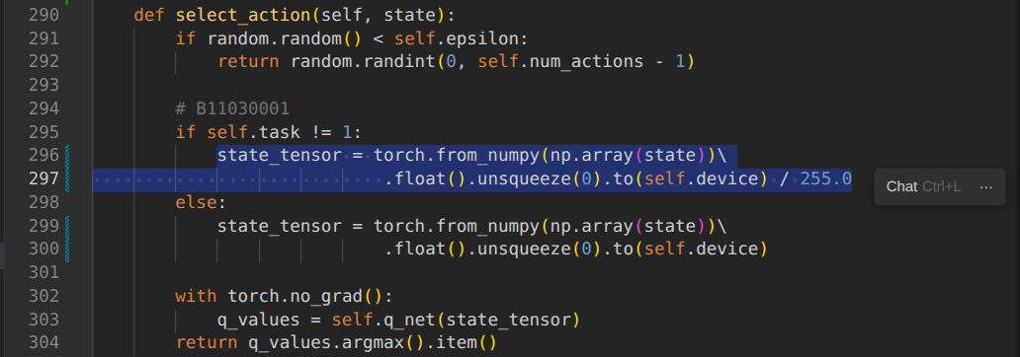

TASK3:

Double DQN is simply changing the calculation of the original loss function. The original loss function simply input the next state into target DQN and let it figure out the max Q value. And the double DQN use the DQN that is interacting with the environment to choose the best action and pass it into target DQN in order to mitigate the over estimation problem.

The modularization implementation of loss function class make the change of code to allow DDQN easy.

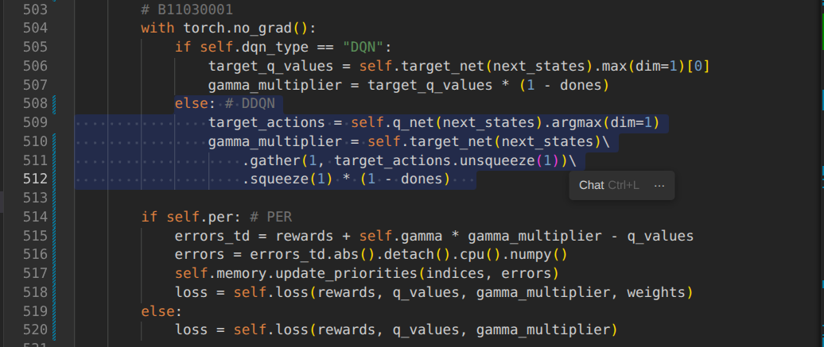
In short, prioritized experience replay records the priority for each transitions, and sample them according to their priorities.

First I want to talk about the sum tree used in prioritized replay buffer. Sum tree data structure is adopted in the paper "PRIORITIZED EXPERIENCE REPLAY”. It takes O(logN) time to sample and can get total priority at O(1) time by simply get the root node.

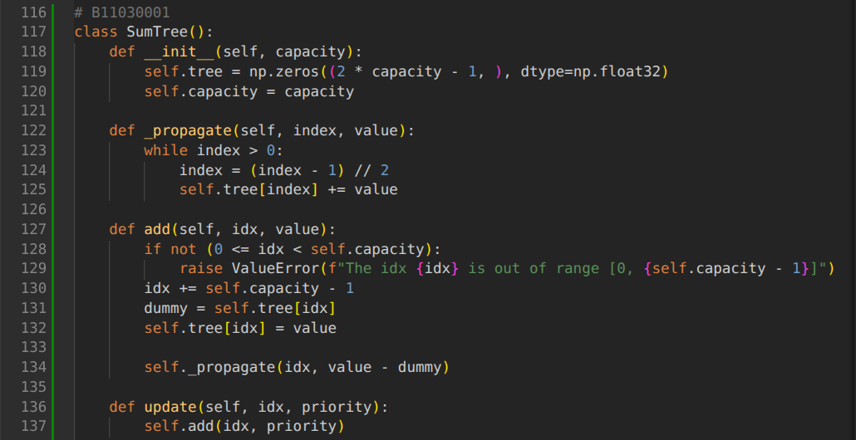
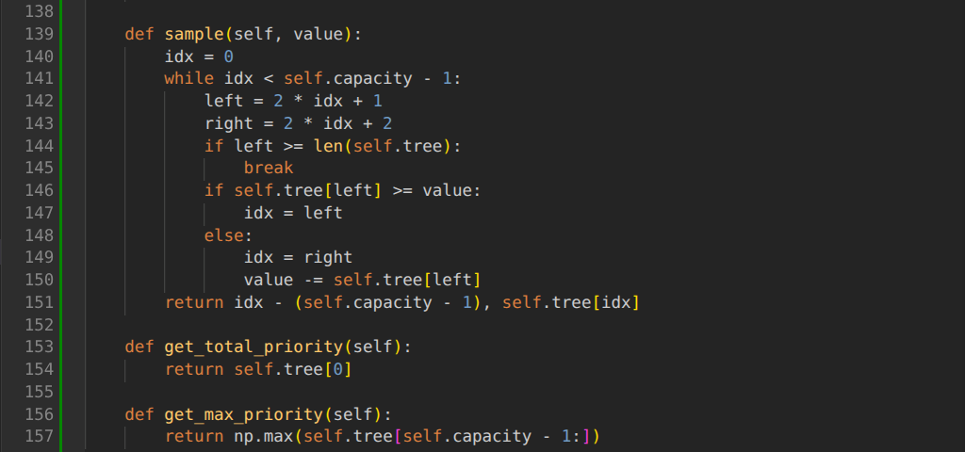

Prioritized replay buffer maintains two data structure storing the transitions and their priorities. Adding a transaction happens when processing a new transaction, which is originally given the current highest priority to ensure it will at least be processed once.

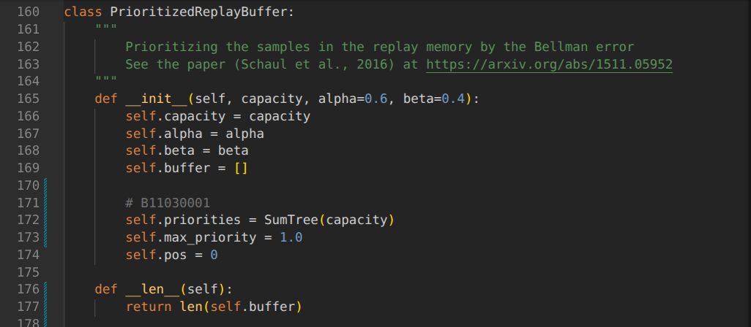
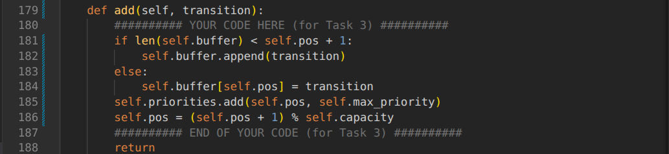

Sampling in the buffer have to check if there is really a transition because the sum tree data structure did not have the information of the transition’s existence. So I implement a resample method to overcome the issue.
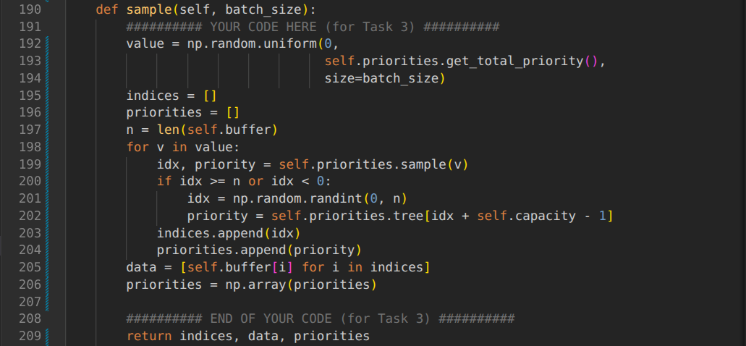
The sampled transition is used for calculate the loss function, their Bellman error will be further used to update their priority.
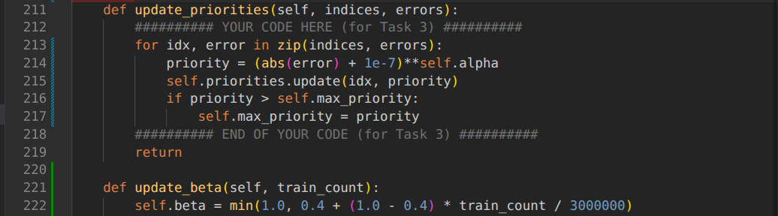
In the train function, use the sample function mentioned above, and update the priority according to the indices. The weight is used to weight the loss according to the biased nature of priority experience replay mechanism.
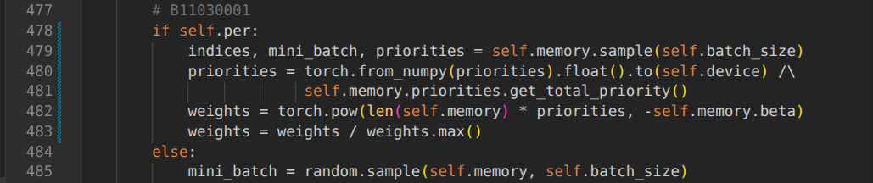
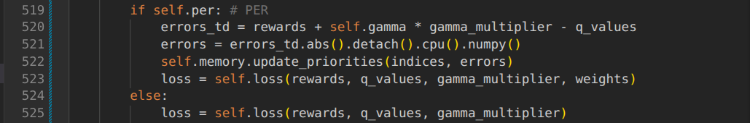

For the multi-step return, I maintained a dedicated buffer for it. If the buffer is full, it need to extract the state and action of the earliest transition, accumulate all transitions discounted reward and get the next state and done state of the latest transition. Pack them into one transition and save into memory. There is a mechanism that every time the function is executed the buffer will pop out the left most (earliest) transition.
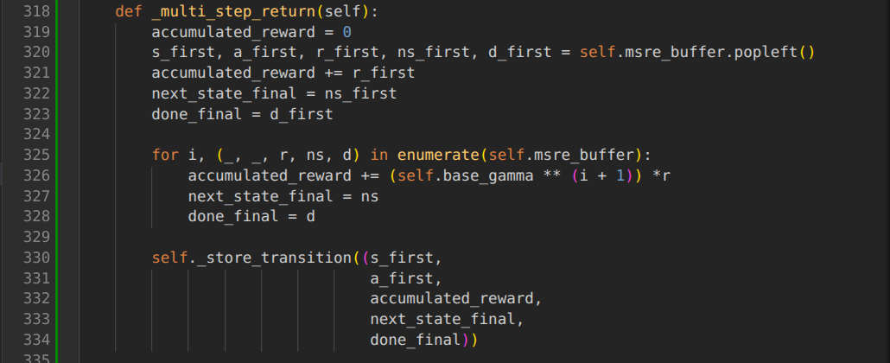
Instead of directly update the memory, I let the multi-step return function do the work. And if the currently added transition is marked down, it will calculate the packed transitions until the multi-step return buffer is empty.

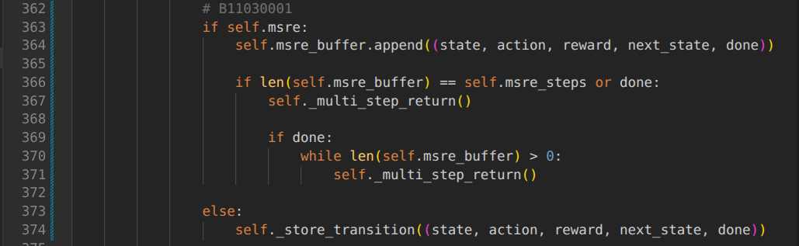
For the Weight & Bias, I use the provided code with addition setting on its panel: Make the env_step-total_reward chart. (The default x axis is not environmental step)

Analysis and discussions

TASK1:

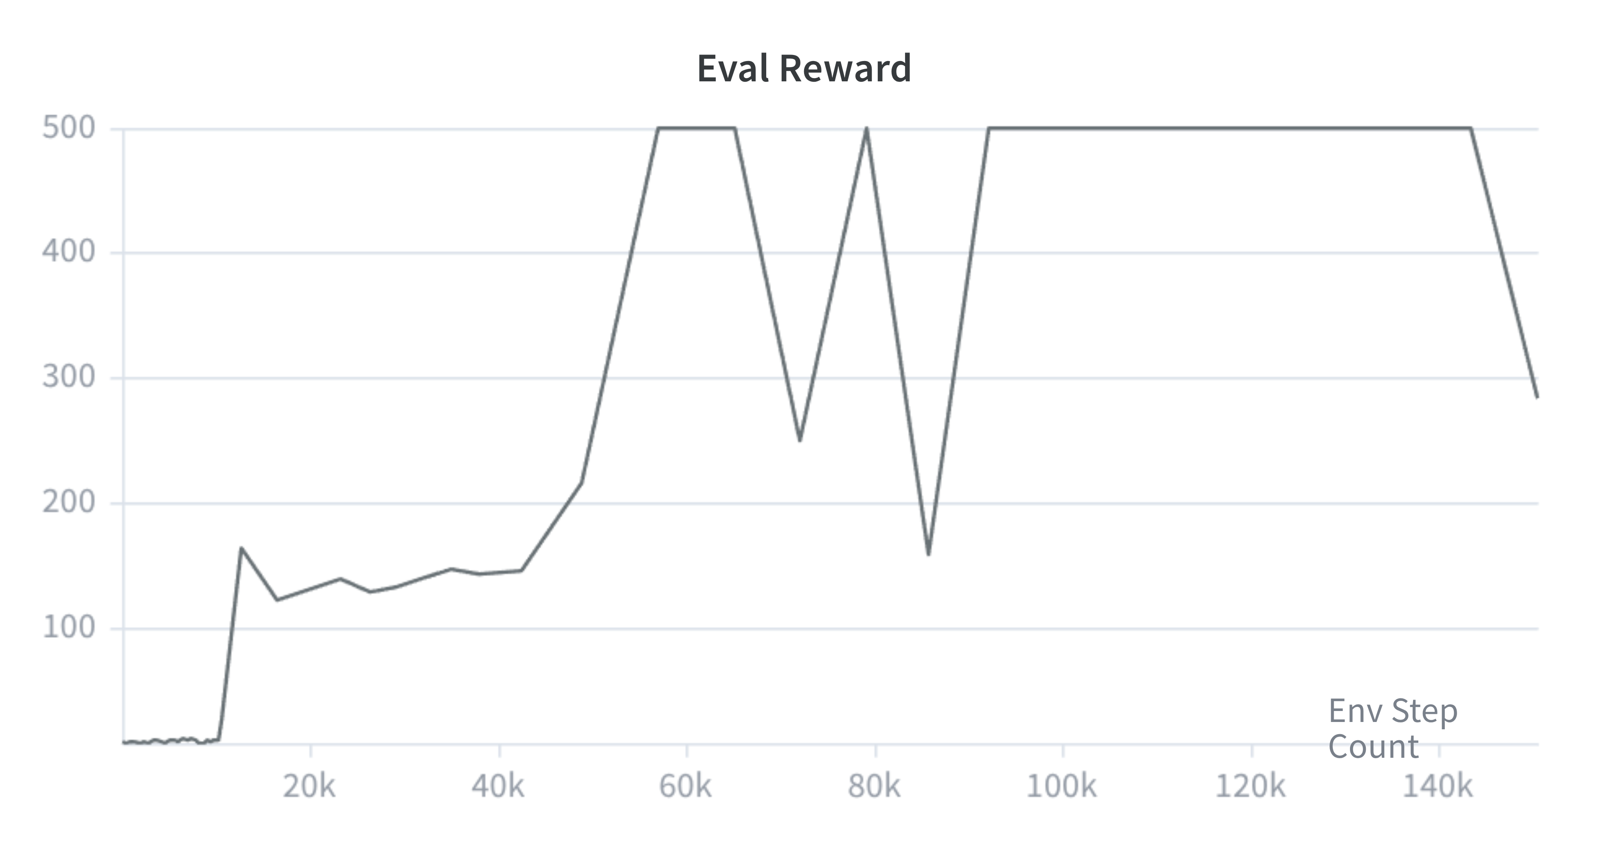

TASK2:
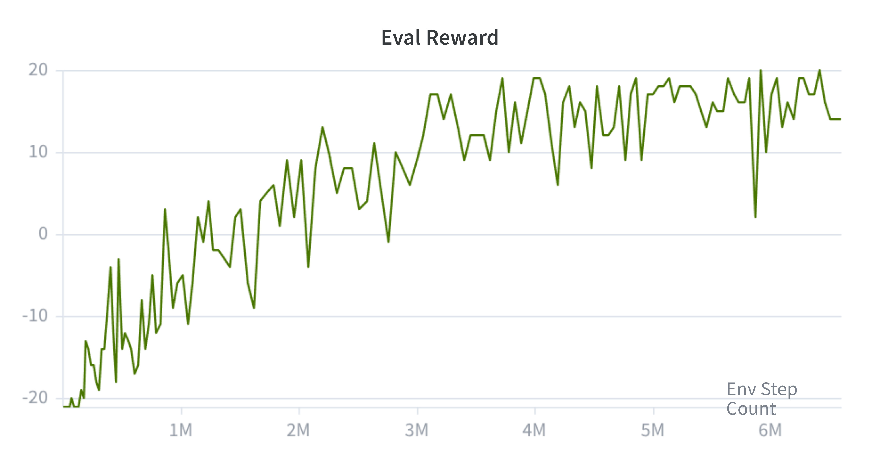
TASK3:

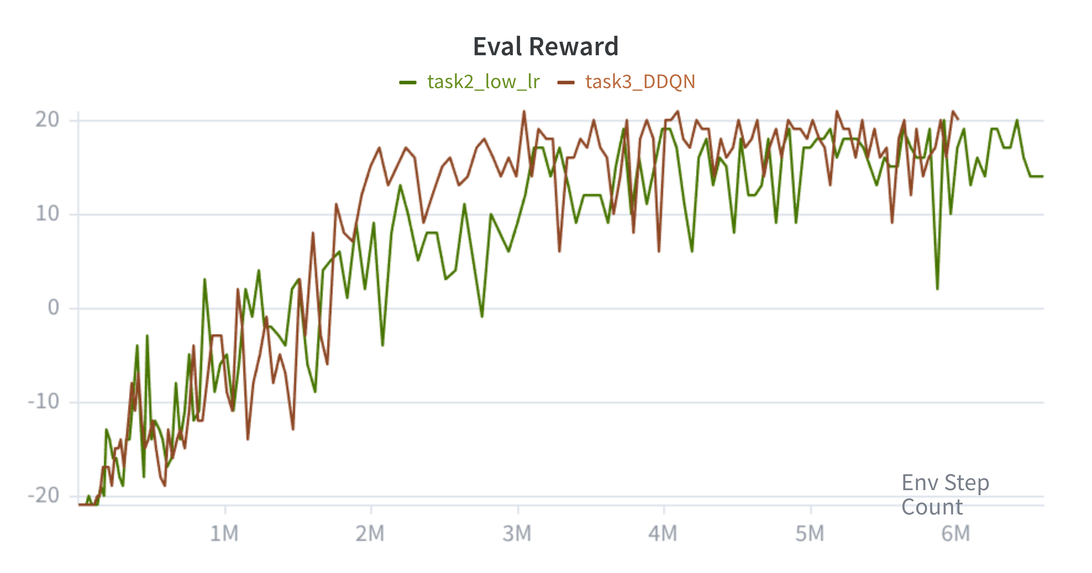
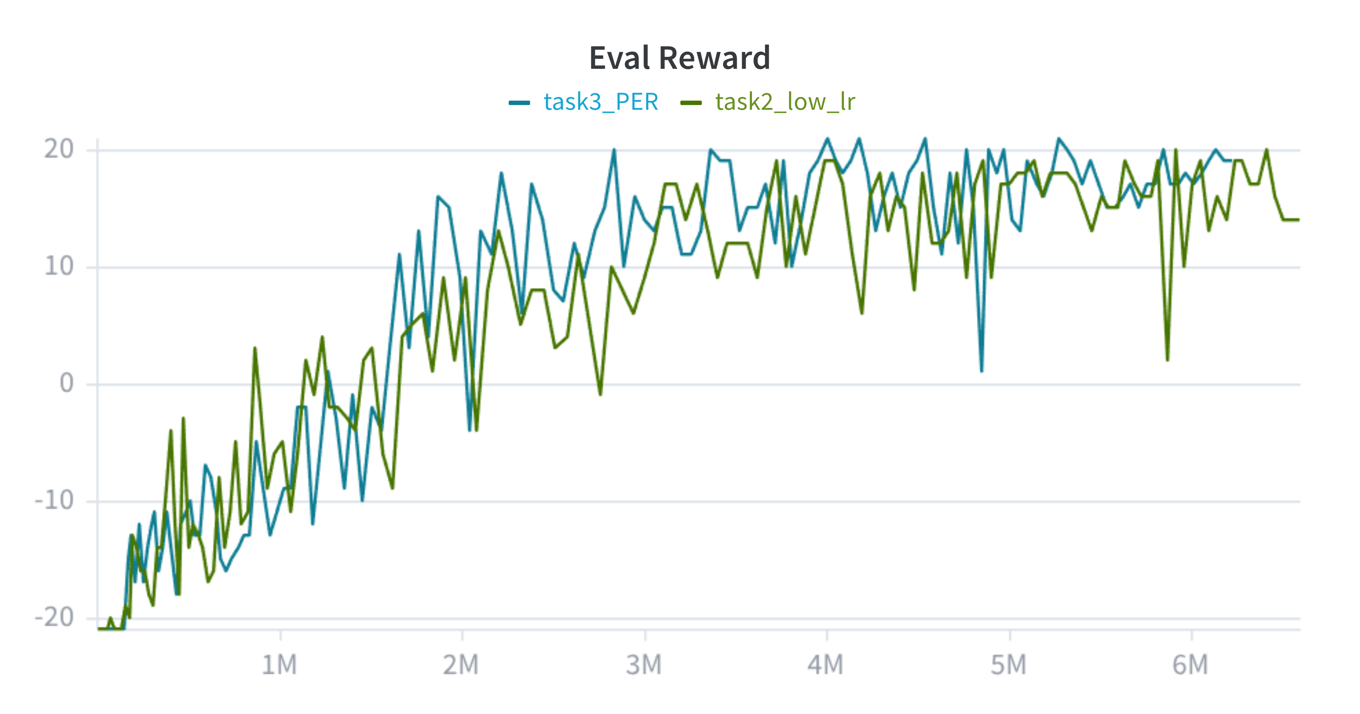
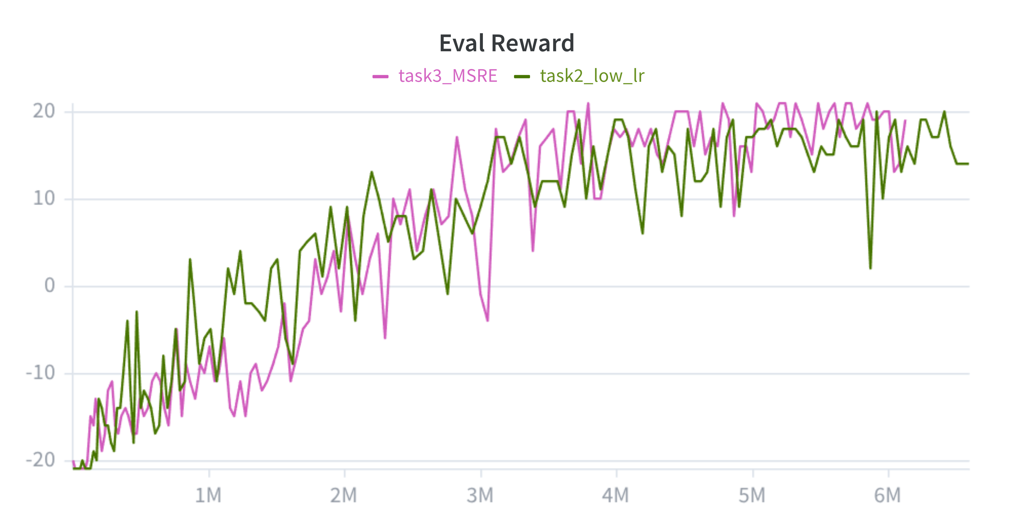
– Plot the training curves (evaluation score versus environment steps) for Task 1, Task 2, and Task 3 separately, please make sure the x-axis represent environment step (3+3+4=10%).
– Analyze the sample efficiency with and without the DQN enhancements (10%).
– Please perform an ablation study on each technique separately (5%).

Additional analysis on other training strategies

