|  |  |
| --- | --- |
| [COS10011] Assignment 2 Report | Version: 1.0 |
| Team Name: Group 1 | Date: [2019-5-08] |
| Title: Room rental | |

1. **Code Explanation**

In this assessment the team has created two JavaScript folder and that is jvs.js and enhancement.js.

In jvs.js it includes validate function to make sure user has entered the information needed and to limit then input. for example, for the given name and family the user is limited only can key in maximum 20 character, only can enter the numeric character for the phone number and postcode, must enter a valid Emil and user must fill the form correctly before they proceed to the next step, section storage function to store the information key in by the user, and two enhancements. One of the enhancement is used to split the form into several steps. Another enhancement is the next button, the button will become the submit button when user reach the last form and the previous button will show out then user at the second form.

Most of the enhancement code was store in the enhancement.js solder to make the page look more interesting. it includes Slide show, read more, lightbox, social media sidebar, dropdown menu, full screen search bar and back to top Button.

1. **Enhancement** 
   1. **Multiple Steps form**

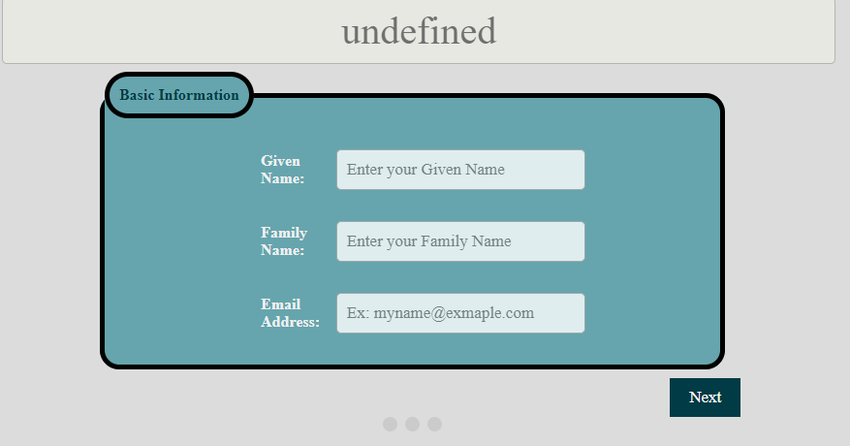

The form is split in to several step after the user done filling the first form then they can press the next button to move to the next from.to do it, first the form is given a same class and the showTab(n)function to decide which form should be show out. After that the nextPrev(n) is used to let the user go to the next form. Lastly when the user goes into the last form the next button will become a submit the button.

* 1. **Auto change Slide show**

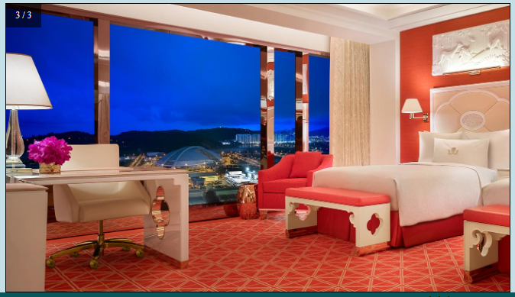

Firstly, using a for loop to let the images display into none one by one. Second when the slideIndex is large then the length of the slide slideIndex will equal 1 then the images will be display in block. lastly the using the setTimeout function to change images every 3 seconds.

* 1. **Search bar**

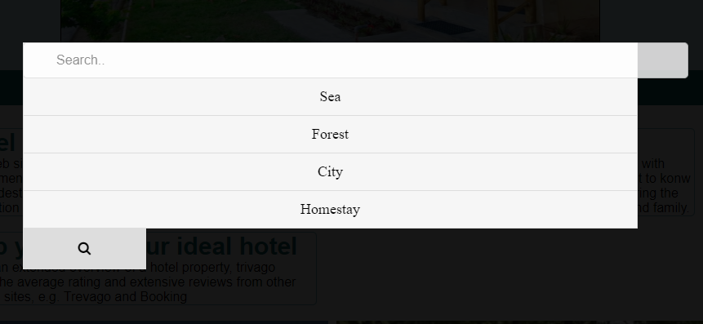

This enhancement includes 2 function. First openSearch() function is used to let the searcher bar display in full screen. Second function filter(), it converts all the user input upper case after that use the input to find out the most simile word and show it out on the screen as above.

* 1. **Back to top button**

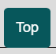

This enhancement will bring the user back to the top of the page after they press this this is because scrollTop is set as 0 in the function.

* 1. **Drop-down list**

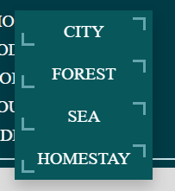

This enhancement the drop-down list will show out when the user clicks on the “Product”. To achieve this the team function to change the list class to “show”.

1. **Contribution**

|  |  |
| --- | --- |
| **Team Member 1** | **Gabriel Kong Qi Hao** |
| **Contribution (%)** | 80 |
| **List of Contribution** | Data transfer between Pages, Data transfer in the same page, Data validation and input checking of Form, Populate drop-down list using JavaScript, Report. |
|  | Enhancement(Multiple form, Slideshow, Back to top button, Dropdown menu, changeable button, searching bar) |

|  |  |
| --- | --- |
| **Team Member 2** | **Tiong Wei Yuan** |
| **Contribution (%)** | 10 |
| **List of Contribution** | Enhancement (Slideshow ,Sticky Social media side bar, Modal image(lightbox), readmore) |

|  |  |
| --- | --- |
| **Team Member 3** | **Kho Ye Sheng** |
| **Contribution (%)** | 0 |
| **List of Contribution** |  |

|  |  |
| --- | --- |
| **Team Member 4** | **Alan Lau Kai Lun** |
| **Contribution (%)** | 10 |
| **List of Contribution** | Enhancement (Slideshow ,Sticky Social media side bar, Modal image(lightbox), readmore) |