|  |  |
| --- | --- |
| [COS10011] Assignment 3 Report | Version: 1.0 |
| Team Name: Group 1 | Date: [2019-5-30] |
| Title: Room rental | |

1. **Code Explanation**
   1. **PHP**

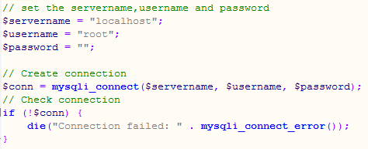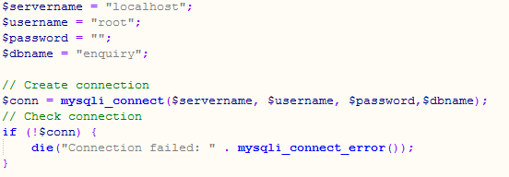

The code above is use to make sure the page is successfully connected to the localhost and database.

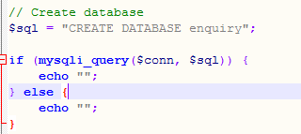

After connect the page to the database, the team used the code shows above to create a database, in this case the database will be named as enquiry.

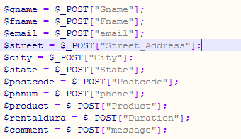

Then, the figure above shows the code used by the team to get the information from the form.

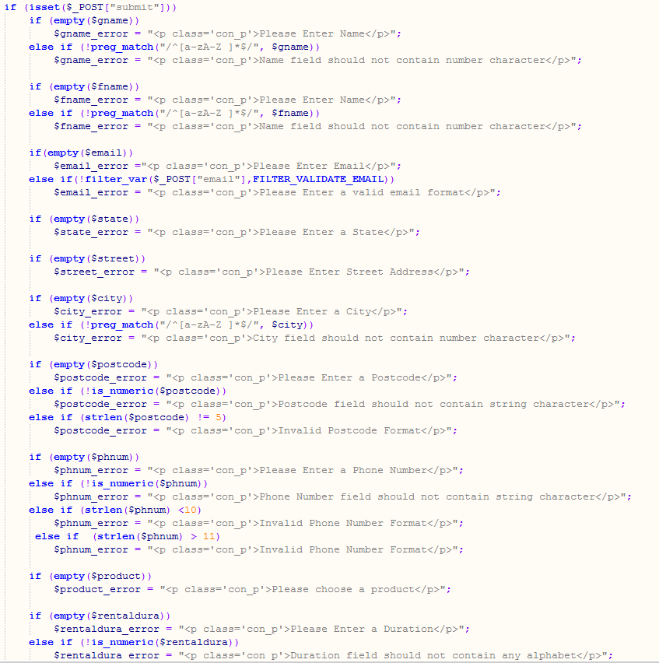

After the team get the information of the user. The team use the code above to do the validation to make sure all the input entered by the user is in a valid form.

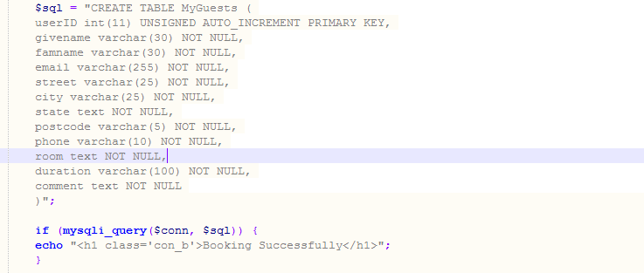

After the validation, the database table was created with some limitations.

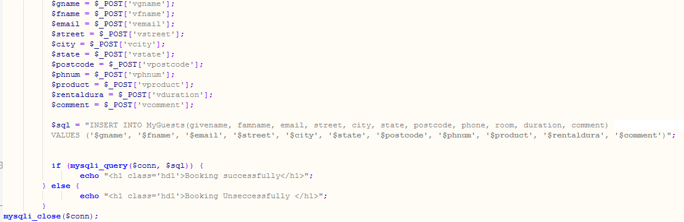

After the table has been created, the information will be store into the database that has been created in the previous code.

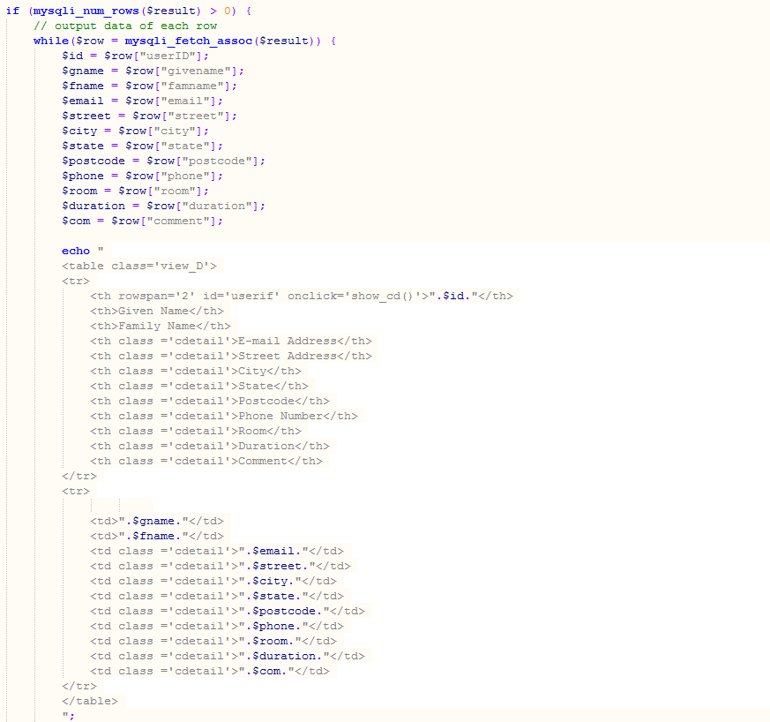

Lastly, the team get the information that store in the database and display it on the view_enquiry.php page to let the webpage owner to know the booking and the detail of the customer. To get all the customer information from the database and show the data in a different table, the team use a loop function. The loop function will loop base on the number of the customer who has successfully booked the room.

* 1. **MySQL**

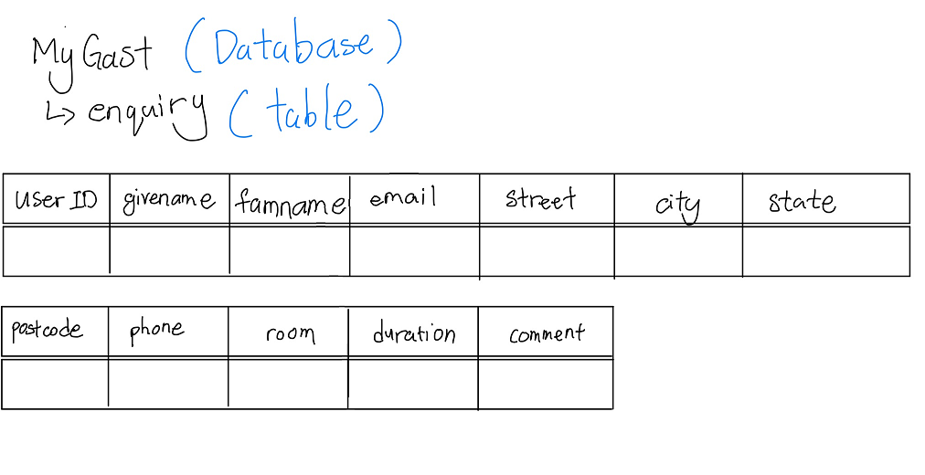

Figure 1:sql database

The table above is the structure of the database

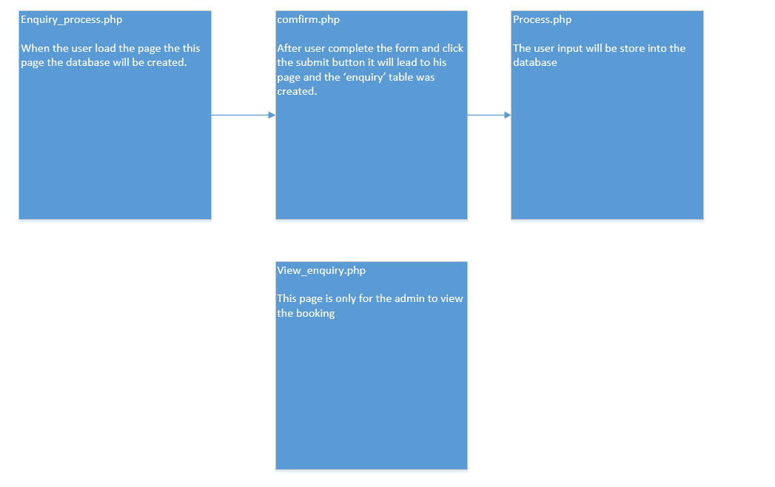

Figure 2:The figure shows how the team create database and store user info

1. **Enhancement**

The team do not have any Enhancement.

1. **Contribution**

|  |  |
| --- | --- |
| **Team Member 1** | **Gabriel Kong Qi Hao** |
| **Contribution (%)** | 33.33 |
| **List of Contribution** | Change reuse common elements to PHP files, Create database table(MySQL), enquiry process PHP, view_enquiry.PHP , Report |

|  |  |
| --- | --- |
| **Team Member 2** | **Tiong Wei Yuan** |
| **Contribution (%)** | 33.33 |
| **List of Contribution** | Create database table(MySQL), enquiry_process PHP |

|  |  |
| --- | --- |
| **Team Member 3** | **Kho Ye Sheng** |
| **Contribution (%)** | 0 |
| **List of Contribution** |  |

|  |  |
| --- | --- |
| **Team Member 4** | **Alan Lau Kai Lun** |
| **Contribution (%)** | 33.33 |
| **List of Contribution** | Create database table(MySQL), enquiry process PHP |