|  |  |
| --- | --- |
| [COS10011] Assignment 1 Report | Version: 1.0 |
| Team Name: Group 1 | Date: [2019-4-07] |
| Title: Room rental | |

# Introduction

For this assignment, the team was required to create a website for the team room rental business. The objective to create this web site is to provide the information through the only and become less dependency on staff. In this report we will talk about the detail of the web side such as the webpage design and structure, the final product, and the contribution of each team member.

## Scope of the website

The scope of this website is to allow the customers to able find the room online and to book or rent it. Also, increase the visibility of the rental services.

## Intended audience

In general, our website attracts local residents like students and families, and tourists looking for a place to stay on a holiday.

**2.0 Webpage Design and Structure**

**2.1 Website Layout Mock ups**

**1.Home Page**

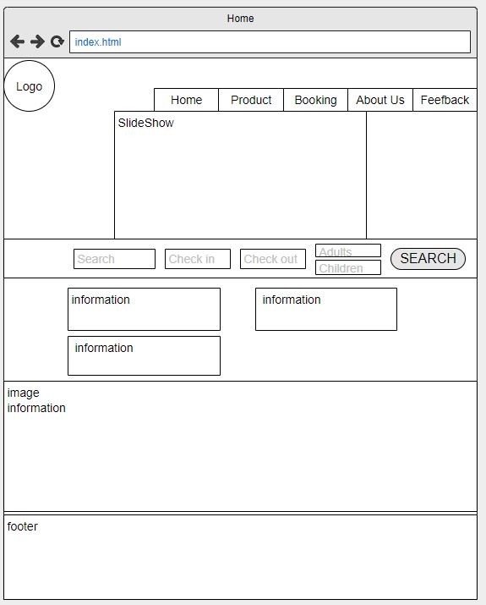

**2.Product brief Page**

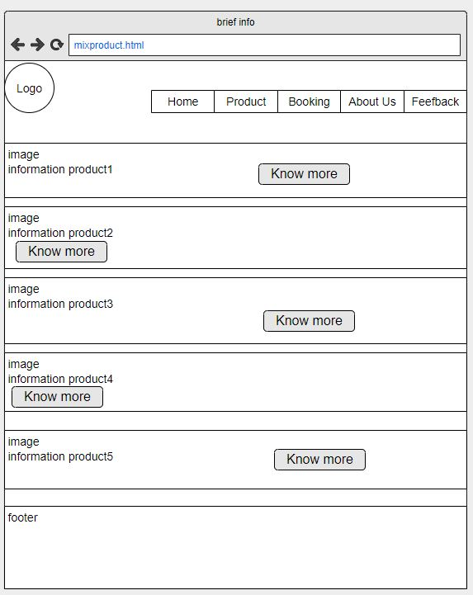

**3.Product detail Page**

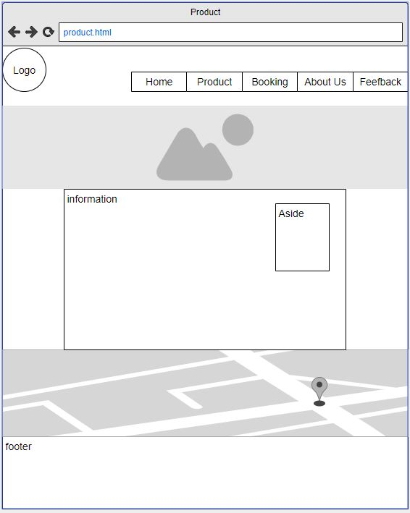

**4.Feedback**

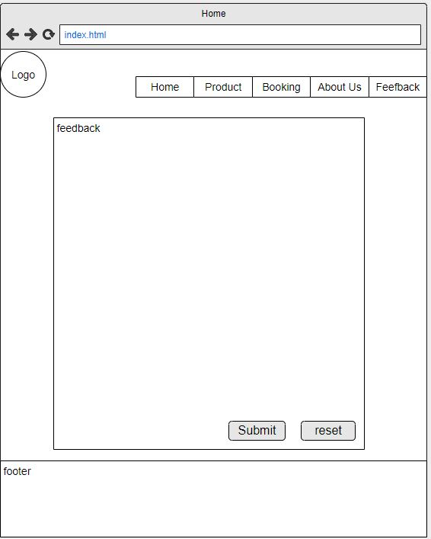

**5.** **Enquiry**

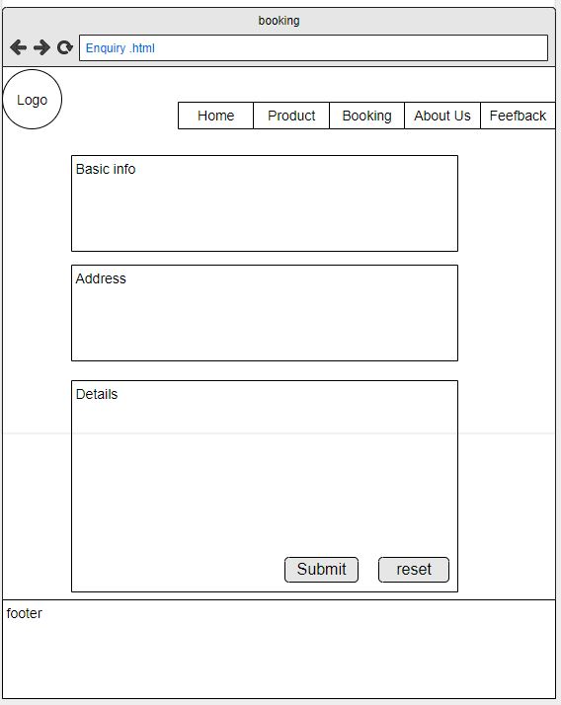

**2.2 Website structure**

Main menu

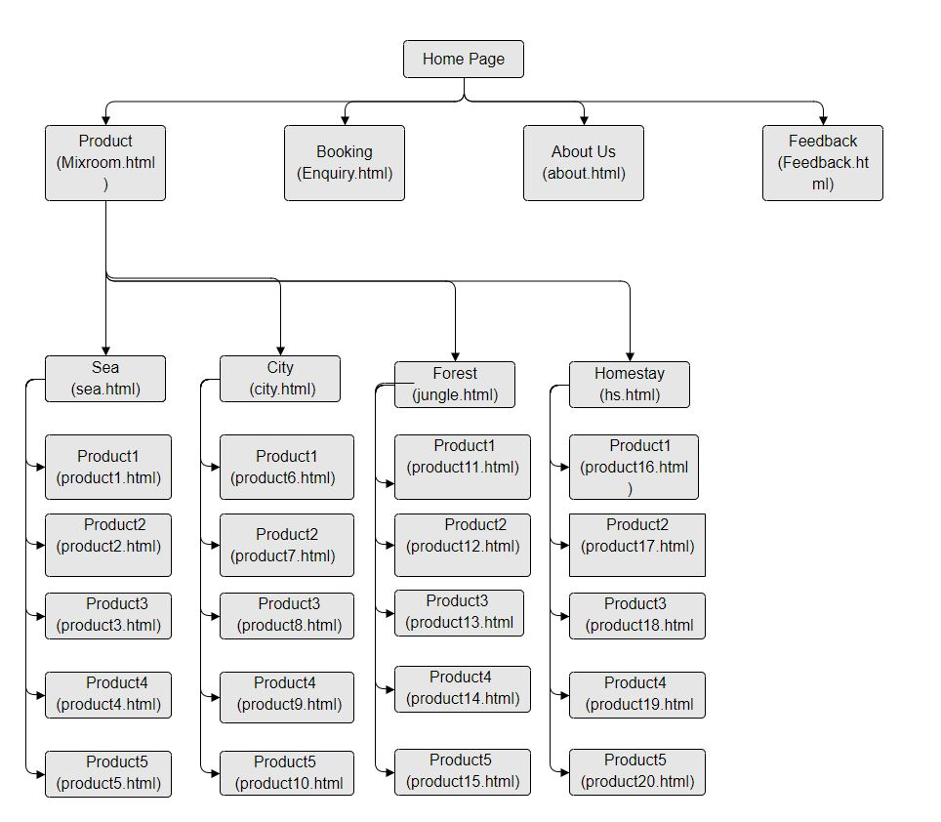

Footer menu

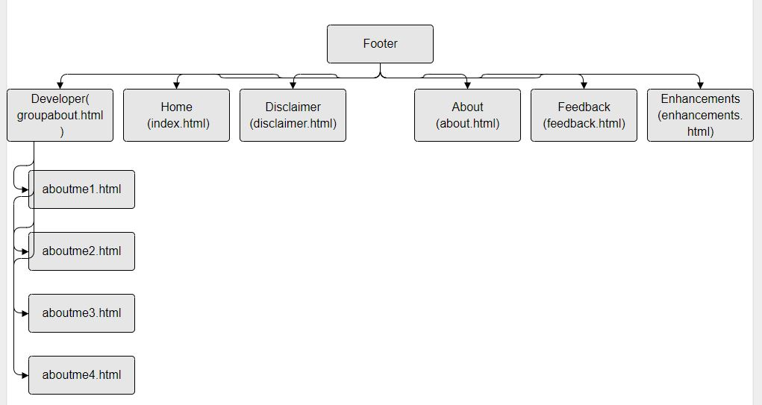

**3.0 End Product**

**3.1 Actual User Interface**

**Balance**

From this picture, balance can be seen as the elements are structured symmetrically with the web elements centered and this suggest a harmonious design.

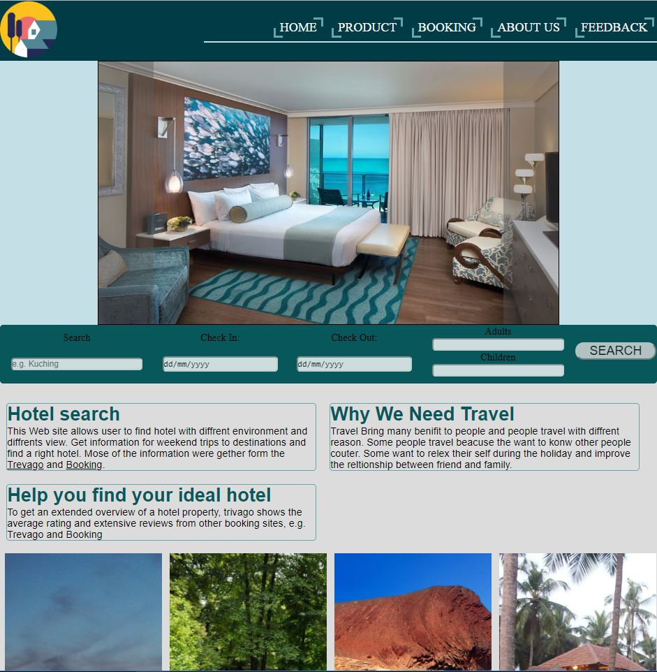

**Proximity**

Furthermore, proximity can also be seen in our website as the contents are placed closely to the headings. Doing so visually connects elements that have a logical relationship which makes it look more organized.

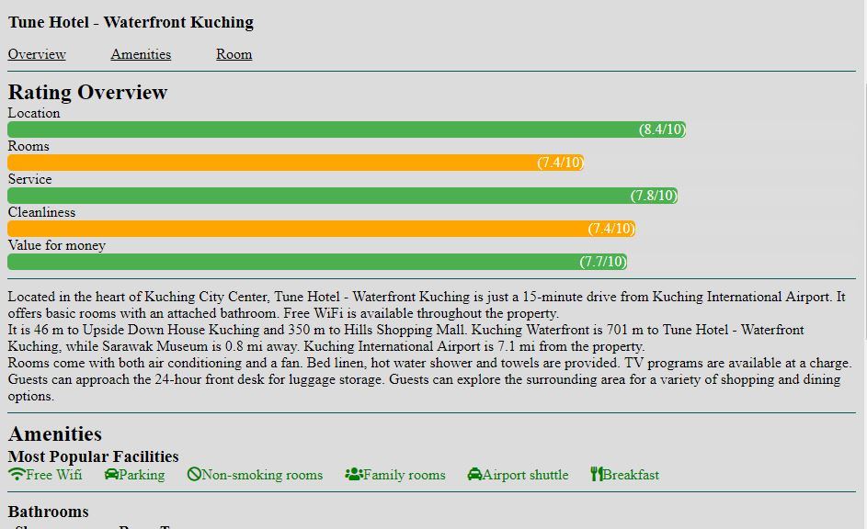

**Contrast and focus**

Contrast and focus can be seen in our website, as the white coloured background and the dark coloured heading of each content give high contrast to each other and creates a focal point at the heading of each content to our contents.

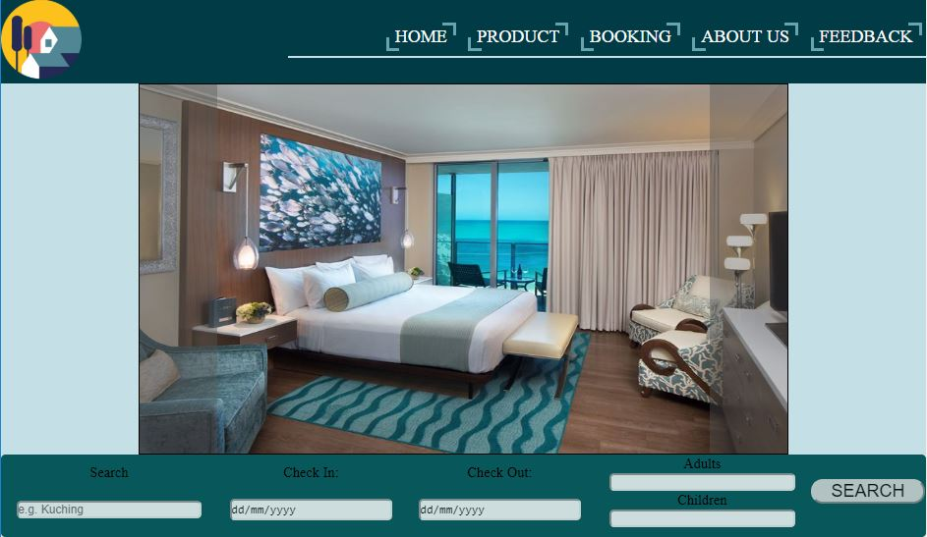

**Unity and Visual identity**

Finally, unity and visual identity can be seen in our website from the logo, font, and colour scheme, these can all be seen in all of our webpages and this gives our website a sense of consistency.



**3.2 Enhancement**

1. Menu Hover effects This enchancement is used in the nevigation for all page.The animated button is created using ".button:after" and ".button:before" in CSS for creating border and the border display none when user hover and change the color of the background.



1. Effects with toggle button



This enhancement used in homepage to show the brief information of all diffrents type of rooms. First insert a images with html and create a check box in side a div with html. second in Css, let the cheack box opaciyi 0 so cent see it in the page and setup a background for the checkbox

when it has been checked.

1. Animated button

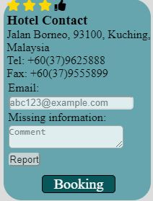

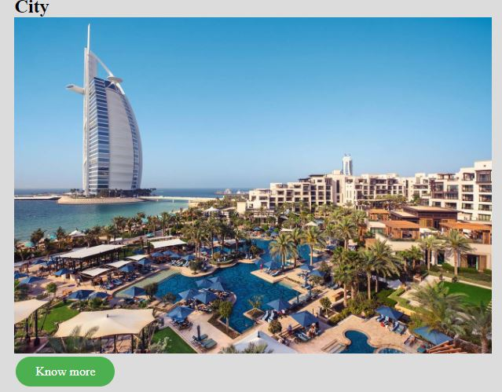

This enhancement is made for the user to booking the room and know more about the room in the product pages. The animated button is created using ".button:after" in css for creating background

and the background sliding down when the user hover to it.

1. Google maps

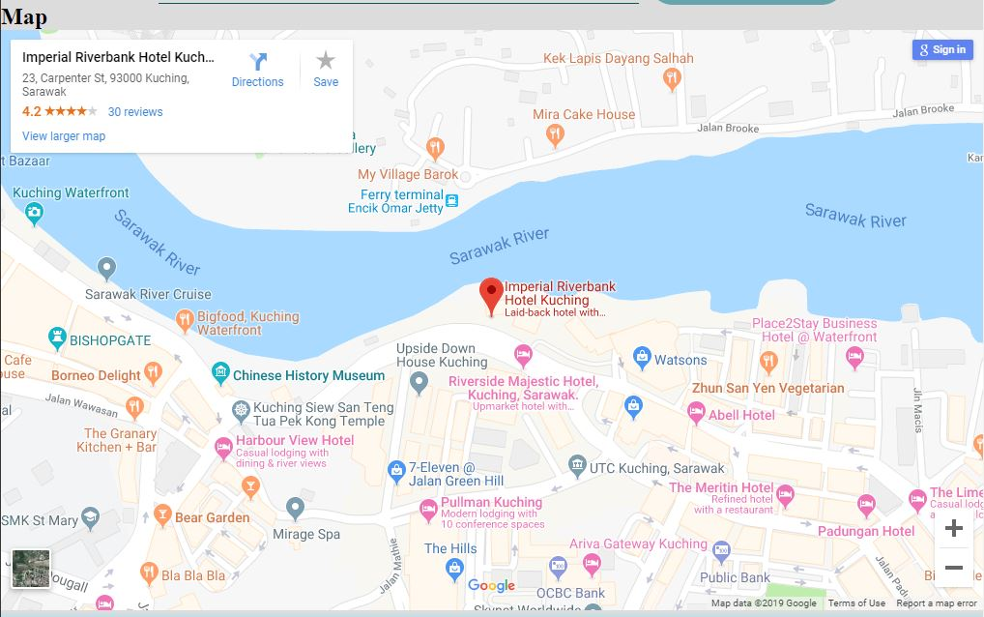

This enhancment made is to let the user know the location of the room or hotel. Embeded link is taken from google map and paste on the website html.

1. Slidesgow

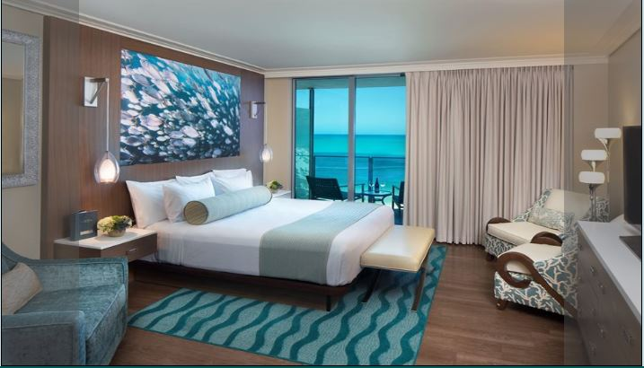

The web page have use slideshow for the product page.In css.firstly position the images with "absolute" after that create a label for the left and right side to let the user change the images.

**4.0 Contribution**

[State the contribution of each member. Assign percentage to each member]

|  |  |
| --- | --- |
| **Team Member 1** | **Gabriel Kong Qi Hao** |
| **Contribution (%)** | **30** |
| **List of Contribution** | **Main layout of Website, Home Page, Feedback and enquiry form** |
|  | **Report** |
|  | **6 product Page** |

|  |  |
| --- | --- |
| **Team Member 2** | **Tiong Wei Yuan** |
| **Contribution (%)** | **28** |
| **List of Contribution** | **Designing of main layout, Feedback and Enquiry form** |
|  | **About Page** |
|  | **6 product Page** |

|  |  |
| --- | --- |
| **Team Member 3** | **Kho Ye Sheng** |
| **Contribution (%)** | **14** |
| **List of Contribution** | **Designing of main layout** |
|  | **6 product Page** |
|  |  |

|  |  |
| --- | --- |
| **Team Member 4** | **Alan Lau Kai Lun** |
| **Contribution (%)** | **28%** |
| **List of Contribution** | **Designing of main layou** |
|  | **Disclaimer Page** |
|  | **6 product Page** |

**5.0 Group Reflection**

The challenges the team faced during doing this assignment is the layout, because the team not only need to be creative also need good in combine color to make the page look nice. Also, as a team, it is a must that we have to constantly communicate with each other even though we have other assignments, to overcome this challenge, we have decided to meet up every time after class to proceed with our assignment.