A* Windy Maze Report (Screenshots + Code Explanations) – Gabriel Ball
Screenshots (I don’t understand what you mean by username, so I put my first and last name
with my UMID to be safe)
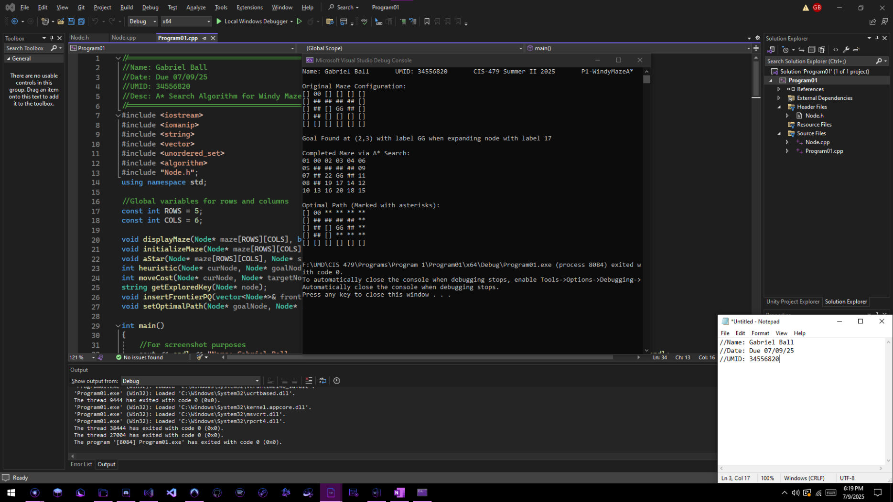
Program execution (Shows my program’s execution of the A* on the given maze. Includes original configuration, completed configuration shown by labels, and the optimal path on original configuration):
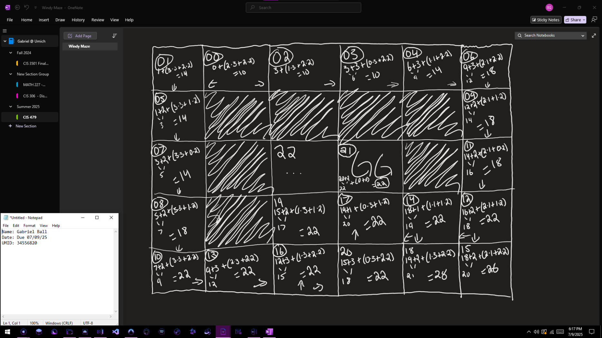
Manual A* Search (Shows my manual execution of A* on the given windy maze):

Code Explanations for Items 3-6 on the rubric are as follows:
- Highlighted Yellow: Item 3 (Data Structure: Priority Queue for frontier set and hash table for explored set)
  - The frontier set is a priority queue made up of a vector of Node*s. When a node is inserted into the frontier set, it’s priority is its f(n) member. If a tie occurs, its secondary priority is its label member (order of discovery). This inserting method ensures that the node with the highest priority (lowest f(n) and label if tie occurred) stays at the front of the frontier set, ready to be expanded.
  - When a node is expanded, it is added to the hash table (explored set) so that it doesn’t get expanded again later, since we have already found the lowest cost path to it. It is added to the explored set by generating a unique key using my getExploredKey() function which returns the node’s row and column in the format “r,c” as a string. The explored set is checked every time a node is being expanded and is looking at its neighbors to see if a neighbor has already been explored (is in the explored set). If it was explored, it skips that neighbor.
- Highlighted Blue: Item 4 (Calculation of f(n) = g(n) + h(n))
  - The g(n) for any given node is the current cost so far, plus the cost to get to its neighbor. The current cost so far is updated on every move, and the cost to get to its neighbor is calculated via my moveCost() function (1 for west, 2 for north/south, and 3 for east). The h(n) for any given node is a modified Manhattan distance calculated by my heuristic() function. This function adds the vertical distance * 2 to the horizontal distance * 1 or 3 depending on horizontal direction. The f(n) for any given node is simply g(n) + h(n).
- Highlighted Green: Item 5 (Adding leaves into frontier)
  - When a node is being expanded (exploring its neighbors), its neighbors are evaluated. If the path to a neighbor has a lower total cost, it will update its label to keep in line with FIFO for when a tie breaker occurs. The node is then inserted into the frontier via my insertFrontierPQ() function.
- Highlighted Pink: Item 6 (Picking the smallest f(n))
  - The frontier is sorted by keeping the node with the lowest f(n) at the front to ensure that the first node in the frontier has the lowest total estimated cost. If the node to be inserted into the frontier has the same f(n) as another node, the node with the lowest label will take precedence, keeping in line with the FIFO aspect of the A* search.

Code (Program ran on Visual Studio 2022 Windows 10, and written in C++)

Program01.cpp:
//========================================
//Name: Gabriel Ball
//Date: Due 07/09/25
//UMID: 34556820
//Desc: A* Search Algorithm for Windy Maze
//========================================
#include <iostream>
#include <iomanip>
#include <string>
#include <vector>
#include <unordered_set>
#include <algorithm>
#include "Node.h";
using namespace std;

//Global variables for rows and columns
const int ROWS = 5;
const int COLS = 6;

void displayMaze(Node* maze[ROWS][COLS], bool pathing);
void initializeMaze(Node* maze[ROWS][COLS], string mazeString);
void aStar(Node* maze[ROWS][COLS], Node* startNode, Node* goalNode);
int heuristic(Node* curNode, Node* goalNode);
int moveCost(Node* curNode, Node* targetNode);
string getExploredKey(Node* node);
void insertFrontierPQ(vector<Node*>& frontier, Node* node);
void setOptimalPath(Node* goalNode, Node* startNode);

int main()
{
//For screenshot purposes
cout << endl << "Name: Gabriel Ball UMID: 34556820 CIS-479 Summer II 2025 P1-WindyMazeA*" << endl << endl;

//Make Maze
Node* maze[ROWS][COLS];
//Works with any size maze as long as ROWS and COLS global variables are set correctly
string mazeString = "[]00[][][][][]########[][]##[]GG##[][]##[][][][][][][][][][]";
initializeMaze(maze, mazeString); //Fill in nodes in maze with mazeString info
cout << "Original Maze Configuration:" << endl;
displayMaze(maze, false);

//Begin algorithm
aStar(maze, maze[0][1], maze[2][3]); //Sends maze, start node, and goal node
}

void aStar(Node* maze[ROWS][COLS], Node* startNode, Node* goalNode)
{
vector<Node*> frontier;
unordered_set<string> explored;
int labelCounter = 0;

//Set g(n), h(n), f(n), and label for start node
startNode->setGn(0);
startNode->setHn(heuristic(startNode, goalNode));
startNode->setFn(startNode->getGn() + startNode->getHn());
startNode->setLabel(to_string(labelCounter));
labelCounter++;
//Put start node in frontier
frontier.push_back(startNode);

//Loop until frontier is empty
while (!frontier.empty())
{
//Picks smallest f(n) in frontier, which is at the front
Node* cur = frontier.front();
frontier.erase(frontier.begin());
//Insert key for this node into explored set
explored.insert(getExploredKey(cur));

//Check if this node is the goal node
if (cur == goalNode)
{
cur->setLabel("GG"); //Reset label if it was overwritten
cout << "Goal Found at (" << cur->getRow() << "," << cur->getCol() << ") with label GG "
<< "when expanding node with label " << cur->getParent()->getLabel() << endl
<< endl << "Completed Maze via A* Search:" << endl;
displayMaze(maze, false); //Display final maze
cout << "Optimal Path (Marked with asterisks):" << endl;
//Mark optimal path by changing parents' pathing labels until start is reached
setOptimalPath(goalNode, startNode);
displayMaze(maze, true); //Display original maze with
return;
}

//Arrays for neighbor exploration order
int dRow[] = { 0, -1, 0, 1 };
int dCol[] = { -1, 0, 1, 0 };
//Check neighbors
for (int direction = 0; direction < 4; direction++) //0: W, 1: N, 2: E, 3: S
{
int newRow = cur->getRow() + dRow[direction];
int newCol = cur->getCol() + dCol[direction];

if (newRow < 0 || newRow >= ROWS || newCol < 0 || newCol >= COLS)
continue; //Skip this neighbor, it is out of bounds

Node* neighbor = maze[newRow][newCol];
if (neighbor->getIsObstacle() || explored.count(getExploredKey(neighbor)))
continue; //Skip this neighbor, it is an obstacle or was already explored

//g(n) for this node is current cost from start, or g(n), plus the cost to get to its neighbor
int curGn = cur->getGn() + moveCost(cur, neighbor);
if (curGn < neighbor->getGn()) //Cheaper path found
{
//Set g(n), h(n), f(n), and parent for this neighbor
neighbor->setGn(curGn);
neighbor->setHn(heuristic(neighbor, goalNode));
neighbor->setFn(neighbor->getGn() + neighbor->getHn());
neighbor->setParent(cur); //Parent is the one that explored it (cur)

//Update label
neighbor->setLabel(to_string(labelCounter));
labelCounter++;
//Add it to frontier
insertFrontierPQ(frontier, neighbor);
}
}
}
//If frontier is empty before goal is found, no path exists
cout << "Goal Not Found. No path exists" << endl;
}

int heuristic(Node* curNode, Node* goalNode)
{
//Horizontal (east/west) distance between node and goal
int horizontal = goalNode->getCol() - curNode->getCol();
//Vertical (north/south) distance between node and goal
int vertical = goalNode->getRow() - curNode->getRow();
//Horizontal cost is 3 if going east (horizontal > 0) and 1 if going west (horizontal < 0)
int costH = (horizontal > 0) ? 3 : 1;
//Vertical cost is 2 regardless of direction being north or south
int costV = 2;
return (abs(horizontal) * costH) + (abs(vertical) * costV); //Returns calculated h(n)
}

int moveCost(Node* curNode, Node* neighbor)
{
//Difference between columns gets horizontal distance and direction
int horizontal = curNode->getCol() - neighbor->getCol();
//Since this function is only used to find direction/cost of a
//node and its neighbor, it only needs to check -1 and 1 distances
if (horizontal == 1) return 1; // West = 1
if (horizontal == -1) return 3; //East = 3
return 2; //North or South = 2
}

void insertFrontierPQ(vector<Node*>& frontier, Node* node)
{
//Loop through frontier until end is reached
for (vector<Node*>::iterator it = frontier.begin(); it != frontier.end(); ++it)
{
int f1 = (*it)->getFn();
int f2 = node->getFn();

//Lower f(n) goes first
if (f1 > f2)
{
//Insert just before the first node with higher f(n)
frontier.insert(it, node);
return;
}

//f(n) tie breaker is based on lower label
if (f1 == f2)
{
string l1 = (*it)->getLabel();
string l2 = node->getLabel();

//Only compare numerically if both labels are digits
if (isdigit(l1[0]) && isdigit(l2[0]) && (stoi(l1) > stoi(l2)))
{
//Insert just before first node with higher label if f(n) was tied
frontier.insert(it, node);
return;
}
}
}
//Insert at end here - loop ended, this node has the highest f(n)
frontier.push_back(node);
}

string getExploredKey(Node* node)
{
//Key is just row,col for hash table
return to_string(node->getRow()) + "," + to_string(node->getCol());
}

void initializeMaze(Node* maze[ROWS][COLS], string mazeString)
{
string label;
for (int i = 0; i < ROWS; i++)
{
for (int j = 0; j < COLS; j++)
{
label = mazeString.substr(0, 2); //First 2 characters of mazeString
//Make node in maze at ith row and jth column with overloaded constructor
maze[i][j] = new Node(i, j, label, label == "GG", label == "##");
mazeString = mazeString.substr(2); //Remove first 2 characters of mazeString
}
}
}

void displayMaze(Node* maze[ROWS][COLS], bool pathing)
{
for (int i = 0; i < ROWS; i++)
{
for (int j = 0; j < COLS; j++)
{
//If pathing is true, we want to display pathing labels for displaying optimal path. Otherwise, display regular label
cout << setw(2) << setfill('0') << ((pathing) ? maze[i][j]->getPathingLabel() : maze[i][j]->getLabel()) << " ";
}
cout << endl;
}
cout << endl;
}

void setOptimalPath(Node* goalNode, Node* startNode)
{
Node* cur = goalNode->getParent(); //Skip overwriting goal node with **
while (cur && cur != startNode) // Loop from goal to start
{
cur->setPathingLabel("**"); //Set new (pathing) label
cur = cur->getParent();
}
}

Node.cpp:

#include "Node.h"

Node::Node() {}

Node::Node(int r, int c, string l, bool g, bool o)
{
row = r;
col = c;
label = l;
isGoal = g;
isObstacle = o;
gn = INT_MAX;
pathingLabel = l;
}

int Node::getRow() const
{
return row;
}

int Node::getCol() const
{
return col;
}

int Node::getGn() const
{
return gn;
}

int Node::getHn() const
{
return hn;
}

int Node::getFn() const
{
return fn;
}

string Node::getLabel() const
{
return label;
}

Node* Node::getParent() const
{
return parent;
}

bool Node::getIsGoal() const
{
return isGoal;
}

bool Node::getIsObstacle() const
{
return isObstacle;
}

string Node::getPathingLabel() const
{
return pathingLabel;
}

void Node::setRow(int r)
{
row = r;
}

void Node::setCol(int c)
{
col = c;
}

void Node::setGn(int g)
{
gn = g;
}

void Node::setHn(int h)
{
hn = h;
}

void Node::setFn(int f)
{
fn = f;
}

void Node::setLabel(string l)
{
label = l;
}

void Node::setParent(Node* p)
{
parent = p;
}

void Node::setPathingLabel(string pl)
{
pathingLabel = pl;
}

Node.h:

#pragma once
#include <string>
using namespace std;
class Node
{
private:
int row;
int col;
int gn; //Cost So Far
int hn; //Heuristic
int fn; //Estimated Total Cost
string label;
Node* parent;
bool isGoal;
bool isObstacle;
string pathingLabel; //Original label unless on optimal path (**)
public:
//Constructors
Node();
Node(int r, int c, string l, bool g, bool o);

//Getters
int getRow() const;
int getCol() const;
int getGn() const;
int getHn() const;
int getFn() const;
string getLabel() const;
Node* getParent() const;
bool getIsGoal() const;
bool getIsObstacle() const;
string getPathingLabel() const;

//Setters
void setRow(int r);
void setCol(int c);
void setGn(int g);
void setHn(int h);
void setFn(int f);
void setLabel(string l);
void setParent(Node* p);
void setPathingLabel(string pl);
};

