FINAL PROJECT DOCUMENTATION

CS121: ADVANCED COMPUTER PROGRAMMING

Submitted By:

BOBADILLA, GABRIEL ANTHONY M.

IT – 2101

1. **PROJECT OVERVIEW**

HeritagePulsePH is a website dedicated to preserving and promoting the rich dance literatures of the Philippine folk dances. It addresses the challenges of fragmented and limited access to cultural dance resources by providing a centralized platform that serves as a digital repository for dance documentation, choreography and historical context. This initiative supports the preservation of cultural identity, enhances educational opportunities, and promotes the appreciation of Philippine folk dances among diverse audiences.

The platform will feature a comprehensive archive of dance literatures, including steps, choreography, costumes, and historical narratives. It will also include multimedia resources such as video demonstrations and an interactive map showcasing the origins of various folk dances. However, it will not cover functionalities like managing event ticketing or live dance performance streaming. HeritagePulsePH’s target users include dance educators, researchers, students, cultural organizations, and enthusiasts of Philippine folk culture.

The project aims to achieve specific, measurable outcomes. These include documenting 70% of known Philippine folk dances within the first year, increasing user engagement by 30% through interactive features by Q3 2025, and reducing the time required to access dance resources by 50% within six months of launch. Additionally, the website aims to provide an interactive GIS-based mapping feature for dance origins by Q4 2024 and curate 200 new folk dance literatures by Q2 2025. HeritagePulsePH will serve as a vital tool in preserving and celebrating the dynamic traditions of Philippine folk dances in the modern digital age, aligning with cultural preservation initiatives supported by the Philippine National Commission for Culture and the Arts (NCCA)【1】, UNESCO’s directives on safeguarding intangible cultural heritage【2】, and academic studies emphasizing the importance of digital repositories in cultural preservation【3】.

1. **PYTHON CONCEPTS AND LIBRARIES**
2. **Tkinter (Graphical User Interface)**

Tkinter is a built-in Python library used for creating graphical user interfaces (GUIs). It provides various widgets like buttons, labels, frames, canvases, and scrollbars to allow user interaction with the application. In these scripts, Tkinter is used to create the app's windows, frames, navigation buttons, and labels. The pack() method is used to arrange widgets in a layout, and event handling (command=lambda) is employed to manage user interactions, such as button clicks to navigate between sections.

1. **Pillow (PIL) (Image Processing)**

Pillow is a Python library for opening, manipulating, and saving image files. In these files, Pillow is used to load and resize images (e.g., dance images) that are displayed within the Tkinter GUI. The Image.open() function is used to open image files, and ImageTk.PhotoImage() is used to convert images into a format that Tkinter can handle and display. Image resizing is done to ensure that images fit within the application window using the resize() method.

1. **Canvas and Scrollbar (Scrollable Content)**

The Canvas widget in Tkinter is used to create a scrollable area for displaying content, while the Scrollbar widget is linked to the canvas to allow vertical scrolling. This is especially useful when displaying large numbers of images, such as dance images or other visual content. The bind() method is used to update the scroll region when the content changes, ensuring that the scrollable area adjusts dynamically.

1. **File Handling (Image Paths)**

File handling is used to manage and access the paths of image files within the app. The image paths for each dance or cultural section are stored in dictionaries or lists, and these paths are dynamically passed to functions such as show_images_for_dance() to display images in the Tkinter window. This allows the app to load and display different images based on user input or selection.

1. **Lambda Functions (Event Handling)**

Lambda functions are anonymous functions used for short, simple operations. In these scripts, lambda functions are used in the command parameter of Tkinter buttons to handle events. For example, when a button is clicked, the lambda function triggers the corresponding function (such as show_muslim_section() or show_images_for_dance()) that displays content or navigates to a different section of the app.

1. **Geometry Management (Widget Positioning)**

Tkinter uses geometry management methods such as pack(), place(), and grid() to control how widgets are positioned within their parent container (such as a frame or window). In these scripts, the pack() method is mainly used to arrange widgets vertically or horizontally within the window. For example, buttons and labels are packed in frames to ensure they are properly aligned in the GUI.

1. **Exception Handling (Error Management)**

Exception handling is used in Python to catch and manage runtime errors, preventing the program from crashing. In these scripts, exception handling is used when loading images or interacting with the file system. For instance, the try...except block is used to catch any errors that may occur when loading an image with Pillow, ensuring that the program handles errors gracefully and provides feedback when an image fails to load.

1. **Dynamic UI Update (Updating Content)**

The application dynamically updates its user interface based on user interaction. For instance, the create_dashboard() method is called whenever the user navigates back to the main dashboard, and content is cleared and refreshed by destroying existing widgets using the winfo_children() method. This allows the app to update content dynamically without restarting or rebuilding the entire GUI.

1. **Image Resizing and Aspect Ratio Calculation (Image Display)**

The app resizes images to fit within the available space in the Tkinter window, ensuring that images maintain their aspect ratio. This is done by calculating the aspect ratio of the original image and adjusting the height based on the width of the window. The resized image is then displayed on the canvas using ImageTk.PhotoImage().

1. **Dictionaries (Data Storage)**

Dictionaries are used to store data, such as image paths for each dance or cultural section. In these scripts, dictionaries are used to map dance names to lists of image file paths, allowing for easy retrieval and display of images when a user selects a particular dance or cultural section.

1. **Frames (Container Widgets)**

Frames are container widgets in Tkinter that group other widgets together. In these scripts, frames are used to organize the layout of the GUI, separating the header, dashboard, image display sections, and navigation buttons. Frames make the layout more structured and easier to manage.

1. **SUSTAINABLE DEVELOPMENT GOALS**
2. **SDG 4: Quality Education**

HeritagePulsePH promotes cultural education by providing a platform to learn about various cultural practices, traditions, and heritage. The app helps preserve indigenous knowledge and educates users about the importance of cultural diversity, fostering lifelong learning.

1. **SDG 10: Reduced Inequalities**

The app highlights and gives visibility to marginalized cultural groups such as indigenous communities and Muslims, reducing cultural inequalities by promoting understanding and respect for their traditions. It serves to bridge cultural gaps and ensure that minority groups' cultural heritage is recognized and celebrated.

1. **SDG 11: Sustainable Cities and Communities**

HeritagePulsePH fosters community pride by preserving local cultures and traditions. This contributes to building strong, sustainable communities where cultural heritage plays an essential role in shaping identity and social cohesion.

1. **SDG 16: Peace, Justice, and Strong Institutions**

By celebrating cultural diversity and promoting understanding between different groups, HeritagePulsePH contributes to peacebuilding and reducing conflict. It helps build stronger communities based on respect and tolerance for various cultural practices and traditions.

1. **SDG 17: Partnerships for the Goals**

HeritagePulsePH can collaborate with local governments, NGOs, cultural organizations, and educational institutions to enhance its cultural preservation efforts and extend its reach, thereby strengthening partnerships for sustainable development.

1. 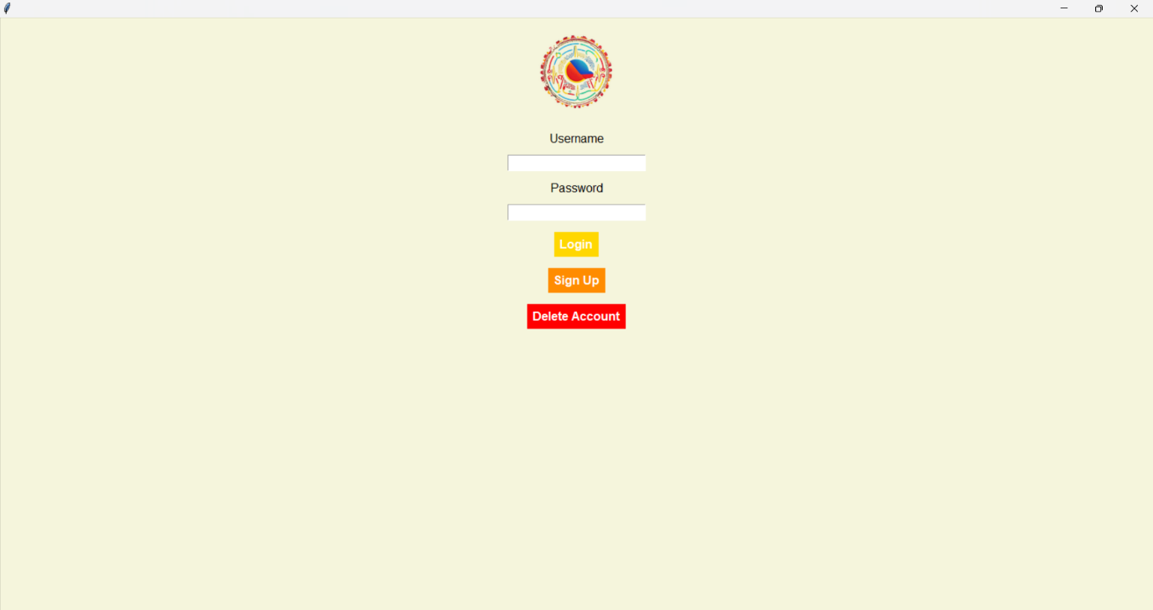**PROGRAM/SYSTEM INSTRUCTIONS**

Click Sign Up button to create a new account

Enter your username and password

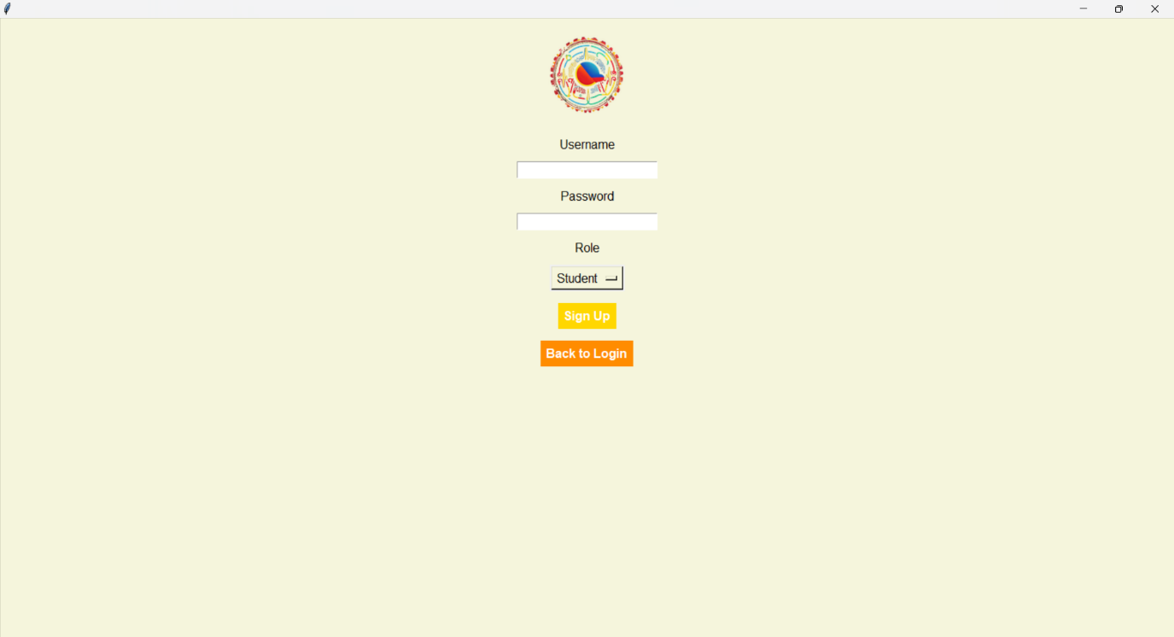**Figure 1. Login Page**

Input your preferred Username and Password then click Sign up.

**Figure 2. Sign Up Page**

The **Sign-Up** Screen allows users to create an account by entering their desired username and password in the provided fields. Once the information is filled out, clicking the **Sign Up button** completes the account creation process, and a confirmation message will appear to indicate success.

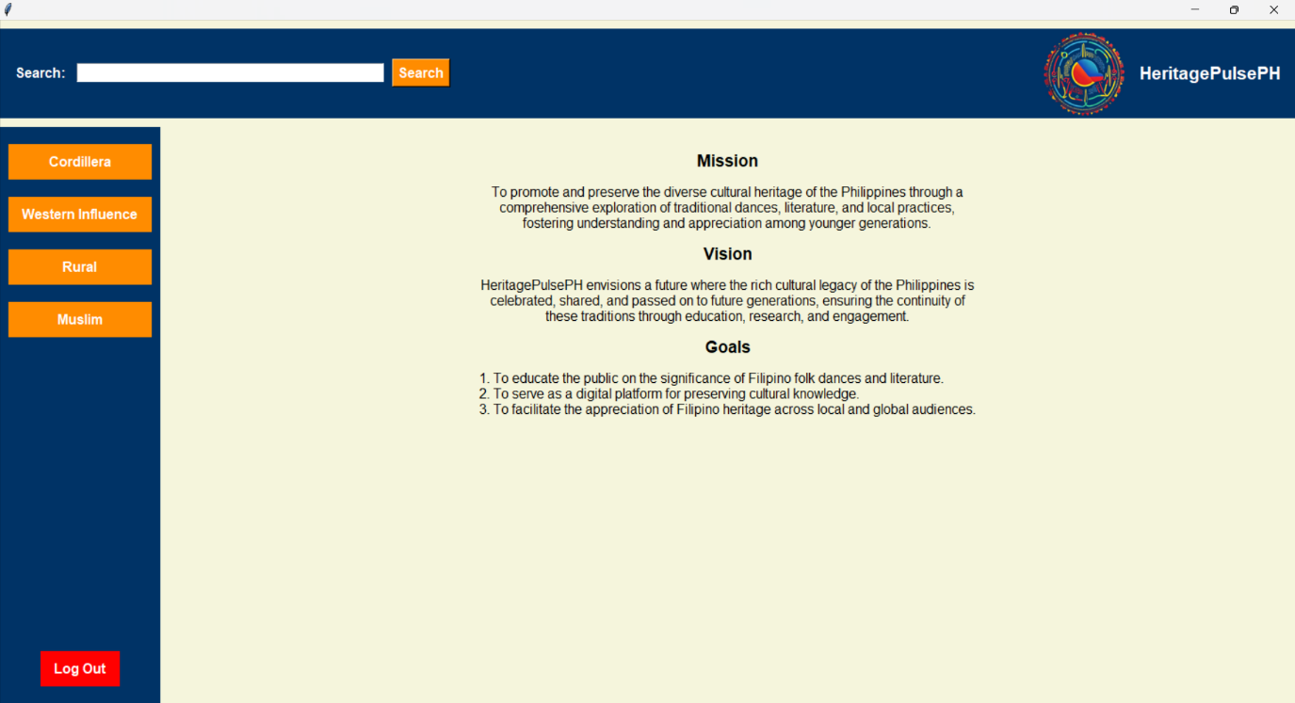

Select the type of dance you want to see

On the Main Dashboard the Mission, Vision, and Goals is presented

**Figure 3. Main Dashboard**

On the **Main Dashboard**, users are introduced to the **Mission, Vision, and Goals** of HeritagePulsePH. This serves as a starting point for exploring the different sections of the platform, such as Rural, Western Influence, Cordillera, or Muslim dances. Additionally, users can use the **Search** tab to locate specific dances or features efficiently

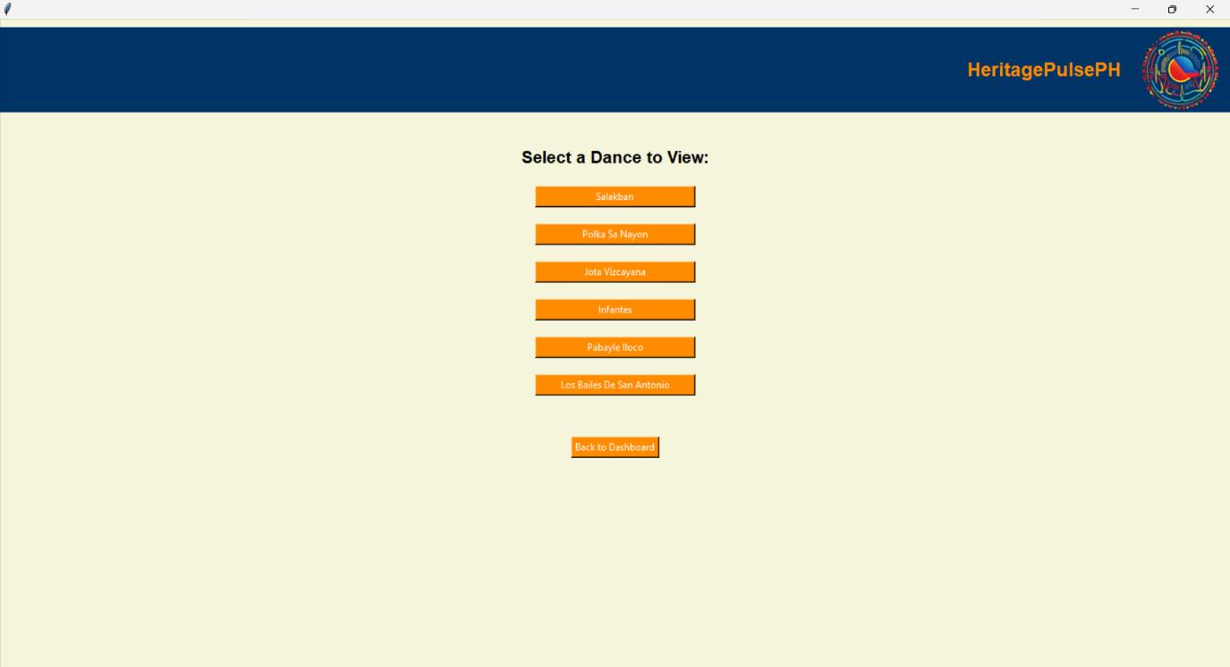

Select the dance you want.

**Figure 4. Selecting a Dance to View**

When selecting a dance, users first choose a category from the available options. After selecting a specific dance, the system presents the **dance literature, including detailed choreography, historical context, and multimedia resources**. This makes it easy to explore and learn about various cultural dances in an engaging way.

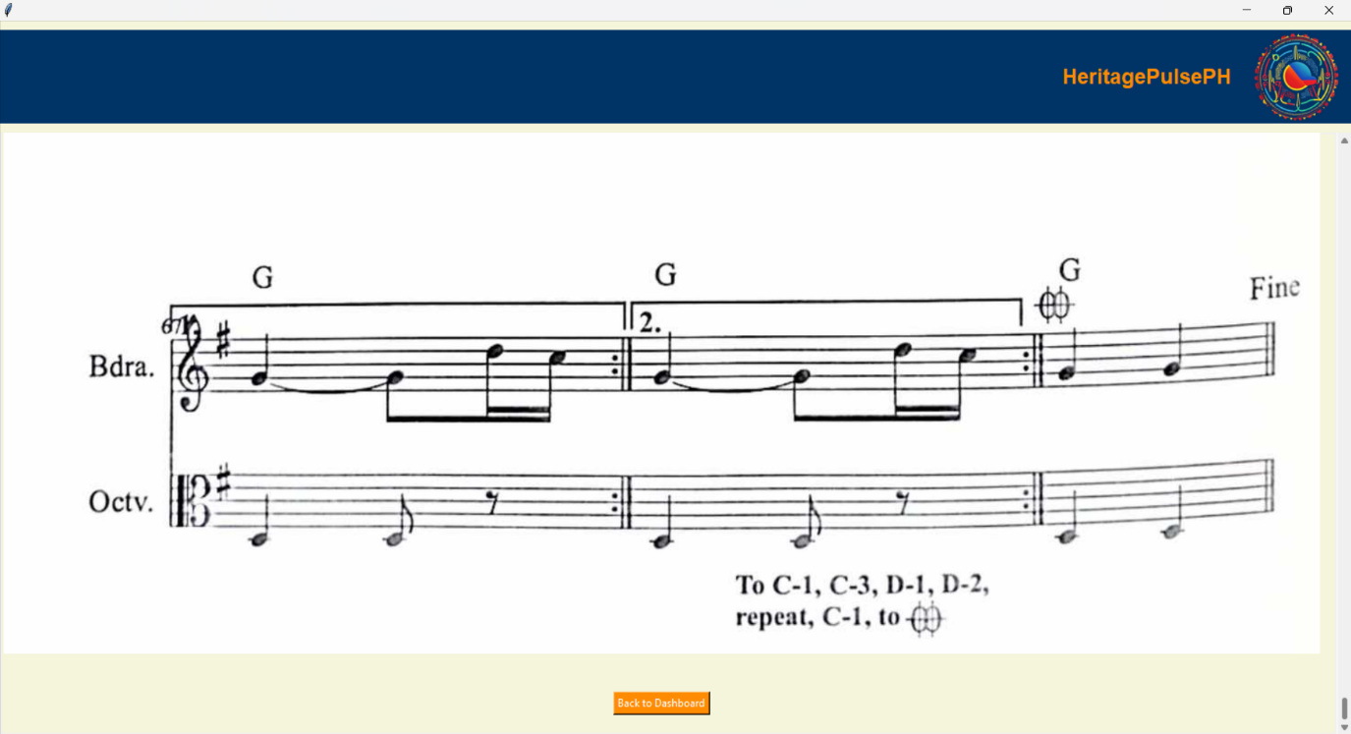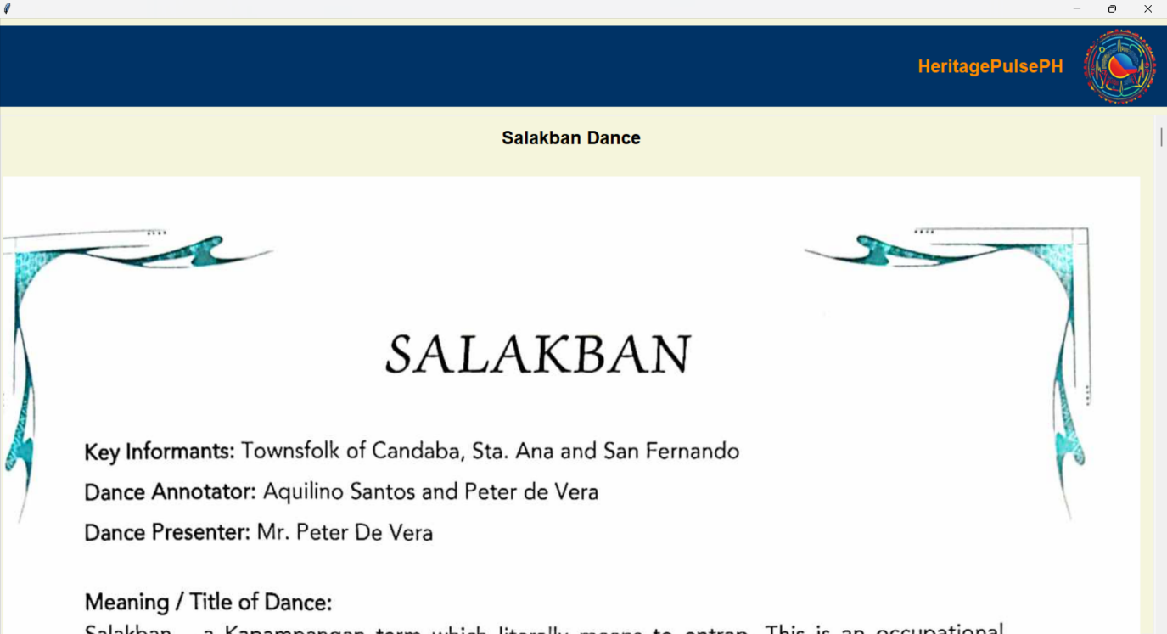**Figure 5. Dane Literature Page**

Click the Back to Dashboard button to go back to the main dashboard

The dance literature will be presented

**Figure 6. Back to Dashboard Button**

To return to the **Main Dashboard** at any point, users can click the **Back to Dashboard** button. This action redirects them to the main menu, where they can continue exploring other sections or dances without losing their progress.

If users wish to log out, they can do so by clicking the **Log Out** button, which prompts a confirmation message to ensure their intent. For those who want to delete their account, the **Delete Account** option is accessible from the login screen, where a confirmation prompt ensures the action is deliberate.

Put the name of the dance you want to see

Click yes if you want to log out

Click the log out button

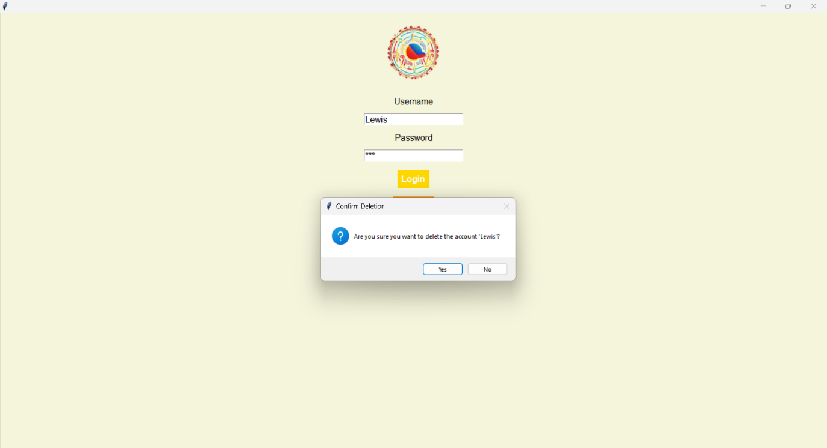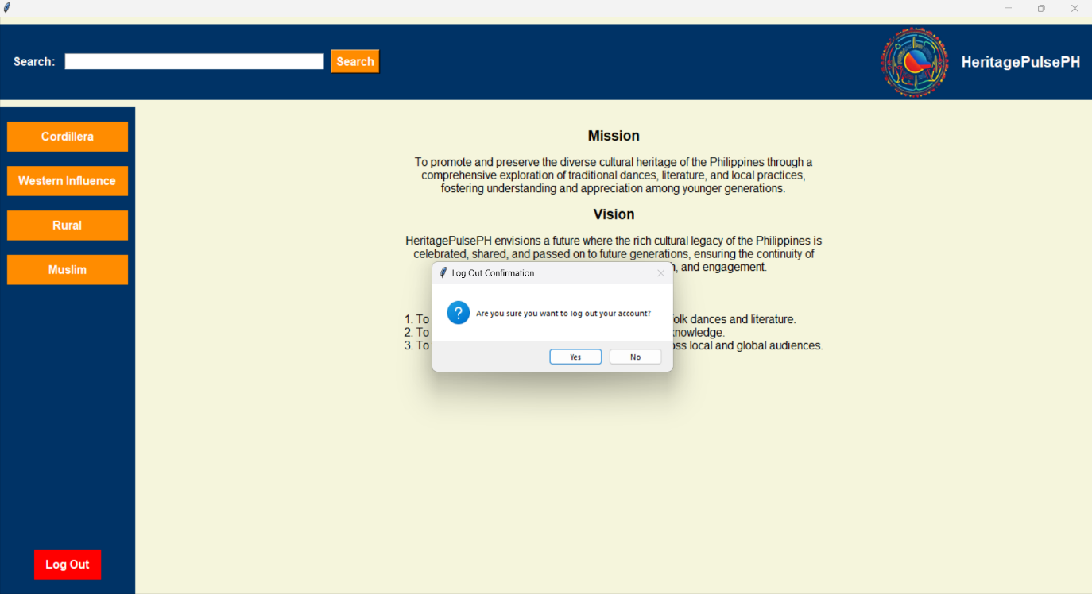**Figure 7. Log Out and Search Bar**

Click Yes if you want to delete your account

Upon clicking the Delete Account Button a confirmation will appear

**Figure 8. Delete Account Button**